* What did you find? Which borough is the most expensive? Any other interesting trends?
  + Waltham Forest is the most expensive with 369% growth in the last 2 decades
  + It’s almost the double of the minimum growth, which is the RU Thames

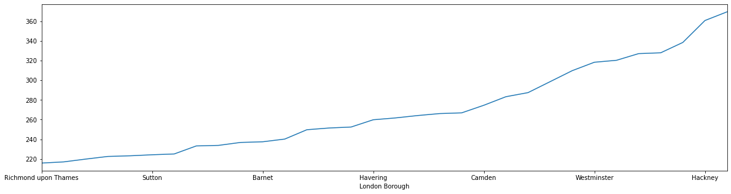

* How did you arrive at your conclusion?
  + Set_index as ‘London Borough’ for the melted data
  + Groupby is applied for both 2000 and 2010
  + Sort_values is applied as ascending
* What were the main challenges you encountered? How did you overcome them? What could you not overcome?
  + No major issues were noted, data was quite thorough
  + One aspect to mention: Postcode appears to be NaN, but it actually was NaT. It required pd.NaT to be removed, that I didn’t know first and it took me awhile to figure it out. However, later on I realized that I don’t need it, since it was repetitive data with the borough names and I dropped it.
* Is there anything you’d like to investigate deeper?
  + I had a chance to practise time-series within the most expensive borough
  + I applied Sarimax from statsmodel library
  + 20%+ price increase is forecasted within the next 5 years

