Exercises: Table Relations
You can check your solutions in the Judge system.

One-To-One Relationship
Create two tables and use appropriate data types.

Example
Persons |  |  |  |  | Passports
PersonID | FirstName | Salary | PassportID |  | PassportID | PassportNumber
1 | Roberto | 43300.00 | 102 |  | 101 | N34FG21B
2 | Tom | 56100.00 | 103 |  | 102 | K65LO4R7
3 | Yana | 60200.00 | 101 |  | 103 | ZE657QP2

Insert the data from the example above. Alter the Persons table and make PersonID a primary key. Create a foreign key between Persons and Passports by using the PassportID column.

One-To-Many Relationship

Create two tables and use appropriate data types.

Example
Models |  |  |  | Manufacturers
ModelID | Name | ManufacturerID |  | ManufacturerID | Name | EstablishedOn
101 | X1 | 1 |  | 1 | BMW | 07/03/1916
102 | i6 | 1 |  | 2 | Tesla | 01/01/2003
103 | Model S | 2 |  | 3 | Lada | 01/05/1966
104 | Model X | 2
105 | Model 3 | 2
106 | Nova | 3
Insert the data from the example above and add primary keys and foreign keys.

Many-To-Many Relationship

Create three tables and use appropriate data types.

Example
Students |  |  |  | Exams |  |  |  | StudentsExams
StudentID | Name |  |  | ExamID |  | Name |  | StudentID | ExamID
1 | Mila |  |  | 101 |  | SpringMVC |  | 1 | 101
2 | Toni |  |  | 102 |  | Neo4j |  | 1 | 102
3 | Ron |  |  | 103 |  | Oracle 11g |  | 2 | 101
 |  |  |  |  |  |  |  | 3 | 103
 |  |  |  |  |  |  |  | 2 | 102
 |  |  |  |  |  |  |  | 2 | 103
Insert the data from the example above and add primary keys and foreign keys. Keep in mind that the table "StudentsExams" should have a composite primary key.

Self-Referencing
Create one table and use appropriate data types.

Example
Teachers
TeacherID | Name | ManagerID
101 | John | NULL
102 | Maya | 106
103 | Silvia | 106
104 | Ted | 105
105 | Mark | 101
106 | Greta | 101
Insert the data from the example above and add primary keys and foreign keys. The foreign key should be between ManagerId and TeacherId.

Online Store Database
Create a new database and design the following structure:
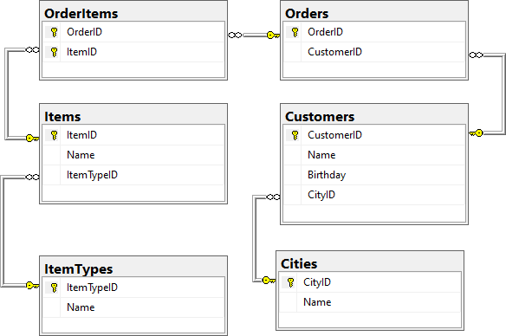

University Database
Create a new database and design the following structure:
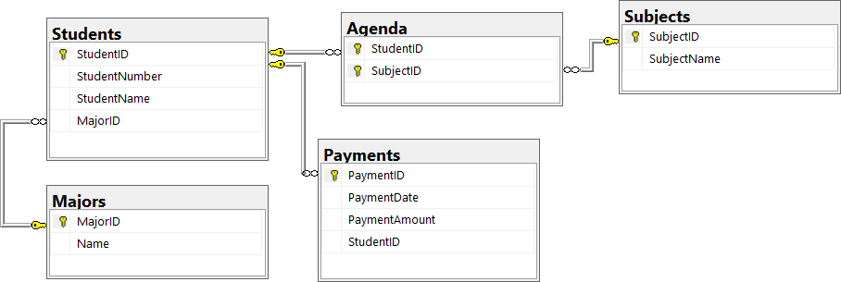

SoftUni Design
Create an E/R Diagram of the SoftUni Database. There are some special relations you should check out:
- Employees are self-referenced (ManagerID)
- Departments have One-to-One with the Employees (ManagerID)
- Employees have One-to-Many (DepartmentID)
You might find it interesting how it looks on the diagram.

Geography Design
Create an E/R Diagram of the Geography Database.

*Peaks in Rila

Display all peaks for "Rila" mountain. Include:
- MountainRange
- PeakName
- Elevation
Peaks should be sorted by elevation descending.

Example
MountainRange | PeakName | Elevation
Rila | Musala | 2925
… | … | …

