Lab: Polymorphism
You can check your solutions here: Polymorphism-Lab

MathOperation
NOTE: You need a public StartUp class with the namespace Operations.
Create a class MathOperations, which should have 3 times method Add(). Method Add() has to be invoked with:
- Add(int, int): int
- Add(double, double, double): double
- Add(decimal, decimal, decimal): decimal
You should be able to use the class like this:
StartUp.cs
public static void Main()
{
MathOperations mo = new MathOperations();
Console.WriteLine(mo.Add(2, 3));
Console.WriteLine(mo.Add(2.2, 3.3, 5.5));
Console.WriteLine(mo.Add(2.2m, 3.3m, 4.4m));
}

Examples
Output
5
11
9.9

Solution
Created MathOperation class should look like this:
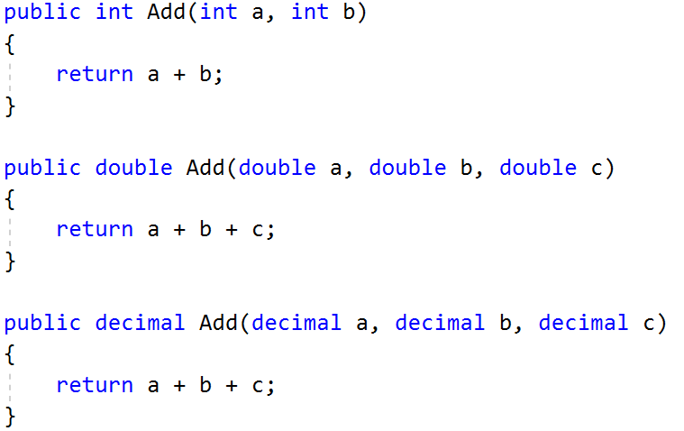

Animals
NOTE: You need a public StartUp class with the namespace Animals.
Create a class Animal, which holds two fields:
- name: string
- favouriteFood: string
An animal has one virtual method ExplainSelf(): string.
You should add two new classes - Cat and Dog. Override the ExplainSelf() method by adding concrete animal sound on a new line. (Look at examples below)
You should be able to use the class like this:
StartUp.cs
Animal cat = new Cat("Peter", "Whiskas");
Animal dog = new Dog("George", "Meat");

Console.WriteLine(cat.ExplainSelf());
Console.WriteLine(dog.ExplainSelf());

Examples
Output
I am Peter and my fovourite food is Whiskas
MEEOW
I am George and my fovourite food is Meat
DJAAF

Solution
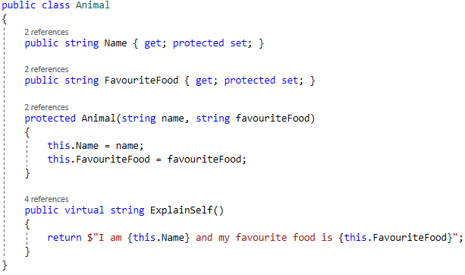
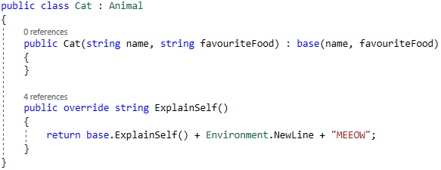

Shapes
NOTE: You need a public StartUp class with the namespace Shapes.
Create a class hierarchy, starting with abstract class Shape:
- Abstract methods:
  - CalculatePerimeter(): double
  - CalculateArea(): double
- Virtual methods:
  - Draw(): string
    - The method should get the name of class type as string, and should return a message in the format: $"Drawing {classType.Name}"
Extend the Shape class with two children:
- Rectangle
- Circle
Each of them needs to have:
- Fields:
  - height and width for Rectangle
  - radius for Circle
- Encapsulation for these fields
- A public constructor
- Concrete methods for calculations (perimeter and area)
- Override methods for drawing

