Exercise: MiniORM Core
This tutorial provides step-by-step guidelines to build an "ORM Framework" in C#, as well as a sample app, which utilizes the framework. The app is designed to resemble the functionality of Entity Framework Core to an extent. You will be provided with a partially-implemented framework C# project.

I. Project Specification
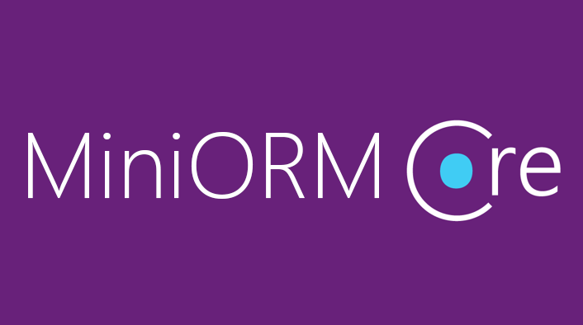
The framework should support the following functionality:
- Connecting to a database via a provided connection string
- Discovering entity classes at runtime
- Retrieving entities via framework-generated SQL
- CRUD operations (inserting, modifying, deleting entities) via framework-generated SQL

Framework Overview
The framework consists of the following classes:
- DbSet<T> – Custom generic collection, which holds the actual entities inside it. The DbContext class has several DbSets, which correspond to all the tables in the database.
- DbContext – Database context class, responsible for retrieving entities from the database and mapping the relations between them (through so-called navigation properties).
- DatabaseConnection – Responsible for establishing database connections and sending SQL queries. Usually used by the DbContext.
- ConnectionManager – Simple DatabaseConnection wrapper, which allows it to be wrapped in a using block for opening and closing connections to the database.
- ChangeTracker – Responsible for tracking the added, modified and deleted entities from the DbSets. Every DbSet has one. Used by the DbContext to persist changes into the database.
- ReflectionHelper – Utility class, which contains some reflection-related methods.
Now that you have a very basic understanding of what each class should do, let's get to implementing them.
It's time to open the provided skeleton and start writing code.

Implement Framework

Implement the ChangeTracker class
In this class, we will need three lists. The first one will store all the entities. The second one will keep track of the added ones and the third – the removed ones. Add a generic constraint to limit the generic type parameters to only reference types, which have a parameter-less constructor.
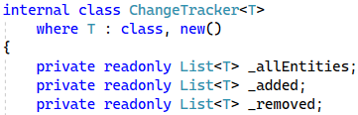
The ChangeTracker constructor will accept a collection of entities as a parameter. In its body, we have to initialize our added and removed lists. Then, the allEntities field will store clones of all the entities of the parent DbSet. We need to clone them, so we can find out which ones were modified when the time for persisting them into the database comes. To do that, we call CloneEntities() with the collection of entities as parameters.
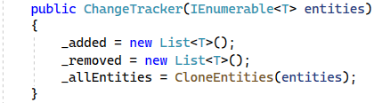
The next step is to implement the CloneEntities method. This method will return a List<T> with the cloned entities. We need another variable of type PropertyInfo[] to collect the properties, we need to clone. We only care about properties, which are part of the database, so we only get the properties with valid SQL types.
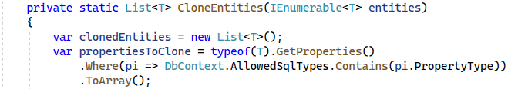
We iterate over each real entity, create a new blank entity of the same type and set all its cloneable properties to the real entity's property values. Lastly, we add the clonedEntity to our List<T>. After we're done cloning our entities, we return them to our caller.
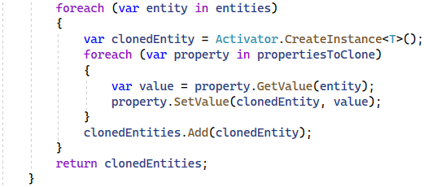
Next, we need to make all the fields of type IReadOnlyCollection<T> because we don't want someone to modify our lists.
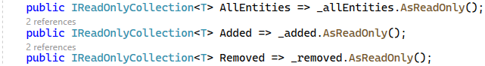
We need Add() and Remove() methods which will take as parameter T element. You can do this on your own.

The next method is GetModifiedEntities(), which takes a DbSet<T> variable as a parameter. The method returns a collection of modified entities. In this method we have to get the primary keys for the current T object, but you already know how to do that.
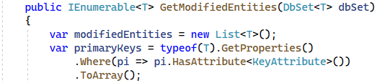
After that, we go through the IReadOnlyCollection of allEntities and use the GetPrimaryKeyValues() method (implement later), which takes our primaryKeys variable as a parameter and the current proxy entity from all the entities. Then, we get the entity from the dbSet which has the same primaryKeyValues as our our proxy entity.
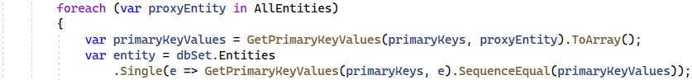
We can check if the original object has been modified, using the IsModified() (implement later) method. If there is any modification, we have to add the real entity to our modifiedEntities.
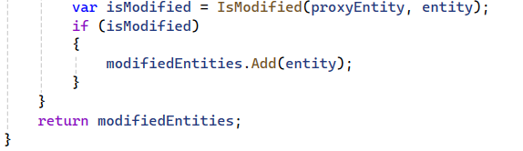
The next method to implement is IsModified(), which takes the original and proxy entities as parameters. They are guaranteed to be of the same type, because they are of the same generic type.
First, we'll extract all properties, which are valid SQL types and ignore the rest. We will use this variable to check for any modified entities. This can be done by making another variable of type PropertyInfo[] and calling method Equals to compare our originalEntity and proxyEntity's property values. Finally, we check if there are any modified properties and return the result.
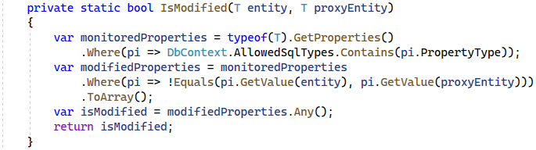
The last method for this class is static and will return an IEnumerable collection of objects. We used this method before to get our primary key values. The method will take an IEnumerable<PropertyInfo> as a parameter, which holds the primary key properties and the entity to which the primary keys belong to. This method only does one thing – gets each primary key property's value.
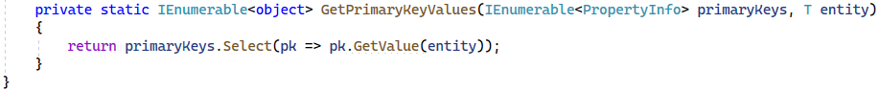

Implement the DbSet class
Create a generic DbSet<TEntity> class, which inherits from ICollection<TEntity>. It should look like this:
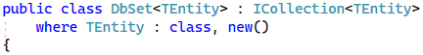
Our DbSet<T> class represents the collection of all entities in the context, or that can be queried from the database, of a given type. The type argument must be a reference type, including any class, interface, delegate, or array type and must have a public parameter-less constructor. In this class we have to define two internal properties with getters and setters. The first one is a which provides access to features of the context that deal with change tracking of entities. The second one is IList<TEntity>, where we are going to collect our entities.
The code should look like this:
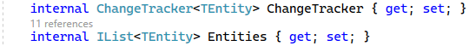
Our DbSet constructor must be internal and should take parameters of type IEnumerable<TEntity> which will be our entities. The constructor sets the entities property and creates a ChangeTracker, so we can track changes in the entities.
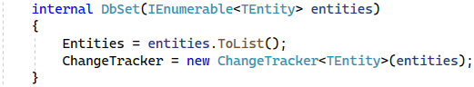
Our DbSet class acts like an ICollection<T>, so we need to implement all of its methods.
First, we need to implement a method for adding entities in the database. If the parameter value is null, we throw an ArgumentNullException with the message "Item cannot be null". After this check, we add our item both in the Entities property and the ChangeTracker.
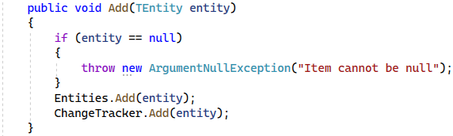
The Clear method removes all entities by using the Remove method. We use it like this, so we can also let the ChangeTracker know, that all the entities were removed.
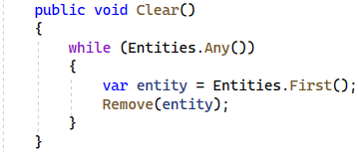
The Contains method checks if our entities contain a particular entity.
The CopyTo method copies our entities to an array of type T, starting at a particular array index. We aren't going to use this anywhere, but it's a part of the ICollection<T> interface, so we need to implement it.
The Count property gets the count of our entities.
The IsReadOnly property checks if our entities collection is of type readonly. Again, we need this because of the ICollection<T> interface.
The last method we have to implement from our ICollection<T> interface is the Remove method. We need to check for two problems. First, the T element must not be null. If it is, we throw an ArgumentNullException with a message "Item cannot be null". After that we need to create a variable where we check if we have successfully removed the item. If we have, we remove it from our change tracker as well.
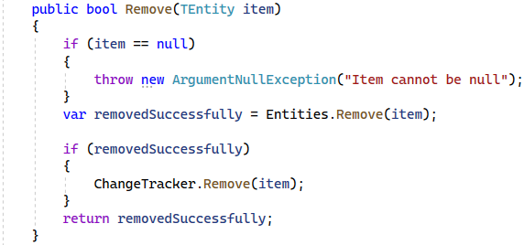
Our DbSet class has two more methods to implement. These methods are IEnumerator<T> GetEnumerator() and IEnumerable.GetEnumerator(). We need them to iterate through our entities collection.
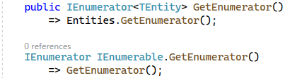
The last thing we need to do in this class is to create a method which will remove a range of entities. To do that, we need to iterate through our entities parameter and remove each entity inside of it.
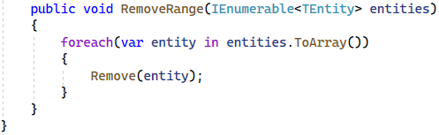

Implement the DbContext
Create an abstract DbContext class. For starters, in this class, we need to have two fields. The first field is a DatabaseConnection. The second one is of type Dictionary<Type, PropertyInfo>, where we're going to store our DbSet<T> properties, once we discover them. Remember, since we're writing a framework, which other people are going to be using, we don't know what entities/DbSets they will define at compile-time, so we need to discover that at runtime.
When you're done, you should have something like this:
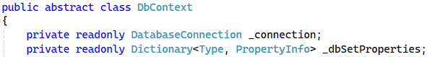
Now we need to create a field, where we store our allowed SQL types. Think about what kinds of data you can store in SQL Server and then list them in your field. When you're done, your code should look something like this:
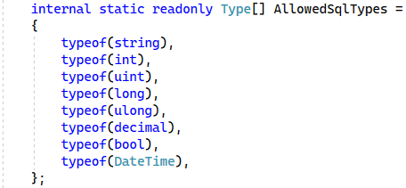
We're going to use these later when we determine what entity properties we're going to involve in our database manipulations.
Our DbContext constructor must be protected and should take as parameter connectionString. In the body of the constructor we have to create an instance of the DatabaseConnection class with the connectionString. We should initialize our dbSetProperties by using a method called DiscoverDbSets() which we will implement later. After that we need a using statement like before, where to open a connection to our database and in this using we should call a method InitializeDbSets(). Out of the using statement body we have to call MapAllRelations method (implement later). Your constructor should look like this:
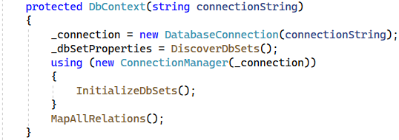
Now we're going to create the only public method – SaveChanges(). All this method does is iterate over each DbSet and execute the Persist<TEntity>() method for each of those DB sets. Since we don't know what the generic types of our DB sets are, we need to dynamically invoke the method, using reflection and provide it with a type parameter. After we make the persist method, we'll wrap its invocation in a try-catch block and provide a few different types of exceptions it's going to catch.
First, we need to declare an array of our actual DB sets as collections:
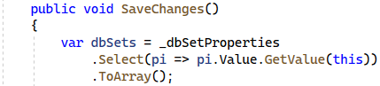
Before we do any persisting, we need to ensure each entity in the context is valid. If any invalid entities exist in our DB set, we throw an InvalidOperationException with message "{invalidEntities.Length} Invalid Entities found in {dbSet.Name}!". The code should look like this:
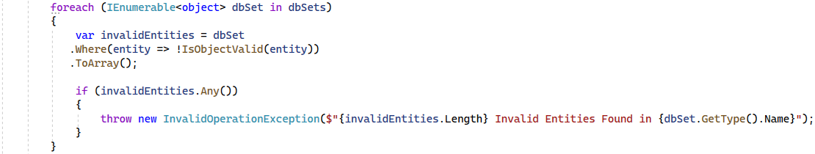
After that, we need a using block, which will open a connection to our database. We wrap each code block, which accesses the database in a using block, so we don't have to close our connection manually. Opening and closing stuff manually, whether it be a database connection, or a stream, or any unmanaged resource is a great recipe for forgetting to write open/close statements and encountering mysterious bugs, so don't ever do it.
Anyway, in this using block, we need to create another using block – this time for starting a database transaction. That way, if anything goes wrong, no entities will be inserted/modified/deleted. The code looks something like this:
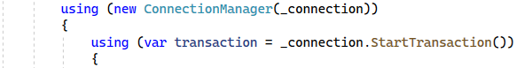
Now we need to find the entity type of each DbSet. We need another variable, which will hold the Persist method (which we are going to implement later) and make a generic version of that method, using the DB set type. The code looks like this:
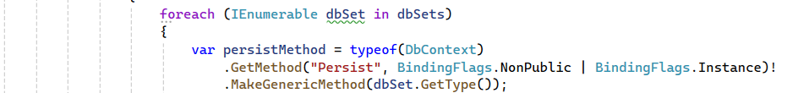
Last, but not least, we need to invoke this method inside a try block with a couple of catch blocks for the different types of exceptions. In the try block, we will invoke the Persist method for the dbSet. The code looks like this:
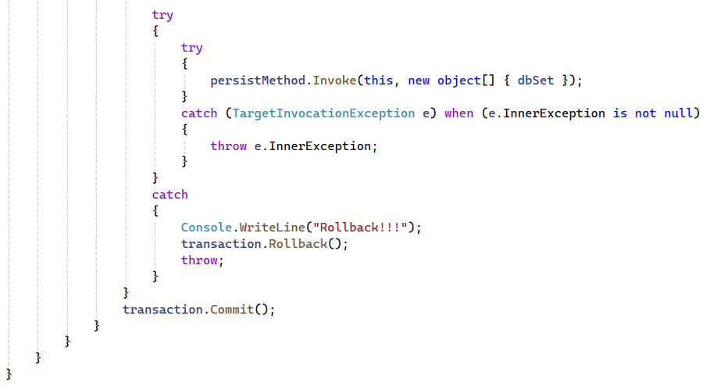
The first catch block will handle TargetInvocationException. If the invoked method throws an exception, this is the exception we need to catch. Consequently, this block throws the inner exception, because this is the actual exception, which occurred within the method invocation, which the second and third catch blocks will handle.
The second and third catch blocks will handle InvalidOperationException and SqlException respectively. In both cases we, need to rollback the transaction. If no exceptions are thrown, we're going to commit the transaction and save our changes to the database.
Now it's time to implement our Persist<TEntity> method. It accepts a DbSet as the generic type parameter and a transaction.
First, we need to create a variable where we can save our current table name (string) using the GetTableName() method (which we'll implement later). Then, we need an array, where we will collect our columns by calling the FetchColumnNames() method (also implemented later). Then, we check the dbSet's ChangeTracker for any added entities and if there are any, we use the InsertEntities() method, which we already have in our DbConnection class.
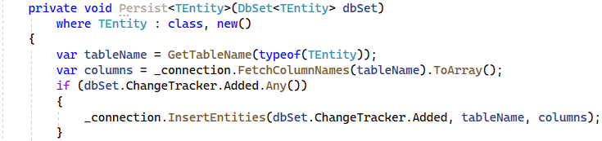
Now we need our modified entities. We can get them by using GetModifiedEntities(), which we will have in our ChangeTracker class. If there are any modified entities, we update our database using UpdateEntities(), which accepts our entities, the table name and table columns as parameters.
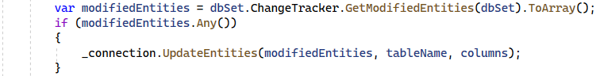
Lastly, we check if there are any removed entities using the ChangeTracker's Removed collection. If we have any, we delete them from our database too.
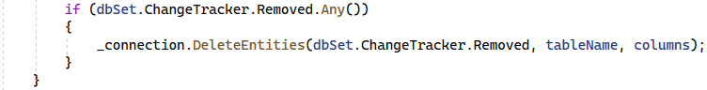
The next step is to create a method for initializing dbSets called InitializeDbSets(). For each DB set, we will invoke the PopulateDbSet(dbSetProperty) method dynamically, because we are providing the generic type parameter at runtime, since we don't know what the framework user's DB sets are.
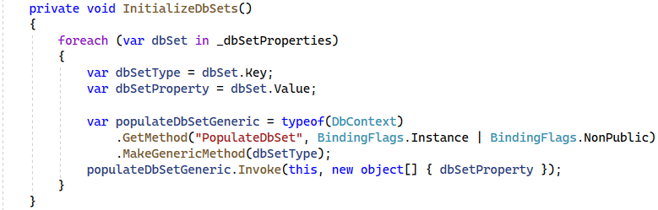
Our next method to implement is PopulateDbSet<TEntity>(). We retrieve the entities from the database, using the LoadTableEntities<TEntity>() method. Then, we create a new DbSet<TEntity> instance, passing the entities to its constructor.
Finally, we need to replace the actual DbSet property in the current DbContext instance with the one we just created. Since the Db sets don't have a setter, we need to replace its backing field, by using the ReflectionHelper.ReplaceBackingField() method. This works, because every auto-property has a private, autogenerated backing field.
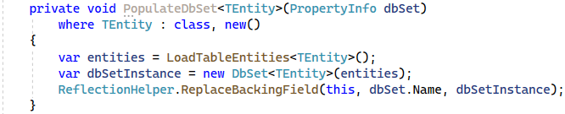
Now, we implement a new method, called MapAllRelations(). All this method will do is call MapRelations() dynamically for each DB set property. This method looks very similar to the InitializeDbSets() method.
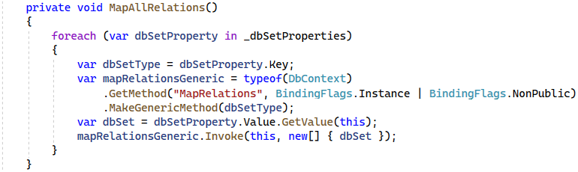
Now it's time to implement our MapRelations<TEntity>() method, we talked about before. This method accepts a DbSet<TEntity> variable as its only parameter.
This method maps all of the relations of the DB set. There are two types of relations: Foreign key properties, which map many-to-one relations, and collections, which map one-to-many and many-to-many relations. First, we map the navigation properties and then we map the collections. In order to discover what collections our TEntity has, we need to reflect the class and find every property, which is of type ICollection<>.
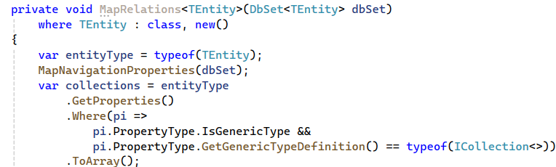
After we find our collections, we iterate through them and call the MapCollection method dynamically for each of them, much like the previo us 2 methods that did something similar.
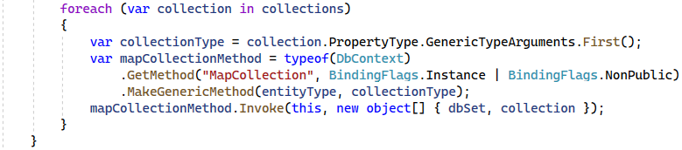
Now it's time for the MapCollection<TDbSet, TCollection>() method's implementation, which accepts a DbSet<TDbSet> and PropertyInfo variables as parameters. Now, we need to get the primary and the foreign keys. The primary ones we find by getting all the properties which have a [Key] attribute in the collectionType variable we declared before. We can get the foreign key in the same way, but using the entityType variable.
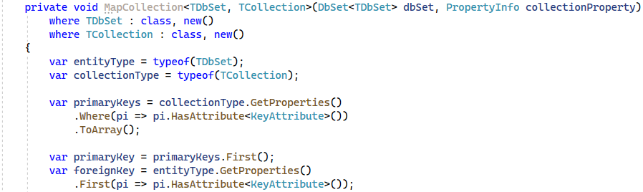
We check if we are dealing with a many-to-many relation, which is only true if we have 2 or more primary keys. If we have a many-to-many relation, we can get the foreign key by finding the first type property, whose name is equal to the foreign key attribute's name and has the same property type as the entity type.
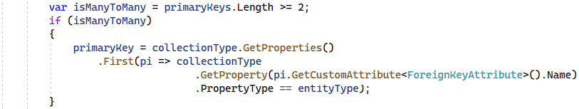
Now we get the collection's DB set, which we will filter with a where clause and extract all of the entities whose foreign keys are equal to the primary key of the current entity.
Finally, call the ReflectionHelper.ReplaceBackingField() method and we replace the null collection with a populated collection.
At the end your code should look like this:
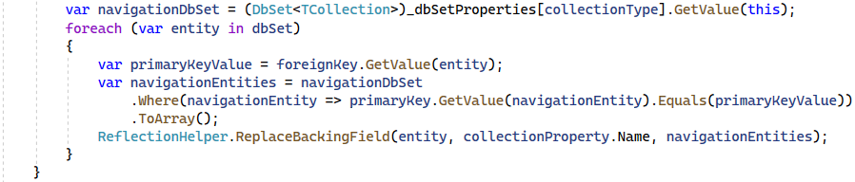
The next method to implement is MapNavigationProperties<TEntity>() which accepts a DB set as a parameter. This method finds the entity's foreign keys (there could be multiple) and iterates over them. For each of those foreign keys, we discover what navigation property they point to and its type. Then, we use this type to get the other side of the relation's DB set. Then, for each entity in that DB set, we find the first entity, whose primary key value is equal to the foreign key value in our TEntity. Finally, we replace the navigation property's value (which is currently null) with the entity we found.
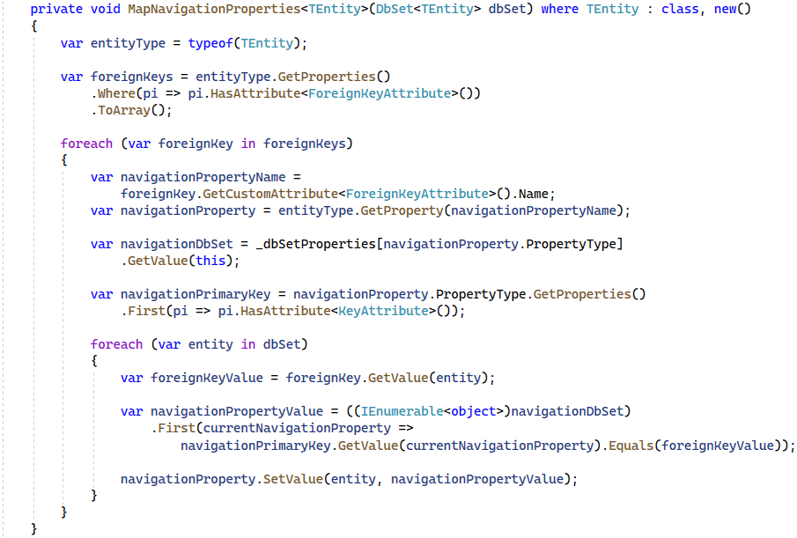
We mentioned a method, called IsObjectValid() which accepts an object as a parameter and returns a bool as result. Since the Validator class is very old, we need to write a bunch of boilerplate code to use it. So instead of writing this everywhere we need to validate an object, we can just extract it into a method. The boilerplate looks like this:
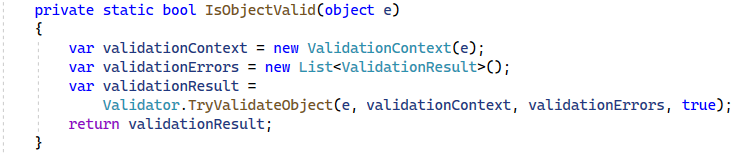
The next method to implement is LoadTableEntities<TEntity>() method. We have to declare a few variables in it. The first one will keep the type of the TEntity and it will be our table. The next one will be for the columns and it will be an array of strings. There, we will keep the column names for the current table by calling GetEntityColumnNames (implement this last). The third variable will be for the table name and we will get it by calling GetTableName() (implement second). The last one and the one our method will return is the fetchedRows variable. We can get the fetched rows by calling the DbConnection's FetchResultSet<TEntity>() method with the expected parameters.
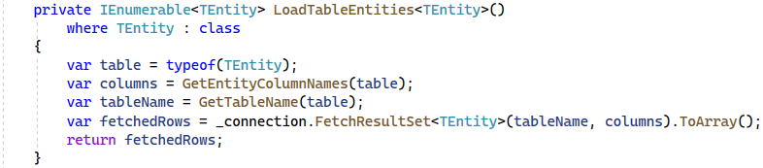
Let's implement GetTableName(), which returns a string and gets the tableType as a parameter. You can implement it yourself
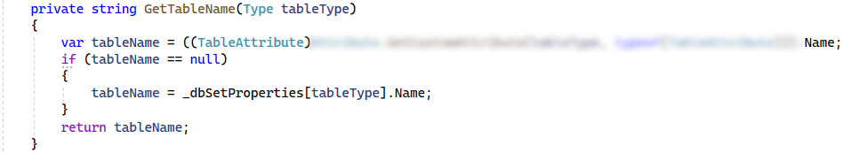
We are almost done with this class. But before that, we need to implement a simple DiscoverDbSets() method. We used that method in our constructor to populate our dbSetProperties field, which is a Dictionary with а Type as a key and a PropertyInfo as a value. Its code is only 3 lines long. Three annoyingly long lines…
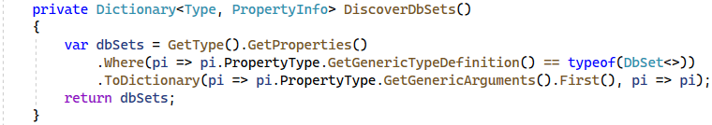
The last method is GetEntityColumnNames(), which returns an array of strings with the column names and accepts the table type as a parameter. Finally, we need to get the table properties, which are of valid SQL types and are contained in the column names. After that, we get the property names (using the Select LINQ extension method) and return them.
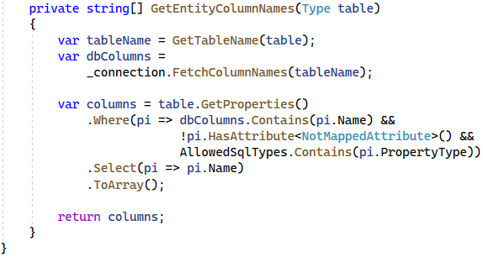
And with this final method, we are done with the framework! Let's go ahead and test it out by writing a simple application, which utilizes it and defines its own data model.

Create a Simple Client App
Now that the framework is ready, let's see how it discovers our database types, tables, relationships and much more, all using the power of reflection.

Create the Database
Import this SQL script into SSMS:
CREATE DATABASE MiniORM
GO
USE MiniORM
GO
CREATE TABLE Projects
(
Id INT IDENTITY PRIMARY KEY,
Name VARCHAR(50) NOT NULL
)

CREATE TABLE Departments
(
Id INT IDENTITY PRIMARY KEY,
Name VARCHAR(50) NOT NULL
)

CREATE TABLE Employees
(
Id INT IDENTITY PRIMARY KEY,
FirstName VARCHAR(50) NOT NULL,
MiddleName VARCHAR(50),
LastName VARCHAR(50) NOT NULL,
IsEmployed BIT NOT NULL,
DepartmentId INT
CONSTRAINT FK_Employees_Departments FOREIGN KEY
REFERENCES Departments(Id)
)
CREATE TABLE EmployeesProjects
(
ProjectId INT NOT NULL
CONSTRAINT FK_Employees_Projects REFERENCES Projects(Id),
EmployeeId INT NOT NULL
CONSTRAINT FK_Employees_Employee REFERENCES Employees(Id),
CONSTRAINT PK_Projects_Employees
PRIMARY KEY (ProjectId, EmployeeId)
)
GO
INSERT INTO MiniORM.dbo.Departments (Name) VALUES ('Research');
INSERT INTO MiniORM.dbo.Employees (FirstName, MiddleName, LastName, IsEmployed, DepartmentId) VALUES
('Sophia', NULL, 'Ivy', 1, 1),
('Peter', 'Isaacs', 'Porter', 0, 1),
('Ian', 'Phillips', 'Taylor', 1, 1),
('George', NULL, 'Wilson', 1, 1);
INSERT INTO MiniORM.dbo.Projects (Name)
VALUES ('C# Project'), ('Java Project');
INSERT INTO MiniORM.dbo.EmployeesProjects (ProjectId, EmployeeId) VALUES
(1, 1),
(1, 3),
(2, 2),
(2, 3)

Create the Project
Create a new C# Console Application, called "MiniORM.App" and add a reference to the MiniORM project:
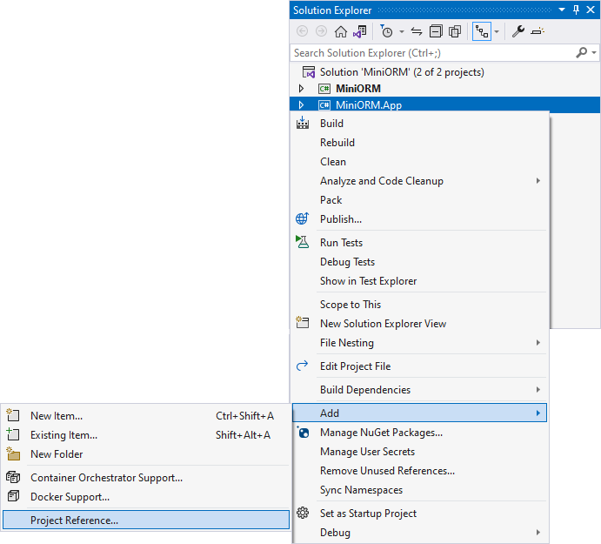
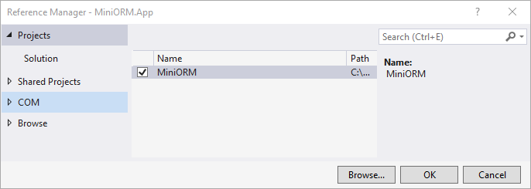

Define the Data Model
Now it's time to create our data models using all the information we have in our database.
Create a Data directory, and inside it, create an Entities directory. When you're done, you should have the following folder structure:
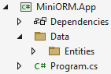
Now, let's get to creating the data model. First, create a Department class inside of the Entities folder. Entity classes have one property for each column of the table.
Create two properties – Id and Name. For the Id, use the [Key] annotation (using System.ComponentModel.DataAnnotations) to let our framework know that this is the primary key of the entity. We can forbid the Name property from having a null value upon calling SaveChanges() by adding the [Required] annotation to it. Our framework takes care of validating every object before persisting any changes. Finally, add an ICollection of employees as a navigation property for all of the employees, who belong to a particular department. When you're done, the class should look like this:
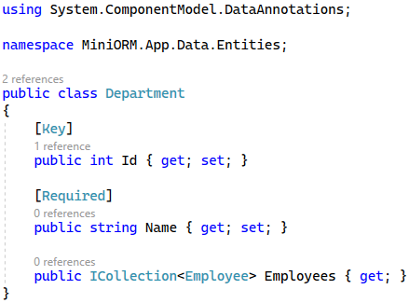
Next, create a Project class with an Id and a Name. The Id is our primary key, while the Name should be required (not null). Additionally, create a navigation property, called EmployeesProjects, which is a mapping entity between our Employee and Project entities. We'll create this class later.
It's generally a good idea to use a get-only property of type ICollection<T> for our navigation properties to prevent them from being redeclared outside of our framework. When you're done, your code should look like this:
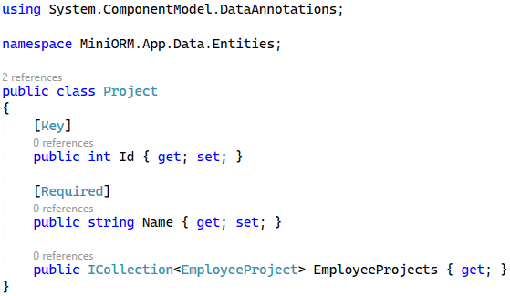
After that, create an Employee class and use the same logic. The only difference between the other two models we've created is that in the Employee class, we need a foreign key to our Department model. We can do that by using [ForeignKey(nameof(Department)] annotation above the DepartmentId property.
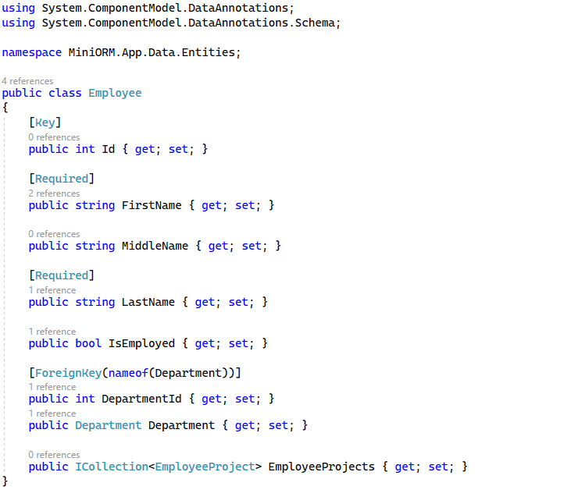
The last class to create is EmployeesProject, where we will have a composite key for the Projects and EmployeesId property. Then make the two composite keys foreign keys too.
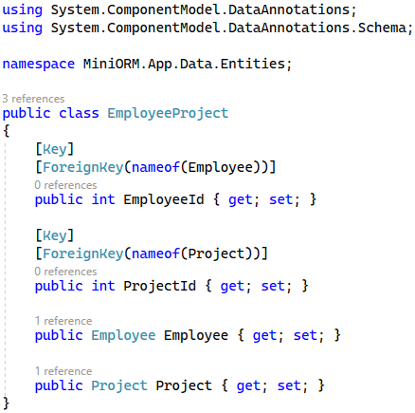
Now, let's create our DbContext class. Create a SoftUniDbContextClass in the Data folder, which inherits from our base DbContext class and has DbSets for all the models we've created. Make sure to inherit the constructor too.
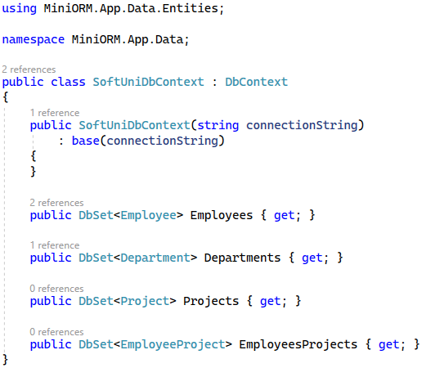
That's it! Our data model is done. Now it's time to test out the framework.

Test the Framework
Let's test our MiniORM Framework by inserting some sample data in our database. Go to your Program.cs and declare your connection string. After that create an instance of the SoftUniDbContext class with your connection string and insert a new Employee. Then, find the first employee and modify their name. Finally, call the context's SaveChanges() method.
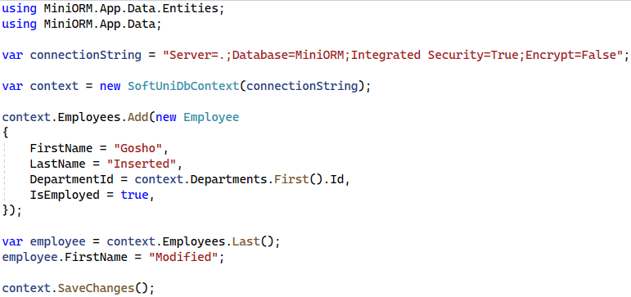
If everything works without any exceptions, we should be done! You've just gained some valuable insight into how an ORM Framework like Entity Framework Core is written. The MiniORM.App code can be transferred to a project, using Entity Framework Core and it will work identically without requiring any syntax changes!
You can try extending the framework by implementing extra stuff like concurrency control by yourself. Happy coding

