Exercises: Introduction to Entity Framework
You can check your solutions in Judge

Import the SoftUni Database
Import the SoftUni database into SQL Management Studio by executing the provided script.
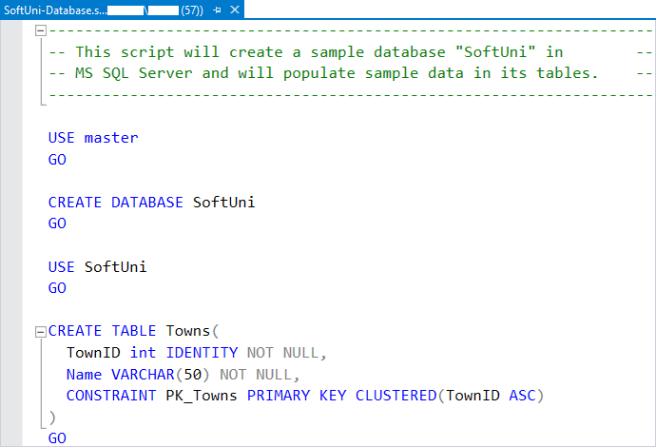

Database First
Model the existing database by using the Database First approach.
First create a new empty .NET Core Console Application and after it is created open the Package Manager Console
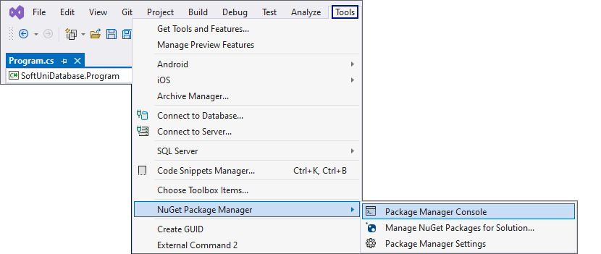
It will look something like this:
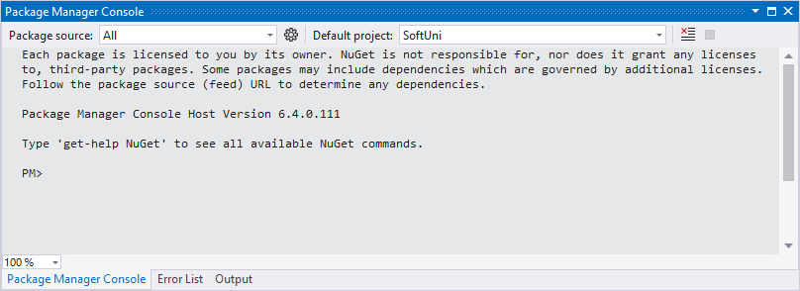
Use it to run the following commands one by one:
Install-Package Microsoft.EntityFrameworkCore.Tools –v 6.0.1
Install-Package Microsoft.EntityFrameworkCore.SqlServer –v 6.0.1
Install-Package Microsoft.EntityFrameworkCore.Design -v 6.0.1
These are the packages you will need, in order to scaffold our SoftUniContext from the SoftUni database.
NOTE: If Package Manager Console gives you any errors while trying to execute the above commands, try using the following ones:
Install-Package Microsoft.EntityFrameworkCore.Tools –Version 6.0.1
Install-Package Microsoft.EntityFrameworkCore.SqlServer –Version 6.0.1
Install-Package Microsoft.EntityFrameworkCore.Design -Version 6.0.1
NOTE: For the next steps you will need public Program class and a static void Main() method.
Next, we must execute the command to scaffold our context class. It will consist of 4 things:
- First, the name of the command:
Scaffold-DbContext
- Second, the connection we will be using (our connection string):
-Connection "Server=<ServerName>;Database=<DatabaseName>;Integrated Security=True;"
For ServerName, use the name of your local MS SQL Server instance or ".".
For DatabaseName, use the name of the database you want to use, in this case – SoftUni.
- Third, we need to declare our service provider, we'll be using Microsoft.EntityFrameworkCore.SqlServer:
-Provider Microsoft.EntityFrameworkCore.SqlServer
- And the fourth thing we'll do, is to give it a directory where all of our models will go (e.g. Models):
-OutputDir Data/Models
Our final command will look like this:
Scaffold-DbContext -Connection "Server=.;Database=SoftUni;Integrated Security=True;" -Provider Microsoft.EntityFrameworkCore.SqlServer -OutputDir Data/Models
Execute the whole command on a single line.
NOTE: You should write only one '\' in the connection string. Otherwise, an InvalidOperationException: Instance failure will be thrown.
Entity Framework Core has successfully mapped the database schema to C# classes. Use the Solution Explorer in Visual Studio to move the SoftUniContext class out of Models into the Data folder and move the Models folder out of the Data folder into the project's directory. Press OK on both of the pop-up windows that will be shown.
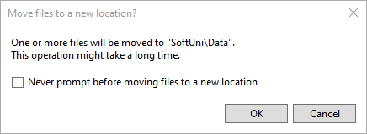
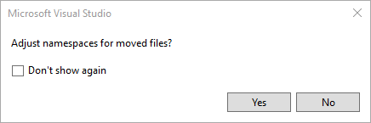
This way Visual Studio will also rename the classes everywhere they're used.
However, sometimes Entity Framework Core isn't good enough with names – all classes may have been pluralized. If this is your case, just rename all of our classes properly. Use right-click → Rename or the F2 shortcut and press OK on this pop-up window after renaming each class:
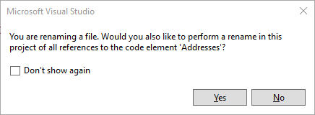
The final result should look like this:
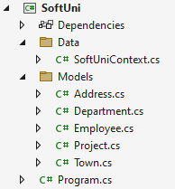
Don't forget to check the SoftUniContext's namespace after moving it and to add a reference to the Models and Data namespaces:
Make sure that your namespaces are exactly the same as these:
SoftUni
SoftUni.Data
SoftUni.Models
Finally, we want to clean up the packages we won't be using anymore from the package manager GUI or by running these commands one by one:
Uninstall-Package Microsoft.EntityFrameworkCore.Tools -r
Uninstall-Package Microsoft.EntityFrameworkCore.Design -RemoveDependencies

Employees Full Information
NOTE: You will need method public static string GetEmployeesFullInformation(SoftUniContext context) and public StartUp class.
Now we can use SoftUniContext to extract data from our database. Your first task is to extract all employees and return their first, last and middle name, their job title and salary, rounded to 2 symbols after the decimal separator, all of those separated with a space. Order them by employee id.

Example
Output
Guy Gilbert R Production Technician 12500.00
Kevin Brown F Marketing Assistant 13500.00
Roberto Tamburello Engineering Manager 43300.00
…

Employees with Salary Over 50 000
NOTE: You will need method public static string GetEmployeesWithSalaryOver50000(SoftUniContext context) and public StartUp class.
Your task is to extract all employees with salary over 50000. Return their first names and salaries in format "{firstName} - {salary}". Salary must be rounded to 2 symbols, after the decimal separator. Sort them alphabetically by first name.

Example
Output
Brian - 72100.00
Dylan - 50500.00
James - 84100.00
…
Use Express Profiler and check if the query Entity Framework Core sent is correct (there is only one query, but there may be more that are performed by EF for checks).
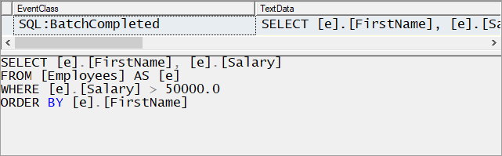

Employees from Research and Development
NOTE: You will need method public static string GetEmployeesFromResearchAndDevelopment(SoftUniContext context) and public StartUp class.
Extract all employees from the Research and Development department. Order them by salary (in ascending order), then by first name (in descending order). Return only their first name, last name, department name and salary rounded to 2 symbols, after the decimal separator in the format shown below:

Example
Output
Gigi Matthew from Research and Development - $40900.00
Diane Margheim from Research and Development - $40900.00
Michael Raheem from Research and Development - $42500.00
…
Use Express Profiler and check if the made query by Entity Framework is correct (there is only one query).
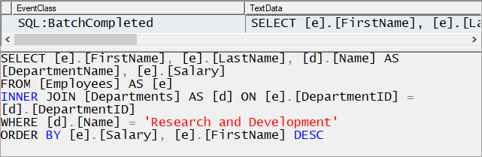

Adding a New Address and Updating Employee
NOTE: You will need method public static string AddNewAddressToEmployee(SoftUniContext context) and public StartUp class.
Create a new address with the text "Vitoshka 15" and TownId = 4. Set that address to the employee with last the name "Nakov".
Then order by descending all the employees by their Address' Id, take 10 rows and from them, take the AddressText. Return the results each on a new line:

Example
Output
Vitoshka 15
163 Nishava Str, ent A, apt. 1
…
After this restore your database for the tasks ahead!

Hints
Create the address and find the employee with last name equal to "Nakov" in order to assign the address to him.

Employees and Projects
NOTE: You will need method public static string GetEmployeesInPeriod(SoftUniContext context) and public StartUp class.
Find the first 10 employees and print each employee's first name, last name, manager's first name and last name. If they have projects started in the period 2001 - 2003 (inclusive), print them with information about their name, start and end date. Then return all of their projects in the format "--<ProjectName> - <StartDate> - <EndDate>", each on a new row. If a project has no end date, print "not finished" instead.

Constraints
Use date format: "M/d/yyyy h:mm:ss tt".

Example
Output
Guy Gilbert - Manager: Jo Brown
--Half-Finger Gloves - 6/1/2002 12:00:00 AM - 6/1/2003 12:00:00 AM
--Women's Tights - 6/1/2002 12:00:00 AM - 6/1/2003 12:00:00 AM
Kevin Brown - Manager: David Bradley
Roberto Tamburello – Manager: Teeri Duffy
--Classic Vest – 6.1.2003 12:00:00 - not finished
…

Addresses by Town
NOTE: You will need method public static string GetAddressesByTown(SoftUniContext context) and public StartUp class.
Find all addresses, ordered by the number of employees who live there (descending), then by town name (ascending) and finally by address text (ascending). Take only the first 10 addresses. For each address return it in the format "<AddressText>, <TownName> - <EmployeeCount> employees"

Example
Output
7726 Driftwood Drive, Monroe - 2 employees
163 Nishava Str, ent A, apt. 1, Sofia - 2 employees
…

Employee 147
NOTE: You will need method public static string GetEmployee147(SoftUniContext context) and public StartUp class.
Get the employee with id 147. Return only his/her first name, last name, job title and projects (print only their names). The projects should be ordered by name (ascending). Format of the output.

Example
Output
Linda Randall - Production Technician
HL Touring Handlebars
…

Departments with More Than 5 Employees
NOTE: You will need method public static string GetDepartmentsWithMoreThan5Employees(SoftUniContext context) and public StartUp class.
Find all departments with more than 5 employees. Order them by employee count (ascending), then by department name (alphabetically). For each department, print the department name and the manager's first and last name on the first row. Then print the first name, the last name and the job title of every employee on a new row. Order the employees by first name (ascending), then by last name (ascending).
Format of the output: For each department print it in the format "<DepartmentName> - <ManagerFirstName> <ManagerLastName>" and for each employee print it in the format "<EmployeeFirstName> <EmployeeLastName> - <JobTitle>".

Example
Output
Engineering – Terri Duffy
Gail Erickson - Design Engineer
Jossef Goldberg - Design Engineer
…

Find Latest 10 Projects
NOTE: You will need method public static string GetLatestProjects(SoftUniContext context) and public StartUp class.
Write a program that returns information about the last 10 started projects. Sort them by name lexicographically and return their name, description and start date, each on a new row.

Constraints
Use date format: "M/d/yyyy h:mm:ss tt".

Example
Output
All-Purpose Bike Stand
Research, design and development of All-Purpose Bike Stand. Perfect all-purpose bike stand for working on your bike at home. Quick-adjusting clamps and steel construction.
9/1/2005 12:00:00 AM
…

Increase Salaries
NOTE: You will need method public static string IncreaseSalaries(SoftUniContext context) and public StartUp class.
Write a program that increases salaries of all employees that are in the Engineering, Tool Design, Marketing, or Information Services department by 12%. Then return first name, last name and salary (2 symbols after the decimal separator) for those employees, whose salary was increased. Order them by first name (ascending), then by last name (ascending). Format of the output.

Example
Output
Ashvini Sharma ($36400.00)
Dan Bacon ($30688.00)
…

Find Employees by First Name Starting with "Sa"
NOTE: You will need method public static string GetEmployeesByFirstNameStartingWithSa(SoftUniContext context) and public StartUp class.
Write a program that finds all employees whose first name starts with "Sa". Return their first, last name, their job title and salary rounded to 2 symbols after the decimal separator in the format given in the example below. Order them by the first name, then by last name (ascending).

Constraints

Find a way to make your query case-insensitive.

Example
Output
Sairaj Uddin - Scheduling Assistant - ($16000.00)
Samantha Smith - Production Technician - ($14000.00)
…

Delete Project by Id
NOTE: You will need method public static string DeleteProjectById(SoftUniContext context) and public StartUp class.
Let's delete the project with id 2. Then, take 10 projects and return their names, each on a new line. Remember to restore your database after this task.

Example
Output
Classic Vest
Full-Finger Gloves
…

Hints
If we try to delete the project directly:
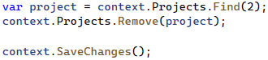
This happens:
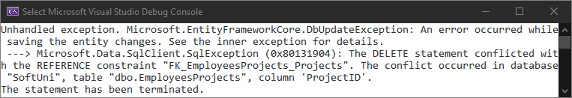
The project is referenced by the join (many-to-many) table EmployeesProjects. Therefore we cannot safely delete it. First, we need to remove any references to that row in the Projects table.
This is done by removing the project from all employees who reference it.
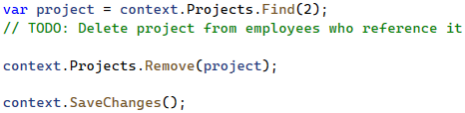

Remove Town
NOTE: You will need method public static string RemoveTown(SoftUniContext context) and public StartUp class.
Write a program that deletes a town with name "Seattle". Also, delete all addresses that are in those towns. Return the number of addresses that were deleted in format "{count} addresses in Seattle were deleted". There will be employees living at those addresses, which will be a problem when trying to delete the addresses. So, start by setting the AddressId of each employee for the given address to null. After all of them are set to null, you may safely remove all the addresses from the context and finally remove the given town.

Example
Output
44 addresses in Seattle were deleted

