Manging Migrations - EF Core - Exercise

Welcome to Managing Migrations with EF Core
In this exercise, you will learn how to create, manage, and apply migrations to a database using EF Core. This is an essential skill for any developer working with data-driven applications, as it allows you to keep your database schema in sync with your application's data model.

What You Will Learn

Database First Approach
We will start with an existing database and generate the corresponding EF Core model classes

Creating Migrations
You will learn how to create migrations to update the database schema when the model changes

Applying Migrations
We will cover how to apply migrations to your database to keep it up-to-date

Seeding Database
Learn how to seed the database with initial data during the migration process

Handling Errors
As with any development process, you may encounter errors. We will learn how to troubleshoot and
resolve common issues that arise during migrations

Practical Guide

Database First Approach

Save the Script
Save the provided SQL script as migrations-dbset.sql

SQL Server Management Studio (SSMS)
 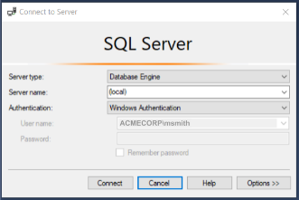
Open SSMS and Connect to your SQL Server instance

Create a New Query
Open a New Query window
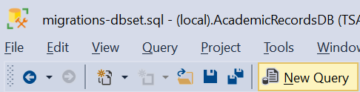
Copy and paste the contents of the migrations-dbset.sql script into the query window
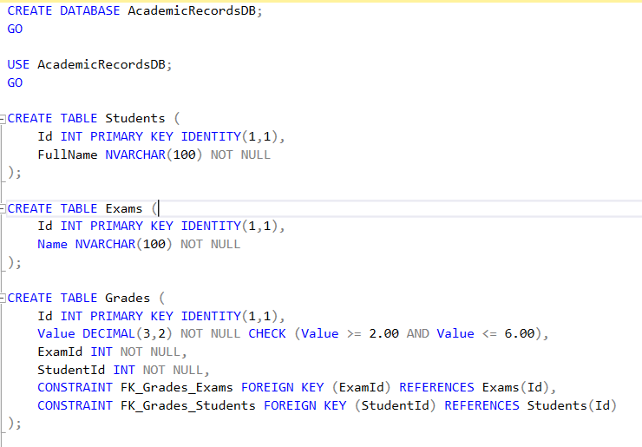

Execute the Script
Execute the script to create the AcademicRecordsDB database, the schema, and populate it with sample data
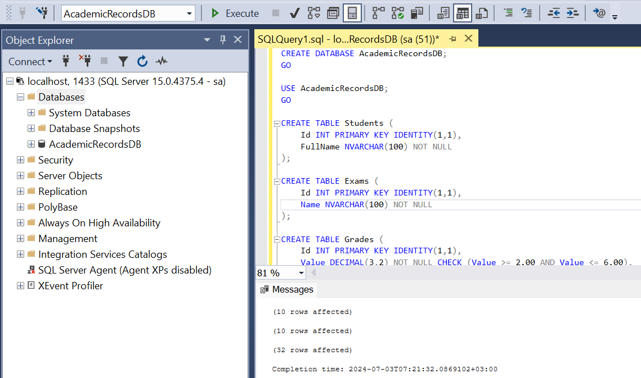

Simple Database Diagram
Now we have managed to create our database in it's initial state

Creating a CS Project and Scaffolding Database

Set Up the Project in Visual Studio
Launch Visual Studio and select Create a new project
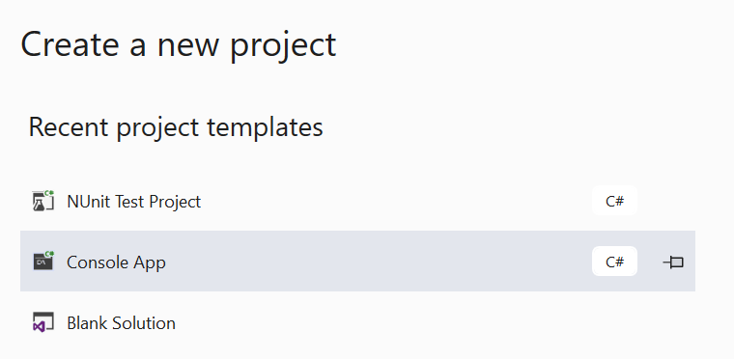
Create New Console App (.NET Core) -> Name your project (e.g., AcademicRecordsApp) and click Create
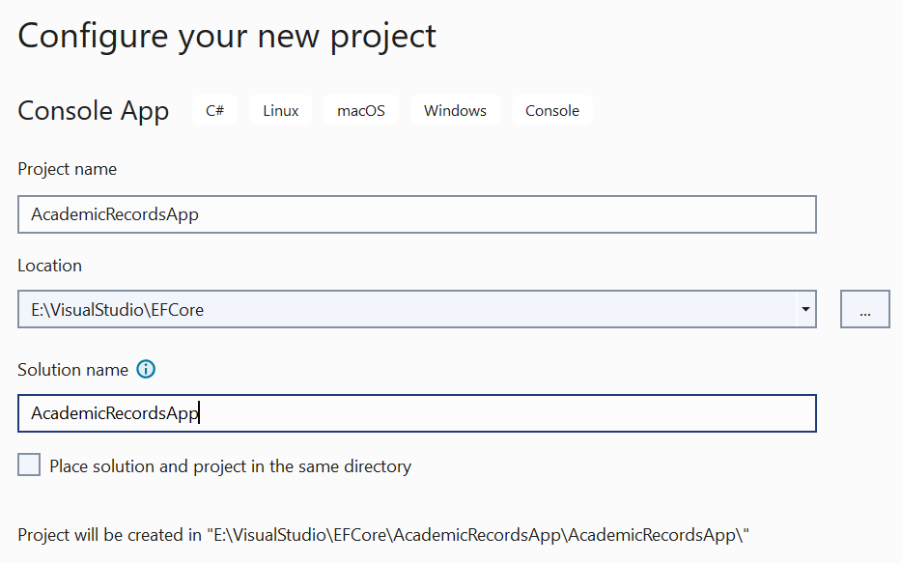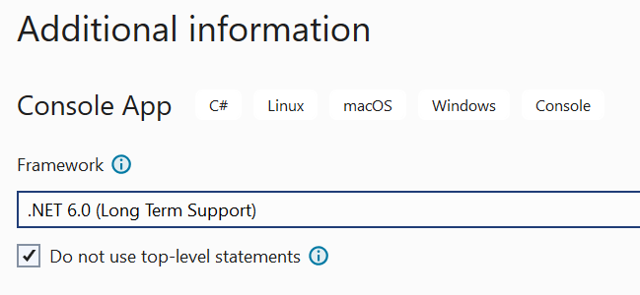

Add EF Core Packages
Right-click on the project in Solution Explorer and select Manage NuGet Packages
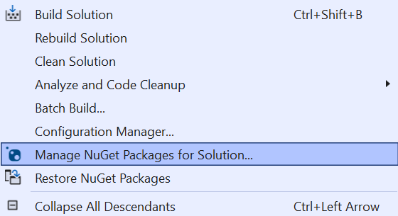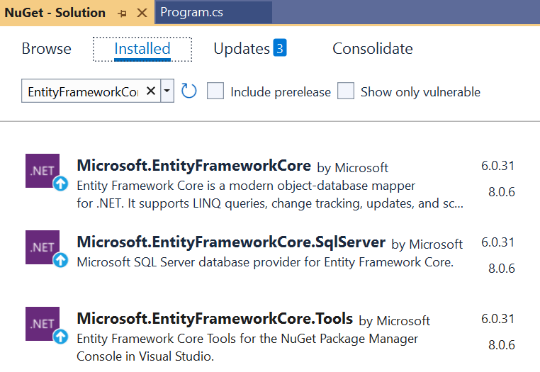

Run the Scaffold Command
In the Package Manager Console, run the following command to scaffold the database
If the SQL Server instance is running on the local machine, the server name might be localhost or '.'
Scaffold-DbContext "Server=YOUR_SERVER_NAME;Database=AcademicRecordsDB; Trusted_Connection=True;" Microsoft.EntityFrameworkCore.SqlServer -OutputDir Models
This command will generate entity classes and a context class based on the existing database schema

Verify the Scaffolded Code
After running the scaffold command, a Models folder will be created (or updated) in your project directory
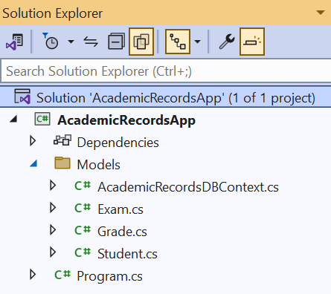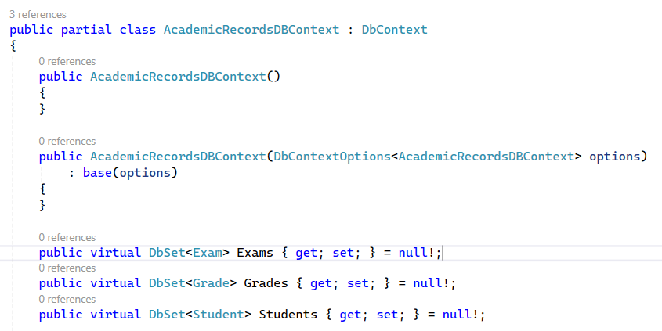
This folder will contain the entity classes representing your database tables (Students, Exams, Grades) as well as the context class (AcademicRecordsDBContext)
Open the generated entity classes and the context class to familiarize yourself with the
structure and relationships defined

The Process of Scaffolding
Scaffolding and migrations are both essential aspects of working with Entity Framework Core, but they serve different purposes and are used in different contexts
Scaffolding is the process of generating code based on an existing database schema. It is used to create entity classes and a DbContext class that correspond to the tables and relationships in your database
You use scaffolding when you have an existing database and you want to generate the initial model code to start working with EF Core in your application

Differences Between Scaffolding and Migrations
Starting Point:
- Scaffolding: Starts with an existing database schema and generates the corresponding model code
- Migrations: Starts with an existing model and generates code to update the database schema
Purpose:
- Scaffolding: Database-first approach (from database to code)
- Migrations: Code-first or model-first approach (from code to database)
Why Scaffolding is Not a Migration:
- Scaffolding is a one-time process to generate the initial code based on an existing database.
It does not track changes or apply incremental updates
- Migrations are used to manage and apply incremental updates to the database schema over time.
They track changes made to the model and generate scripts to apply those changes to the database

Organize the Project Structure and Rebuild the Solution
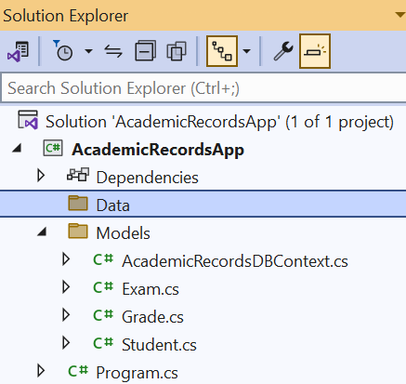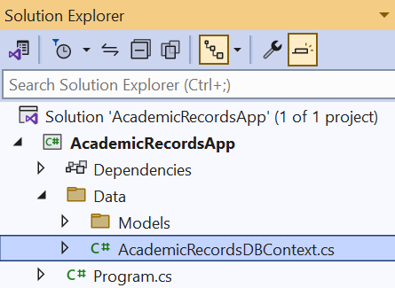
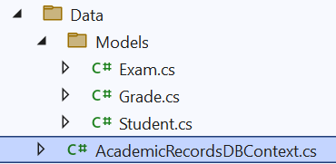

Detailed Analysis of AcademicRecordsDBContext

Namespace and Using Directives
The namespace is AcademicRecordsApp.Data, which aligns with the new folder structure
It includes necessary directives for EF Core and collections
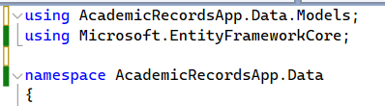

Constructors
The parameterless constructor is useful for scenarios where options are set externally
The constructor with DbContextOptions<AcademicRecordsDBContext> allows passing configuration options when instantiating the context
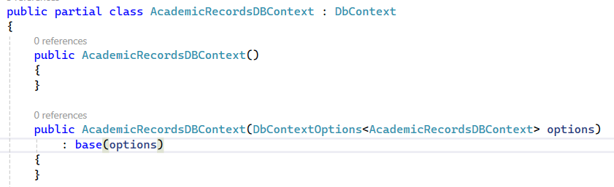

DbSet Properties
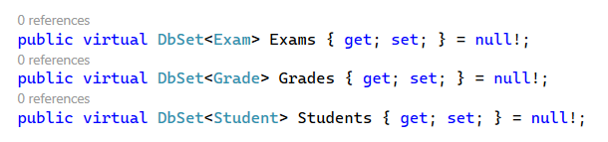
These properties represent the tables in the database and provide a way to query and save instances
of these entities

OnConfiguring Method
This method is called during context configuration, it sets up the connection string for the SQL Server database.
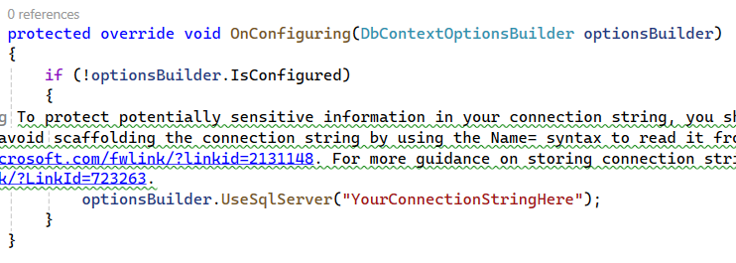
The #warning directive suggests moving the connection string out of the source code for security reasons

OnModelCreating Method
Configures the model's properties and relationships using the Fluent API
Defines constraints and relationships for the Exam, Grade, and Student entities
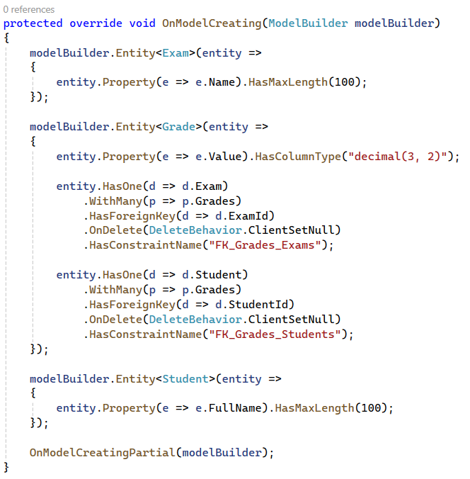

Partial Method
This partial method allows for further customization in another partial class

Evolving Database and Models
This section will guide you through the process of evolving your database schema and models. You will learn how to add new entities, modify existing ones, and apply these changes to the database using EF Core migrations

Adding a New Entity: Course
Add a new class called Course.cs in the Models folder
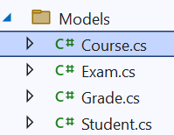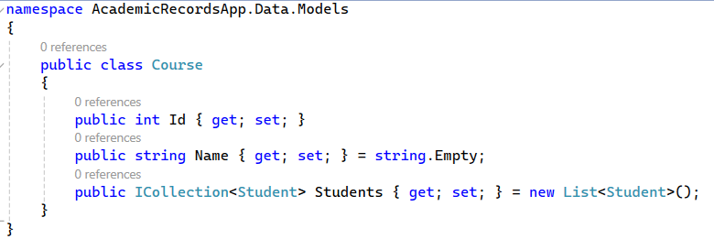
Update the Student entity class. Modify the Student class to include a collection of Courses
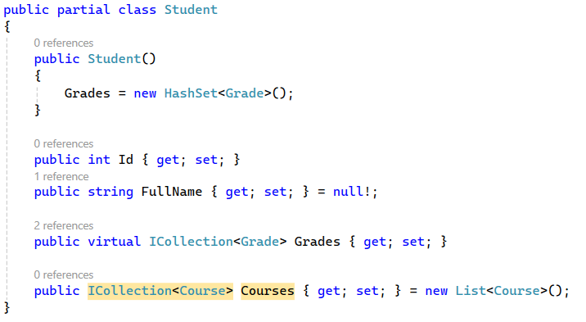

Update the DBContext
Add a DbSet for the Course entity in AcademicRecordsDBContext.cs
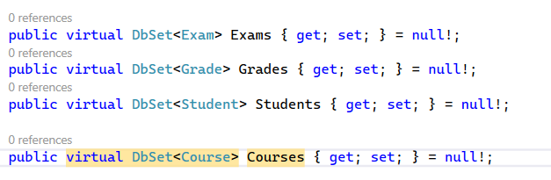

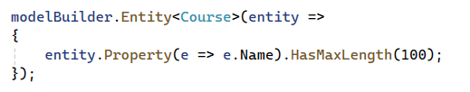
Set the maximum length for the Name property to 100 characters. HasMaxLength() is a method that specifies the maximum length for a string property in the database

Creating and Applying the Migration
Ensure the Model Changes:
- Created Course.cs
- Updated Student.cs
- Updated AcademicRecordsDBContext.cs
Add a Migration
- Open the Package Manager Console (Go to Tools > NuGet Package Manager > Package Manager Console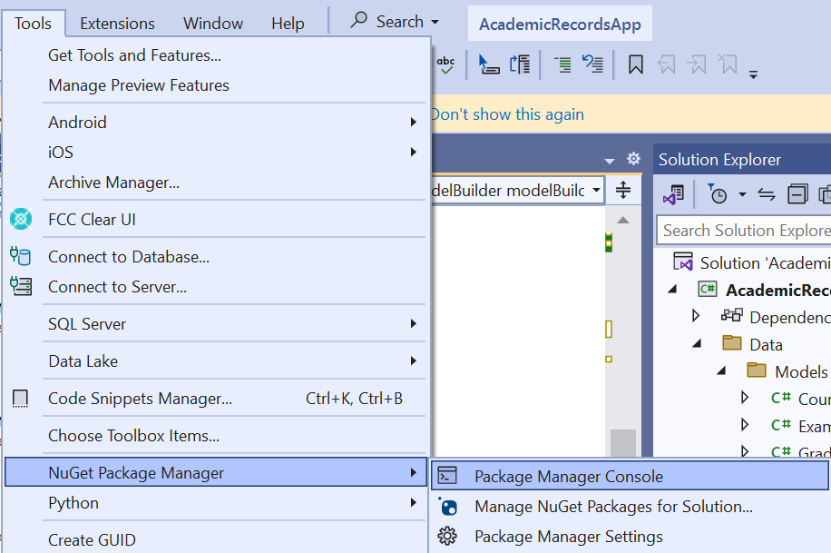
- Run the Add-Migration Command
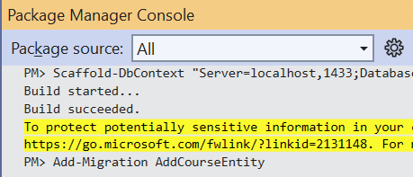
- Review the Migration Script
Visual Studio will generate a migration script. Review the script to understand what changes will be applied to the database
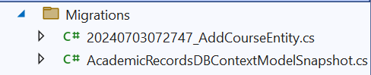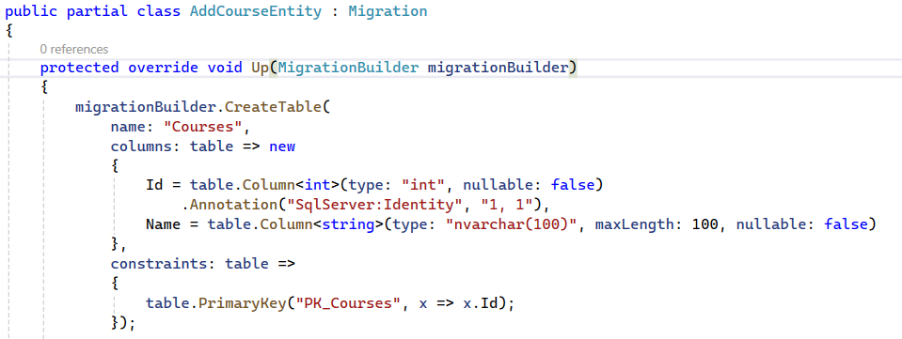

Update-Database
Run the Update-Database Command in the Package Manager Console
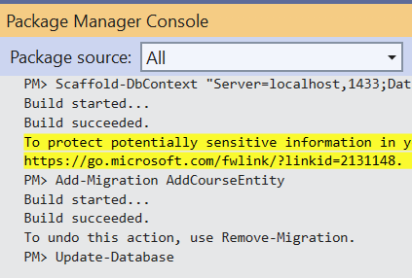

Encounter Update-Database Errors
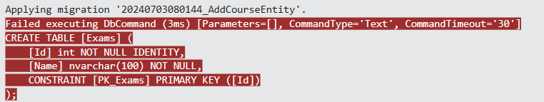
The migration is creating the Exams, Students, and other tables because it doesn't have any record of the current database schema. This can happen if the migration history is out of sync with the actual database schema, or if the initial migration didn't accurately reflect the existing state of the database

Sync Migration History with the Database
Remove Existing Migrations
- Delete all existing migration files in the Migrations folder
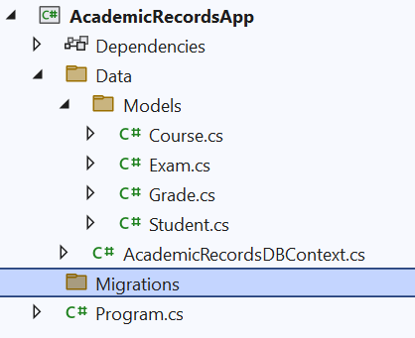
Reset the Migration History
- If necessary, you can manually reset the migration history table in the database. This is typically the __EFMigrationsHistory table
- Open SQL Server Management Studio (SSMS) and run the following command to clear the migration history
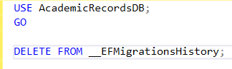
Create an Initial Baseline Migration
- Create a new initial migration that reflects the current state of the database without trying to create tables that already exist
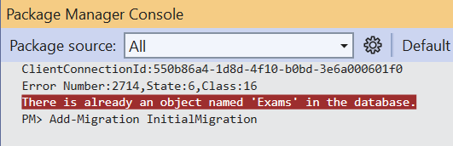
Manually Adjust the Initial Migration
- Open the generated migration file and remove or comment out the creation of existing tables
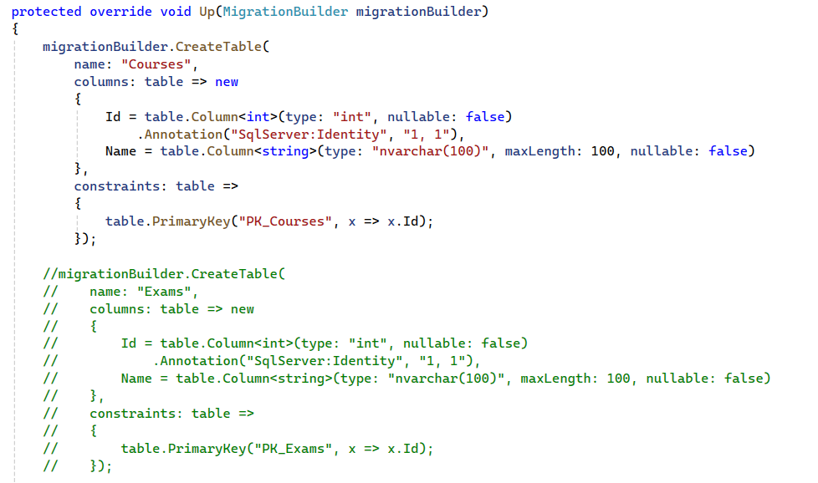
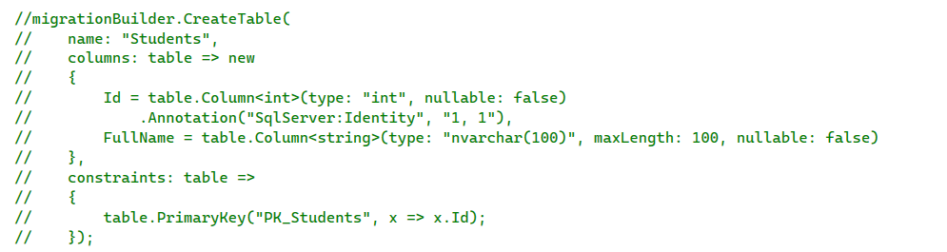
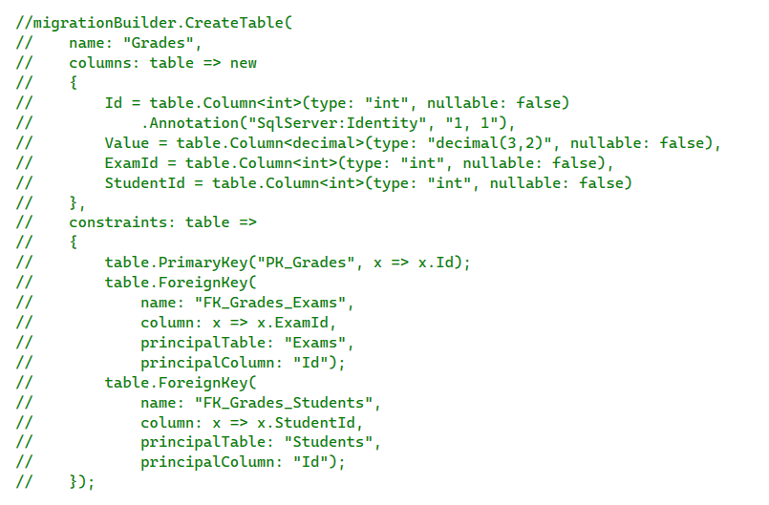
Ensure that the Down method does not drop the existing tables (Exams, Students, Grades). You should only drop the tables that were added in this migration (Courses and CourseStudent).
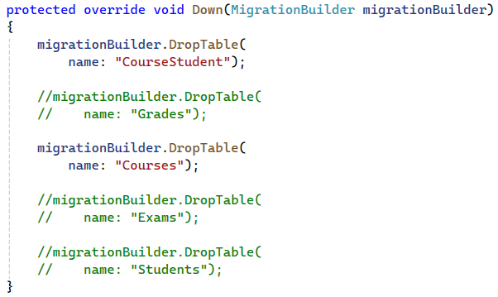

Rename Using Search and Replace
Yes, it is generally better to have the join table named StudentsCourses instead of CourseStudent, following the convention of placing the primary entity name first, which helps in readability and consistency.
- Press Ctrl + Shift + H to open the "Replace in Files" dialog
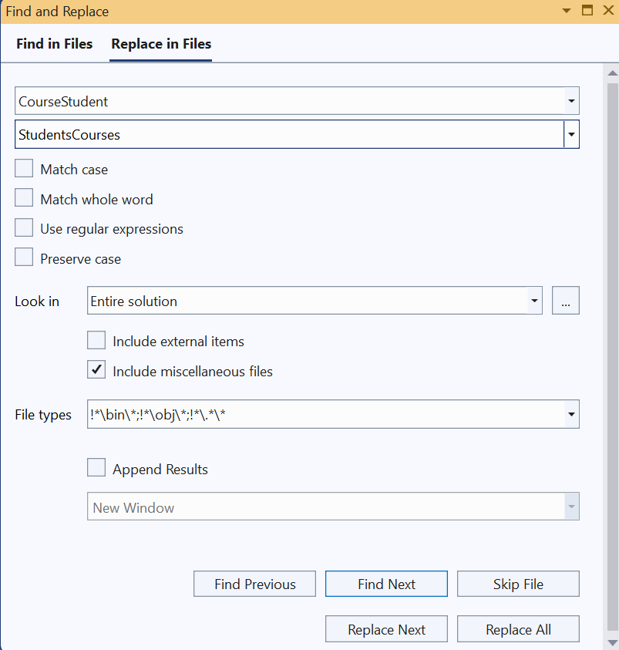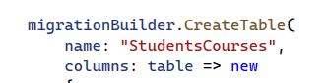

Update Database
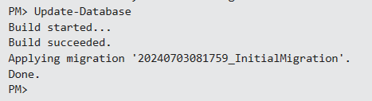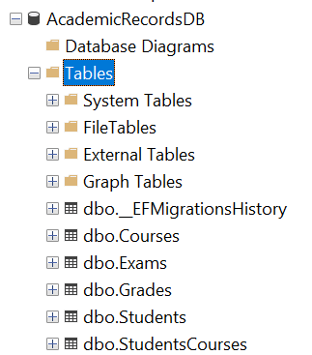

Error Explanation
Initial Error:
- We created the Course entity and updated the Student entity to include a collection of Courses without properly configuring the relationships in the OnModelCreating method
- As a result, the generated migration script attempted to recreate existing tables (Exams, Students, Grades), leading to conflicts and errors
Lack of Fluent API Configuration:
- Without using the Fluent API to configure the many-to-many relationship, EF Core was unable to correctly create and manage the join table for the Students and Courses relationship
- This caused issues with the migration process and could lead to an inconsistent or incorrect database schema
- The Fluent API allows you to explicitly define the relationships between entities, ensuring that EF Core correctly understands and manages the relationships
- Proper configuration helps avoid conflicts and errors during the migration process, ensuring that existing tables and data are not inadvertently modified or deleted

Correct Configuration with Fluent API:
- To correct the mistake, the OnModelCreating method should be updated in the AcademicRecordsDBContext to explicitly define the many-to-many relationship between Students and Courses using the Fluent API
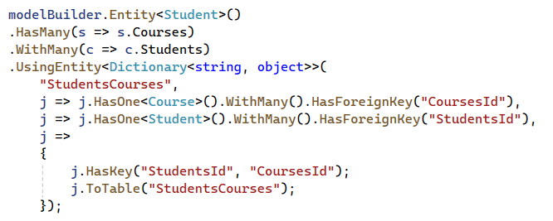

Resolve the Issue
Remove Existing Migrations
- Delete all existing migration files and reset the migration history in the database to ensure a clean state
Create an Initial Baseline Migration
- Let's start from the beginning by scaffolding the database again and then creating an initial migration
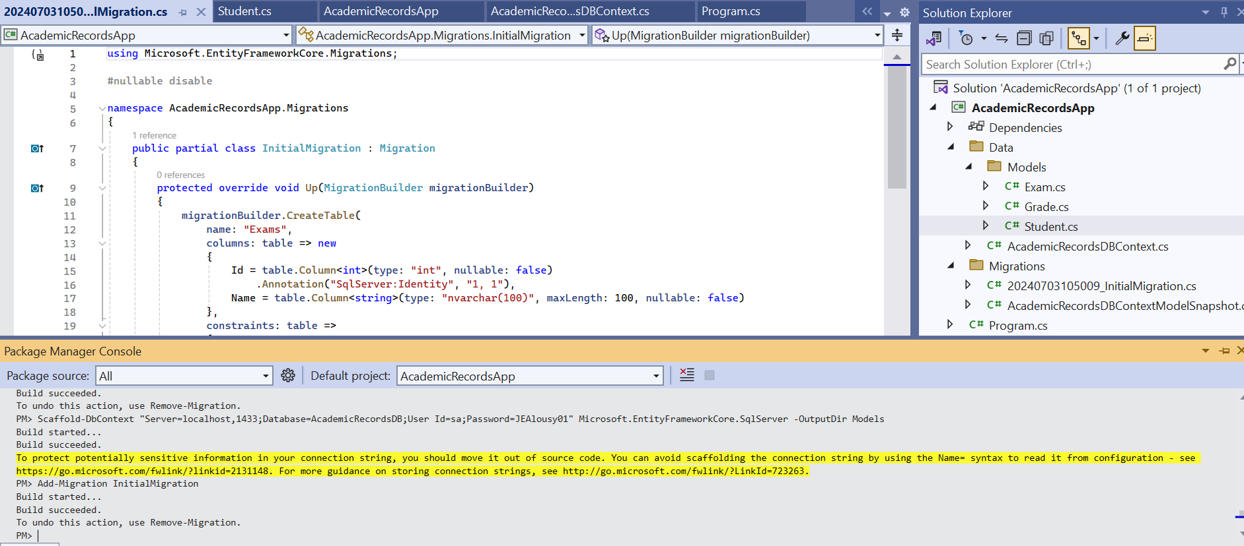
Creating Course Entity && Configure Relationships Using Fluent API
Apply the Migration
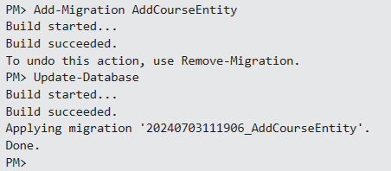

Updated Database Diagram
Refresh the existing tables, and build a New Diagram
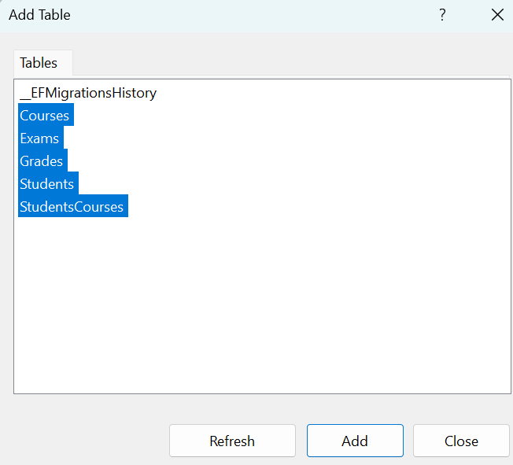
In the updated database schema, we have introduced two significant changes. First, we added a new table called Courses to store information about the various courses offered, each identified by a unique Id and a Name. Second, we established a many-to-many relationship between Students and Courses using a join table named StudentsCourses. This join table includes foreign keys StudentsId and CoursesId, linking students to the courses they are enrolled in.

Creating New Data Model Relations
In this section, we will focus on establishing a new relationship between Student, Course and Exam entities. Specifically, we will define that every exam belongs to one course only, while one course can have many exams. This relationship is known as a one-to-many relationship. Additionally, we will establish a many-to-many relationship between Student and Course, where every student can enroll in multiple courses, and each course can have many students. Follow these steps to create and configure these relationships in your data model.

Using Data Anotations to Configure Relationships
Data Annotations provide a way to configure the model classes directly using attributes. This can make the model classes more readable by keeping the configuration close to the properties they configure.

Update Entities
Exam Entity:
- In the Exam entity, we have introduced several enhancements using Data Annotations to ensure proper configuration and validation of the database schema.
- We added a CourseId property to serve as a foreign key, which establishes a one-to-many relationship with the Course entity. This is enforced by the [ForeignKey("CourseId")] annotation.
- Additionally, we used the [Required] and [MaxLength(100)] annotations on the Name property to ensure that every exam has a name and that it does not exceed 100 characters in length.
- The Course navigation property provides a link to the associated Course entity, allowing us to navigate from an Exam to the Course it belongs to.
- These changes ensure that each exam is associated with a specific course, enhancing data integrity and the logical structure of our database.
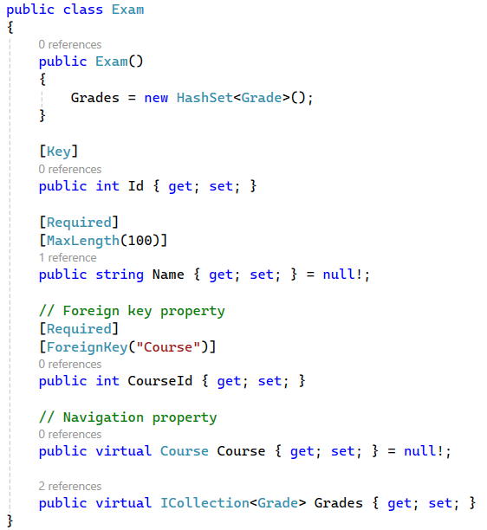
Course Entity:
- In the Course entity, we have implemented several enhancements using Data Annotations to ensure accurate configuration and validation of the database schema
- We introduced a Name property with the [Required] and [MaxLength(100)] annotations to guarantee that each course has a name and that the name does not exceed 100 characters in length
- The Exams navigation property was added to represent the collection of Exam entities associated with a particular course. This creates a one-to-many relationship, allowing each course to have multiple exams
- These changes enhance the relational structure of the database, ensuring that courses can be linked to their respective exams, thereby improving data organization and integrity. The Course entity now accurately reflects the academic structure, where each course can encompass various exams
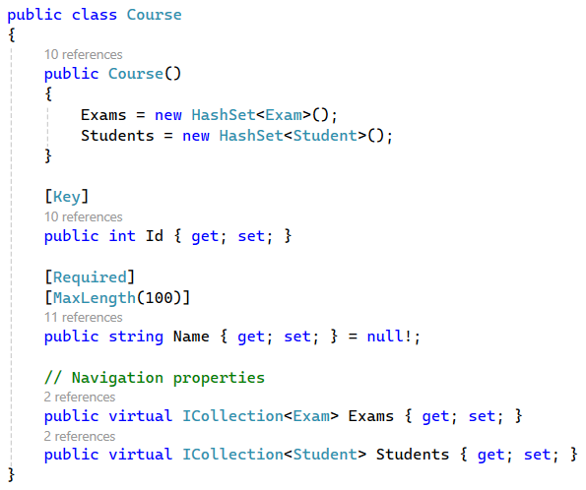
Student Entity:
- In the Student entity, we have introduced several enhancements using Data Annotations to ensure proper configuration and validation of the database schema
- We added a FullName property with the [Required] and [MaxLength(100)] annotations to ensure that every student has a full name and that it does not exceed 100 characters in length
- The Grades navigation property was added to represent the collection of Grade entities associated with a particular student. This allows each student to have multiple grades for different exams
- The Courses navigation property was added to establish a many-to-many relationship between Student and Course entities. This allows each student to enroll in multiple courses, and each course to have multiple students
- These changes enhance the relational structure of the database, ensuring that students can be linked to their respective grades and courses, thereby improving data organization and integrity. The Student entity now accurately reflects the academic structure, where each student can have multiple grades and enroll in multiple courses
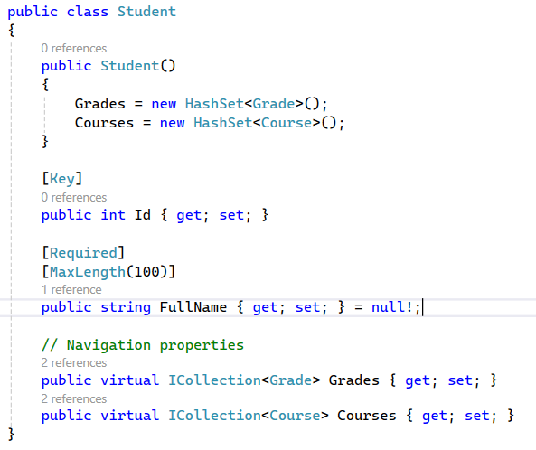

Update DBContext
In this section, we will configure the relationships and constraints in our DbContext using the Fluent API. This configuration ensures that our entity relationships are accurately represented in the database schema.
Configuring Relationships in DbContext
We will update the OnModelCreating method in the DbContext to define the relationships between the Student, Course, and Exam entities using the Fluent API

Add the Migration and Update the Database
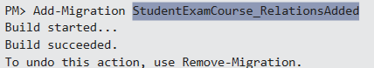
- We have successfully added the new migration called StudentExamCourse_RelationsAdded
- We are going to attempt to update the database with this new migration
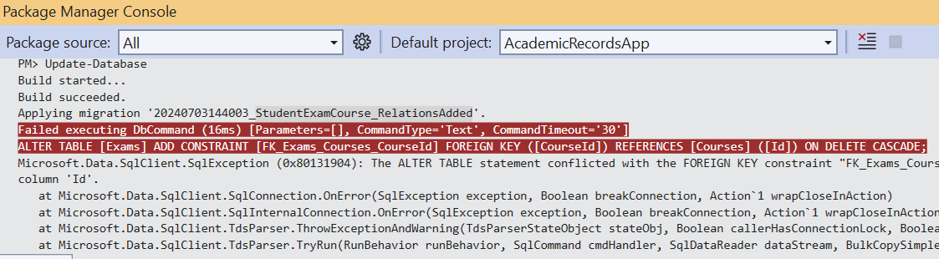
- We attempted to update the database with the new migration, but encountered an error
- The error message indicates that there was a conflict with the FOREIGN KEY constraint

Understanding the Issue
The error occurs because the Exams table has a foreign key constraint that references the Courses table. The specific issue is likely caused by existing data in the Exams table that doesn't match any Id in the Courses table
This can happen if:
- There are records in the Exams table with CourseId values that don't exist in the Courses table
- The CourseId column in the Exams table has NULL values, and the foreign key constraint doesn't allow NULLs

Resolve the Problem
Remove the Failed Migration:
- Since the update was unsuccessful, we'll first remove the failed migration
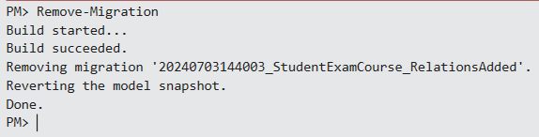
- Modify OnModelCreating to Allow Nulls Temporarily
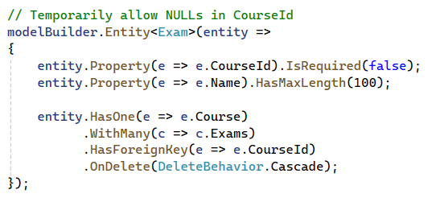

What Will Happen Later When the Property is Made Required?
- Schema Update
  - EF Core will generate a migration that updates the schema to enforce the property as required (non-nullable)
  - This will alter the table definition to disallow nulls in the column
- Data Validation
  - Existing data must comply with the new non-nullable constraint. If there are any null values in the column, the migration will fail
  - EF Core will ensure at the application level that any new records or updates to this column must provide a non-null value
- Foreign Key Constraints
  - The foreign key relationship will enforce that every entry in the Exams table must reference a valid Id in the Courses table
  - This ensures data integrity by preventing orphaned records in the Exams table

Add and Apply a Migration
It seems that the migration will be successful this time
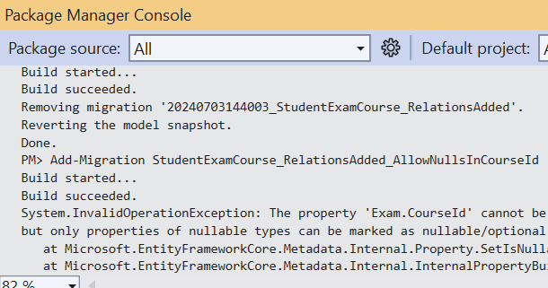
But encounter a new issue
We encountered an error while attempting to make the CourseId property nullable. The error message indicates that the property cannot be marked as nullable unless it is defined as a nullable type in the model class

Nullable Integer Property Resolution
Remove the Failed Migration
- Remove the failed migration to revert the model snapshot
Update the Model Class
- Remove the Required Attribute
- Modify the Exam model to make the CourseId property a nullable integer (int?)
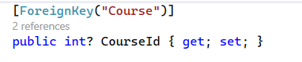

Add a New Migration and Update the Database
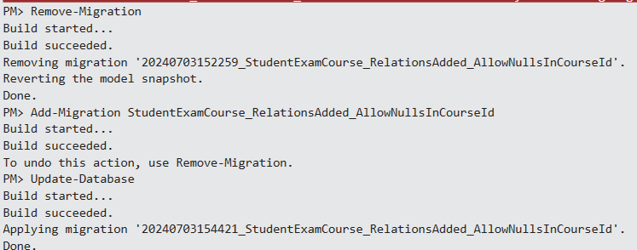

Completing the Migration and Updating the Database Schema
Congratulations on successfully creating the migration and updating the database schema!

