Entity Framework Core – ASP.NET Essentials


Introduction to CinemaWebApp and Entity Framework Core
Welcome to the Entity Framework Core Workshop! In this workshop, we will build the CinemaWebApp step by step, focusing on backend development using ASP.NET Core and Entity Framework Core. Throughout this journey, you will learn how to design and manage a database, work with models, and implement CRUD operations.
Frontend development will be covered in a future ASP.NET course, so for now, we will focus exclusively on the database and backend logic

Start Thinking About Your Graduation Project
As we progress with building the CinemaApp, it’s important to highlight that this project closely resembles what you will need to create and defend for your graduation:
- The concepts and architecture we use here can be adapted to your own graduation project
- Think about how you will design your own database and entities for your final project

Start Exploring ASP.NET Architecture
You Will Need This for Your Graduation Project
- Just like with the database design, your graduation project will require you to structure your backend, business logic, and frontend properly
- The sooner you start exploring ASP.NET architecture, the easier it will be when you need to build your own project

Workshop Goals
- Create an empty ASP.NET Core MVC project and set up EF Core
- Define and configure database models using EF Core
- Apply migrations to generate the database schema
- Seed initial data into the database
- Implement basic CRUD operations using EF Core

Demonstration of the Application
Before starting the development, let's explore the final outcome of the CinemaWebApp. This will help you understand the goal and structure of the application you will be building:
- These are the credentials that could be used initially for exploring the application
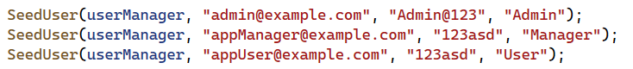


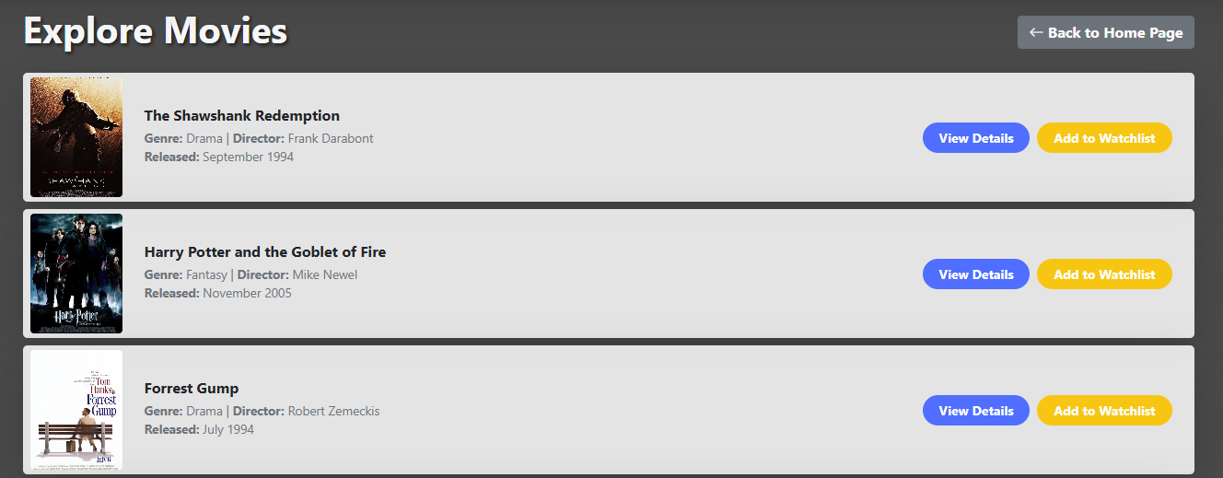



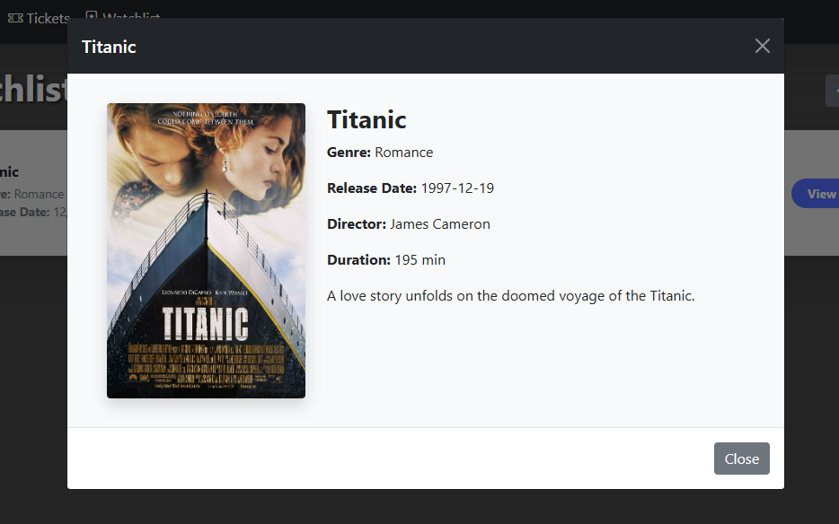
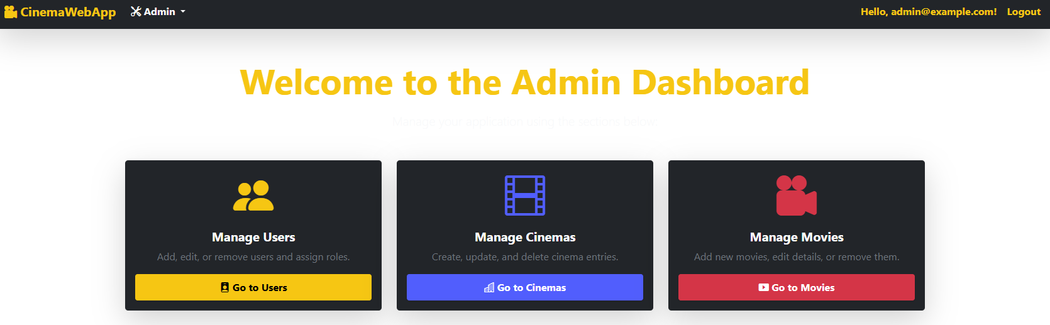
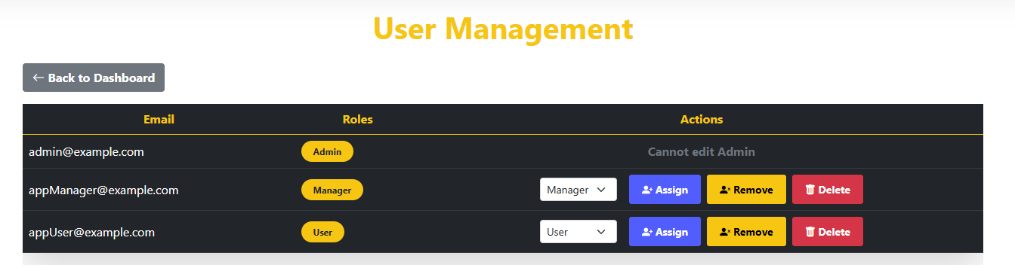
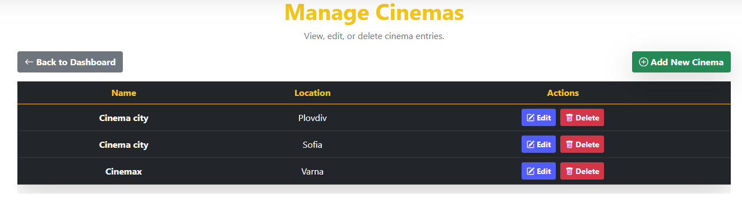
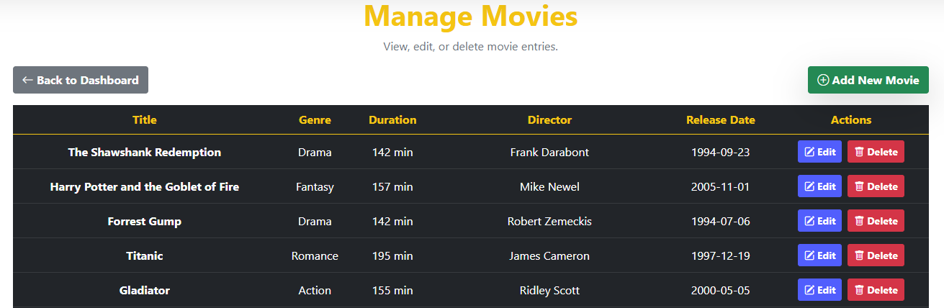
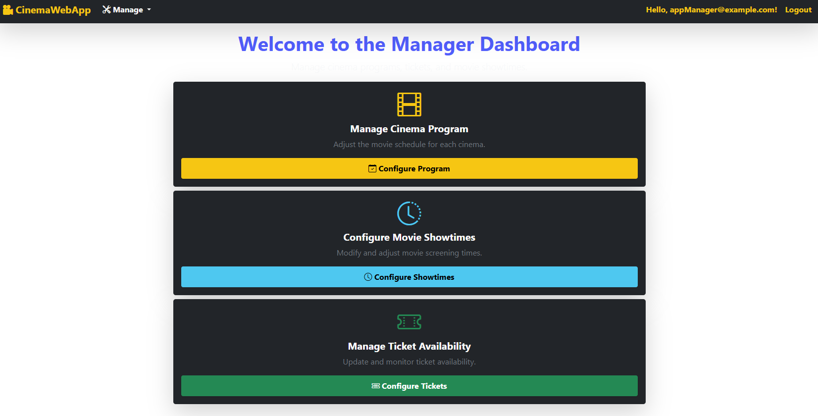
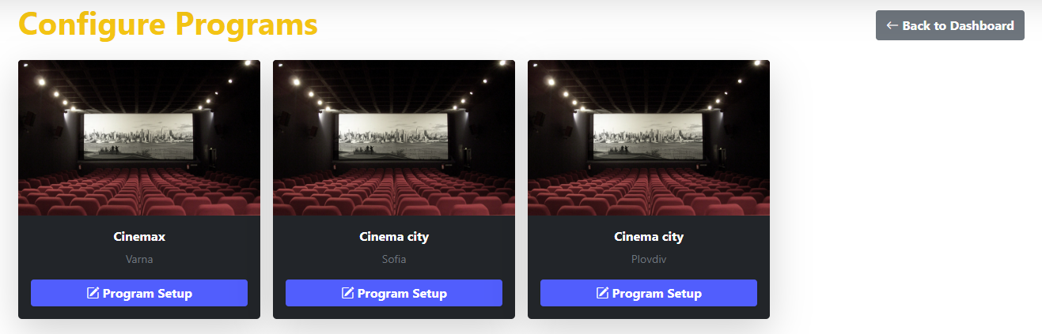
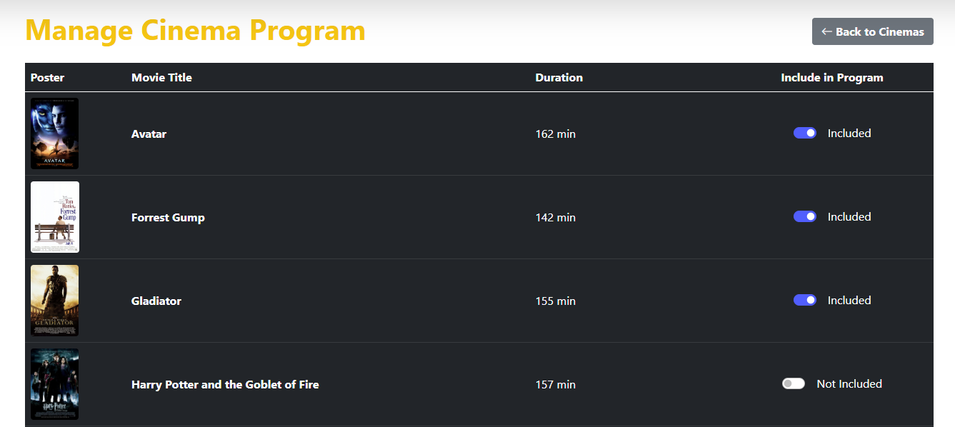
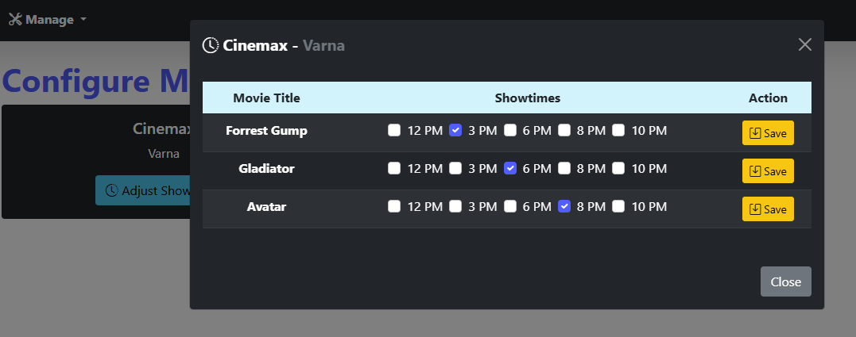
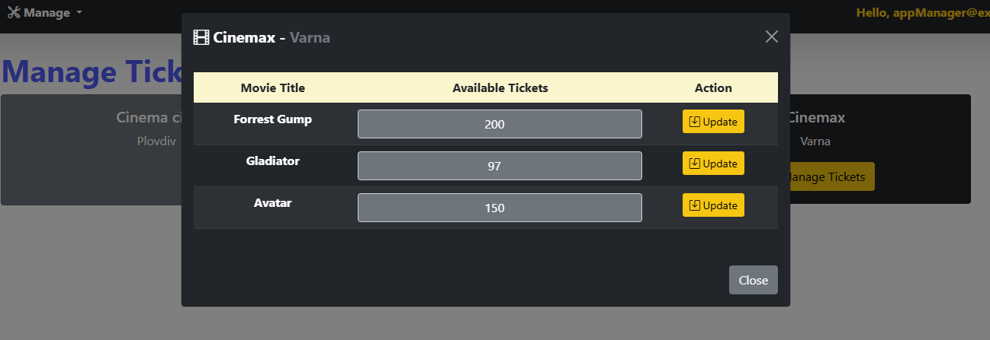

Database Overview

Creating an ASP.NET Core MVC Project

Setting Up the Project
Create a New ASP.NET Core MVC Project:
- Open Visual Studio and select Create a new project
- Choose ASP.NET Core Web App (Model-View-Controller) and click Next
- Name the project (CinemaApp) and choose a location to save it
- Select .NET 8 as the framework and click Create
- Run the application to ensure it is working properly (Ctrl + F5)

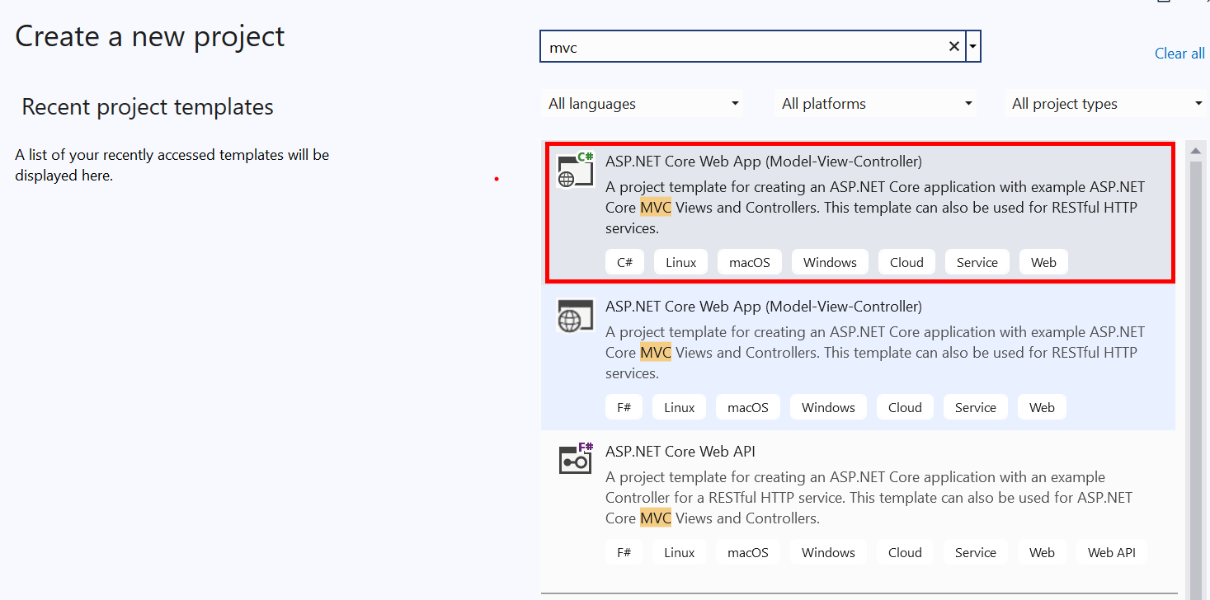
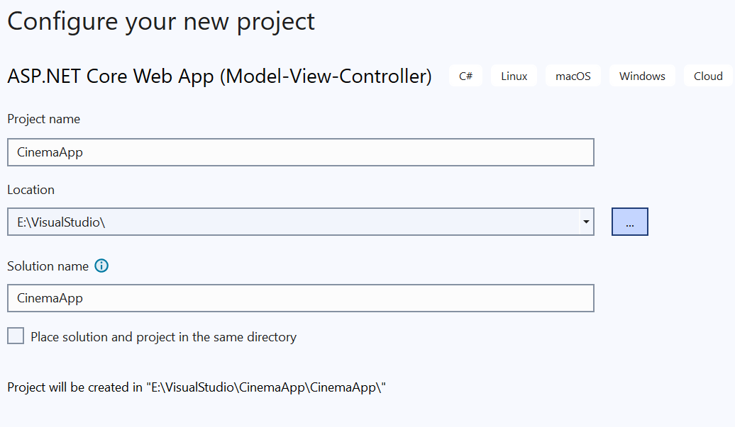
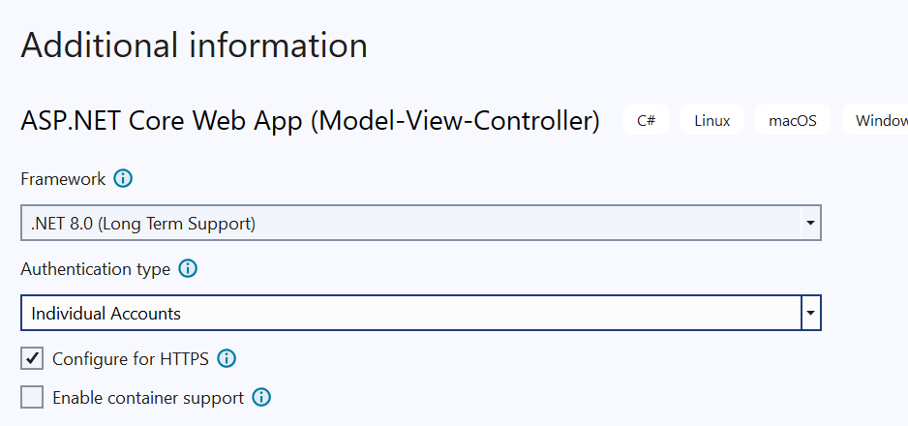
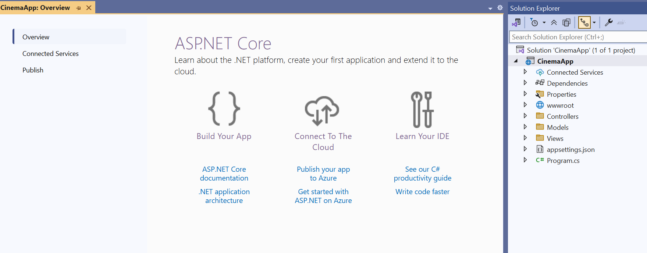
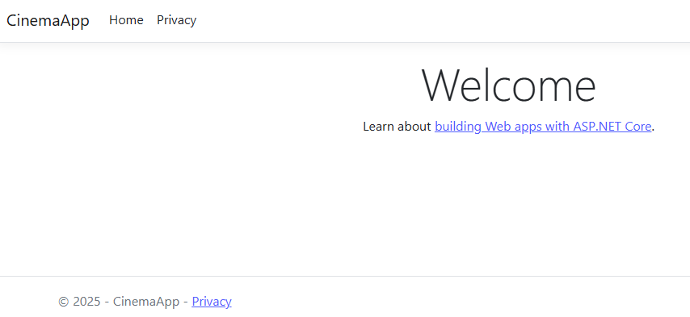

Setting Up the Project Architecture
To keep the project well-organized, we will create the Data folder, which will contain all database-related components

Create the Data Folder
- In Solution Explorer, right-click the project and select Add > New Folder.
- Name the folder Data (for organizational purposes)
- Creating Class Library Projects for Separation of Concerns
  - CinemaApp.Data.Models – Stores all database models
  - CinemaApp.Data – Handles database access (DbContext, repositories, configurations)
- Adding References
  - Right-click CinemaApp.Data → Select Add Project Reference
  - Select CinemaApp.Data.Models and click OK
- Ensuring the package dependencies are correctly installed
- 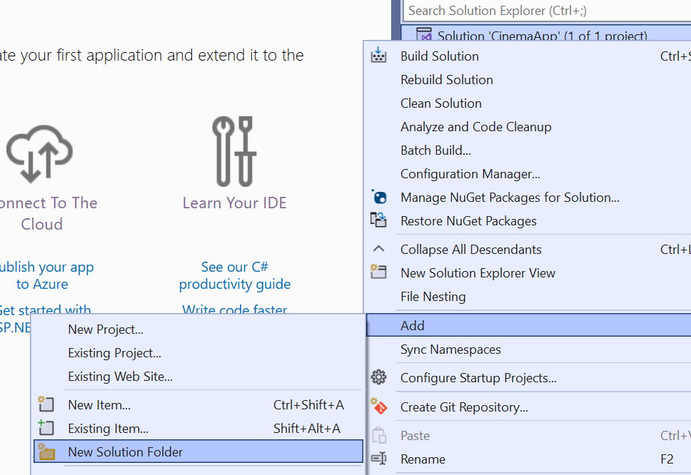
- 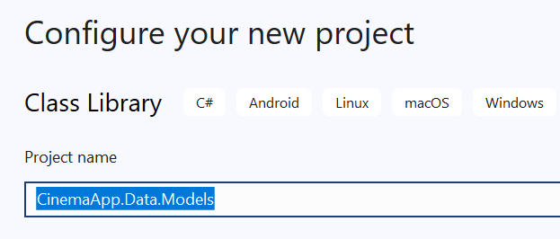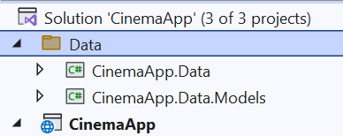
- 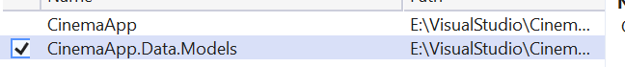

Install EF Core Packages in CinemaApp.Data
Since we are working with Entity Framework Core (EF Core) for database management, we need to install the required packages:

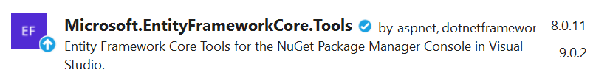


Once all packages are installed, we can move forward with creating all data models

Creating Data Models
We will now create the core entity models inside CinemaApp.Data.Models before implementing the database context

ApplicationUser
Extends IdentityUser<Guid>
- This ensures that ASP.NET Core Identity handles user authentication
- Uses GUID instead of an integer (int) for user IDs
Constructor: Generates a New GUID for Id
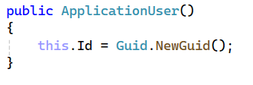
Navigation Properties
- ApplicationUserMovies - Represents the many-to-many relationship between users and movies
- Tickets - a collection of type Ticket

Cinema
- Id – Guid, Primary Key
- Name – string (required)
- Location – string (required)
- IsDeleted – bool
- CinemaMovies - a collection of type CinemaMovie
- Tickets - a collection of type Ticket

Movie
- Id – Guid, Primary Key
- Title – string (required)
- Genre – string (required)
- ReleaseDate – DateTime (required)
- Director – string (required)
- Duration – int (required, represents movie length in minutes)
- Description – string (required)
- ImageUrl – string?
- IsDeleted – bool
- MovieCinemas – a collection of type CinemaMovie
- MovieApplicationUsers – a collection of type ApplicationUserMovie
- Tickets – a collection of type Ticket (one-to-many relationship)

CinemaMovie
- MovieId – Guid, Foreign Key (References Movie)
- Movie – Movie (Navigation Property)
- CinemaId – Guid, Foreign Key (References Cinema)
- Cinema – Cinema (Navigation Property)
- AvailableTickets – int, Tracks remaining tickets for the movie in a specific cinema
- IsDeleted – bool
- Showtimes – string (formatted as "00000", stored as varchar(5))

ApplicationUserMovie
- ApplicationUserId – Guid, Foreign Key (References ApplicationUser)
- ApplicationUser – a navigation property of type ApplicationUser
- MovieId – Guid, Foreign Key (References Movie)
- Movie – a navigation property of type Movie

Ticket
- Id – Guid, Primary Key
- Price – decimal (required)
- CinemaId – Guid, Foreign Key (References Cinema)
- Cinema – Cinema (Navigation Property)
- MovieId – Guid, Foreign Key (References Movie)
- Movie – a navigation property of type Movie
- ApplicationUserId – Guid, Foreign Key (References ApplicationUser)
- ApplicationUser – a navigation property of type ApplicationUser

Creating a ValidationConstants Class for Centralized Validations
A separate class to store validation rules could be created (option). This will help keep the code clean, maintainable, and reusable:
- Avoid Hardcoded Values – Keeps validation rules in a single place instead of spreading them across models
- Improves Readability – Models are cleaner and easier to understand
- Easy Updates – If a validation rule changes, update it in one place instead of multiple files

Creating CinemaAppDbContext
Now that we have created all the models, we need to set up the database context, which will serve as the main bridge between our application and the database. The database context is responsible for managing the entities and database operations using Entity Framework Core (EF Core).

Important Note for Students: Remove the Legacy Data Folder
When setting up the Entity Framework Core (EF Core) project, students must delete the legacy Data folder that is automatically created when an ASP.NET project includes Identity by default.
Why is This Important?
Prevents Duplicate DbContext Issues
- The default Identity setup creates an extra ApplicationDbContext inside the Data folder.
- If not removed, EF Core detects multiple DbContext classes, leading to confusion when applying migrations.

Create the CinemaAppDbContext Class
- Inside CinemaApp.Data, create a new file called CinemaAppDbContext.cs
- Extending IdentityDbContext for Authentication
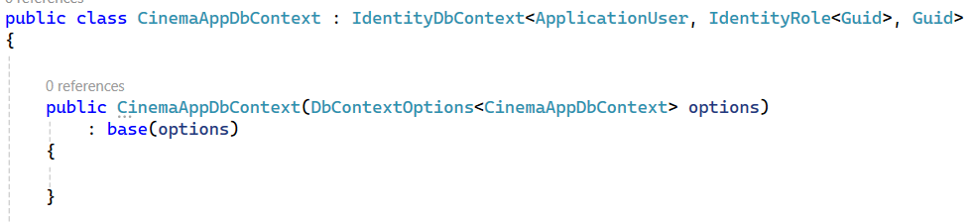
  - Extends IdentityDbContext to include authentication support
  - Uses GUID as the primary key for users and roles
  - Receives database connection settings via dependency injection
  - Passes options to the base constructor (IdentityDbContext)

Defining Database Tables
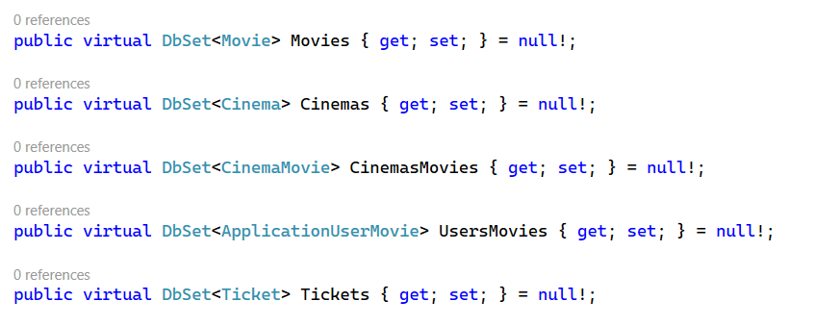

Configuring Entities Using Fluent API
In Entity Framework Core, we can configure entity relationships and constraints using Data Annotations or Fluent API. While Data Annotations work well for simple cases, using Fluent API in separate configuration classes provides better control, flexibility, and maintainability.

Using Configuration Classes
- Inside CinemaApp.Data, create a new folder named Configuration
- Create a Configuration Class for Each Model
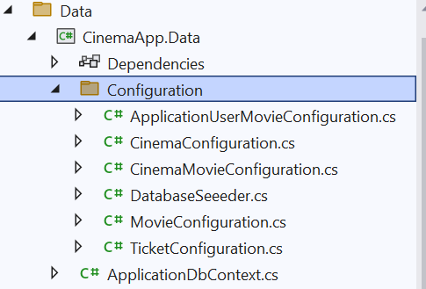

Understanding OnModelCreating in CinemaAppDbContext
The OnModelCreating method in Entity Framework Core (EF Core) is responsible for configuring the database schema, relationships, and entity constraints before the database is created.

Why Do We Need OnModelCreating?
Defines Entity Relationships – Ensures correct table relationships (One-to-Many, Many-to-Many).
✅Applies Fluent API Configurations – Loads entity configurations from the Configuration folder.
✅ Applies Identity Settings – Calls base.OnModelCreating(modelBuilder) to apply ASP.NET Core Identity configurations.
✅ Allows Data Seeding – Adds default data to tables during database creation.

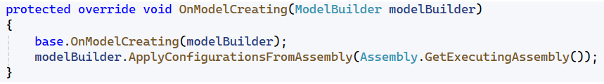
base.OnModelCreating(modelBuilder);
- Calls the base class implementation (from IdentityDbContext)
- This ensures that Identity tables (AspNetUsers, AspNetRoles, etc.) are created properly
modelBuilder.ApplyConfigurationsFromAssembly(Assembly.GetExecutingAssembly());
- Automatically applies all entity configurations from the Configuration folder
- Instead of defining relationships in DbContext, we keep them separate for better maintainability

Updated Program.cs for This Stage
- Database Connection Configuration
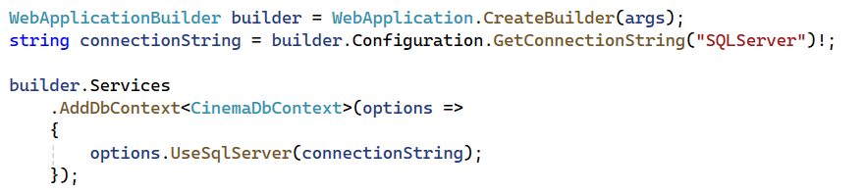
- Identity Setup
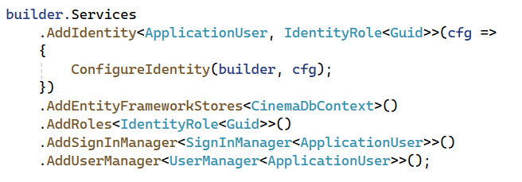
- Middleware Setup
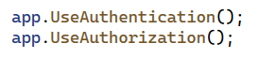
- Routing Setup
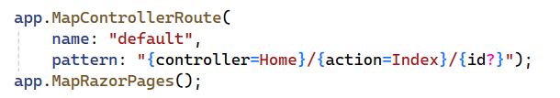

Configure appsettings.json to include the database connection string

Add-Migration && Update-Database

Verify the Database in SQL Server Management Studio (SSMS)
