EF Core Best Practices and Architecture (Exercise)


Introduction
Welcome back!
In the previous exercise, we built the initial structure of our ASP.NET Core application and successfully executed the JSON import functionality. Today we continue from that point, but we shift our focus to how real, maintainable, professional applications are built.
This lecture is divided into three key themes:
- Finishing the Import Module – Implementing the XML Import
- Architecture & Clean Code – Moving logic from Controllers into Services
- Validation & Debugging – Understanding broken data and catching errors properly
By the end of this lecture, you will clearly understand why architecture matters and how to write cleaner, safer, and more scalable applications

Completing the Import: XML
In the last session, we implemented the JSON import live.
Today, your task is to finish the XML import, using the exact same structure and concepts.
Your goals:
- Read XML input
- Deserialize into Import DTOs
- Validate each DTO
- Map DTO → Entity
- Save valid data into the database
What matters here:
✔ Data must pass validation before we save it.
✔ Incorrect records must be skipped.
✔ XML structure must match our DTO structure exactly.
Tip: XML is less forgiving than JSON. Expect more real-world issues, and use breakpoints often

Clean Architecture: Moving Logic into Services
Last time, our controllers became “fat”

They were doing too much: validation, mapping, database queries, decisions.
This is not how modern ASP.NET applications are built.
Today’s principle:
Controllers should only take the request and return the response. Nothing more.
All logic belongs in Services.

Validation: Understanding Broken Data
In real applications, the worst errors come from bad input.
That’s why today we work with broken data on purpose.


Types of validation you will see today:

Data Annotation Validation
[Required], [Range], [StringLength], etc.
Custom Business Validation in Services
Example: “A cinema cannot have two movies with the same name.”
Import Validation (XML/JSON)
Strict checking of DTOs before mapping.
Database-Level Validation
Foreign keys, unique indexes, constraints.

Debugging Validation
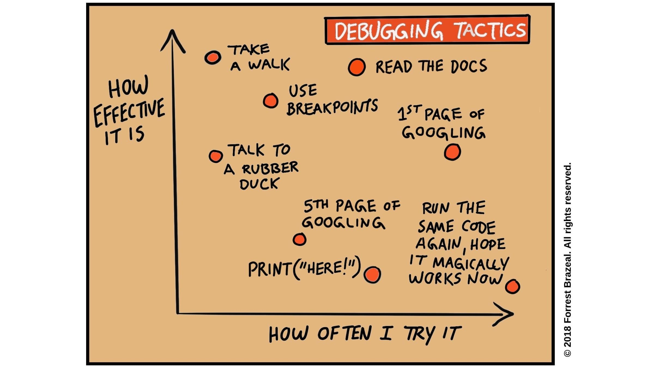
We will learn how to catch validation errors using:
- Breakpoints
- ModelState.Errors
- Logging
- Checking DTO values before mapping
- Understanding XML deserialization errors

Your debugging checklist:
✔ Did the DTO match the XML exactly?
✔ Did you decorate all required properties?
✔ Is the relationship valid?
✔ Are you trying to insert duplicates?
✔ Are identifiers correct?
By intentionally breaking data, you will understand why validation exists and how to track failures when they happen.

