EF Core – ASP.NET Essentials II


Overview
In this exercise, students will focus on implementing the backend logic of the CinemaApp project. The primary objective is to build CRUD (Create, Read, Update, Delete) operations for managing data while working directly with DbContext via Dependency Injection (DI). This will provide a hands-on understanding of handling database interactions efficiently in an ASP.NET Core MVC application.

Learning Objectives
By completing this exercise, students will:
- Implement CRUD functionality in controllers for key entities
- Work with DbContext using Dependency Injection
- Understand how to structure controller logic for interacting with the database
- Learn how to manage data import and export using helper methods

Best Practices and Approach
A common best practice in ASP.NET Core applications is to use:
- Repository Pattern
- Service Layer
to separate concerns and avoid direct interaction with DbContext in controllers.
However, to keep the application simple and avoid introducing too much information at the beginning, we will directly interact with DbContext in this exercise.
Later, students can refactor the application to follow best practices.

Identity Setup

Scaffolding Identity
- Right-click on the Project in Solution Explorer
- Select Add > New Scaffolded Item
- Choose Identity
- Select Account: Login, Register, Logout
- Choose CinemaAppDbContext as the data context
- Click Add
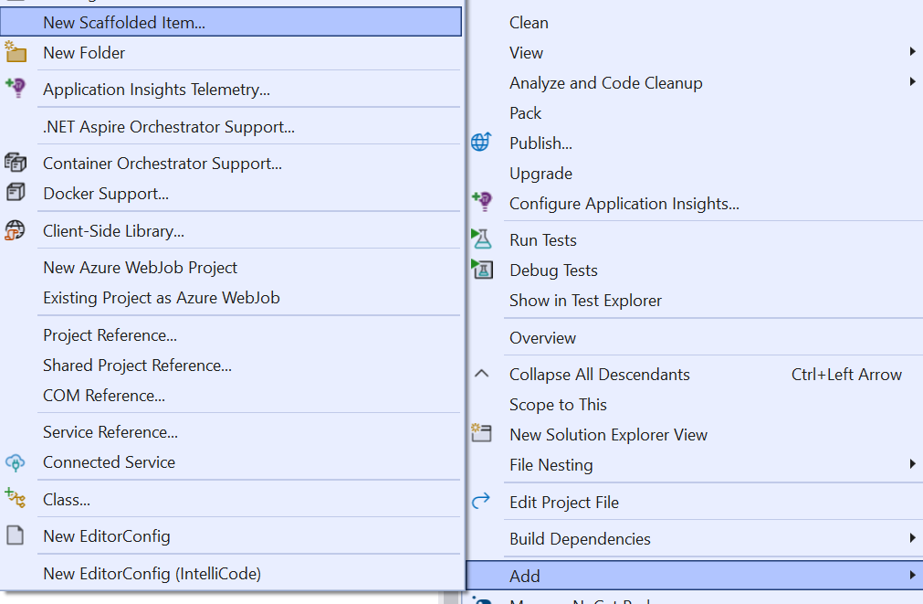
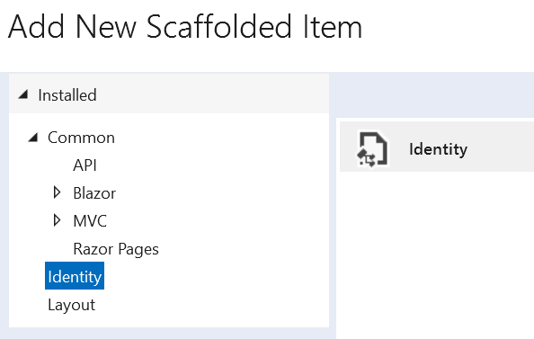
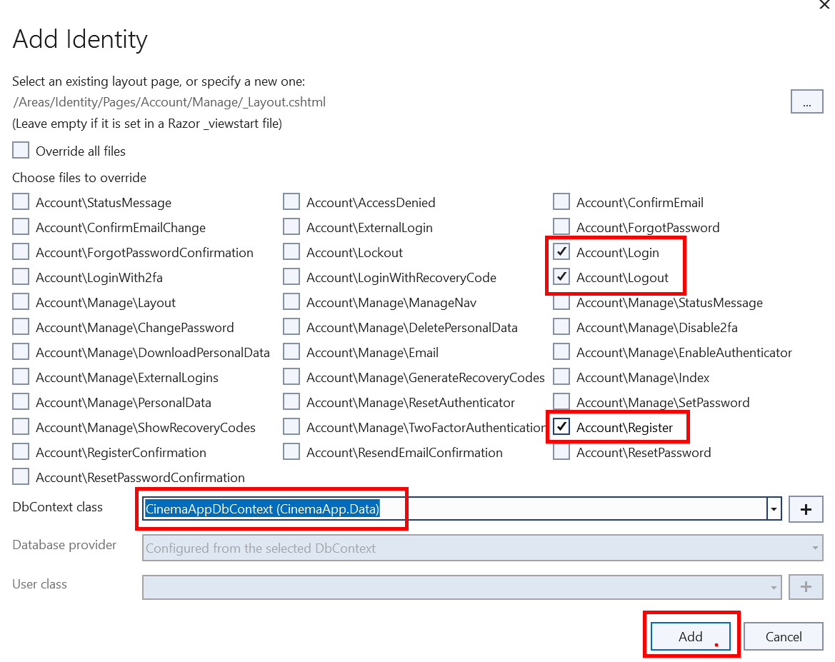
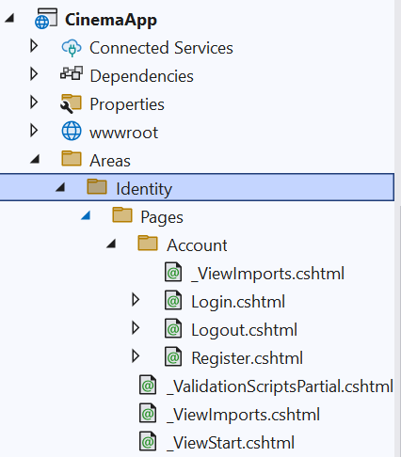

Change IdentityUser to ApplicationUser
After scaffolding, the Identity pages (such as Register.cshtml and Login.cshtml) will use IdentityUser by default. However, if you have a custom ApplicationUser class, you must update all occurrences of IdentityUser in the scaffolded files.
- Update Register.cshtml.cs, Login.cshtml.cs and Logout.cshtml.cs
- Apply Migrations

Register a User and Extract User IDs from SSMS
- Editing _LoginPartial.cshtml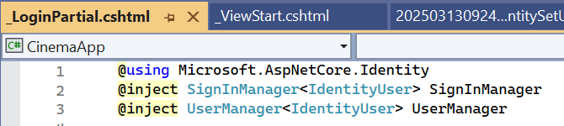
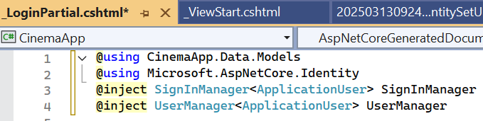
By default, the _LoginPartial.cshtml file injects UserManager<IdentityUser> and SignInManager<IdentityUser>.
However, since we are using ApplicationUser, you must update this file to prevent runtime errors.
- Remove Password Restrictions
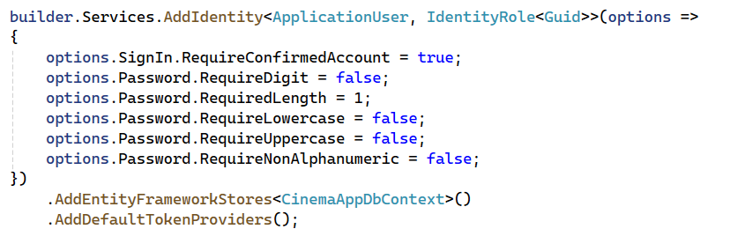
- Run the Application and navigate to the Register page:
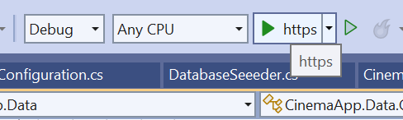
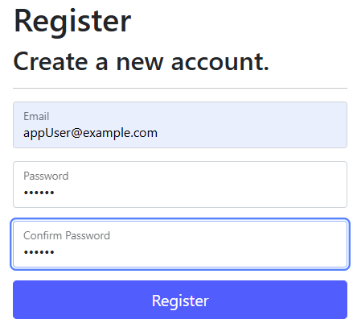



Creating a DataProcessor static class

Seeding Files for Import
- Additional movies to import:
- CinemasMovies relations to import:
- Tickets to import:
Contains a list of predefined movies that will be imported into the database
The tickets.xml file includes ticket data with placeholders for `UserId` elements.
These values are initially **empty** and can be updated once users are registered through the default **ASP.NET Identity** registration functionality.
This ensures that ticket ownership can be correctly assigned.

Assigning Users to Tickets in the XML File
Now that we have users created in the database, we need to update the tickets.xml file by assigning Id values to each ticket.
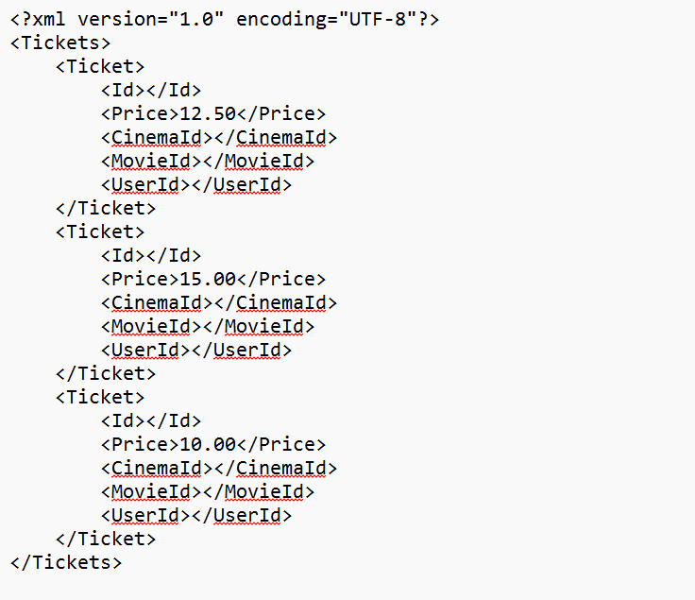

Where to Place the DataProcessor Class?
The DataProcessor class should be placed in a logical and reusable location within your ASP.NET Core project

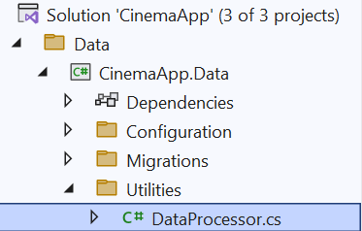

Creating DataProcessor Class Empty Methods
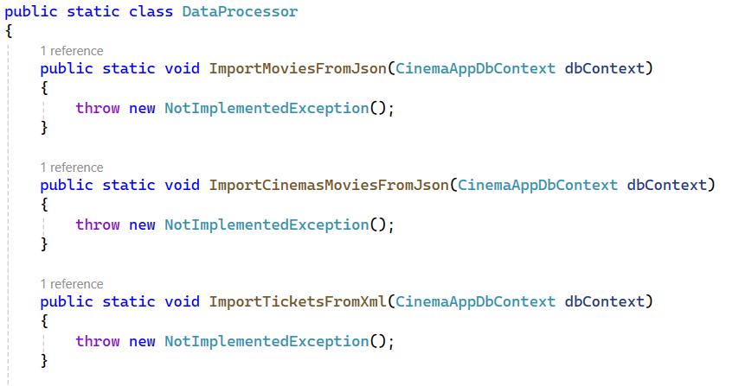
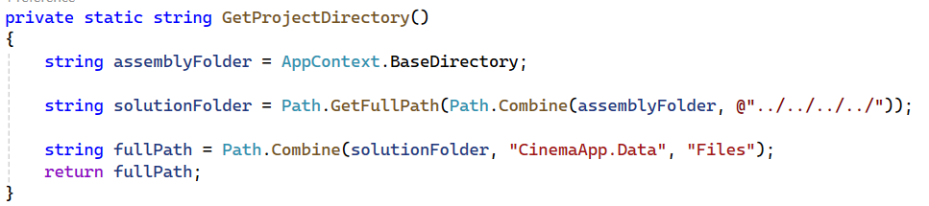

Create a Folder for Data Files
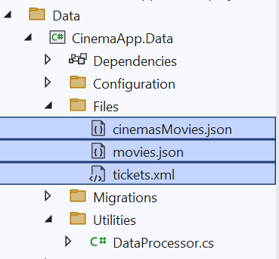

Triggering DataProcessor When the App Starts
- To execute the DataProcessor at startup, we need to modify Program.cs to call DataSeeder.
- This will ensure that the data is imported when the application starts.
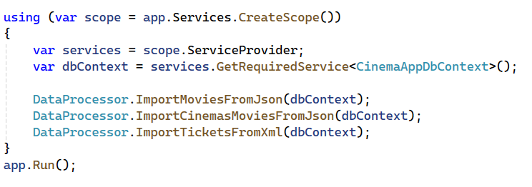

Comment Out the Following Lines
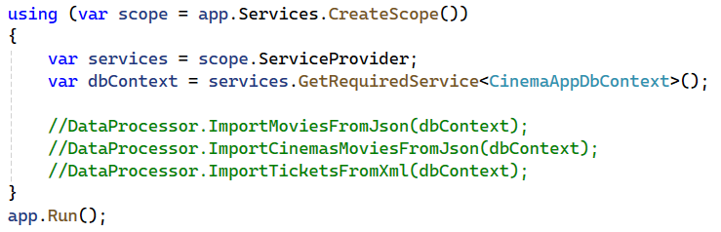
- We will uncomment one by one the DataProcessor methods, and seed the new entries in the database

Import Movies From Json
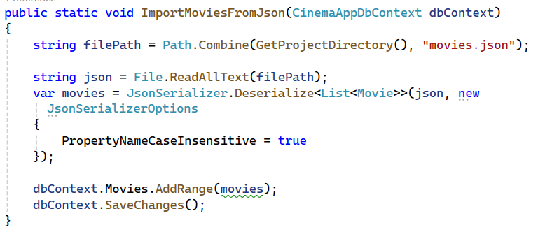

Ensure Movies are Imported Successfully
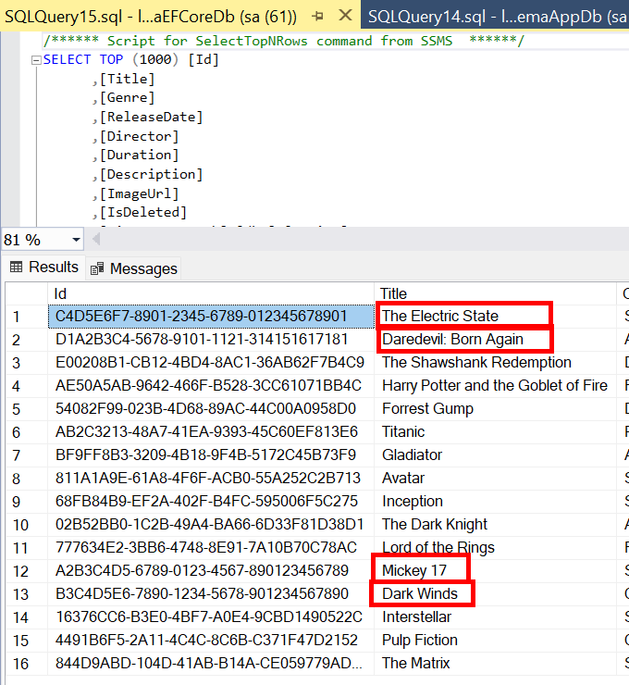

Next Steps for Import:

ImportCinemasMoviesFromJson
- Create a CinemaMovieDTO
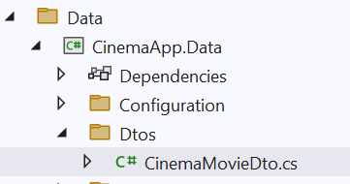
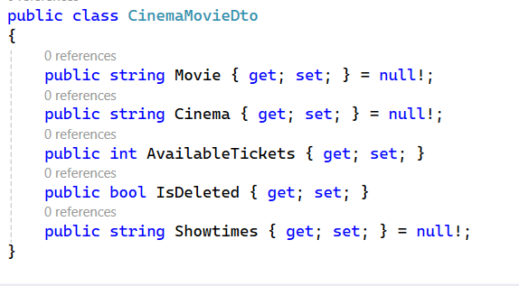
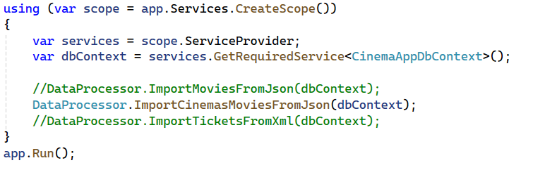

ImportTicketsFromXML

