Exercises: CRUD Operations

Create the Database
Create a MongoDB database with the name "Articles" and populate it using the following JSON:
Sample code usage
{
"articles": [
{
"author": "Bill Gates",
"date": "27-01-2020",
"name": "Top 5 programming languages in 2020",
"rating": "5"
},
{
"author": "Svetlin Nakov",
"date": "02-05-2020",
"name": "How to write bug-free code",
"rating": "10"
},
{
"author": "Nikolay Kostov",
"date": "08-07-2020",
"name": "Set up your very own web server!",
"rating": "20"
},
{
"author": "Elon Musk",
"date": "17-04-2020",
"name": "The future of space travel",
"rating": "50"
},
{
"author": "Alen Paunov",
"date": "10-07-2020",
"name": "How to manage effectively",
"rating": "50"
}
]
}
Create a Console Application (.NET Core) and connect it to your MongoDB database. To do that, first install the NuGet package MongoDB.Driver.

Read
Print on the console the names of all articles in the database.
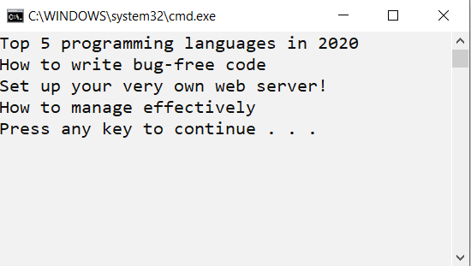

Create a new article
Add a new article with author "Steve Jobs", date "05-05-2005", name "The story of Apple", rating "60".
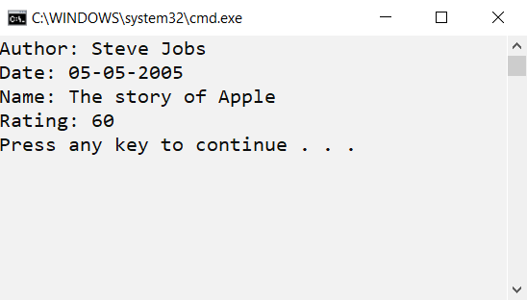

Update
Add 10 points to the rating of all articles.

Delete
Delete all articles with rating less than or equal to 50. Print the names of the remaining articles on the Console.
