Exercises: Introduction to Databases

Create New Database
Connect to the Server with Authentication Mode:
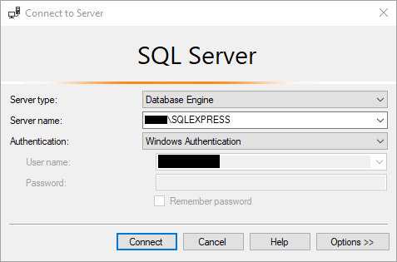
Create a new database:
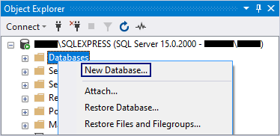
Type the name of the database and click [OK]. This will create your database.
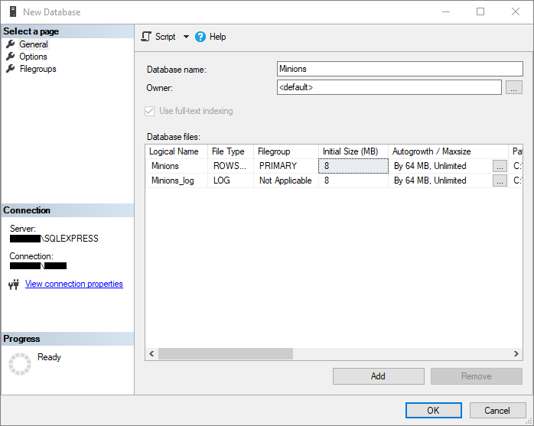

Create Table
Create table Minions:
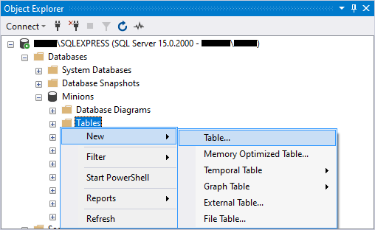
Create columns Id, Name and Age. Id and Name are required; Age should allow null values.
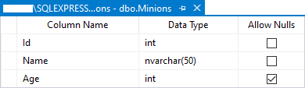
Set the Id as a primary key:
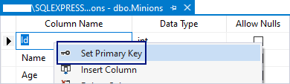

Insert Data in the Table
Insert data in the table as shown on the picture below:
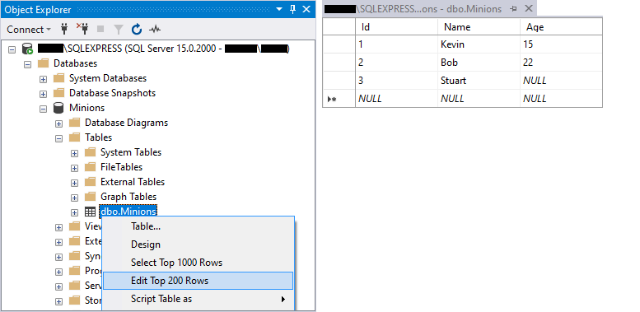

Select Data from Table
Select all columns from the Minions table:
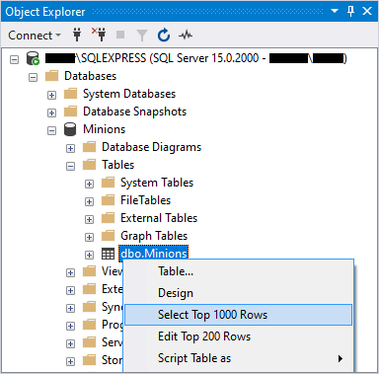
Open a new query window, then write the SQL.
- Select only Names from the Minions table.
- Order them ascending by Name.
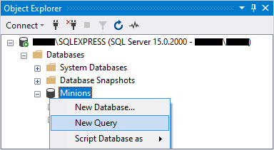

Update One Record
Change Stuart's age from NULL to 10.

Update All Records
Change the age of all Minions to be +1 year.

Delete Record
Open the table in Edit Mode, right click on the row where Bob is situated and delete it.
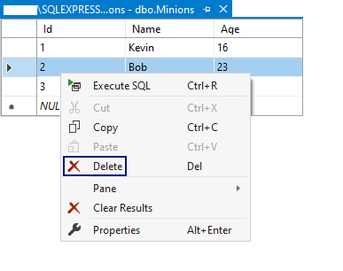

Create New Table
Create a new table Towns. Every town has Id (int) and Name (text). Make the Id column a primary key.

*Connect Tables
Now let's make a connection (a relationship) between our two tables. First we need to modify our Minions table. Add a column TownId in it (IMPORTANT: The type of the column must be the same as the type of the column Id of the Towns table).
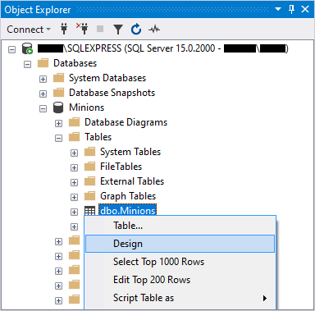
Now we can make a new diagram. The diagram shows all tables in the database and the relationships between them.
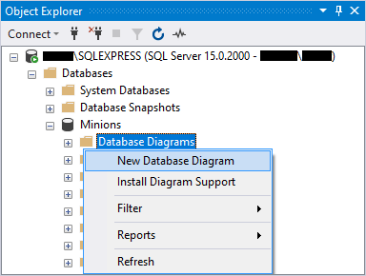
Select all tables to be on the diagram and click on the [Add] button.
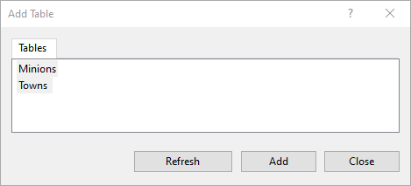
Finally, simply drag the TownId column and drop it on the Id column in Towns. Then make sure the window looks like this and click [OK].
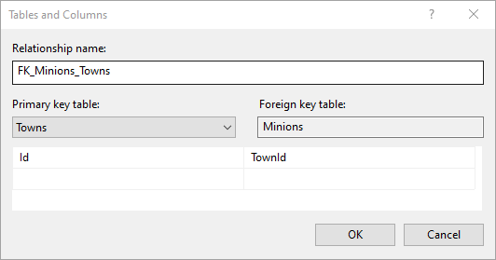
That's all. Now the two tables have a relationship between them.

Create New Database
Now, on your own, create a new database School. Add a few tables to the database: Students (Id, Name, Age, PhoneNumber), Classes (Id, Name, MaxStudents), Teachers(Id, Name, Class). Add columns for the tables. Populate the tables with some random content. Then delete and make changes in some records.

*Generate SQL Script
Generate SQL script for the School database. View the script file and try to understand the different commands. Execute the script.

