Guidelines for installing SQL Server 2019 and SQL Server Management Studio
This document contains guidelines for installing the needed software for the "Databases Basics – MS SQL" course @ Software University.

 | SQL Server Management Studio (SSMS) 18 works properly only with SQL Server 2019.  SQL Server Management Studio (SSMS) 19 Preview works properly only with SQL Server 2022.  This guideline is for installing SQL Server Management Studio (SSMS) 18 and SQL Server 2019.  If you'd like to use SQL Server Management Studio (SSMS) 19 (Preview) version, download SSMS 19 from here and download SQL Server 2022 from here. The steps for installation are identical as the steps for SSMS 18 and SQL Server 19.

1. Download and install SQL Server Express

Step 1. Download SQL Server 2019 (Express edition)
Click on the link below from the Microsoft website and download SQL Server 2019 Express: https://www.microsoft.com/en-us/download/details.aspx?id=101064. This should automatically download the installation file. If it doesn't download it automatically, click on the [Download] button.
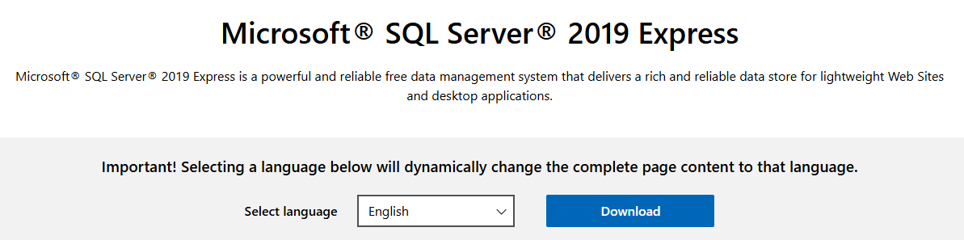

Step 2. Install SQL Server 2019
Start the downloaded installation file. Choose the Basic option.
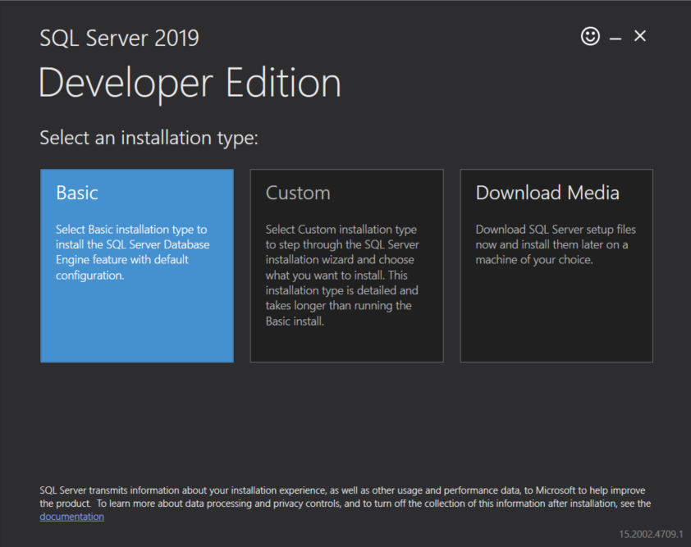

On the next screen, you have to accept the License Terms and Privacy Statement.
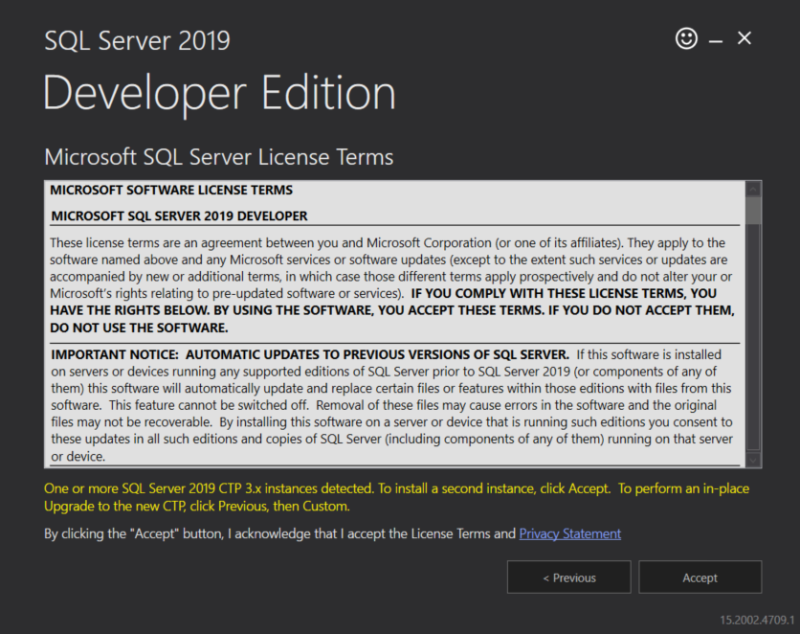

Before clicking on the [Install] button, you have to choose the directory to install the product to. You don't have to change anything, unless you have some specific preference. 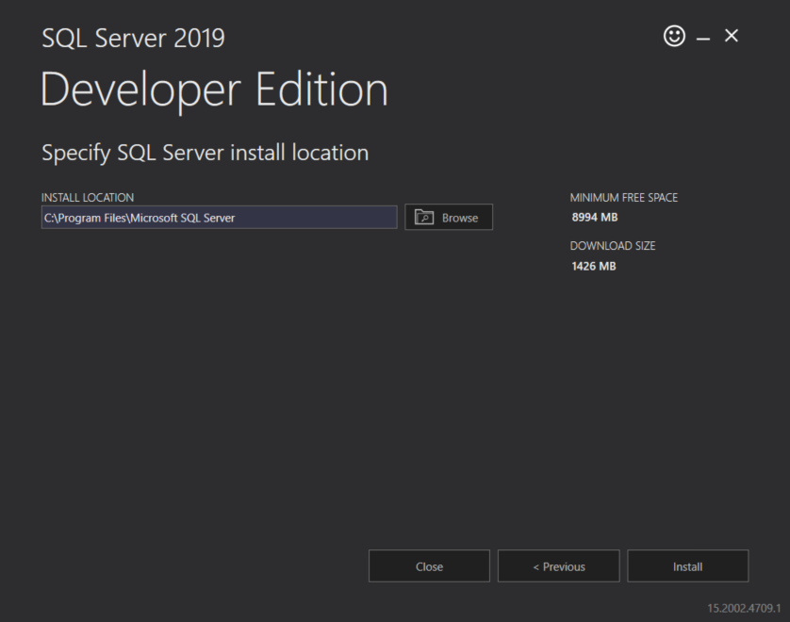
After the installation is successfully completed, you can use the [Install SSMS] button, which will take you to the Microsoft website in order for you to download the SQL Server Management Studio installer. You can find the same link in the next chapter of this document.

2. Download and install the SQL Server Management Studio

Step 1. Download SQL Server Management Studio
If you haven't downloaded the installation file from the previous chapter, click on this link and download the SQL Server Management Studio.

Step 2. Install SQL Server Management Studio
Open the downloaded installation file and click on the [Install] button. After the installation is completed successfully, you'll have to restart your computer.