Practical Project: Random Sentences Generator
This is additional practical project and it is not mandatory and it is not included in the final score. The main purpose is to use gained knowledge in different type of problems and to improve your portfolio and GitHub skills.

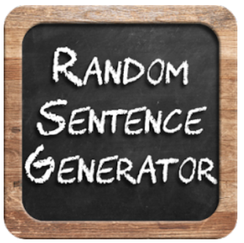
This random sentence generator is just for fun! These sentences can provide humour and be a cool way to surprise others by sharing a standout sentence on social media platforms and gathering your network's reaction.
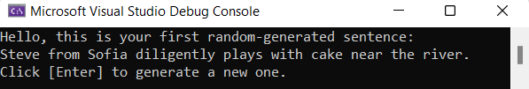
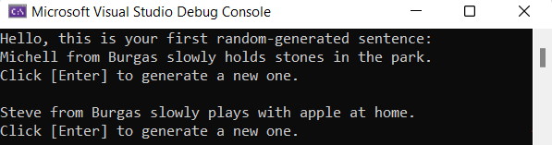

Create GitHub Repository
Create a new repository from https://github.com/new. Choose a meaningful name, e. g. "RandomSentencesGeneratorByUsername", add a short description, and make your repo public. Also, add a README.md file and .gitignore for Visual Studio. Finally, change the license to "MIT" and click on the [Create] button to create your repository.
 | Please choose your original and unique name for your project!  Your GitHub profile should be unique, not the same as your colleagues'.  You can follow this tutorial, but you can also make changes and implement your project differ from your colleagues.
Now your repository is created and should look like this:
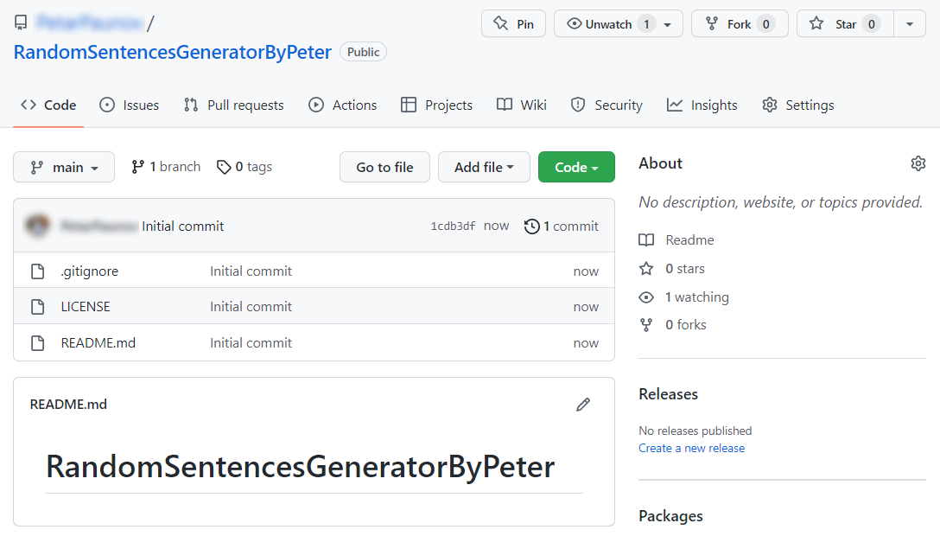
Now let's see how to write the code of our application.

Write the Sentences Generator Code
Let's create the application and play with it.

Create a Visual Studio Project
First, we should start Visual Studio and create a new C# console application. Then, choose an appropriate name and a place to save the project. On the next screen, choose [.NET 6 (Long-term support)] and create the project.
Our project should be created and should look like this:
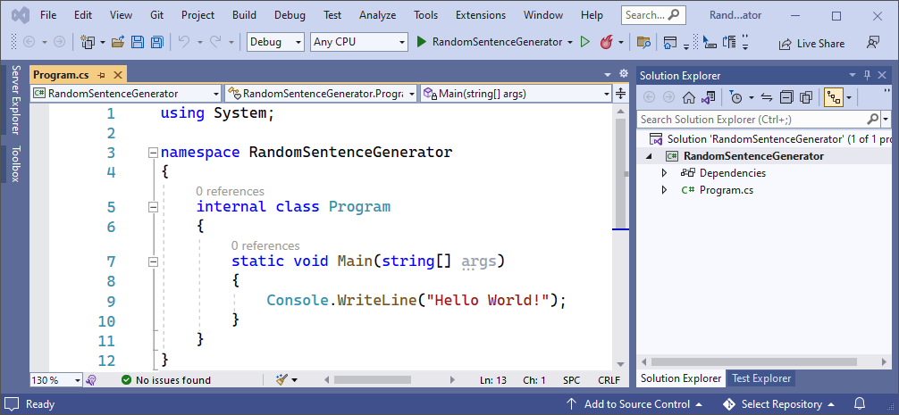
Before we continue, let's change the name of our main class to something more meaningful:
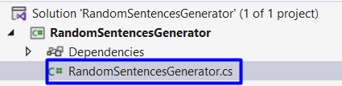

Implement the Generator Logic
Now let's start working on our project.

Create the Sentence Model
To create our sentences we are going to need: names, places, verbs, nouns, adverbs and details. The sentence that we will create is based on the following model:
- One sentence needs [Who from where] [Action] [Detail] to be created.
  - "Who from where" example: [Name + from + Place] ("David from London").
  - "Action" example: [Adverb] + [Verb] + [Noun] ("calmly watched the sunset").
  - "Detail" example: "near the river", "at home", "in the park".

Add Words for the Sentences
Let's start by creating arrays with all the words that we are going to use to create a random sentence. Arrays are used to store multiple values in a single variable, instead of declaring separate variables for each value.
To declare an array, define its variable type with square brackets, do it as follow:
Now let's create our first array and call it "names". To fill the array we have to use curly brackets. Inside the brackets, write names, separated by a comma. These are some example names that you can use:
"Peter", "Michell", "Jane", "Steve"
You array should look like this:
Now we need to create arrays with words for "places", "verbs", "nouns", "adverbs" and "details". Do this by yourself. Here are some words you can use:
- Places:
"Sofia", "Plovdiv", "Varna", "Burgas"
- Verbs:
"eats", "holds", "sees", "plays with", "brings"
- Nouns:
"stones", "cake", "apple", "laptop", "bikes"
- Adverbs:
"slowly", "diligently", "warmly", "sadly", "rapidly"
- Details:
"near the river", "at home", "in the park"
Finally, arrays should look like this:
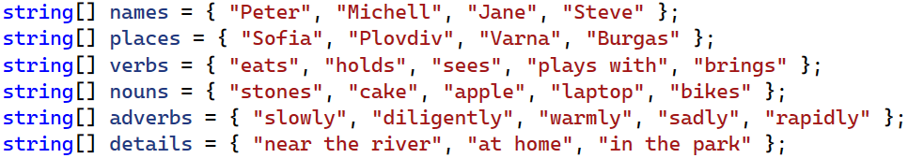
More information about arrays: https://docs.microsoft.com/en-us/dotnet/csharp/programming-guide/arrays/.

Create a Method for Getting a Random Word
Now we are going to create a method. Generally, methods are useful to improve code reusability by reducing code duplication. If we have the same functionality to perform in multiple places, then we can create one method with the required functionality and reuse it wherever it is necessary in the application. In our case, the method will help us choose random words every time.
To create a method, you need the following things:
- First, our method should have a return type string.
- Second, we need a name for the method.
- Third, we should define parameters that the method will receive.
Do it as follow:
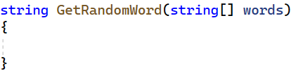
Now let's write the method logic. First, we need to create a variable from the type Random – you already know how to do that:
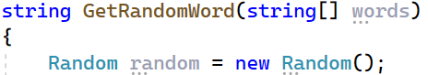
Now we should use the Next() method of the Random class to choose a random index. However, the index should not be greater than the length of the words array, so do it like this:
Next thing is to create a variable of type string for our random generated word. This word will be on the randomly-generated index from the words array:
The last thing we should do is to return our random generated word to the method:
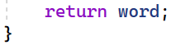
Now our method GetRandomWord() is created and ready to use. It looks like this:
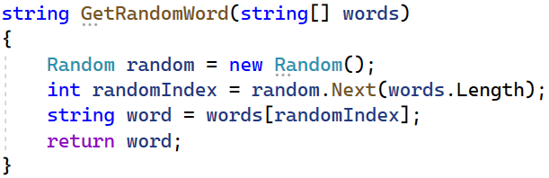
We will learn more about methods in the Methods/Functions lesson, but you can read more information about methods here: https://docs.microsoft.com/en-us/dotnet/csharp/programming-guide/classes-and-structs/methods.
It's time for the easy part – let's make the generator work.

Implement Generator Logic
First, we should create an endless while loop. You already know how to do this:
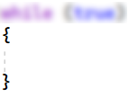
Now we should create variables for all different random words. To do this we will use our method GetRandomWord(), which will do all the work for us.
First, create a variable from the type string and name it "randomName". Make the variable keep the result from our GetRandomWord() method and pass our words array as an argument to the method. Do it as follow:
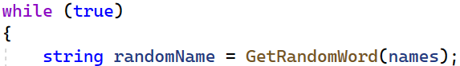
Now try to create variables for the other words yourself. They should all pass the necessary arrays and keep the results from the GetRandomWord() method. Finally, it should look like this:
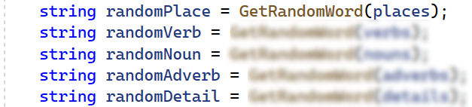
Next thing is to construct our random sentence. Remember the model that we are working on – first, we need "Who from where", then "Action" and last "Details":
To construct "Who from where" we need [name + from + place]. Do it like this:
To construct "Action" we need [adverb + verb + noun]. Do it like this:
We already have our details ready so the last thing we should do is to combine them in a sentence. Use the model and try to do it yourself:
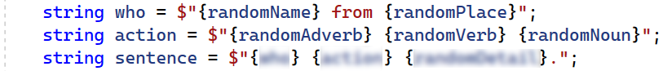
Now what is left is to write the sentence on the console. Next, write a message to the user to press [Enter] to generate a new sentence and read his input. You know how to do that:
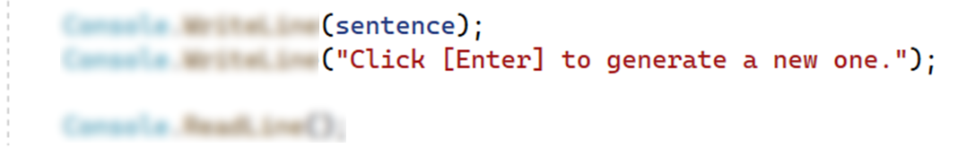
You can also write a greeting message before the while loop:
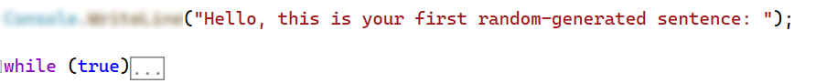
This is all it takes to finish our project, after you run it, the generator should look like this:
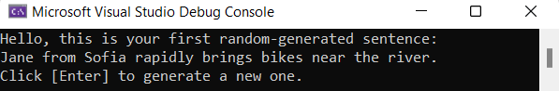
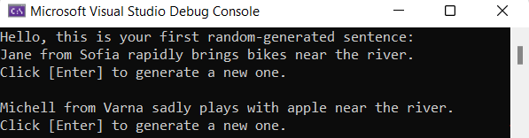
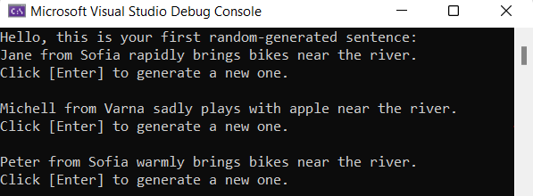
Now let's upload it to GitHub.

Upload Your Project to Github
We already know how to clone our repository by using Git Bash or TortoiseGit.

Use TortoiseGit (Option 1)
Use Git clone for cloning with TortoiseGit. Go to the desired directory, right-click on a blank space anywhere in the folder and click [Git Clone]. Now go to our newly created repository and copy the repository's URL – you should already know how to do this. The last thing that we should do is to open our TortoiseGit to paste the URL and click [OK].
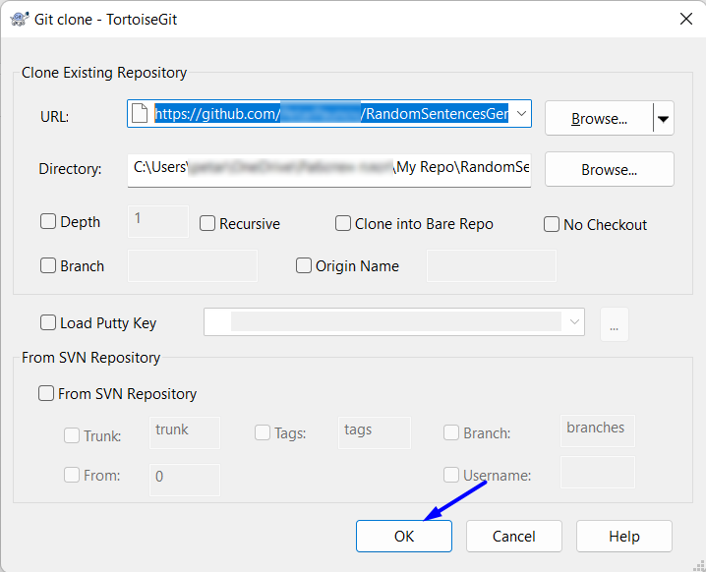
Your files from your GitHub repo will be downloaded to a sub-folder called as your project in GitHub, "RandomSentencesGeneratorByPeter" in our case.
Move your files from your old folder to the new repo one. It should look like this:
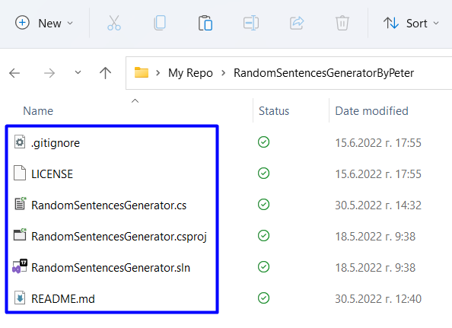
Now to upload our changes from our working project folder to GitHub.
We can use TortoiseGit's [Git Commit…]. Go to your project's folder, right-click on blank space anywhere in the folder and click [Git Commit -> "main"…].
Add an appropriate message and click [Add] so you don't miss any files, finally click [Commit].
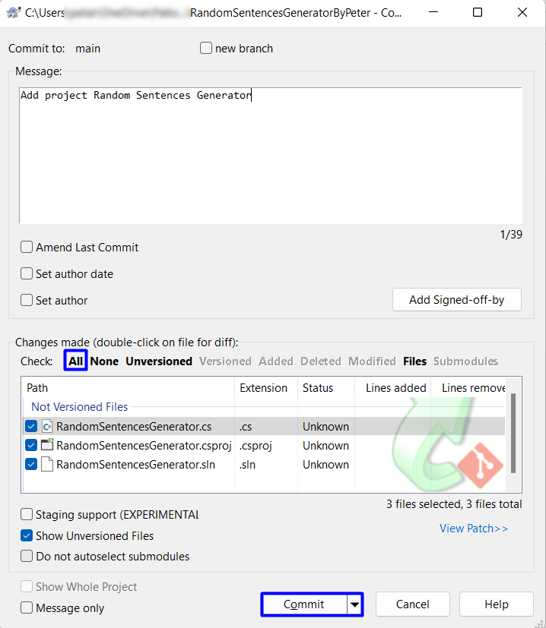
After that click [Push] and then [OK]:
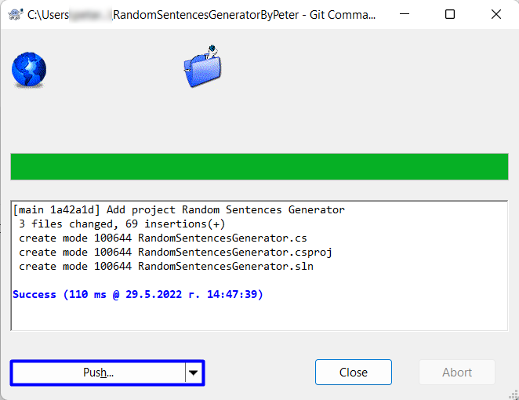
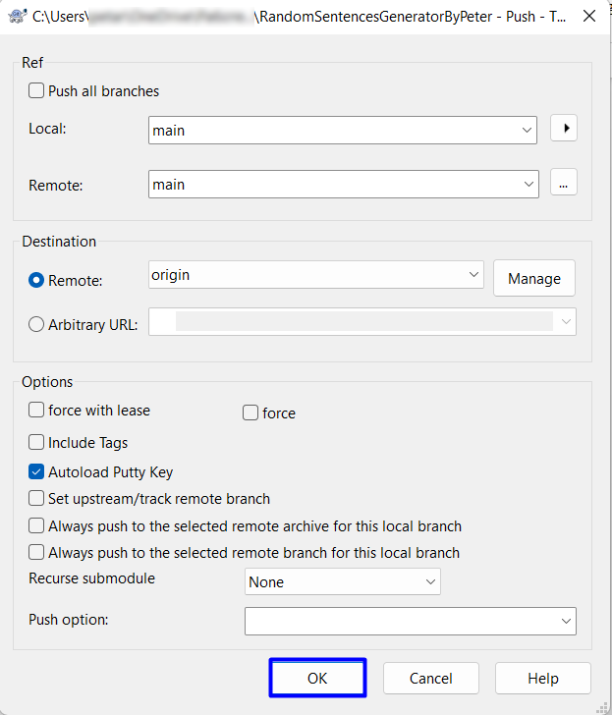
This is all you need to upload your project source code to your GitHub repository using TortoiseGit.

Use Git Bash (Option 2)
Alternatively, use Git Bash to commit and push your local changes to the repo.
Go to the desired directory, right click on blank space anywhere in the folder, select "Git Bash Here" to open the Git command line console. If the "Git Bash Here" menu is missing, you should first install Git. Type "git clone" command followed by the link of your repository:
git clone
This command is for cloning with Git Bash, paste your repository URL after the command.
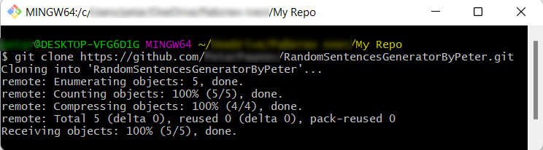
Your files from your GitHub repo will be downloaded to a sub-folder called as your project in GitHub, "RandomSentencesGeneratorByPeter" in our case.
Next thing to do is to add your project files into your cloned repository folder. It should look like this:
Now we are ready to upload our changes from "Git Bash clone". Go to the desired folder, right click on blank space anywhere in the folder, select "Git Bash Here" and run the following commands.
Type the following command:
git status
The git status command displays the state of the working directory and the staging area.
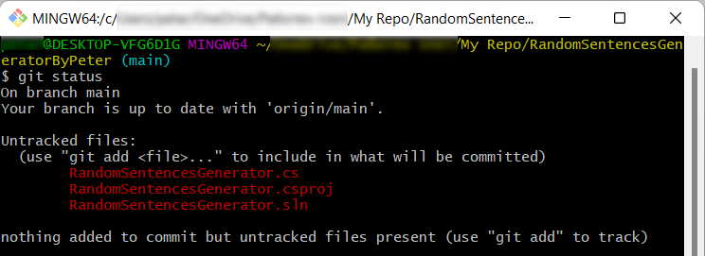
Now type:
git add .
This command adds all modified files.
Next type:
git commit -m "Your message here"
This command commits your changes. We also should add an appropriate message.
Second to the last type.
git pull
This command updates your local repository.
Now the last thing that we should do is to push our changes by using the command:
git push
This command pushes your changes to our local repository.
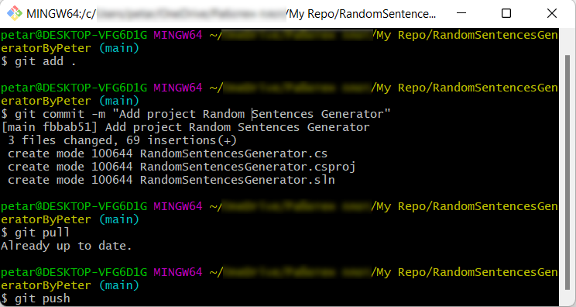
This is all you need to update your repository with Git Bash.

* Modify the Code, Write Your Own Features
Now, it's time to play with the code and modify it.
This is your own project. Be unique. Don't be a copy-paster!
- Implement your own features.
- Implement the code yourself, using your own coding style, code formatting, comments, etc.
- Make the project more interesting. Learn by playing with the code and adding your own changes.
Below are a few ideas of what you can implement or modify as an addition to your code.

Add More Words
You can think of more words to add to make the sentences more interesting and fun.

Try Different Sentence Structures
You can change your sentence and make it more complex:
- You can turn your sentence to a question: ["Who" question word/phrase] + [Verb] + [Subject] + [Main Verb] + [Object or Other Information].
- You can add more sentence parts on the right places or change the place of the current ones.
- You can think of more ways to change your sentence.

Additional Ideas
- Consider a way to create a more complex sentence generator.
  - Example of a more complex generator: http://lomacar.github.io/Random-Sentence-Generator.
- You can add anything else in your code, based on your own ideas?

Commit to GitHub
Now commit and push your code changes to your GitHub repo!
It is very important to commit frequently your code to GitHub. This way you create a rich commit history for your project and your GitHub contribution graph is growing:
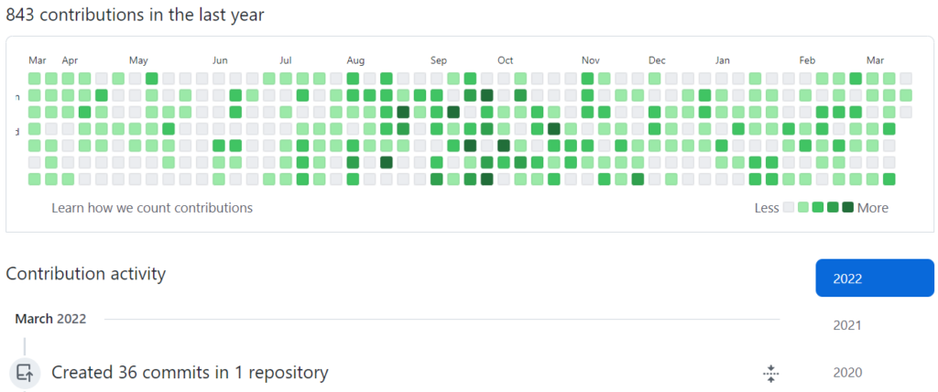

Write a README.md File
It's highly recommended to provide documentation as part of your project in GitHub to describe what the project is doing. So, let's make one for this project. Let's start by editing the README.md file from our repo at GitHub:
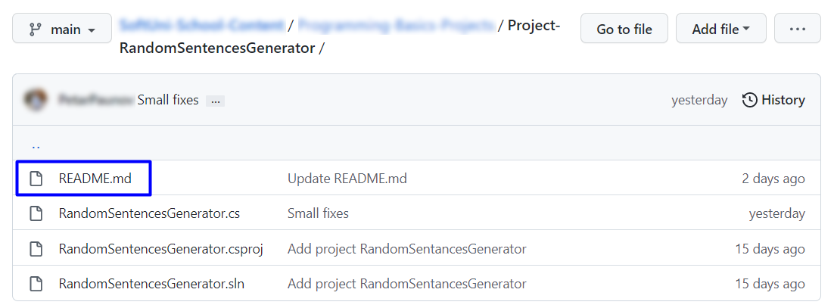

Documentation Sections
Add information about your project in your README.md file: project goals, technologies used, screenshots, live demo, etc. Typically, you should have the following sections:
- Project title (should answer the question "What's inside this project?")
- Project goals (what problem we solve, e. g. we implement a certain game)
- Solution (should describe how we solve the problem algorithms, technologies, libraries, frameworks, tools, etc.)
- Source code link (give a direct link to your source code)
- Screenshots (add screenshots from your project in different scenarios of its usage)
- Live demo (add a one-click live demo of your code)

Use Markdown
Note that the GitHub README.md file is written in the Markdown language. Markdown combines text and special formatting tags to describe formatted text documents.

Project Goals
Start your documentation by describing your project goals. What problem does your project solve?

Sample Documentation
This is an example of how you can document your project. Don't copy and paste it!
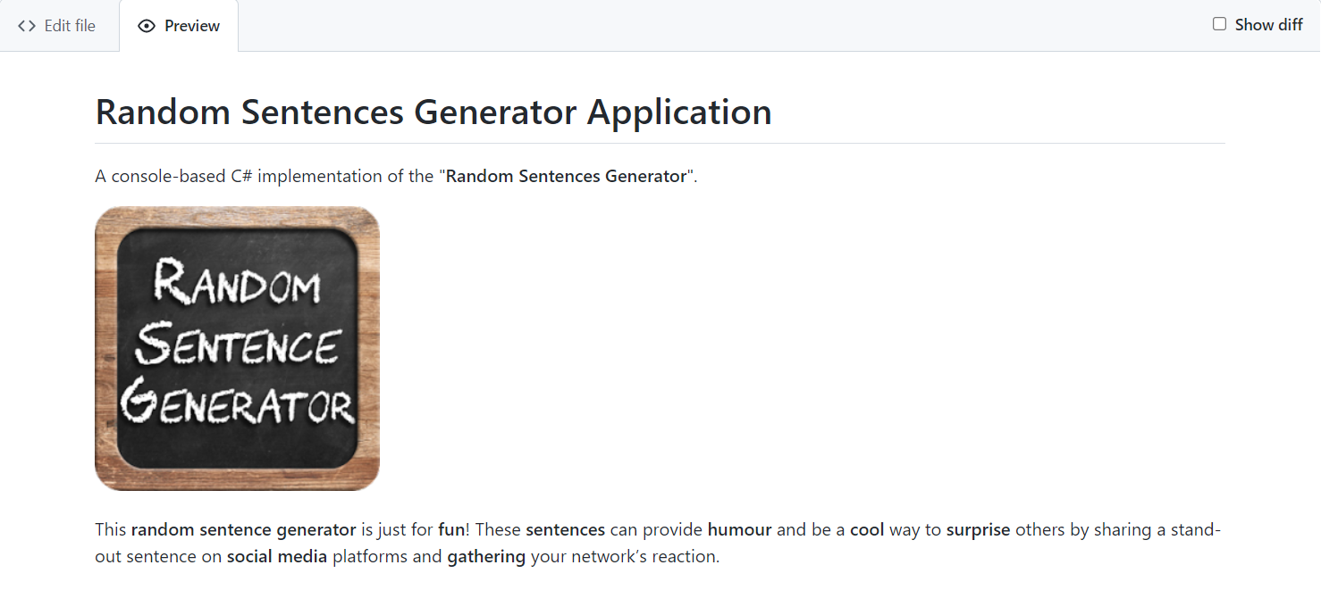
Write the project documentation yourself. Don't copy and paste it!
This is your unique GitHub profile and your own unique project. Be different from others.
Find an appropriate image and add it. You can add images as follows:

Your Solution
Describe how you solve the problem: algorithms, technologies, libraries, frameworks, tools, etc:
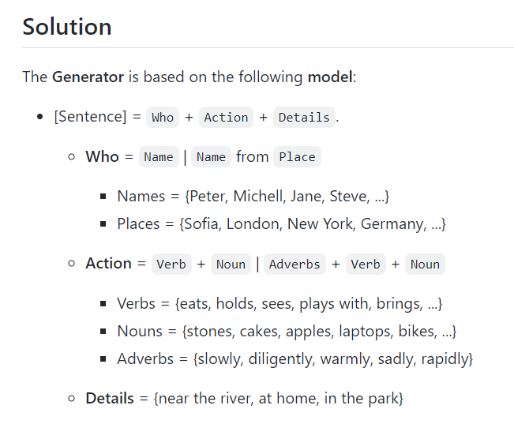
You can use the backtick (`) at the start and end of the word to make it grey:
You can also use the double-asterisk (**) at the start and end of the word to bold it:

Link to the Source Code
Add a link to your source code as follows:
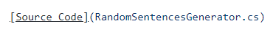

Screenshots
Add screenshots of your project:
- Take a screenshot with your favourite tool (e.g. the Snipping Tool in Windows).
- Paste the screenshot in the GitHub Markdown editor, using [Ctrl+V]:
Example screenshots for the "Random Sentences Generator" game:
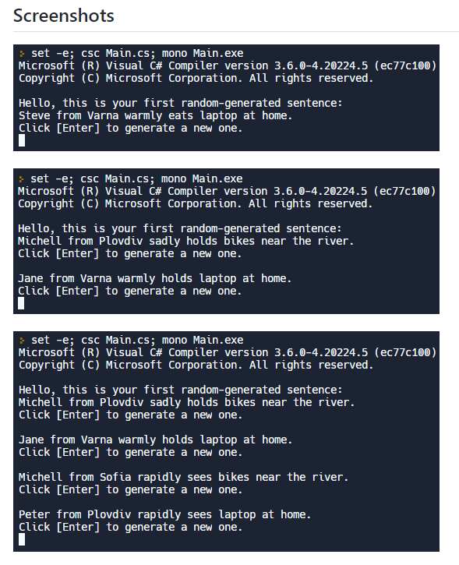

Upload Your App to Replit
You already should have a Replit profile. Now let's add our project there so we can share it with our friends and add it to our GitHub profile. You already should know how to do that.
Open the menu in the upper left corner. Click [Create], then select the language in which your project is written, select a name, and create the project. If your project is in C#, choose "Mono C#":
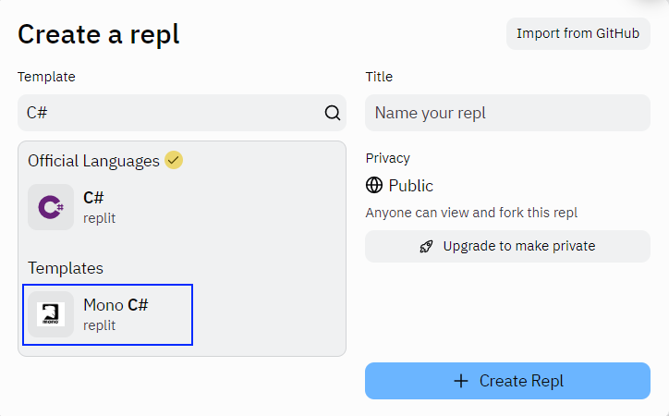
Add your code in "Main.cs" file.
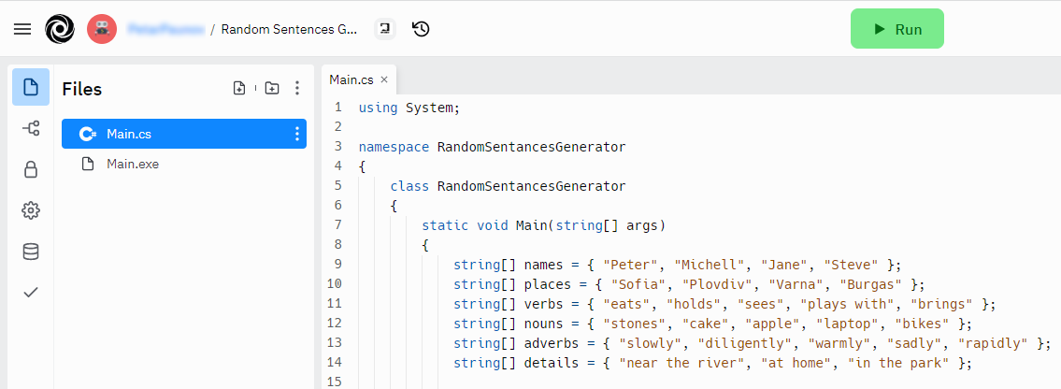
Click [Run] and enjoy your console application.
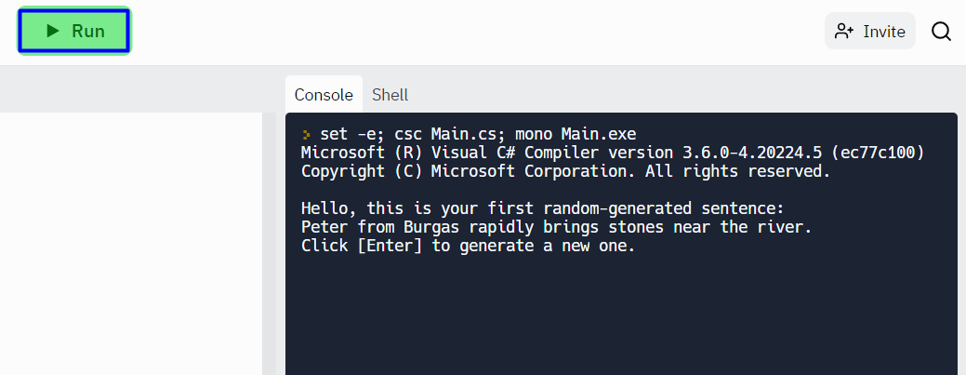
You can now share your app with your friends.

Add Replit Link to Your README.md
Now add a "one-click live demo" of your project from your GitHub project documentation. You can do it as follows:
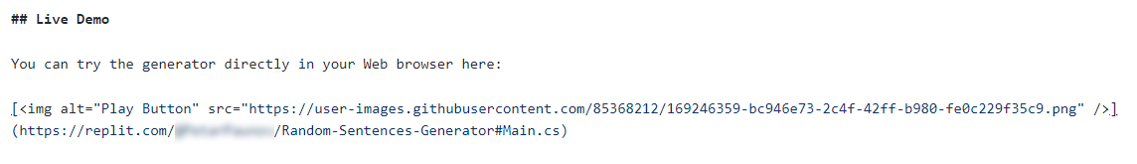
You can take a screenshot from Replit.com and paste it into the GitHub documentation editor directly with [Ctrl+V].
This is what it should look like after the changes in your README.md documentation:
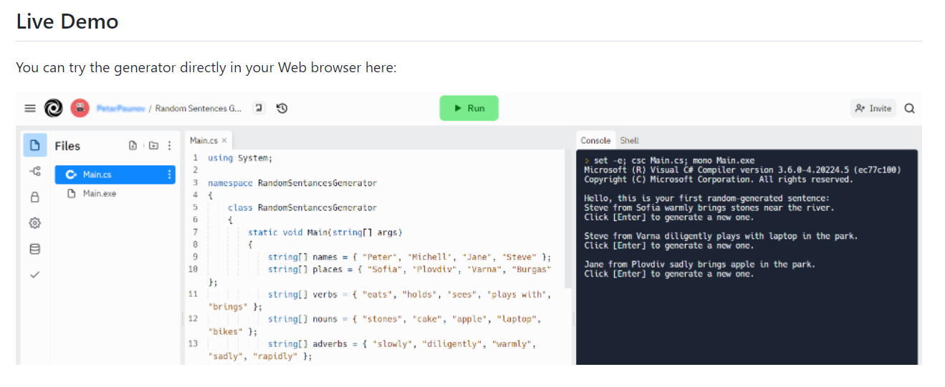
Now we have completed our Random Sentences Generator and we have a new project in our GitHub portfolio.

