Lab: Interfaces and Abstraction
You can check your solutions here: Interfaces-and-Abstraction-Lab

Shapes
NOTE: You need a public StartUp class with the namespace Shapes.
Build a hierarchy of interfaces and classes:
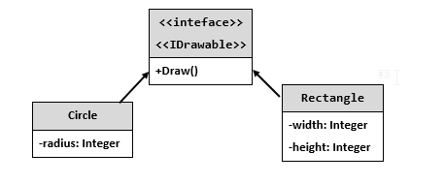
You should be able to use the class like this:
StartUp.cs
var radius = int.Parse(Console.ReadLine());
IDrawable circle = new Circle(radius);

var width = int.Parse(Console.ReadLine());
var height = int.Parse(Console.ReadLine());
IDrawable rect = new Rectangle(width, height);

circle.Draw();
rect.Draw();

Examples
Input | Output
3  4  5 | *******  ** **  ** **  * *  ** **  ** **  *******  ****  * *  * *  * *  ****

Solution
The algorithm for drawing a circle is:
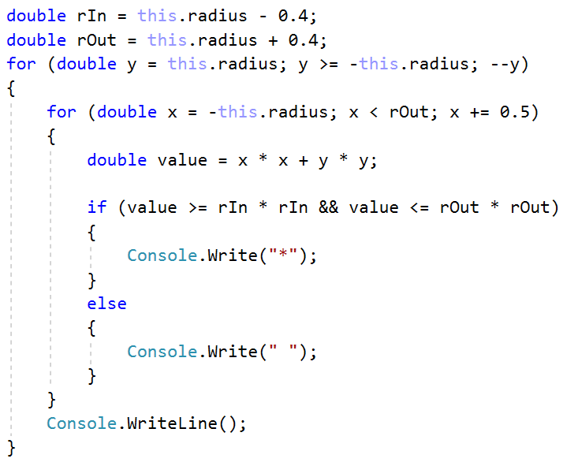
The algorithm for drawing a rectangle is:
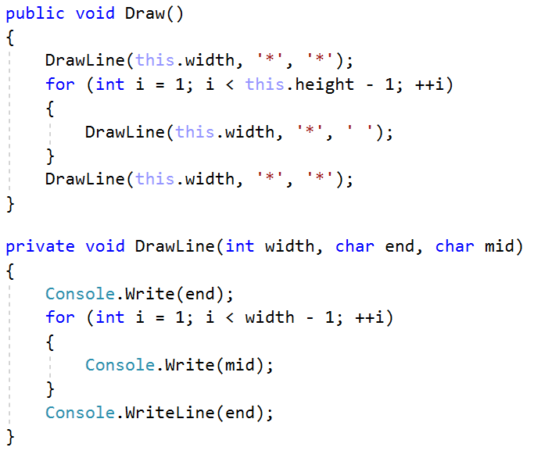

Cars
NOTE: You need a public StartUp class with the namespace Cars.
Build a hierarchy of interfaces and classes:
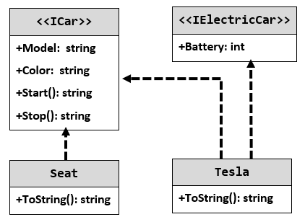
Your hierarchy must be used with this code:
StartUp.cs
ICar seat = new Seat("Leon", "Grey");
ICar tesla = new Tesla("Model 3", "Red", 2);

Console.WriteLine(seat.ToString());
Console.WriteLine(tesla.ToString());

Examples
Output
Grey Seat Leon
Engine start
Breaaak!
Red Tesla Model 3 with 2 Batteries
Engine start
Breaaak!

