Create Custom Data Structures

Overview
In this workshop, we will create our own custom data structures – a custom list, a custom stack and a custom queue. The custom list will have similar functionality to C# lists that you've used before. Our custom list will work only with integers for now, but this will be fixed later in the course. It will have the following functionality:
- void Add(int element) – Adds the given element to the end of the list
- int RemoveAt(int index) – Removes the element at the given index
- bool Contains(int element) - Checks if the list contains the given element returns (True or False)
- void Swap(int firstIndex, int secondIndex) - Swaps the elements at the given indexes
Feel free to implement your functionality or to write the methods by yourself.
The custom stack will also have similar functionality to the C# stack and again, we will make it work only with integers. Later on, we will learn how to implement it in a way that will allow us to work with any type. It will have the following functionality:
- void Push(int element) – Adds the given element to the stack
- int Pop() – Removes the last added element
- int Peek() – Returns the last element in the stack without removing it
- void ForEach(Action<int> action) – Goes through each of the elements in the stack
Feel free to implement your functionality or to write the methods by yourself.
The custom queue will also have similar functionality to the C# queue and again, we will make it work only with integers. Later on, we will learn how to implement it in a way that will allow us to work with any type. It will have the following functionality:
- void Enqueue(int element) – Adds the given element to the queue
- int Dequeue() – Removes the first element
- int Peek() – Returns the first element in the queue without removing it
- void Clear() – Delete all elements in the queue
- void ForEach(Action<int> action) – Goes through each of the elements in the queue
Feel free to implement your functionality or to write the methods by yourself.

Implement the CustomList Class
Details about the Structure
First of all, we must make it clear how our structure should work under the provided public functionality.
- It should hold a sequence of items in an array.
- The structure should have a capacity that grows twice when it is filled, always starting at 2.
The CustomList class should have the properties listed below:
- int[] items – An array that will hold all of our elements.
- int Count – This property will return the count of items in the collection.
- indexer – The indexer will provide us with functionality to access the elements using integer indexes.
The structure will have internal methods to make the managing of the internal collection easier.
- Resize – this method will be used to increase the internal collection's length twice.
- Shrink – this method will help us to decrease the internal collection's length twice.
- Shift – this method will help us to rearrange the internal collection's elements after removing one.

Implementation
Create a new public class CustomList and add a private constant field named InitialCapacity and set the value to 2. This field is used to declare the initial capacity of the internal array. It's always a good practice to use constants instead of magic numbers in your classes. This approach makes the code better for managing and reading.
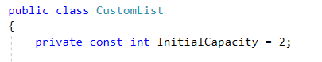
Now let's create the initial collection, which is a private array of type int. To initialize the array, we will use the constructor of the class.
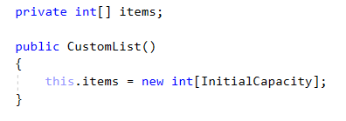
Keep in mind that if the internal array has a length of 4, this doesn't mean that our collection holds 4 elements. So we need a property, which will keep the information of the actual count of the elements in the structure.
This property should be updated every single time when we make changes related to the count of the elements like adding or removing.

It would be awesome if we can access the items in the collection without exposing the internal array. So, let's implement this functionality. It can be done in the following way:
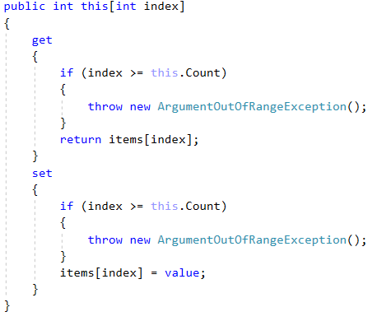

When somebody tries to access our collection using an index, the get accessor is invoked and the indexer will return the value on the given index. When someone is trying to set a value to a given index the set accessor is invoked.
In both accessors, we must check if the index is less than the Count and greater or equal to zero because our structure actual items count might be different from the internal array length.
The whole class should look like this:
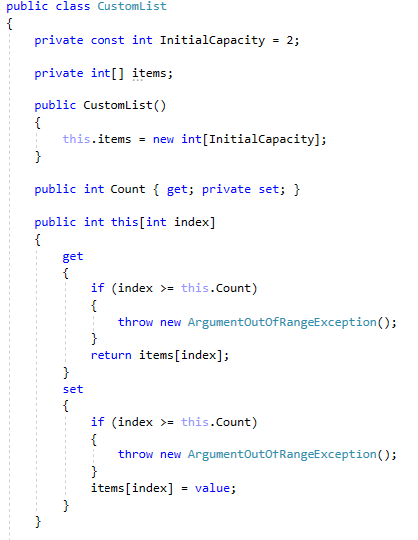
Implement Void Add(int Element) Method
It is time to create the method, which adds a new element to the end of our collection, just like in the C# lists. It looks like an easy task, but keep in mind that if our internal array is filled, we have to increase it by twice the length it currently has and add the new element.
To make our job easier let's create a Resize() method first. The method should be used only within the class so it must be private.
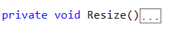
Here is how the method should work step by step.
- Create a new array with a length twice the current length of the internal array:

- Iterate through the items in the internal array and fill the newly created array:
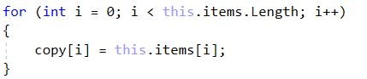

- Set the newly created array to the field "items":
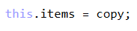
The whole method should look like this:
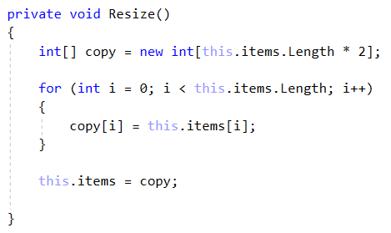
Now, we are ready to start implementing the logic behind the Add() method. This is how the method should work:
- Check if the Count of the actual items in our CustomList is equal to the Length of our collection.
If it is, this means that the internal array is filled and we need to use the Resize() method.
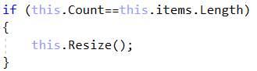
- After we have checked that we have space in the internal array, we can just add the new item at the end and update the "Count" property:
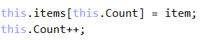
The whole method should look like this:
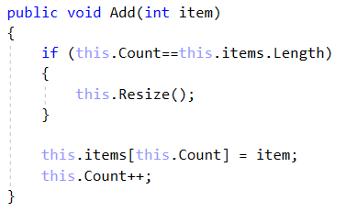
Before proceeding with the next tasks, it is a good practice, since you've done so much work, to test if everything is fine. Use the debugger to test for bugs.
Implement int RemoveAt(int Index) Method
The RemoveAt() method has the functionality to remove an item on the given index and return the item. Let's think about how to solve this problem by dividing it into smaller tasks.
- First, we must check if the index is valid and if not, we should throw ArgumentOutOfRangeException.
- Get the item on the given index and assign it to a variable, which will be returned at the end.
- Set the value on the given index to the default value of int.
- Now we have an empty element and we need to shift the elements.
- Reduce the count and check if the count is 4 times smaller than the internal array length. If it is we have to think about a way to shrink the array.
- In the end, return the variable to which we assigned the value of the requested index.
So you already know that we need to implement the other 2 internal methods Shift() and Shrink().
Void Shift(int Index)
The shift method uses a loop, which moves all the elements to the left starting from a given index.
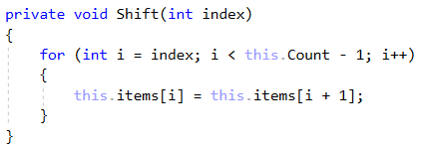
Void Shrink()
The Shrink() method is the same as the Resize() method with the small difference that it will reduce the length twice, instead of increasing it.
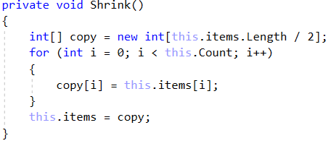
Now we are ready to proceed with the implementation of the RemoveAt() method.
- First, we need to validate that our index is valid. Keep in mind that the validation of the index should be verified using the Count property.
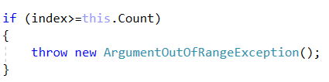

- Get the value on the given index, assign it to a variable, and set the value in the array on the specified index to default. Also, don't forget to shift the items.
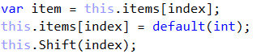

- Now we must reduce the Count and check if shrinking the array is required.
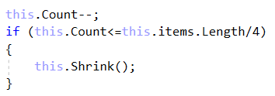

- After all, just return the element that we saved at the start.
The whole method should look like this:
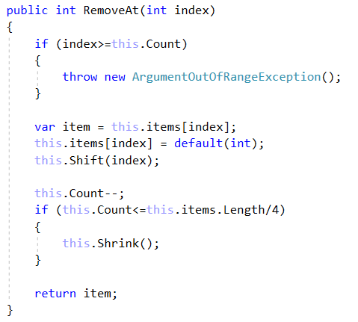
It is time to test out your CustomList again. If everything works fine, proceed with the next task.
Implement void Insert(int Index, Int Item) Method
You are already familiar with this method, so let us go straight to the implementation. First of all, we will split the logic into smaller tasks:
- We have an index parameter, so we must validate the index.
- We must check if the array should be resized.
- We have to rearrange the items to free the space for the required index.
- Finally, insert the given item on the index and increase the count.
You probably have already noticed, that since we have a method to rearrange the items to the left, used to fill up the space when we remove an item, we must have a method to rearrange items to the right, so let's create it.
Starting from the end of the actual elements, this method will copy every single item on the next index. The loop will end on the requested index.
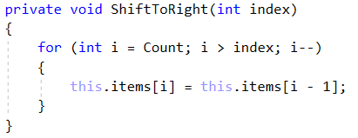
You'll be given the implemented method with blurred parts, so you have to do it on your own. Follow the description above.
Hint: Inserting an item on the index equal to the Count (inserting item at the end of the collection) should be a valid operation and it should do the same as the Add() method.
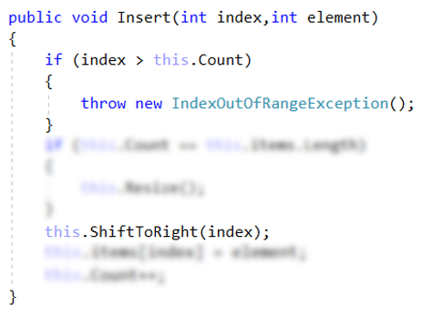
Implement bool Contains(int Element) Method
This method should check if the given element is in the collection. Return true, if it is and false, if it's not. It's a simple task, so you should do it all on your own.
Hint: When you are iterating through the items, use the "Count" property as an end condition, instead of the internal array length.
Implement void Swap(int FirstIndex, Int SecondIndex) Method
Just like the method above, we consider this an easy task for you. Of course, you have a hint. When we work with indexes, we must always check if they are less than the count, because you may end up in the situation, where the collection has 3 actual elements, while the internal array has a length of 4.
If you have good ideas to implement new functionalities, like Find(), Reverse() or overriding ToString methods, feel free to do it.

Implement the CustomStack Class
Details about the Structure
The implementation of a custom stack is much easier, mostly because you can only execute actions over the last index of the collection, plus you can iterate through the collection. You should be able to create it entirely on your own. The first thing you can do is have a clear vision of how you want your structure to work under the provided public functionality. For example:
- It should hold a sequence of items in an array.
- The structure should have a capacity that grows twice when it is filled, always starting at 4.
The CustomStack class should have the properties listed below:
- int[] items – An array, which will hold all of our elements.
- int Count – This property will return the count of items in the collection.
- const int InitialCapacity – this constant's value will be the initial capacity of the internal array.

Implementation
Create a new public class CustomStack and add a private constant field named InitialCapacity and set the value to 4. This field is used to declare the initial capacity of the internal array. We already know that it's not a good practice to have magic numbers in your code. Afterward, we are going to declare our internal array and a field for the count of elements in our collection.
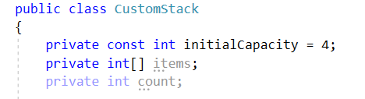
Of course, you have to initialize the collection. Also, set the count variable to 0. As we already know, this can be done inside the constructor of the class:
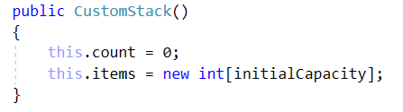
Next, you have to add a public property Count that holds the value of the count field. This way, you will be able to get the count of items in the collection from other classes.
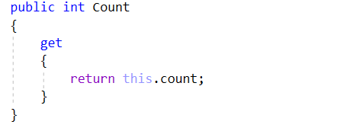
Now you can proceed to the implementation of the methods, which your CustomStack is going to have. All of the functionality described in the description is very easy to implement, so we strongly recommend for you try to do it on your own. If you have any difficulties, you can help yourself with the code snippets below.
Implement void Push(int Element) Method
This method adds an element to the end of the collection, just like the C# Stack Push() method does. This is a very easy task. Here is the code you can use, if you meet any difficulties:

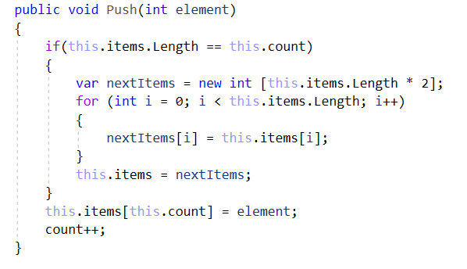
Implement int Pop() Method
The Pop() method returns the last element from the collection and removes it. The implementation is easier than the implementation of the RemoveAt(int index) and Remove() methods of the CustomList. Try to implement it on your own. Afterward, you can look at this implementation:
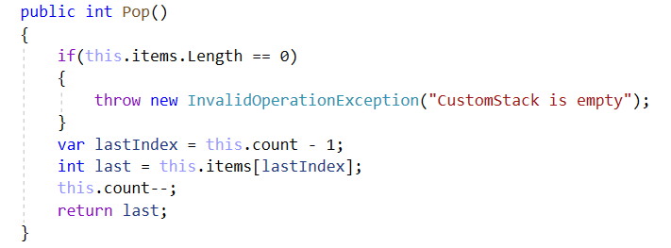
Implement int Peek() Method
The Peek() method has the same functionality as the C# Stack – it returns the last element from the collection, but it doesn't remove it. The only thing we need to consider is that you can't get an element from an empty collection, so you must make sure you have the proper validation. For sure, you will be able to implement it on your own.
Implement void ForEach(Action<object> Action) Method
This method goes through every element from the collection and executes the given action. The implementation is very easy, but it requires some additional knowledge, so here is what you can do:
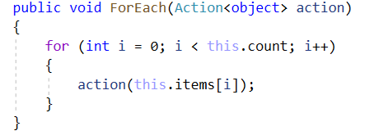
You can add any kind of functionalities to your CustomStack and afterward you can test how it works in your Main() method in your StartUp class.

Implement the CustomQueue Class
Details about the Structure
When implementing a custom queue keep in mind that you can add elements at the end and remove elements from the beginning of the queue, plus you can iterate through the collection. You should be able to create it entirely on your own. The first thing you can do is have a clear vision of how you want your structure to work under the provided public functionality. For example:
- It should hold a sequence of items in an array.
- The structure should have a capacity that grows twice when it is filled, always starting at 4.
The CustomQueue class should have the properties listed below:
- void Enqueue(int element) – Adds the given element to the queue
- int Dequeue() – Removes the first element
- int Peek() – Returns the first element in the queue without removing it
- void Clear() – Delete all elements in the queue
- void ForEach(Action<int> action) – Goes through each of the elements in the queue

Implementation
Create a new public class CustomQueue and add a private constant field named InitialCapacity and set the value to 4. This field is used to declare the initial capacity of the internal array. We already know that it's not a good practice to have magic numbers in your code, so we should add also FirstElementIndex and set its value to 0, which represents the index of the first element. Afterward, we are going to declare our internal array and a field for the count of elements in our collection.
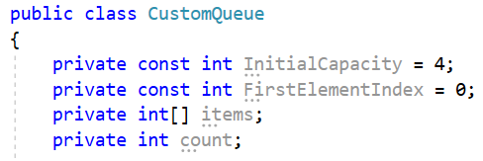
Of course, you must initialize the collection. Also, set the count variable to 0. As we already know, this can be done inside the constructor of the class:
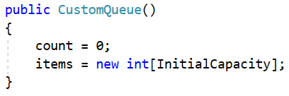
Next, you must add a public property Count that holds the value of the count field. This way, you will be able to get the count of items in the collection from other classes.
Now you can proceed to the implementation of the methods, which your CustomQueue is going to have. All of the functionality described in the description is very easy to implement, so we strongly recommend for you try to do it on your own. If you have any difficulties, you can help yourself with the code snippets below.
Implement void Enqueue(int Element) Method
This method adds an element at the beginning of the collection, just like the C# Queue Enqueue() method does. This is a very easy task. Here is the code you can use if you meet any difficulties:
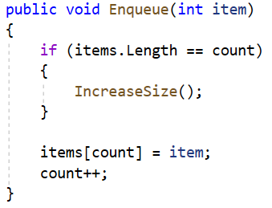
You also need to implement a private method IncreaseSize, which will double the size of the inner array: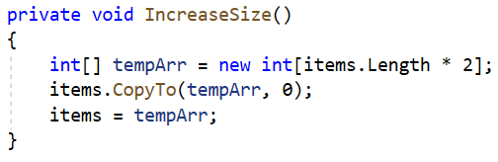
Implement int Dequeue() Method
The Dequeue() method returns the first element from the collection and removes it. The implementation is easier than the implementation of the RemoveAt(int index) and Remove() methods of the CustomList. Try to implement it on your own. Afterward, you can look at this implementation:
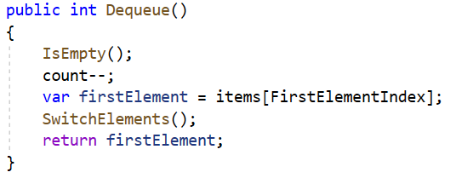
Here we have two additional private methods:
The IsEmpty checks whether the queue is empty or not:
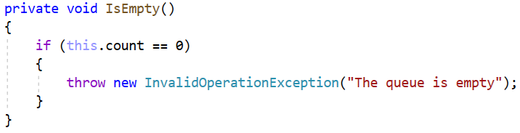
The SwitchElements moves every element one position forward into the queue:
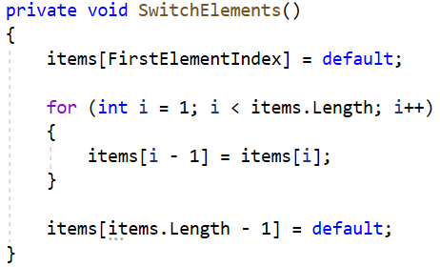
As you can see this method could experience performance issues when working with a queue holding a lot of elements. You can think of a way to improve the CustomQueue performance when working with huge data.
Implement int Peek() Method
The Peek() method has the same functionality as the C# Qeueue – it returns the first element from the collection, but it doesn't remove it. The only thing we need to consider is that you can't get an element from an empty collection, so you must make sure you have the proper validation. For sure, you will be able to implement it on your own.
Implement int Clear() Method
The Clear() method has the same functionality as the C# Qeueue – it removes all the elements from the collection. The only thing we need to consider is that you can't remove an element from an empty collection, so you must make sure you have the proper validation. For sure, you will be able to implement it on your own.
Implement void ForEach(Action<object> Action) Method
This method goes through every element from the collection and executes the given action. The implementation is very easy, but it requires some additional knowledge, so here is what you can do:

You can add any kind of functionalities to your CustomQueue and afterward you can test how it works in your Main() method in your StartUp class.

