CSS Layout - Flexbox – Lab
CSS Layout - Flexbox – Lab 1
Topics Covered 1
Resources 1
Tasks 2
1. Property – display: flex; 2
2. Property – flex-direction 3
3. Property – flex-wrap 4
4. Property – justify-content 5
5. Property – align-items 6
6. Property: Align Content 7
7. Property: Gap 8
8. Property: Flex Grow 9
9. Property: Flex Shrink 10
10. Property: Flex Basis 11
11. Property: Align Self 12
12. Property: Order 13

Topics Covered
Flexbox is a one-dimensional layout method for arranging items in rows or columns. Items flex (expand) to fill additional space or shrink to fit into smaller spaces. This article explains all the fundamentals.

Resources
- Flexbox MDN
  - https://developer.mozilla.org/en-US/docs/Learn/CSS/CSS_layout/Flexbox
- A Complete Guide to Flexbox
  - https://css-tricks.com/snippets/css/a-guide-to-flexbox/
- An Interactive Guide to Flexbox
  - https://www.joshwcomeau.com/css/interactive-guide-to-flexbox/
- Flexbox cheat sheet
  - https://codepen.io/kdankov/pen/QWoVyZJ

Tasks

Property – display: flex;
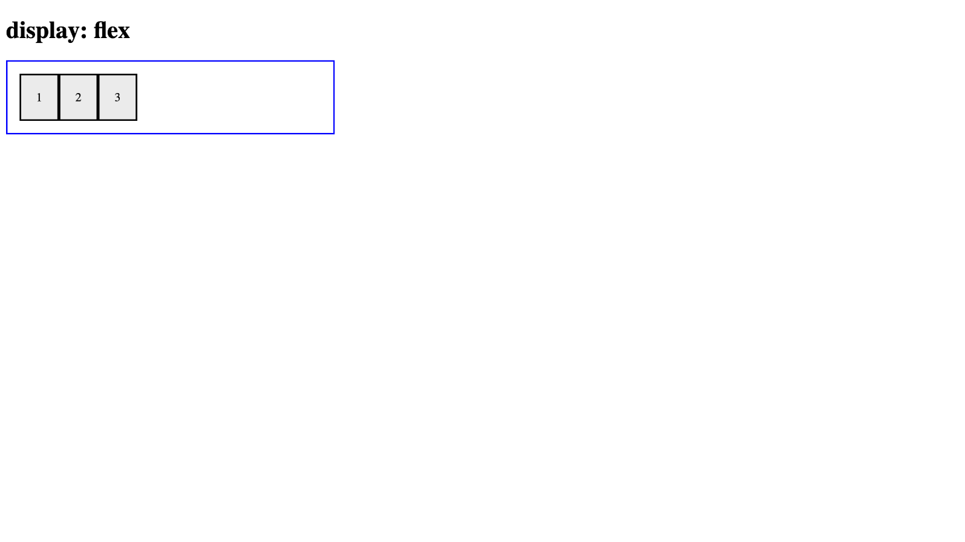
For full screenshot check the screenshot.png file in the folder for the task

Objective:
Create a webpage that looks like the screenshot above.

Requirements:
- File Setup:
  - Create an HTML document named display-flex.html
  - Create a CSS file named display-flex.css
- Element creation
  - Add title of the page in an <h1> element
  - Create a <div> element with a class – "flex-container"
  - Create 3 <div> elements inside the .flex-container element with a class of "flex-item"
  - Add text to the .flex-item elements as shown on the screenshot
- Styling
  - Add the following styles the .flex-container element:
    - Width – 400px
    - Padding – 1em
    - Border – 2px solid blue
    - Display – flex
  - Add the following styles to the .flex-item elements inside the .flex-container element:
    - Background - #eee
    - Padding – 20px
    - Border – 2px solid #000

Property – flex-direction
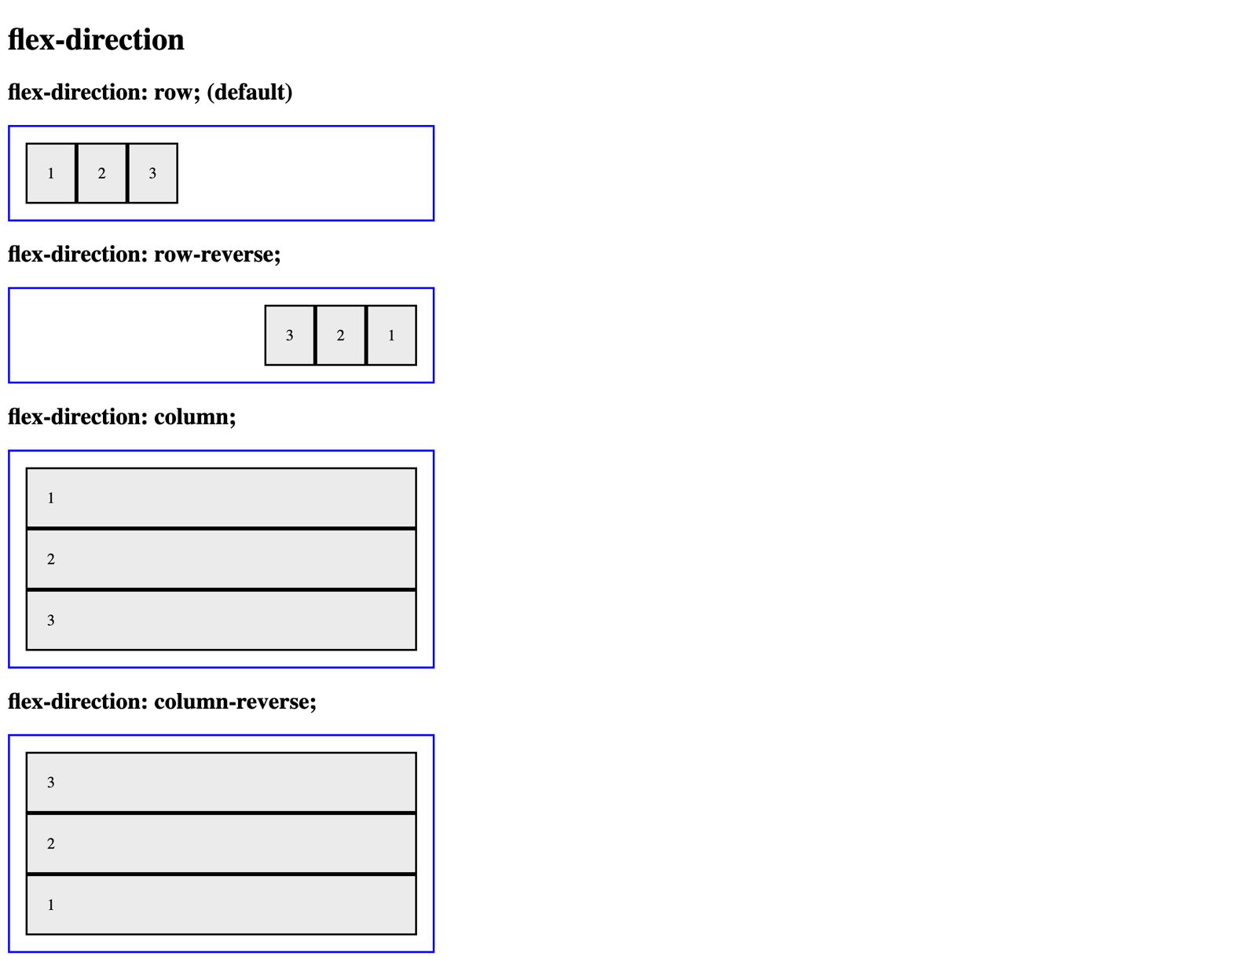
For full screenshot check the screenshot.png file in the folder for the task

Objective:
Create a webpage that looks like the screenshot above.

Requirements:
- File Setup:
  - Create an HTML document named flex-direction.html
  - Create a CSS file named flex-direction.css
- Element creation
  - Add title of the page in an <h1> element
  - Create 4 sets of <h2> element with a <div> element with a class – "flex-container" as shown in the screenshot
    - Create <div> elements inside the .flex-container element with a class of "flex-item"
    - Add text to the .flex-item elements as shown on the screenshot
- Styling
  - Copy the styles from Task 1
  - Create a new class "flex-direction-row" with the following styles
    - Flex-direction – row
  - Create a new class "flex-direction-row-reverse" with the following styles
    - Flex-direction – row-reverse
  - Create a new class "flex-direction-column" with the following styles
    - Flex-direction – column
  - Create a new class "flex-direction-column-reverse" with the following styles
    - Flex-direction – column-reverse
  - Apply the classes to the appropriate .flex-container elements to achieve the results shown in the screenshot

Property – flex-wrap
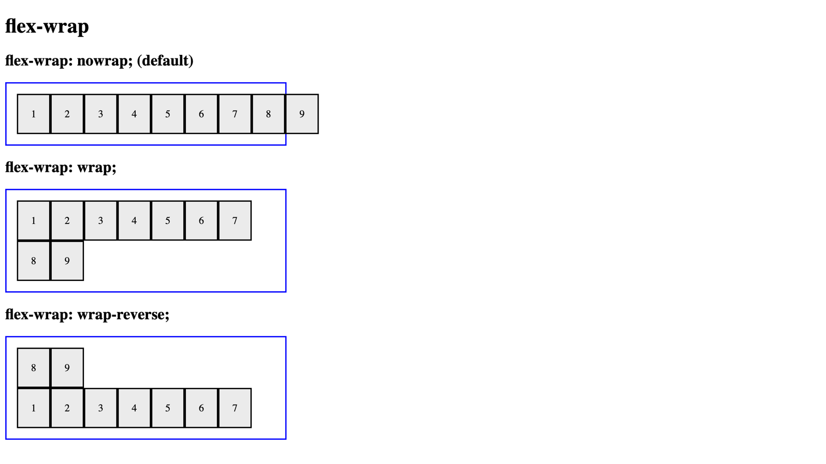
For full screenshot check the screenshot.png file in the folder for the task

Objective:
Create a webpage that looks like the screenshot above.

Requirements:
- File Setup:
  - Create an HTML document named flex-wrap.html
  - Create a CSS file named flex-wrap.css
- Element creation
  - Add title of the page in an <h1> element
  - Create 3 sets of <h2> element with a <div> element with a class – "flex-container" as shown in the screenshot
    - Create <div> elements inside the .flex-container element with a class of "flex-item"
    - Add text to the .flex-item elements as shown on the screenshot
- Styling
  - Copy the styles from Task 1
  - Create a new class "flex-wrap-nowrap" with the following styles
    - Flex-wrap – nowrap
  - Create a new class "flex-wrap-wrap" with the following styles
    - Flex-wrap – wrap
  - Create a new class "flex-wrap-wrap-reverse" with the following styles
    - Flex-wrap – wrap-reverse
  - Apply the classes to the appropriate .flex-container elements to achieve the results shown in the screenshot

Property – justify-content
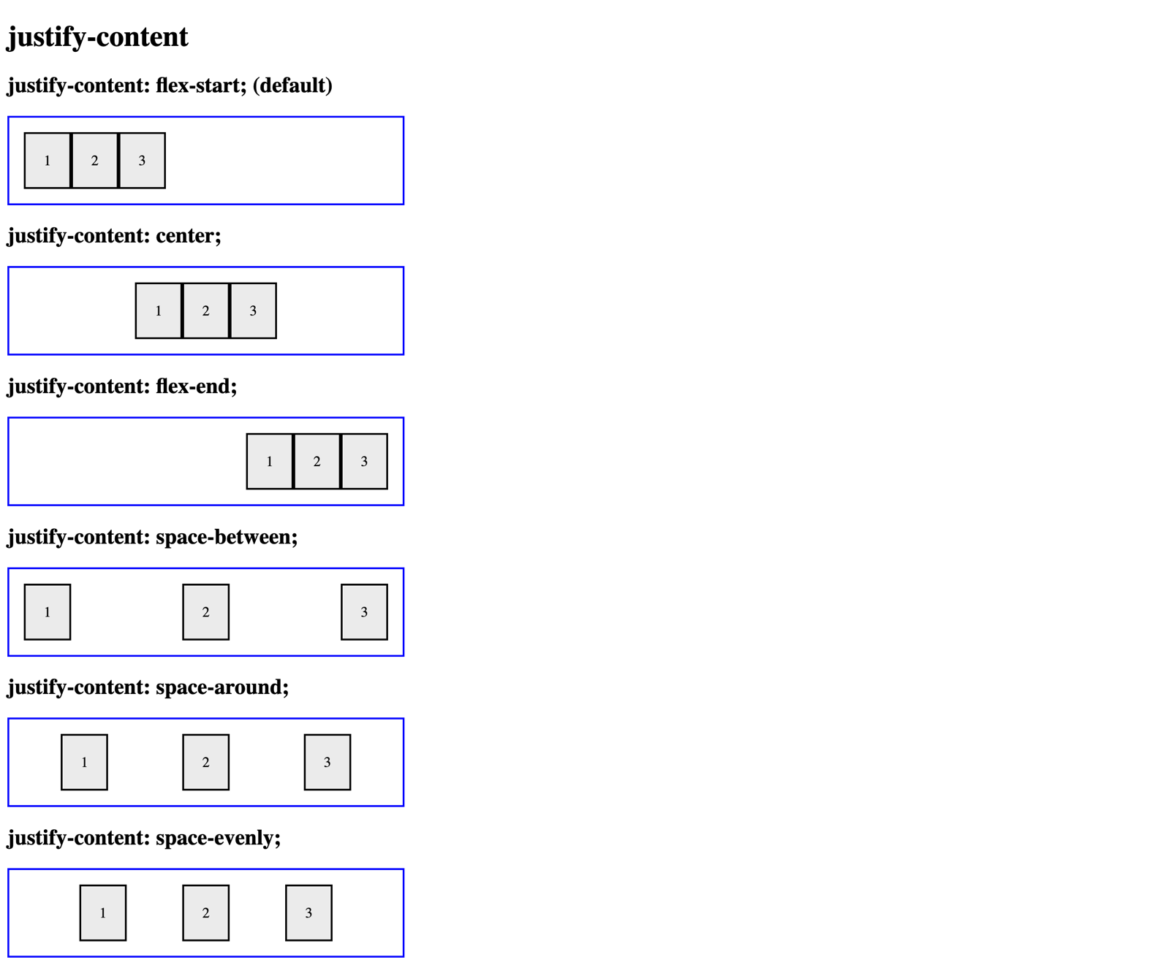
For full screenshot check the screenshot.png file in the folder for the task

Objective:
Create a webpage that looks like the screenshot above.

Requirements:
- File Setup:
  - Create an HTML document named justify-content.html
  - Create a CSS file named justify-content.css
- Element creation
  - Add title of the page in an <h1> element
  - Create 6 sets of <h2> element with a <div> element with a class – "flex-container" as shown in the screenshot
    - Create <div> elements inside the .flex-container element with a class of "flex-item"
    - Add text to the .flex-item elements as shown on the screenshot
- Styling
  - Copy the styles from Task 1
  - Create a new class "justify-content-flex-start" with the following styles
    - justify-content – flex-start
  - Create a new class "justify-content-center" with the following styles
    - justify-content – center
  - Create a new class "justify-content-flex-end" with the following styles
    - justify-content – flex-end
  - Create a new class "justify-content-space-between" with the following styles
    - justify-content – space-between
  - Create a new class "justify-content-space-around" with the following styles
    - justify-content – space-around
  - Create a new class "justify-content-space-evenly" with the following styles
    - justify-content – space-evenly
  - Apply the classes to the appropriate .flex-container elements to achieve the results shown in the screenshot

Property – align-items
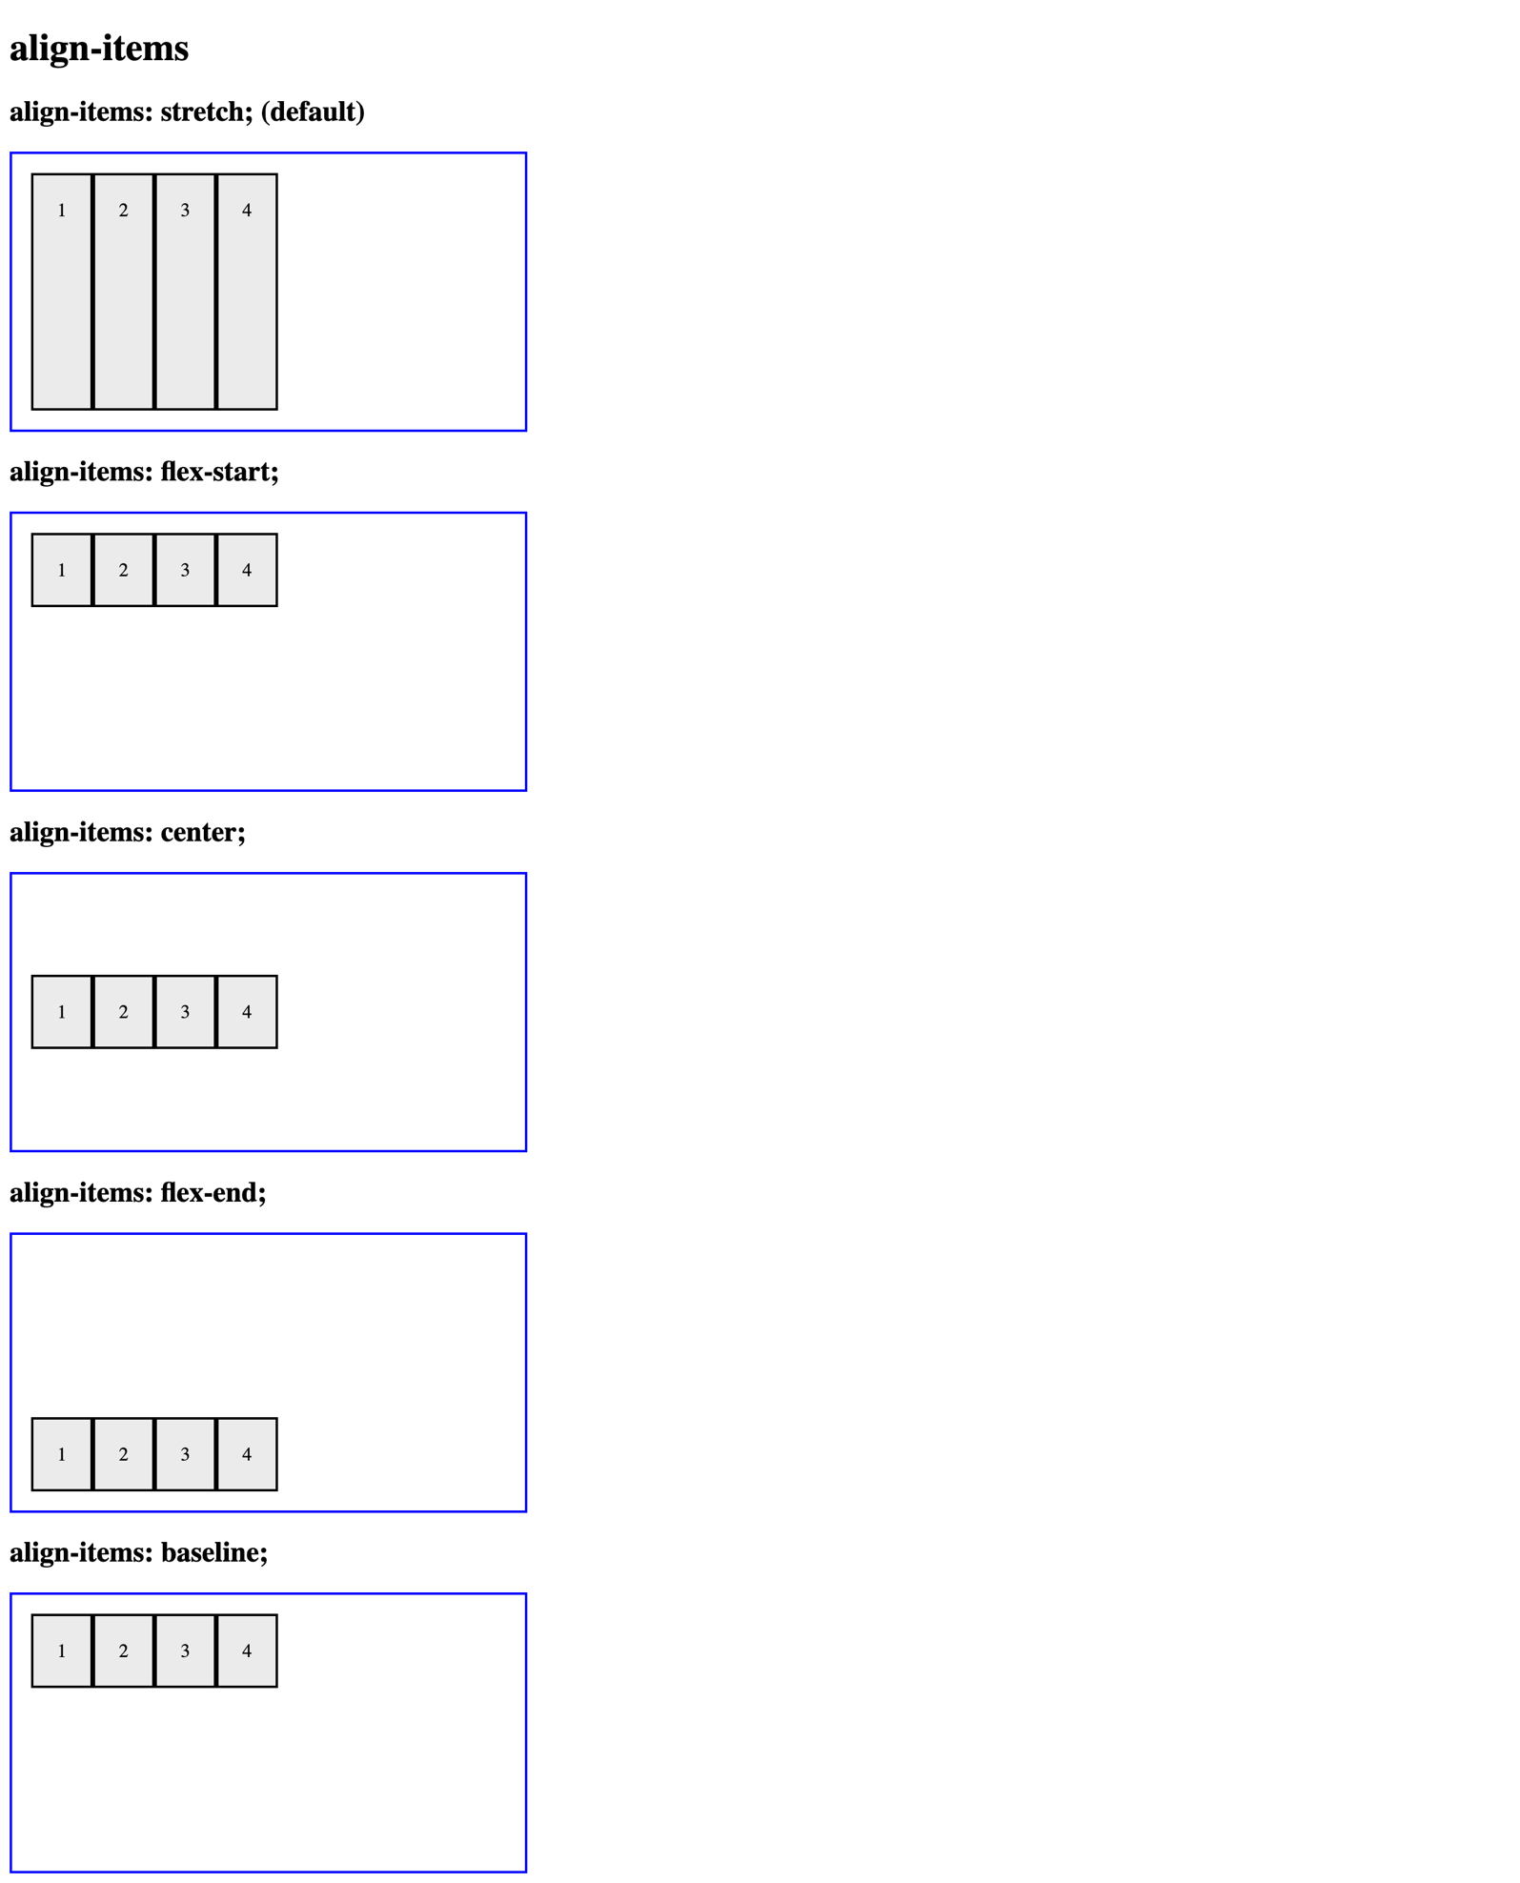
For full screenshot check the screenshot.png file in the folder for the task

Objective:
Create a webpage that looks like the screenshot above.

Requirements:
- File Setup:
  - Create an HTML document named align-items.html
  - Create a CSS file named align-items.css
- Element creation
  - Add title of the page in an <h1> element
  - Create 5 sets of <h2> element with a <div> element with a class – "flex-container" as shown in the screenshot
    - Create <div> elements inside the .flex-container element with a class of "flex-item"
    - Add text to the .flex-item elements as shown on the screenshot
- Styling
  - Copy the styles from Task 1
  - Add the following styles to the .flex-container class:
    - height - 200px
  - Create a new class "align-items-stretch" with the following styles
    - align-items – stretch
  - Create a new class "align-items-flex-start" with the following styles
    - align-items – flex-start
  - Create a new class "align-items-center" with the following styles
    - align-items – center
  - Create a new class "align-items-flex-end" with the following styles
    - align-items – flex-end
  - Create a new class "align-items-baseline" with the following styles
    - align-items – baseline

  - Apply the classes to the appropriate .flex-container elements to achieve the results shown in the screenshot

Property: Align Content
Use the skeleton is in resources to achieve the following view: 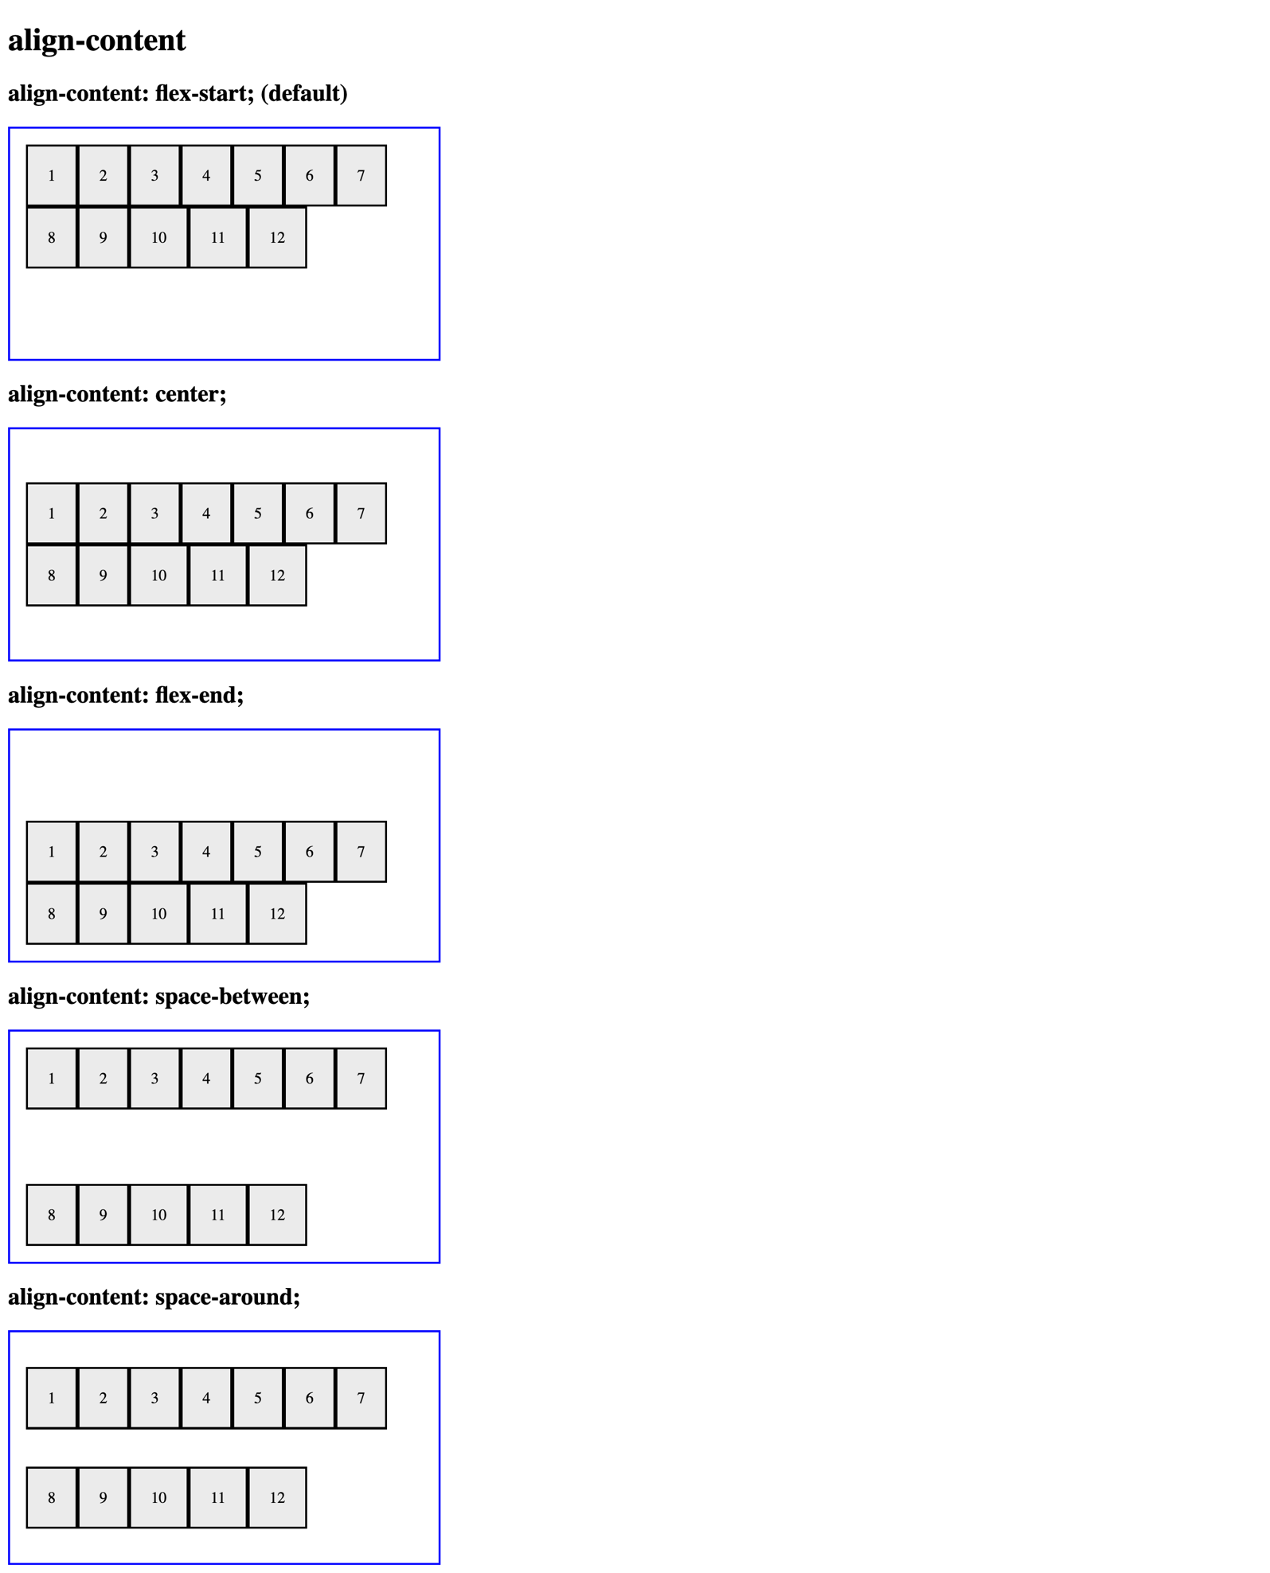
For full screenshot check the screenshot.png file in the folder for the task

Objective:
Create a webpage that looks like the screenshot above.

Requirements:
- File Setup:
  - Create an HTML document named align-content.html
  - Create a CSS file named align-content.css
- Element creation
  - Add title of the page in an <h1> element
  - Create 5 sets of <h2> element with a <div> element with a class – "flex-container" as shown in the screenshot
    - Create <div> elements inside the .flex-container element with a class of "flex-item"
    - Add text to the .flex-item elements as shown on the screenshot
- Styling
  - Copy the styles from Task 1
  - Add the following styles to the .flex-container class:
    - height - 200px
    - align-items - flex-start
    - flex-wrap - wrap
  - Create a new class "align-content-flex-start" with the following styles
    - align-content – flex-start
  - Create a new class "align-content-center" with the following styles
    - align-content – center
  - Create a new class "align-content-flex-end" with the following styles
    - align-content – flex-end
  - Create a new class "align-content-space-between" with the following styles
    - align-content – space-between
  - Create a new class "align-content-space-around" with the following styles
    - align-content – space-around
  - Apply the classes to the appropriate .flex-container elements to achieve the results shown in the screenshot

Property: Gap
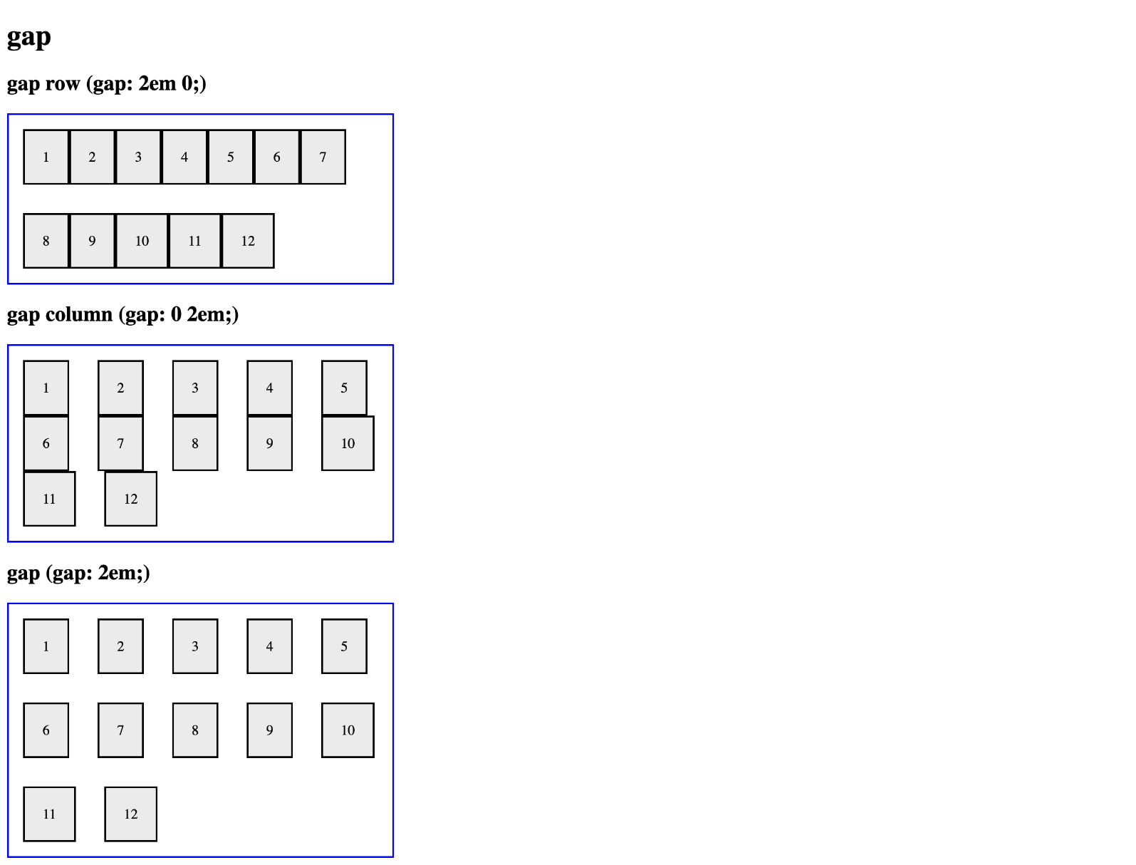
For full screenshot check the screenshot.png file in the folder for the task

Objective:
Create a webpage that looks like the screenshot above.

Requirements:
- File Setup:
  - Create an HTML document named gap.html
  - Create a CSS file named gap.css
- Element creation
  - Add title of the page in an <h1> element
  - Create 3 sets of <h2> element with a <div> element with a class – "flex-container" as shown in the screenshot
    - Create <div> elements inside the .flex-container element with a class of "flex-item"
    - Add text to the .flex-item elements as shown on the screenshot
- Styling
  - Copy the styles from Task 1
  - Add the following styles to the .flex-container class:
    - align-items – flex-start
    - flex-wrap - wrap
  - Create a new class "gap-row" with the following styles
    - gap - 2em 0;
  - Create a new class "gap-column" with the following styles
    - gap - 0 2em;
  - Create a new class "gap" with the following styles
    - gap - 2em;
  - Apply the classes to the appropriate .flex-container elements to achieve the results shown in the screenshot

Property: Flex Grow
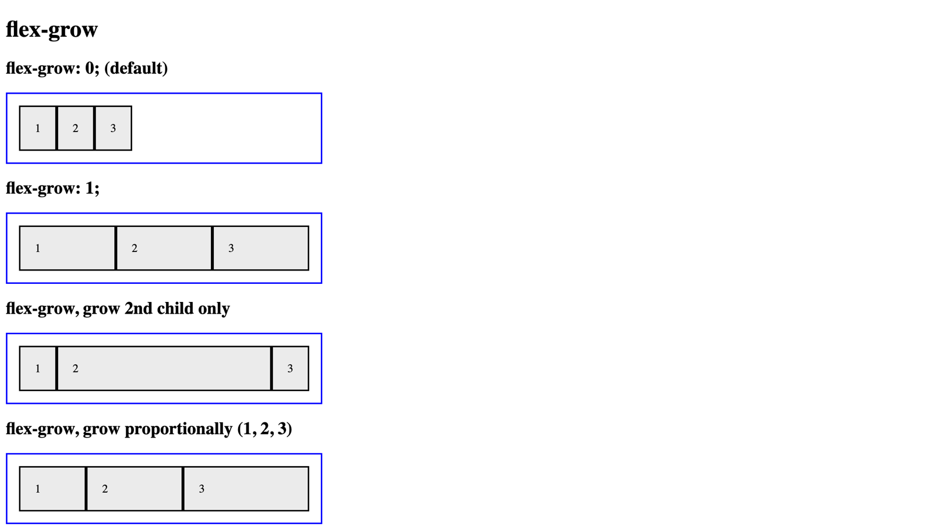
For full screenshot check the screenshot.png file in the folder for the task

Objective:
Create a webpage that looks like the screenshot above.

Requirements:
- File Setup:
  - Create an HTML document named flex-grow.html
  - Create a CSS file named flex-grow.css

- Element creation
  - Add title of the page in an <h1> element
  - Create 4 sets of <h2> element with a <div> element with a class – "flex-container" as shown in the screenshot
    - Create <div> elements inside the .flex-container element with a class of "flex-item"
    - Add text to the .flex-item elements as shown on the screenshot
- Styling
  - Copy the styles from Task 1
  - Add the following styles to the .flex-container class:
    - align-items – flex-start
    - flex-wrap - wrap
  - Create a new class "flex-grow-one" and use it to style all .flex-item elements inside it with the following styles
    - flex-grow - 1;
  - Create a new class "flex-grow-2nd-only" and use it to style the 2nd .flex-item element inside it with the following styles
    - flex-grow - 1;
  - Create a new class "flex-grow-proportional" and use it to style each .flex-item element inside it with the following styles
    - Element 1
      - flex-grow - 1;
    - Element 2
      - flex-grow - 2;
    - Element 3
      - flex-grow - 3;
  - Apply the classes to the appropriate .flex-container elements to achieve the results shown in the screenshot

Property: Flex Shrink
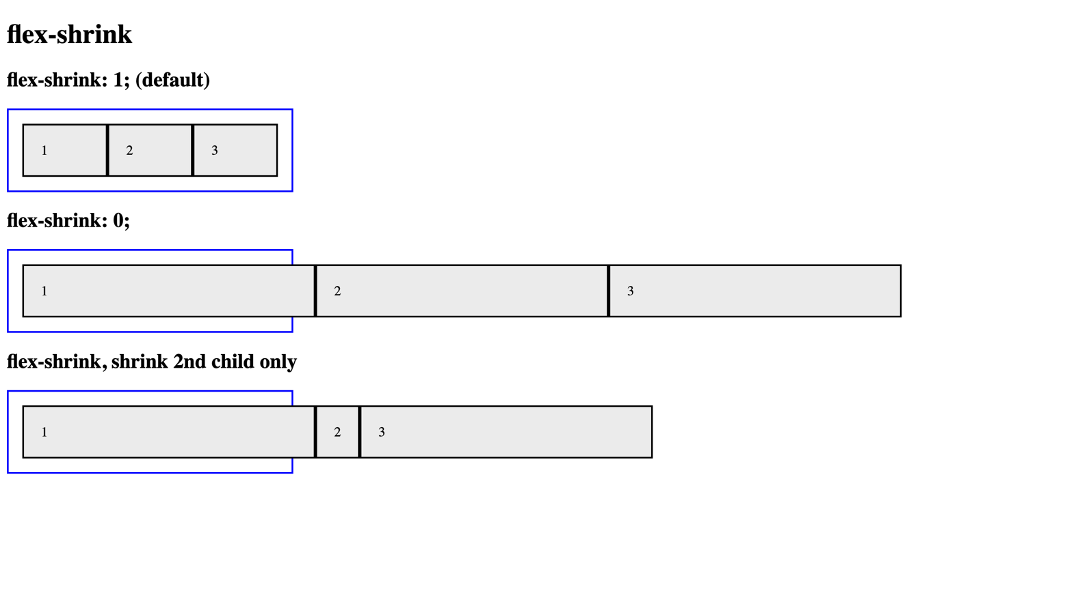
For full screenshot check the screenshot.png file in the folder for the task

Objective:
Create a webpage that looks like the screenshot above.

Requirements:
- File Setup:
  - Create an HTML document named flex-shrink.html
  - Create a CSS file named flex-shrink.css
- Element creation
  - Add title of the page in an <h1> element
  - Create 3 sets of <h2> element with a <div> element with a class – "flex-container" as shown in the screenshot
    - Create <div> elements inside the .flex-container element with a class of "flex-item"
    - Add text to the .flex-item elements as shown on the screenshot
- Styling
  - Copy the styles from Task 1
  - Add the following styles to the .flex-item class:
    - flex-basis – 300px
  - Add the following styles to the .flex-container class:
    - align-items – flex-start
    - width – 300px
  - Create a new class "flex-shrink-zero" and use it to style all .flex-item elements inside it with the following styles:
    - flex-shrink - 0;
  - Create a new class "flex-shrink-2nd-only" and use it to style all .flex-item element inside it with the following styles:
    - flex-shrink - 0;
  - Use the class "flex-shrink-2nd-only" to style the 2nd .flex-item element inside it with the following styles:
    - flex-shrink - 1;
  - Apply the classes to the appropriate .flex-container elements to achieve the results shown in the screenshot

Property: Flex Basis
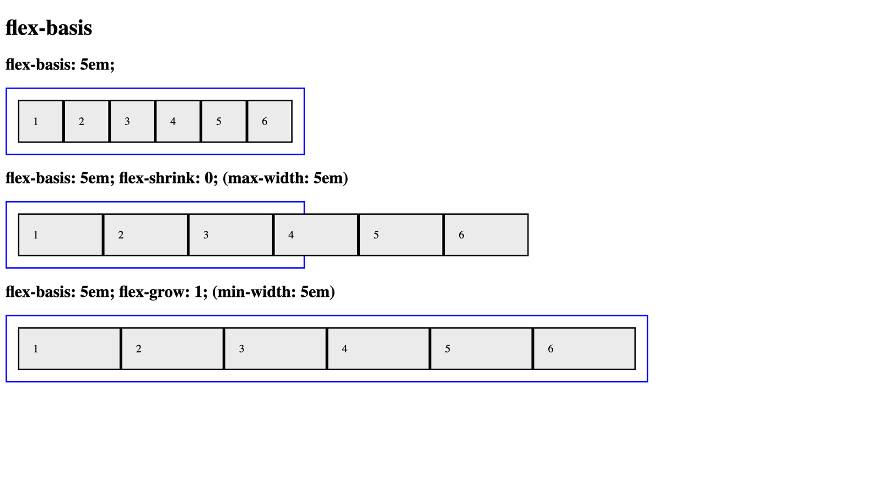
For full screenshot check the screenshot.png file in the folder for the task

Objective:
Create a webpage that looks like the screenshot above.

Requirements:
- File Setup:
  - Create an HTML document named flex-basis.html
  - Create a CSS file named flex-basis.css
- Element creation
  - Add title of the page in an <h1> element
  - Create 3 sets of <h2> element with a <div> element with a class – "flex-container" as shown in the screenshot
    - Create <div> elements inside the .flex-container element with a class of "flex-item"
    - Add text to the .flex-item elements as shown on the screenshot
- Styling
  - Copy the styles from Task 1
  - Create a new class "flex-basis-5em" and use it to style all .flex-item elements inside it with the following styles:
    - flex-basis - 5em;
  - Create a new class "flex-shrink-zero" and use it to style all .flex-item element inside it with the following styles:
    - flex-shrink - 0;
  - Create a new class "flex-grow-one" with the following styles:
    - Width - 900px;
  - Use the class "flex-grow-one" it to style all .flex-item element inside it with the following styles:
    - flex-grow - 1;
  - Apply the classes to the appropriate .flex-container elements to achieve the results shown in the screenshot

Property: Align Self
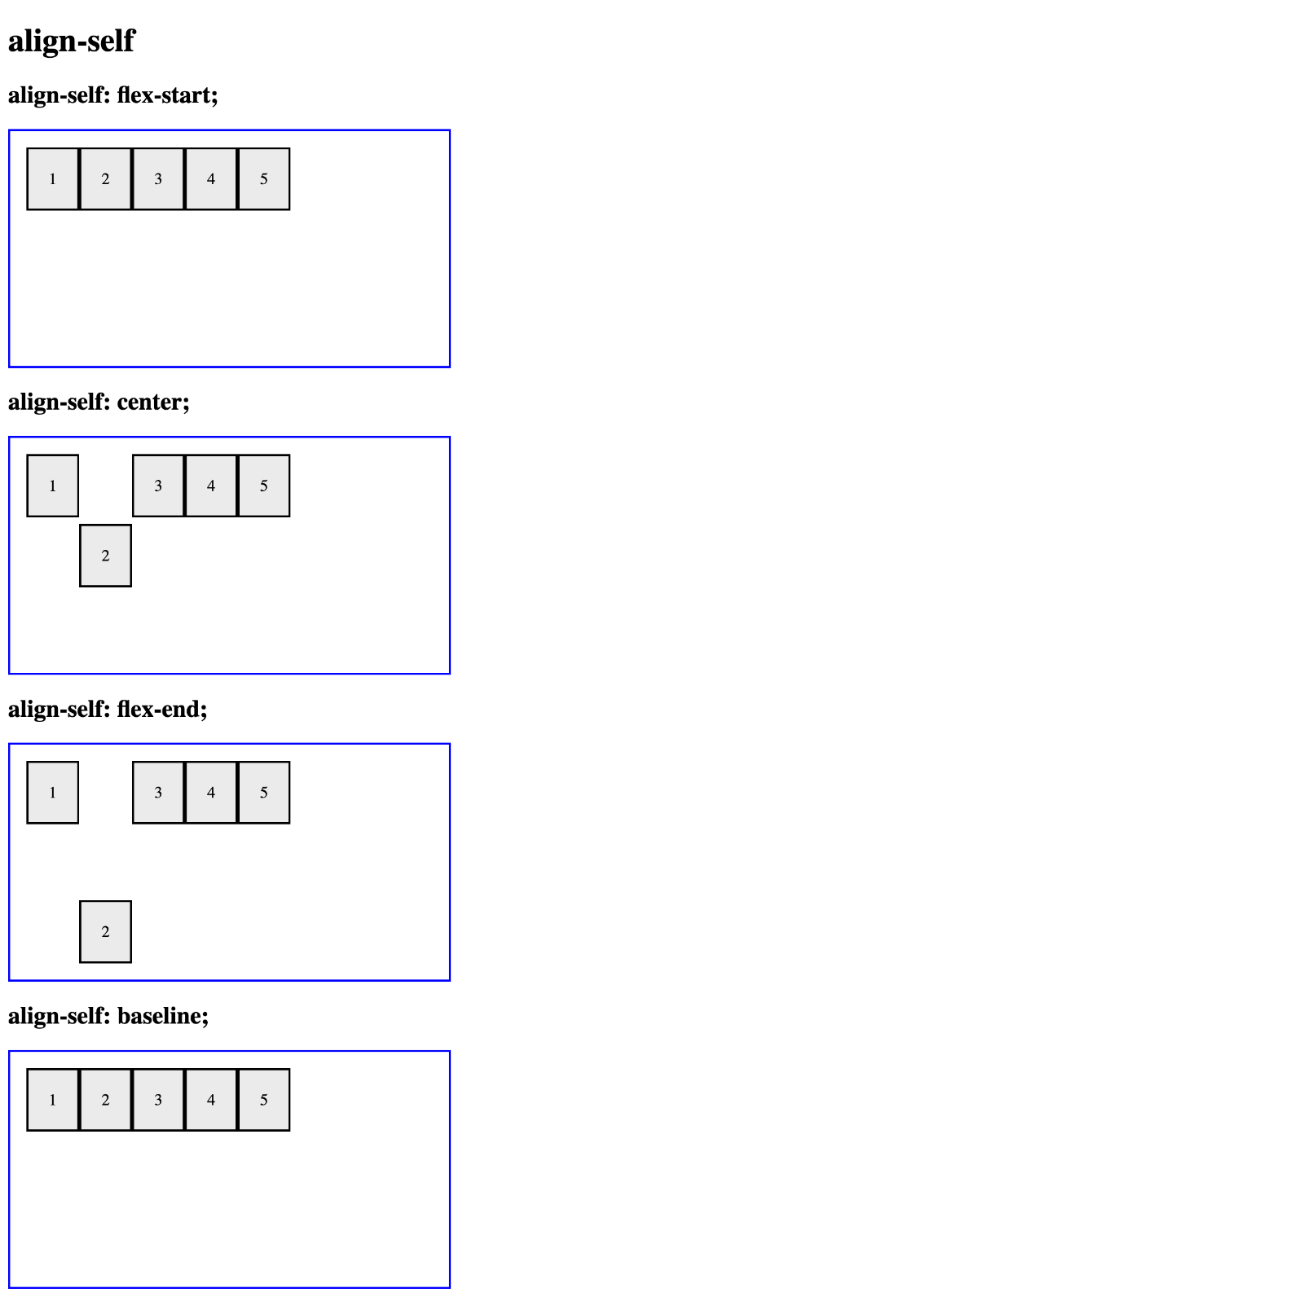
For full screenshot check the screenshot.png file in the folder for the task

Objective:
Create a webpage that looks like the screenshot above.

Requirements:
- File Setup:
  - Create an HTML document named align-self.html
  - Create a CSS file named align-self.css
- Element creation
  - Add title of the page in an <h1> element
  - Create 4 sets of <h2> element with a <div> element with a class – "flex-container" as shown in the screenshot
    - Create <div> elements inside the .flex-container element with a class of "flex-item"
    - Add text to the .flex-item elements as shown on the screenshot
- Styling
  - Copy the styles from Task 1
  - Add the following styles to the .flex-container class:
    - align-items – flex-start
  - Create a new class "align-self-flex-start" and use it to style the 2nd .flex-item element inside it with the following styles:
    - align-self - flex-start;
  - Create a new class "align-self-center" and use it to style the 2nd .flex-item element inside it with the following styles:
    - align-self - center;
  - Create a new class "align-self-flex-end" and use it to style the 2nd .flex-item element inside it with the following styles:
    - align-self - flex-end;
  - Create a new class "align-self-baseline" and use it to style the 2nd .flex-item element inside it with the following styles:
    - align-self - baseline;
  - Apply the classes to the appropriate .flex-container elements to achieve the results shown in the screenshot

Property: Order
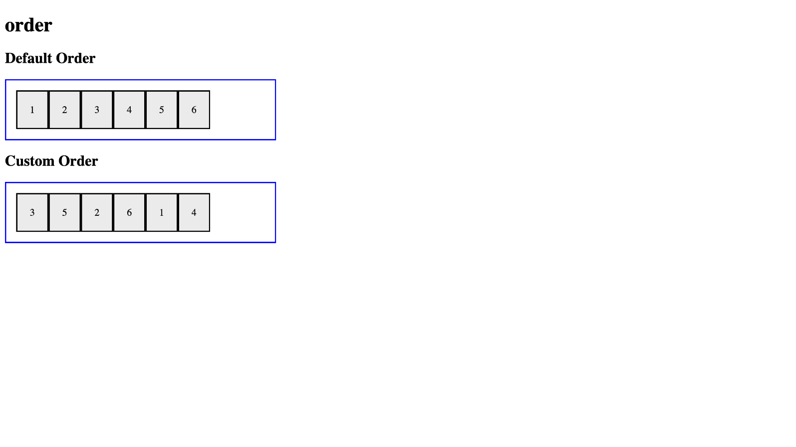
For full screenshot check the screenshot.png file in the folder for the task

Objective:
Create a webpage that looks like the screenshot above.

Requirements:
- File Setup:
  - Create an HTML document named order.html
  - Create a CSS file named order.css
- Element creation
  - Add title of the page in an <h1> element
  - Create 2 sets of <h2> element with a <div> element with a class – "flex-container" as shown in the screenshot
    - Create <div> elements inside the .flex-container element with a class of "flex-item"
    - Add text to the .flex-item elements as shown on the screenshot
- Styling
  - Copy the styles from Task 1
  - Add the following styles to the .flex-container class:
    - align-items – flex-start
  - Create a new class “custom-order” and use it to style each individual .flex-item element inside it with the following styles:
    - Item 1
      - Order – 5
    - Item 2
      - Order – 3
    - Item 3
      - Order – 1
    - Item 4
      - Order – 6
    - Item 5
      - Order – 2
    - Item 6
      - Order – 4
  - Apply the classes to the appropriate .flex-container elements to achieve the results shown in the screenshot

