CSS Box Model and Typography - Lab

Topics Covered
Everything in CSS has a box around it, and understanding these boxes is key to being able to create more complex layouts with CSS, or to align items with other items. In this lesson, we will take a look at the CSS Box Model. You'll get an understanding of how it works and the terminology that relates to it.

Resources
- The Box Model
  - https://developer.mozilla.org/en-US/docs/Learn/CSS/Building_blocks/The_box_model

- Typography
  - https://developer.mozilla.org/en-US/docs/Learn/CSS/Styling_text/Fundamentals
- Position
  - https://developer.mozilla.org/en-US/docs/Learn/CSS/CSS_layout/Positioning

Tasks

Box Model - display
This task aims to provide students with a practical understanding of how the display property affects the rendering of HTML elements, which is crucial for creating well-designed and functional web pages.
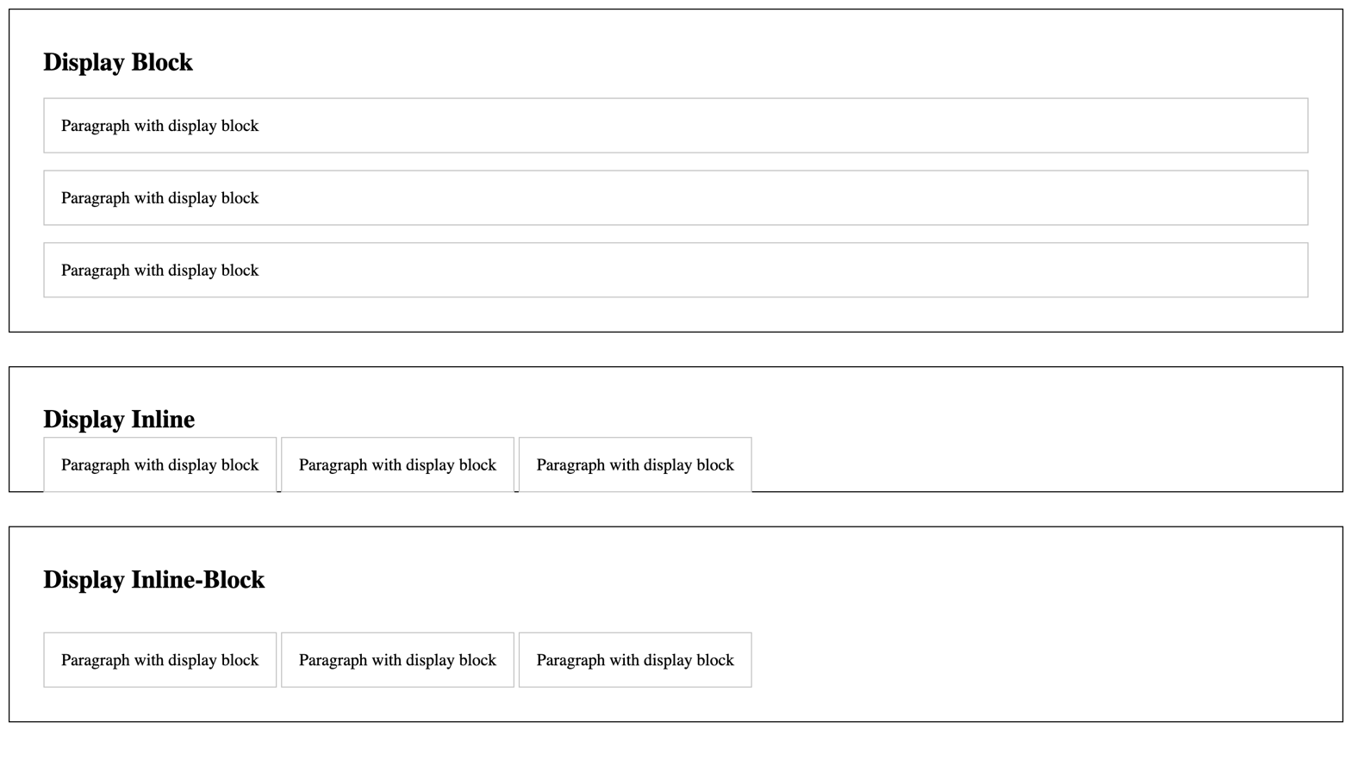
For full screenshot check the screenshot.png file in the folder for the task

Objective
Create a webpage that demonstrates the use and effects of the CSS display property on HTML elements, emphasizing how it controls whether and how elements are displayed.

Requirements
- File Setup:
  - Create an HTML document named display-examples.html
  - Create a CSS file named display-examples.css
- Element Creation:
  - Create 3 sections by using the section tag and place one h2 heading inside along with 3 paragraphs.
  - Add class to each section – block, inline, inline-block
- CSS Styling:
  - Sections
    - Border of 2px solid black
    - Padding 1em from top and bottom and 2em from left and right
    - Bottom margin 2em
  - All paragraphs in sections
    - Border of 1px solid #ccc
    - Padding of 1em
  - All paragraphs in a section with class "block"
    - Display of block
  - All paragraphs in a section with class "inline"
    - Display of inline
  - All paragraphs in a section with class "inline-block"
    - Display of inline-block

Box Model – padding
This task aims to provide students with a hands-on understanding of how padding affects element sizing and spacing, which is crucial for mastering CSS layout techniques.
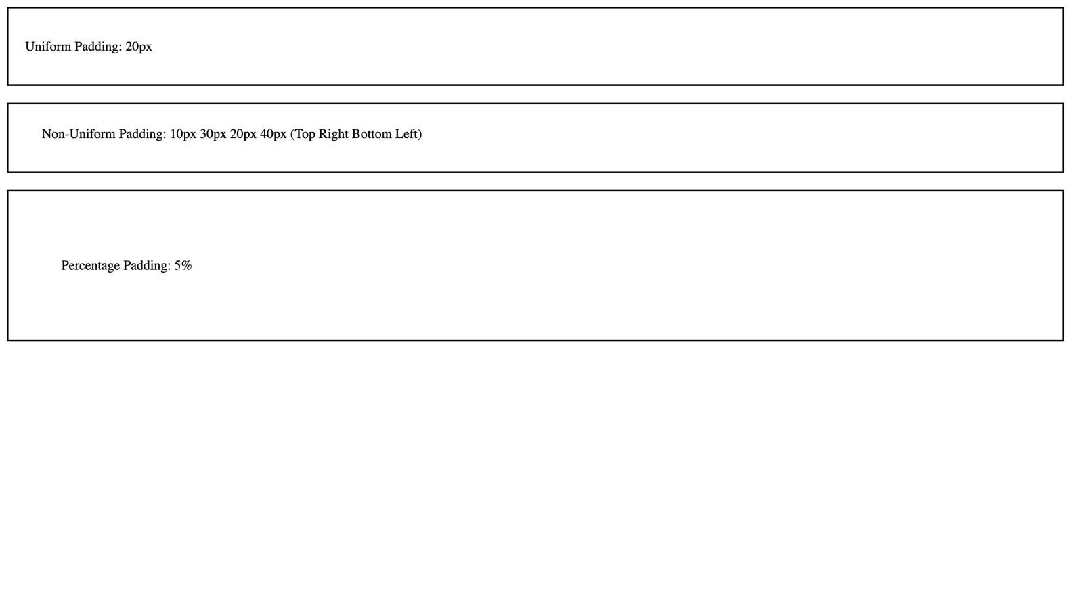
For full screenshot check the screenshot.png file in the folder for the task

Requirements
- File Setup:
  - Create an HTML document named padding-examples.html
  - Create a CSS file named padding-examples.css
- Element Creation:
  - Create 3 <div> elements each designed to showcase different aspects and effects of padding
  - Add a paragraph inside of each div with the appropriate text to show what case it represents.
- Styling
  - Add classes to each div element for each type of padding
    - First element – Uniform padding
            - padding: 20px;
    - Second element – Non-Uniform Padding
            - padding: 10px 30px 20px 40px;
              - order is – top, right, bottom, left
          - Third element – Percentage Padding
            - padding: 5%;
              - in this scenario the % value is derived from the width of the element

Box Model – margin
This task aims to provide students with a practical understanding of how the margin property affects the layout and spacing of elements, which is crucial for creating well-designed web pages.
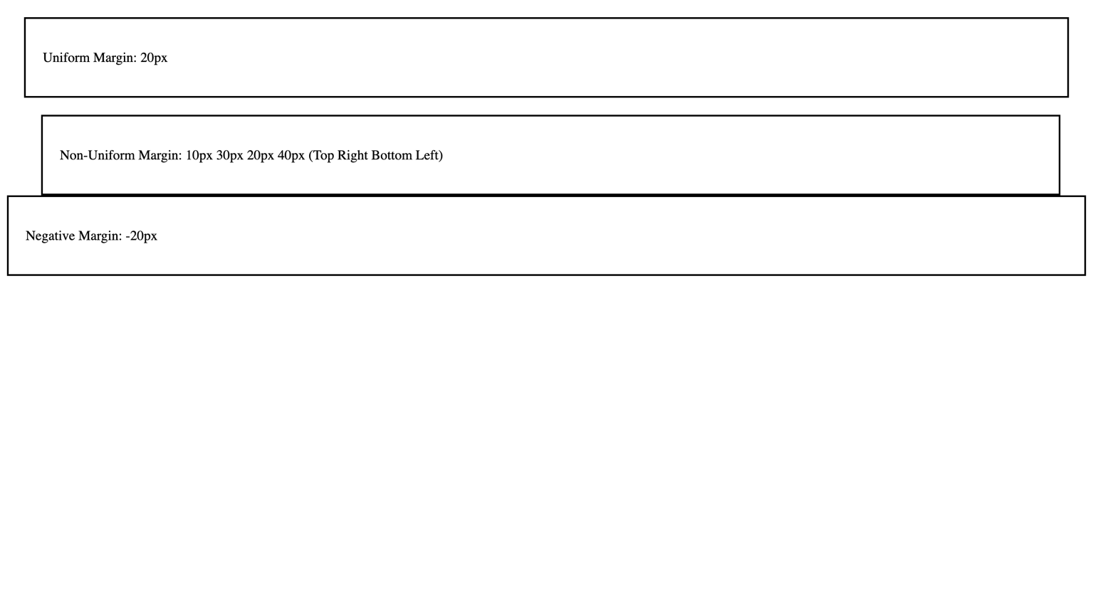
For full screenshot check the screenshot.png file in the folder for the task

Requirements
- File Setup:
  - Create an HTML document named margin-examples.html
  - Create a CSS file named margin-examples.css
- Element Creation:
  - Place 3 paragraphs each inside its own <div> element
  - Add a paragraph inside of each div with the appropriate text to show what case it represents.
- Styling
  - Add classes to each div element for each type of margin
    - First element – Uniform margin
            - margin: 40px;
    - Second element – Non-Uniform Padding
            - margin: 10px 30px 20px 40px;
              - order is – top, right, bottom, left
          - Third element – Negative margin
            - margin: -20px;
              - In this case the only effect is that the element will be moved up 20px as it is impossible to move it negatively 20px in all directions

Box Model – width
This task aims to provide students with a practical understanding of how the width property affects the horizontal sizing of elements, which is crucial for creating well-designed and responsive web pages.
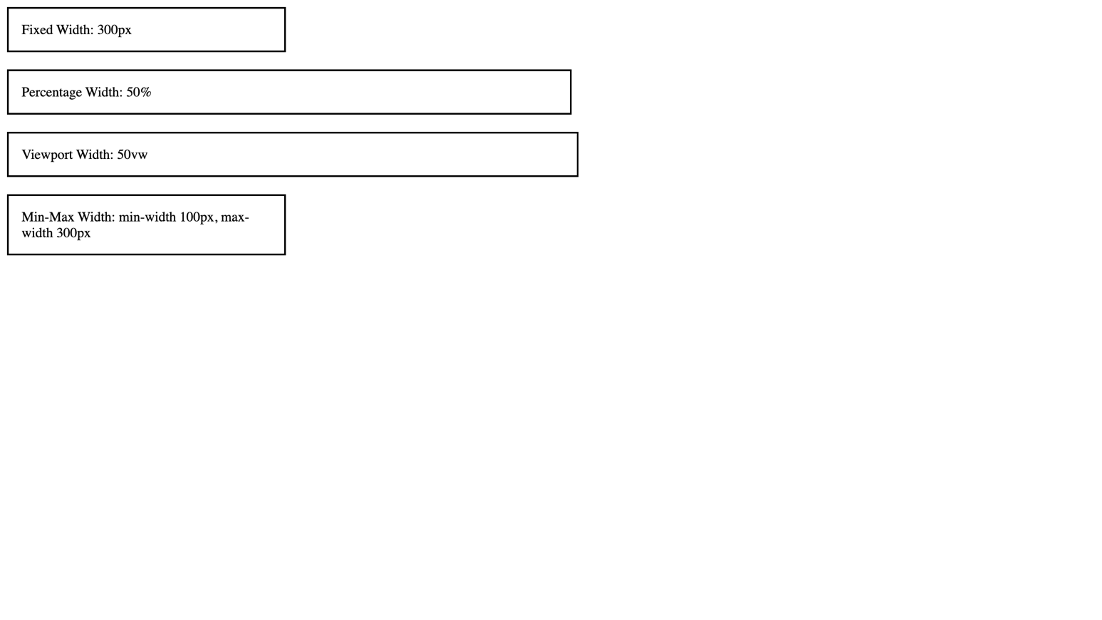
For full screenshot check the screenshot.png file in the folder for the task

Requirements
- File Setup:
  - Create an HTML document named width-examples.html
  - Create a CSS file named width-examples.css
- Element Creation:
  - Create 4 <div> elements
  - Add a paragraph inside of each div with the appropriate text to show what case it represents.
- CSS Styling:
  - Add classes for each div element for the following cases:
    - Fixed Width – 300px
    - Percentage Width – 50%
    - Viewport Width – 50vw
    - Min-Max Width – min-width 100px, max-width 300px

Box Model – height
This task aims to provide students with a practical understanding of how the height property affects the vertical sizing of elements, which is crucial for creating well-designed web pages.
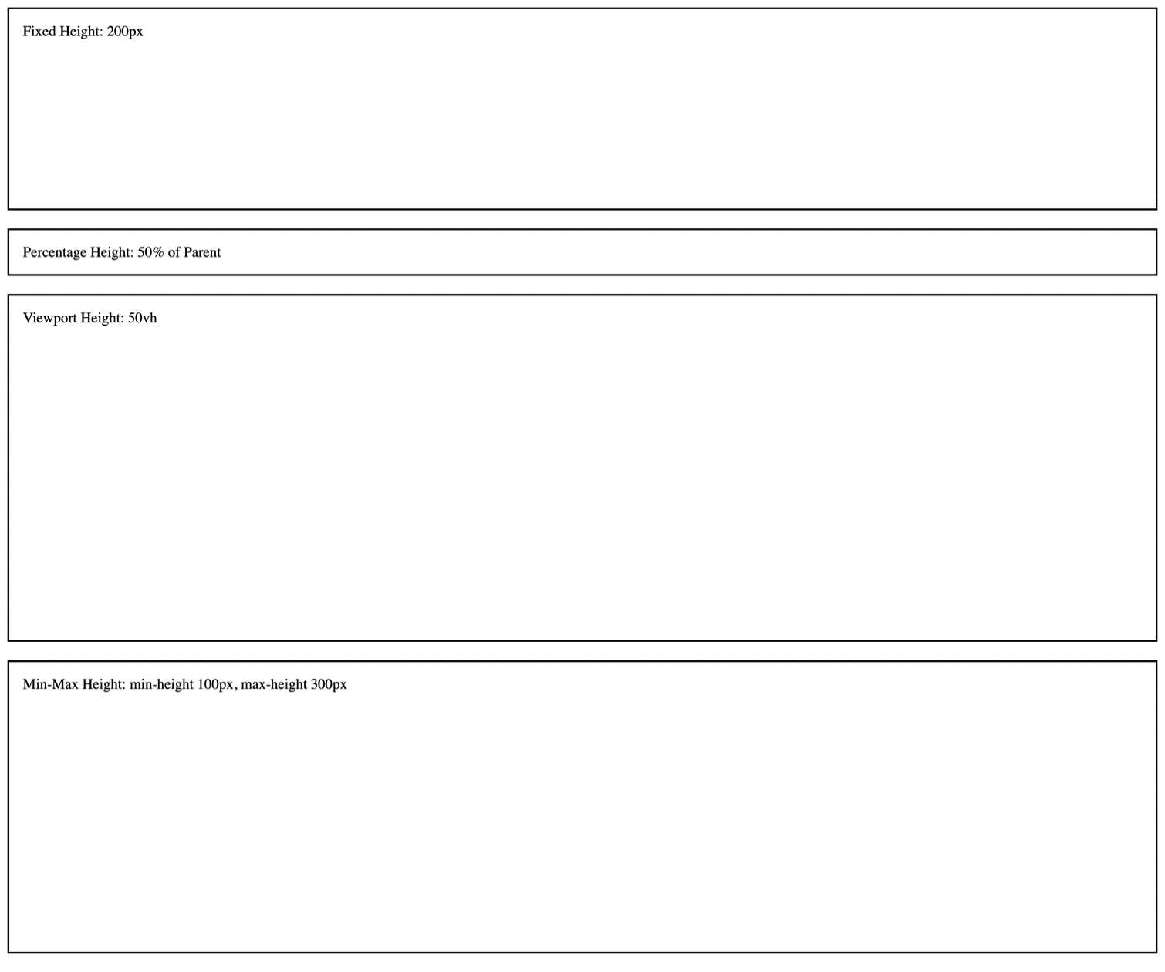
For full screenshot check the screenshot.png file in the folder for the task

Requirements
- File Setup:
  - Create an HTML document named height-examples.html
  - Create a CSS file named height-examples.css
- Element Creation:
  - Create 4 <div> elements
  - Add a paragraph inside of each div with the appropriate text to show what case it represents.
- CSS Styling:
  - Add classes for each div element for the following cases:
    - Fixed Height - 200px
    - Percentage Height - 50%
    - Viewport Height – 50vh
    - Min-Max Height – min-height 100px, max-height 300px

Box Model – border
This task aims to provide students with a practical understanding of how the border property can be used to enhance the visual aesthetics of web elements, which is crucial for effective web design.
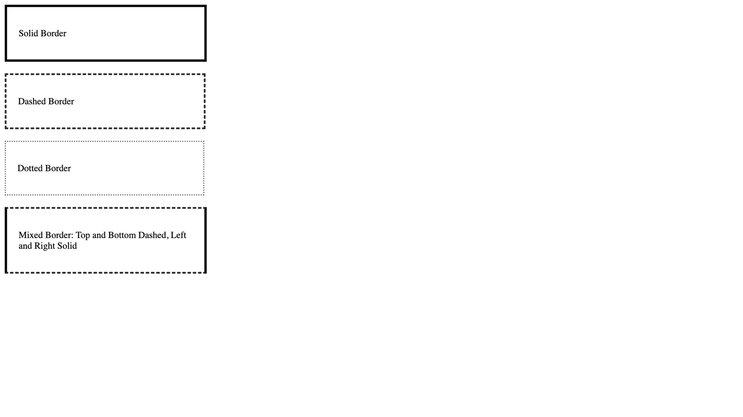
For full screenshot check the screenshot.png file in the folder for the task

Requirements
- File Setup:
  - Create an HTML document named border-examples.html
  - Create a CSS file named border-examples.css
- Element Creation:
  - Create 4 <div> elements
  - Add a paragraph inside of each div with the appropriate text to show what case it represents.
- CSS Styling:
  - Add classes for each div element for the following cases:
    - Solid Border – 4px solid black
    - Dashed Border – 3px dashed #333
    - Dotted Border – 2px dotted #666
    - Mixed Border
      - Top – 3px dashed #333
      - Bottom – 3px dashed #333
      - Left – 4px solid #000;
      - Right – 4px solid #000;

Box Model – box-sizing
This task aims to provide students with a practical understanding of how the box-sizing property affects the sizing of elements in CSS, thereby enhancing their ability to manage layouts more effectively in web design.
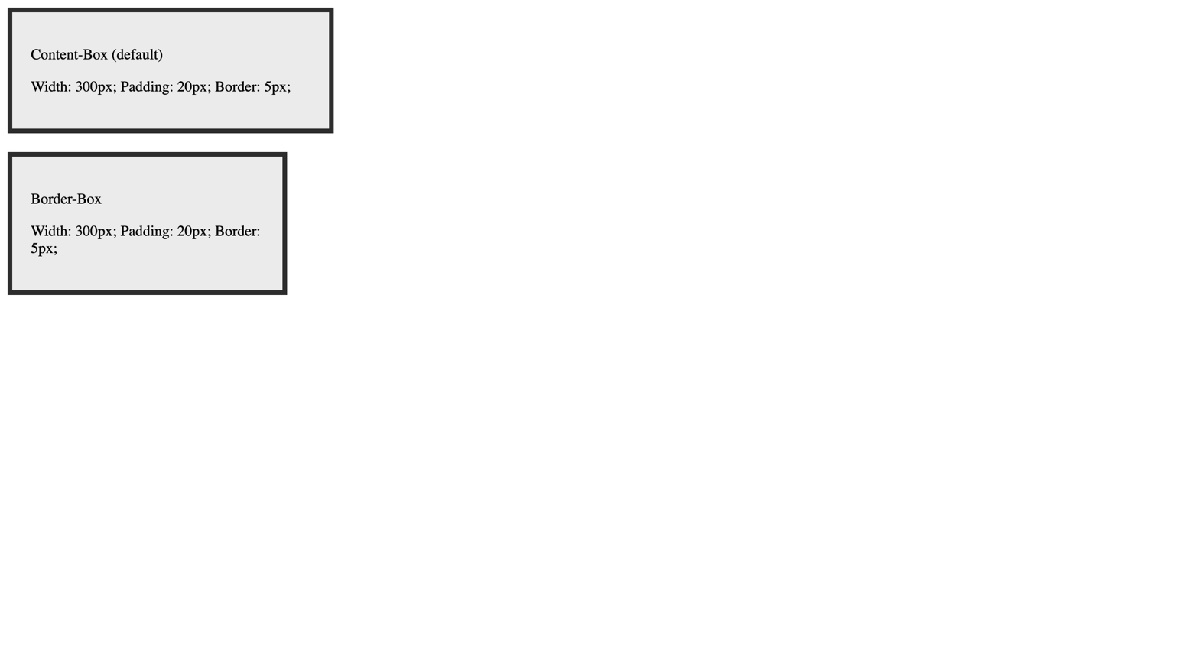
For full screenshot check the screenshot.png file in the folder for the task

Requirements
- File Setup:
  - Create an HTML document named box-sizing.html
  - Create a CSS file named box-sizing.css
- Element Creation:
  - Create 2 <div> elements
- CSS Styling:
  - Apply the following classes to all div elements
    - Width – 300px
    - Padding – 20px
    - Border – 5px solid #333
    - Margin Bottom – 20px
    - Background - #eee
  - Add classes for the 2 values of box-sizing and apply the following styles:
    - Content-box
      - Box-sizing – content-box
    - Border-box
      - Box-sizing – border-box

Box Model - overflow
This task aims to provide students with a practical understanding of how the overflow property affects the display of overflowing content within elements, which is crucial for creating well-designed and functional web pages.
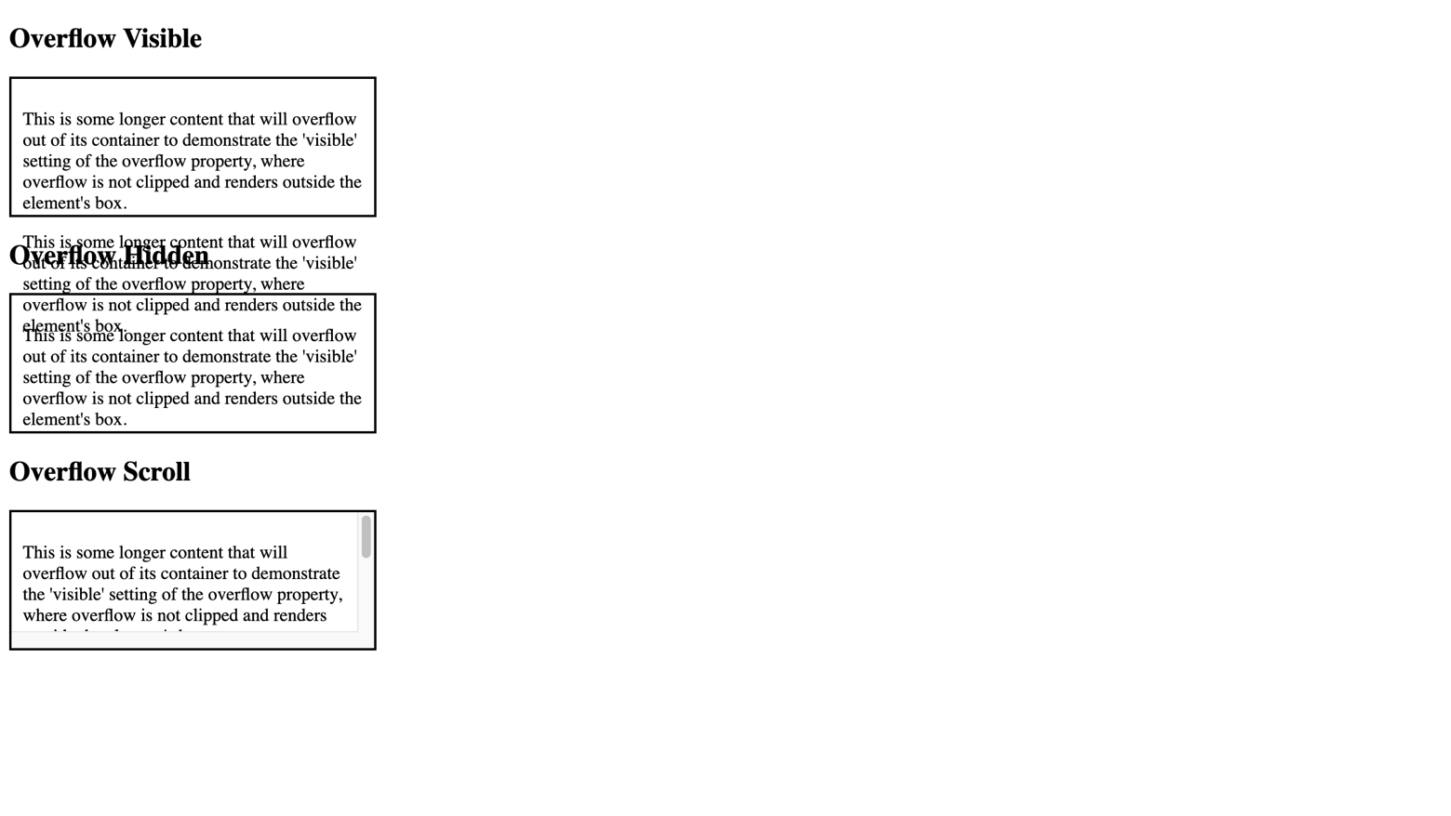
For full screenshot check the screenshot.png file in the folder for the task

Requirements
- File setup:
  - Create an HTML document named overflow-examples.html
  - Create a CSS file named overflow-examples.css
- Element Creation:
  - Create a set of <div> and <h2> elements for the following cases:
    - Overflow Visible
    - Overflow Hidden
    - Overflow Scroll
  - Add 2 <p> elements inside each of the divs
    - Use the copy provided in the text.txt file
- CSS Styling:
  - Add classes to the div elements and apply the following styles to the appropriate cases:
    - Overflow - Visible
    - Overflow - Hidden
    - Overflow - Scroll

Font Properties
This task aims to provide students with a practical understanding of how various CSS font properties can be used to style text, which is crucial for creating visually appealing and readable web content.
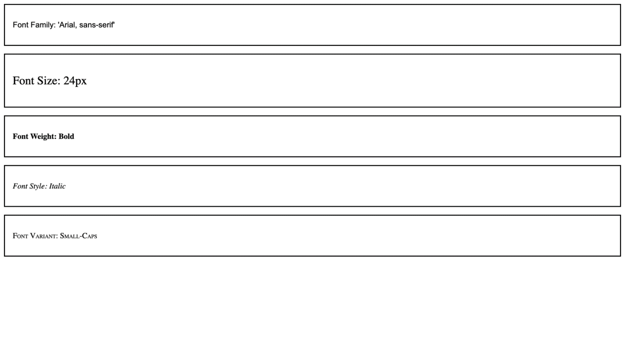
For full screenshot check the screenshot.png file in the folder for the task

Requirements
- File Setup:
  - Create an HTML document named font-examples.html
  - Create a CSS file named font-example.css
- Element Creation:
  - Create 5 <div> elements with <p> elements inside
- CSS Styling:
  - Apply different class to each div element to illustrate how each font property affects the text appearance:
    - font-family - Arial, sans-serif).
    - font-size - 24px
    - font-weight - bold
    - font-style - italic
    - font-variant - small-caps

Reset CSS
This task aims to provide students with an exercise and a practical example of how to reset most of the whitespace styling from browsers and set the stage for their custom styles.
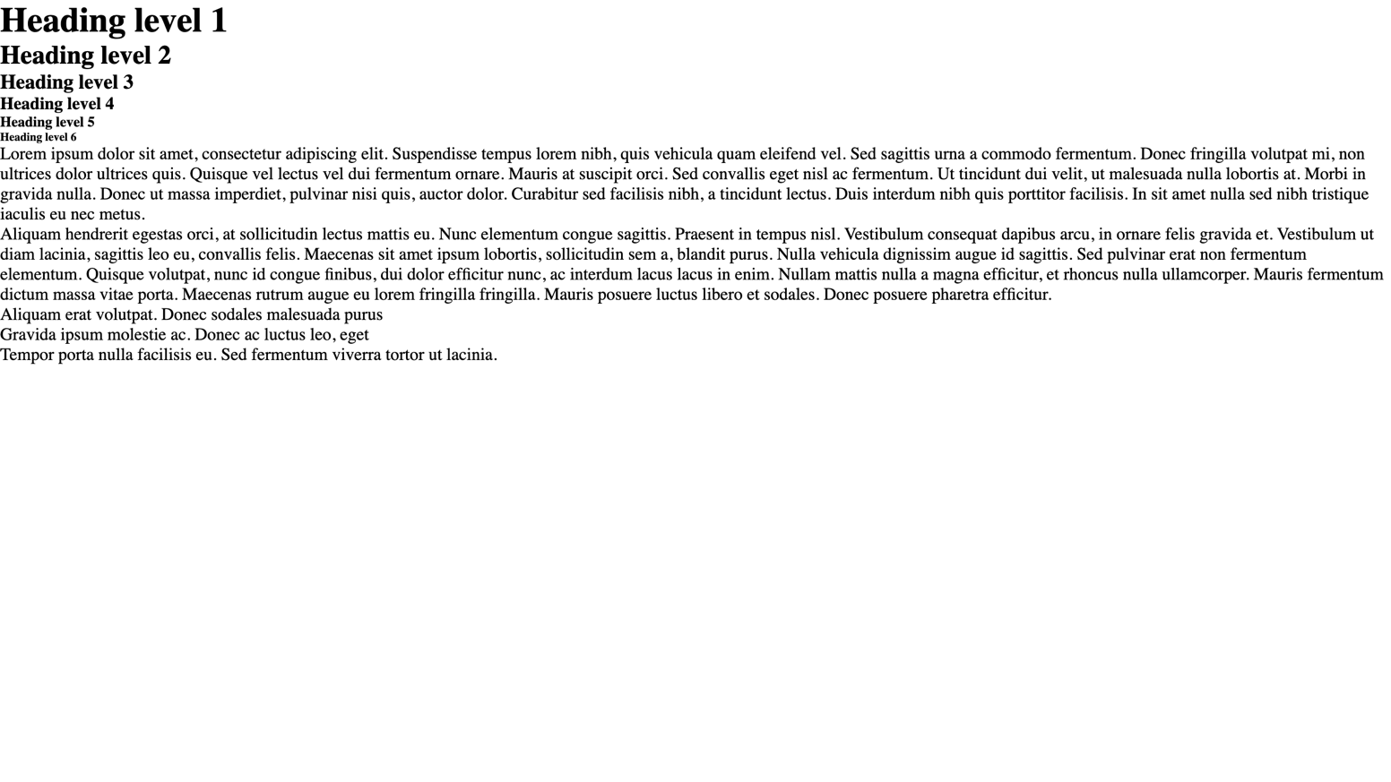
For full screenshot check the screenshot.png file in the folder for the task

Requirements
- File setup:
  - Create an HTML document named reset.html
  - Create a CSS file named reset.css
- CSS Styling:
  - Remove all padding and margin from all elements
  - Set box-sizing to inherit on all elements
  - Set box-sizing to border-box on the html element

Typography CSS
This task aims to provide students with an exercise and a practical example of how to set the styling for text in a web page.
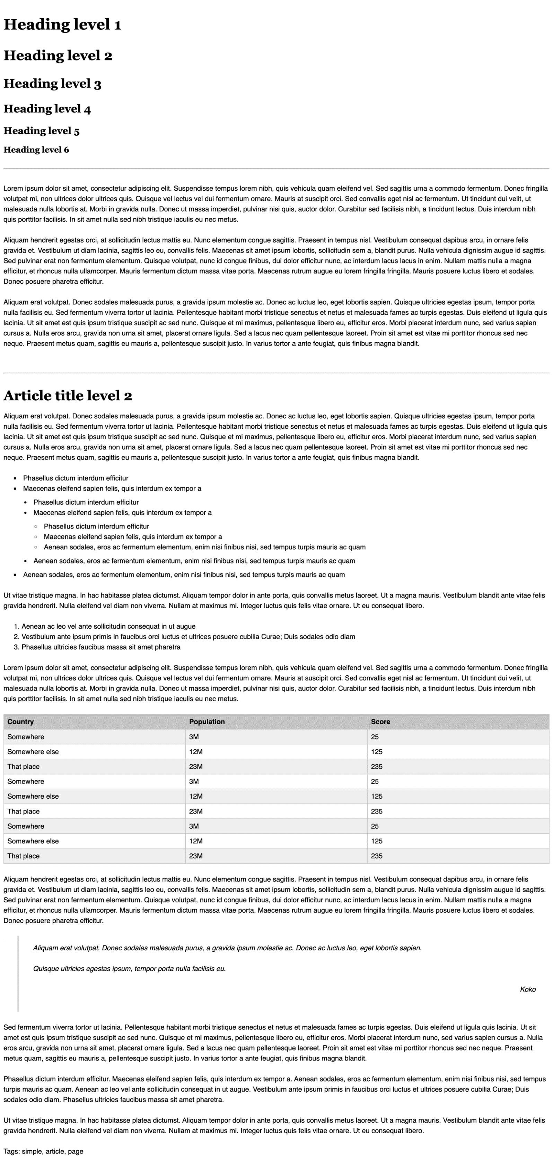
For full screenshot check the screenshot.png file in the folder for the task

Requirements
- File setup:
  - Create an HTML document named typography.html
  - Create a CSS file named typography.css
  - Copy the reset.css file from Task 10 Reset.css
  - Include the reset.css in the html file
- Element Creation:
  - Use the copy in the text.txt file for the elements
  - Add heading elements, from h1 to h6
  - Add hr element
  - Add 3 paragraphs
  - Add hr element
  - Add h2 element
  - Add p element
  - Create a nested unordered list like the one in the screenshot
  - Add p element
  - Create a simple ordered list
  - Add p element
  - Create a table like the one in the screenshot
  - Add p element
  - Create a blockquote element like the one in the screenshot
  - Add 3 p elements
- Styling
  - HTML element should have the following styles
    - Font-size – 16px
    - Line-height – 1.5
    - Font-family – Helvetica, sans-serif
  - Paragraphs, Ordered and Un-ordered lists should have padding-bottom – 1.5rem
  - Ordered and Un-ordered lists should have padding-left – 1.5rem
  - Headings should have the following styles
    - Line-height – 1.2
    - Margin-top – 1em
    - Margin-bottom – 0.5em
    - Font-family – Georgia
  - Add styles for tables, blockquote and hr according to the screenshot

Font specimen - Lato
This task aims to provide students with an exercise and a practical example of how to change the font family
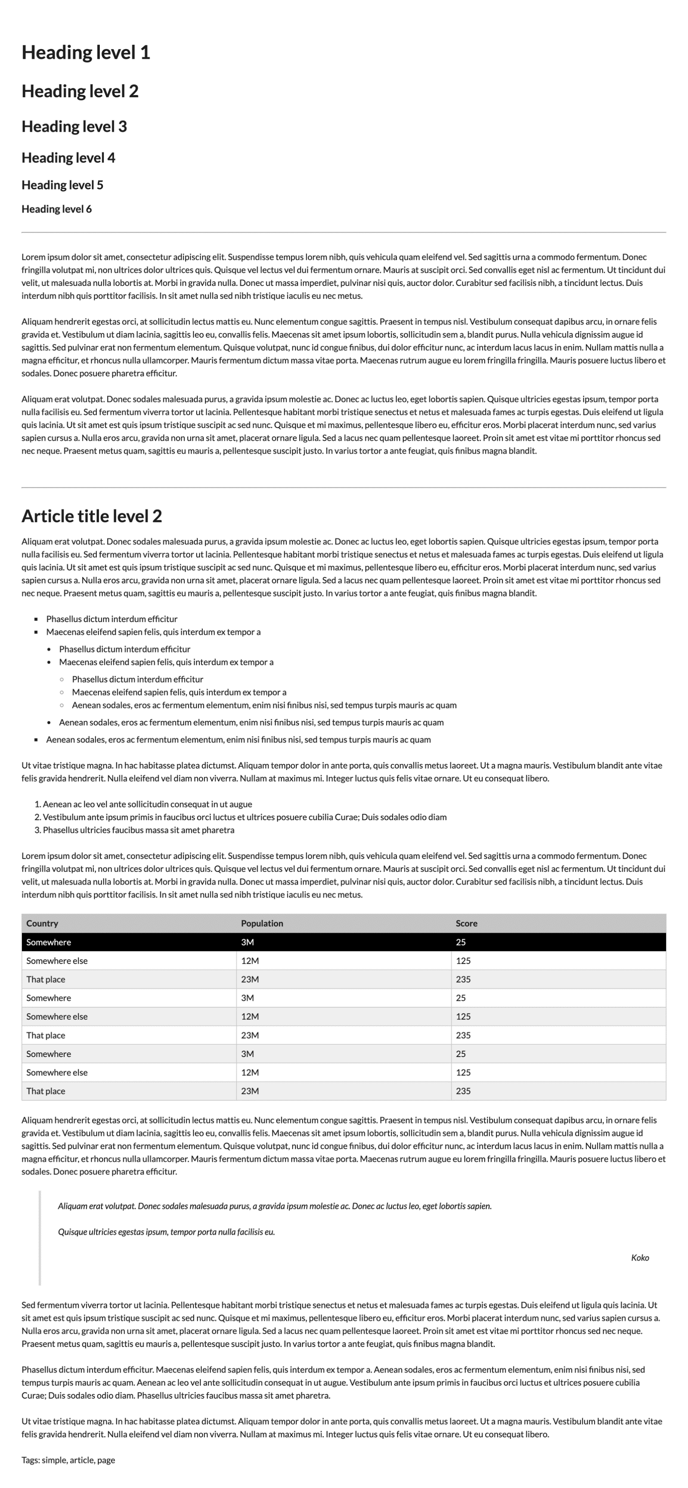
For full screenshot check the screenshot.png file in the folder for the task

Requirements
- File setup:
  - Create an HTML document named font-specimen-lato.html
  - Create a CSS file named font-specimen-lato.css
  - Copy the html from task 12 Typography CSS
  - Copy the typography.css file
  - Include the typography.css file in the html file
- Styling
  - Set the font-family of the html element to "Lato, sans-serif"
  - Set the font-family of the body and all heading elements to "inherit"

Position
This task aims to provide students with an exercise for using the position property
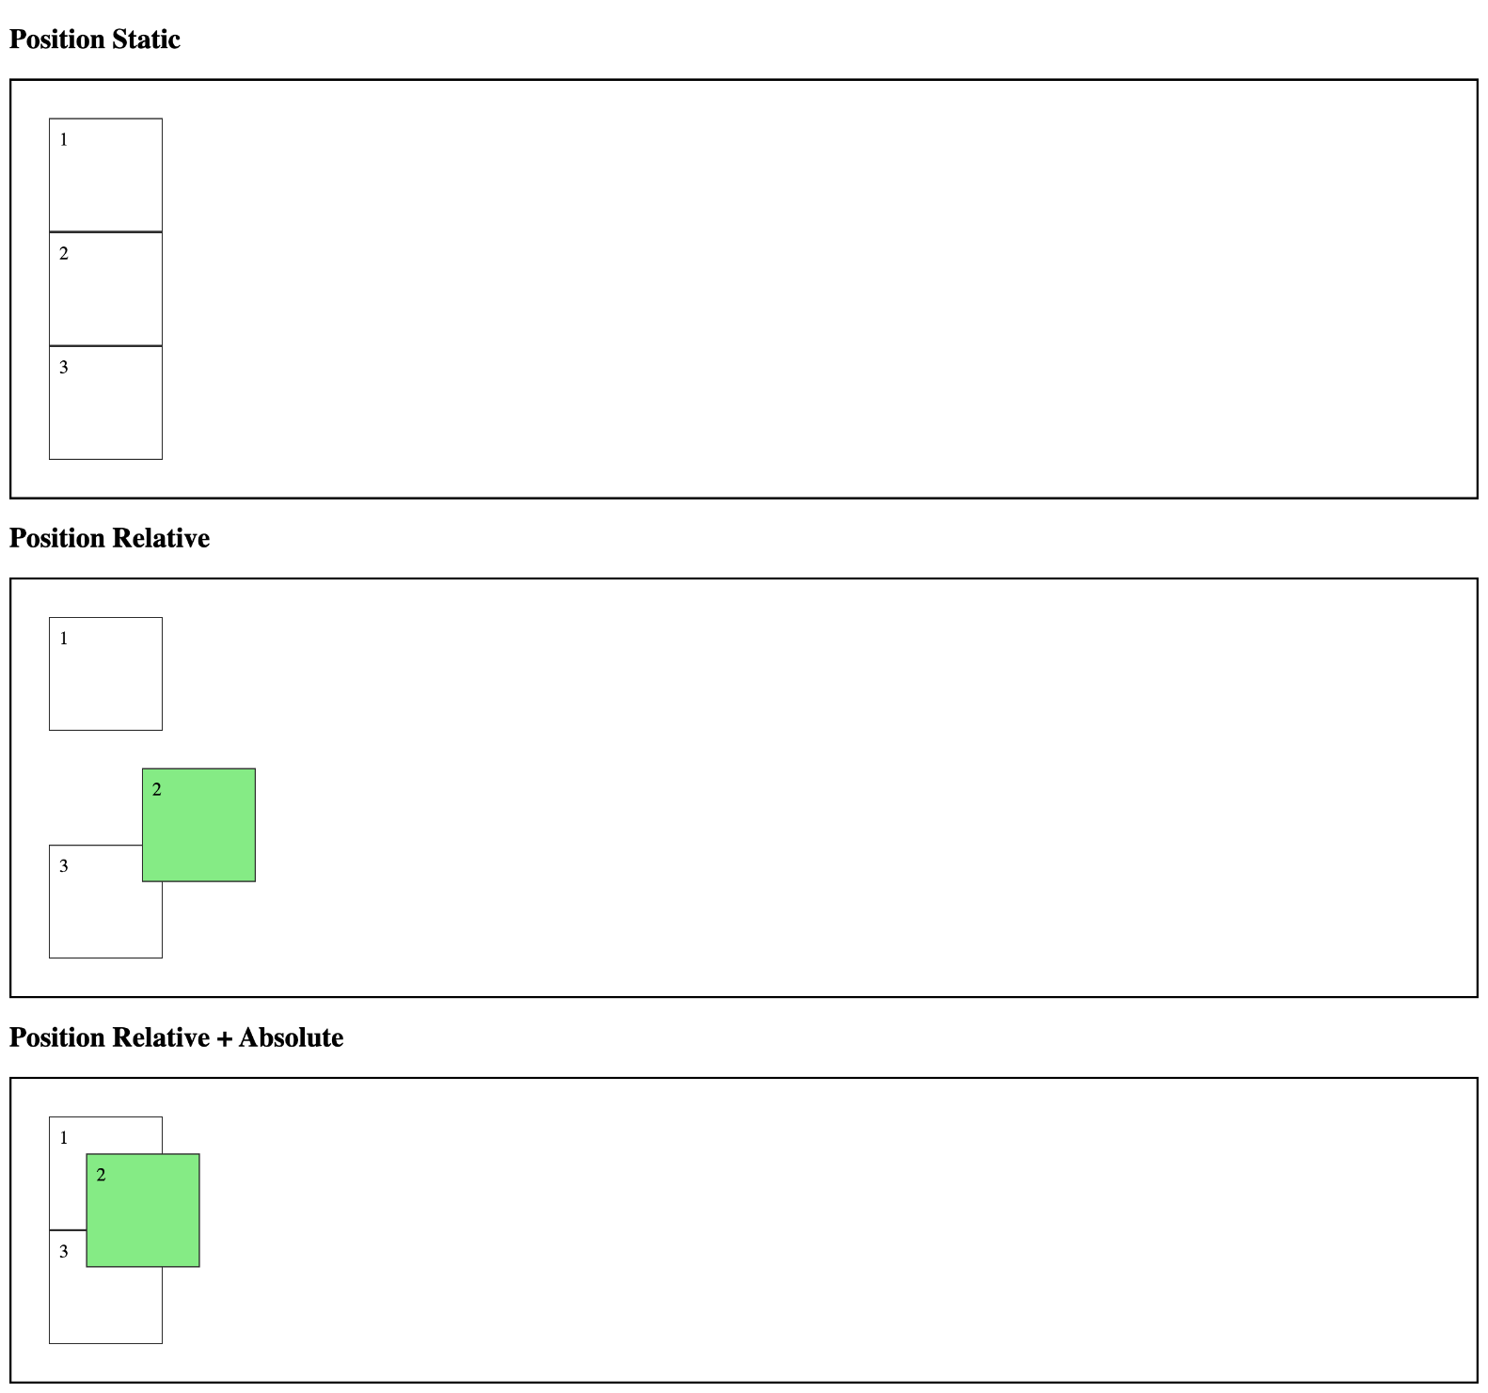
For full screenshot check the screenshot.png file in the folder for the task

Requirements
- File setup:
  - Create an HTML document named position.html
  - Create a CSS file named position.css
- Element Creation:
  - Create 3 <section> elements with <h2> elements before each for the following cases
    - Position Static
    - Position Relative
    - Position Relative + Absolute
  - Add 3 <div> elements with class "item" inside of each section
- CSS Styling:
  - All section elements should have the following styles:
    - Border – 2px solid #000
    - Padding – 2em
    - Position - Relative
  - All div elements with class “item” should have the following styles:
    - Border – 1px solid #333
    - Padding – 0.5em
    - Width – 5em
    - Height – 5em
  - For the second .item element of the Position relative section – add the following styles
    - Position – relative
    - Left – 5em
    - Top – 2em
    - Background – lightgreen
  - For the second .item element of the Position relative + Absolute section – add the following styles
    - Position – absolute
    - Left – 4em
    - Top – 4em
    - Background – lightgreen

