Responsive Web Design – Exercise
Responsive Web Design – Exercise 1
Topics Covered 1
Resources 1
Tasks 2
1. Simple blog layout 2
2. Blog layout 3
3. Responsive typography 3
4. Responsive tables 4
5. Responsive navigation 5
6. Fancy Quotes 5
7. Responsive Banner 6
8. Fancy numbered list 6
9. Responsive vertical timeline 7
10. Cards – Online course 8

Topics Covered
Responsive web design (RWD) is a web design approach to make web pages render well on all screen sizes and resolutions while ensuring good usability. It is the way to design for a multi-device web. In this article, we'll help you understand some techniques that can be used to master it.

Resources
- Responsive design
  - https://developer.mozilla.org/en-US/docs/Learn/CSS/CSS_layout/Responsive_Design
- Beginner's guide to media queries
  - https://developer.mozilla.org/en-US/docs/Learn/CSS/CSS_layout/Media_queries

Tasks

Simple blog layout
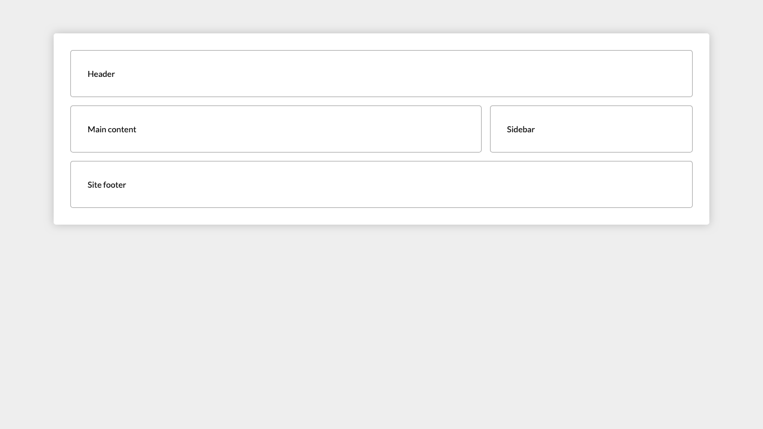
For full screenshot check the screenshot_[***px].png file in the folder for the task – (there is more than one screenshot)

Objective:
Create a webpage that looks like the screenshot above.

Requirements:
- File Setup:
  - Create an HTML document named simple-blog-layout.html
  - Create a CSS file named simple-blog-layout.css

Blog layout
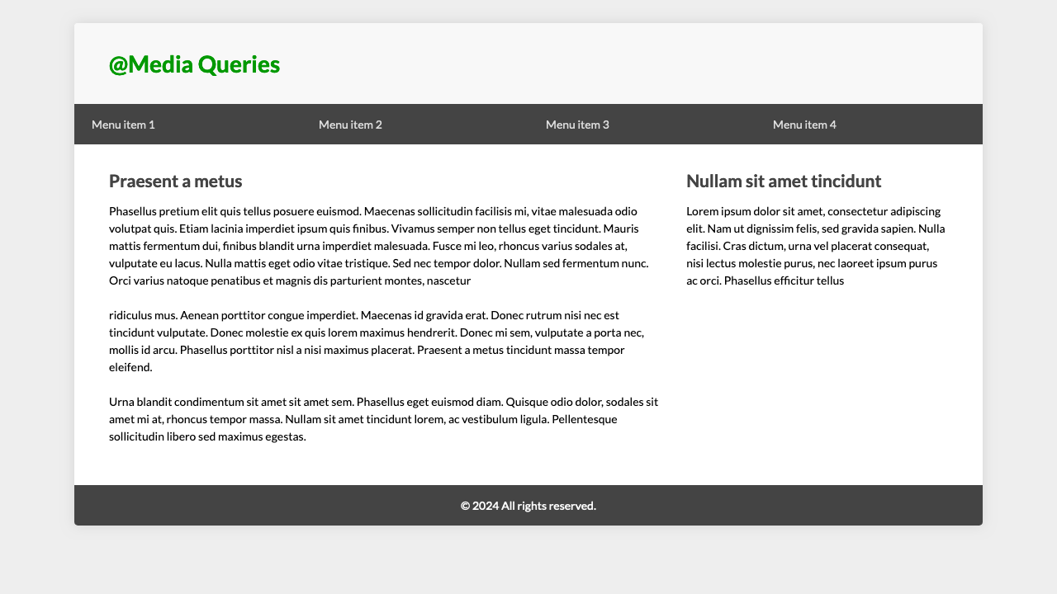
For full screenshot check the screenshot_[***px].png file in the folder for the task – (there is more than one screenshot)

Objective:
Create a webpage that looks like the screenshot above.

Requirements:
- File Setup:
  - Create an HTML document named blog-layout.html
  - Create a CSS file named blog-layout.css

Responsive typography
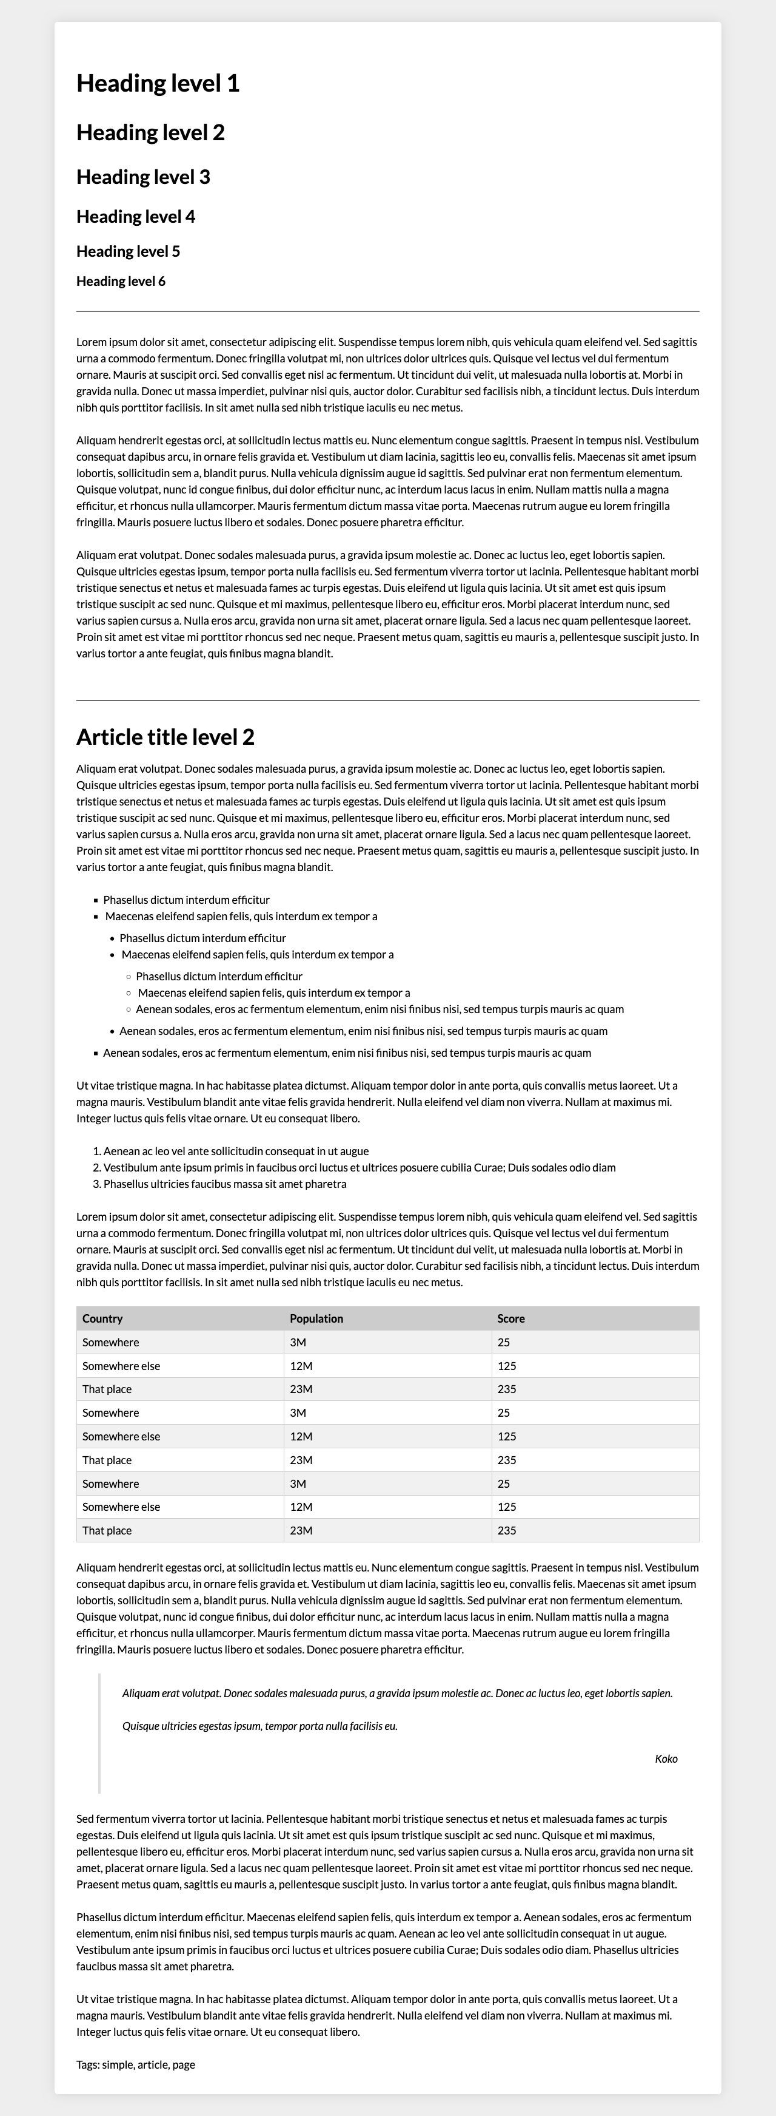
For full screenshot check the screenshot_[***px].png file in the folder for the task – (there is more than one screenshot)

Objective:
Create a webpage that looks like the screenshot above.

Requirements:
- File Setup:
  - Create an HTML document named responsive-typography.html
  - Create a CSS file named responsive-typography.css

Responsive tables
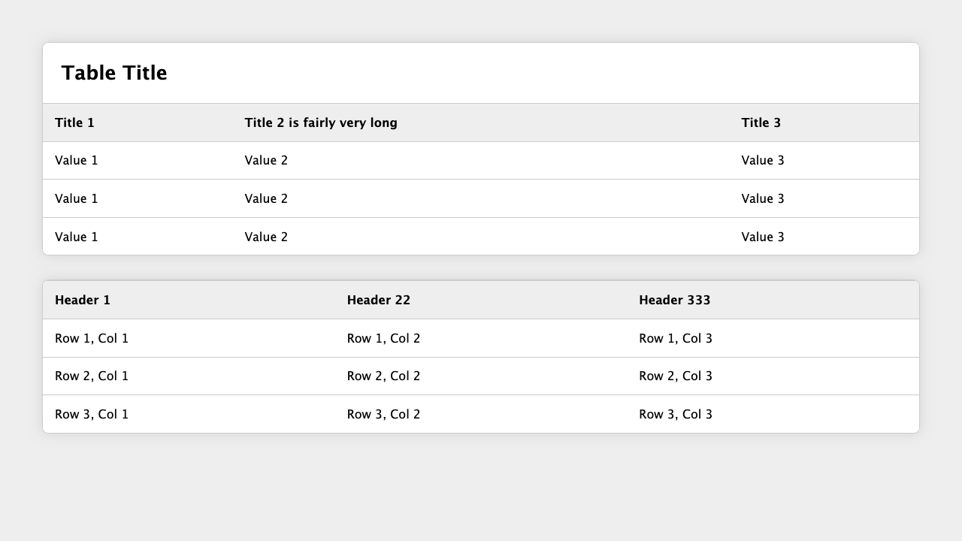
For full screenshot check the screenshot_[***px].png file in the folder for the task – (there is more than one screenshot)

Objective:
Create a webpage that looks like the screenshot above.

Requirements:
- File Setup:
  - Create an HTML document named responsive-tables.html
  - Create a CSS file named responsive-tables.css

Responsive navigation
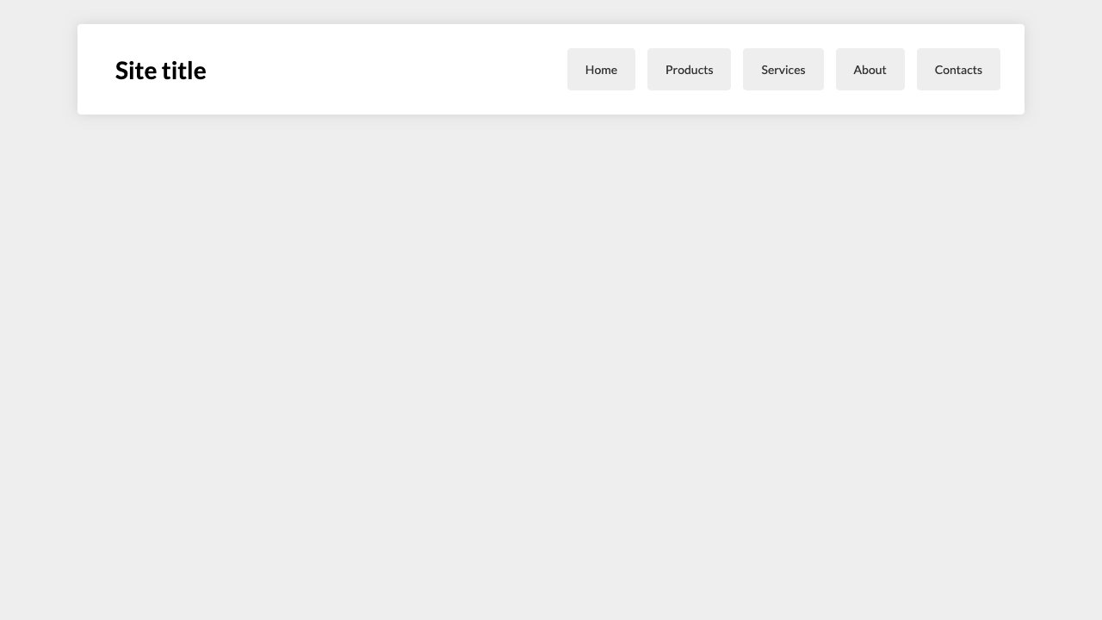
For full screenshot check the screenshot_[***px].png file in the folder for the task – (there is more than one screenshot)

Objective:
Create a webpage that looks like the screenshot above.

Requirements:
- File Setup:
  - Create an HTML document named responsive-navigation.html
  - Create a CSS file named responsive-navigation.css

Fancy Quotes
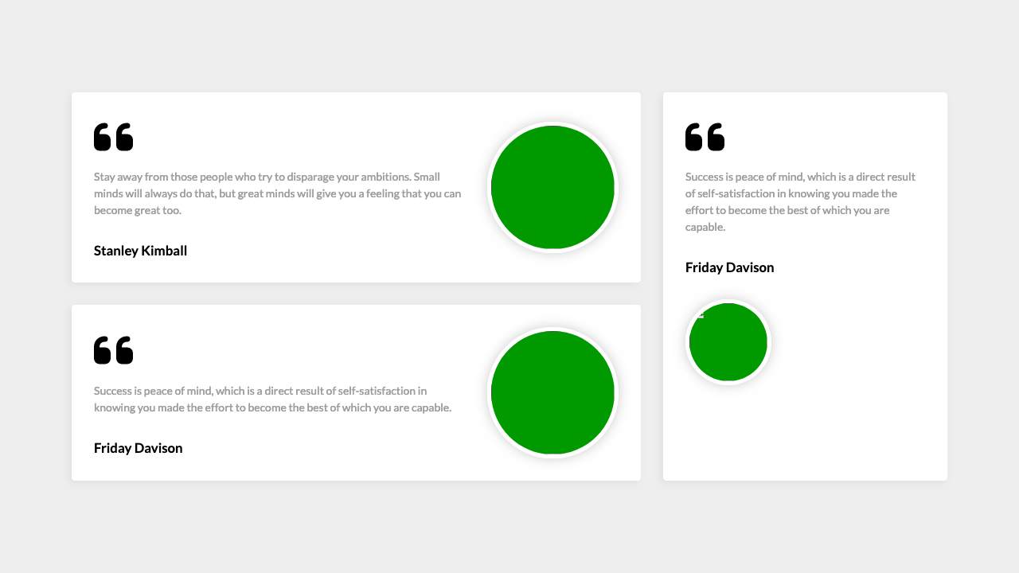
For full screenshot check the screenshot_[***px].png file in the folder for the task – (there is more than one screenshot)

Objective:
Create a webpage that looks like the screenshot above.

Requirements:
- File Setup:
  - Create an HTML document named fancy-quotes.html
  - Create a CSS file named fancy-quotes.css

Responsive Banner
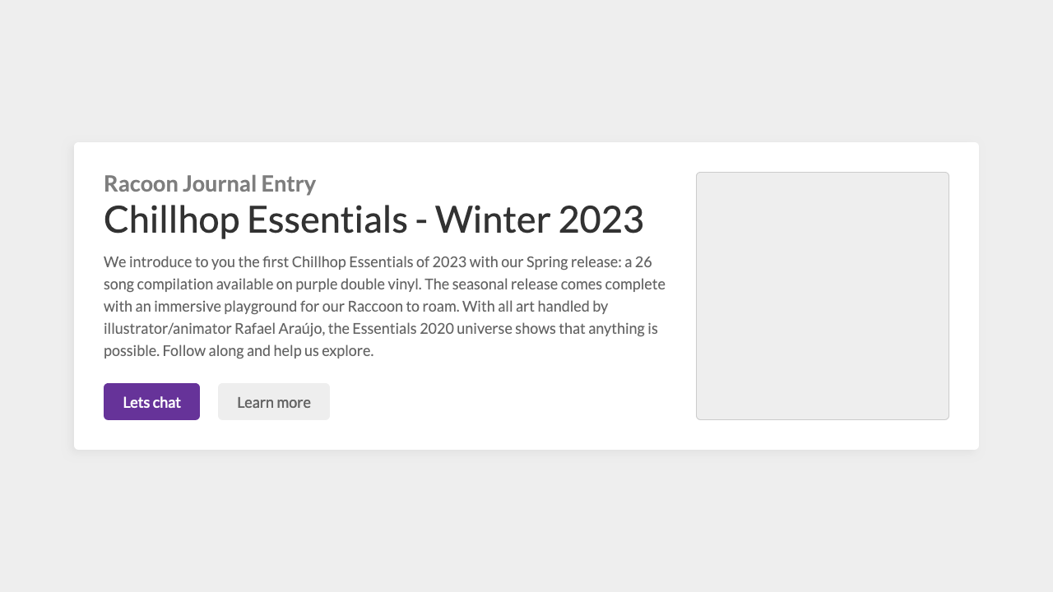
For full screenshot check the screenshot_[***px].png file in the folder for the task – (there is more than one screenshot)

Objective:
Create a webpage that looks like the screenshot above.

Requirements:
- File Setup:
  - Create an HTML document named responsive-banner.html
  - Create a CSS file named responsive-banner.css

Fancy numbered list
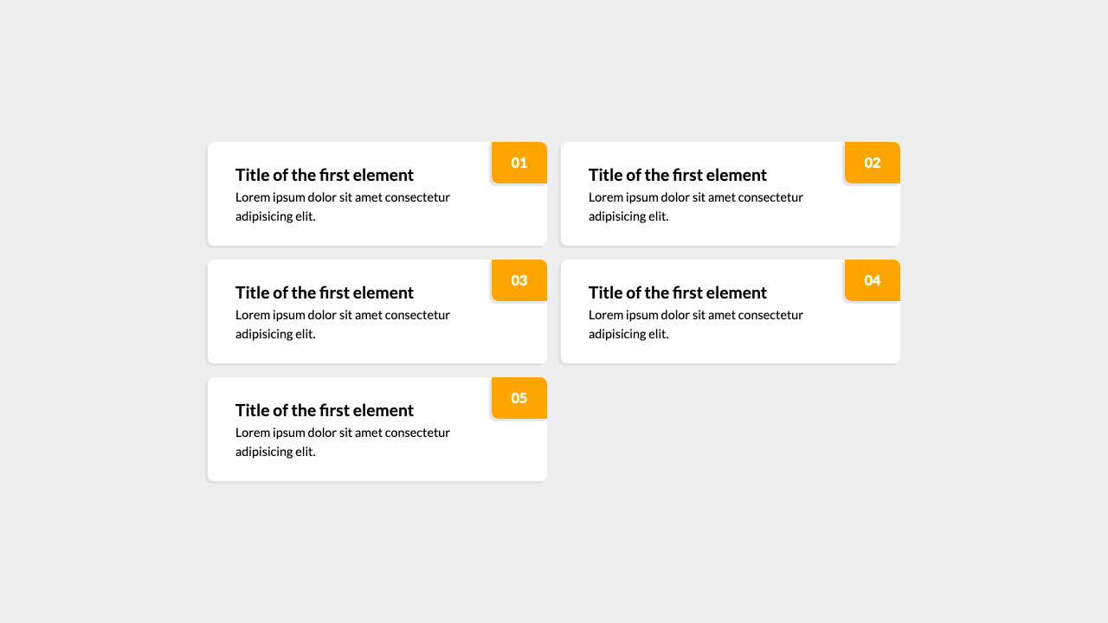
For full screenshot check the screenshot_[***px].png file in the folder for the task – (there is more than one screenshot)

Objective:
Create a webpage that looks like the screenshot above.

Requirements:
- File Setup:
  - Create an HTML document named fancy-numbered-list.html
  - Create a CSS file named fancy-numbered-list.css

Responsive vertical timeline
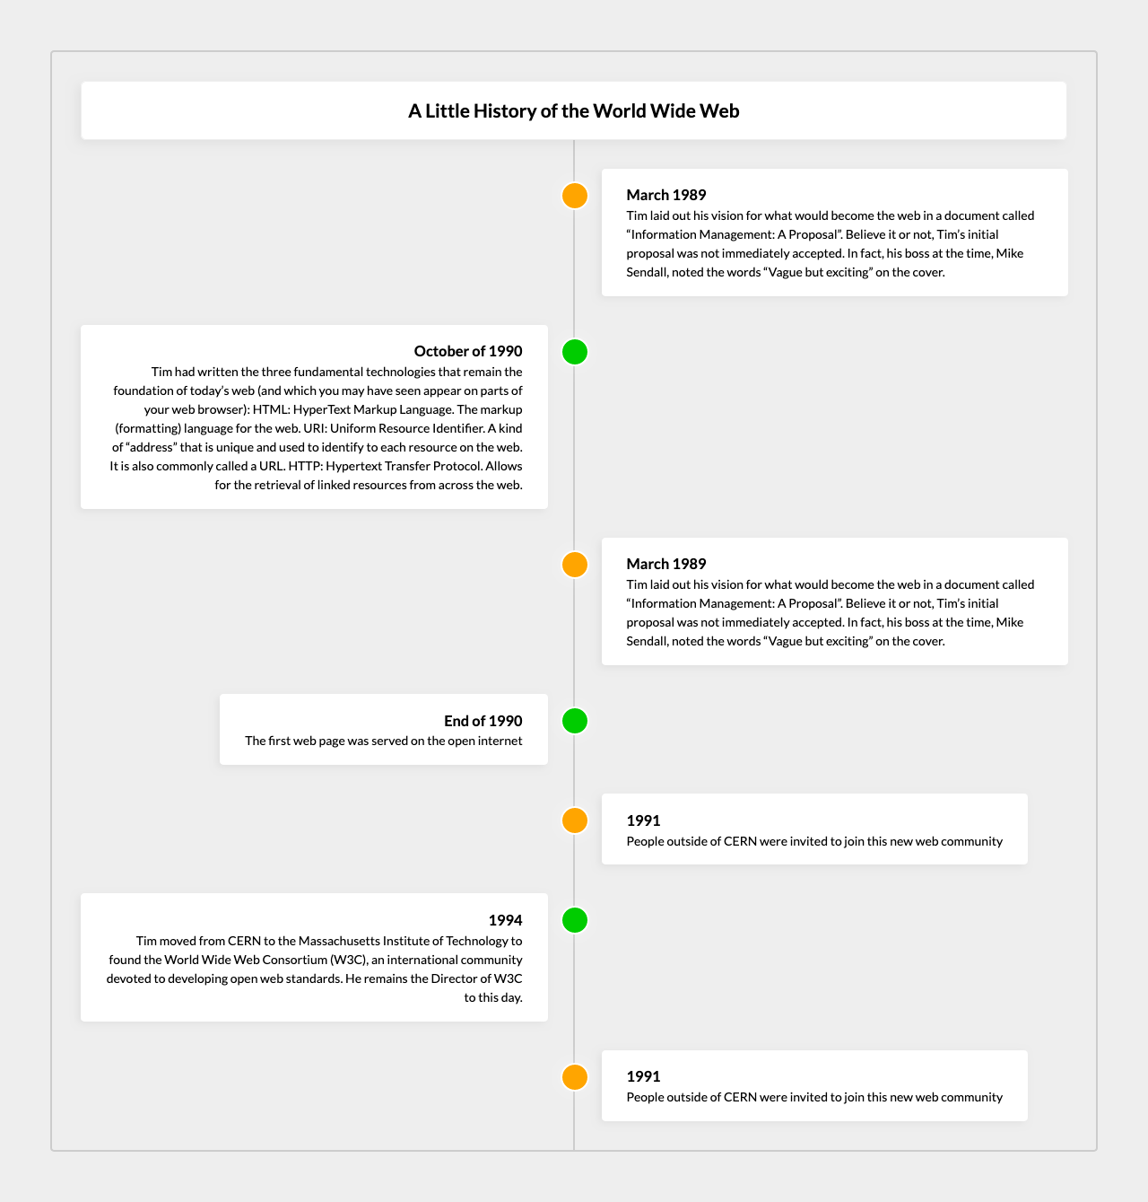
For full screenshot check the screenshot_[***px].png file in the folder for the task – (there is more than one screenshot)

Objective:
Create a webpage that looks like the screenshot above.

Requirements:
- File Setup:
  - Create an HTML document named responsive-vertical-timeline.html
  - Create a CSS file named responsive-vertical-timeline.css

Cards – Online course
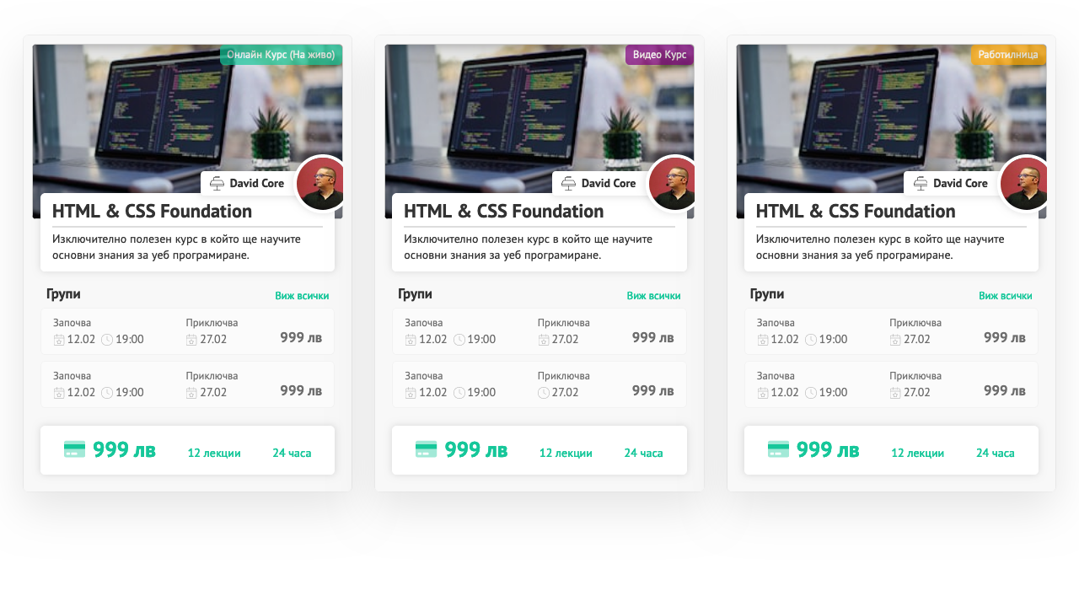
For full screenshot check the screenshot_[***px].png file in the folder for the task – (there is more than one screenshot)

Objective:
Create a webpage that looks like the screenshot above.

Requirements:
- File Setup:
  - Create an HTML document named card-online-course.html
  - Create a CSS file named card-online-course.css

