ESP8266EX Small Modules – Comparison
 |  |  |  |  |  | UA | RT |  |  | J | T | A | G
Module | Antenna (type) | Pin Layout (pitch) | W x L  (mm) | VCC | GND | URXD | UTXD | GPIO0 | GPIO2 | GPIO12 | GPIO13 | GPIO14 | GPIO15 | GPIO16 | CH_PD | RESET | Antenna | (NC) | Comments
ESP-01 | Built-in  (on PCB) | 2x4 header  0.1” | 14.3 x 24.8 | ✓ | ✓ | ✓ | ✓ | ✓ | ✓ |  |  |  |  | ✓ |  | ✓ |  |  | The most common module with printed PCB antenna
ESP-02 a | External  (U.FL conn.) | DIP 8-pin  0.1” | 14.7 x 14.2 | ✓ | ✓ | ✓ | ✓ | ✓ | ✓ |  |  |  |  |  | ✓ | ✓ |  |  | A less common module, may be compatible with breadboards
ESP-02 b |  |  | 14.2 x 14.2 | ✓ | ✓ | ✓ | ✓ | ✓ | ✓ |  |  |  | ✓ |  |  | ✓ |  |  | New version?
ESP-02de |  |  | ? | ✓ | ✓ | ✓ | ✓ | ✓ | ✓ |  |  |  |  |  | ✓ | ✓ |  |  | Alternate pinout version of “a”?
ESP-03 | Built-in (ceramic)+pin | SMT 14-pin  2mm | 12.2 x 17.4 | ✓ | ✓ | ✓ | ✓ | ✓ | ✓ | ✓ | ✓ | ✓ | ✓ | ✓ | ✓ |  | ✓ | ✓ | Surface mount, many I/O  (voted most wanted)
ESP-04 | External  (pin) | SMT 14-pin  2mm | 12.0 x 15.0 | ✓ | ✓ | ✓ | ✓ | ✓ | ✓ | ✓ | ✓ | ✓ | ✓ | ✓ | ✓ |  | ✓ | ✓ | Same as ESP-03 without built-in antenna
ESP-05 a | External  (U.FL conn.) | 1x4 header  0.1” | 14.2 x 14.2 | ✓ | ✓ | ✓ | ✓ |  |  |  |  |  |  |  |  |  |  |  | Simple UART-only module with antenna connector
ESP-05 b |  | 1x5 header | 14.2 x 14.2 | ✓ | ✓ | ✓ | ✓ |  |  |  |  |  |  |  |  | ✓ |  |  | New version?
ESP-06 | External  (pin) | bot. mount  2.6/2.9mm | 13.1 x 16.3 | ✓ | 4 | ✓ | ✓ | ✓ | ✓ | ✓ | ✓ | ✓ | ✓ | ✓ | ✓ |  | ✓ |  | FCC CE metal shield
ESP-07 | U.FL + Built-in (ceramic)+pin | semi-hole  2mm | 16.0 x 20.0 | ✓ | ✓ | ✓ | ✓ | ✓ | ✓ | ✓ | ✓ | ✓ | ✓ | ✓ | ✓ |  | ✓ | ✓ | FCC CE metal shield
ESP-08 | External  (pin) | semi-hole  2mm | 16.0 x 17.0 | ✓ | ✓ | ✓ | ✓ | ✓ | ✓ | ✓ | ✓ | ✓ | ✓ | ✓ | ✓ |  | ✓ | ✓ | Like ESP-07 minus built-in antenna
ESP-09 | External  (pin) | bot. mount  1.9mm | 10.0 x 10.0 | ✓ | 4 | ✓ | ✓ | ✓ | ✓ | ✓ | ✓ | ✓ | ✓ |  | ✓ | ✓ | ✓ |  | Ultra-small footprint, 4-layer, 1MB flash
ESP-10 | External  (extra hole) | 1x5 edge? | 10.0 x 14.2 | ✓ | ✓ | ✓ | ✓ |  |  |  |  |  |  |  |  | ✓ |  |  | Narrow body, for light w/controller
ESP-11 | Built-in (ceramic) | 1x8 edge? | 13.0 x 18.0 | ? | ✓ | ? | ? | ✓ | ✓ |  |  |  |  |  | ? | ? |  |  | Small size
CH_PD = Chip Powerdown = CHIP_EN (tied also to reset if no separate reset line ???)
Is this meaningful to mention?: ESP-09 impedance matching through the bottom mount technology
And some pictures:
Module | Module Pinout | Picture
ESP-01 | 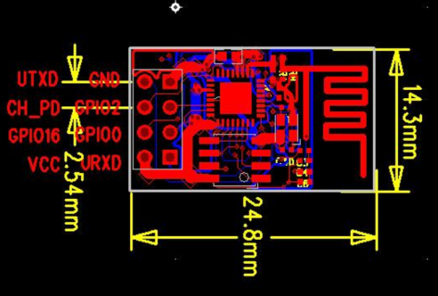 | 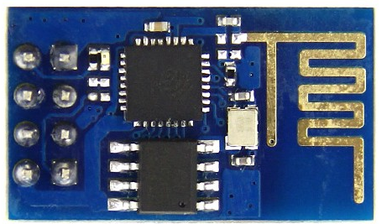
ESP-02 “a”  (“a” and “b” and “de” are not official; added to distinguish) | 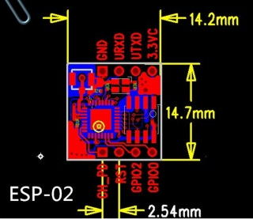 | ?
ESP-02 “b” | 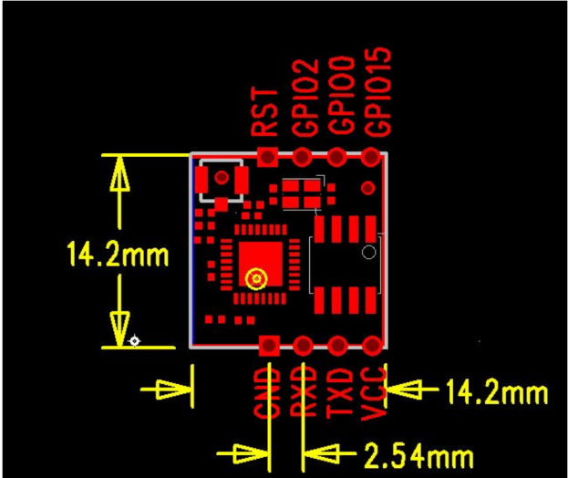 | 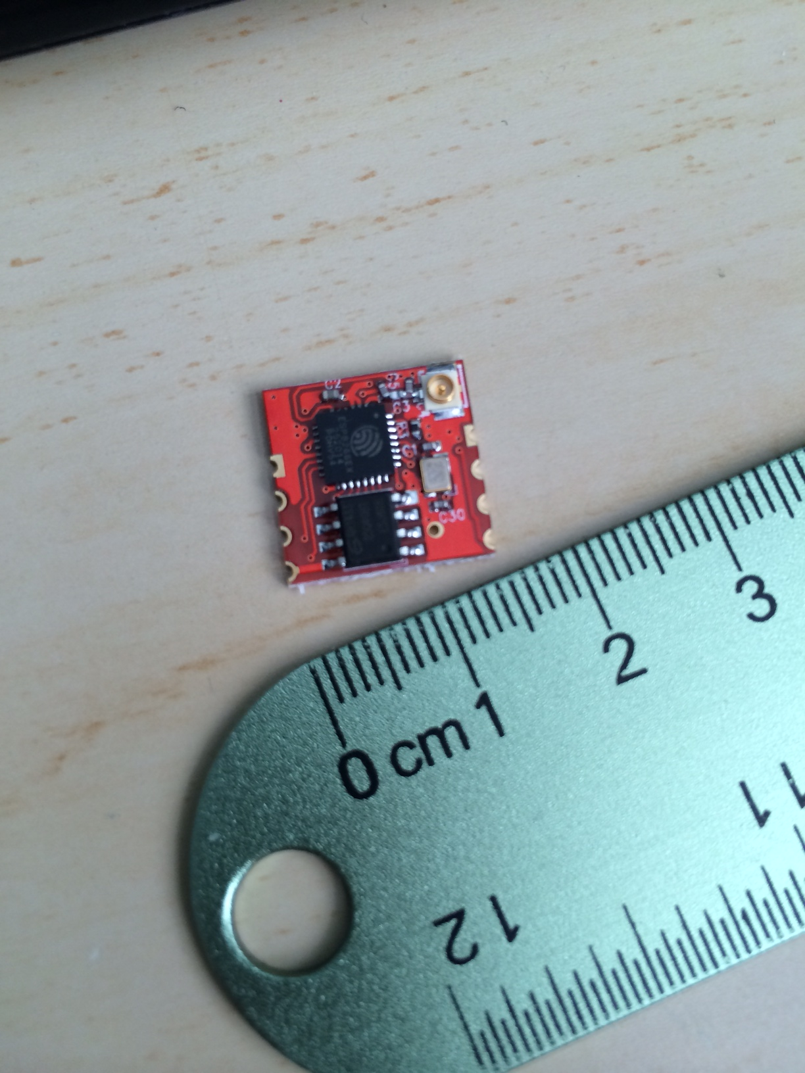
ESP-02 “de” | (see picture on right)  From https://ex-store.de/Funk/Wireless-Netzwerk/ESP8266-ESP-02-Version-2-WIFI-Wlan2Serial::161.html | 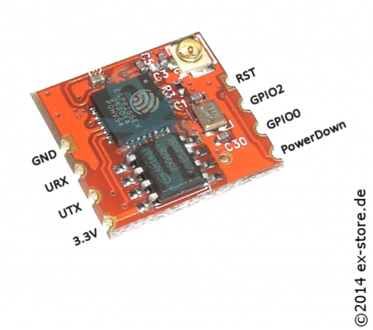
ESP-03 | 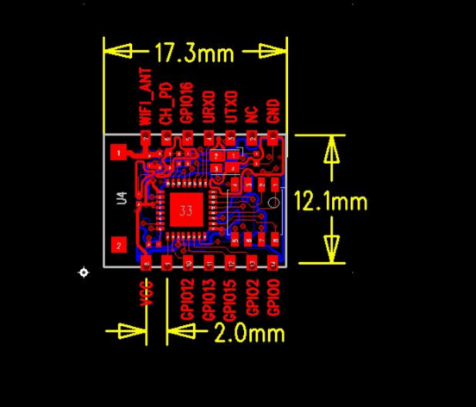 | 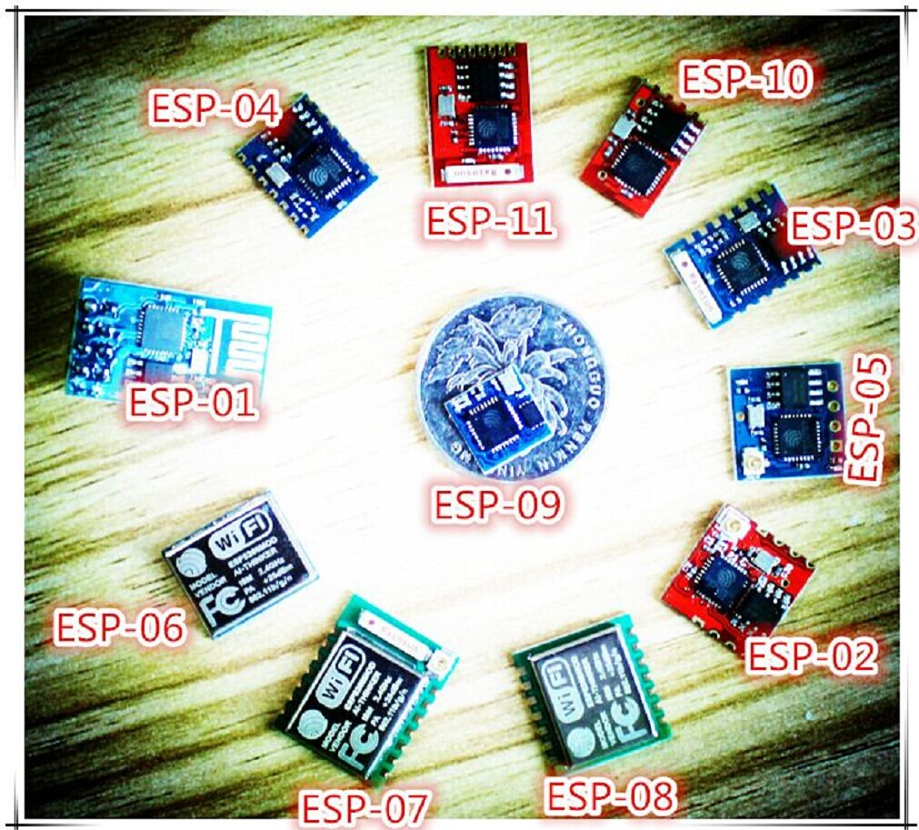
ESP-04 | 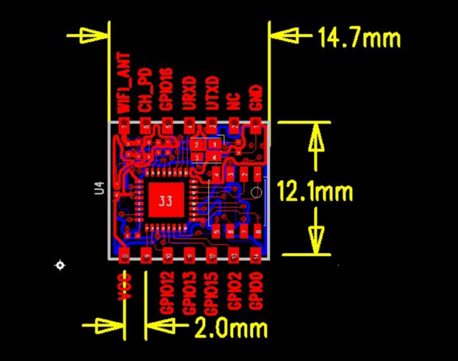
ESP-05 “a” (“a” and “b” are not official; added to distinguish) | 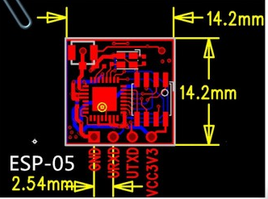
ESP-05 “b” | 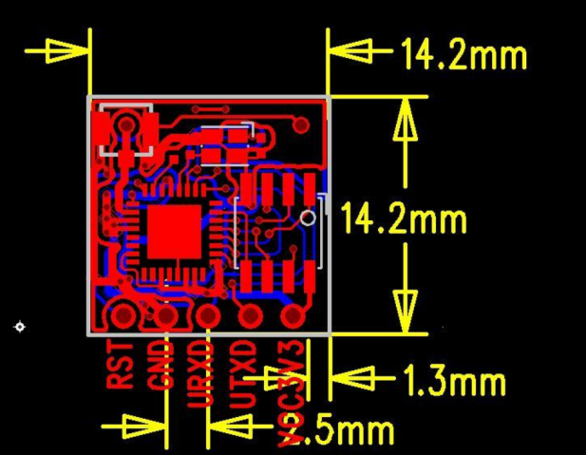 | ?
ESP-06 | 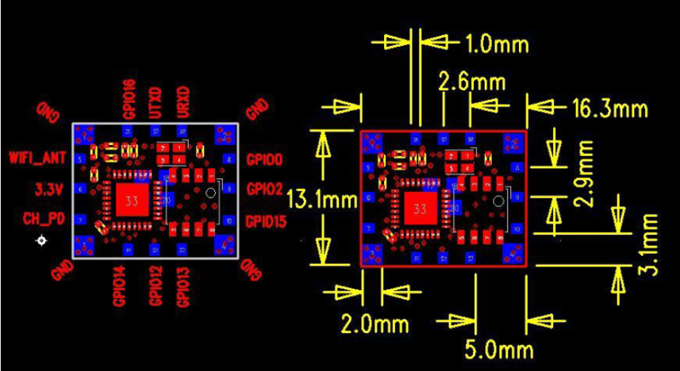
ESP-07 | 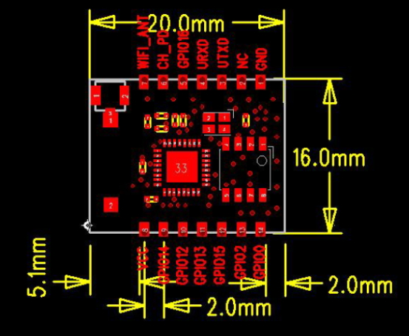
ESP-08 | 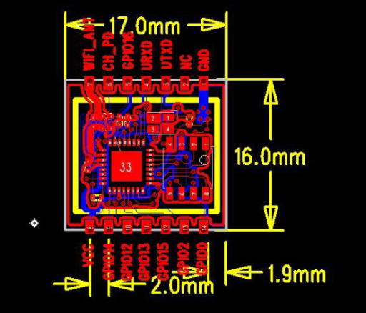
ESP-09 | 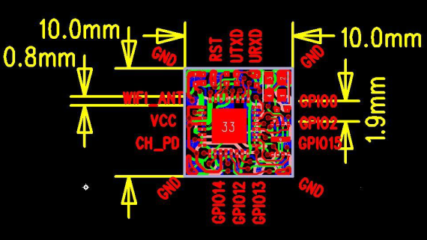
ESP-10 | 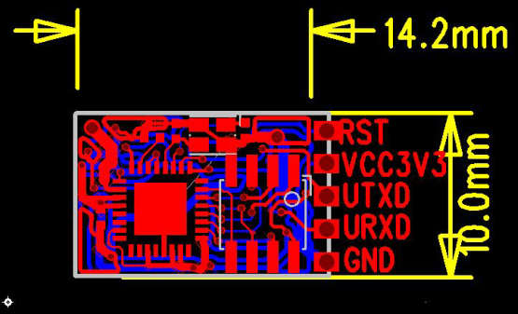
ESP-11 | 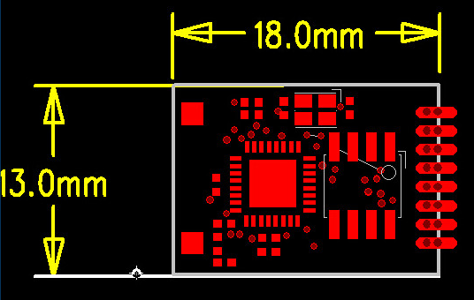

Dual Inline Package, two rows of pins, on both sides of module
Surface Mount Technology, with pins as castellated pads, on both sides of module

