WEEK 4 · HOMEWORK 2 SQL-II

Week 4. Homework 2. SQL-II

Submission Guidelines

- Dataset: You must use the provided IMDB.sqlite dataset to answer all questions.
- Code and Output: Copy your code and attach screenshots of your outputs under each question.
- Submission Format: Each student is required to push one Word or PDF file to a designated GitHub repository you create specifically for this week's assignment.
- Repository Name: Use the format Week 4-HW2-LastName, where LastName is your last name.
- Code Quality: Ensure your code is organized for easy understanding.
- AI Usage: You should make a serious attempt at each problem prior to using an LLM. Remember, you may be tested on SQL knowledge without assistance in a technical interview. If prompting an LLM, I suggest telling it your starting point, your thought process, and asking it to guide you. I've done this learning SQL and it is helpful and I learned more that way. Disclose your usage at the end of the file; you will not be penalized regardless, but this give me some information.

Questions

Date-Based Queries

1. Find the First and Last Movie Released Each Year
Retrieve the first and last movie released in each year. Display the year, first movie title, and last movie title.
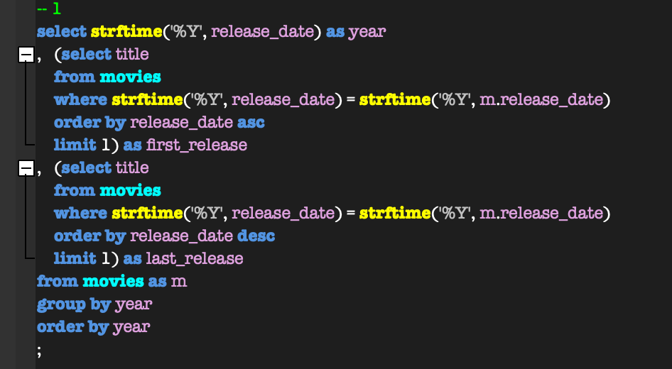
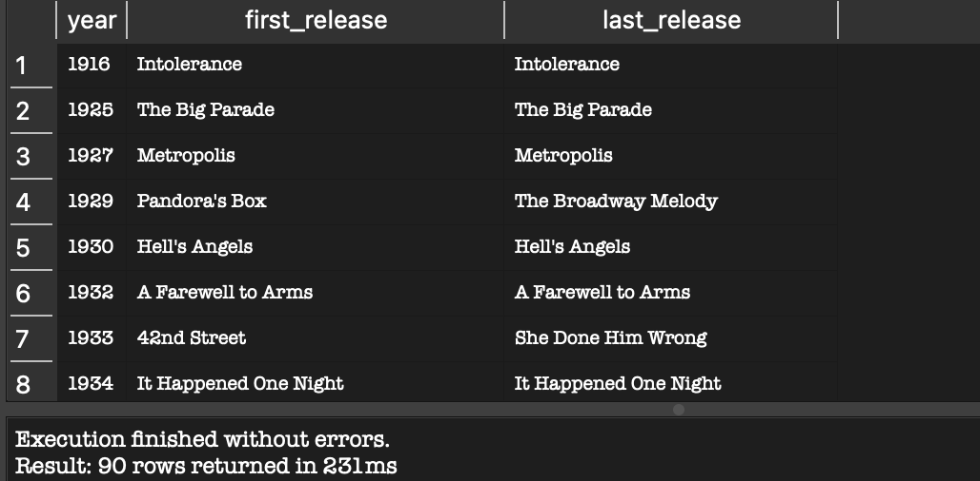

2. Total Revenue Generated Each Year
Calculate the total revenue generated by movies released in each year. Display the year and total revenue, ordered by revenue in descending order.
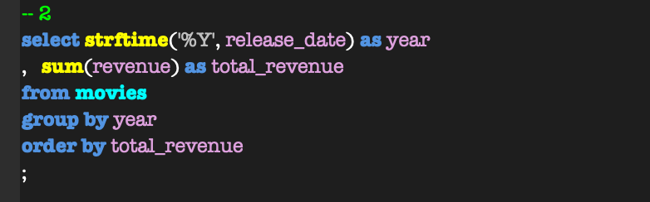
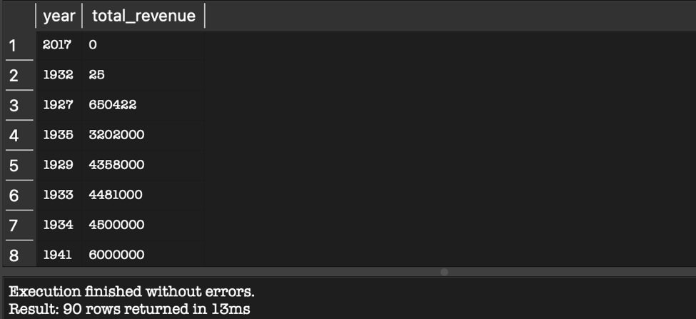

3. Movies Released in the First Half of the Year
Find all movies that were released between January and June. Display the movie title, release date, and director name.
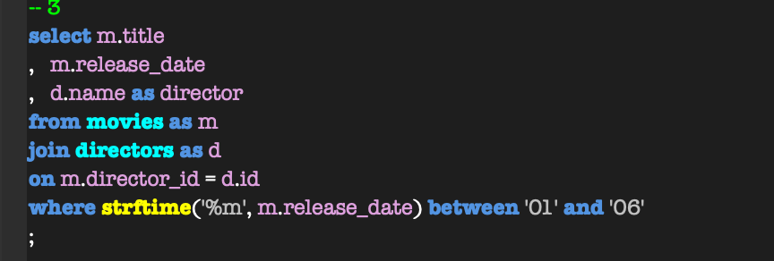

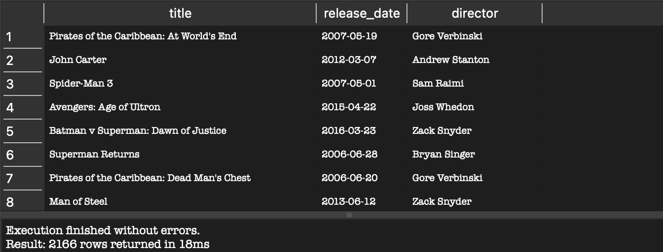

4. Number of Movies Released on Weekends
Count the total number of movies released on a weekend (Saturday or Sunday). Use SQLite's strftime('%w') to determine the day of the week (0 = Sunday, 6 = Saturday).



CASE Statement Queries

5. Categorize Directors Based on Total Revenue
DATA 4381 · Week 4 Homework 2 · SQL-II · 1

WEEK 4 · HOMEWORK 2 SQL-II

Classify directors based on the total revenue of their movies:
- High Revenue if total revenue > $1 billion
- Moderate Revenue if total revenue is between $500 million and $1 billion
- Low Revenue if total revenue < $500 million
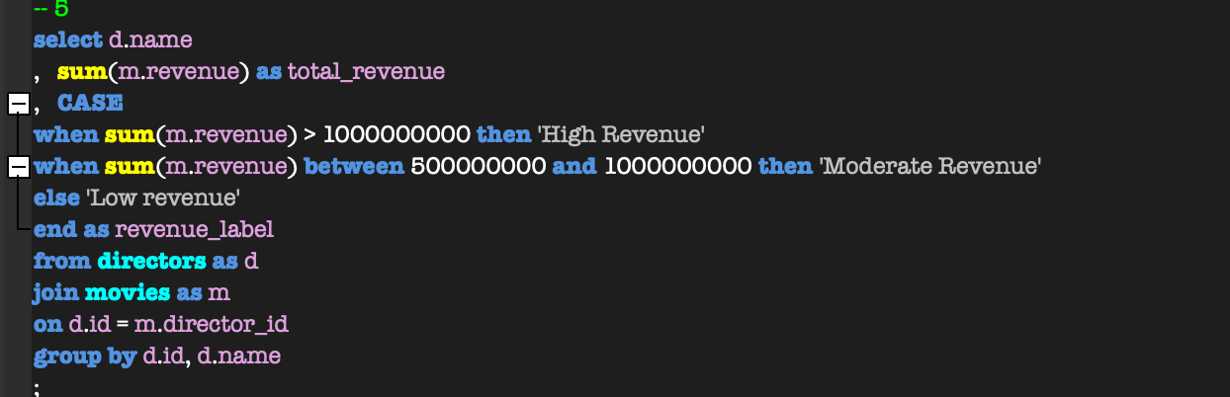
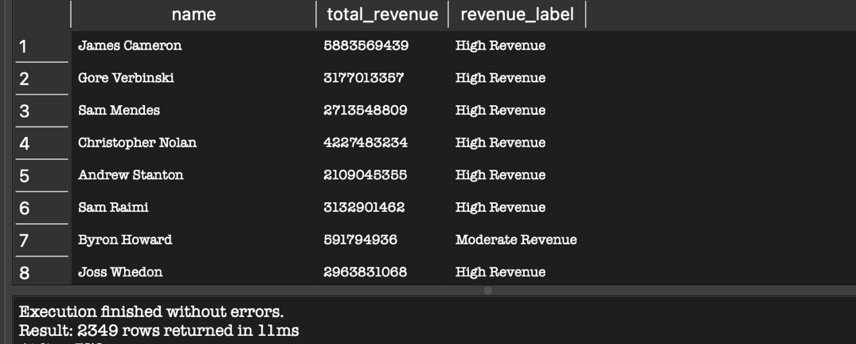

6. Movies Based on Popularity and Revenue
Classify movies into the following categories based on popularity and revenue:
- Blockbuster if popularity > 100 and revenue > $500 million
- Hit if popularity > 50 and revenue between $100 million and $500 million
- Average for all other movies
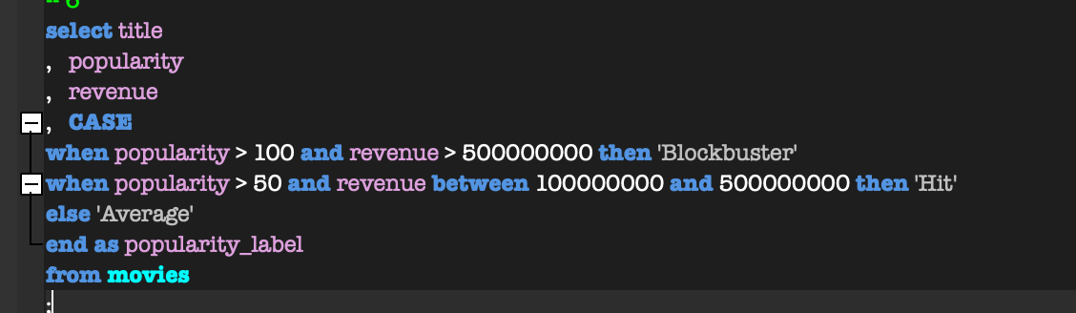
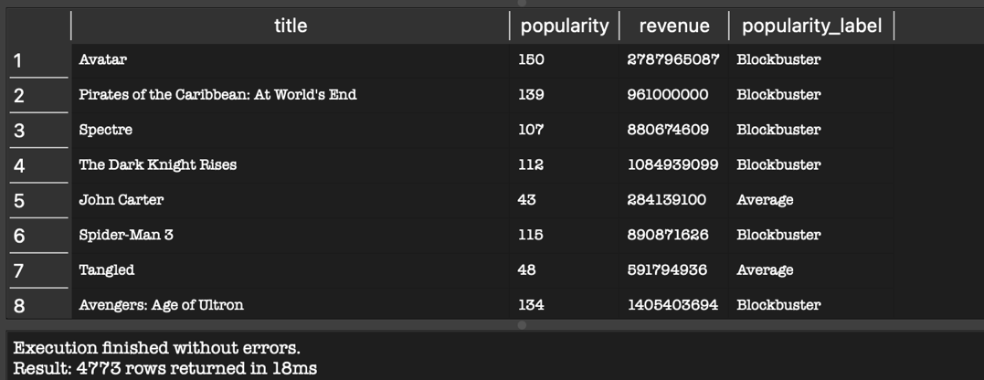

7. Directors with Critically Acclaimed and Poorly Rated Movies
List directors and count how many of their movies fall into these categories:

- Critically Acclaimed if vote_average >= 8
- Poorly Rated if vote_average < 5
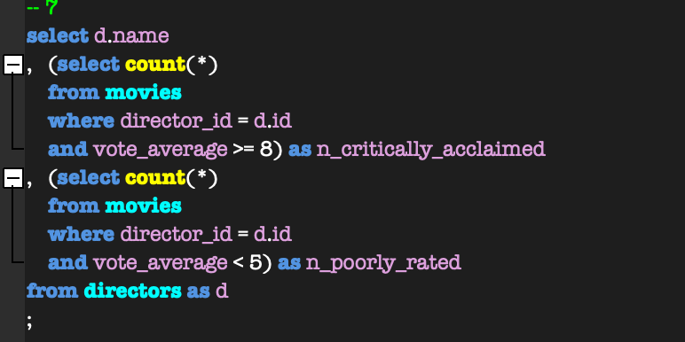
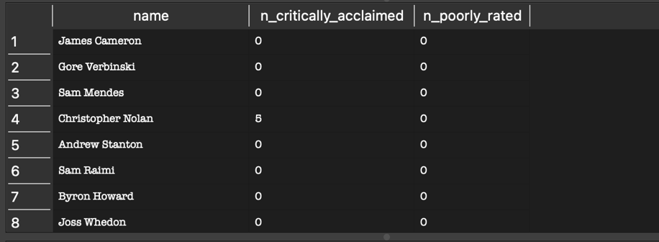

AI Usage:
Questions 2-7 were answered organically. Whereas I did struggle a bit with q.1. I could not figure out how to implement certain things properly so after about 30 mins at attempting it, I asked ChatGPT for methods to do so, building off what already had written. My prompt was something like: ‘Given my current script: ___ Was are some methods of adding …’ I did fully look through each method and made an effort to fully understand them. From there I figured out I somehow hadn’t considered subqueries, so rewrote my query using this because it felt the most straightforward and was quickest to understand.

DATA 4381 · Week 4 Homework 2 · SQL-II · 2

