Week 3. Homework 1. SQL Basic
Due date: September 12, 11:59 pm

Submission Guidelines
- Dataset: You must use the provided IMDB.sqlite dataset to answer all questions.
- Code and Output: Copy your code and attach screenshots of your outputs under each question.
- Submission Format: Each student is required to push one Word or PDF file to a designated GitHub repository you create specifically for this week's assignment.
- Repository Name: Use the format Week 3-HW1-LastName, where LastName is your last name.
- Code Quality: Ensure your code is organized for easy understanding.
- AI Usage: You should make a serious attempt at each problem prior to using an LLM. Remember, you may be tested on SQL knowledge without assistance in a technical interview. If prompting an LLM, I suggest telling it your starting point, your thought process, and asking it to guide you. I’ve done this learning SQL and it is helpful and I learned more that way. Disclose your usage at the end of the file; you will not be penalized regardless, but this give me some information.

Questions

1. Directors and Their Departments
List the names of all directors along with their respective departments.
select name
, department
from directors
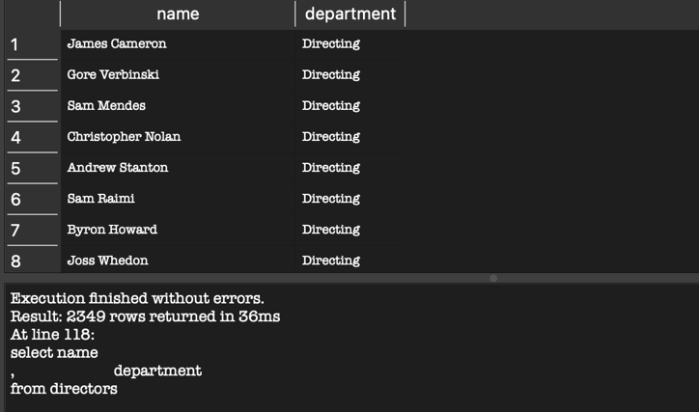

2. Popular Movies
Find the titles of all movies with a popularity score greater than 5.
select title
, popularity
from movies
where popularity > 5
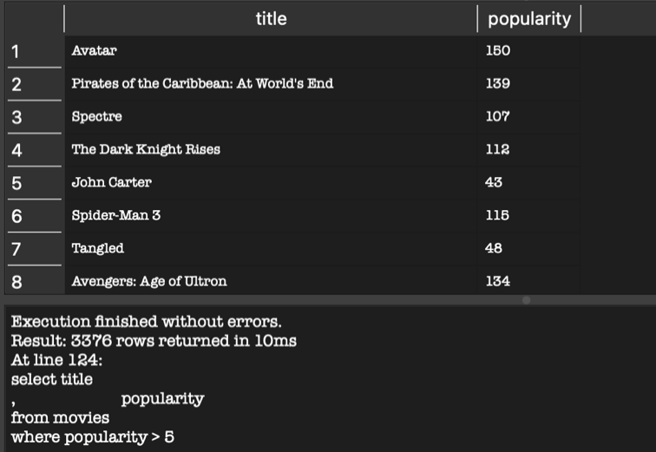

3. Directors in the Directing Department
Retrieve the names and IDs of directors who are in the 'Directing' department and have a gender value of '2'.
select name
, id
, gender
, department
from directors
where (department = 'Directing')
and (gender = '2')
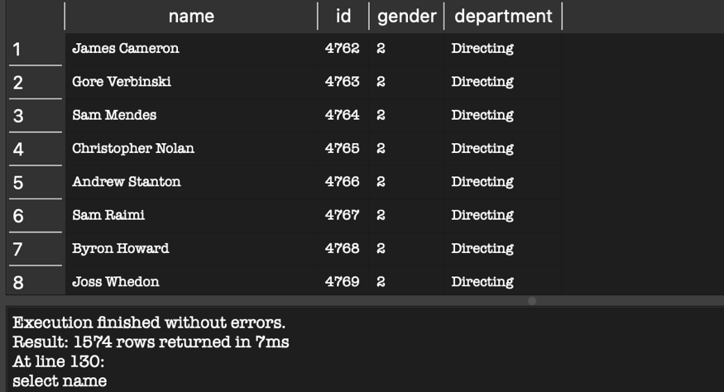

4. Directors with 'Sam' in Their Name
Find all directors whose names include the word 'Sam'.
select name
from directors
where name like '%Sam%'
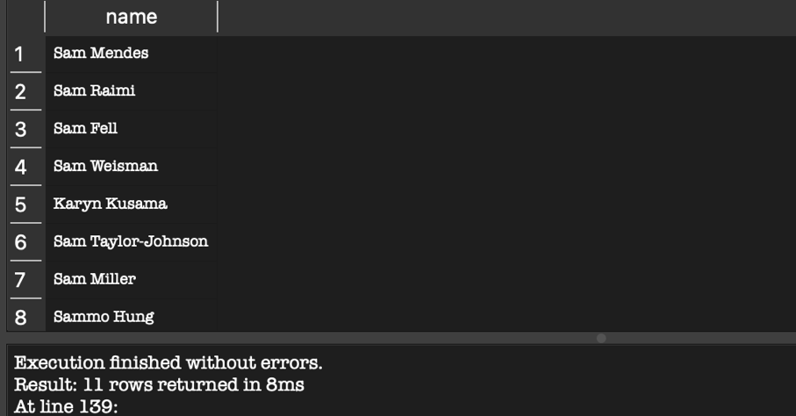

5. First 10 Movies by Release Date
Show the first 10 movies in the database, sorted by release date in ascending order.
select *
from movies
order by release_date
limit 10
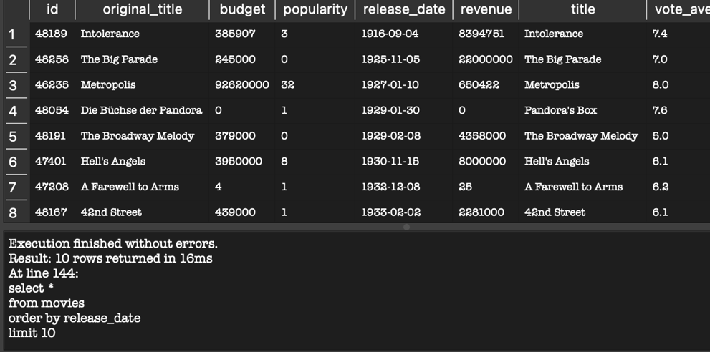

6. 'Star' Movies with High Ratings
List all movies with the word 'Star' in the title and a vote average greater than 7.
select title
, vote_average
from movies
where (title like '%Star%')
and ( vote_average > 7)
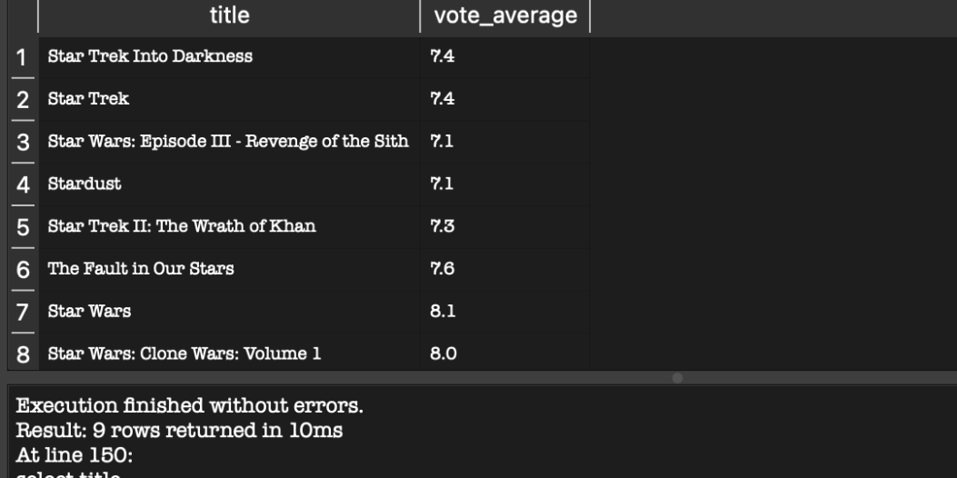

7. Movies with Limited Revenue (1995–2000)
Find the titles of movies released between January 1, 1995, and December 31, 2000, with revenues not exceeding 10 million.
select title
, release_date
, revenue
from movies
where (release_date between '1995-01-01' and '2000-12-31')
and (revenue <= 10000000)
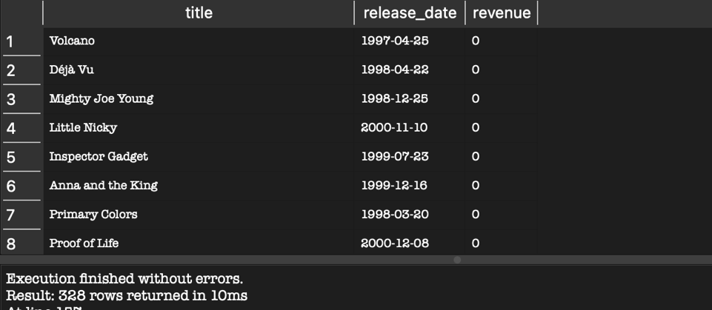

8. Directors with Specific 'uid' Values
List the names of directors who have a uid greater than 7,000 or less than 100.
select name
, uid
from directors
where uid > 7000
or uid < 100
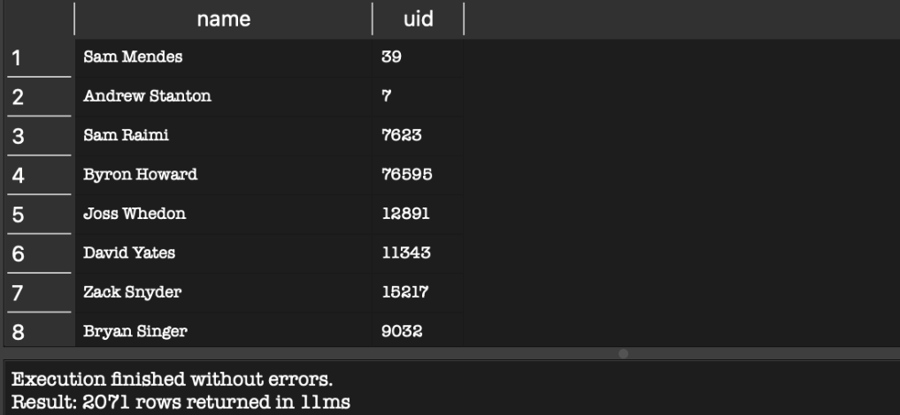

9. Movies with Specific Vote Counts
Retrieve the titles of movies that have:
- A vote counts between 50 and 100, inclusive.
- A vote average of exactly 7.0.
select title
, vote_count
, vote_average
from movies
where (vote_count between 50 and 100)
and (vote_average = 7.0)
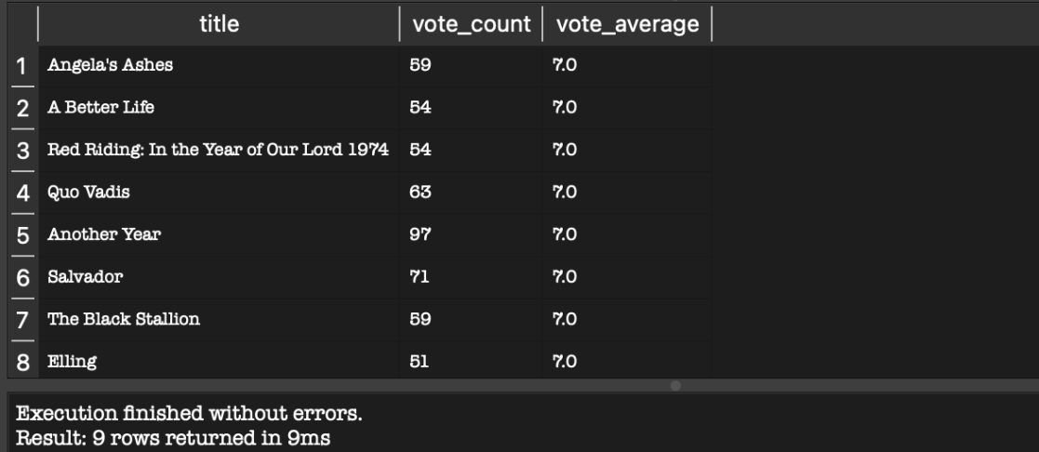

10. Directors Named 'John' with Specific 'uid' Values
Find the names of directors who:
- Have 'John' in their name.
- Have a uid between 5,000 and 10,000 (exclusive).
select name
, uid
from directors
where (name like '%John%')
and uid > 5000
and uid < 10000
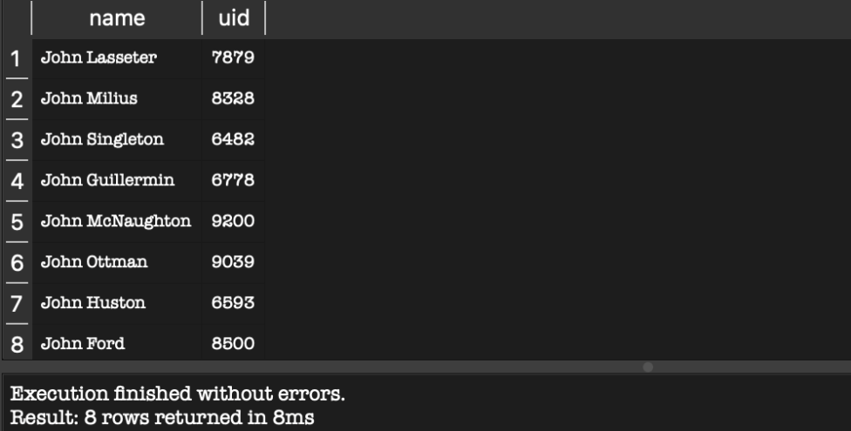

11. Movies with Odd 'uid' and Even Vote Count
Retrieve the titles of movies that meet the following criteria:
- The uid is an odd number.
- The vote count is an even number and greater than 500.
select title
, uid
, vote_count
from movies
where ((uid % 2) != 0)
and ((vote_count % 2) = 0)
and (vote_count > 500)
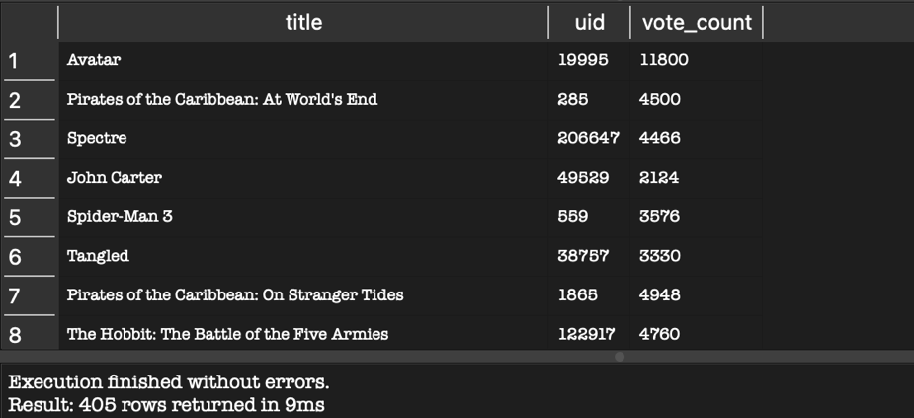

12. Movies with Specific Ratings or Budgets
Find the titles of movies that meet any of the following criteria:
- Have a vote average between 6.0 and 8.0, with a vote count of exactly 200.
- OR have a budget greater than 100,000 but less than 500,000.
select title
, vote_average
, vote_count
, budget
from movies
where ((vote_average between 6.0 and 8.0) and (vote_count = 200))
or ( budget > 100000 and budget < 500000)
