

### 

Contents

Problem Definition 2

Literature Review 3

Model formulations 4

Analysis 5

Recommendations 7

Future Work 8

Appendix 9

References 12

Team Work Plan 14

### Code

Please see <https://github.com/espeigle36/points-of-dispense> for code, Jupyter notebooks, and the ArcGIS geodatabase.

### Problem Definition

Public health emergencies take many forms, from infectious disease outbreaks to terrorist attacks. Systems to quickly create and maintain medical and nutritional assistance and distribute information to citizens can have life-saving consequences. To prepare for these disasters, Allegheny County can set up points of dispense (PODs) to provide essential medicine and emergency care to residents in need. This project will determine the optimal distribution of sites from among 47 candidate PODs in Allegheny County to distribute these essential supplies and medicines.

**Scope**

Effective allocation of resources is critical in emergency response situations. In events such as an outbreak or natural disaster, misplaced or underutilized resources such as vaccines or field hospitals put human lives at risk. This paper presents a Point of Dispense (POD) location model under 3 different scenarios within Allegheny County, Pennsylvania:

1. *Global* Coronavirus outbreak: Ongoing COVID-19 outbreak
2. *Local* Natural disaster: Flooding in eastern Allegheny County
3. *Local* Anthrax attack: Release of inhalation anthrax over the Central Business District of the City of Pittsburgh affecting central Allegheny County

For the purposes of this project, we use the term “scenario” as an independent and discrete event. We will create models that assume we know the event first and then build the model to suit the particulars of each scenario. We perform a sensitivity analysis on the number of PODs to open in each scenario.

**Assumptions**

1. A local disaster, such as a flood, presumes an expected number of victims. For a local disaster, the location of the disaster is known, we assume that POD serves as a triage site and places greater weight on minimizing the distance traveled for the first wave of victims who are closest to the natural disaster.
2. We assume no spillover effect. Each area is served by only one POD. We also assume each POD has infinite capacity to serve those areas.
3. We assume time is static and that a POD can serve everyone at a single time.
4. We assume wind does not affect the spread of anthrax.
5. We assume the anthrax attack would only affect people *living* in the downtown Census block groups, not downtown workers who live elsewhere.
6. The models assume that people have access to a car and can drive to their designated POD or that car driving distance is a sufficient proxy for time spent on public transportation.

**Data**

Our model uses two primary sources of data. One is a list of pre-selected points of dispense as a “menu of options” for potential sites to open in an emergency that includes location and general information. We also collected data from the U.S. Census Bureau on the number of people and households in each of the 1,100 Allegheny County block groups. We also collected data on car ownership rates for each block group. Given the geographic nature of this problem, we collected data on the population-weighted centroid of each block group and its GIS shapefile. Finally, to estimate which block groups might be affected in the flood and anthrax scenarios, we used Commonwealth of Pennsylvania data on flood zones and academic literature to select block groups that might be affected by floods in Allegheny County as well as the area where an anthrax attack might occur - the Central Business District in downtown Pittsburgh.

For more specific information on the data plan, refer to the References and Appendix I.

### Literature Review

The flooding and anthrax scenarios assume a local emergency confined to a narrow number of Census Block Groups within the county while Covid 19 scenario assumes community spread of the disease throughout the county. This report will present 2 different optimizations: (1) minimize the maximum total distance any resident must travel to reach a POD and (2) minimize the maximum distance any single resident must travel to reach a POD.

While both anthrax and COVID-19 represent a public health emergency, there are striking differences in how emergency management professionals must prepare in each attack. The fundamental difference between an Anthrax attack and COVID-19 is that anthrax is not contagious from person to person, although it can be spread through contaminated water and food [(Anon n.d.)](http://f1000.com/work/citation?ids=8569731&pre=&suf=&sa=0). For simplification, our model assumes the Allegheny County water supply has not been contaminated.  Another distinguishing characteristic of anthrax is the high rate of mortality. If inhaled, anthrax has a mortality rate of over 80% within 48 hours [(Webb 2003)](http://f1000.com/work/citation?ids=1675730&pre=&suf=&sa=0). Abay et al (2006) and Lee et al. (2006) create models to minimize the amount of time spent building a field hospital or minimizing the time spent within a POD so as to increase the number of people treated [(Aaby et al. 2006)](http://f1000.com/work/citation?ids=8569777&pre=&suf=&sa=0) [(Lee et al. 2006)](http://f1000.com/work/citation?ids=8569742&pre=&suf=&sa=0).

Unlike anthrax, infectious diseases such as COVID-19 require PODs that can be easily accessible to an entire community. While many anthrax models seek to model arrival rate in order to increase shelter capacity, PODs of infectious diseases must carefully model the arrival rate of patients to prevent increased exposure and disease spread.  Ablah et al (2010) suggest that in this instance, a centralized model of dispensing where people from different locales arrive works well for infectious diseases because “dry-through” clinics can be used to minimize contact between patients and clinicians [(Ablah et al. 2010)](http://f1000.com/work/citation?ids=8566033&pre=&suf=&sa=0). This drive-through clinic model is starting to be widely used across the United States for COVID-19 testing [(Anon n.d.)](http://f1000.com/work/citation?ids=8569800&pre=&suf=&sa=0).

 A natural disaster event, such a flood presents a unique problem. Kara and Savaer (2017) state that while a facility location model is critical to providing disaster relief, many natural disaster relief projects must also take the form of a routing problem [(Kara and Savaşer 2017)](http://f1000.com/work/citation?ids=5299231&pre=&suf=&sa=0). In the event of a flood, it is highly likely that key infrastructure, such as roads, may be destroyed or damaged. An effective disaster response plan is one that combines a facility location model and also incorporates emergency road repairs, such as the model created by Yan and Shih (2009). Our models consider these as additional constraints and areas for future research once we move beyond a simplistic working model.

### Model formulations

**Model A: Minimize total distance among all residents**

*Sets:*

$j$ = 1, …, 1100 Census block groups

$i$ = 1, …, 47 points of dispense (POD)

*Parameters:*

$N_{j}$ = total population in Census block group $j$

${dist}_{ij}$ = distance from block group $j$ to POD $i$

${prop}_{j}$ = proportion of population in block group to include (varies by scenario)

*Decision Variables:*

$x_{i}$ = 1 if POD $i$ is opened and 0 if not

$y_{ij}$ = 1 if POD $i$ serves Census block group *j*,

0 otherwise

*Objective Function:*

$\sum_{j=1}^{1100}{\sum_{i=1}^{47}{x_{i}y_{ij}{dist}_{ij}N_{j}{prop}_{j}}}$ (1)

*Constraints:*

$y_{ij}≤x_{i}$ $∀i=1…47,j=1…1100$ (2)

$\sum_{i=1}^{47}{x_{i}}≤\{number of PODs\}$ (3)

$\sum_{i=1}^{47}{y_{ij}}=1$ $∀j=1…1100$ (4)

$x_{i}, y_{ij}$ binary (5)

1. Describes the objective function to minimize the total distance traveled to a POD by all residents.
2. Places a constraint that a POD only serves a Census block group if a POD is opened.
3. Places a constraint that the maximum number of PODs opened is {number of PODs}. This is a parameter we will vary.
4. Places a constraint that a Census block group is only served by one POD.
5. Ensures that the decision variables are binary.

**Model B: Minimize maximum distance of any resident**

*Sets:*

$j$ = 1, …, 1100 Census block groups

$i$ = 1, …, 47 points of dispense (PODs)

*Parameters:*

$N_{j}$ = total population in Census block group $j$

${dist}_{ij}$ = distance from block group $j$ to POD $i$

${prop}_{j}$ = proportion of population in block group

to include (varies by scenario)

*Decision Variables:*

$x_{i}$ = 1 if POD $i$ is opened and 0 if not

$y_{ij}$ = 1 if POD $i$ serves Census block group *j*,

0 otherwise

$w_{j}$ = 1 if ${N_{j}prop}_{j}$ for Census block group *j* is 0,

1 otherwise

*Objective Function:*

$min z$ (6)

*Constraints:*

$y_{ij}≤x_{i}$ $∀i=1…47,j=1…1110$ (2)

$\sum_{i=1}^{47}{x_{i}}≤\{number of PODs\}$ (3)

$\sum_{i=1}^{47}{y_{ij}}=1$ $∀j=1…1100$ (4)

$x_{i}, y_{ij},{ w}_{j}$ binary (5)

$Mw_{j}≥{N_{j}prop}_{j}$ $∀j=1…1100$ (7)

${dist}_{ij}y_{ij}w_{j}≤z$ $∀i=1…47,j=1…1100$ (8)

$z≥0$ (9)

1. Describes the objective function to minimize *z*, the maximum distance traveled to a POD by any resident.
2. Ensures that the auxiliary variable *w* is equal to 1 if the population affected in any block group is non-zero. *M* is a large number, in this case 9,999.
3. Places a constraint that the distance to any POD is less than *z*, the objective function.
4. Ensures that *z*, the maximum distance, is non-zero.

### Analysis

**I. Global Model - Disease Outbreak**

A key question in emergency preparedness is how many PODs to open in an emergency situation. Too many PODs can be costly, while too few can fail to serve the immediate need of a community. Emergency planners should seek to find the optimal number of PODs where there is a marginal increase in benefit with each successive POD. In our analysis of an Allegheny County-wide outbreak, we found that when minimizing the total average distance traveled from each centroid of a Census block group, each additional POD was associated with a decline in distance. This confirms the heuristic that more PODs results in a lower average total distance. When minimizing the maximum distance of any one block group to a POD, the lowest maximum distance was achieved at 19 PODs.

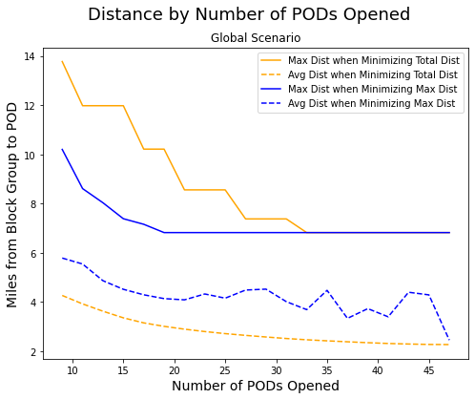

When limiting the number of PODs opened to 19, we observe that the distribution of population-weighted distances from each block group to its assigned POD centers around 2-3 miles with a long right-skewed tail with a minority of the population traveling over 6 miles. The average distance traveled when minimizing total distance is 2.9 miles with a maximum distance of 10.2 miles. In contrast, when minimizing the maximum distance, we observe a flatter distribution with all residents traveling less than 7 miles. The average distance traveled when minimizing the maximum distance is 4.1 miles with a maximum distance of 6.8 miles. 

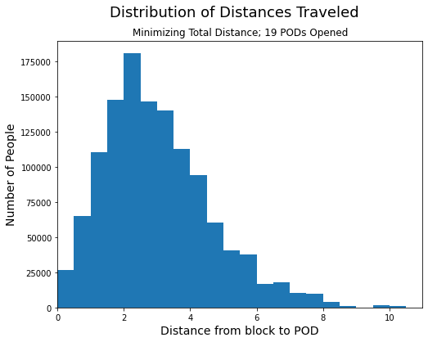 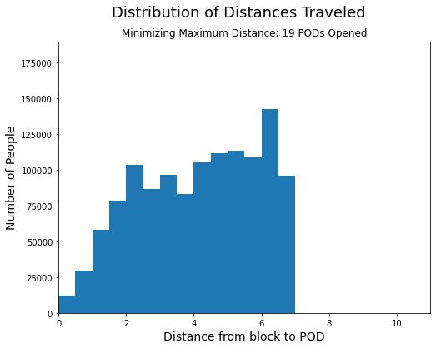



The following maps of Allegheny County show the 19 PODs that are selected to open under both models of the global outbreak scenario.

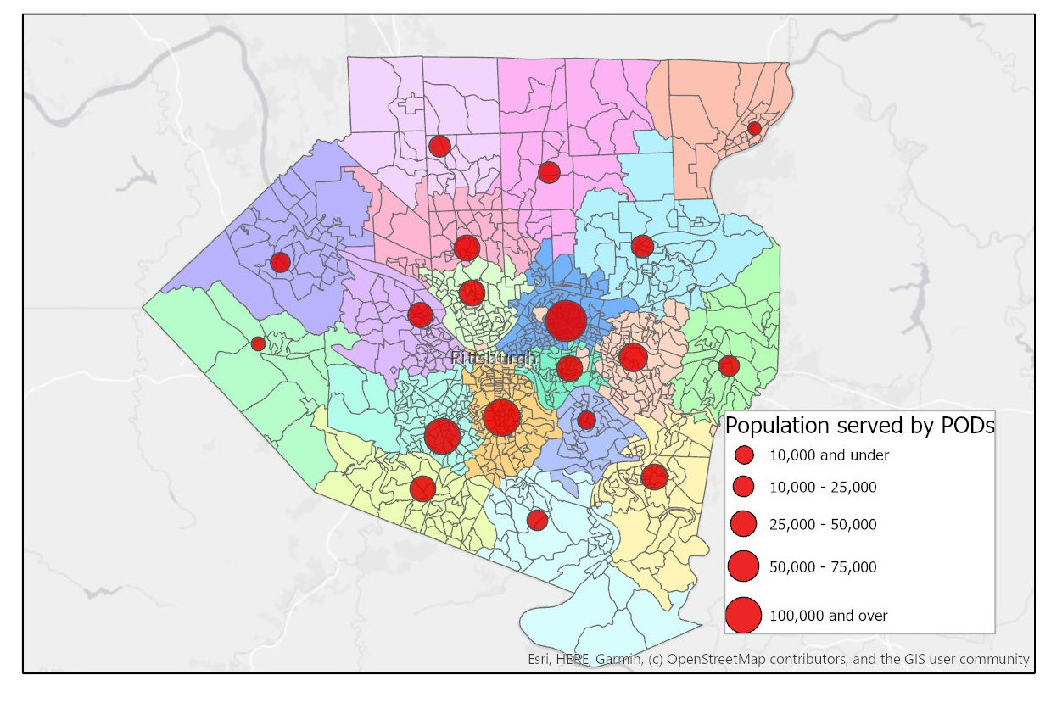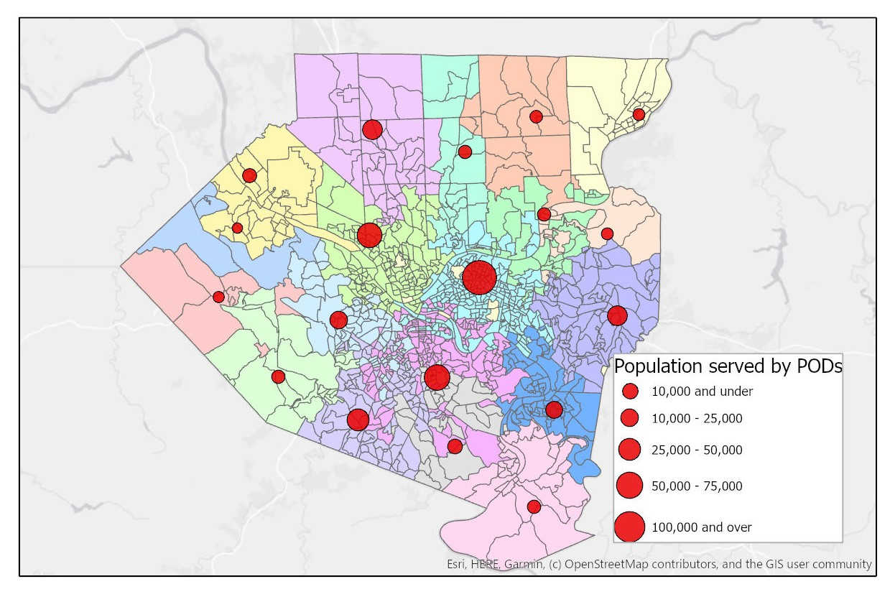



**II. Local Model - Flooding in Eastern Allegheny County**

In a local flooding scenario, where just a fraction of Allegheny County is affected, fewer PODs are needed to service the immediate emergency need. In particular, vast sections of the county remain unaffected and have no need for access to a POD. Therefore, PODs are concentrated in the affected area of the county. In this scenario, when both minimizing total distance and minimizing the maximum distance to the PODs, the change in distance traveled becomes marginal after 7 PODs, as seen in Figure 6. At this point, the benefit of an additional POD may be less than the cost to service an additional POD. 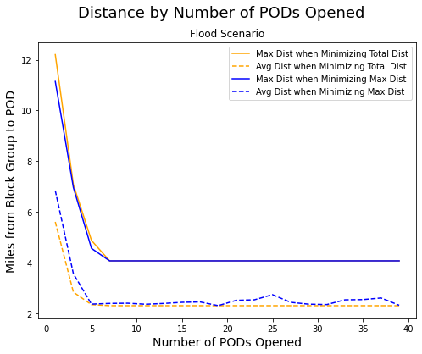

Additionally, there is much less of a difference in average and total distance traveled when comparing the two model formulations, minimizing total distance and minimizing maximum distance. In both models, when opening 7 PODs, the maximum distance traveled is 4.0 miles, and the average distance traveled is 2.3 miles in the minimizing total distance model and 2.4 miles in the minimizing total distance model. The difference between these numbers and the global outbreak model is related to the location of the affected region in Allegheny County. The most populous regions of the county do not lie in flood plains, while the less dense areas are more likely to be in a flood plain. The distribution of population-weighted distances for each model when opening 7 PODs is in Appendix II.

**III. Local Model - Anthrax Attack**

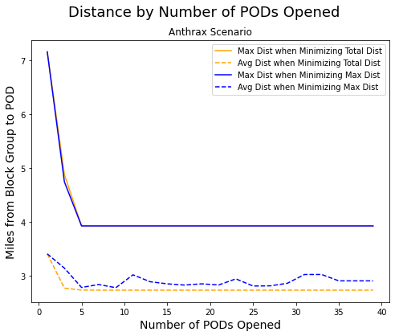

In the third scenario, we considered a localized anthrax attack centered in Downtown Pittsburgh. Similar to the local flooding scenario, there was little difference in the maximum distance traveled in either model formulation, while the average distance was consistently slightly lower in the model minimizing total distance. As demonstrated in Figure 7, there is a sharp inflection point at 5 PODs, where there is no gain in either average or maximum distance traveled when adding additional PODs. The distribution of population-weighted distances for each model when opening 5 PODs is in Appendix II.



**High Priority PODs**

While running multiple scenarios, we observed that certain PODs were overrepresented in the solution set. These PODs tended to be spread throughout Allegheny County and included the periphery of the county, as well as the heart of Pittsburgh. Our analysis found that *North Allegheny County High School, Pittsburgh Obama Academy, Mt. Lebanon High School, McKeesport Area High School* were included in all of the possible solutions for the global Covid-19 scenario when minimizing total distance. We recommend that these PODs be targeted as priority locations when assessing emergency preparedness given their importance to decreasing the distance traveled by Allegheny County residents to access essential supplies. Additional analysis on high priority PODs can be found in Appendix III.

### Recommendations

As a result of our analysis, we provide the following recommendations to Allegheny County:

**1. Number of PODs to open**

1. In the event of a county-wide outbreak, the county should open **19 PODs** across the county. We recommend selecting a model that prioritizes minimizing the maximum distance from any single block group to a POD. While minimizing for the total distance may result in a lower average travel distance, in the event of an emergency, all residents must be able to access the POD. Scenarios in which a few residents must travel significant distances might result in those residents not seeking emergency help. In the case of an infectious disease, this would hinder the county’s ability to manage the outbreak in other parts of the county.
2. In a localized flooding scenario, the county should open **7 PODs** using either model. Because it is a localized event isolated to a portion of the county, we find that there is no substantive difference between models.
3. In a localized anthrax attack, the county should open **5 PODs** using either model. Again, our analysis finds no substantive difference between models. However, due to the unique time constraints in an anthrax attack, we recommend further research to incorporate time and capacity constraints.

**2. Equity and Accessibility: Car Ownership Rates**

An important policy consideration will be how Allegheny County can get supplies to those who do not have access to a personal vehicle, especially given that many of these emergencies and disasters will render public transport inaccessible. These models assume that each person can travel to a POD to pick up supplies, but reality is different. There are over 71,000 households in Allegheny County with no car. Our team analyzed ACS data on the car ownership rates in each POD and conducted analysis by POD opened in a county-wide scenario that minimizes total distance in which 19 PODs are opened. Further analysis finds that the distribution between PODs is quite spread out. For example, POD 44 has just 335 households without access to a car. At the other end of the range, over 14,500 households (representing 26.5% of households) served by Obama Academy in East Liberty do not have a car.

In order to better serve neighborhoods like East Liberty, Allegheny County and Pittsburgh should create contingency plans for low-car-ownership neighborhoods. These plans might include designated delivery shuttles for specified areas. In addition, the recent use of school buses by 412 Food Rescue (Catalano 2020) to deliver food at “bus stops” along a designated route offers a useful model for delivering supplies.

**3. Cost Considerations**

The cost of operating a POD is highly dependent on the number of people staffing each facility and the time needed to remain open, with some fixed costs that include utilities and rental cost. We therefore recommend opening the largest number of facilities in each scenario that provide a marginal improvement in the maximum or average distance traveled by the affected population.

### Future Work

One next step to improve these models would be to vary the service capacity at each POD as well as add time-based features from the scenarios. There will be large differences in the number and geographic spread of PODs to open based on this capacity and the length of time that supplies must be distributed. For example, an anthrax attack may require that PODs distribute supplies to 100,000 households in 48 hours. The shelter must be able to meet the capacity of each block group within 48 hours of the anthrax attack in order to provide the necessary care to residents due to the high fatality rate of anthrax. A time-based model would impose a POD capacity constraint and a 48-hour service time constraint. In contrast, a county-wide infectious disease outbreak might require PODs to distribute supplies to 500,000 households over a two-month period. The different formulations and added constraints could lead to better insights for addressing these emergencies as they arise.

### Appendix

**Appendix I: Data and Methodology**

Our team calculated the distances between the population-weighted block group centroids in Allegheny County and the PODs using the Network Analyst Tools in ArcGIS Pro 2.4.1. We created an Origin-Destination (OD) cost matrix (*Make OD Cost Matrix Analysis Layer* tool) of the distance between every POD and every block group centroid.

Our team then reviewed potential flood areas in Allegheny County by referencing news articles on floods in Allegheny County and found the eastern part of the county to be impacted relatively often and recently by flooding events (CBS 2020). We then cross-referenced a map of flood zones published by the Pennsylvania Department of Community and Economic Development (2020) with Allegheny County block groups in the eastern Allegheny County areas identified by our research. We selected 40 block groups primarily along the Allegheny River. Given that we do not have a reliable method for identifying exactly how many people might be affected by the flooding, we simply “flagged” (i.e., used a binary variable to designate that a block group is affected by the flood) the 40 selected block groups for this scenario.

We created rough estimates of the number of people impacted by an anthrax attack by selecting 100 block groups surrounding the downtown area of Pittsburgh and calculating the Euclidean distance between the centroid of Census block group 420030201003 in the Central Business District and the centroids of the 99 other block groups using ArcGIS Pro 2.4.1 (*Generate Near Table* tool). Based on a block group’s distance and percentile rank,[1] our team estimated the proportion of people affected by an anthrax attack based on their distance from the Central Business District to be between 25% and 100%.

We collected the following data for Allegheny County:

* Shapefiles for each Census block group (U.S. Census Bureau 2018)
* Population-weighted centroid for each Census block group (U.S. Census Bureau 2018)
* Number of households in each Census block group (U.S. Census Bureau 2018)
* Population in each Census block group (U.S. Census Bureau 2018)
* Miles between each centroid and each POD (matrix of 1,100 BGs x 47 PODs) (calculated using ArcGIS)

Finally, the model data used is:

* Vector of size 1,100 that contains the total population in each Census block group
* Matrix of size 1,100 by 47 that indicates the distance, in miles, between each Census block group and each POD
* Matrix of size 1,100 by 3 with the percent of the population in each Census block group affected by each scenario

**Appendix II: Distribution of Distances in Local Flood and Anthrax Attack Scenarios**

The distributions of population-weighted distances are fairly similar between the models minimizing total distance (left) and maximum distance (right) in each local scenario, indicating that at the chosen number of PODs to open, there is not a significant tradeoff between the two models.

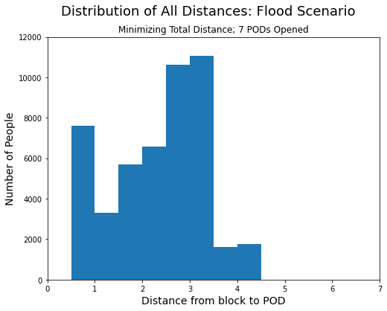 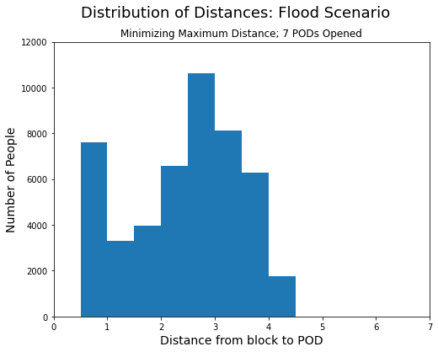

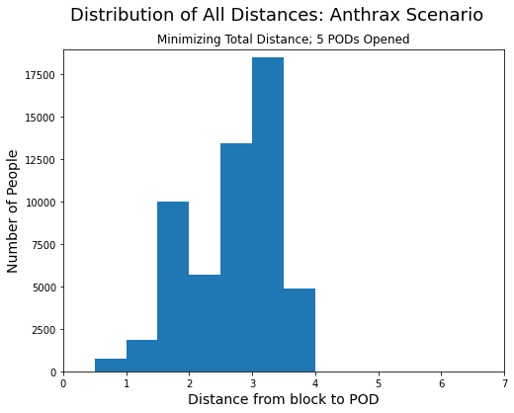 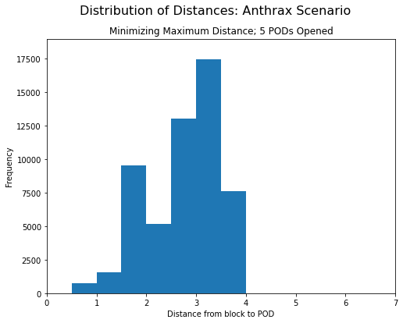

**Appendix III: Population Served by High Priority PODs - Global Scenario**

The following charts indicate the number of times each POD is selected out of the twenty models of each type run in the sensitivity analysis for the global model.

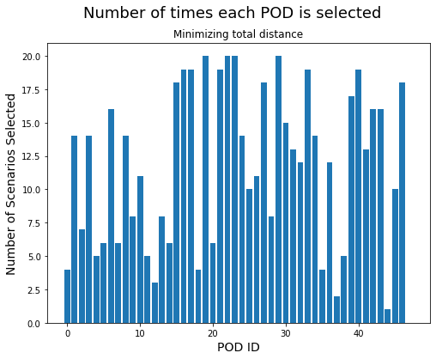 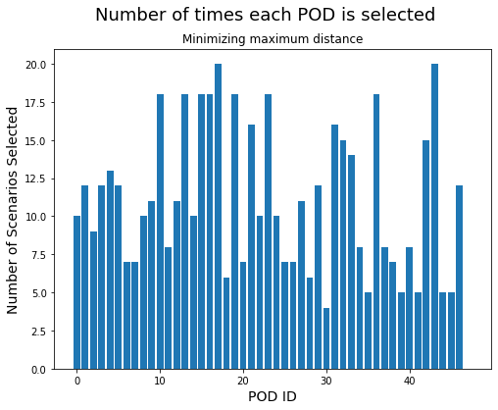

Four of the PODs are selected in every model minimizing the total distance, and the table below shows the population served when selecting the recommended 19 PODs. Even though they show up in every solution, the population served by these four sites varies widely. For example, in the solution in which Allegheny County opens 19 PODs, these four sites serve a range of between 51,413 and 124,739 people, with an average of 87,388 people. Pittsburgh-Obama Academy must service over 120,000 people. This is in part due to the POD’s location in the densely-packed residential neighborhood of East Liberty. Based on this finding, emergency planners should consider Pittsburgh-Obama Academy the epicenter of the emergency response in a county wide emergency.

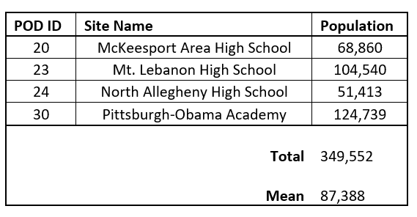

### 

### References

[Aaby, K., Herrmann, J.W., Jordan, C.S., Treadwell, M. and Wood, K. 2006. Montgomery county’s public health service uses operations research to plan emergency mass dispensing and vaccination clinics. *Interfaces* 36(6), pp. 569–579.](http://f1000.com/work/bibliography/8569777)

[Ablah, E., Scanlon, E., Konda, K., Tinius, A. and Gebbie, K.M. 2010. A large-scale points-of-dispensing exercise for first responders and first receivers in Nassau County, New York. *Biosecurity and Bioterrorism: Biodefense Strategy, Practice, and Science* 8(1), pp. 25–35.](http://f1000.com/work/bibliography/8566033)

Allegheny County Division of Computer Services “GIS Open Data.” <http://openac-alcogis.opendata.arcgis.com/>

[Anon Basic Information | Anthrax | CDC [Online]. Available at: https://www.cdc.gov/anthrax/basics/index.html Accessed: 4 April 2020.](http://f1000.com/work/bibliography/8569731)

[Anon Coronavirus drive-through testing station to open in New York | World news | The Guardian [Online]. Available at: https://www.theguardian.com/world/2020/mar/18/coronavirus-drive-through-testing-new-york-station-opening Accessed: 4 April 2020.](http://f1000.com/work/bibliography/8569800)

Catalano, Emily. “412 Food Rescue Expanding School Bus Stop Food Distribution This Week.” Good Food Pittsburgh, April 6, 2020. https://goodfoodpittsburgh.com/412-food-rescue-expanding-school-bus-stop-food-distribution-this-week/.

CBS. “Tornado, Flash Flood Warnings Issued For Pittsburgh Area.” CBS Pittsburgh. CBS Pittsburgh, March 28, 2020. Accessed 5 April 2020. https://pittsburgh.cbslocal.com/2020/03/28/tornado-warning-issued-for-allegheny-county-western-pa/

Department of City Planning, City of Pittsburgh. “Floodplain.” Accessed April 18, 2020. https://pittsburghpa.gov/dcp/floodplain

[Kara, B.Y. and Savaşer, S. 2017. Humanitarian Logistics. In: Batta, R., Peng, J., Smith, J. C., and Greenberg, H. J. eds. *The operations research revolution*. INFORMS, pp. 272–309.](http://f1000.com/work/bibliography/5299231)

[Lee, E.K., Maheshwary, S., Mason, J. and Glisson, W. 2006. Large-Scale Dispensing for Emergency Response to Bioterrorism and Infectious-Disease Outbreak. *Interfaces* 36(6), pp. 591–607.](http://f1000.com/work/bibliography/8569742)

### Pennsylvania Department of Community and Economic Development. “PA Flood Zone Map.” ArcGIS Web Application. Accessed April 26, 2020. http://dced.maps.arcgis.com/apps/webappviewer/index.html?id=4321d9e3e1094dc494f942c039604d3a.

Pennsylvania Department of Community and Economic Development. “Flood Zone Map.” Accessed April 3, 2020. <http://dced.maps.arcgis.com/apps/webappviewer/index.html?id=4321d9e3e1094dc494f942c039604d3a>

US Census Bureau. “Glossary.” The United States Census Bureau, September 16, 2019. https://www.census.gov/programs-surveys/geography/about/glossary.html#par_textimage_4.

US Census Bureau. “Centers of Population.” The United States Census Bureau, October 11, 2019. <https://www.census.gov/geographies/reference-files/time-series/geo/centers-population.html>.

U.S. Environmental Protection Agency, EnviroAtlas. “Floodplains by Block Group.” <https://catalog.data.gov/dataset/enviroatlas-pittsburgh-pa-people-and-land-cover-in-floodplains-by-block-group>

[Webb, G.F. 2003. A silent bomb: the risk of anthrax as a weapon of mass destruction. *Proceedings of the National Academy of Sciences of the United States of America* 100(8), pp. 4355–4356.](http://f1000.com/work/bibliography/1675730)

Wein, Lawrence M et al. “Emergency response to an anthrax attack.” *Proceedings of the National Academy of Sciences of the United States of America* vol. 100,7 (2003): 4346-51. doi:10.1073/pnas.0636861100

[Yan, S. and Shih, Y.-L. 2009. Optimal scheduling of emergency roadway repair and subsequent relief distribution. *Computers & operations research* 36(6), pp. 2049–2065.](http://f1000.com/work/bibliography/8569828)

### 

### Team Work Plan

|  |  |  |  |
| --- | --- | --- | --- |
| **Task** | **Lead** | **Support** | **Date due** |
| 1. **Background research** | Nora | Elizabeth, Max | *Monday, April 30* |
| 1. **Project proposal** |  |  | Monday, March 30 |
| 2a. Problem Definition | Max | Elizabeth, Nora |  |
| 2b. Formulation | Elizabeth | Max, Nora |  |
| 2c. Data plan | Max | Elizabeth, Nora |  |
| 1. **Collect data** |  |  | *Wednesday, April 8* |
| 3a. Create matrix of driving distance time between centroid and each POD | Max | Nora |  |
| 3b. Data Dictionary | Max | Nora, Elizabeth |  |
| 3c. Determine population affected by scenario | Max | Nora, Elizabeth |  |
| 1. **Updated project proposal** | All |  | Monday, April 13 |
| 1. **Python - Gurobi** | All |  | *Friday, April 24* |
| 5a. Test first version with one scenario | Elizabeth | Max, Nora | *Monday, April 13* |
| 5b. Final version with all three scenarios | Elizabeth | Max, Nora | *Friday, April 24* |
| 1. **Final report** |  |  | Sunday, April 26 |
| Background/literature review | Nora | Max, Elizabeth |  |
| Problem statement | Max | Nora, Elizabeth |  |
| Mathematical formulation | Elizabeth | Max, Nora |  |
| Data summary | Max | Nora, Elizabeth |  |
| Implementation, analysis | Elizabeth | Max, Nora |  |
| Visualization of results (charts, maps) | All |  |  |
| Recommendations | All |  |  |
| Citations | Nora |  |  |
| Review final report (Technical/Stylistic) | Nora |  |  |
| **Presentation** | All |  | Monday, April 27 |

1. That is, if a block group’s distance is greater than 60% of other block groups, its estimated proportion of persons affected is greater than the 60% of block groups that lie farther from the Central Business District.