Contents

WHAT IS ARTIFICIAL INTILLIGENCE? 2

DEFINITION 2

EXAMPLE 2

USES 2

WHAT IS DATA SCIENCE? 3

DEFINATION 3

BREAKDOWN 3

EXAMPLE 3

WHAT IS CYBERSECURITY? 4

DEFINATION 4

BREAKDOWN 4

IN ONE WORD 4

WHAT IS DBMS? 5

DEFINATION 5

BREAKDOWN 5

APPLICATIONS 5

ARTIFICIAL INTELLIGENCE

# WHAT IS ARTIFICIAL INTILLIGENCE?

## DEFINITION

Artificial Intelligence (AI) Is making computer and Machine Think Like Humans.

## EXAMPLE

1-CHAT GPT

2-XAI

3-LUMA

## USES

**1-In Automation**

**2-In Industries**

DATA SCIENCE

# WHAT IS DATA SCIENCE?

## DEFINATION

Data Science Is The Process Of Using Data To Learn About The World And Make Better Decisions.

## BREAKDOWN

1-Collecting Data

2-Analyzing Data

3-Interpretating It

## EXAMPLE

**1-Predicting Customer Behaviour**

**2-Improving HealthCare**

CYBERSECURITY

# WHAT IS CYBERSECURITY?

## DEFINATION

CyberSecurity In Simple Trems Is Protecting Your Digital Life.

## BREAKDOWN

1-Protection

2-Network Security

3-Technology

## IN ONE WORD

1-INFORMATION TECHNOLOGY SECURITY

DBMS

# WHAT IS DBMS?

## DEFINATION

It is a Software That Helps To Store And Manage Data.

## BREAKDOWN

1-Creating

2-Accessing

3-ModifyingApplications

## APPLICATIONS

1-MSSQL

2-SQL MANAGEMENT

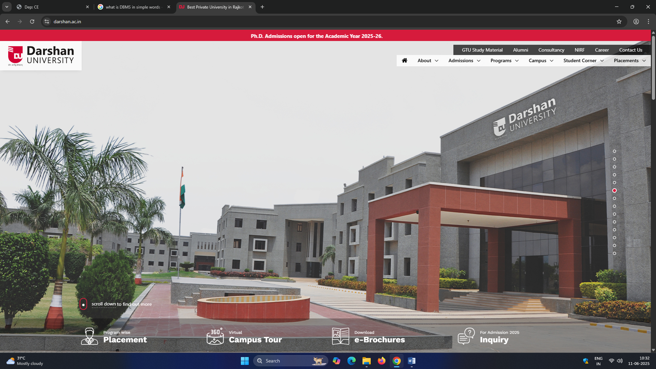

* Video provides a powerful way to help you prove your point. When you click Online Video, you can paste in the embed code for the video you want to add. **You can also type a keyword to** search online for the video that best fits your document. To make your document look *professionally* produced, Word provides **header, footer, cover page, and text box designs** that complement each other. For example, you can add a matching cover page, header, and sidebar.

1. Click Insert and then choose the elements you want from the different galleries. Themes and styles also help keep your document coordinated. When you click Design and choose a new **Theme, the pictures, charts, and SmartArt graphics change to match your new theme**. When you apply styles, your headings change to match the new theme. Save time in Word with new buttons that show up where you need them.

To change the way a picture fits in your document, click it and a button for layout options appears next to it. **When you work on a table,** click where you want to add a row or a column, and then click the plus sign. rEADING IS EASIER, TOO, in the new **Reading view**. You can collapse parts of the *document and focus on the text you want.* If you need to stop reading before you reach the end, Word remembers where you left off - even on another device.

Name: Darpan Parmar

Roll No: 267

Class: CE-3A