Resources:

Transmission grid:

* File from Dharik
* Transmission service providers (TSP):
  + Texas New Mexico Power Company (TNMP) (far west and far east)
  + Sharyland Utilites
  + AEP North (blue in mid and west)
  + AEP Central (green in south)
  + Oncor (most of DFW, Dallas-Fort Worth included) (light green in north)
  + CenterPoint (Houston and surrounding areas)

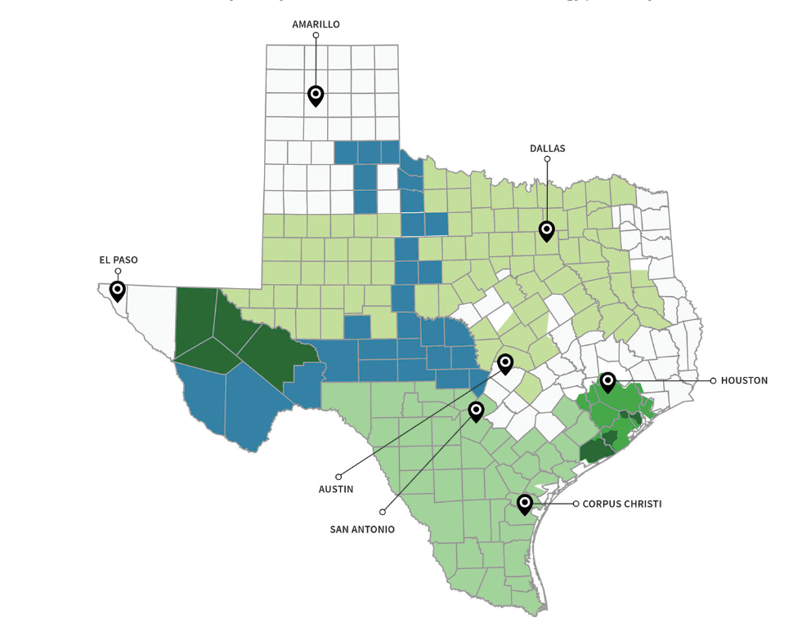

CENTERPOINT

AEP - Central

AEP - North

TNMP

ONCOR

Load:

* Historical data for weather zones available at: <http://www.ercot.com/gridinfo/load/load_hist>
* 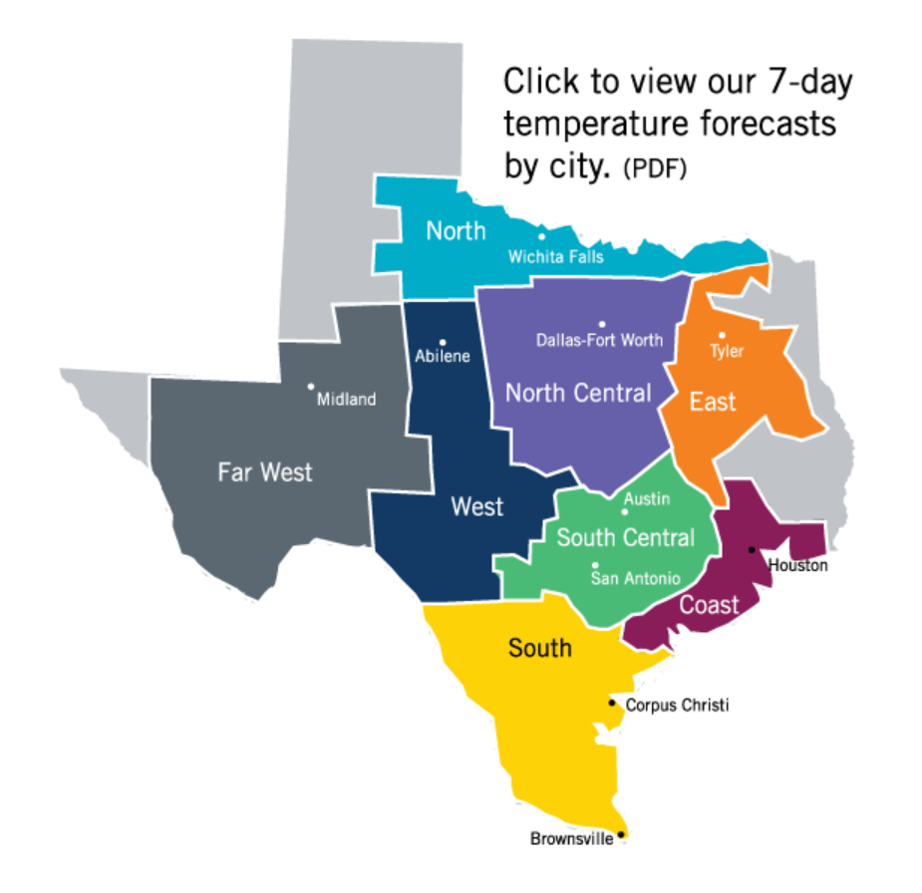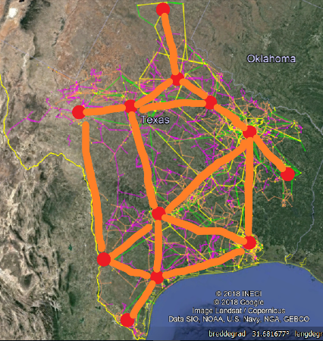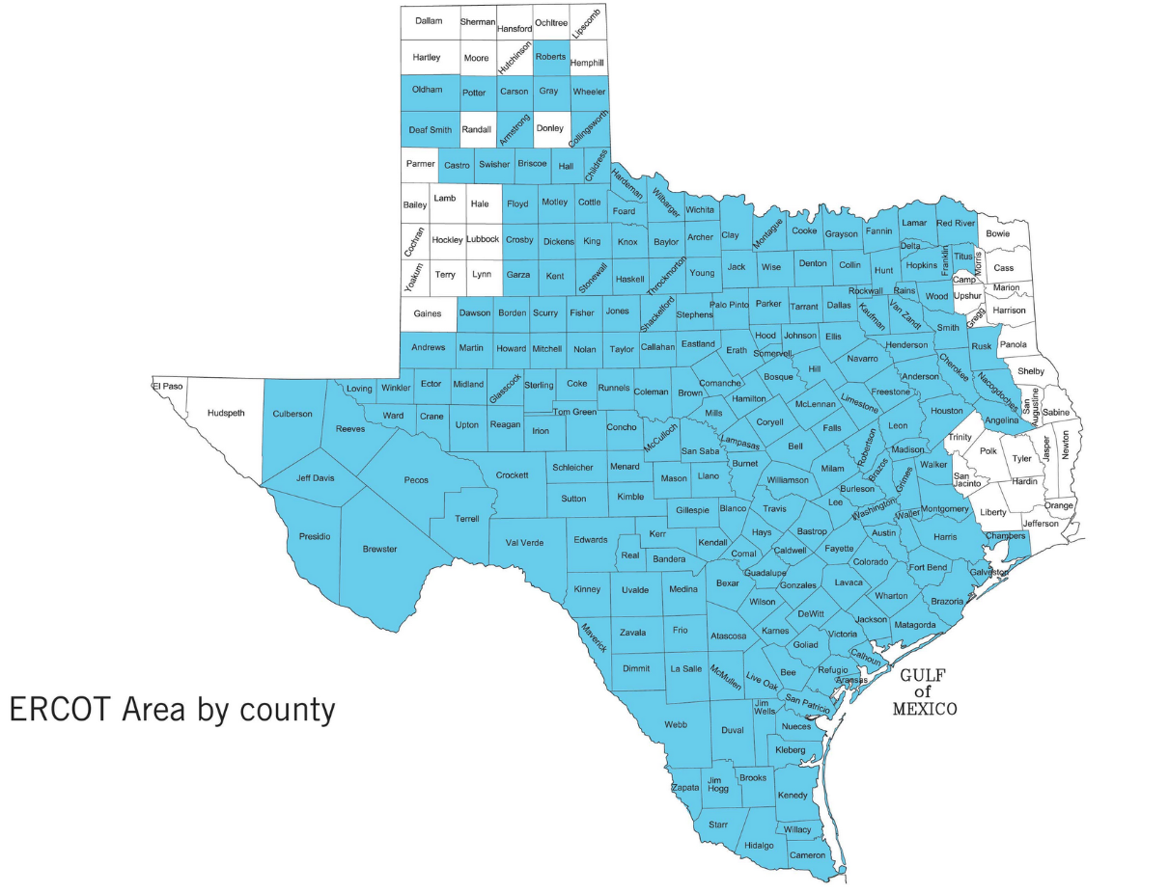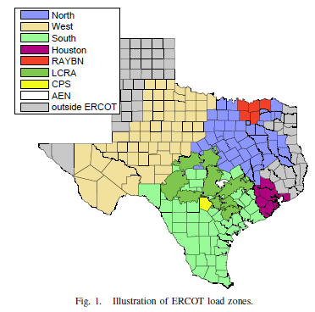

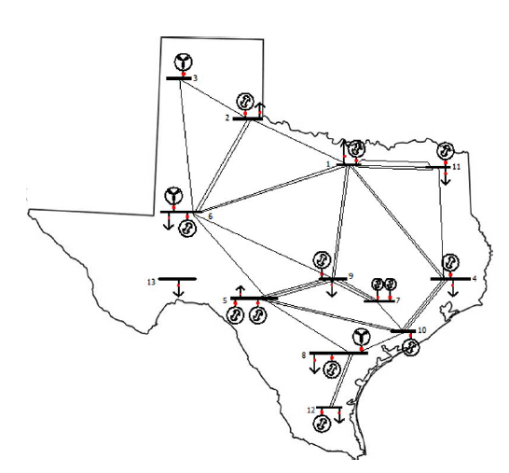

Wind power :

* Profiles available for 2014 data at: <https://www.renewables.ninja/>
* Installed wind power and historical output (2010- jan 2016): <http://www.ercot.com/gridinfo/generation/windintegration> (shit - pdf files)

Div:

* <http://www.ercot.com/gridinfo/resource>
* Maps : <http://www.ercot.com/news/mediakit/maps>