ERC Starting Grant 2026

Part B2

(not evaluated in Step 1)

Part II of the Scientific Proposal (max. 7 pages, references do not count towards the page limits).

Project implementation
With DePeer, I will develop a framework that integrates concepts from education, psychology and genetics to provide a new perspective on peer effects. From this, I will provide novel empirical investigations of peer effects in education by utilizing full-population data with an unprecedented combination of young people (N ≈ 1,200,000) in schools (N ≈ 300) and classes (N ≈ 300,000) crossed with genealogical records from 1960 an onwards (N ≈ 8,940,000), linked to a longitudinal study with detailed genotype and psychological measurements from families (N ≈ 110,000). To reach these goals, the project will be implemented in four working packages (WPs). WP1 will develop theory and justifications for the framework. WP2, WP3 and WP4 are based on WP1 and propose novel research questions along with methodological approaches permitting empirical applications.

WP1: A framework for complex peer effects
A key contribution of DePeer is a framework that recognize the complexity of social interactions by suggesting two central properties of peer effects: 1) Peer effects are general qualities of the individual that cannot be summarized by measuring specific characteristics, 2) Peer effects are complex traits underpinned by many genetic and environmental factors.
Peer effects are general qualities of the individual. In essence, a peer effect refers to the effect that an individual exerts on others (Sacerdote, 2011). In quantitative genetics, a similar concept is referred to as an indirect genetic effect (Bijma, 2014). Within social and personality psychology, the focus is partners’ influence on behavior or personality (Back & Kenny, 2010). Common to these disciplines is that they aim to describe how traits or behaviors depend on others through social interactions. Because the predominant focus in psychology and genetics has been on the total influence that an individual or organism exert on others, these effects are often conceptualized as unobserved, or latent, variables that does not depend on measurable characteristics. This contrasts with educational research, where almost invariably peer effects are identified by measuring a fixed set of characteristics of the peer group, such as test scores or socioeconomic indicators. These approaches can be seen as two opposing paradigms; the latent variable approach can identify the total - or net - peer effect without relying on any measurable characteristic of peers. This is preferable if the aim is to characterize the total contribution of peers. On the other end, the fixed characteristics approach can identify specific aspects of peers that influence others but assumes that all relevant aspects of peers are measurable and have been measured without error. I argue, in line with Fruehwirth (2014), that current knowledge of human behavior and social interaction cannot justify the derivation of specific behaviors that underlie peer effects. I also argue that most research questions on peer effects do not center on specific behaviors of peers but rather focus on the identity of peers. As such, the fixed characteristics approach in education is in many applications a methodological limitation that may lead to misleading inference and contradictory results. A latent variable approach will often be more adequately aligned with the research question and can naturally accommodate both latent and measured characteristics of peers within the same framework. This provides an additional advantage that have not been previously exploited as it facilitates a methodology for quantifying how much of the total peer effect for a specific educational outcome that can be accounted for by a set of observed characteristics. This provides a framework for gradually understanding the mechanisms of peer effects and a way to reconcile previous results that have relied on different measured characteristics of peers.

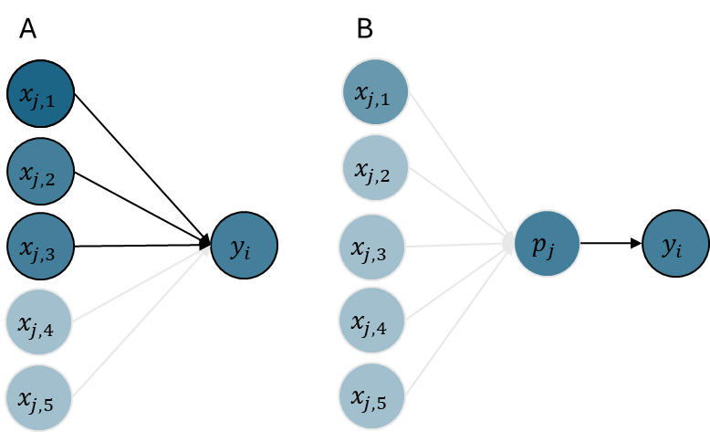
Figure 1. Panel A illustrates the predominant “fixed characteristics” approach to peer effects. The effect of individual $j$ on the performance of individual $i$, is identified by the measured characteristics $x_{j,1}$-$x_{j,3}$ (dark blue). Because characteristic $x_{j,4}$ and $x_{j,5}$ (light blue) were not measured, the total contribution of peers cannot be evaluated. Panel B illustrates a latent variable approach where the combined influence of $x_{j,1}$-$x_{j,5}$ is summarized with a latent variable $p_{j}$. Although the effect of individual characteristics cannot be evaluated, their aggregate effect is detectable in the latent variable even if none of the characteristics are measured.

Although a connection to the latent variable literature has yet to be made, there are a few exceptions that have considered unobservable peer effects. Burke and Sass (2013) characterized this as a measurement problem of peer ability, which they approached by measuring “peer fixed-effects”. Isphording and Zölitz (2020) suggested the concept of peer value-added to describe the total contribution of a student to the performance of others. With DePeer, I will build on the strong methodological foundation existent in educational research (Angrist, 2014; Manski, 1993) and unify the concept of peer value-added with models from genetics and psychology that enables peer effects to be considered as latent variables that can be identified without measurements of peer characteristics.
Peer effects are complex traits. Social interactions have played a vital role through human evolution (Boyd et al., 2011). The ability to forge strong social bonds, communicate effectively, learn and collaborate with others would likely have led to significant advantages in navigating an uncertain world (Bornstein, 2013). A consequence of this premise is that traits and behaviors that underpin social interactions are to some extent expressions of genetic variation – they are complex traits influenced by a large number of genetic and environmental factors (Lynch & Walsh, 1998). I suggest that peer effects can be viewed as an “extended phenotype” (see text box 1), formalized as
Text box 1: Homo Sociabilis: Humans are fundamentally social beings, and our ability to learn through interactions with others have likely played a key role in shaping our development (Boyd et al., 2011). From this perspective, it seems evident that we are surrounded by a social environment full of genetic variation. Analogously, differences between our genes likely play a role in how we interact with our peers. In the classic book The Selfish Gene (Dawkins, 1976) Dawkins introduced the concept of extended phenotypes, meaning that genes can have effects that extend beyond an organism’s body to influence environments and other organisms. Despite the widespread interest in using genetic variation to explaining human traits, surprisingly little empirical work has explored how the same variation can explain our social environment.
$$p=g+e.$$
This decomposition recognizes the peer effect that an individual express towards other ($p$) as the sum of all relevant genetic effects ($g$) and all relevant environmental effects ($e$). The implications of this decomposition are greater than what the simple equation may suggest. If peer effects are partially expressions of genetic variation, it implies that: 1) The educational outcomes of students are affected by the genes of their peers. 2) Relatives will – to a known extent – express similar peer effects. 3) Part of the peer effects can be attributed to individual’s genotype, representing the complete set of genetic information inherited from parents, which are fixed at conception and do not change in response to development or environmental conditions. Below I outline how DePeer will exploit these implications to provide novel insights into peer effects in education.

WP2: Characterizing the totality of peers
The social relations model is the predominant approach to the study of social interactions in psychology (Back & Kenny, 2010). For identification, some variation of “round-robin” designs, where each individual interacts with and rate every other individual, is required. In an educational setting, such designs are not feasible, because measures of performance are provided by teachers, not peers. However, by recognizing the similarity with models from quantitative genetics, a latent peer effect can be separated from the student’s own ability, even with a single measurement per individual. This is because from a genetic perspective, a relatives’ interaction with other individuals is the same person up to a fraction – i.e., the coefficient of relatedness. With DePeer, I propose a model for the educational outcomes of individual $i$ that includes an effect representing the ability of the student itself $a_{i}$ and the sum of all peer effects $p_{j}$ from students in the same group of size $n$ (except for the peer effect of the individual itself). The model can be expressed as in Equation (1):
(1) | $$y_{i}=a_{i}+\sum_{\begin{aligned}j=1 \\ j≠i\end{aligned}}^{n}{p_{j}},$$ | (2) | $$y_{i}=(g_{i}+e_{i})+\sum_{\begin{aligned}j=1 \\ j≠i\end{aligned}}^{n}{(g_{j}+e_{j})}.$$
From a complex trait perspective, both $a_{i}$ and $p_{j}$ in (1) has a gene-environment decomposition so that the model can be written as in Equation (2). This makes it apparent that when peer effects are present, educational outcomes depend on genes of peers. In other words, genes of student $j$ are expressed in student $i$. In genetics, this is referred to as indirect genetic effects, in contrast to direct genetic effects from the individuals own genes (Bijma, 2014). The key to separating the terms is that they have covariance structure that follow the genetic relatedness among students. Relatives will have more similar outcomes and affect their surrounding peers more similarly than non-relatives. This means that we can exploit these direct and indirect genetic components to study latent peer effects. To avoid unnecessary levels of detail in later arguments, I will avoid explicit separation of genetic and environmental effects and implicitly assume that students own abilities and peer effects comply to a gene-environment decomposition.
Figure 2. Panel A illustrates data from a “grouped round-robin” design used in psychology to identify latent actor and partner effects. Individual 1-4 and 5-7 belong to separate groups and within each group everybody rates everybody but themselves. Panel B illustrate data from an observational study where individual 1-4 and 5-7 belong to different peer groups and educational performance are scored once per individual. Without additional information, latent peer effects are not separable from student’ own ability. However, genetic data provide identifying information. Individual 2 in group 1 is a first degree relative to individual 6 in group 2 (coefficient of relatedness = ½). We may therefore think of the two performance ratings as partial multiple ratings on the same genetic ancestry.

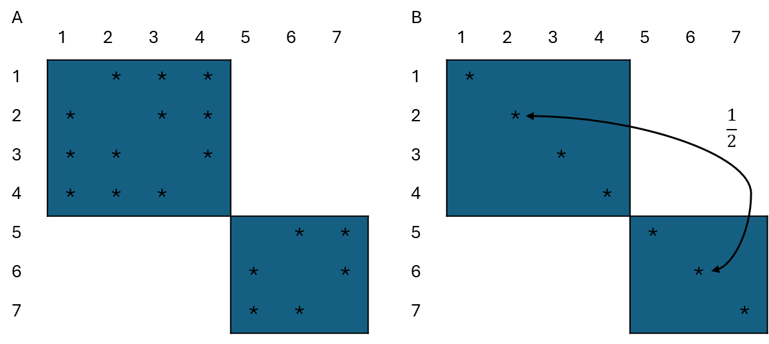
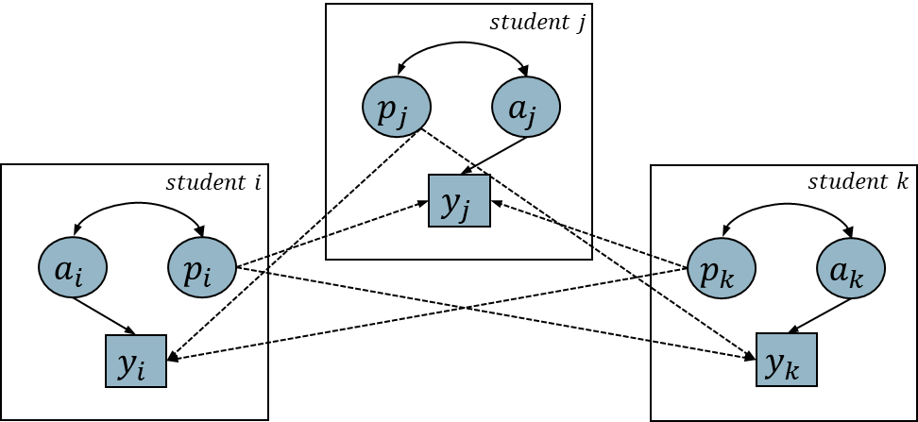
The traditional linear-in-means model consider peer effects at the level of the group (Sacerdote, 2011). A novel implication of DePeer’s individual-level framework, is that the peer effect a student express may be correlated with their abilities. Figure 3 illustrates important parts of the model for three students $i$, $j$ and $k$. Each student exerts two latent effects, its own ability $a$, influencing their own outcome, and its own peer effect $p$, influencing the outcome of all group members. Because both type of effects originate in the same individual, they may reflect partly the same underlying mechanisms and traits which result in correlated effects. This is informative for discriminating hypothesis of peer effects in the literature. For example, the “invidious comparison model” suggest that outcomes are worsened by the presence of better achieving peers (Sacerdote, 2011), implying a negative correlation between ability and peer effects. A social learning model on the other hand, where students imitate high-achieving classmates (Griffith & Main, 2019), imply a positive correlation between ability and peer effects. These arguments lead to the first set of research question in DePeer:
Figure 3. Illustration of peer effects as an individual-level variable. The educational outcome $y$ of student $i$, $j$ and $k$ are influences by their own ability $a$, indicated by the solid arrows. They also exhibit a peer effect $p$ towards the all the other students, indicated by dashed directed arrows. At the level of the individual, these two effects may be correlated, indicated by the two-headed solid arrows.

RQ2.1: What is the total influence of peers to differences in educational outcomes?
RQ2.2: Are peer groups characterized by a cooperative environment where students with high abilities tend to increase the performance of their peers, or are they characterized by a competitive environment where students of high abilities tend to decrease the performance of their peers?

Aim. Due to the reliance of the fixed characteristics approach in previous applications, RQ2.1 has not been addressed before. The latent variable approach of DePeer permits me to obtain estimates of the total effect that is attributable to peers. This has a natural interpretation as a measure of peer value-added, and is directly comparable to other value-added measures frequently studied in the educational literature, such as school, teacher or parents (Cunha & Miller, 2014). It will further allow me to evaluate to what extent previous applications capture the total peer effect. This will help reconcile contradictory results in the literature and provide a benchmark for identifying the relevant features and mechanisms underlying peer effects. RQ2.2 is based on estimating the correlation between students own ability and the peer effect expressed towards others. A positive correlation would be expected for example if students of high ability tend to help or motivate others, whereas a negative correlation would be expected if high performing students tend to decrease the motivation of others or attract more teacher attention at the cost of others. Thus, characterizing how students own abilities is associated with the peer effect they express can provide novel insights into social processes that contribute to educational outcomes. To address the issue of separating peer effects from social stratification, I will model schools with “fixed-effects” (McNeish & Kelley, 2019), so that peer effects in classes are evaluated within schools, not subject to social stratification occurring at the level of schools. Because the Norwegian Education Act does not permit organization of students in classes according to gender, ethnicity or skills (Opplæringsloven, 1998), it appears unlikely that classes within the same school differ systematically according to background characteristics.
Data. To reach aim 1 And 2 DePeer will focus on two types of educational performance indicators, available for all students in Norway from the National Educational Database. National school tests measure capabilities in reading, mathematics and English in 5th, 8th and 9th grade, while grade point averages are available for completion of 10th and 13th grade. I will also study school dropout, which can be measured by whether grades are available by completion. The database contains records for approximately 1,200,000 students, 300,000 classes and 300 schools. Importantly, the availability of class membership provides sufficient information to identify classes as the social context for peer effects. To identify genetic effects, I will use the Norwegian population registry that includes more than 8,950,000 current and historical identification numbers registered from 1960 and onwards. The register includes up to seven generations of relatives, and more than 117,000,000 distinct genetic relations.

WP3: Genetic architecture of peer effects
While WP2 aims to establish the total influence of peers based on a latent variable model, WP3 aims to use measured genetic variation between students to explain their influence on others. This can inform peer effects in at least two novel ways. The first is that genetic variants represent a form of measurable exogenous variation that will help resolve problems with confounding and stratification with respect to peer effects. As an individual’s genotype is fixed at conception, there is no ambiguity of direction of causation. Genetic variation may associate with behavior towards peers, but peers’ do not alter genotypes. This is a convenient property but is not alone sufficient to rule out endogeneity with respect to genotypes. Social stratification may lead to both genetic and socioeconomic differences, thus inducing “spurious” association between genetic variants and educational outcomes (Abdellaoui et al., 2025). I suggest addressing this endogeneity problem by studying genetic variation within families. Genetic theory dictates that given parental genotypes; the genotype of the offspring is randomly determined during meiosis. This within-family genetic variation is thus not correlated with socioeconomic factors, in essence mimicking a randomized experiment (Young et al., 2019). Therefore, genetic variations provide a new method for identifying measurable exogenous peer effects (Manski, 1993). I suggest to apply the genome-wide association study (GWAS) methodology from molecular genetics (Uffelmann et al., 2021) to characterize the genetic architecture of peer effects (P-GWAS). In essence, the methodology scans across millions of positions on the genome and test whether individuals with different genotype also differ in complex trait levels or disease risk (Abdellaoui et al., 2023). With P-GWAS, I will extend the methodology to not only model the association with the focal individuals own genotype but also the genotype of their peers. To resolve endogeneity due to stratification, I will further condition on the genotype of the focal individuals’ parents and their peers’ parents. The method is applied to measured variants across the genome, confined to positions with single-nucleotide polymorphisms (SNP). For a given SNP, the main features of the model can be represented as
$$y_{i}=αx_{i}+δ{(x}_{mi}+x_{fi})+β\sum_{\begin{aligned}j=1 \\ j≠i\end{aligned}}^{n}{x_{j}}+θ\sum_{\begin{aligned}j=1 \\ j≠i\end{aligned}}^{n}{{(x}_{mj}+x_{fj})}.$$
The educational outcome ($y_{i}$) for student $i$ is explained with their genotype ($x_{i}$), the total genotype of their mother and father ${(x}_{mi}+x_{fi})$, the genotype of their peers ($x_{j}$) and the total genotype of their peers’ mother and father ${(x}_{mj}+x_{fj})$. $β$ now provide an estimate of exogenous peer effects associated with a particular SNP. By iterating across the genome, estimate for multiple SNPs are obtained. This type of “social GWAS” has not been previously applied neither in the field of genetics or social sciences. The second way that measured genetic variants can inform peer effects is that the explanatory variables in a GWAS are the human genome, which is common across all GWAS’s of human characteristics. For example, a SNP that is found associated with a peer effect, may have been found associated with the personality trait extraversion in other studies. The results from GWAS’s are frequently made available through open database (Uffelmann et al., 2021), which makes it possible to use techniques such as LD Score regression to estimate genetic correlations between peer effects and a range of different traits and characteristics (Bulik-Sullivan et al., 2015). From these arguments, I suggest the following research question:

RQ3.1: Can we identify specific genetic variants associated with peer effects?
RQ3.2: Do peer effects have a genetic association with other measurable individual-level complex traits?

Aim. RQ3.1 seeks to identify a new source of exogenous variation, which will be valuable regarding causal inference on the role of peer effects in education. Such evidence is necessary to develop valid models of social interaction, and for evaluating potential for policy and intervention. RQ3.2 aims to identify other traits and behaviors that are genetically correlated with peer effects, which will help us better understand central processes that underly peer effects.
Data. Genotype data on peers and their parents are central to reach the aims of WP3. This is available via a linkage from the educational data described in WP2, with the Norwegian Mother, Father and Child Cohort Study (MoBa), which include genotype data for more than 110,000 individuals and their parents. The MoBa study recruited participants from all of Norway, and therefore genotype data is available from a large number of schools and classes. In contrast to the situation in WP2, genotype data will not be available for complete schools and classes. However, as the total number of students in each class and school is available from the National Educational Database, the “missing” genotypes can be accounted for via a standard weighting procedure.

WP4: Individual sensitivity and contextual heterogeneity
That individuals may respond differently to their peers’ have received little attention in the education literature, except for a few exceptions (Burke & Sass, 2013; Cooley, 2010). In social and personality psychology, the interaction between dispositional and situational influences is a central topic (Hewstone & Stroebe, 2021). In genetics, the interaction between genes and environments is of particular interest (Manuck & McCaffery, 2014). And, developmental psychology emphasizes the role of individual differences in environmental sensitivity (Pluess, 2015). Theoretical models and empirical evidence from other disciplines therefore strongly motivates the need to also address individual differences in sensitivity towards peers in education. Such interactions are potentially of large interest, because they reveal fundamental dimensions where individuals differ, facilitating our understanding of mechanisms underlying social interactions. I will extend the latent peer model developed in WP2 to accommodate interactions between students’ abilities and peer effects. The extended model can be expressed as:
$$y_{i}=a_{i}+\sum_{\begin{aligned}j=1 \\ j≠i\end{aligned}}^{n}{p_{j}}+\sum_{\begin{aligned}\begin{aligned}j=1 \\ j≠i\end{aligned}\end{aligned}}^{n}{{ap}_{i,j}+}e_{i}.$$
The interaction term ${ap}_{i,j}$, describes the deviation unique to the interaction between student $i$ and peer $j$, above their marginal effect irrespective of the interacting peer. Statistical identification of these pairwise interactions rely on the study design, specifically whether some students participate in multiple classes. I will further include a range of measured personality variables to study whether such individual sensitivity can be explained by dispositional personality characteristics. Individuals in the same group may resemble each other for other reasons than social interactions. For example, students in the same class share the same teacher and students in the same school tend to share background characteristics and the unique school climate (Manski, 1993). Because such unobserved heterogeneity result in within-group similarity, it is necessary to account for to accurately infer effects of peers. And, if group heterogeneity is of importance, it is valuable for understanding educational outcomes in itself. While WP2 aims to account for school heterogeneity, WP4 aims to understand it.
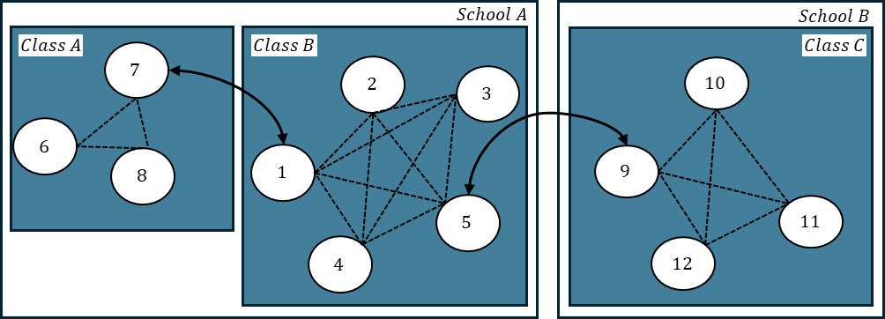
Figure 4. Primary aspect of the study design for WP4. Because genetic information provides linkages between students from different classes and different schools, peer effects can be separated from group-level heterogeneity.

Statistical separation of peer effects from unobserved heterogeneity at the class and school level rely strongly on the study design that DePeer exploit. Figure 4 illustrates 12 students from three classes (A, B, C) in two schools (A, B). Peer effects within classes are indicated by dashed lines and the solid two-headed arrows indicate relatives (1 & 7, 5 & 9). Teacher effects will only induce similarity within the same classes (6-8, 1-5, 9-12) whereas school effects will only induce similarity within the same school (1-8, 9-12). However, peer effects have the consequence that they will induce similarity between all students because the social networks in each class are connected through relatives that tend to express similar peer effects in other networks. With DePeer I will address unobserved heterogeneity at both the class and school level. I will further explore interaction questions related to whether peer effects depend on the context that they are expressed in - the school environment. To accommodate group level heterogeneity between classes and between schools, as well as school-by-peer interactions, the latent peer model will be extended:
$$y_{i}=a_{i}+\sum_{\begin{aligned}j=1 \\ j≠i\end{aligned}}^{n}{p_{j}}+\sum_{\begin{aligned}\begin{aligned}j=1 \\ j≠i\end{aligned}\end{aligned}}^{n}{{ap}_{i,j}+}u_{c}+v_{s}+\sum_{\begin{aligned}\begin{aligned}j=1 \\ j≠i\end{aligned}\end{aligned}}^{n}{{vp}_{s,j}+}e_{i}.$$
While $u_{c}$ and $v_{s}$ indicates class and school effects, the interaction term ${vp}_{s,j}$ define how the peer effect differs depending in which school it is expressed in. The key to identification of the peer-by-school interaction is that these effects do not induce dependence between relatives in different schools - only within schools. I will further introduce a wide array of contextual variables representing socioeconomic markers and characteristics of schools, to describe and understand heterogeneity of peer effects. Based on this, I propose the following research questions:

RQ4.1: How important are individual sensitivity to peers to differences in educational outcomes? Do males and females differ in sensitivity towards peers? Which dimensions of personality can describe explain why some individuals are more sensitive to peers than others?
RQ4.2: How important are peer effects relative to shared background factors between classes and schools for educational outcomes?
RQ4.3: Are peer effects more important in some schools than others? What are the school and socioeconomic characteristics that explain such heterogeneity?

Aim. WP4 will provide a more nuanced understanding of peer effects compared to WP2 and WP3. RQ4.1 investigate whether models of individual sensitivity from other fields are also useful to understand social interactions in education. This will contribute to refined models of peer effects and can reveal important mechanisms for how peer effects work. If the unique interaction between pairs of students is important, this may be undetected in “additive” models because these interactions are cancelled when collapsing over the interacting students - this is an empirical question. I will then study whether gender and specific aspects of personality, such as extraversion or agreeableness, can explain why some students are more sensitive to peers than others. This can inform how the composition of peer groups can be exploited to improve educational outcomes. RQ4.2 investigate class and school effects as alternative explanations for similarity among peers. This will be important for accurately inferring the magnitude of peer effects. RQ4.3 is addressing the school, or institutional, context as shaping how peer effects are expressed. Bronfenbrenner’s highly influential bioecological model (Bronfenbrenner & Morris, 2007) emphasizes the role of ecological systems, such as schools, in human development. Such higher order systems may plausible also shape how students’ development depend on their peers. By introducing a large set of socioeconomic and school quality contextual variables, I will distinguish how these different social structures impede or promote peer influence.
Data. The research questions in WP4 relies on the same data linkages as in WP2 and WP3. RQ4.1 relies on personality assessments from MoBa and is therefore restricted to the same sub-sample as for WP3. RQ4.1 also relies on part of the students having membership in several classes. I will address this by exploiting longitudinal assessment over multiple years from the same student. Across multiple years of schooling (5th, 8th and 9th grade for national school tests; 10th and 13th grade for grade point averages), it is relatively common for students to change classes. To study contextual school factors, I will use a linkage to the Primary and Lower Secondary Information System (GSI) and Counties main Enrollment System (VIGO), which contain yearly updated information on the organization and structure of Norwegian schools. Socioeconomic indicators will be obtained from the Norwegian Population Registry which contains yearly information on workforce participation, social benefits, housing, income, wealth and education.

Work plan
The research group. The project will be managed by Espen Moen Eilertsen. Together with colleagues, I have previously developed methodology utilizing genetics to study social relations within families (Eilertsen et al., 2021; Valstad et al., 2025). I have written statistical software to estimate general latent variable models, and extensions that incorporate social relations structured according to genetic relatedness (Eilertsen, 2021a, 2021b). The methodology and software have later been applied by several researcher to study indirect genetic effects (Bjørndal et al., 2024; Eilertsen et al., 2022; Hegemann et al., 2025; Perry et al., 2025). I have made several contributions to the study of how social interactions among family members relate to mental health, published in high-impact journals (Eilertsen et al., 2022; Eilertsen et al., 2017; Eilertsen et al., 2018). Torkild Hovde Lyngstad is a professor at Department of Sociology and Human Geography, UiO. Lyngstad’s research includes combining genetic and registry data to study sociological issues. He is previously employed at Statistics Norway, which provide the majority of the data resources that the project relies on. Torkild’s unique expertise with Norwegian registry data will make sure that the project utilize the best data resources available and acknoweldge the intricate details of data collection. Elsje van Bergen is associate professor at the department of Biological Psychology, Vrije Universiteit (VU) Amsterdam. She is also a visiting professor at the CREATE – Centre for Research on Equality in Education, UiO. Van Bergen has extensive experience with research on genetics and education and will contribute to making sure that complexities and issues specific to the topic are acknowledged and properly addressed. Lyngstad and van Bergen both has extensive experience with the study of genetics in social sciences and will contribute to both theoretical and applied development in the project. Hans Fredrik Sunde is a postdoctoral researcher at the Centre for Fertility and Health, Norwegian Institute of Public Health (NIPH). I was a supervisor for Sunde during his PhD, where he developed latent variable models to account for non-random selection of partners. His work with models for selection will make an important contribution to developing models for social stratification in DePeer. The PhD student and postdoc will both be situated in the PROMENTA research center at the Department of Psychology, UiO. Here they will be part of a large interdisciplinary group of researchers. They will be integrated with The European Social Science Genetics Network (ESSGN) network, where UiO is a partner, and have opportunity to participate on the yearly ESSGN conference. The project will be integrated with the PROMENTA research center, UiO. PROMENTA will facilitate the infrastructure and management of the data resources. A scientific assistant will be recruited in the initial phase of the project, to help with quality insurance of the data.
Organization. As PI, I will be responsible for the management of all the WPs and have the main responsibility for the conceptual and methodological developments of the project. Sunde will also be especially involved in this part of the project. Lyngstad and van Bergen will be assigned to WP1 and WP2, which is their field of expertise. The postdoctoral researcher, PhD candidate, and I will together have the main responsibility for the empirical research topics in WP2, WP3 and WP4. I plan for the PhD and postdoc to each contribute with 3-4 research papers through the project, and I will contribute 2-3 research papers. Although the data is already available, the project require significant management of data. To do this effectively, the project will include a data manager from PROMENTA that will work in close collaboration with the research group. Due to the project’s reliance on sensitive data, the data manager will have an important role in complying to requirements and guidelines regarding privacy and secure data management. I will have the main responsibility for supervising the PhD candidate and postdoc, and the other senior researchers will have different roles as co-supervisor for the specific sub-projects depending on their expertise. The core group, including the PhD candidate, postdoc and myself, will be situated at PROMENTA and have daily contact. I plan weekly meetings with the core group together, as well as individual supervision. The extended group will meet at least monthly, or more frequently depending on the stage of the project.

Risk assessment and mitigating measures
Data. A strong advantage in terms of reducing risk of the project is that all data linkages and ethical approvals have already been obtained within the PROMENTA research group. Therefore, the risk associated with data access is low. The data is stored and computations will be performed within TSD, a service developed by the university of Oslo for secure data management (https://www.uio.no/english/services/it/research/sensitive-data/index.html).
Computations. The project is ambitious with respect to the statistical modelling of peer effects as latent variables, as it places significant demands on computational resources when applied to a nationwide study sample. Relatives in different classes induce covariance between all students in the separate classes (figure 4). This results in a much more difficult computational problem than would occur if genetic effects were ignored, as the covariance pattern cannot be represented as block-diagonal. Current simulation experiments indicate that a latent peer model can be fit to 2000 classes with an average of 20 students in each class within an hour on a laptop computer but scale quadratically when increasing number of classes. Applying this to the full dataset therefore appear infeasible. It is thus a risk that we are not able to apply the statistical models to the complete population data. To resolve this, I plan to break the computations into sets of schools that are analyzed independently and aggregated using meta-analytic techniques. By exploiting UiO’s HPC (https://www.uio.no/english/services/it/research/hpc/colossus/), I am optimistic that the whole population of Norwegian schools can be analyzed within reasonable time. To perform a GWAS of peer effects, a least squares solution for a linear model is obtained independently for each position of the genome. Experiments with an implementation in Julia indicate that we can analyze 100,000 genetic variants within approximately 20 minutes. GWASs are relatively easily parallelizable, and we can likely extend the method to cover millions of genetic variants within a few hours of computation on the computing cluster.
Appendix: All current grants and on-going / submitted grant applications of the PI
(Funding ID)
Mandatory information (does not count towards page limits)

Current research grants (Please indicate "No funding" when applicable):
No funding.

On-going / submitted grant applications (Please indicate "None" when applicable):
Project Title | Funding source | Amount  (Euros) | Period | Role of the PI | Relation to current  ERC proposal²
ComPeer: A fresh approach to peer effects in education | The Research Council of Norway | 857,000 | 2026-2030 | Project manager | About peer effects in education, with less focus on genetics

Abdellaoui, A., Martin, H. C., Kolk, M., . . . Visscher, P. M. (2025). Socio-economic status is a social construct with heritable components and genetic consequences. Nature Human Behaviour, 1-13.
Abdellaoui, A., Yengo, L., Verweij, K. J., . . . Visscher, P. M. (2023). 15 years of GWAS discovery: realizing the promise. The American Journal of Human Genetics, 110(2), 179-194.
Angrist, J. D. (2014). The perils of peer effects. Labour Economics, 30, 98-108.
Back, M. D., & Kenny, D. A. (2010). The social relations model: How to understand dyadic processes. Social and Personality Psychology Compass, 4(10), 855-870.
Bijma, P. (2014). The quantitative genetics of indirect genetic effects: a selective review of modelling issues. Heredity, 112(1), 61-69.
Bjørndal, L. D., Eilertsen, E. M., Ayorech, Z., . . . Havdahl, A. (2024). Disentangling direct and indirect genetic effects from partners and offspring on maternal depression using trio-GCTA. Nature Mental Health, 2(4), 417-425.
Bornstein, M. H. (2013). Handbook of parenting: Volume 2 Biology and ecology of parenting. Psychology Press.
Boyd, R., Richerson, P. J., & Henrich, J. (2011). The cultural niche: Why social learning is essential for human adaptation. Proceedings of the national academy of sciences, 108(supplement_2), 10918-10925.
Bronfenbrenner, U., & Morris, P. A. (2007). The bioecological model of human development. Handbook of child psychology, 1.
Bulik-Sullivan, B., Finucane, H. K., Anttila, V., . . . Robinson, E. B. (2015). An atlas of genetic correlations across human diseases and traits. Nature genetics, 47(11), 1236-1241.
Burke, M. A., & Sass, T. R. (2013). Classroom peer effects and student achievement. Journal of Labor Economics, 31(1), 51-82.
Cooley, J. (2010). Desegregation and the Achievement Gap: Do Diverse Peers Help? Unpublished manuscript. Department of Economics, University of Wisconsin at Madison.
Cunha, J. M., & Miller, T. (2014). Measuring value-added in higher education: Possibilities and limitations in the use of administrative data. Economics of Education Review, 42, 64-77.
Dawkins, R. (1976). The Selfish Gene. Oxford University Press.
Eilertsen, E. M. (2021a). svcm - Fit structured variance component models with sparse relationship matrices. In (Version 0.4.0)
Eilertsen, E. M. (2021b). VCModels.jl - A Julia package for fitting variance component models with relationship matrices. In (Version 0.1.0) https://github.com/espenmei/VCModels.jl
Eilertsen, E. M., Cheesman, R., Ayorech, Z., . . . Torvik, F. A. (2022). On the importance of parenting in externalizing disorders: an evaluation of indirect genetic effects in families. Journal of Child Psychology and Psychiatry, 63(10), 1186-1195.
Eilertsen, E. M., Gjerde, L. C., Reichborn-Kjennerud, T., . . . Ystrøm, E. (2017). Maternal alcohol use during pregnancy and offspring attention-deficit hyperactivity disorder (ADHD): a prospective sibling control study [Vitenskapelig artikkel]. International journal of epidemiology, 46(5), 1633-1640. https://doi.org/http://dx.doi.org10.1093/ije/dyx067
Eilertsen, E. M., Hannigan, L. J., McAdams, T. A., . . . Gjerde, L. C. (2018). Parental prenatal depression and offspring ADHD: a genetically informed intergenerational study. 469-469. http://hdl.handle.net/10852/67349
http://www.springer.com/psychology/journal/10519
Eilertsen, E. M., Jami, E. S., McAdams, T. A., . . . Ystrom, E. (2021). Direct and indirect effects of maternal, paternal, and offspring genotypes: Trio-GCTA. Behavior genetics, 51, 154-161.
Fruehwirth, J. C. (2014). Can achievement peer effect estimates inform policy? a view from inside the black box. Review of Economics and statistics, 96(3), 514-523.
Griffith, A. L., & Main, J. B. (2019). First impressions in the classroom: How do class characteristics affect student grades and majors? Economics of Education Review, 69, 125-137.
Hegemann, L., Eilertsen, E., Hagen Pettersen, J., . . . Havdahl, A. (2025). Direct and indirect genetic effects on early neurodevelopmental traits. Journal of Child Psychology and Psychiatry.
Hewstone, M., & Stroebe, W. (2021). An introduction to social psychology. John Wiley & Sons.
Isphording, I. E., & Zölitz, U. (2020). The value of a peer.
Lynch, M., & Walsh, B. (1998). Genetics and analysis of quantitative traits (Vol. 1). Sinauer Sunderland, MA.
Manski, C. F. (1993). Identification of endogenous social effects: The reflection problem. The review of economic studies, 60(3), 531-542.
Manuck, S. B., & McCaffery, J. M. (2014). Gene-environment interaction. Annual review of psychology, 65(1), 41-70.
McNeish, D., & Kelley, K. (2019). Fixed effects models versus mixed effects models for clustered data: Reviewing the approaches, disentangling the differences, and making recommendations. Psychological methods, 24(1), 20.
Lov om grunnskolen og den videregående opplæringa (LOV-1998-07-17-61), (1998). https://lovdata.no/dokument/NLO/lov/1998-07-17-61/KAPITTEL_9#%C2%A78-1
Perry, L. C., Chevalier, N., & Luciano, M. (2025). Maternal education and prenatal smoking associations with adolescent executive function are substantially confounded by genetics. Developmental psychology.
Pluess, M. (2015). Individual differences in environmental sensitivity. Child development perspectives, 9(3), 138-143.
Sacerdote, B. (2011). Peer effects in education: How might they work, how big are they and how much do we know thus far? In Handbook of the Economics of Education (Vol. 3, pp. 249-277). Elsevier.
Uffelmann, E., Huang, Q. Q., Munung, N. S., . . . Posthuma, D. (2021). Genome-wide association studies. Nature Reviews Methods Primers, 1(1), 59.
Valstad, M., Eilertsen, E., Ayorech, Z., . . . Ystrom, E. (2025). Indirect genetic effects of siblings. https://doi.org/10.31234/osf.io/b4c76_v1
Young, A. I., Benonisdottir, S., Przeworski, M., . . . Kong, A. (2019). Deconstructing the sources of genotype-phenotype associations in humans. Science, 365(6460), 1396-1400.

Instructions for completing Part B2 can be found in the ‘Information for Applicants to the Starting and Consolidator Grant 2026 Calls’.

