Scaling Online Communities with Javamlm

Ellen Spertus
Mills College
5000 MacArthur Blvd.
Oakland, CA 94613
spertus@mills.edu

Robin Jeffries
Sun Microsystems, Inc.
901 San Antonio Rd.
Palo Alto, CA 94303
Robin.Jeffries@sun.com
Kiem Sie
(Mills College)
729 Solano Avenue
Albany, CA 94706-1516
ksie@acm.org

Abstract: Unmoderated computer-mediated discussion groups suffer from the paradox that the more successful they are, the more difficult they are to use and administer, because of the increasing number of users and discussions. Traditional solutions to this problem, such as creating static subgroups or requiring Web access, can change the nature of the community in undesired ways. We discuss the shortcomings of traditional solutions and present an approach to scaling online communities that we believe increases, rather than decreases, communication opportunities without overwhelming users or administrators.

Introduction
Systers is an unmoderated email list for women in computer science, originally created in 1987 for 12 women (Borg 1993). The list has been tremendously successful at creating a community for people who had felt isolated, growing to include over 2300 members in 38 countries. As Systers has grown, however, it has lost hundreds of members, especially senior women, because of the increased message volume that has come with increased membership. Additionally, members have felt less free to post to the entire list, instead responding directly to the sender of a message or not at all, reducing the sense of community and the utility of the list. Our goal is to provide a better format for such a large community than an unmoderated email list, while keeping the features that make Systers successful.

Figure 3: Model of Posting on Systers

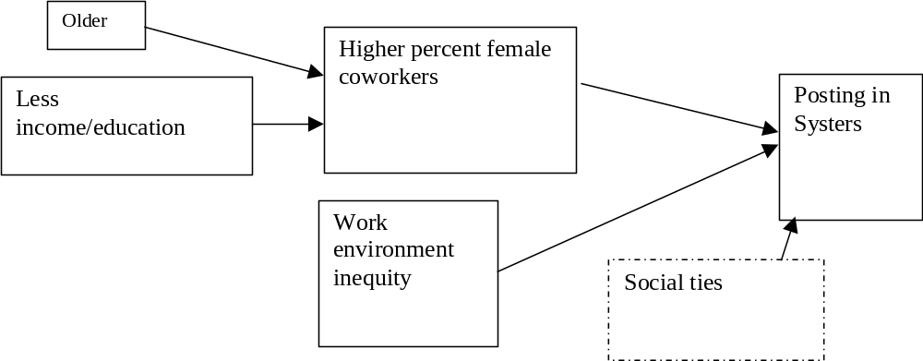

Rejected Alternatives
A common general solution to heavy volume on mailing lists is moderation, which can be performed top-down by a small set of administrators or bottom-up through collaborative filtering. While the most obvious cost of moderation is the human overhead required, a more fundamental problem is that moderation schemes limit diversity through the “tyranny of the majority”. A topic of little interest to the majority may be of great interest and value to a minority. A better scheme (which we describe below) would allow users to customize which messages they see.
A conventional alternative to moderation would be creating static subgroups of Systers interested in particular topics. There might be technical groups focused on Web design, groups discussing how best to deal with maternity leave, or support groups for women in the final stages of their dissertations. However, while an individual Syster may not be interested enough in maternity leave to join a group that discusses it exclusively, part of what members find valuable is hearing about other women's experiences in a wide range of areas, especially ones they might be relevant in the future. Thus, completely eliminating the sharing of information about maternity leave with the broader group lessens the value of the list. In the limit, there would be no common discussion among the entire group, just a vast collection of special interests. For these reasons, we rejected the idea of relying primarily on static sublists.
The most obvious way to support customized views is to go to a Web-based, newsgroup-like format, where Systers can browse the topics that interest them. Because is it not email-based, this solution would be unacceptable to many long-time Systers, who have expressed a preference for email, as well as to members in poorer countries with less Internet connectivity. It also removes the immediacy of the information, since most Systers would check the web site at most daily or weekly, which would change the feel of the community.

Our Proposal
We have a solution that we believe meets many of our design goals. Our system, called Javamlm, is oriented around conversations. Members would be able to subscribe to or unsubscribe from individual conversations while remaining subscribed to the list. The opening message of a conversation would be sent to all members. When a member signs up to Systers, she specifies whether she wants to see all messages or only the first message of each conversation. The default behavior is for users to be subscribed to all conversations in order to mimic the behavior of the current system. Users may also specify whether they prefer to receive messages as plain or formatted (html) text.
A member creates a new conversation by sending an introductory message to systers-new@systers.org. If she wishes to name the conversation “conferences”, for example, rather than having a system-assigned name, she would send her introductory message to systers-new-conferences@systers.org. All members would then receive the first message in this new conversation. If a recipient wishes for her default preference (e.g., “view all messages in new conversations”) to apply, she need not do anything. If she wishes to override her default preference, she clicks on an embedded link or replies to an indicated email address, which automatically processes her request. If she wishes to contribute to the conversation, she simply replies to the message and the message is properly directed.
Planned future functionality would give users the option of seeing only the first and last (summary) message in a conversation or receiving the messages as bundled digests. Observe that no administrator overhead is required to honor users’ preferences.
Conversations could exist for a limited period of time or be permanent. Under the current system, a volunteer collects job listings and posts them to the list once per week. She also forwards them immediately to Systers who are looking for employment. Having a “systers-jobs” conversation would eliminate the human administration costs while increasing functionality. An individual could specify any of the following behaviors:
- Receiving each job posting immediately
- Receiving digests of job listings on a daily, weekly, or monthly basis
- Never seeing job listings
At any time, she could change her preference without going through a human administrator. Additional planned functionality would allow users to receive messages containing individually specified keywords. For example, a member looking for a faculty position might choose to see all messages containing “faculty” or “professor”.

From: ada@diffeng.org
Reply-To: systers-conferences@systers.org
To: hopper@systers.org
Subject: SYSTERS: Good conferences for students?
I’m currently advising a number of undergraduate and graduate students. Can anyone recommend good conferences for students to attend?

To unsubscribe from this thread, send a blank email to systers-conferences-unsubscribe@tap.mills.edu.
Figure 1: A Sample Message. This message is part of the conferences thread. By default, our sample user, hopper@systers.org, is subscribed to all new threads. She can unsubscribe from this thread by clicking on the embedded link or sending email to the indicated address.

Status
We have built the Java Mailing List Manager (javamlm), which provides the described functionality and a number of additional features designed to minimize administration cost, such as archiving and variable envelope return paths [1], which simplify the handling of bounced messages. Information about users, conversations, and messages in kept in a relational database. We are currently using Postgres as our database management system. We have also built a Web interface to the database for users and administrators using AOLserver and Tcl. All of these tools are open source, which will allow us to release the entire package for free modification and distribution.
From: ada@diffeng.org
Reply-To: systers-conferences@systers.org
To: hopper@systers.org
Subject: SYSTERS: Good conferences for students?
I’m currently advising a number of undergraduate and graduate students. Can anyone recommend good conferences for students to attend?

To unsubscribe from this thread, send a blank email to systers-conferences-unsubscribe@tap.mills.edu.
Figure 1: A Sample Message. This message is part of the conferences thread. By default, our sample user, hopper@systers.org, is subscribed to all new threads. She can unsubscribe from this thread by clicking on the embedded link or sending email to the indicated address.

We have conducted a small user test, which showed the need for improved instructions and user interfaces for subscribers not already familiar with threaded discussion forums. User interface design is particularly difficult for subscribers with text-only mail programs.

Acknowledgments
We are grateful to Sara Kiesler, Jennifer Goetz, and Lee Sproull for performing a study of Systers members with Robin Jeffries upon which this work is based. We are grateful to Anita Borg and to the Systers members who participated in those surveys and informal discussions, offered many ideas for redesign of Systers, and volunteered their skills and effort to improve the Systers community. We have also received useful input from Gloria Montano, who is participating in the first user test. Ellen Spertus and Kiem Sie are partially supported by a National Science Foundation Faculty Early Career Development grant. This work is being done in cooperation with the Institute for Women and Technology, which hosts Systers.

References

- Borg, Anita (1993). Why Systers? Computing Research News. http://www.systers.org/keeper/whysys.html.
- Spertus, Ellen; Jeffries, Robin; and Sie, Kiem (2001). Javamlm: A Customizable Mailing-List Manager, Fifteenth Systems Administration Conference (LISA), USENIX, San Diego, CA.
- Irwin, Mary Jane and Friedman, Frank. 1998-1999 Taulbee Survey, Computing Research News, March 2000.

- 6) Multimedia: See pictures of Systers members, Hear/view audio/video clips of Systers members, Participate in same time “chat sessions" with several other Systers, and Participate in same time “private chats" with one other Syster.

