
Donor Typing to HML
Windows Executable User Manual
For the Donor_Typing_To_hml_full_gui_v3.exe application
Author: Eric Spierings, UMC Utrecht
(C) 2026
Manual version: 1.0
Generated: 2026-07-02

Important Scope and Privacy Notice
Scope: This manual describes how to use the Windows executable version of Donor Typing to HML. It focuses on daily operation, login/session handling, donor queue management, and output review.

Privacy: The application processes donor information from Donordata. Use it only in an approved clinical or laboratory environment, store generated files in approved locations, and avoid sharing screenshots or output folders that contain donor data.

The screenshots in this manual are illustrative mock screenshots using fictional ET numbers and synthetic data. They are included to explain the interface without exposing real donor information.

Document Map
Audience | Users who run the Windows executable to convert Donordata HLA typing into HML.
Required access | A valid Donordata account with two-factor authentication.
Browser requirement | Microsoft Edge or Google Chrome must be installed.
Output | HML files plus diagnostic files in donor-specific output folders.
Support posture | Use the Activity Log, row status, and output folders to troubleshoot before rerunning a donor.

Quick Start
- Place the executable in a known folder, for example a dedicated Donor Typing to HML folder.
- Double-click the executable to start the application.
- Open Settings, choose Login, and complete Donordata login and two-factor authentication in Edge or Chrome.
- Confirm that the app reports an active Donordata session.
- Choose the output folder and HML folder if the defaults are not suitable.
- Add ET donor numbers manually or import a CSV file with ET numbers in the first column.
- Tick the donors you want to run and click Run selected, or click Run all.
- Review the queue colors, selected donor panel, GL string, and output files.

What the Application Does
Donor Typing to HML reads the HLA Typing section from an authenticated Donordata donor report, identifies the CIWD genotype rows, selects the most useful typing block when more than one typing is present, builds a GL string, and writes a minimal HML 1.0.1 file.
Function | How it behaves
Authentication | Uses your normal Donordata login and 2FA in Edge or Chrome. The app does not store your password.
Donor lookup | Uses ET donor numbers from the queue and reads the authenticated page in the background.
Typing selection | Uses the typing block with CIWD genotype rows. If several are usable, it favors fewer slash ambiguities and more two-field allele results.
Output | Writes HML plus diagnostic text/CSV files, and copies the HML into the configured HML folder.
Failure handling | Marks failed rows in light red and records details in the activity log and failure folder when available.

Starting the Executable
The Windows executable is intended to be started by double-clicking the `.exe` file. It does not require a console window and should open directly into the graphical interface.
- Recommended filename: Donor_Typing_To_hml_full_gui_v3.exe.
- The executable may also be renamed, for example Donor_Typing_To_HML.exe, without changing how the program works.
- Keep the executable in a stable folder. The app stores browser profile/session helper files next to the configured working/output location.
Windows SmartScreen: If Windows warns that the application is from an unknown publisher, this is expected for a locally built executable that has not been code-signed. Only run executable files obtained from a trusted internal source.

Interface Overview
The main window is divided into a toolbar, a donor queue, a browser/session status area, a selected donor panel, an output files panel, and an activity log.
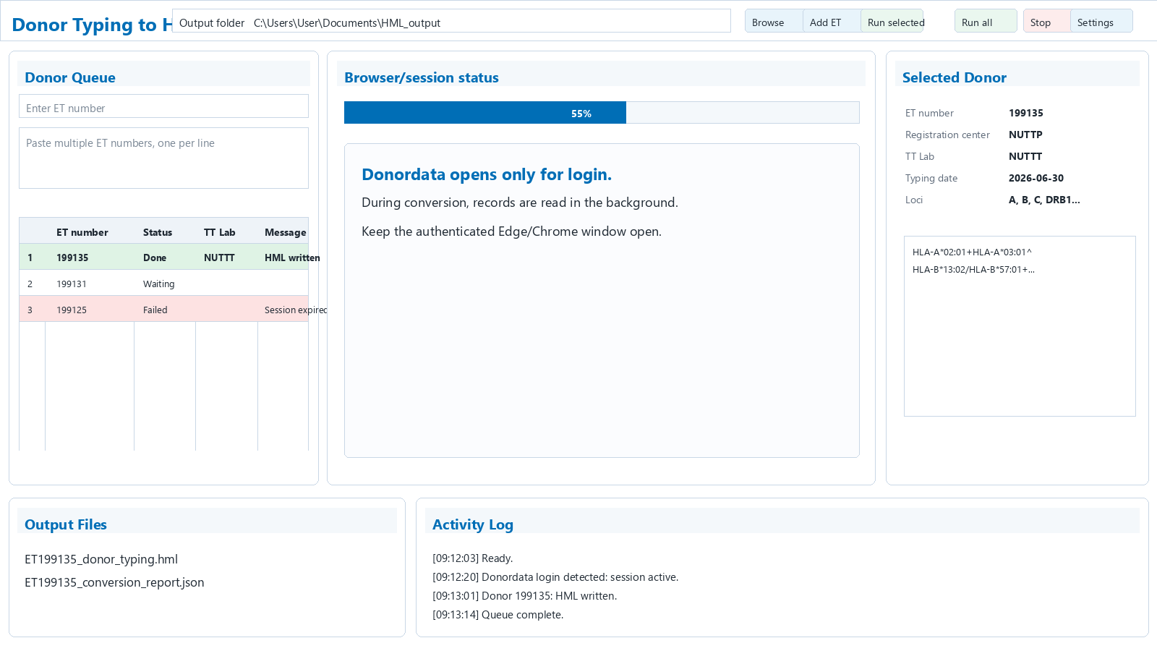
Figure 1. Main window overview using fictional donor data.
Area | Purpose
Toolbar | Choose output folder, import ET numbers, run selected rows, run all rows, stop processing, and open settings.
Donor Queue | Shows ET numbers, run selection checkboxes, conversion status, TT lab, and donor-specific messages.
Browser/session status | Shows whether the app is idle, waiting for login, or processing donors in the background.
Selected Donor | Shows metadata, loci, and GL string for the selected donor after successful conversion.
Output Files | Lists generated files and provides shortcuts to open HML/output folders.
Activity Log | Chronological operational log for login detection, donor loading, successes, and failures.

First Login
The app cannot access Donordata until you have completed the normal browser login and two-factor authentication. Login is intentionally done in Edge or Chrome so that the standard Donordata security flow remains unchanged.
- Click Settings.
- Click Login.
- A browser window opens to Donordata.
- Enter your Donordata credentials.
- Complete two-factor authentication.
- Keep the browser window open.
- Return to the app and wait for the session status to show active.
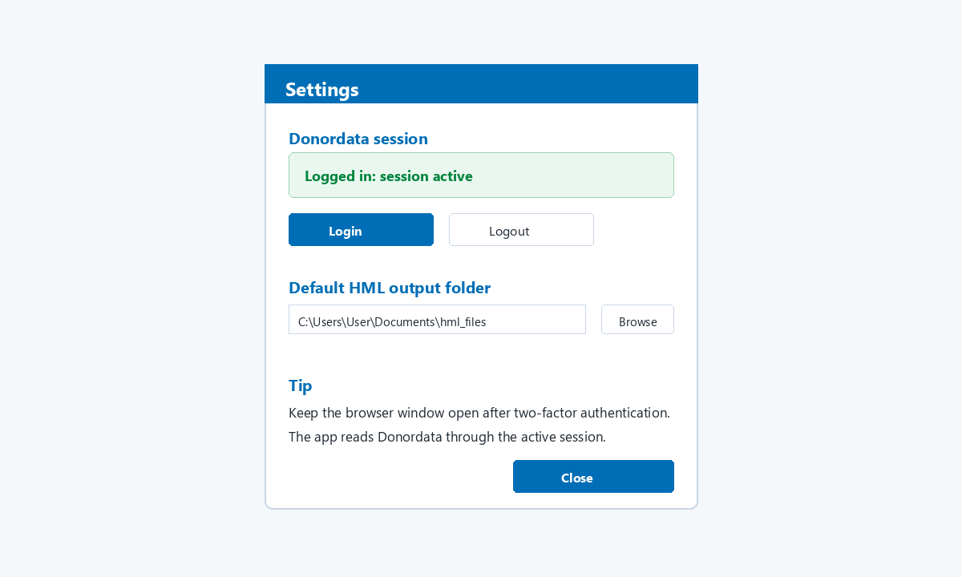
Figure 2. Settings dialog with session and output-folder controls.
Keep the browser open: After login, do not close the Edge/Chrome window opened by the app. The converter uses that authenticated session to read donor records in the background.

Output Folder Settings
The output folder controls where donor-specific conversion folders are created. The HML folder controls where final HML copies are collected.
Setting | Recommendation
Output folder | Choose a secure working folder where diagnostic files are allowed to be stored.
HML folder | Use the default `hml_files` folder or select a controlled folder used by your laboratory workflow.
Folder naming | Each donor conversion receives its own dated folder, making repeated conversions traceable.
Access control | Do not place output folders in uncontrolled shared or public locations.

Adding Donors
There are two ways to add ET donor numbers.

Manual entry
- Type one ET number in the single-line ET number box.
- Or paste several ET numbers into the multi-line box, one ET number per line.
- Click Add.

CSV import
Click Add ET to import a CSV file. The app reads ET donor numbers from the first column. Additional columns are ignored.
Valid CSV example | Meaning
199135 | One donor number in the first column.
199131,comment | Only `199131` is used; the comment column is ignored.
199125 | Another donor number.

Selecting and Running Donors
The checkbox in the first column controls whether a donor is included when using Run selected. Run all processes all eligible queued donors.
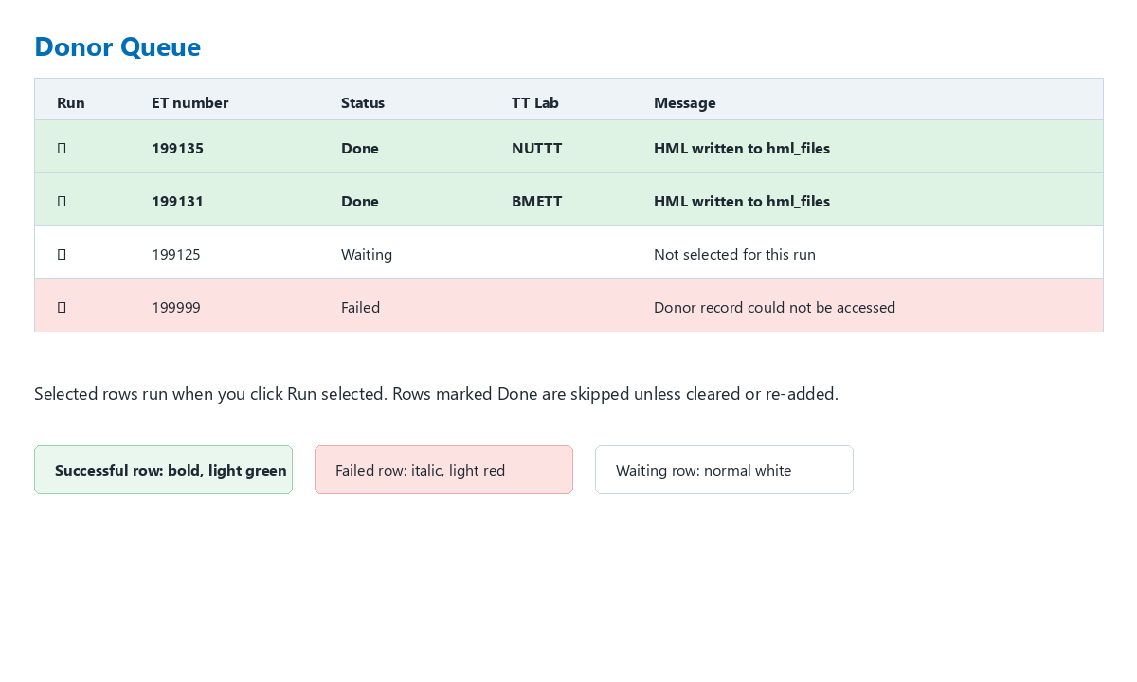
Figure 3. Queue status examples using fictional ET numbers.
Button | Use when
Run selected | Only checked rows should be converted.
Run all | Every queued donor should be converted.
Stop | You need to interrupt the current run. The app stops after the current polling/action point.
Clear | You want to remove queued donor numbers and start again.

Understanding Queue Status and Colors
Status | Color/style | Meaning
Waiting | Normal white row | The donor is queued but not yet processed.
Loading donor page | Normal white row | The app is accessing the donor record through the authenticated browser session.
Writing HML | Normal white row | The app has parsed the typing and is writing output files.
Done | Bold text, light green row | The HML file was successfully written.
Failed | Italic text, light red row | The donor could not be accessed, the typing could not be read, or HML output was not generated.
Login needed | Normal row with message | The app cannot currently access Donordata. Log in again through Settings.

Reviewing Results
After a successful conversion, select the donor row to review metadata, loci, and GL string. The selected donor panel is the quickest way to confirm that the intended donor and TT lab were used.
- ET number should match the intended donor.
- Registration center should match the donor report header.
- TT Lab should match the selected HLA Typing block.
- Typing date should be the HLA Typing entry date.
- Loci should include the expected HLA loci, including HLA-C when present.
- The GL string should contain the ambiguity structure used in the HML.

Output Files
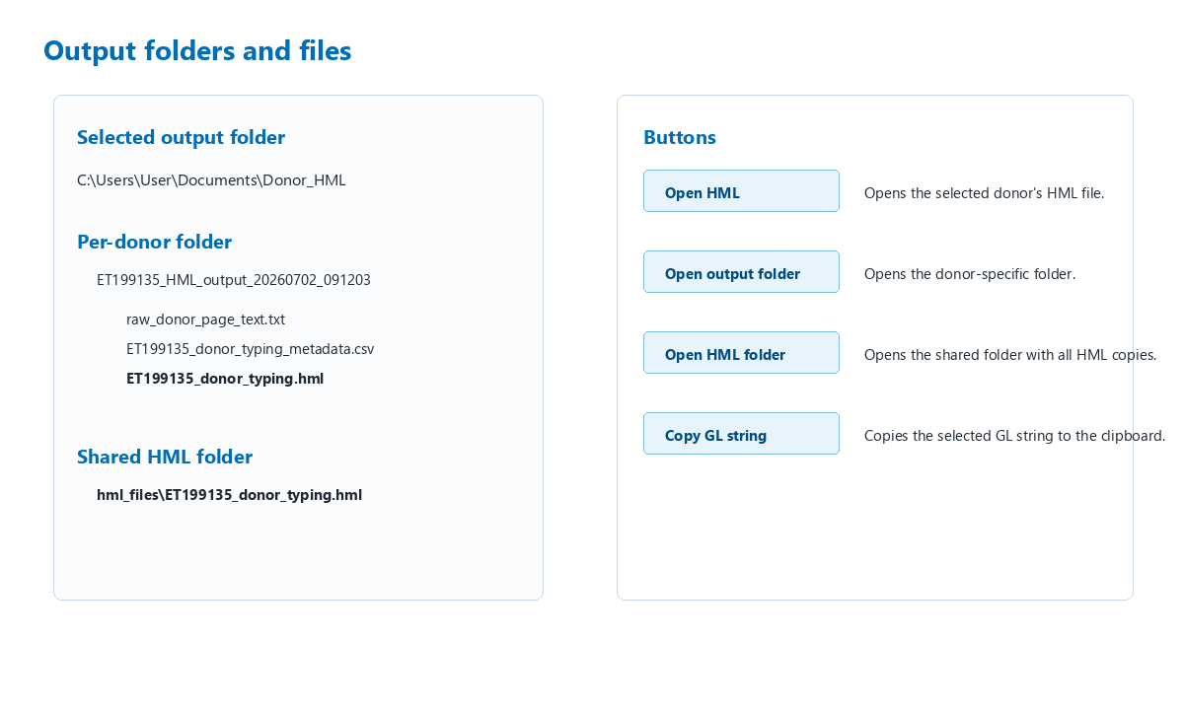
Figure 4. Output structure and file shortcuts.
File/folder | Description
ET<donor>_HML_output_<timestamp> | Donor-specific output folder for one conversion run.
raw_donor_page_text.txt | Raw text captured from Donordata for diagnostics.
normalised_donor_page_text.txt | Normalized text used for parsing.
*_metadata.csv | Extracted donor number, registration center, TT lab, and typing date.
*_hla_row_candidates.csv | Candidate rows detected by the parser.
*_selected_hla_rows.csv | Rows selected for HML generation.
*_parsed_hla_typing.csv | Parsed loci and allele groups.
*_gl_string.txt | GL string written into HML.
*_donor_typing.hml | Final HML file.
hml_files | Shared folder that receives a copy of every generated HML file.

How the Typing Is Selected
Some donors have more than one HLA Typing entry. The application does not simply take the first visible entry. It selects the most useful CIWD genotype block.
- A typing block must contain usable CIWD genotype allele rows.
- If more than one typing block is usable, the app favors fewer ambiguity slash characters in the GL string.
- It also favors more two-field allele results, such as A*02:01 rather than A*02.
- The selected TT Lab and typing date are shown in the selected donor panel and written into the HML metadata.

Daily Operating Procedure
Phase | Action | Check
Start | Open the executable. | Main window appears without console input.
Authenticate | Use Settings > Login. | Session active is detected.
Prepare | Choose output folder and HML folder. | Folders point to approved storage.
Queue | Add ET numbers manually or by CSV. | All intended donors are listed once.
Run | Use Run selected or Run all. | Progress bar and Activity Log update.
Review | Click each completed row. | ET number, TT Lab, loci, and GL string look plausible.
Collect | Open HML folder. | Expected `.hml` files are present.
Close | Close the app when finished. | Generated files remain in output folders.

Troubleshooting
Problem | Likely cause | What to do
Run buttons work but rows fail | Donordata session expired or browser was closed. | Open Settings > Login, complete 2FA again, keep browser open, rerun failed rows.
Login is not detected | Browser did not expose the expected controlled session. | Use Settings > Login from the app rather than opening Donordata manually.
Row becomes light red | Donor inaccessible, CIWD table unreadable, or no HML written. | Select the row, read the message, review Activity Log, rerun after confirming login.
Wrong TT Lab appears | Another HLA Typing block may have been selected. | Check selected donor metadata and diagnostic CSV files; verify source donor page.
No HML in expected folder | Output folder was changed or conversion failed. | Use Open output folder and Open HML folder from the app.
Windows blocks the app | Executable is not code-signed. | Only proceed if the file came from a trusted internal source.

Failure Review Checklist
- Is the browser window opened by Settings > Login still open?
- Can that browser still show Donordata without asking for login again?
- Does the ET number exist and can your account access it?
- Is the HLA Typing section present on the donor report?
- Is a CIWD Genotype table present for at least one typing entry?
- Does the Activity Log mention a timeout, inaccessible donor, or missing HML output?
- Was a failure folder created with raw text and error details?

Security, Data Handling, and Audit Considerations
The program uses your authenticated browser session but does not ask for, store, or transmit your Donordata password. Generated files can contain donor data and HLA typing information, so treat output folders as controlled clinical/laboratory data.
- Store output only in approved folders.
- Avoid emailing raw output folders unless this is explicitly permitted.
- Do not include real donor screenshots in training material.
- Remove old diagnostic folders according to local retention policy.
- Use the generated metadata and selected-row CSVs when investigating unexpected HML content.

Updating or Replacing the Executable
- Close the app.
- Keep a copy of the previous executable until the new version has been tested.
- Place the new executable in the same application folder or a clearly versioned folder.
- Start the new executable.
- Log in again if needed.
- Run a known donor test and confirm the output appears in the expected HML folder.

Appendix A - Terms Used in the App
Term | Meaning
ET number | Eurotransplant donor number used to load the donor report.
TT Lab | Typing laboratory shown in the selected HLA Typing entry.
CIWD Genotype | Allele genotype table used by the converter to build the GL string.
GL string | Text representation of HLA genotype ambiguities written into HML.
HML | XML-based Histoimmunogenetics Markup Language file.
hml_files | Collection folder containing a copy of each generated HML file.

Appendix B - Minimal CSV Template
Use one ET number per row in the first column:
199135
199131
199125
CSV import rule: The first column is used as the ET number. Extra columns are ignored, so a file exported from another list can be used as long as the ET number is in column A.

Appendix C - Before Contacting Support
Collect | Why it helps
Screenshot of the app without donor details if possible | Shows status, buttons, and general failure state.
Activity Log text | Shows timing and failure messages.
ET number and time of attempted conversion | Allows tracing the relevant output/failure folder.
Failure folder error.txt if created | Contains technical details needed for debugging.
Version/filename of executable | Confirms which build was used.

