Exploratory Analysis - Kitchen Stoves

JJ Espinoza

Sunday, August 23, 2015

The following exploratory analysis examines data on product characteristics of kitchen stoves.

**Stove Requirements**

Stainless steel

Dimensions of the stove: Depth = 25in, Width = 30in, Height 45in

**Key Findings (statistically significant):**

* The average price of a stainless steel stove with gas burners is $1,500
* The dimensions of the stove we need is common
* There is a strong correlation between price and weight; likely due to better materials
* The capacity of the stove is also a key driver, specifically the capacity of the oven
* The effectiveness of the stove is important but mainly driven by the heating capacity of the oven

## Importing the data.

data <- read.csv("C:/Users/ESPIJ090.WDW/Home - Kitchen Stoves/data/Kitchen Stove.csv")

### We want to limit our search to stainless steel stoves only.

stainless <- data[which(data$Color=="Stainless steel" & data$CookingSurface=="Gas: sealed burners"),]

## Data Visualization and Analysis

### What should we expect to pay for a stove?

hist(stainless$Price, col = "red", main="Stainless Stove Prices", xlab = "Price($)")

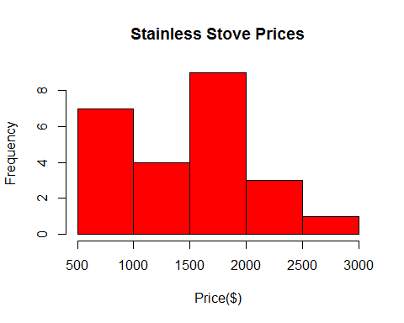

summary(stainless$Price)

## Min. 1st Qu. Median Mean 3rd Qu. Max.   
## 521.0 914.8 1546.0 1458.0 1762.0 2699.0

### What are the common dimmensions of stoves in relation to what we are looking for?

We are looking for a stove that is no more than 30in.

hist(stainless$Width, col = "blue", main="Width of Stainless Stoves ", xlab = "Width (in)")

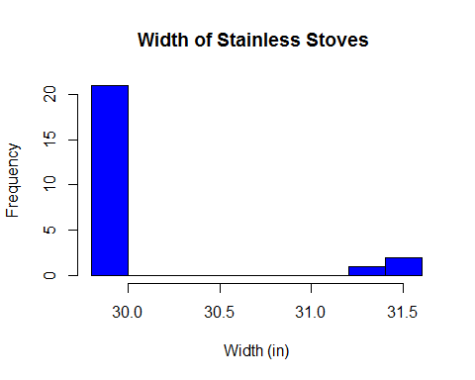

summary(stainless$Width)

## Min. 1st Qu. Median Mean 3rd Qu. Max.   
## 29.87 29.90 30.00 30.13 30.00 31.50

We are looking for a stove that is close to 45 in height.

hist(stainless$Height, col = "blue", main="Height of Stainless Stoves ", xlab = "Height (in)")

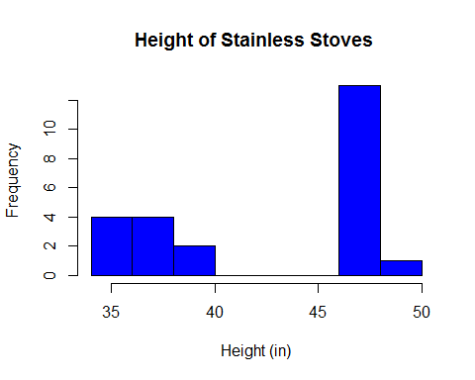

summary(stainless$Height)

## Min. 1st Qu. Median Mean 3rd Qu. Max.   
## 35.62 36.62 47.12 43.07 47.50 49.00

We are looking for a stove that is close to 25 in depth.

hist(stainless$Depth, col = "blue", main="Depth of Stainless Stoves ", xlab = "Depth (in)")

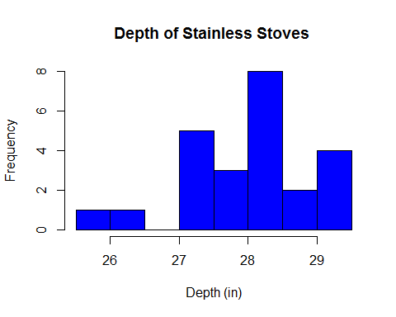

summary(stainless$Depth)

## Min. 1st Qu. Median Mean 3rd Qu. Max.   
## 25.75 27.25 28.31 28.08 28.49 29.50

### What are the tradeoffs between stove dimensions and price?

The correlation matrix shows a strong correlation between price and weight.

library(car)  
scatterplot.matrix(~Price+Depth+Height+Width+Weight , data=stainless, main="Price Correlated with Dimensions of Stove")

## Warning: 'scatterplot.matrix' is deprecated.  
## Use 'scatterplotMatrix' instead.  
## See help("Deprecated") and help("car-deprecated").

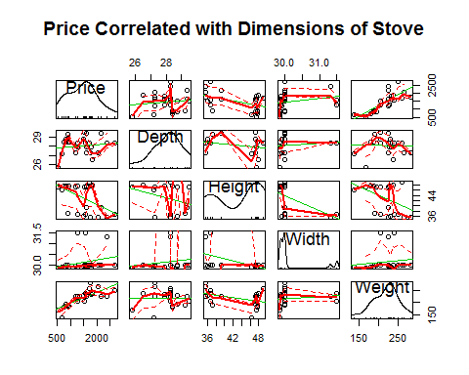

Taking a closer look one can see the clear relationship.

plot(y = stainless$Price, x = stainless$Weight, pch = 19, col = "red",main = "Correlation between Weight and Price", xlab="Weight (lbs)", ylab = "Price ($)")  
  
abline(lm(stainless$Price~stainless$Weight), col="red") # regression line (y~x)

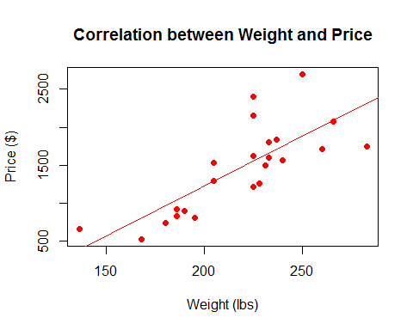

Regression estimate of relationship between price and weight.

summary(lm(Price~Weight, data = stainless))

##   
## Call:  
## lm(formula = Price ~ Weight, data = stainless)  
##   
## Residuals:  
## Min 1Q Median 3Q Max   
## -560.6 -233.8 -83.3 138.3 852.9   
##   
## Coefficients:  
## Estimate Std. Error t value Pr(>|t|)   
## (Intercept) -1411.150 508.159 -2.777 0.011 *   
## Weight 13.148 2.303 5.708 9.66e-06 ***  
## ---  
## Signif. codes: 0 '***' 0.001 '**' 0.01 '*' 0.05 '.' 0.1 ' ' 1  
##   
## Residual standard error: 367.7 on 22 degrees of freedom  
## Multiple R-squared: 0.597, Adjusted R-squared: 0.5786   
## F-statistic: 32.59 on 1 and 22 DF, p-value: 9.663e-06

### What other features are correlated with price?

scatterplot.matrix(~Price+ MainOvenCapacityCuFt+ NumberofElementsBurners , data=stainless, main="Price Correlated with Dimensions of Stove - Plot1")

## Warning: 'scatterplot.matrix' is deprecated.  
## Use 'scatterplotMatrix' instead.  
## See help("Deprecated") and help("car-deprecated").

## Warning in smoother(x, y, col = col[2], log.x = FALSE, log.y = FALSE,  
## spread = spread, : could not fit smooth

## Warning in smoother(x, y, col = col[2], log.x = FALSE, log.y = FALSE,  
## spread = spread, : could not fit smooth

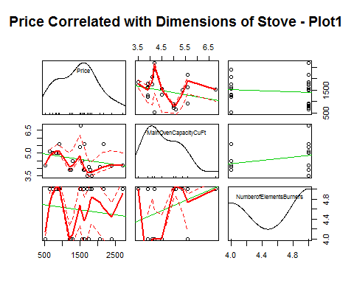

scatterplot.matrix(~Price + MainOvenNumberofRackPositions + NumberofOvenRacks , data=stainless, main="Price Correlated with Dimensions of Stove - Plot2")

## Warning: 'scatterplot.matrix' is deprecated.  
## Use 'scatterplotMatrix' instead.  
## See help("Deprecated") and help("car-deprecated").

## Warning in smoother(x, y, col = col[2], log.x = FALSE, log.y = FALSE,  
## spread = spread, : could not fit smooth

## Warning in smoother(x, y, col = col[2], log.x = FALSE, log.y = FALSE,  
## spread = spread, : could not fit smooth

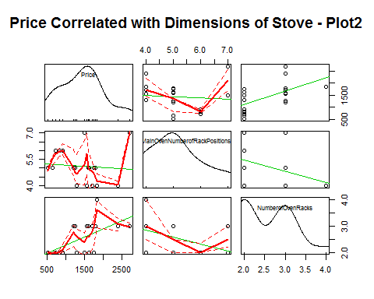

Taking a closer look at the correlations betwen Number of Oven Racks and Price we see a negative relationship.

plot(y = stainless$Price, x = stainless$NumberofOvenRacks, pch = 19, col = "red",main = "Correlation between Number of Oven Racks and Price", xlab="Number of Oven Racks", ylab = "Price ($)")  
  
abline(lm(stainless$Price~stainless$NumberofOvenRacks), col="red") # regression line (y~x)

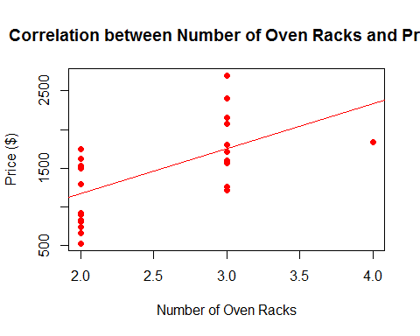

Regression estimate of relationship between price and number of oven racks.

summary(lm(Price~NumberofOvenRacks, data = stainless))

##   
## Call:  
## lm(formula = Price ~ NumberofOvenRacks, data = stainless)  
##   
## Residuals:  
## Min 1Q Median 3Q Max   
## -645.57 -375.82 -94.51 374.32 949.99   
##   
## Coefficients:  
## Estimate Std. Error t value Pr(>|t|)   
## (Intercept) 1.698 417.854 0.004 0.99679   
## NumberofOvenRacks 582.438 162.855 3.576 0.00168 **  
## ---  
## Signif. codes: 0 '***' 0.001 '**' 0.01 '*' 0.05 '.' 0.1 ' ' 1  
##   
## Residual standard error: 460.6 on 22 degrees of freedom  
## Multiple R-squared: 0.3676, Adjusted R-squared: 0.3389   
## F-statistic: 12.79 on 1 and 22 DF, p-value: 0.001685

### How does the effectiveness and efficiency correlate with price?

The scatterplot below shows that the higher the BTUs the lower the price, which seems counterintuitive.

scatterplot.matrix(~Price + BroilerBurnerBTUs + MainOvenBakeBurnerBTUs , data=stainless, main="Price Correlated with Effectiveness of Oven")

## Warning: 'scatterplot.matrix' is deprecated.  
## Use 'scatterplotMatrix' instead.  
## See help("Deprecated") and help("car-deprecated").

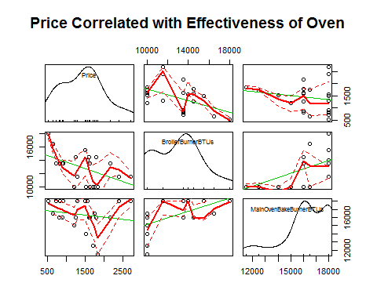

## Regression Analysis

model <- lm(Price ~ Weight + MainOvenCapacityCuFt + NumberofOvenRacks + BroilerBurnerBTUs + MainOvenBakeBurnerBTUs , data=stainless )

summary(model)

##   
## Call:  
## lm(formula = Price ~ Weight + MainOvenCapacityCuFt + NumberofOvenRacks +   
## BroilerBurnerBTUs + MainOvenBakeBurnerBTUs, data = stainless)  
##   
## Residuals:  
## Min 1Q Median 3Q Max   
## -470.17 -209.17 6.17 204.00 483.02   
##   
## Coefficients:  
## Estimate Std. Error t value Pr(>|t|)   
## (Intercept) -4.035e+03 1.358e+03 -2.972 0.00855 **  
## Weight 9.836e+00 2.920e+00 3.369 0.00365 **  
## MainOvenCapacityCuFt 2.256e+02 1.020e+02 2.212 0.04097 *   
## NumberofOvenRacks 5.592e+02 1.643e+02 3.404 0.00338 **  
## BroilerBurnerBTUs -6.045e-02 4.058e-02 -1.490 0.15459   
## MainOvenBakeBurnerBTUs 1.034e-01 4.842e-02 2.136 0.04750 *   
## ---  
## Signif. codes: 0 '***' 0.001 '**' 0.01 '*' 0.05 '.' 0.1 ' ' 1  
##   
## Residual standard error: 313.4 on 17 degrees of freedom  
## (1 observation deleted due to missingness)  
## Multiple R-squared: 0.7612, Adjusted R-squared: 0.691   
## F-statistic: 10.84 on 5 and 17 DF, p-value: 8.239e-05

plot(model)

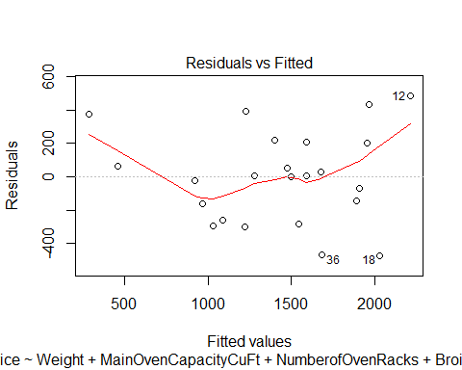 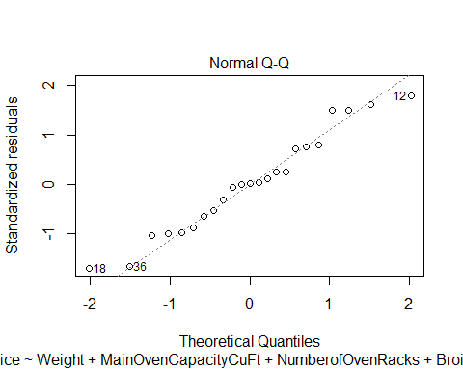 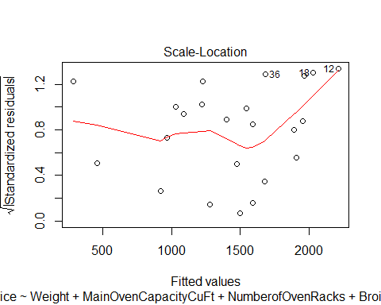 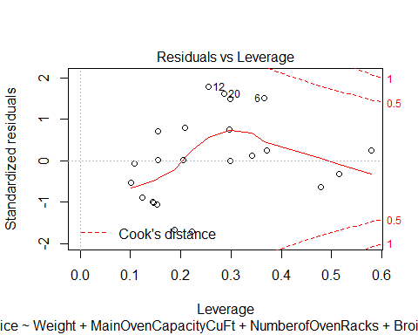

### How good does the regression model fit the data?

plot(x = predict(model, stainless), y = stainless$Price, main = "Model Predictions vs. Actual Prices", xlab = "Predicted Price", ylab = "Actual Price")  
abline(0, 1)

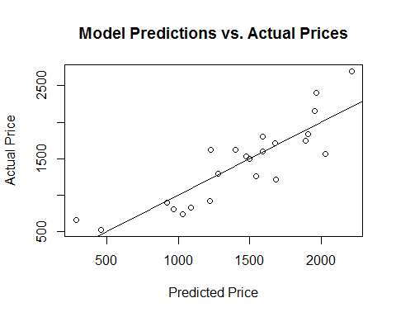

## The model accuracy is:

mean(abs((stainless$Price - predict(model, stainless))/stainless$Price), na.rm=TRUE)

## [1] 0.1735026

### Appendix - Summary Statistics

Summary statistics

summary(stainless)

## Brand   
## Kenmore :7   
## GE :5   
## LG :4   
## Whirlpool :3   
## Frigidaire:2   
## KitchenAid:2   
## (Other) :1   
## Name   
## GE 30" Slide-In Gas Range : 2   
## LG 6.1 cu. ft. Double-Oven Gas Range w/EasyClean : 2   
## Electrolux 30" Gas Slide-In Electric Range w/ Wave-Touch : 1   
## Frigidaire 4.2 cu. ft. Freestanding Gas Range : 1   
## Frigidaire Gallery Gallery 5.8 cu. ft. Double-Oven Gas Range: 1   
## GE 5.0 cu. ft. Gas Range w/ Steam Clean : 1   
## (Other) :16   
## Model.No Price Color ControlType  
## JGS750SEFSS: 1 Min. : 521.0 Beige & Bisque : 0 : 5   
## 31073 : 1 1st Qu.: 914.8 Black : 0 Digital : 3   
## 32603 : 1 Median :1546.5 Slate : 0 Electric :16   
## 32613 : 1 Mean :1457.8 Stainless steel:24 Mechanical: 0   
## 74133 : 1 3rd Qu.:1761.8 White : 0   
## 74233 : 1 Max. :2699.0   
## (Other) :18   
## CookingSurface OvenCleaningMethod  
## Electric: radiant glass surface: 0 Self-cleaning :22   
## Gas: open (standard) burners : 0 Standard clean : 2   
## Gas: sealed burners :24 Standard clean : 0   
##   
##   
##   
##   
## Depth Height MainOvenCapacityCuFt Weight   
## Min. :25.75 Min. :35.62 Min. :3.500 Min. :136.0   
## 1st Qu.:27.25 1st Qu.:36.62 1st Qu.:3.900 1st Qu.:193.8   
## Median :28.31 Median :47.12 Median :4.350 Median :225.0   
## Mean :28.08 Mean :43.07 Mean :4.600 Mean :218.2   
## 3rd Qu.:28.49 3rd Qu.:47.50 3rd Qu.:5.025 3rd Qu.:234.0   
## Max. :29.50 Max. :49.00 Max. :6.800 Max. :283.0   
##   
## Width BroilerBurnerBTUs MainOvenBakeBurnerBTUs  
## Min. :29.87 Min. :10000 Min. :11500   
## 1st Qu.:29.90 1st Qu.:10750 1st Qu.:16000   
## Median :30.00 Median :13500 Median :16250   
## Mean :30.13 Mean :12891 Mean :16354   
## 3rd Qu.:30.00 3rd Qu.:14250 3rd Qu.:18000   
## Max. :31.50 Max. :18000 Max. :18000   
## NA's :1   
## MainOvenNumberofRackPositions NumberofElementsBurners NumberofOvenRacks  
## Min. :4.000 Min. :4.000 Min. :2.0   
## 1st Qu.:4.250 1st Qu.:4.000 1st Qu.:2.0   
## Median :5.000 Median :5.000 Median :2.0   
## Mean :5.111 Mean :4.583 Mean :2.5   
## 3rd Qu.:5.750 3rd Qu.:5.000 3rd Qu.:3.0   
## Max. :7.000 Max. :5.000 Max. :4.0   
## NA's :6   
## NumberofOvens OvenType   
## Double oven: 8 Convection:14   
## Single oven:16 Standard :10   
##   
##   
##   
##   
##