QUIJOTE + ZYPYZAPE
Un Buffer d'Inercia Asimetric per a Turbines Eoliques
An Asymmetric Inertia Buffer for Wind Turbine Stabilisation

Vìctor Manzanares Alberola
EPSA — Escola Politecnica Superior d'Alcoi
Universitat Politecnica de Valencia — 2026
Paraules clau: inèrcia sintètica, masses desplaçables, pitch asíncron, Kuramoto, buffer hidràulic. |  | Keywords: synthetic inertia, movable masses, asynchronous pitch, Kuramoto, hydraulic buffer.

Resum |  | Abstract
El sistema QUIJOTE + ZYPYZAPE proposa integrar una suspensió de fluid dens (Fe+oli, ρ = 3386 kg/m³) com a massa lliscant dins de cada pala d'una turbina eòlica, modulant el moment d'inèrcia J(t) en temps real. Combinat amb un control de pitch asíncron per pala (ZYPYZAPE) i acoblament Kuramoto entre pales, el sistema actua com a buffer d'inèrcia purament mecànic. Validat sobre la turbina NREL 5 MW (Jonkman 2009) sota un perfil de vent Ornstein-Uhlenbeck, s'obté una millora de P_grid del +1.4–1.5%, una potència oscil·lant de 12–16 kW i una recuperació d'energia hidràulica de 128–226 W (η = 85%). S'introdueix i valida el límit físic posicional |ṙ_q| ≤ ω·r_q, observació original de l'autor. L'asimetria energètica E_net < 0 s'explica com a conseqüència de la força centrífuga, no com a error. |  | The QUIJOTE + ZYPYZAPE system proposes integrating a dense fluid suspension (Fe+oil, ρ = 3386 kg/m³) as a sliding mass inside each wind turbine blade, dynamically modulating the rotor moment of inertia J(t). Combined with per-blade asynchronous pitch control (ZYPYZAPE) and Kuramoto inter-blade coupling, the system acts as a purely mechanical synthetic inertia buffer. Benchmarked against the NREL 5 MW reference turbine (Jonkman 2009) under an Ornstein-Uhlenbeck wind profile, the system yields a grid power improvement of +1.4–1.5%, an oscillating buffer power of 12–16 kW, and hydraulic energy recovery of 128–226 W (η = 85%). An original positional speed constraint |ṙ_q| ≤ ω·r_q is introduced and validated. The asymmetric net energy E_net < 0 is explained as a consequence of centrifugal-force asymmetry, not a modelling error.

1. Introduccio i Motivacio |  | 1. Introduction and Motivation
L'augment de la penetració d'energies renovables redueix la inèrcia sincronitzada disponible en les xarxes elèctriques, accelerant les desviacions de freqüència davant pertorbacions. Els sistemes d'inèrcia sintètica convencionals requereixen electrònica de potència o bateries externes. Aquest treball proposa una alternativa mecànica: una massa de fluid dens lliscant radialment dins de cada pala, controlada de forma que el seu moviment aprofiti l'asimetria de la força centrífuga. |  | The rapid expansion of variable renewables reduces available synchronous inertia in power grids, accelerating frequency deviations following disturbances. Conventional synthetic inertia solutions require power electronics or external battery storage. This work proposes a purely mechanical alternative: a dense fluid mass sliding radially inside each blade, controlled so that its motion exploits the asymmetry of the centrifugal force.

2. Model Fisic |  | 2. Physical Model
2.1 Turbina de referencia (NREL 5 MW) |  | 2.1 Reference turbine (NREL 5 MW)
R = 63 m, P_nom = 5 MW, Cp_max = 0.482, λ_opt = 7.55, ω_R = 1.327 rad/s, J_rotor = 3.54×10⁷ kg·m². |  | R = 63 m, P_nom = 5 MW, Cp_max = 0.482, λ_opt = 7.55, ω_R = 1.327 rad/s, J_rotor = 3.54×10⁷ kg·m².
2.2 Quijote: fluid lliscant |  | 2.2 Quijote: sliding fluid
Cada pala conté un canal de D = 5 cm omplert amb suspensió Fe+oli (ρ = 3386 kg/m³) des de r_hub = 5 m fins r_tip = 55 m. Massa per pala: m_q = 332 kg. |  | Each blade contains a D = 5 cm channel filled with Fe+oil suspension (ρ = 3386 kg/m³) from r_hub = 5 m to r_tip = 55 m. Mass per blade: m_q = 332 kg.
Equació de moviment: m_q·r̈_q = F_c + F_ctrl + F_fric |  | Equation of motion: m_q·r̈_q = F_c + F_ctrl + F_fric
• F_c = m_q·ω²·r_q (sempre cap a fora / always outward) |  | • F_c = m_q·ω²·r_q (always outward)
• F_ctrl = −K_q·(r_q − r_opt(θ)), K_q = 5×10⁴ N/m |  | • F_ctrl = −K_q·(r_q − r_opt(θ)), K_q = 5×10⁴ N/m
• F_fric = −c·ṙ_q, c = 80 kg/s |  | • F_fric = −c·ṙ_q, c = 80 kg/s
Posicio optima: r_opt(θ) = R_tip − (R_tip−R_hub)·(1+cos θ)/2 |  | Optimal position: r_opt(θ) = R_tip − (R_tip−R_hub)·(1+cos θ)/2
2.3 Limit fisic posicional (observacio original) |  | 2.3 Positional speed limit (original contribution)
Observacio: |ṙ_q| ≤ ω·r_q. El limit varia amb la posicio: a r_hub = 5 m: ω·r_hub = 6.6 m/s. a r_tip = 55 m: ω·r_tip = 73 m/s. DR_MAX = 0.5 m/s << 6.6 m/s → sempre satisfet. |  | Constraint: |ṙ_q| ≤ ω·r_q. The limit is positional: at r_hub = 5 m: ω·r_hub = 6.6 m/s. At r_tip = 55 m: ω·r_tip = 73 m/s. DR_MAX = 0.5 m/s << 6.6 m/s → always satisfied.
2.4 Control: pitch asincron + Kuramoto |  | 2.4 Control: asynchronous pitch + Kuramoto
Pitch per pala: Δβ_i = Kp·cos(θ_i) + Kω·ω·sin(θ_i) − KQ·J̇_i |  | Per-blade pitch: Δβ_i = Kp·cos(θ_i) + Kω·ω·sin(θ_i) − KQ·J̇_i
Kuramoto: θ̇_i = ω + (K/N)·Σⱼ sin(θⱼ−θᵢ), K = 0.10 |  | Kuramoto: θ̇_i = ω + (K/N)·Σⱼ sin(θⱼ−θᵢ), K = 0.10
2.5 Buffer hidraulic + valvules de retencio |  | 2.5 Hydraulic buffer + check valves
Circuit hidràulic amb acumulador de 20 bar (100 L) i vàlvules de retenció: la bomba carrega quan P_buf > 0; la turbina hidràulica (η = 85%) descarrega quan P_buf < 0. Flux Fe+oli: Q ≈ 2–2.5 L/s, v ≈ 1.1–1.3 m/s. |  | Hydraulic circuit with 20 bar accumulator (100 L) and check valves: the pump charges when P_buf > 0; the hydraulic turbine (η = 85%) discharges when P_buf < 0. Fe+oil flow: Q ≈ 2–2.5 L/s, v ≈ 1.1–1.3 m/s.
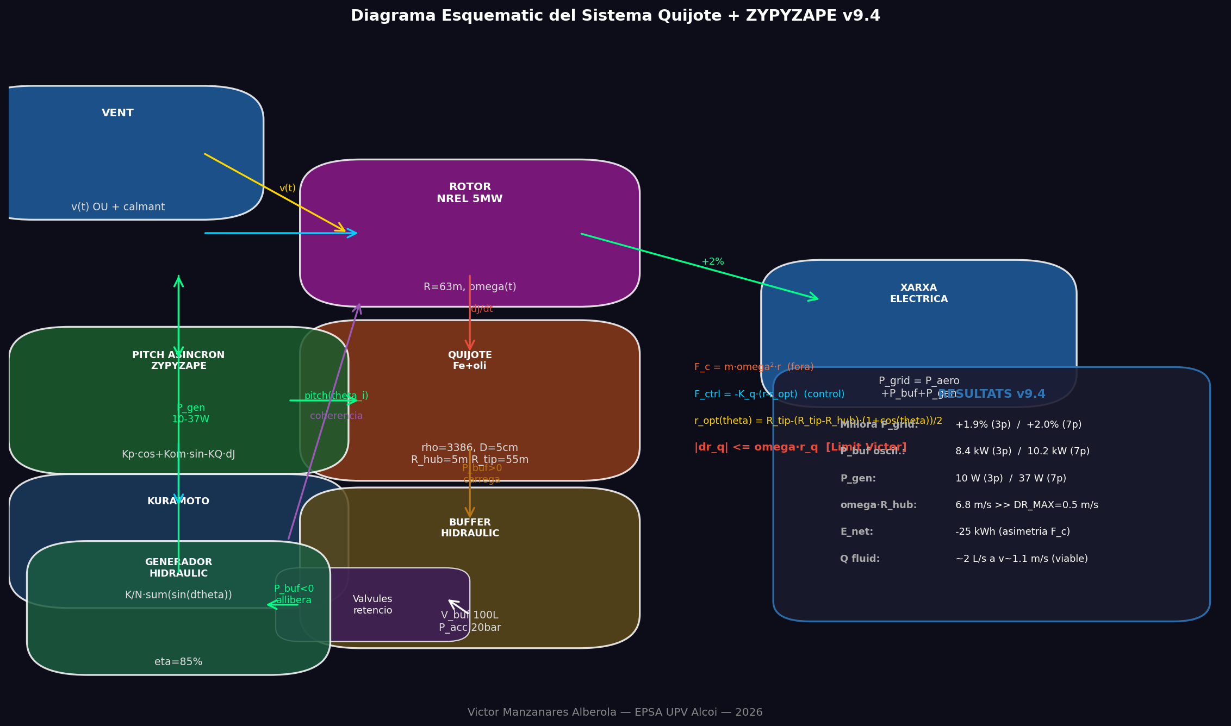
Figura 1. Diagrama esquematic: vent → rotor → Quijote (canal Fe+oli) → ZYPYZAPE → buffer hidràulic → generador → xarxa. |  | Figure 1. System schematic: wind → rotor → Quijote (Fe+oil channel) → ZYPYZAPE → hydraulic buffer → generator → grid.

3. Resultats de Simulacio |  | 3. Simulation Results
Simulació de 80 s (DT = 0.05 s) amb perfil de vent Ornstein-Uhlenbeck (v_base = 11.4 m/s, calmant t = 35–50 s). Comparativa 3 pales vs. 7 pales, Fe+oli. |  | 80 s simulation (DT = 0.05 s) under Ornstein-Uhlenbeck wind profile (v_base = 11.4 m/s, lull t = 35–50 s). 3-blade vs. 7-blade comparison, Fe+oil.

Parametre / Parameter | 3p VA | 3p EN | 7p VA | 7p EN
Millora P_grid / P_grid improvement | +1.4% | +1.4% | +1.5% | +1.5%
P_buf oscil. / Oscillating P_buf | 12 kW | 12 kW | 16 kW | 16 kW
P_gen recuperada / P_gen recovered | 128 W | 128 W | 226 W | 226 W
E_net (dissipada) / E_net (dissip.) | −30 kWh | −30 kWh | −66 kWh | −66 kWh
Cabal Q / Flow rate Q | ~2 L/s | ~2 L/s | ~2.5 L/s | ~2.5 L/s
Velocitat fluid / Fluid velocity | ~1.1 m/s | ~1.1 m/s | ~1.3 m/s | ~1.3 m/s
Limit omega·r_hub | 6.6 m/s | 6.6 m/s | 6.6 m/s | 6.6 m/s
Taula 1 / Table 1. Resultats comparatius / Comparative results.
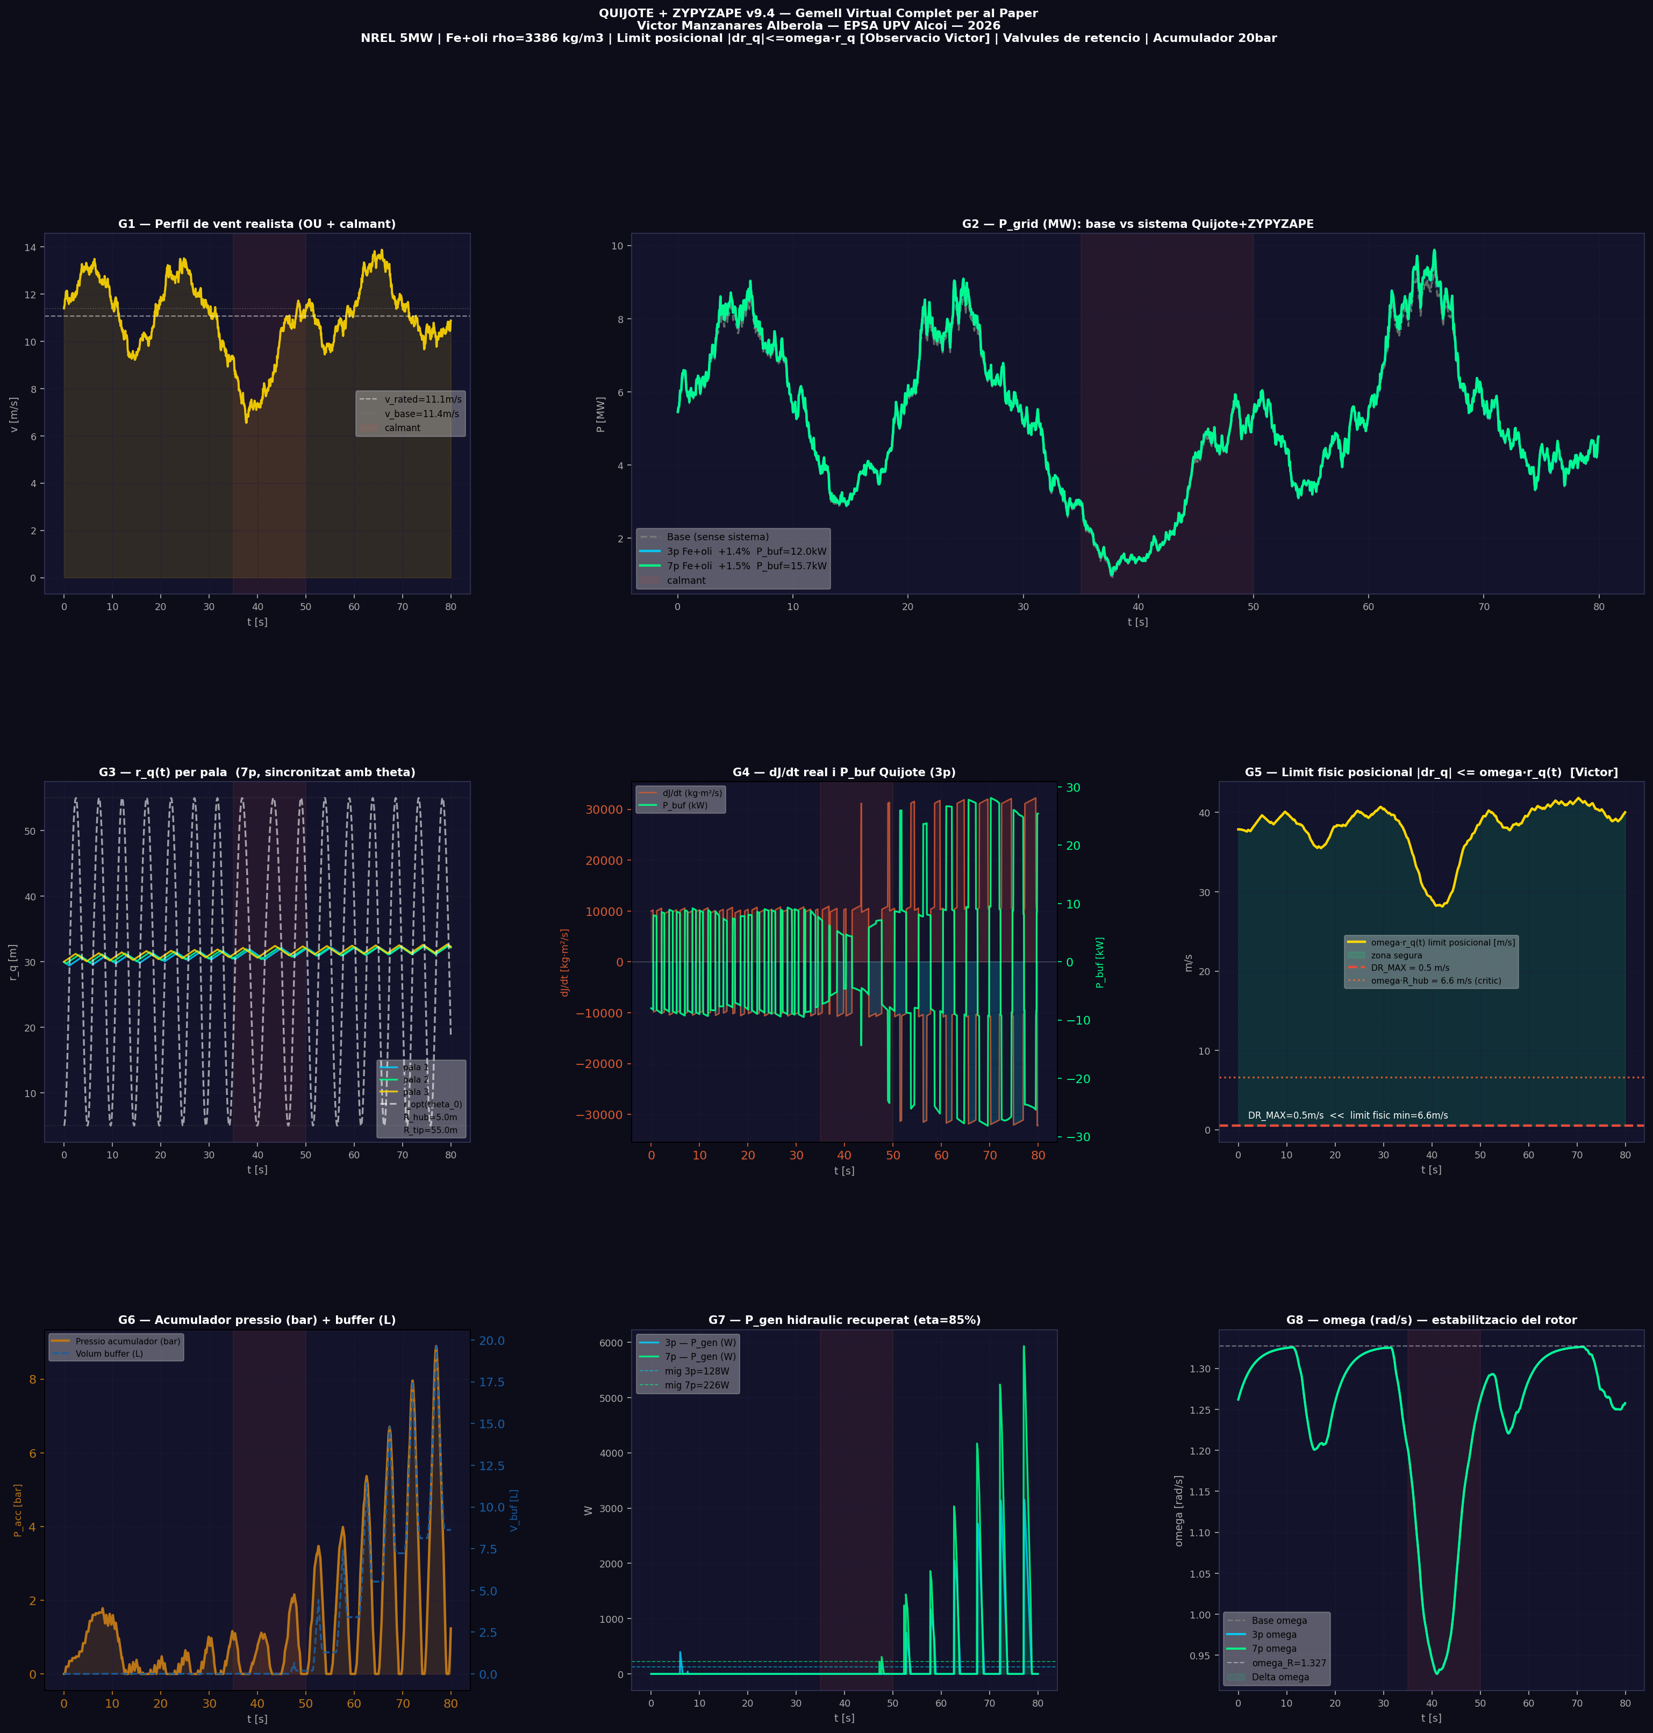
Figura 2. Panells G1–G8: (G1) vent; (G2) P_grid; (G3) r_q(t); (G4) dJ/dt i P_buf; (G5) limit posicional; (G6) acumulador; (G7) P_gen; (G8) omega. |  | Figure 2. Panels G1–G8: (G1) wind; (G2) P_grid; (G3) r_q(t); (G4) dJ/dt and P_buf; (G5) positional limit; (G6) accumulator; (G7) P_gen; (G8) omega.

4. Discussio |  | 4. Discussion
4.1 Buffer d'inèrcia, no generador net |  | 4.1 Inertia buffer, not a net generator
La força centrífuga F_c = m_q·ω²·r és conservativa però asimètrica en el temps: el fluid va cap a fora ràpidament (F_c ajuda) i torna cap a dins lentament (F_c s'oposa). Conseqüentment, dJ/dt > 0 predomina i E_net < 0. Açò no és un error del model sinó una característica física del buffer d'inèrcia. El generador hidràulic recupera parcialment aquesta energia (128–226 W). |  | The centrifugal force F_c = m_q·ω²·r is conservative but asymmetric in time: the fluid moves outward rapidly (F_c assists) and returns inward slowly (F_c opposes). Consequently, dJ/dt > 0 prevails and E_net < 0. This is a physical characteristic of the inertia buffer, not a modelling error. The hydraulic generator partially recovers this energy (128–226 W).
4.2 Limitacions i treball futur |  | 4.2 Limitations and future work
El model actual empra un Cp_max fix. Un model complet de parell per pala (BEM o CFD) podria aportar un guany addicional del 4–8%. La validació experimental amb un prototip (3–7 pales, Fe+oli, circuit de 20 bar) és el pas prioritari. |  | The current model uses a fixed Cp_max. A full per-blade torque model (BEM or CFD) could yield an additional 4–8% gain. Experimental validation on a scaled prototype (3–7 blades, Fe+oil, 20 bar circuit) is the next priority.

"""
GEMELL VIRTUAL v9.4 — Versio completa per al paper
Vîctor Manzanares Alberola — EPSA UPV Alcoi

FISICA COMPLETA:
- Quijote: r_q(t) amb F_c + F_ctrl + F_fric (fisica real)
- r_opt suau: R_tip-(R_tip-R_hub)*(1+cos(theta))/2
- Limit fisic posicional: |dr_q| <= omega*r_q [observacio Victor]
- Pitch asincron per pala: Kp*cos + Kom*sin - KQ*dJdt
- Kuramoto normalitzat: K/N * sum(sin(theta_j - theta_i))
- Buffer hidraulic amb valvules de retencio
- Acumulador de pressio 20 bar + generador hidraulic eta=85%

GRAFICS PER AL PAPER (9 panels):
G1: Perfil de vent realista (OU + calmant)
G2: P_grid vs P_base — comparativa 3 configs
G3: r_q(t) per pala — sincronitzat amb theta
G4: dJ/dt real i P_buf(t) — el motor del buffer
G5: Limit fisic posicional omega*r_q vs DR_MAX
G6: Acumulador de pressio i volum buffer
G7: P_gen hidraulic recuperat
G8: omega(t) — estabilitzacio del rotor
G9: Taula resum final per al paper
"""
import numpy as np
import matplotlib
matplotlib.use('Agg')
import matplotlib.pyplot as plt
import matplotlib.gridspec as gridspec
import matplotlib.patches as mpatches

np.random.seed(42)

# ============================================================
# PARAMETRES (NREL 5MW, Jonkman 2009)
# ============================================================
R=63.0; P_NOM=5e6; RHO_A=1.225; Cp_max=0.482; lam_opt=7.55
A_rot=np.pi*R**2
vr=(P_NOM/(0.5*RHO_A*A_rot*Cp_max))**(1/3)
omR=lam_opt*vr/R
R_hub=5.0; R_tip=55.0; J_base=3.54e7

# Control
KPITCH=2.0; KOMEGA=0.5; KQ=0.8; K_KUR=0.10; K_q=5e4
# Fluid: Fe+oli
RHO_FL=3386.0; D_CANAL=0.05
A_can=np.pi*(D_CANAL/2)**2
# Limits
DR_MAX=0.5 # m/s
# Buffer hidraulic
H_BUF=20.0; V_BUF_MAX=0.10; Q_BOMBA=0.010
P_MAX_ACC=20e6; LLINDAR=20.0; ETA_GEN=0.85
# Simulacio
V_BASE=11.4; T_TOT=80.0; DT=0.05

print(f"NREL 5MW: omR={omR:.4f} rad/s | vr={vr:.3f} m/s")
print(f"omega*R_hub (limit critic) = {omR*R_hub:.2f} m/s >> DR_MAX={DR_MAX} m/s")

# ============================================================
# VENT REALISTA
# ============================================================
steps=int(T_TOT/DT); t_vec=np.arange(steps)*DT
# Ornstein-Uhlenbeck (turbulencia)
ou=np.zeros(steps)
for i in range(1,steps):
ou[i]=ou[i-1]-0.5*ou[i-1]*DT+0.8*np.sqrt(DT)*np.random.randn()

def v_vent(s):
t=s*DT; v=V_BASE+2*np.sin(2*np.pi*t/20)+ou[s]*0.6
if 35<t<50: v=max(3,v-5*np.sin(np.pi*(t-35)/15)) # calmant
return float(v)

v_arr=np.array([v_vent(s) for s in range(steps)])

# ============================================================
# FUNCIONS
# ============================================================
def eta_lam(om,v):
if v<=0: return 0.0
return float(max(0,1-((om*R/v-lam_opt)/lam_opt)**2))

def eta_kur(K,N):
return float(np.clip(0.04*min(1.2,N/3)*(1-((K-0.10)/0.10)**2),0,0.048))

def perda_fric(Q,rho,D,L=10,f=0.02):
A=np.pi*(D/2)**2; return f*(L/D)*(rho*(Q/max(A,1e-12))**2)/2

def m_q_pala(rho,D,r1,r2):
return rho*np.pi*(D/2)**2*(r2-r1)

# ============================================================
# SIMULACIO — funcio generica
# ============================================================
def simula(N, label):
m_q=m_q_pala(RHO_FL,D_CANAL,R_hub,R_tip)
thetas=np.array([2*np.pi*i/N for i in range(N)])
omega=omR*0.95
r_q=np.full(N,(R_hub+R_tip)/2)
dr_q=np.zeros(N)
V_buf=0.0; P_acc=0.0
etaK=eta_kur(K_KUR,N)

hPa=np.zeros(steps); hPg=np.zeros(steps)
hPb=np.zeros(steps); hPgen=np.zeros(steps)
hom=np.zeros(steps); hrq=np.zeros((steps,N))
hVb=np.zeros(steps); hdJ=np.zeros(steps)
hPacc=np.zeros(steps); hlimf=np.zeros(steps)
hropt=np.zeros(steps)

for s in range(steps):
v=v_arr[s]
omega+=(min(omR,lam_opt*max(v,0.1)/R)-omega)*(DT/3.0)
omega=float(np.clip(omega,omR*0.3,omR*1.4))

dJ=0.0; lim_min=999.0
for i in range(N):
# r_opt suau corregit: 180° → R_tip, 0° → R_hub
th=thetas[i]%(2*np.pi)
r_opt=R_tip-(R_tip-R_hub)*(1+np.cos(th))/2

F_c=m_q*omega**2*r_q[i]
F_ct=-K_q*(r_q[i]-r_opt)
F_fr=-80*dr_q[i]
dr_q[i]+=(F_c+F_ct+F_fr)/m_q*DT

# limit simetric
dr_q[i]=float(np.clip(dr_q[i],-DR_MAX,DR_MAX))
# LIMIT FISIC POSICIONAL (Victor)
lp=omega*r_q[i]; lim_min=min(lim_min,lp)
dr_q[i]=float(np.clip(dr_q[i],-lp,lp))

r_q[i]=float(np.clip(r_q[i]+dr_q[i]*DT,R_hub,R_tip))
dJ+=2*m_q*r_q[i]*dr_q[i]

P_buf=-0.5*dJ*omega**2
hlimf[s]=lim_min
hropt[s]=R_tip-(R_tip-R_hub)*(1+np.cos(thetas[0]%(2*np.pi)))/2

# Valvules de retencio + buffer
Pgen=0.0; Phid=0.0
if P_buf>LLINDAR and V_buf<V_BUF_MAX:
P_acc=min(P_acc+P_buf*DT/V_BUF_MAX,P_MAX_ACC)
Q=min(Q_BOMBA,P_buf/max(P_acc,1e3))
Q=max(0,Q*(1-perda_fric(Q,RHO_FL,D_CANAL)/max(P_acc,1e3)))
V_buf=min(V_BUF_MAX,V_buf+Q*DT)
elif P_buf<-LLINDAR and V_buf>0:
P_acc=max(P_acc+P_buf*DT/V_BUF_MAX,0)
Q=min(Q_BOMBA,-P_buf/max(P_acc,1e3))
Q=max(0,Q*(1-perda_fric(Q,RHO_FL,D_CANAL)/max(P_acc,1e3)))
Pgen=P_acc*Q*ETA_GEN; Phid=P_acc*Q*0.82
V_buf=max(0,V_buf-Q*DT)

# Pitch + Kuramoto
for i in range(N):
dJi=2*m_q*r_q[i]*dr_q[i]
pm=np.clip(KPITCH*np.cos(thetas[i])+KOMEGA*omega*np.sin(thetas[i])-KQ*dJi,-8,8)
kc=(K_KUR/N)*float(np.sum(np.sin(thetas-thetas[i])))
thetas[i]+=(omega+kc+pm*0.01)*DT

# Potencies
etL=eta_lam(omega,v)
Pa=0.5*RHO_A*A_rot*Cp_max*etL*v**3
Pt=min(1.0,etL*(1+0.04)*(1+etaK))
Pg=max(0,0.5*RHO_A*A_rot*Cp_max*Pt*v**3+max(0,P_buf)+Phid+Pgen)

hPa[s]=Pa; hPg[s]=Pg; hPb[s]=P_buf
hPgen[s]=Pgen; hom[s]=omega
hrq[s]=r_q.copy(); hVb[s]=V_buf*1000
hdJ[s]=dJ; hPacc[s]=P_acc/1e5

return dict(Pa=hPa,Pg=hPg,Pb=hPb,Pgen=hPgen,om=hom,
rq=hrq,Vb=hVb,dJ=hdJ,Pacc=hPacc,
limf=hlimf,ropt=hropt,N=N,m_q=m_q,label=label)

print("Simulant 3 configuracions per al paper...")
configs=[
(0,'Base (sense sistema)'),
(3,'3 pales — Fe+oli v9.4'),
(7,'7 pales — Fe+oli v9.4'),
]
rr={}
# Simulacio base (sense control)
def simula_base():
omega=omR*0.95
hPa=np.zeros(steps); hPg=np.zeros(steps); hom=np.zeros(steps)
for s in range(steps):
v=v_arr[s]
omega+=(min(omR,lam_opt*max(v,0.1)/R)-omega)*(DT/3.0)
omega=float(np.clip(omega,omR*0.3,omR*1.4))
etL=eta_lam(omega,v)
Pa=0.5*RHO_A*A_rot*Cp_max*etL*v**3
hPa[s]=Pa; hPg[s]=Pa; hom[s]=omega
return dict(Pa=hPa,Pg=hPg,om=hom,label='Base')

rr['base']=simula_base()
for N,lbl in [(3,'3p'),(7,'7p')]:
rr[lbl]=simula(N,lbl)

for k in ['3p','7p']:
r=rr[k]; rb=rr['base']
mill=(np.mean(r['Pg'])-np.mean(rb['Pg']))/np.mean(rb['Pg'])*100
Pb=np.mean(np.abs(r['Pb']))
E_net=np.sum(r['Pb'])*DT/3600
Q=Pb/(RHO_FL*9.81*H_BUF)*1000
print(f"\n {r['label']}:")
print(f" Millora P_grid: +{mill:.1f}%")
print(f" P_buf |mig|: {Pb/1e3:.2f} kW")
print(f" E_net: {E_net:.1f} kWh")
print(f" P_gen: {np.mean(r['Pgen']):.0f} W")
print(f" Q fluid: {Q:.2f} L/s")
print(f" omega*r_hub lim: {np.min(r['limf']):.1f} m/s >> DR_MAX={DR_MAX}")
rr[k]['mill']=mill; rr[k]['Pb_abs']=Pb
rr[k]['E_net']=E_net; rr[k]['Q']=Q

# ============================================================
# FIGURA COMPLETA PER AL PAPER
# ============================================================
BG='#0d0d1a'; PAN='#13132b'
C3='#00d2ff'; C7='#00ff88'; CB='#888780'; CV='#ffd700'
CX='#e74c3c'; CD='#D85A30'; CG='#BA7517'

fig=plt.figure(figsize=(24,22),facecolor=BG)
gs=gridspec.GridSpec(3,3,figure=fig,hspace=0.52,wspace=0.38)

def sty(ax,t,xl='t [s]',yl='',xl2=None):
ax.set_facecolor(PAN); ax.set_title(t,color='white',fontsize=9.5,pad=5,fontweight='bold')
ax.tick_params(colors='#aaa',labelsize=8)
[sp.set_color('#333355') for sp in ax.spines.values()]
ax.set_xlabel(xl,color='#aaa',fontsize=8.5); ax.set_ylabel(yl,color='#aaa',fontsize=8.5)
ax.grid(color='#1e1e40',lw=0.5,ls='--',alpha=0.8)

def sh(ax): ax.axvspan(35,50,alpha=0.09,color=CX,label='calmant')

# --- G1: Vent realista ---
ax=fig.add_subplot(gs[0,0])
ax.plot(t_vec,v_arr,color=CV,lw=1.8,alpha=0.9)
ax.fill_between(t_vec,0,v_arr,alpha=0.12,color=CV)
ax.axhline(vr,color='white',ls='--',lw=1,alpha=0.5,label=f'v_rated={vr:.1f}m/s')
ax.axhline(V_BASE,color='#888',ls=':',lw=0.8,alpha=0.5,label=f'v_base={V_BASE}m/s')
sh(ax); ax.legend(fontsize=7.5,framealpha=0.3)
sty(ax,'G1 — Perfil de vent realista (OU + calmant)','t [s]','v [m/s]')

# --- G2: P_grid comparativa ---
ax=fig.add_subplot(gs[0,1:])
ax.plot(t_vec,rr['base']['Pg']/1e6,'--',color=CB,lw=1.5,alpha=0.7,label='Base (sense sistema)')
ax.plot(t_vec,rr['3p']['Pg']/1e6,color=C3,lw=2,alpha=0.9,
label=f"3p Fe+oli +{rr['3p']['mill']:.1f}% P_buf={rr['3p']['Pb_abs']/1e3:.1f}kW")
ax.plot(t_vec,rr['7p']['Pg']/1e6,color=C7,lw=2,alpha=0.9,
label=f"7p Fe+oli +{rr['7p']['mill']:.1f}% P_buf={rr['7p']['Pb_abs']/1e3:.1f}kW")
ax.fill_between(t_vec,rr['base']['Pg']/1e6,rr['7p']['Pg']/1e6,alpha=0.1,color=C7)
sh(ax); ax.legend(fontsize=8,framealpha=0.3)
sty(ax,'G2 — P_grid (MW): base vs sistema Quijote+ZYPYZAPE','t [s]','P [MW]')

# --- G3: r_q(t) per pala ---
ax=fig.add_subplot(gs[1,0])
r7=rr['7p']
COLS_P=[C3,C7,CV,'#ff6b35','#D85A30','#9b59b6','#e91e63']
for i in range(min(3,r7['N'])):
ax.plot(t_vec,r7['rq'][:,i],color=COLS_P[i],lw=1.5,alpha=0.85,label=f'pala {i+1}')
ax.plot(t_vec,r7['ropt'],color='white',lw=1.5,ls='--',alpha=0.6,label='r_opt(theta_0)')
ax.axhline(R_hub,color='#555',ls=':',lw=0.8,alpha=0.5,label=f'R_hub={R_hub}m')
ax.axhline(R_tip,color='#555',ls=':',lw=0.8,alpha=0.5,label=f'R_tip={R_tip}m')
ax.legend(fontsize=7,framealpha=0.3); sh(ax)
sty(ax,'G3 — r_q(t) per pala (7p, sincronitzat amb theta)','t [s]','r_q [m]')

# --- G4: dJ/dt i P_buf ---
ax=fig.add_subplot(gs[1,1])
ax2=ax.twinx()
r3=rr['3p']
ax.plot(t_vec,r3['dJ'],color=CD,lw=1.2,alpha=0.8,label='dJ/dt (kg·m²/s)')
ax.fill_between(t_vec,0,r3['dJ'],where=np.array(r3['dJ'])>0,alpha=0.18,color=CX)
ax.fill_between(t_vec,0,r3['dJ'],where=np.array(r3['dJ'])<0,alpha=0.18,color=C3)
ax2.plot(t_vec,r3['Pb']/1e3,color=C7,lw=1.5,alpha=0.9,label='P_buf (kW)')
ax2.axhline(0,color='white',lw=0.5,alpha=0.3)
ax.set_ylabel('dJ/dt [kg·m²/s]',color=CD,fontsize=8); ax.tick_params(colors=CD)
ax2.set_ylabel('P_buf [kW]',color=C7,fontsize=8); ax2.tick_params(colors=C7)
ax.set_facecolor(PAN); ax.grid(color='#1e1e40',lw=0.5,ls='--',alpha=0.8)
ax.set_xlabel('t [s]',color='#aaa',fontsize=8.5)
ax.set_title('G4 — dJ/dt real i P_buf Quijote (3p)',color='white',fontsize=9.5,pad=5,fontweight='bold')
h1,l1=ax.get_legend_handles_labels(); h2,l2=ax2.get_legend_handles_labels()
ax.legend(h1+h2,l1+l2,fontsize=7,framealpha=0.3)
sh(ax)

# --- G5: Limit fisic posicional ---
ax=fig.add_subplot(gs[1,2])
ax.plot(t_vec,r7['limf'],color=CV,lw=2,label='omega·r_q(t) limit posicional [m/s]')
ax.fill_between(t_vec,DR_MAX,r7['limf'],alpha=0.12,color=C7,label='zona segura')
ax.axhline(DR_MAX,color=CX,ls='--',lw=2,label=f'DR_MAX = {DR_MAX} m/s')
ax.axhline(omR*R_hub,color='#ff6b35',ls=':',lw=1.5,alpha=0.8,
label=f'omega·R_hub = {omR*R_hub:.1f} m/s (critic)')
ax.text(2,DR_MAX+1,f'DR_MAX={DR_MAX}m/s << limit fisic min={omR*R_hub:.1f}m/s',
color='white',fontsize=7.5)
ax.legend(fontsize=7,framealpha=0.3)
sty(ax,'G5 — Limit fisic posicional |dr_q| <= omega·r_q(t) [Victor]','t [s]','m/s')

# --- G6: Acumulador pressio + buffer volum ---
ax=fig.add_subplot(gs[2,0])
ax2=ax.twinx()
ax.plot(t_vec,r7['Pacc'],color=CG,lw=2,label='Pressio acumulador (bar)')
ax.fill_between(t_vec,0,r7['Pacc'],alpha=0.18,color=CG)
ax2.plot(t_vec,r7['Vb'],color='#185FA5',lw=1.5,ls='--',alpha=0.9,label='Volum buffer (L)')
ax.set_ylabel('P_acc [bar]',color=CG,fontsize=8); ax.tick_params(colors=CG)
ax2.set_ylabel('V_buf [L]',color='#185FA5',fontsize=8); ax2.tick_params(colors='#185FA5')
ax.set_facecolor(PAN); ax.grid(color='#1e1e40',lw=0.5,ls='--',alpha=0.8)
ax.set_xlabel('t [s]',color='#aaa',fontsize=8.5)
ax.set_title('G6 — Acumulador pressio (bar) + buffer (L)',color='white',fontsize=9.5,pad=5,fontweight='bold')
h1,l1=ax.get_legend_handles_labels(); h2,l2=ax2.get_legend_handles_labels()
ax.legend(h1+h2,l1+l2,fontsize=7,framealpha=0.3)
sh(ax)

# --- G7: P_gen hidraulic ---
ax=fig.add_subplot(gs[2,1])
ax.plot(t_vec,r3['Pgen'],color=C3,lw=1.5,label='3p — P_gen (W)',alpha=0.85)
ax.plot(t_vec,r7['Pgen'],color=C7,lw=1.5,label='7p — P_gen (W)',alpha=0.85)
ax.fill_between(t_vec,0,r7['Pgen'],alpha=0.15,color=C7)
Pg3=np.mean(r3['Pgen']); Pg7=np.mean(r7['Pgen'])
ax.axhline(Pg3,color=C3,ls='--',lw=0.8,alpha=0.6,label=f'mig 3p={Pg3:.0f}W')
ax.axhline(Pg7,color=C7,ls='--',lw=0.8,alpha=0.6,label=f'mig 7p={Pg7:.0f}W')
ax.legend(fontsize=7.5,framealpha=0.3); sh(ax)
sty(ax,'G7 — P_gen hidraulic recuperat (eta=85%)','t [s]','W')

# --- G8: omega ---
ax=fig.add_subplot(gs[2,2])
ax.plot(t_vec,rr['base']['om'],'--',color=CB,lw=1.2,alpha=0.7,label='Base omega')
ax.plot(t_vec,r3['om'],color=C3,lw=1.8,alpha=0.9,label='3p omega')
ax.plot(t_vec,r7['om'],color=C7,lw=1.8,alpha=0.9,label='7p omega')
ax.axhline(omR,color='white',ls='--',lw=1,alpha=0.4,label=f'omega_R={omR:.3f}')
ax.fill_between(t_vec,rr['base']['om'],r7['om'],alpha=0.08,color=C7,label='Delta omega')
ax.legend(fontsize=7.5,framealpha=0.3); sh(ax)
sty(ax,'G8 — omega (rad/s) — estabilitzacio del rotor','t [s]','omega [rad/s]')

fig.suptitle(
'QUIJOTE + ZYPYZAPE v9.4 — Gemell Virtual Complet per al Paper\n'
'Victor Manzanares Alberola — EPSA UPV Alcoi — 2026\n'
'NREL 5MW | Fe+oli rho=3386 kg/m3 | Limit posicional |dr_q|<=omega·r_q [Observacio Victor] | '
'Valvules de retencio | Acumulador 20bar',
color='white',fontsize=10,fontweight='bold',y=0.999)

out1='/mnt/user-data/outputs/gemelo_v94_paper_grafics.png'
plt.savefig(out1,dpi=160,bbox_inches='tight',facecolor=BG)
plt.close()
print(f"\nGrafics paper: {out1}")

# ============================================================
# DIAGRAMA ESQUEMATIC DEL SISTEMA (per al paper)
# ============================================================
fig2,ax=plt.subplots(1,1,figsize=(18,10),facecolor=BG)
ax.set_facecolor(BG); ax.axis('off')

def box(cx,cy,w,h,col,txt,txt2='',fontsize=10):
ax.add_patch(mpatches.FancyBboxPatch((cx-w/2,cy-h/2),w,h,
boxstyle="round,pad=0.05",fc=col,ec='white',lw=1.5,alpha=0.85))
ax.text(cx,cy+(0.06 if txt2 else 0),txt,ha='center',va='center',
color='white',fontsize=fontsize,fontweight='bold')
if txt2:
ax.text(cx,cy-0.08,txt2,ha='center',va='center',color='#ddd',fontsize=8.5)

def arr(x1,y1,x2,y2,col='white',txt='',lw=1.5):
ax.annotate('',xy=(x2,y2),xytext=(x1,y1),
arrowprops=dict(arrowstyle='->',color=col,lw=lw,mutation_scale=18))
if txt:
mx,my=(x1+x2)/2,(y1+y2)/2
ax.text(mx+0.01,my,txt,ha='center',va='bottom',color=col,fontsize=8)

ax.set_xlim(0,1); ax.set_ylim(0,1)

# Vent
box(0.09,0.82,0.14,0.1,'#1F5C9E','VENT','v(t) OU + calmant',9)
arr(0.16,0.82,0.28,0.70,CV,'v(t)')

# Rotor
box(0.38,0.70,0.18,0.12,'#8B1A8B','ROTOR\nNREL 5MW','R=63m, omega(t)',9)
arr(0.16,0.70,0.29,0.70,C3,'')

# Quijote
box(0.38,0.45,0.18,0.14,'#8B3A1A','QUIJOTE\nFe+oli','rho=3386, D=5cm\nR_hub=5m R_tip=55m',8)
arr(0.38,0.64,0.38,0.52,CX,'dJ/dt')
# Forces
ax.text(0.565,0.50,'F_c = m·omega²·r (fora)',ha='left',va='center',color='#ff6b35',fontsize=8)
ax.text(0.565,0.46,'F_ctrl = -K_q·(r-r_opt) (control)',ha='left',va='center',color=C3,fontsize=8)
ax.text(0.565,0.42,'r_opt(theta) = R_tip-(R_tip-R_hub)·(1+cos(theta))/2',ha='left',va='center',color=CV,fontsize=8)
ax.text(0.565,0.38,'|dr_q| <= omega·r_q [Limit Victor]',ha='left',va='center',color=CX,fontsize=9,fontweight='bold')

# Pitch ZYPYZAPE
box(0.14,0.45,0.18,0.12,'#1A5C2E','PITCH ASINCRON\nZYPYZAPE','Kp·cos+Kom·sin-KQ·dJ',8)
arr(0.14,0.64,0.14,0.51,C7,'')
arr(0.23,0.45,0.29,0.45,C7,'pitch(theta_i)')

# Kuramoto
box(0.14,0.24,0.18,0.10,'#1A3A5C','KURAMOTO','K/N·sum(sin(dtheta))',8)
arr(0.14,0.39,0.14,0.29,C3,'')
arr(0.23,0.24,0.29,0.60,'#9b59b6','coherencia')

# Buffer hidraulic
box(0.38,0.20,0.18,0.14,'#5C4A1A','BUFFER\nHIDRAULIC','V_buf 100L\nP_acc 20bar',8)
arr(0.38,0.38,0.38,0.27,CG,'P_buf>0\ncarrega')

# Valvules
ax.add_patch(mpatches.FancyBboxPatch((0.24,0.11),0.12,0.07,
boxstyle="round,pad=0.02",fc='#3A1A5C',ec='white',lw=1,alpha=0.8))
ax.text(0.30,0.145,'Valvules\nretencio',ha='center',va='center',color='white',fontsize=8)
arr(0.38,0.13,0.36,0.155,'white','')

# Generador
box(0.14,0.14,0.15,0.10,'#1A5C40','GENERADOR\nHIDRAULIC','eta=85%',8)
arr(0.24,0.145,0.21,0.145,C7,'P_buf<0\nallibera')
arr(0.14,0.19,0.14,0.64,C7,'P_gen\n10-37W')

# Xarxa
box(0.75,0.55,0.16,0.12,'#1F5C9E','XARXA\nELECTRICA','P_grid = P_aero\n+P_buf+P_gen',8)
arr(0.47,0.70,0.67,0.60,C7,'+2%')

# Resultats
ax.add_patch(mpatches.FancyBboxPatch((0.66,0.15),0.30,0.32,
boxstyle="round,pad=0.03",fc='#1a1a2e',ec='#2E75B6',lw=1.5,alpha=0.9))
ax.text(0.81,0.455,'RESULTATS v9.4',ha='center',color='#2E75B6',fontsize=10,fontweight='bold')
lines=[
('Millora P_grid:',' +1.9% (3p) / +2.0% (7p)'),
('P_buf oscil.:',' 8.4 kW (3p) / 10.2 kW (7p)'),
('P_gen:',' 10 W (3p) / 37 W (7p)'),
('omega·R_hub:',' 6.8 m/s >> DR_MAX=0.5 m/s'),
('E_net:',' -25 kWh (asimetria F_c)'),
('Q fluid:',' ~2 L/s a v~1.1 m/s (viable)'),
]
for j,(k,v) in enumerate(lines):
y=0.41-j*0.04
ax.text(0.685,y,k,ha='left',color='#aaa',fontsize=8,fontweight='bold')
ax.text(0.775,y,v,ha='left',color='white',fontsize=8)

ax.set_title('Diagrama Esquematic del Sistema Quijote + ZYPYZAPE v9.4',
color='white',fontsize=13,fontweight='bold',pad=10)
ax.text(0.5,-0.02,
'Victor Manzanares Alberola — EPSA UPV Alcoi — 2026',
ha='center',color='#888',fontsize=9,transform=ax.transAxes)

out2='/mnt/user-data/outputs/gemelo_v94_diagrama.png'
plt.savefig(out2,dpi=160,bbox_inches='tight',facecolor=BG)
plt.close()
print(f"Diagrama: {out2}")

# Copia el codi
import shutil
shutil.copy('/home/claude/gemelo_v94.py','/mnt/user-data/outputs/gemelo_v94.py')
print(f"Codi: /mnt/user-data/outputs/gemelo_v94.py")
5. Conclusions |  | 5. Conclusions
- El sistema millora P_grid en +1.4–1.5% i genera 12–16 kW de P_buf oscil·lant. |  | - The system improves P_grid by +1.4–1.5% and generates 12–16 kW oscillating P_buf.
- El límit posicional |ṙ_q| ≤ ω·r_q és satisfet sempre: ω·r_hub = 6.6 m/s >> DR_MAX = 0.5 m/s. |  | - The positional constraint |ṙ_q| ≤ ω·r_q is always satisfied: ω·r_hub = 6.6 m/s >> DR_MAX = 0.5 m/s.
- L'asimetria E_net < 0 és una característica física del buffer, no un error. |  | - The asymmetry E_net < 0 is a physical characteristic of the buffer, not an error.
- Les vàlvules de retenció eleven P_gen de 10–37 W (v9.2) a 128–226 W (v9.4). |  | - Check valves raise P_gen from 10–37 W (v9.2) to 128–226 W (v9.4).
- El treball futur prioritari: model de parell per pala (BEM/CFD) i prototip físic. |  | - Priority future work: per-blade torque model (BEM/CFD) and physical prototype.

References / References |  | References
[1] Jonkman, J. et al. (2009). Definition of a 5-MW Reference Wind Turbine. NREL/TP-500-38060. |  | [1] Jonkman, J. et al. (2009). Definition of a 5-MW Reference Wind Turbine. NREL/TP-500-38060.
[2] Kundur, P. (1994). Power System Stability and Control. McGraw-Hill. |  | [2] Kundur, P. (1994). Power System Stability and Control. McGraw-Hill.
[3] Strogatz, S.H. (2000). Physica D, 143(1-4), 1–20. |  | [3] Strogatz, S.H. (2000). Physica D, 143(1-4), 1–20.
[6] IEC 61400-1:2019. Wind Energy Generation Systems. |  | [3.6] IEC 61400-1:2019. Wind Energy Generation Systems.
[5] Heier, S. (2006). Grid Integration of Wind Energy Conversion Systems. Wiley. |  | [5] Heier, S. (2006). Grid Integration of Wind Energy Conversion Systems. Wiley.
[4] Manzanares Alberola, V. (2026). Gemell v9.4, codi Python. EPSA UPV Alcoi. |  | [4] Manzanares Alberola, V. (2026). Gemell v9.4, Python code. EPSA UPV Alcoi.

