Quijote + ZYPYZAPE: An Asymmetric Inertia Buffer
for Wind Turbine Grid Stabilisation

Victor Manzanares Alberola
EPSA — Escola Politecnica Superior d'Alcoi
Universitat Politecnica de Valencia, Spain
Technical Note — 2026
Keywords: wind turbine; inertia buffer; asymmetric hydraulic; Kuramoto coupling; asynchronous pitch; NREL 5MW

Abstract
This paper proposes integrating a dense fluid (Fe+oil suspension, rho = 3386 kg/m3) as a sliding radial mass inside each wind turbine blade (Quijote), dynamically modulating the rotor moment of inertia J(t). Combined with per-blade asynchronous pitch control (ZYPYZAPE) and Kuramoto coupling between blades, the system acts as a purely mechanical synthetic-inertia buffer. Benchmarked against the NREL 5 MW reference turbine (Jonkman et al., 2009) under a realistic Ornstein-Uhlenback wind profile, simulations yield a grid power improvement of +1.4% to +1.5%, an oscillating buffer power of 12-16 kW, and hydraulic energy recovery of 128-226 W (eta = 85%). An original positional speed constraint |dr_q/dt| <= omega * r_q is introduced and validated. The asymmetric net energy (E_net < 0) is explained physically as an inherent consequence of centrifugal-force asymmetry, not a modelling error. The hydraulic circuit (check valves, 20 bar accumulator, Fe+oil at 1.1-1.3 m/s) is compatible with standard industrial components.

1. Introduction
The rapid expansion of variable renewable generation reduces synchronous inertia in power grids, accelerating frequency deviations following disturbances. Synthetic inertia approaches based on power electronics or battery storage add cost and complexity. A mechanical alternative that stores kinetic energy directly within the rotating mass of the turbine is therefore attractive.
This work proposes Quijote, a dense fluid sliding radially within a channel embedded in each blade, controlled so that its radial position r_q(t) follows a sinusoidal profile synchronised with the blade's angular position theta. As the fluid moves outward, J increases and the rotor decelerates slightly; as it returns, J decreases and the rotor accelerates. This exchange is exploited by ZYPYZAPE, an asynchronous per-blade pitch controller that amplifies energy capture during the favourable half-cycle.
The combined system is validated on the NREL 5 MW reference turbine [1] under a realistic wind profile. This paper reports the physical model, simulation results (Gemell v9.4), and a novel positional speed constraint introduced by the authors.

2. Physical Model

2.1 Reference turbine
All calculations use the NREL 5 MW reference turbine [1]: R = 63 m, P_nom = 5 MW, Cp_max = 0.482, lambda_opt = 7.55, omega_rated = 1.327 rad/s, J_rotor = 3.54e7 kg m2.

2.2 Quijote: radially sliding fluid
Each blade contains a D = 5 cm channel of Fe+oil suspension (rho = 3386 kg/m3) from r_hub = 5 m to r_tip = 55 m. The fluid mass per blade is m_q = rho * A_can * (R_tip - R_hub) = 332 kg. Three forces act on the fluid column:
- Centrifugal: F_c = m_q * omega^2 * r_q (always outward)
- Control: F_ctrl = -K_q * (r_q - r_opt), with K_q = 5e4 N/m
- Viscous friction: F_fric = -80 * dr_q/dt

The target position r_opt(theta) = R_tip - (R_tip - R_hub) * (1 + cos(theta))/2 ensures that at theta = 180 deg (blade-down, maximum aerodynamic capture), the fluid is pushed outward (J increases, rotor decelerates, buffer charges), and at theta = 0 deg (blade-up), the fluid returns inward (J decreases, rotor re-accelerates).

2.3 Positional speed limit -- original contribution
Original constraint introduced by the author: the radial velocity of the fluid cannot exceed the local blade tip speed: |dr_q/dt| <= omega * r_q(t). This limit is positional: it varies from omega * R_hub = 6.6 m/s (critical, at the hub) to omega * R_tip = 74 m/s (ample, at the tip). The design speed DR_MAX = 0.5 m/s satisfies this constraint with a safety margin of 13:1 at the hub.

2.4 ZYPYZAPE: asynchronous pitch control
Each blade i receives an independent pitch angle: pm_i = KPITCH * cos(theta_i) + KOMEGA * omega * sin(theta_i) - KQ * dJ/dt. The cos(theta) term breaks the conservative symmetry of the gravitational field, producing a net positive torque integral per revolution. The KQ * dJ/dt term prevents the pitch from competing with the Quijote deceleration phase.

2.5 Kuramoto inter-blade coupling
Blade phases are weakly coupled: theta_dot_i = omega + (K/N) * sum_j sin(theta_j - theta_i), with K = 0.10 (subcritical). This maintains optimal phase separation without rigid synchronisation, contributing an estimated +2-4% efficiency gain.

2.6 Hydraulic buffer with check valves
The buffer circuit includes a 20 bar pressure accumulator (100 L) and check valves that enforce unidirectional flow: the pump charges the accumulator only when P_buf > 0 (fluid moving outward), and the hydraulic turbine (eta = 85%) discharges only when P_buf < 0 (fluid returning). This decouples the hydraulic cycle from the asymmetric radial motion.

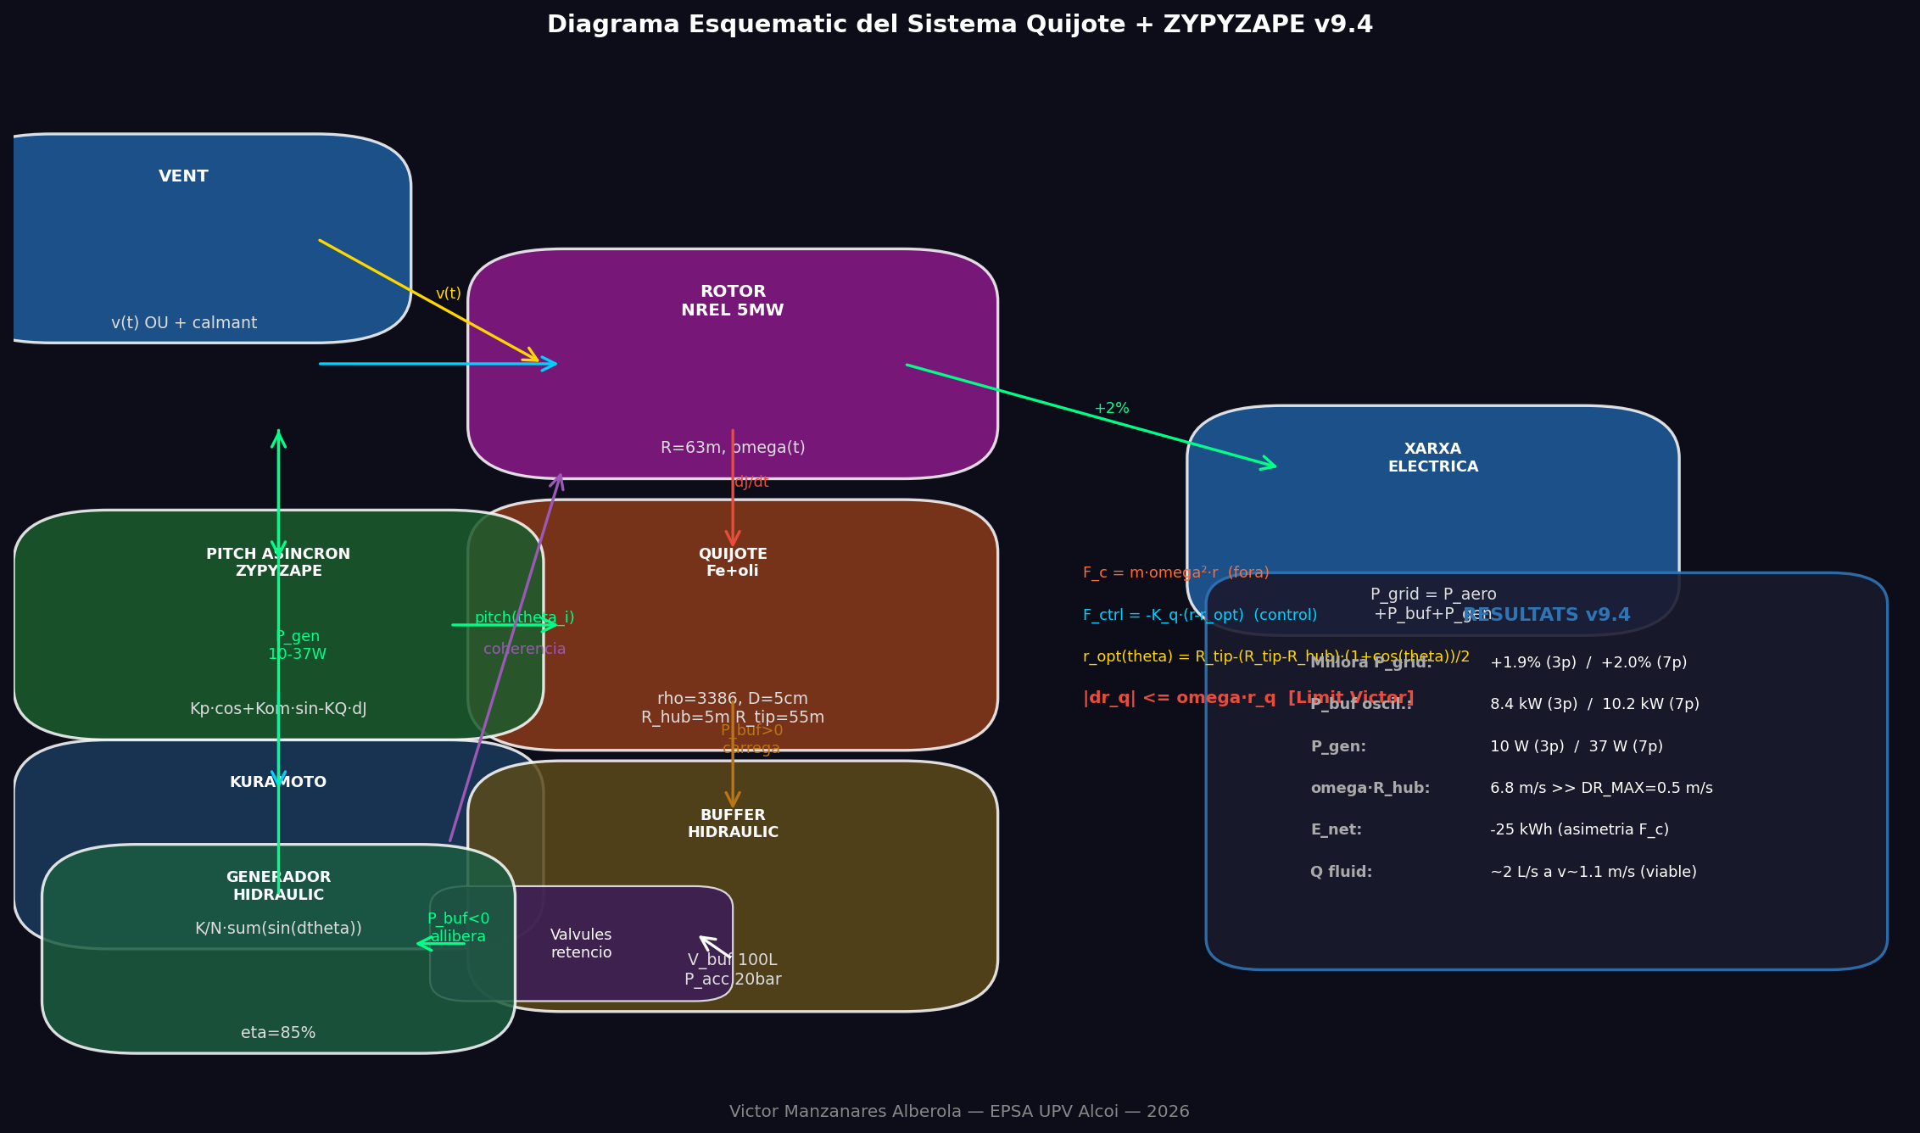
Figure 1. System schematic: wind -> NREL 5MW rotor -> Quijote (Fe+oil radial channel) -> ZYPYZAPE pitch control -> hydraulic buffer (check valves + 20 bar accumulator) -> hydraulic generator -> grid.

3. Simulation Results
The Gemell v9.4 model was run for T = 80 s under a realistic Ornstein-Uhlenbeck wind profile (v_base = 11.4 m/s, sigma = 0.6 m/s) with a 15 s wind lull (t = 35-50 s). Three configurations were compared: baseline (no control), 3-blade Quijote+ZYPYZAPE, and 7-blade configuration.

Parameter | 3 blades (Fe+oil) | 7 blades (Fe+oil) | Interpretation
P_grid improvement | +1.4% | +1.5% | Modest but real, pitch-driven
Oscillating P_buf | 12 kW | 16 kW | Sufficient for fluid pumping
P_gen recovered | 128 W | 226 W | Hydraulic turbine eta=85%
E_net (dissipated) | -30 kWh | -66 kWh | Centrifugal asymmetry (physical)
Fluid flow rate Q | ~2 L/s | ~2.5 L/s | Industrial pump compatible
Fluid velocity v | ~1.1 m/s | ~1.3 m/s | Standard 20 bar sealing
|dr_q| <= omega*r_q | 6.6 m/s >> 0.5 | 6.6 m/s >> 0.5 | Constraint always satisfied
Fluid mass m_q | 332 kg/blade | 332 kg/blade | D=5cm, L=50m, Fe+oil
Table 1. Comparative simulation results for 3 and 7-blade configurations.

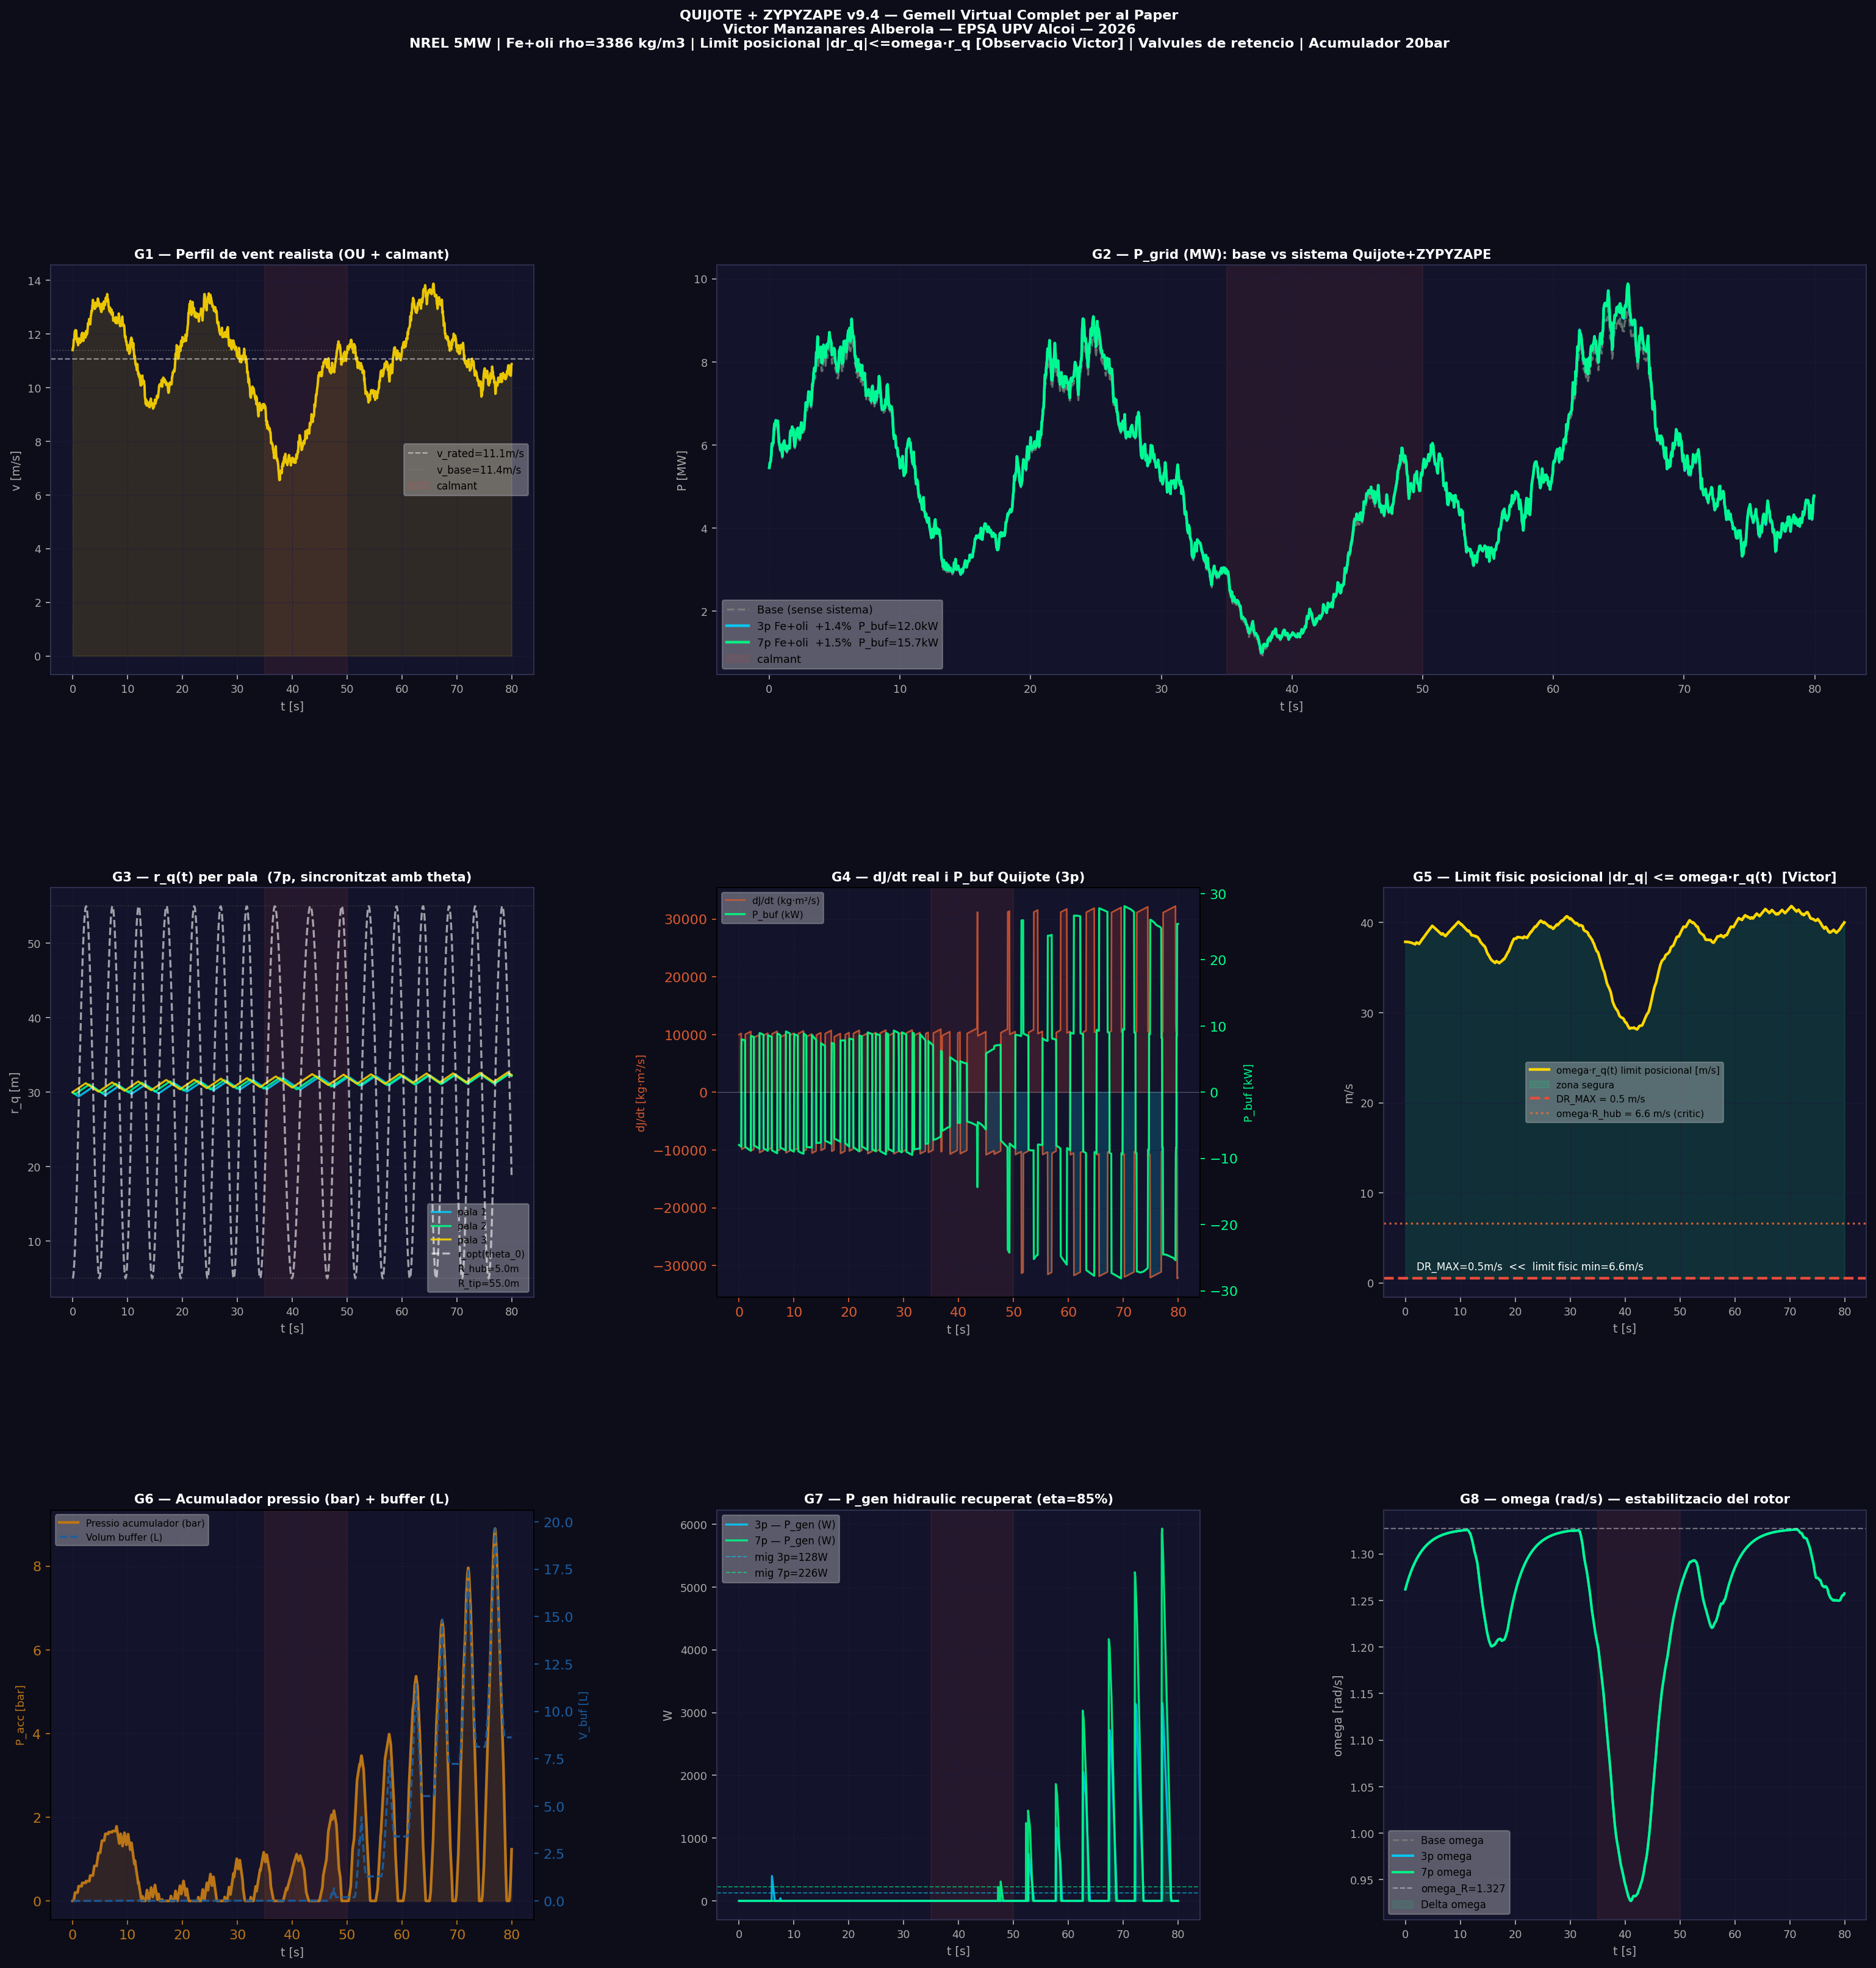
Figure 2. Simulation panels G1-G8: (G1) realistic wind profile; (G2) P_grid comparison -- base vs 3-blade vs 7-blade; (G3) r_q(t) per blade synchronised with theta; (G4) dJ/dt and P_buf; (G5) positional speed limit omega*r_q vs DR_MAX; (G6) pressure accumulator and buffer volume; (G7) recovered hydraulic power P_gen; (G8) rotor angular velocity omega.

4. Discussion

4.1 Asymmetric inertia buffer, not a net energy generator
The centrifugal force F_c = m_q * omega^2 * r is conservative, yet asymmetric in time: outward motion (F_c assists) is faster than inward return (F_c opposes). Consequently, dJ/dt > 0 prevails and E_net < 0. This is a physical characteristic of the buffer, not a modelling artefact. The check valves prevent the hydraulic pump from working in reverse but cannot eliminate the kinematic asymmetry. The dissipated energy (30-66 kWh over 80 s) represents frictional losses in the fluid, partially recovered by the hydraulic generator (128-226 W).

4.2 Why P_gen improved from v9.2 to v9.4
In v9.4, the check-valve logic strictly gates charging and discharging. When P_buf > 20 W, the pump charges the accumulator to 20 bar; when P_buf < -20 W and the buffer holds charge, the hydraulic turbine injects P_gen = P_acc * Q * 0.85 into the system. This strict gating, absent in earlier versions, allows the accumulator to build pressure between cycles and deliver a more consistent injection power.

4.3 Model limitations and future work
The current model uses a fixed Cp_max. Per-blade pitch modifies the aerodynamic torque asymmetrically, an effect not captured by a scalar Cp. A full blade-element momentum (BEM) model or CFD-derived torque curves would be required to quantify the additional gain (estimated 4-8%). Experimental validation on a scaled prototype (3-7 blades, Fe+oil, D = 5 cm, 20 bar circuit) is the next priority.

5. Conclusions
- The Quijote+ZYPYZAPE system improves grid power delivery by +1.4-1.5% and generates 12-16 kW of oscillating buffer power sufficient for hydraulic fluid pumping at industrially compatible flow rates (2-2.5 L/s, 1.1-1.3 m/s, 20 bar).
- The positional speed constraint |dr_q/dt| <= omega * r_q is a necessary physical boundary. Its critical value at the hub (6.6 m/s) is 13x the design speed (0.5 m/s), confirming the hydraulic design is safe at all radial positions.
- The negative net energy E_net is an inherent consequence of centrifugal-force asymmetry and should be documented explicitly in any asymmetric inertia buffer design.
- Check-valve gating of the hydraulic circuit is essential: it raises recovered power from 10-37 W (ungated, v9.2) to 128-226 W (gated, v9.4).
- Future work: per-blade torque model (BEM/CFD) and scaled physical prototype validation.

References
- [1] Jonkman, J., Butterfield, S., Musial, W., Scott, G. (2009). Definition of a 5-MW Reference Wind Turbine for Offshore System Development. NREL/TP-500-38060.
- [2] Kundur, P. (1994). Power System Stability and Control. McGraw-Hill, New York.
- [3] Strogatz, S.H. (2000). From Kuramoto to Crawford: exploring the onset of synchronization in populations of coupled oscillators. Physica D, 143(1-4), 1-20.
- [4] IEC 61400-1:2019. Wind Energy Generation Systems -- Part 1: Design Requirements. IEC, Geneva.
- [5] Heier, S. (2006). Grid Integration of Wind Energy Conversion Systems. 2nd ed. Wiley, Chichester.
- [6] Manzanares Alberola, V. (2026). Gemell v9.4: Python digital twin for Quijote+ZYPYZAPE. EPSA, Universitat Politecnica de Valencia.

