**Setting Up a React Native Environment**

**System Requirements**

**Operating System**

React Native can be run for Windows apps only on:

* All Windows 11 devices
* Windows 10 devices with Windows version: 10.0.16299.0 (aka 1709, aka Redstone 3, aka Fall Creators Update) or higher.
* Some features may still not work on all versions. See [Windows 10 Compatibility](https://microsoft.github.io/react-native-windows/docs/win10-compat) for version support details.

**CPU**

A multi-core processor with virtualization support (Intel Core i5 or equivalent).

**RAM**

At least 8GB (preferably 16GB or higher).

**Installation Instructions**

The necessary tools, dependencies, and installation include Node.js, Visual Studio Code, and Expo Go.

**Download Node.js**

React Native requires the Node.js download.

1. Navigate to the Node.js website (<https://nodejs.org/en>) and download the LTS version.

*During installation, accept the agreement and use the defaults for all installation steps.*

**Install Visual Studio Code**

1. Navigate to <https://code.visualstudio.com/>
2. Click “Download for Windows” and run in the installer executable.

*During installation accept the agreement and use the defaults for all installation steps.*

**Create an Expo Go Account and Install the Application**

1. Navigate to <https://expo.dev/>
2. Click “Sign Up for Free” and follow the steps to create an account.
3. Install the Expo Go app on the Android phone from the Google Play Store and sign into your account.

**Install the Expo CLI (Expo Go Quickstart)**

1. Search and open the “Node.js command prompt” on your computer.
2. In the command prompt, type and enter the command “npm install expo” to install the necessary packages and dependencies for the project.

*If a notice shows as follows, run the applicable command to update.*

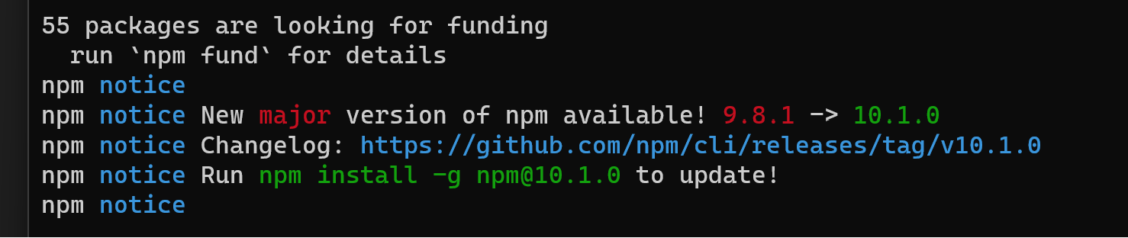

In this case, the command npm install -g npm@10.1.0 is entered.

**Configuration Steps**

No additional configuration steps are required for the basic quickstart setup.

**Project Creation**

1. Open Visual Studio Code.
2. Within Visual Studio Code, click the or maximize Visual Studio Code to full screen to access the menu bar.
3. Open a new terminal (Terminal > New Terminal).
4. Within the terminal, use the change directory (`cd`) command to navigate to the path of where you want to save the project.

*Example:*

*The project will be saved in the C: Drive>Jamie>SAIT>Semester3>CPRG303 folder.*

*Navigate and right-click on the folder you want to save the project to.*

*Click on the “Copy address as text.”*

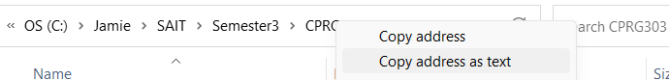

1. Back to the terminal within Visual Studio Code, type cd and paste the location of the folder and press enter.



1. To create an app, type the command: npx create-expo-app NameOfProject

npx create-expo-app AwesomeProject

1. Press enter.
2. If a message “Ok to proceed? (y)” appears, follow the prompt by pressing y and enter.

*A message should display “Your project is ready!”*

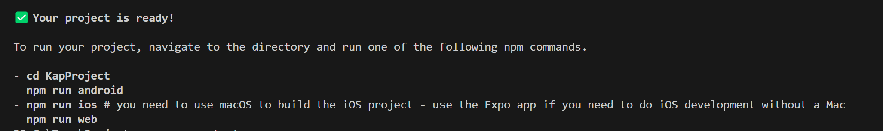

**Running the Project**

1. To run a project, use the change directory (`cd`) command to navigate to the newly created project and press enter.

cd AwesomeProject

1. Type the command: npx expo start
2. Press enter.
3. If a message “Ok to proceed? (y)” appears, follow the prompt by pressing y and enter.
4. Launch the Expo Go application on your mobile device.

*Important: Ensure that the mobile device is connected to the same wireless network as your computer.*

1. On the android device, use the Expo Go app to scan the QR code from the terminal.

*The application should display onto the mobile device*.

1. To modify the code, within the same Visual Studio Code window, click File > Open File on the menu bar.
2. Navigate to the newly created project.
3. Open and edit the code using JavaScript in the App.js file.

*The application should reload automatically once changes are saved.*

1. To disconnect and exit the server, press ctrl+c.

**Troubleshooting**

* If the error npm ERR! ENOENT appears within the terminal when creating a new app, enter the npm install -g npm in the “Node.js command prompt”
* To debug runtime issues, refer to the Expo Debugging Guide (<https://docs.expo.dev/debugging/runtime-issues/?redirected>).
* If there is a problem with Expo, refer to the Expo Issues (<https://github.com/expo/expo/issues>) to see if there are any similar existing issues.

**Resources**

Here are some other helpful resources for learning:

* For questions specific to the tool, refer to Expo Docs at <https://docs.expo.dev/>
* Expo has a Discord group where you can ask for help: <https://discord.com/invite/TercuSpcC7>
* About React Native: <https://reactnative.dev/docs/getting-started>
* Basics of React Native: <https://reactnative.dev/docs/tutorial>
* Node.js API reference documentation: <https://nodejs.org/en/docs>
* For the API reference documentation on Node.js, refer to their website at <https://nodejs.org/en/docs>
* Basics of Visual Studio Code: <https://code.visualstudio.com/docs/introvideos/basics>