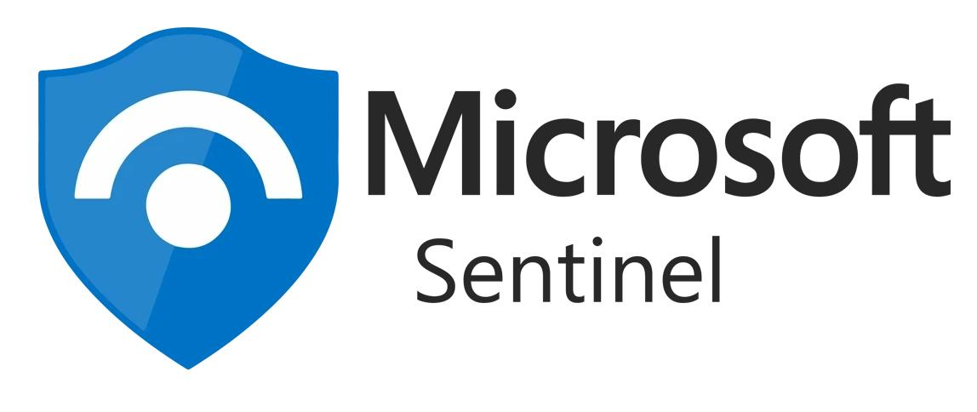

Microsoft Sentinel - SOC Attack Simulation And Investigation

Prepared By

E Spoorthi

Computer Science and Engineering (Cyber Security)

CVR College of Engineering

Academic Year: 2026 - 2027

INDEX

S.No | Contents | Page No
1 | Steps to Sign in | 1
2 | I. Create a Resource Group | 2
3 | II. Create Log Analytics Workspace | 3
4 | III. Microsoft Sentinel | 4
5 | IV. Create the Windows Virtual Machine | 4–6
6 | V. Microsoft Sentinel Data Connector | 6
7 | VI. Generate Windows Security Events and Verify Sentinel Data Collection | 7–10
8 | VII. Microsoft Sentinel Logs Workspace | 11–14
9 | VIII. Attack Simulations | 15–38
10 | IX. Creating Microsoft Sentinel Analytics Rule | 39–41
11 | X. Review Questions and Analysis | 42–47

Microsoft Sentinel–Based SOC Attack Simulation and Investigation
Using the Microsoft Sentinel environment configured with an Azure Windows Virtual Machine, Log Analytics Workspace, Azure Monitor Agent (AMA), and a Data Collection Rule, controlled security activities were simulated on the isolated Windows VM. Windows Security Events were collected and investigated in Microsoft Sentinel using KQL. Additional endpoint activities, including process creation, file creation, DNS queries, and registry modifications, were investigated locally using Sysmon. The investigation focused on correlating security events, constructing an incident timeline, identifying affected accounts and hosts, developing detection logic, and documenting findings and recommended response actions.

Steps to Sign in

- Open the Azure for Students page: Azure for Students
- Click Sign in at the top-right corner.
- Enter your college/school Microsoft account credentials.
- Complete the verification if Microsoft asks for OTP/MFA.
- After successful login, you will be redirected to the Azure Portal.
- Open the Azure Portal: Microsoft Azure Portal
- Check the account shown in the top-right corner.
- To verify your student subscription, search for Subscriptions in the Azure Portal.
- Select Azure for Students and verify that the subscription is Active.

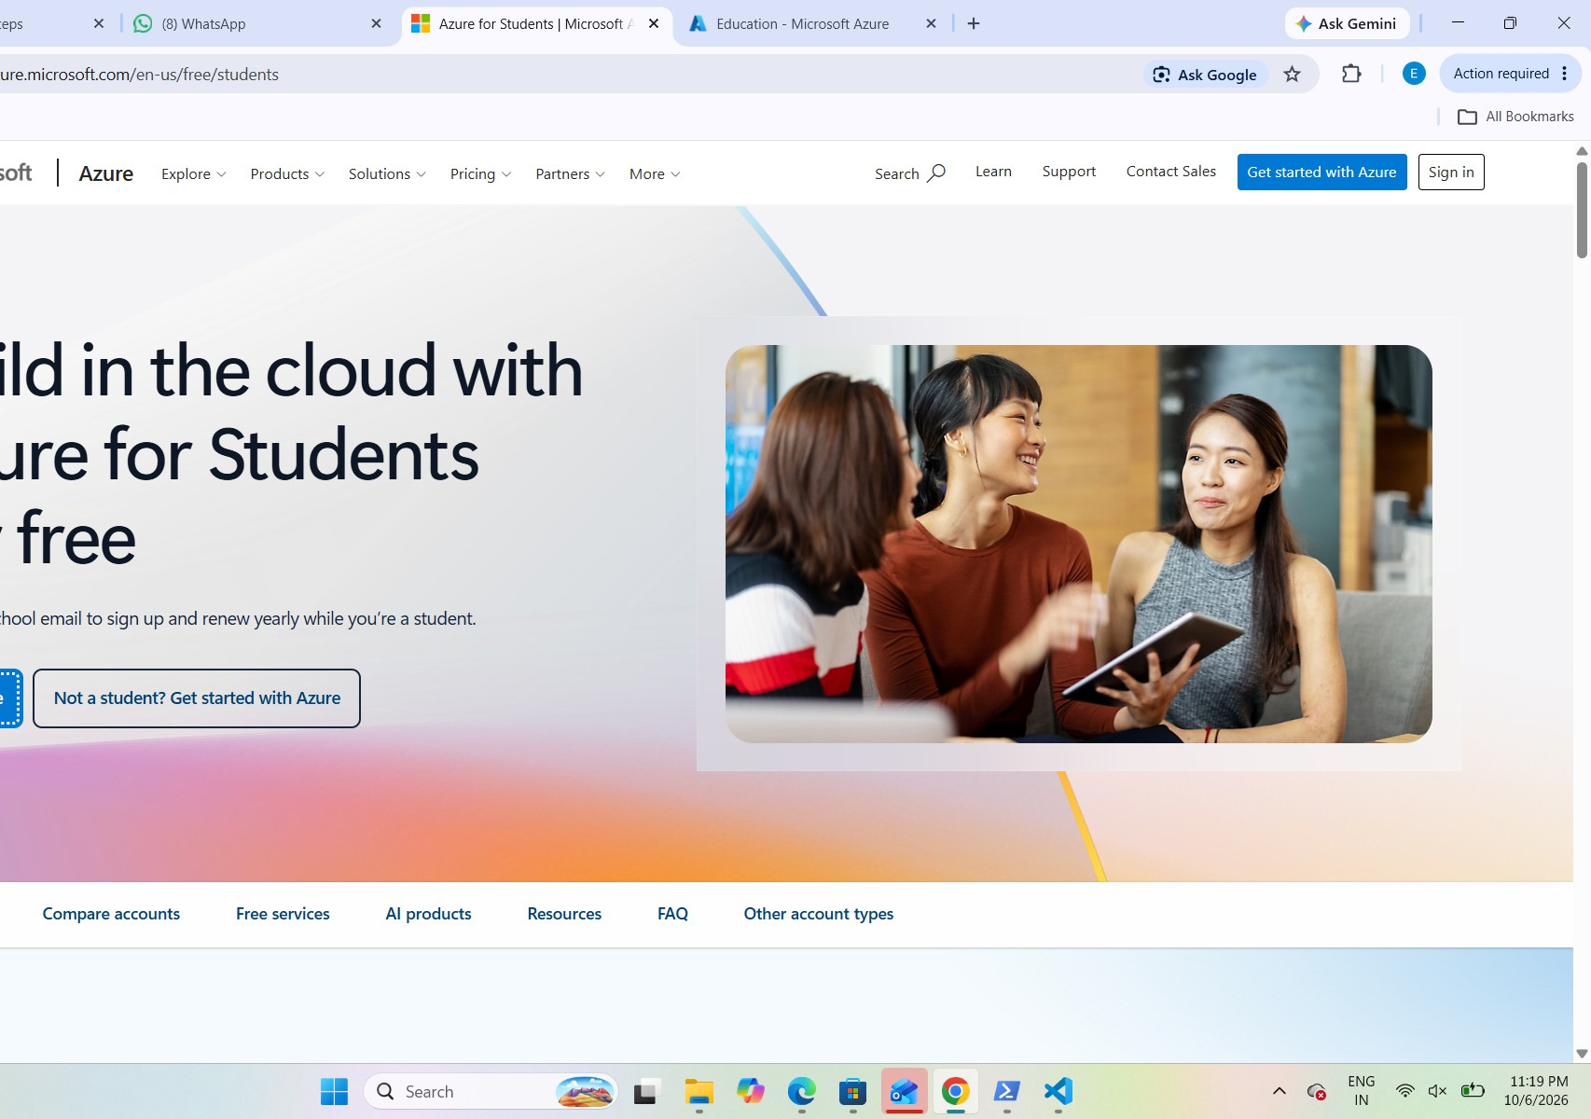

I.Create a Resource Group
A Resource Group was created to logically organize all resources used in the SOC lab.

- In the Azure Portal, search for Resource Groups.
- Select Create.
- Select the Azure for Students subscription.
- Enter a suitable resource group name – myresg
- Select an appropriate Azure region – central India
- Click Review + create.
- After validation is completed, click Create.

The Resource Group acts as a container for the virtual machine, monitoring resources, and other components used in the lab.

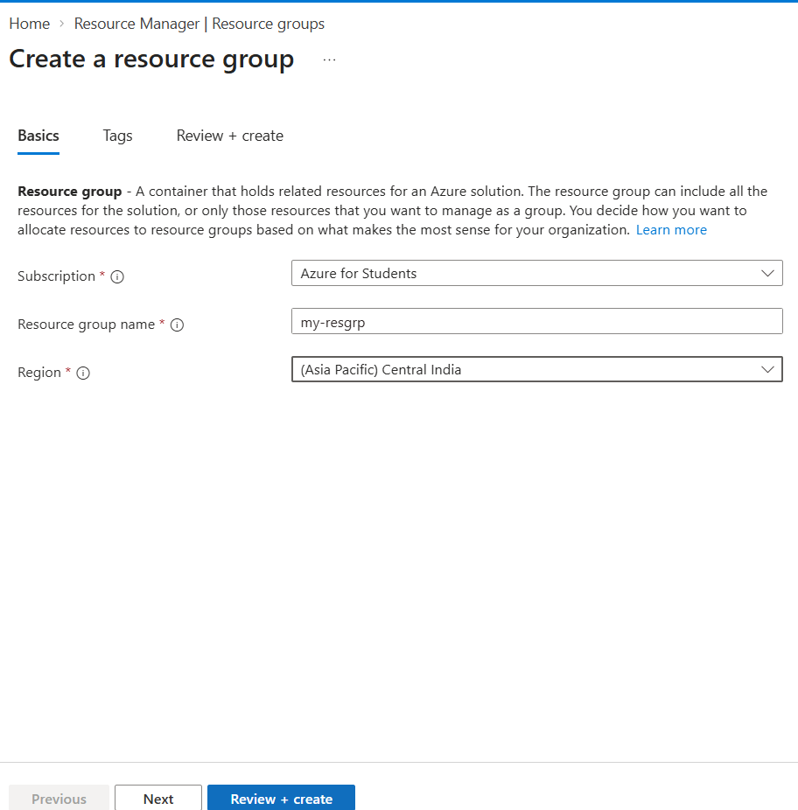

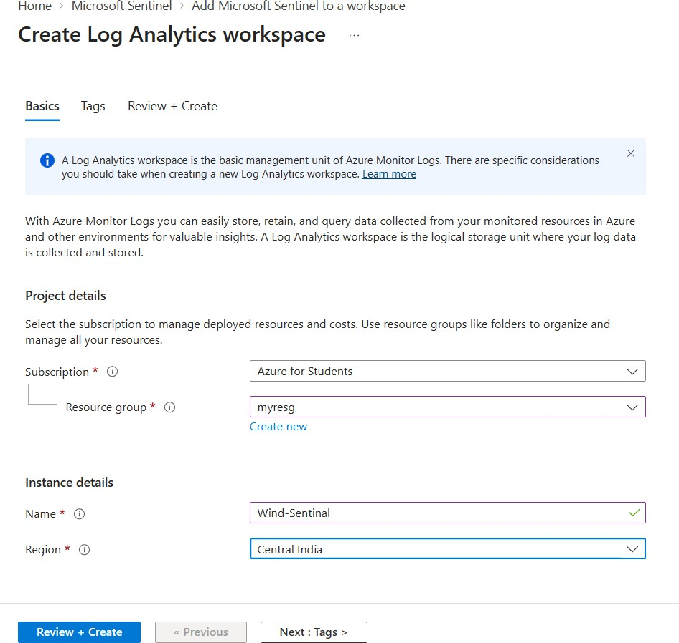
II. Create Log Analytics Workspace in Microsoft Sentinel

The workspace was configured with the following details:

  - Subscription: Azure for Students
  - Resource Group: myresg
  - Workspace Name: Wind-Sentinel
  - Region: Central India

1. Search Log Analytics workspaces → Create
2. Enter details as shown above. Then click Review + Create. Then click Create.

III. Microsoft Sentinel

1. In the Azure Portal, search for Microsoft Sentinel and open it.

2. Select your workspace(wind-Sentinal). Click on Add.

IV. Create the Windows Virtual Machine
A Windows virtual machine was created to act as the monitored endpoint for the SOC lab.

- Search for Virtual Machines in the Azure Portal.
- Click Create → Azure virtual machine.
- Select the previously created Resource Group(myresg), Provide a VM name(Win-MyVM).
- Region – Malaysia West
- Select a suitable Windows Server/Windows operating system image- windows 11 pro.
- Select an appropriate VM size within the available Azure for Students quota.
- Configure the administrator username: azureuser and password : <yourpassword>.
- Review the configuration.
- Click Create.
- Wait until Azure completes the deployment.
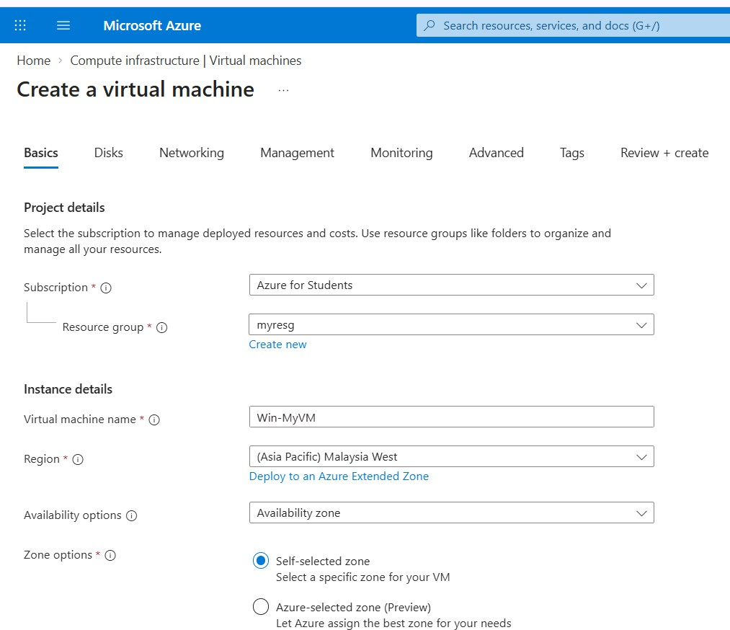

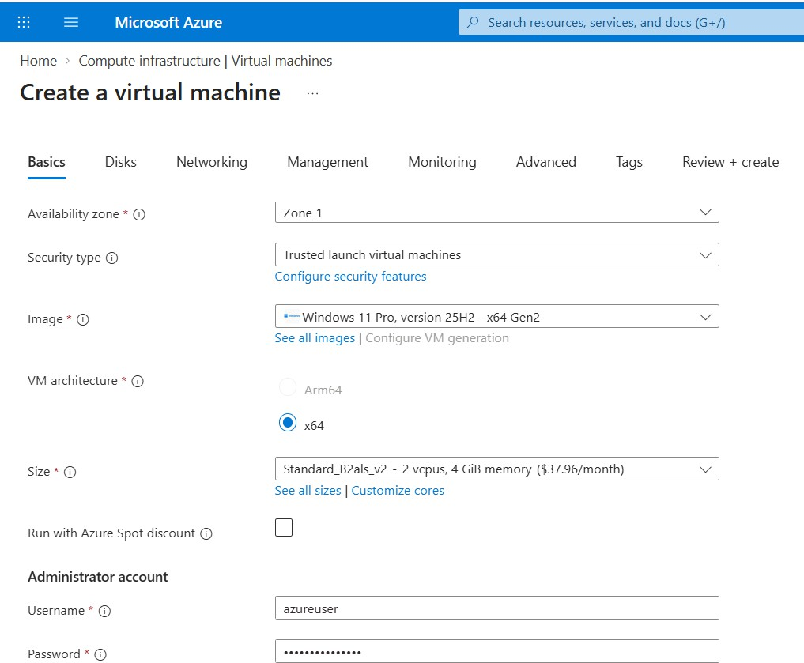

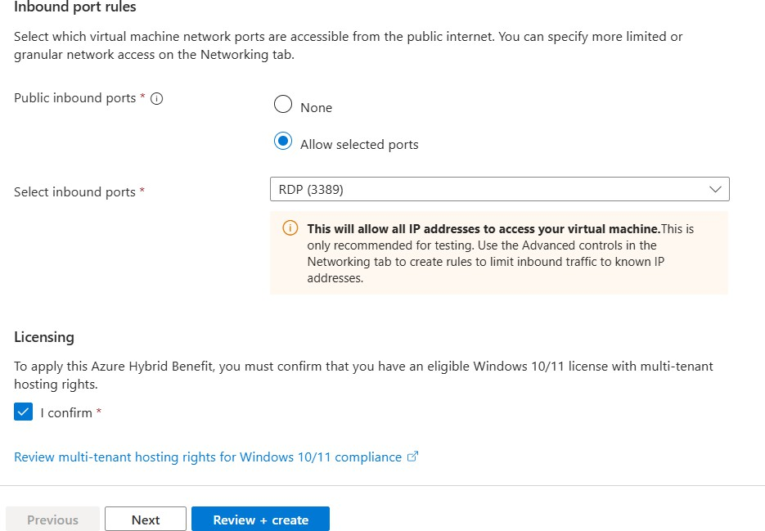

V. Microsoft Sentinel Data Connector

1. Search Microsoft Sentinel. Then open myresg
2. Click Configuration → Data connectors
3. Search for: Windows Security Events via AMA. Then click connector page
4. Click: + Create data collection rule. This opens the panel on the right.
5. Enter:
● Data rule name: MySecEvtRule1
● Subscription: Azure for Students
● Resource group:myresg

6. Click Next. Click + Add resource(s). Select Win-MyVM, then click Apply.
7. Click Next. Select Common.
8. Click Review + create. Make sure Validation passed is displayed.
9. Click Create.
10. Return to the Windows Security Events via AMA connector page. Click Refresh and verify that the Data Collection Rule appears under Configuration
VI. Generate Windows security events and verify that Sentinel is receiving them.
1. Go to Virtual Machines.
2. Open Win-MyVM → Connect → RDP → Download RDP file.
3. Open the downloaded .rdp file on your PC and connect using the username and password you created for the VM.
4. Then we get connected to azureuser remotely.

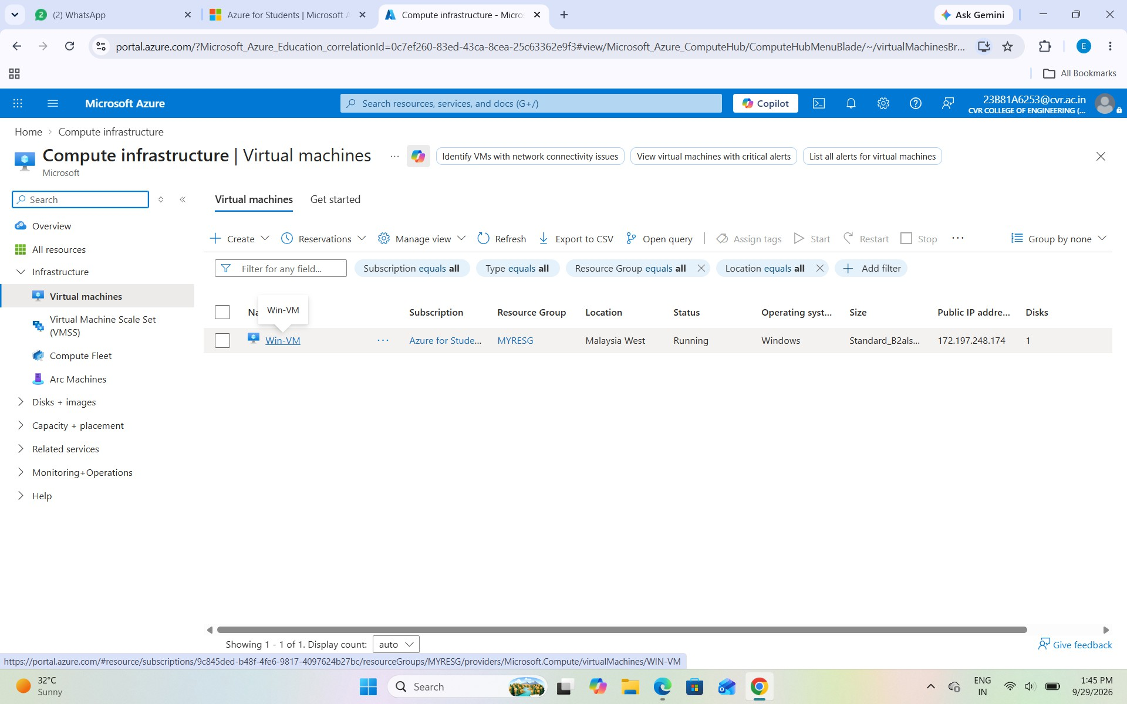

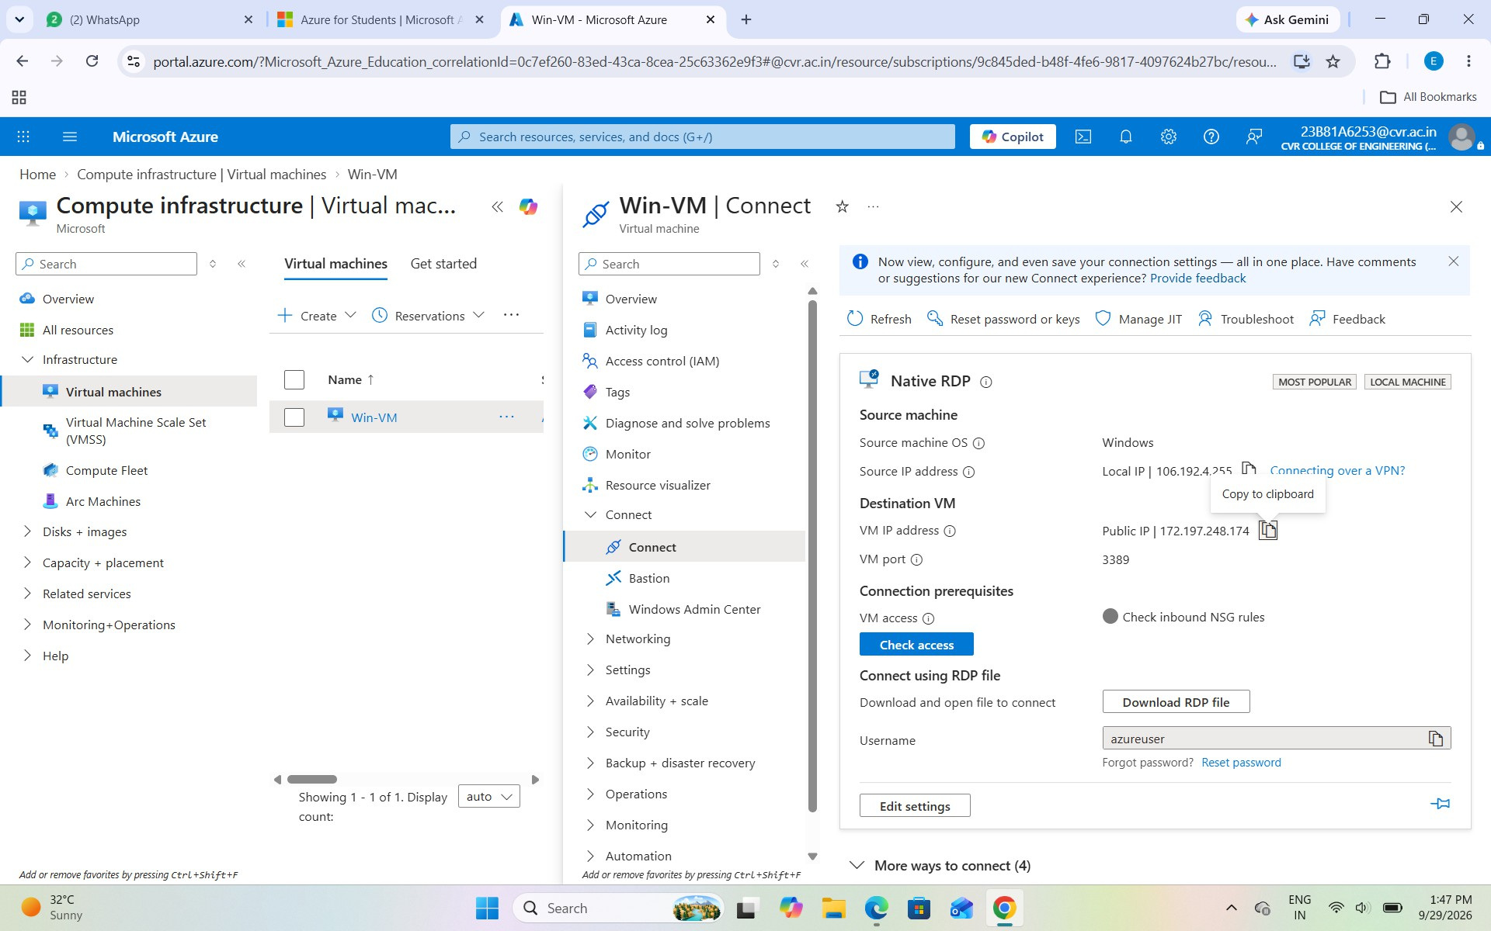

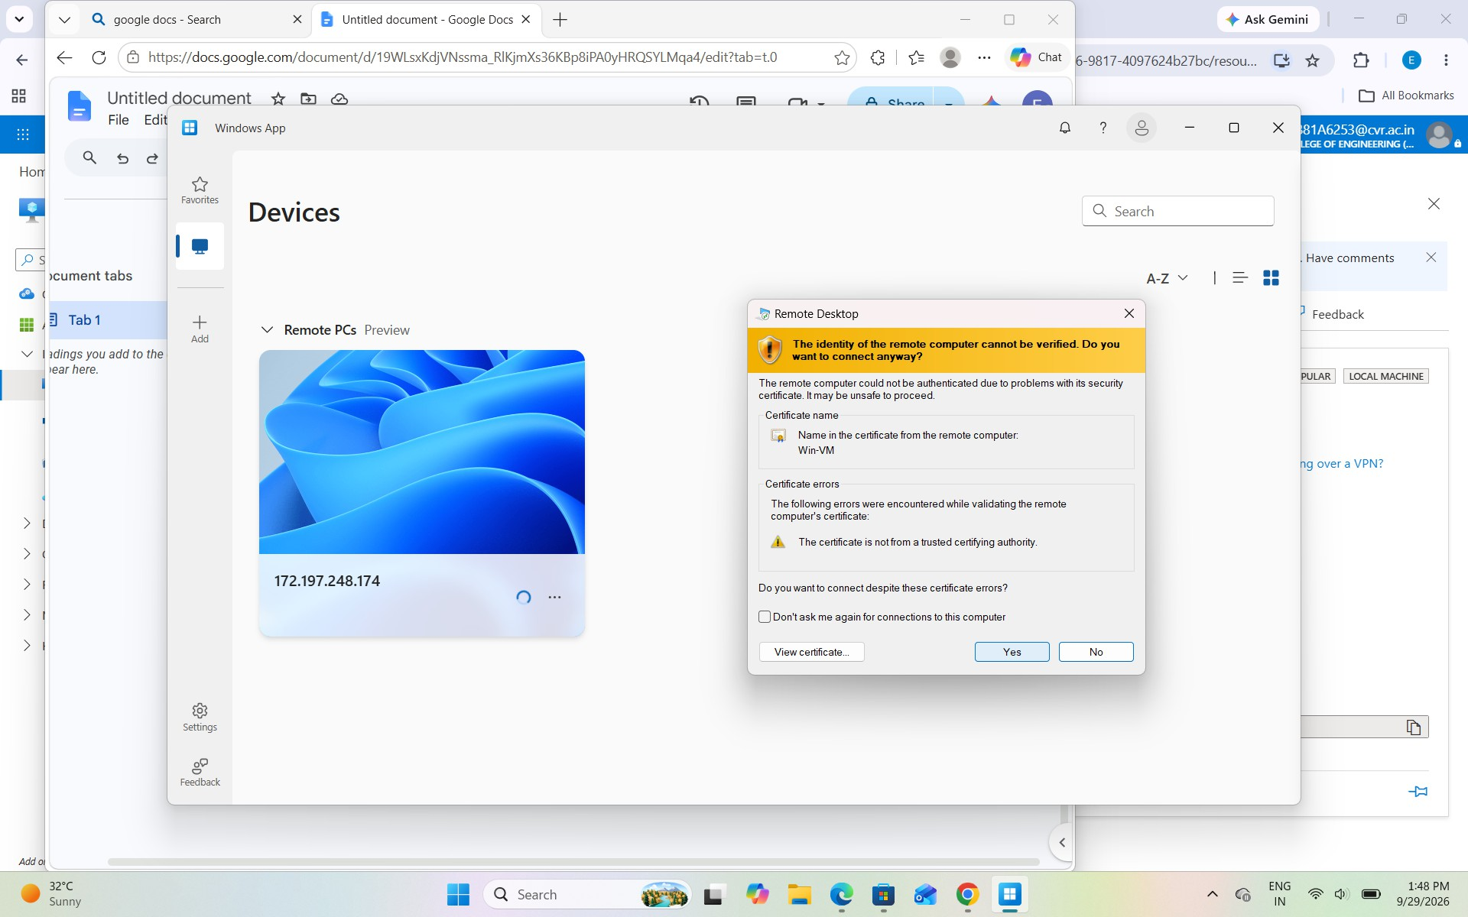



Install Windows App (if you dont want to download and use the RDP file to access the Windows VM)

- Create Administrator Account
Created soc_admin01 using Command Prompt and added it to the Administrators group. The account was verified using net user and net localgroup Administrators
- Create Standard Users
Created four standard accounts:

  - soc_user01
  - soc_user02
  - soc_user03
  - soc_user04

soc_user01 was added to the Remote Desktop Users group so it could be used for RDP while remaining a standard user.

Verify User Privileges

Add soc_admin01 to the Administrators group using the command: net localgroup Administrators soc_admin01 /add. This gives soc_admin01 local administrator privileges.

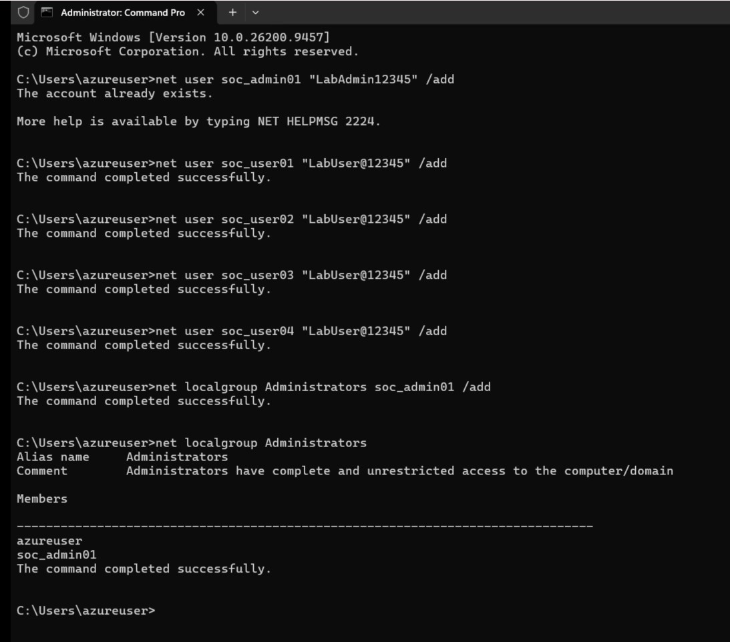
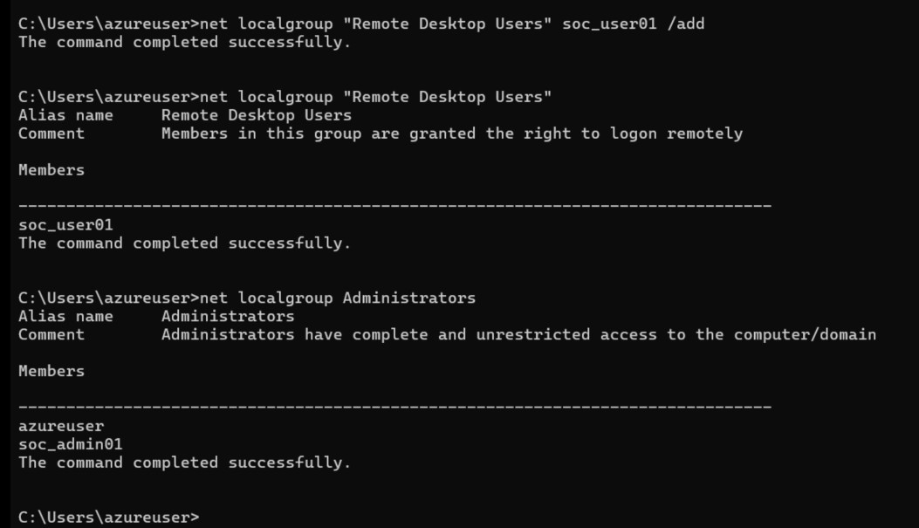

VII. Microsoft Sentinel Logs Workspace

This screenshot shows the Microsoft Sentinel → Logs page for the Wind-Sentinal workspace. The Logs section is used to run KQL (Kusto Query Language) queries and investigate security data collected from the Windows VM. It is the main interface used throughout the lab to search, analyze, and investigate events generated during the attack simulations.

How to Open Microsoft Sentinel Logs:

- Sign in to the Microsoft Azure Portal.
- From the Azure Portal, search for Microsoft Sentinel in the search bar.
- Open Microsoft Sentinel from the search results.
- Select the Sentinel workspace used for the lab, Wind-Sentinel.
- From the left-side menu, select Logs under the General section.
- The Logs page will open with the KQL query editor.
- Enter the required KQL query in the editor and click Run.
- The query results will be displayed in the Results section below the editor.

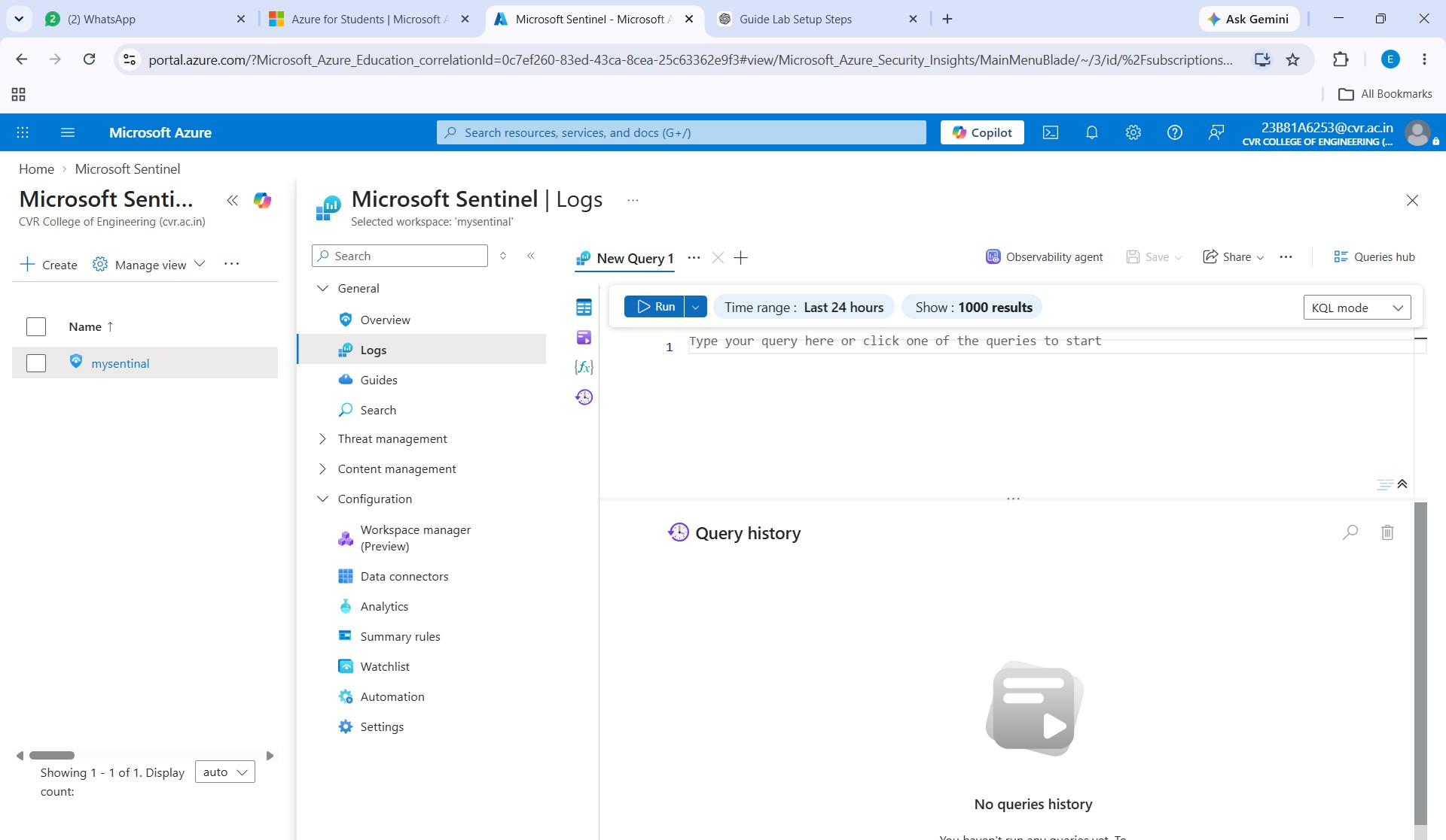

In Microsoft Sentinel → Logs, run:

Check Heartbeat status

Heartbeat
| summarize LastSeen=max(TimeGenerated) by Computer

This confirms that the Windows VM is connected and sending data to Sentinel.

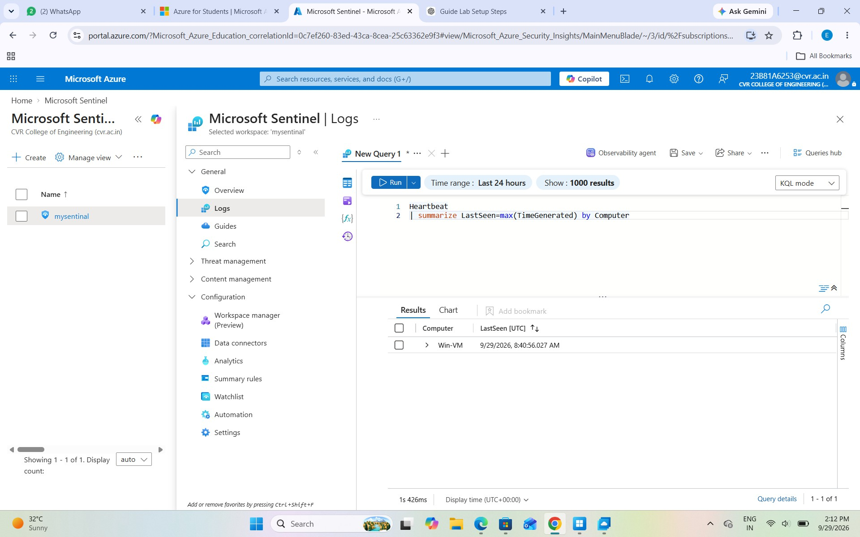

2.Check Security Events
Run:

SecurityEvent
| take 20

If records are displayed, Windows Security Events are being successfully collected by Sentinel.

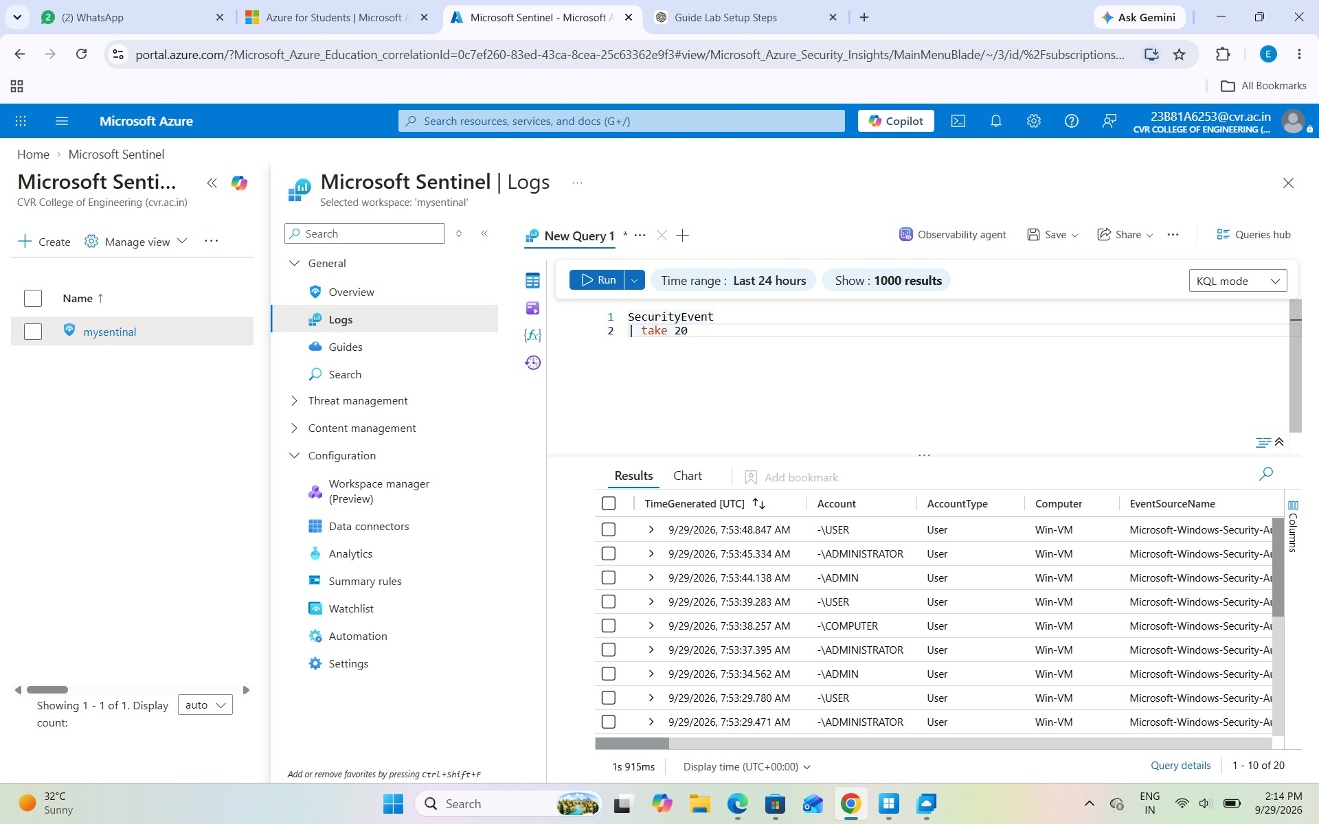

3.To see which event IDs are available:

SecurityEvent
| summarize Count=count() by EventID
| order by Count desc

- Check the current user activity:

SecurityEvent
| where Account has "soc_"
| project TimeGenerated, EventID, Computer, Account, Activity
| order by TimeGenerated desc

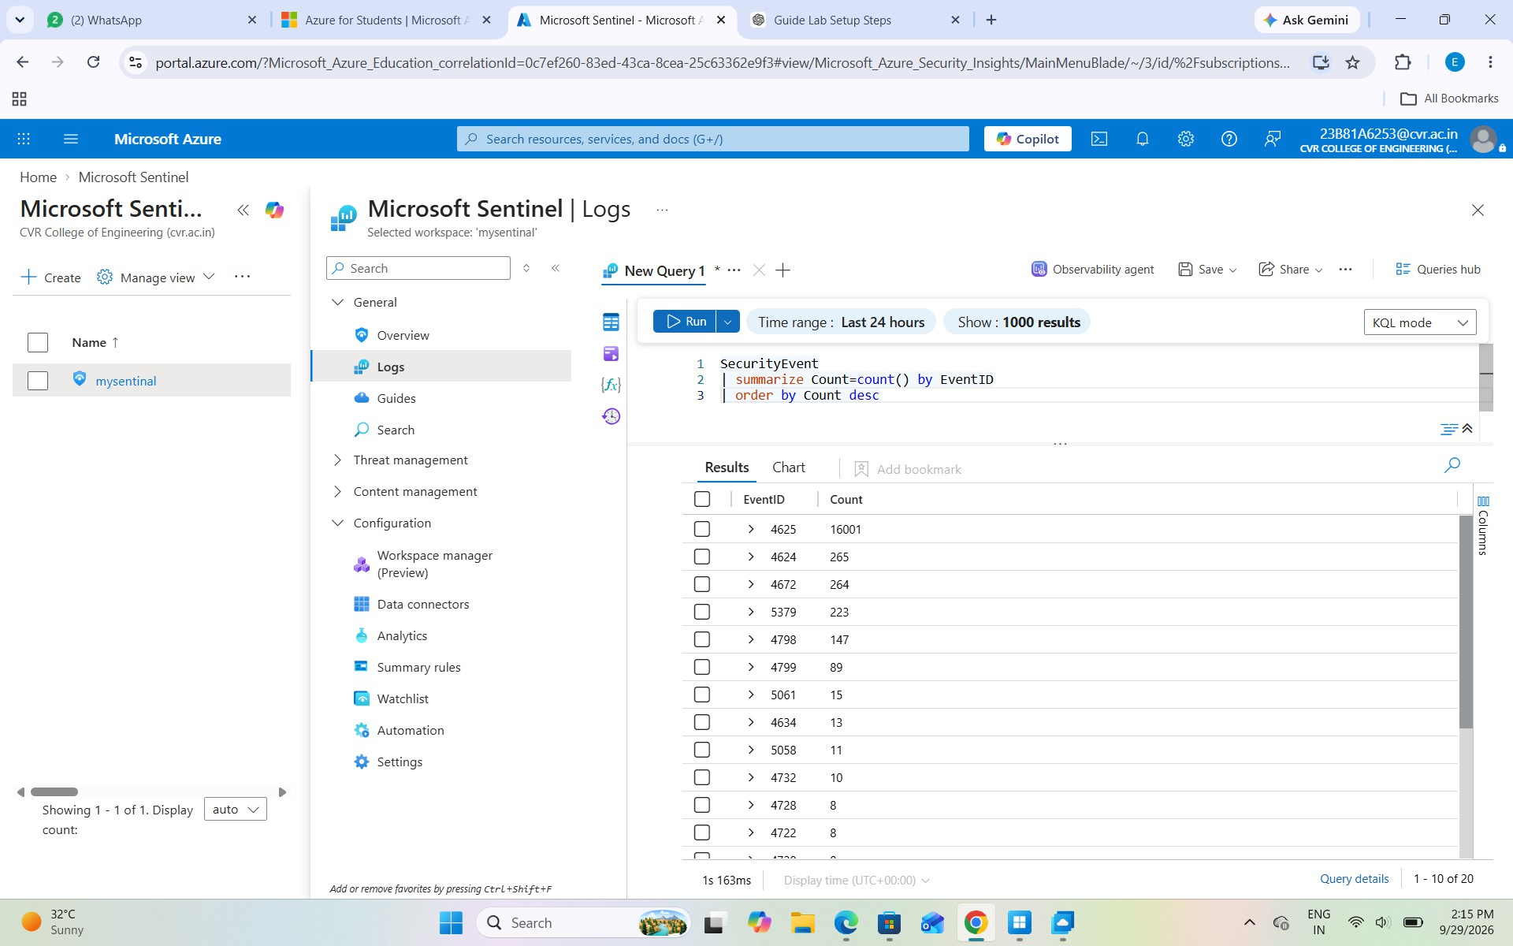
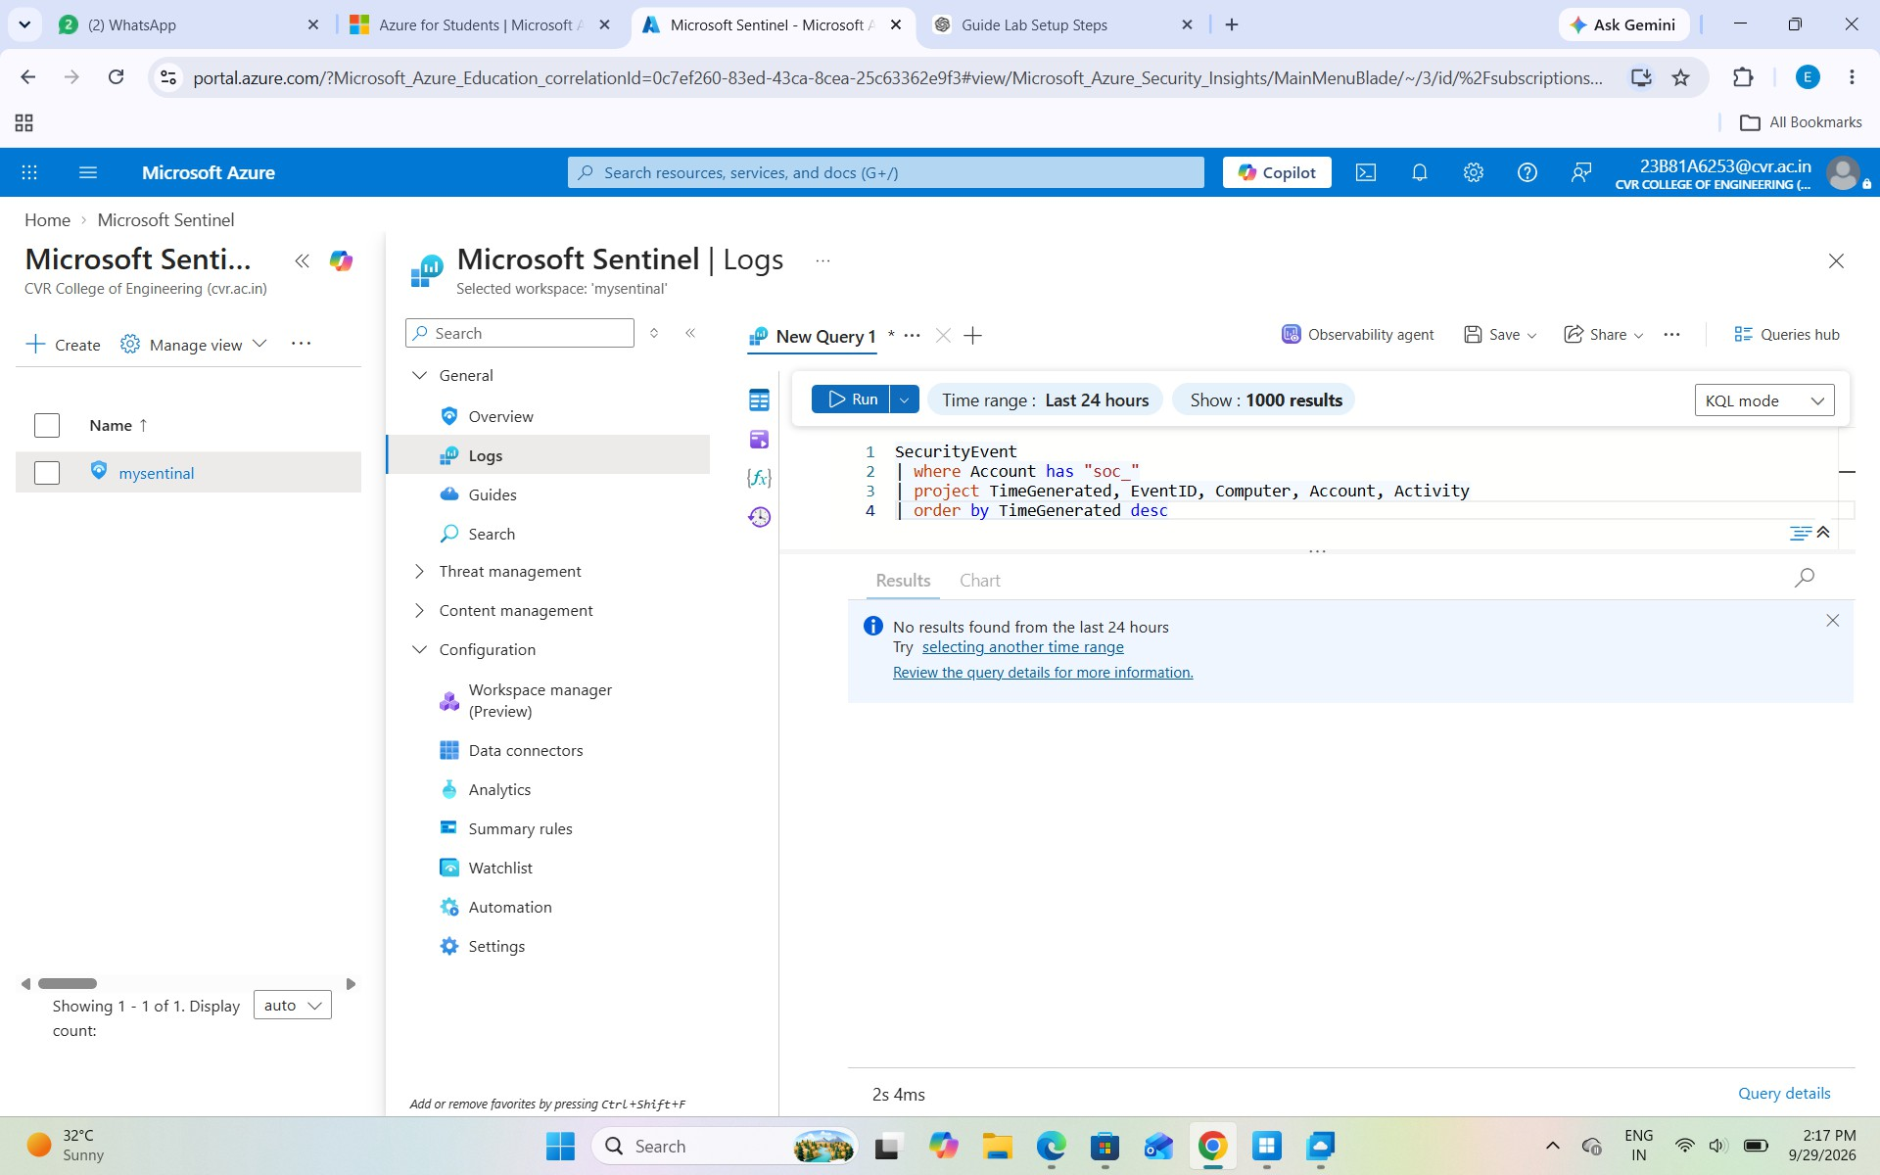

VIII. Attack Simulations

Attack 1 — Failed Login / Brute-Force Simulation

Objective:
In this attack, we simulated multiple failed login attempts against the lab account soc_user01. The purpose was to generate failed authentication events that Microsoft Sentinel could detect and investigate. The expected Windows Security Event ID is 4625 – An account failed to log on.

Procedure:
We attempted to log in to the Windows VM using soc_user01 with an intentionally incorrect password several times. These failed attempts generated security events on the Windows VM.

Sentinel Investigation:
In Microsoft Sentinel → Logs, we searched for Event ID 4625 and filtered for the soc_ accounts. The query displayed the time, computer, account, IP address, logon type, and activity related to the failed attempts.
Run:
SecurityEvent
| where EventID == 4625
| where Account has "soc_"
| project TimeGenerated, Computer, Account, IpAddress, LogonType, Activity
| order by TimeGenerated desc

To detect 5 or more failed attempts within 5 minutes, run:
SecurityEvent
| where EventID == 4625
| summarize FailedAttempts=count() by Account, IpAddress, bin(TimeGenerated, 5m)
| where FailedAttempts >= 5
| order by TimeGenerated desc
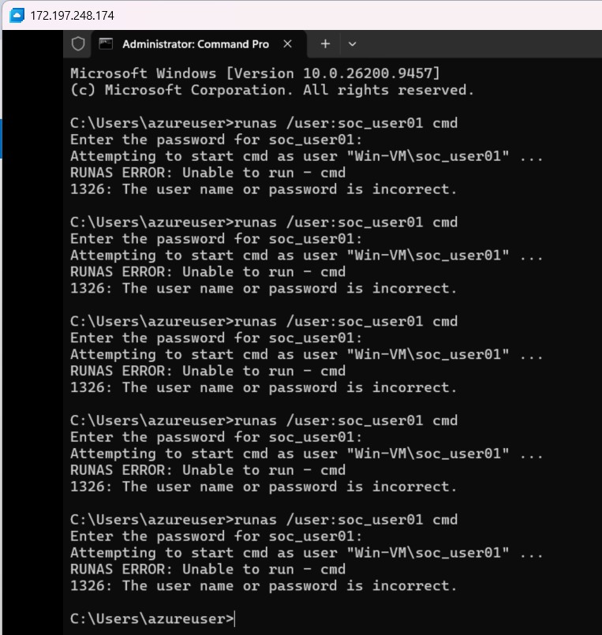
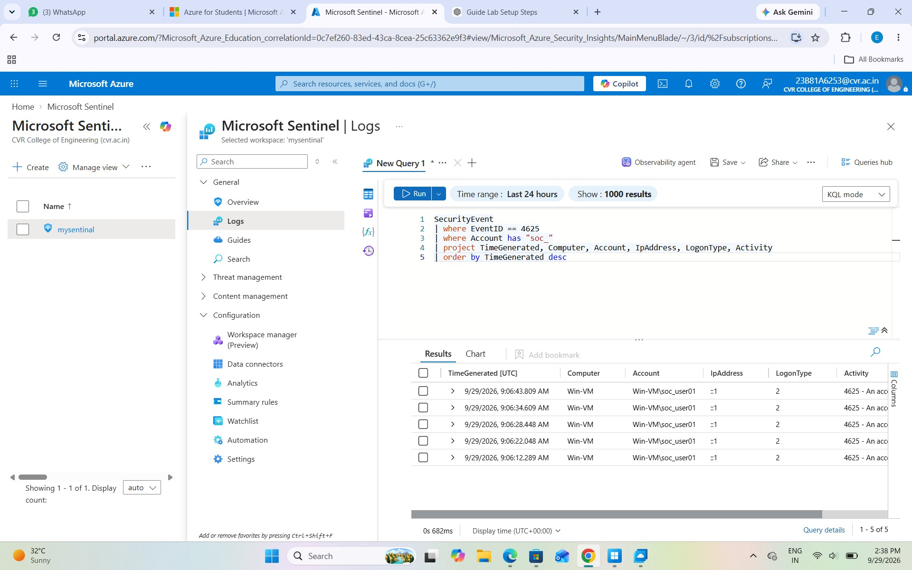

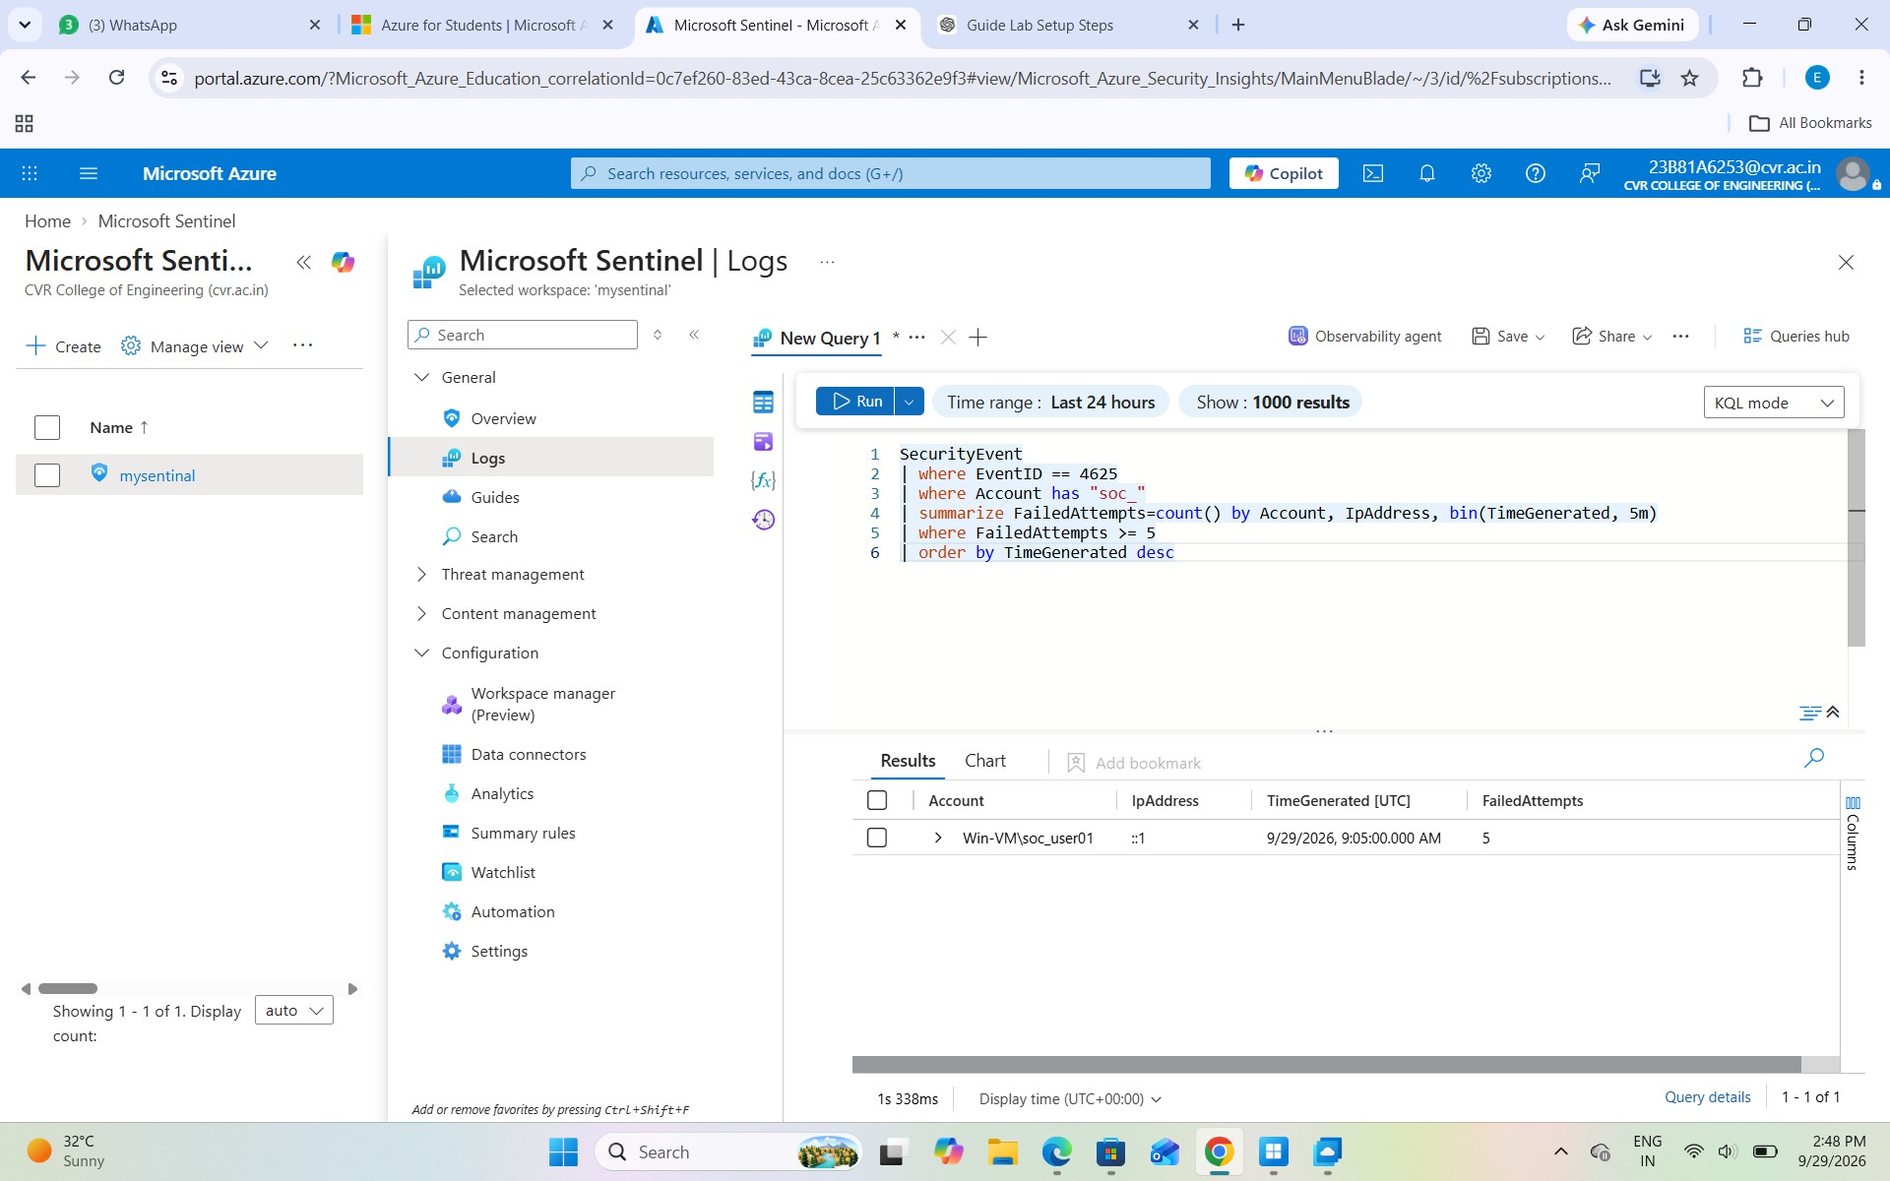

Attack 2 – Failed Login → Successful Login

Objective:
To correlate failed and successful login events and understand the sequence of authentication activity.

Procedure:
After generating the failed login attempts in Attack 1, we logged in successfully to the Windows VM using the correct password for soc_user01.

Sentinel Investigation:
In Microsoft Sentinel, we searched for both Event ID 4625 and Event ID 4624 using the following KQL query:
SecurityEvent
| where EventID in (4624, 4625)
| where Account has "soc_"
| project TimeGenerated, EventID, Computer, Account, IpAddress, LogonType, Activity
| order by TimeGenerated desc

4625 – Failed Login → 4625 – Failed Login → 4625 – Failed Login → 4625 – Failed Login

→ 4624 – Successful Login
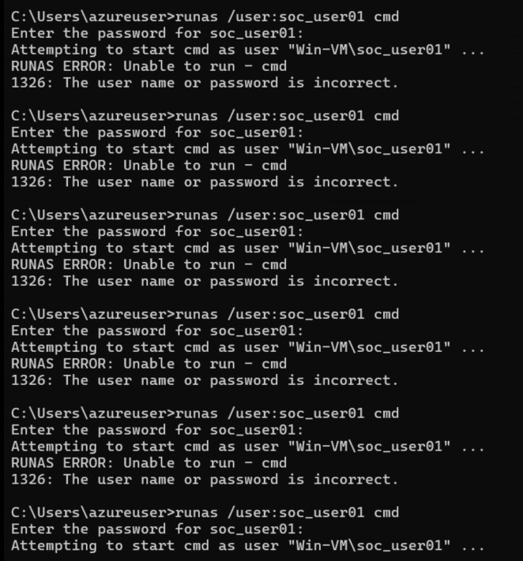
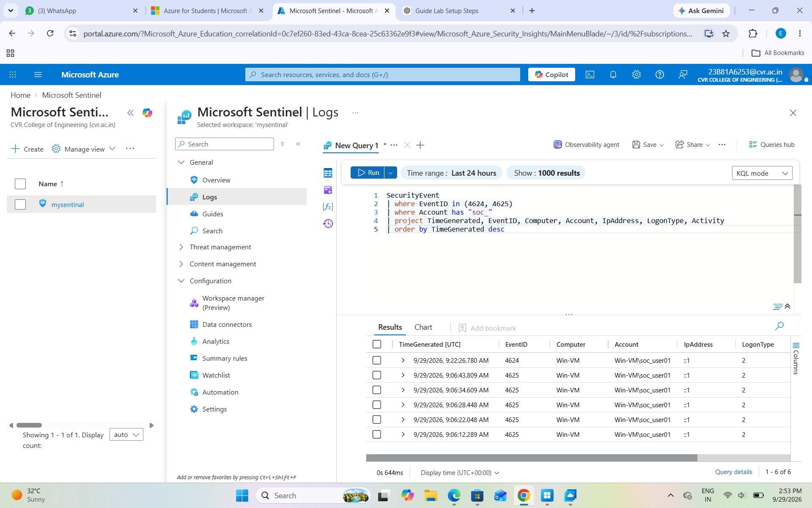

Attack 3 – Password Spray Simulation

Objective:
To simulate password-spraying activity and detect multiple accounts being targeted from the same source.

Procedure:
We attempted to log in to soc_user01, soc_user02, soc_user03, and soc_user04 using the same intentionally incorrect password, WrongPassword@123.

Sentinel Investigation:
In Microsoft Sentinel, we searched for Event ID 4625 and counted the number of different accounts targeted from the same IP address within a 5-minute window.
SecurityEvent
| where EventID == 4625
| summarize FailedAttempts=count(), TargetAccounts=dcount(Account) by IpAddress, bin(TimeGenerated, 5m)
| where TargetAccounts >= 3
| order by TimeGenerated desc
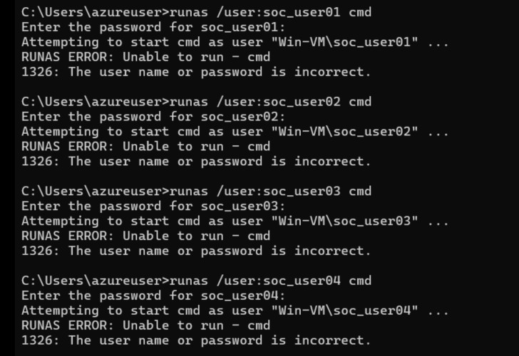
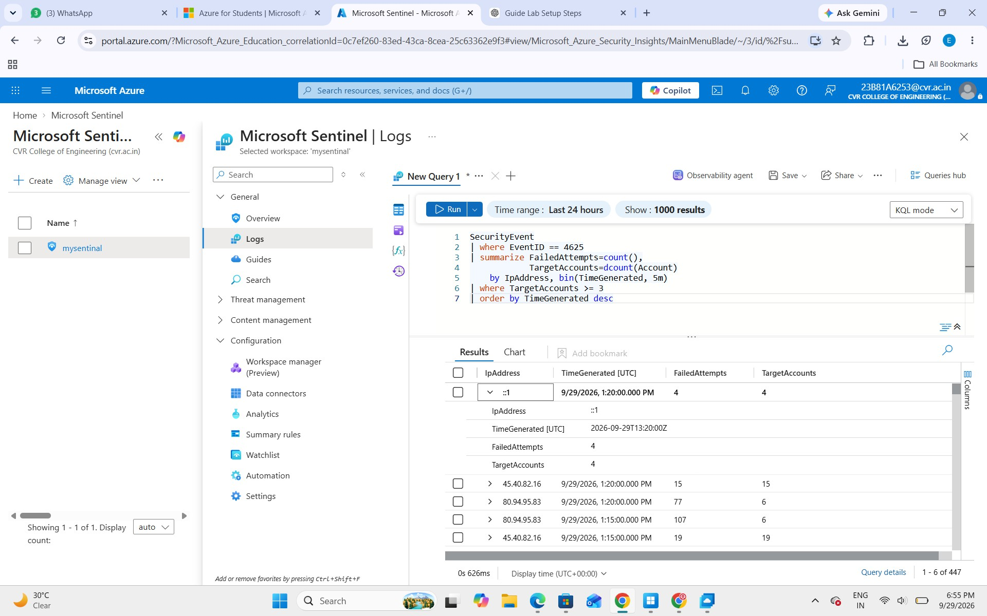
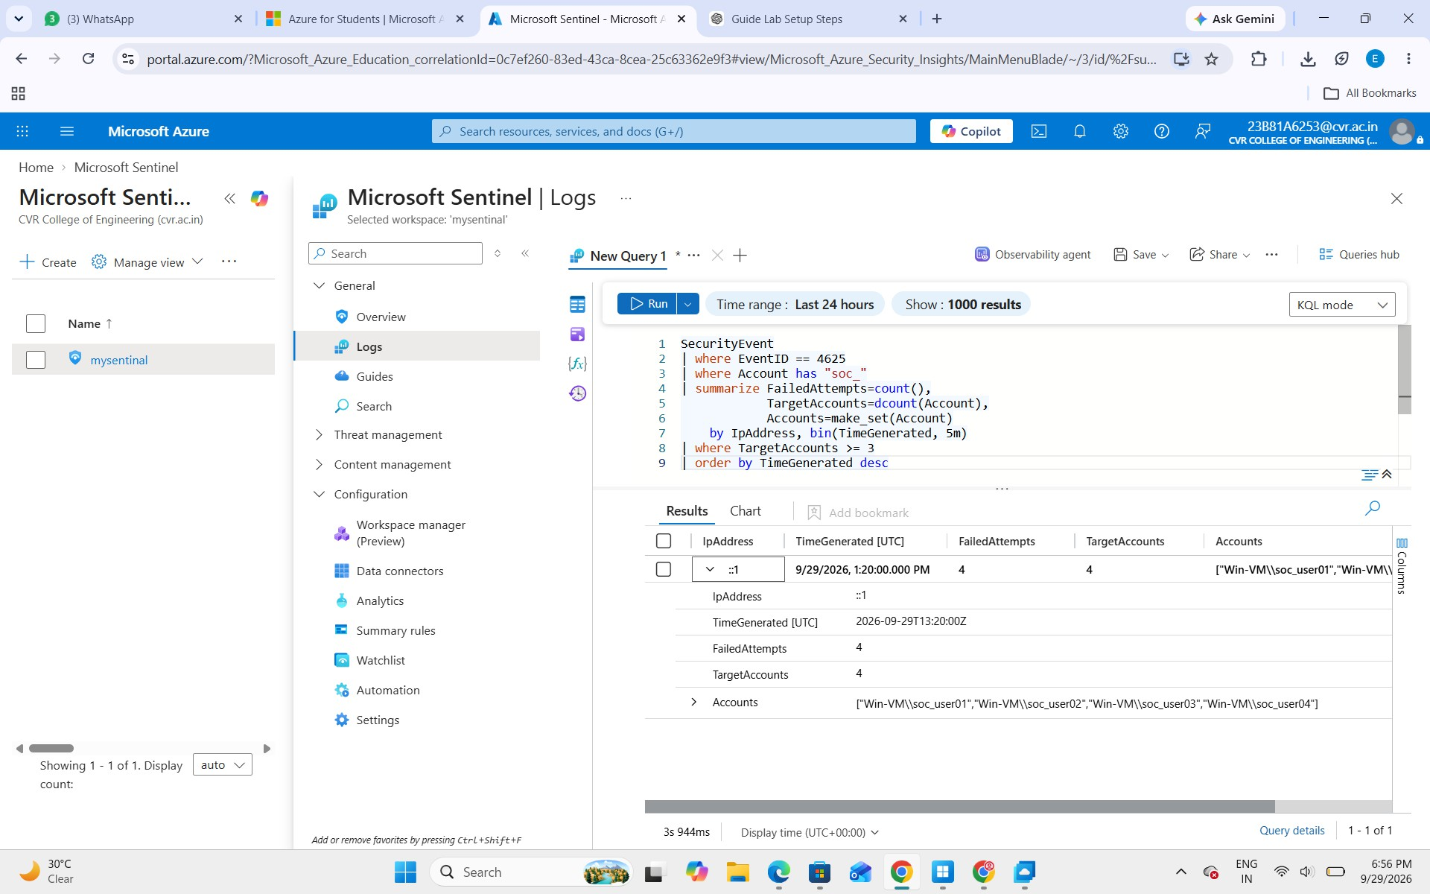

Attack 4 – Simulated Account Creation

Objective:
To simulate the creation of a new user account and detect it using Microsoft Sentinel.

Procedure:
We created a temporary account named soc_test01 using Administrator Command Prompt: net user soc_test01 "LabTest@12345" /add
This generated Event ID 4720, which represents a user account being created.

Sentinel Investigation:
In Microsoft Sentinel, we searched for Event ID 4720 and checked details such as the time, computer, account that performed the action, and the newly created account.

Observation:
The main investigation question was: “Who created soc_test01?”
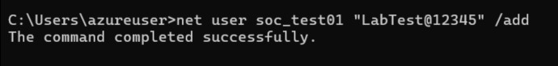
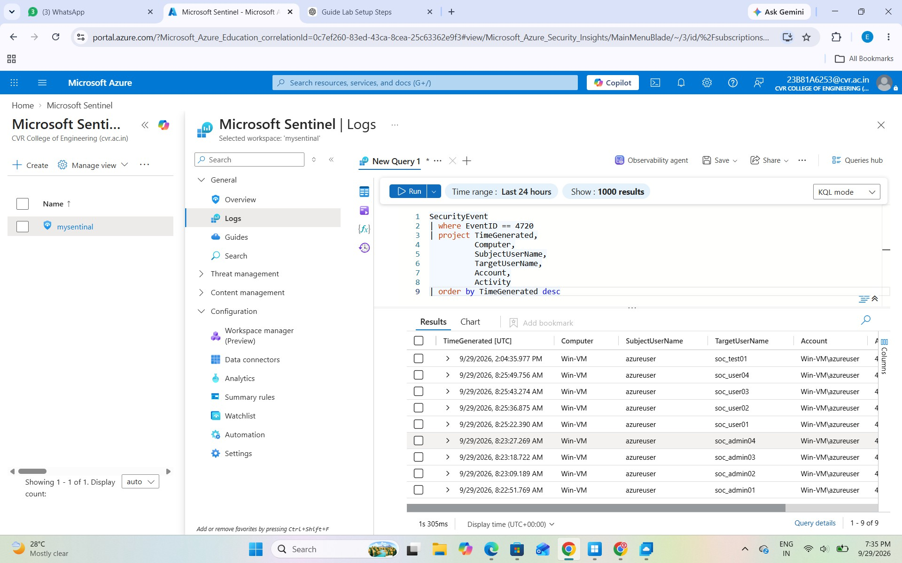

Attack 5 – Simulated Privilege Escalation

Objective:
To simulate a privilege escalation by changing a standard user into a local administrator.

Procedure:
We added soc_user01, which was initially a standard user, to the local Administrators group using:
net localgroup Administrators soc_user01 /add

This generated Event ID 4732, which indicates that a member was added to a security-enabled local group.

Sentinel Investigation:
In Microsoft Sentinel, we searched for Event ID 4732 and examined the user who performed the change, the member added, and the target group.

Observation:
The investigation focused on the question: “Why was the standard account soc_user01 added to the local Administrators group?”

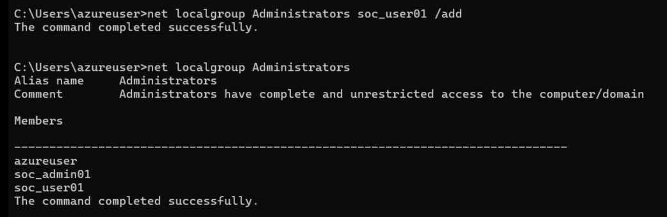

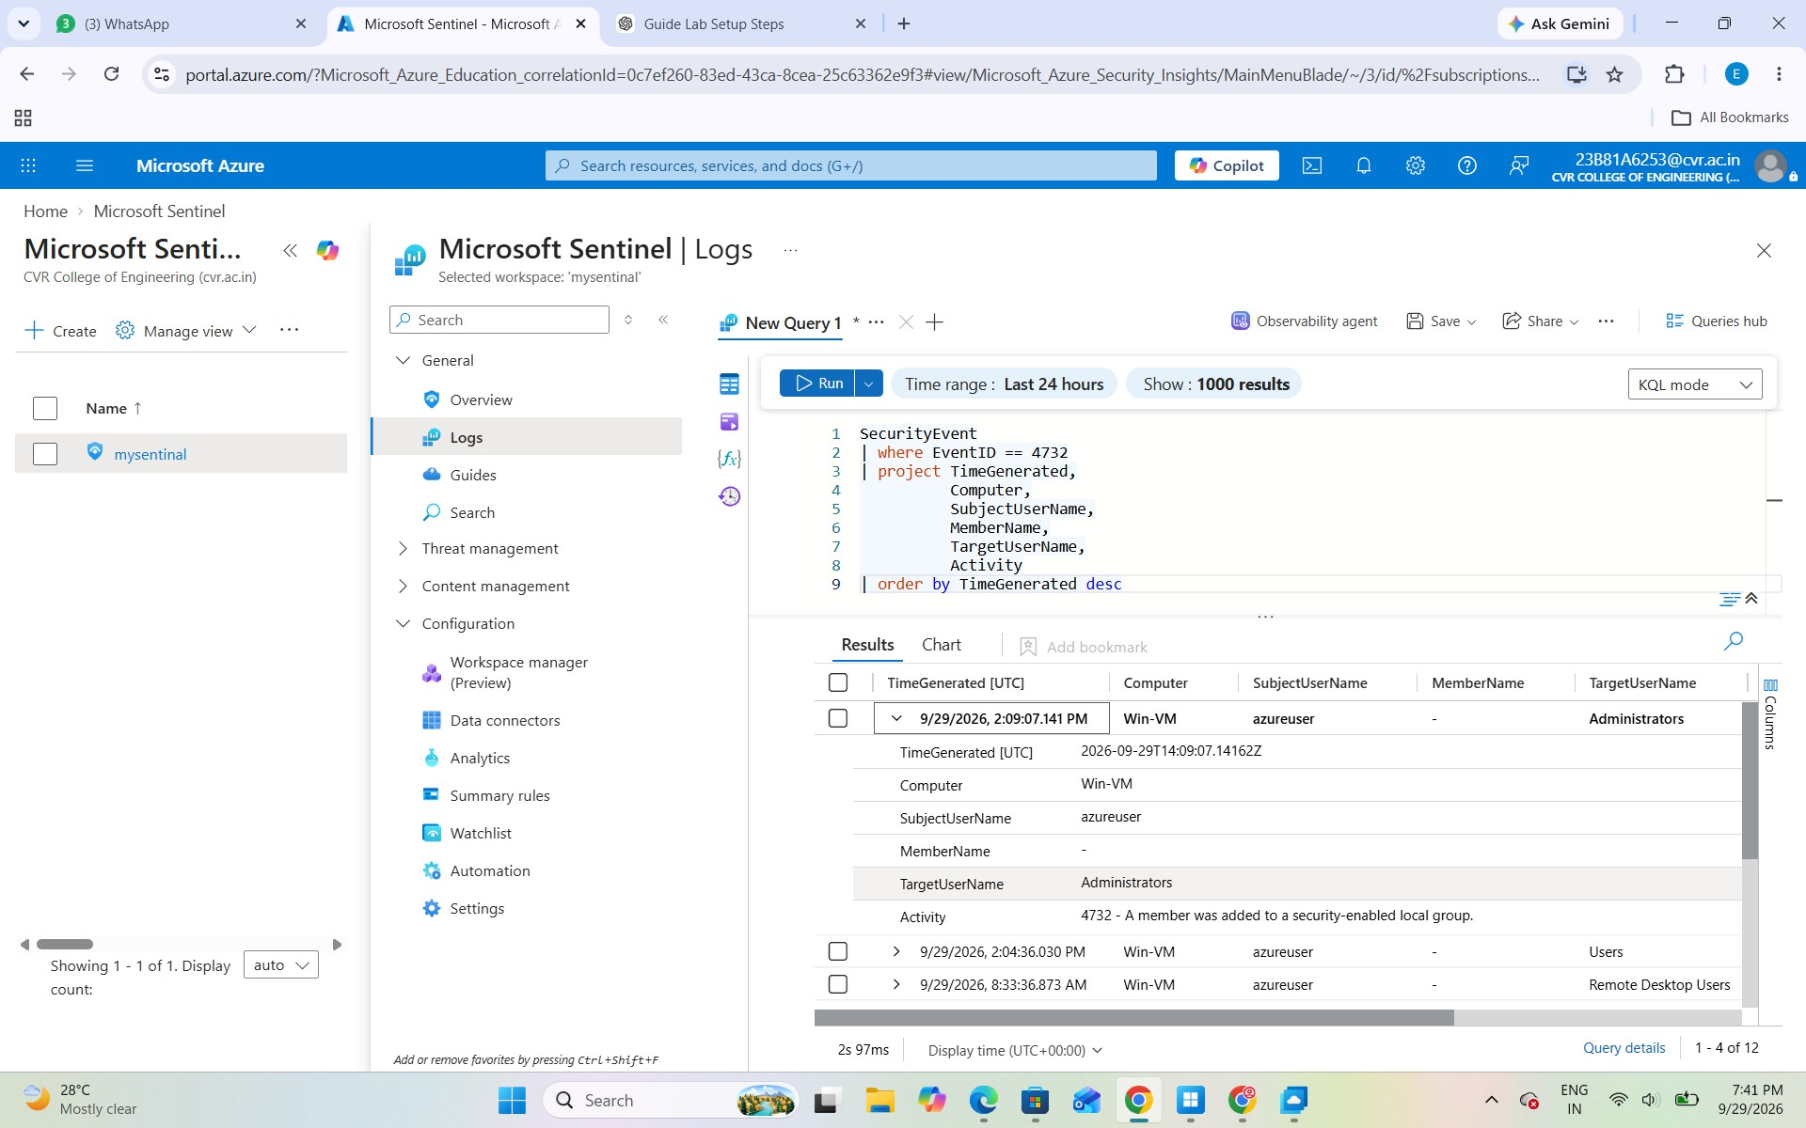

Attack 6 – Privileged Logon

Objective:
To identify a logon where special privileges were assigned to the user.

Procedure:
After adding soc_user01 to the Administrators group in Attack 5, we logged out and logged in again using soc_user01.

Sentinel Investigation:
In Microsoft Sentinel, we searched for Event ID 4672, which indicates that special privileges were assigned to a new logon.
SecurityEvent
| where EventID == 4672
| where Account has "soc_"
| project TimeGenerated, Computer, Account, SubjectUserName, Activity
| order by TimeGenerated desc

Observation:
The event provides information about account and the privileges assigned during logon.
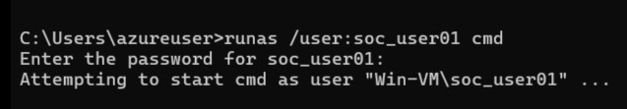
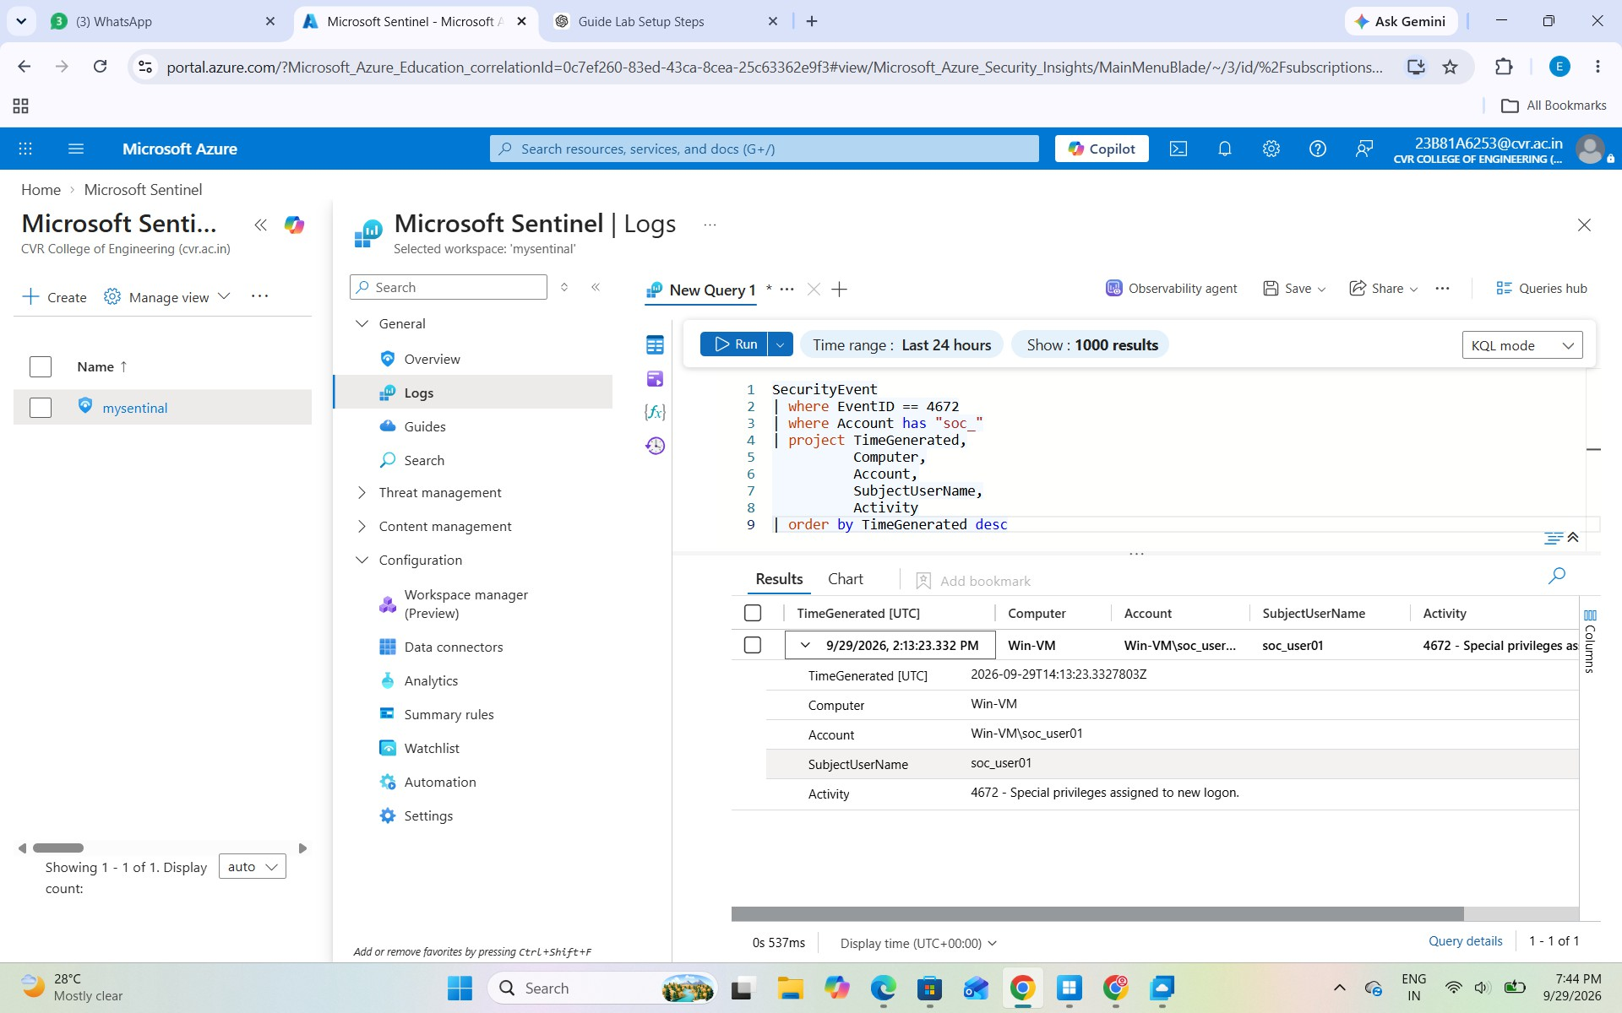

Microsoft Sentinel – Correlated Security Events
This screenshot shows a Microsoft Sentinel Logs query used to investigate multiple security events related to the soc_ lab accounts. The query filters events such as 4624 (successful login), 4625 (failed login), 4720 (account creation), 4732 (group membership change), and 4672 (privileged logon).
The results table displays details including the time, Event ID, computer, account, subject user, and target user. This helps us correlate different activities performed during the lab and understand the sequence of events.
Observation: The results show Event ID 4720, indicating that new user accounts such as soc_admin01, soc_admin02, soc_admin03, soc_admin04, soc_user01, and soc_user02 were created on the Windows VM.

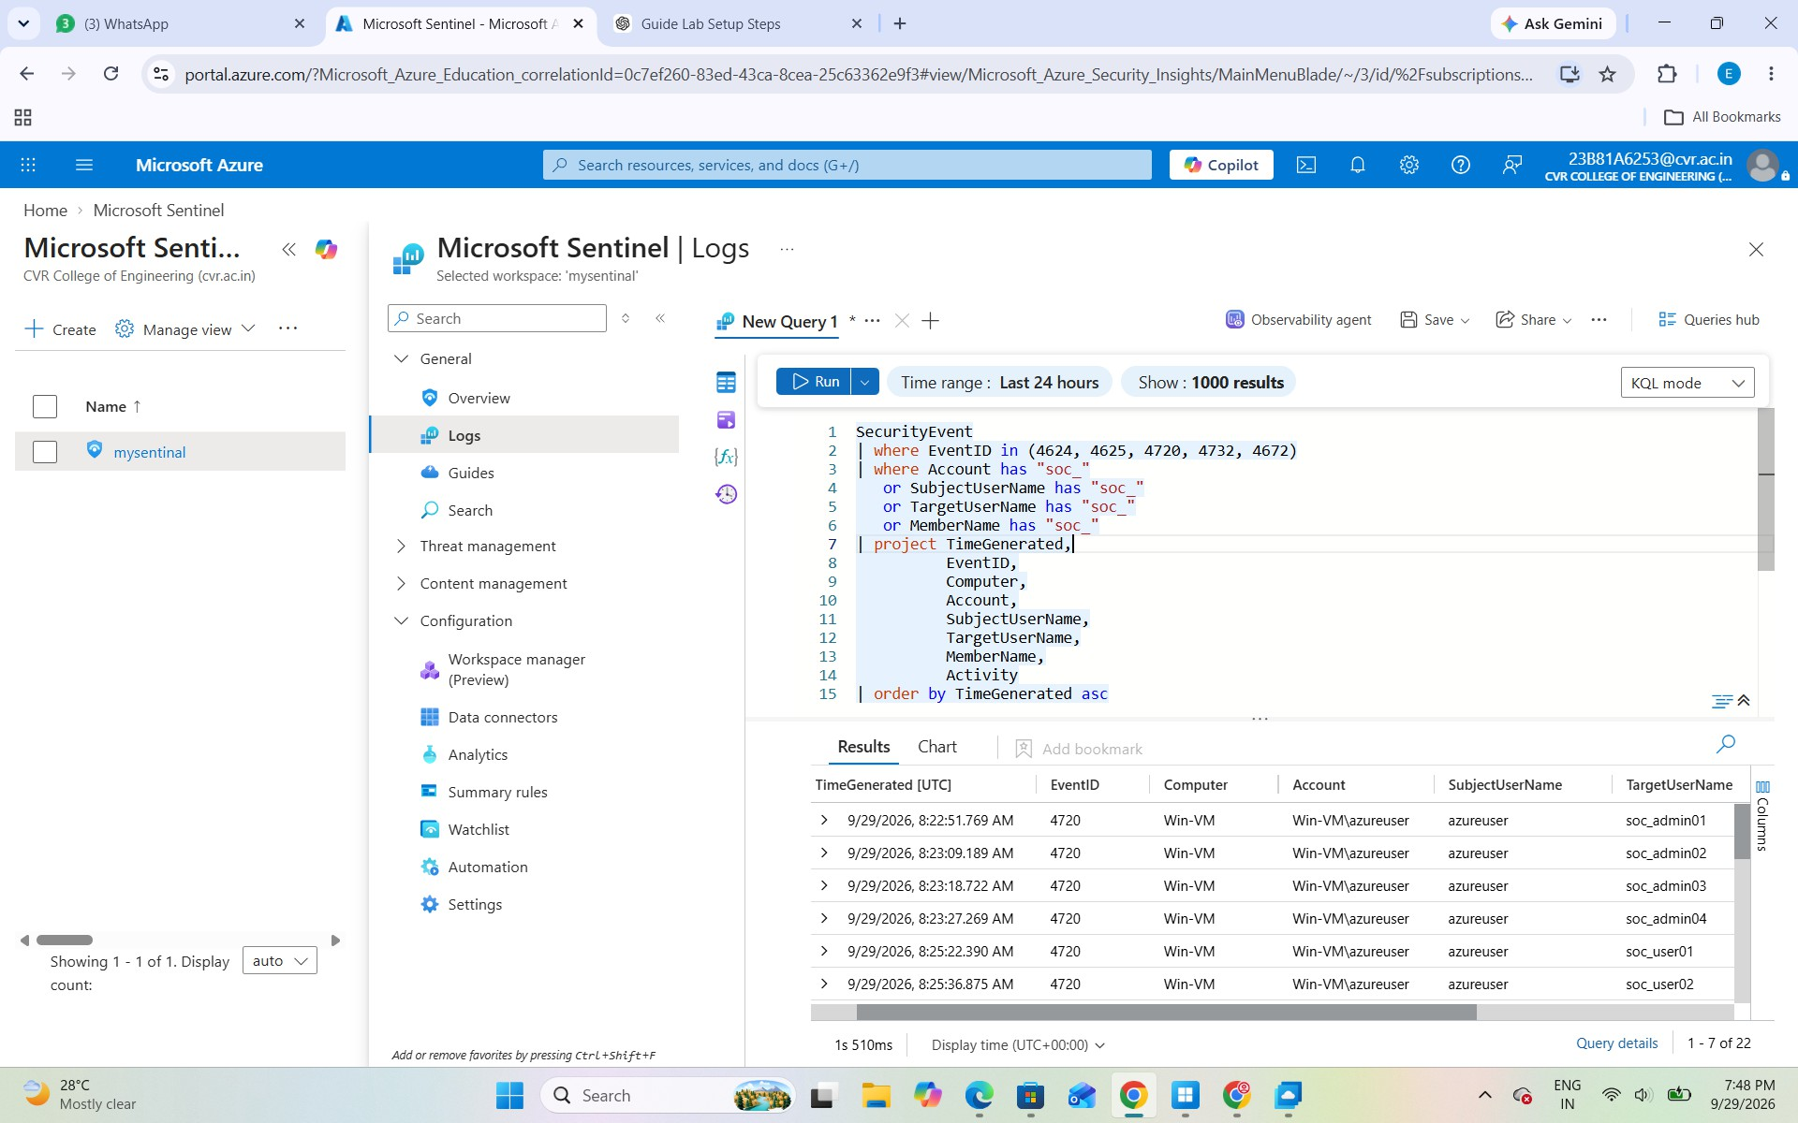

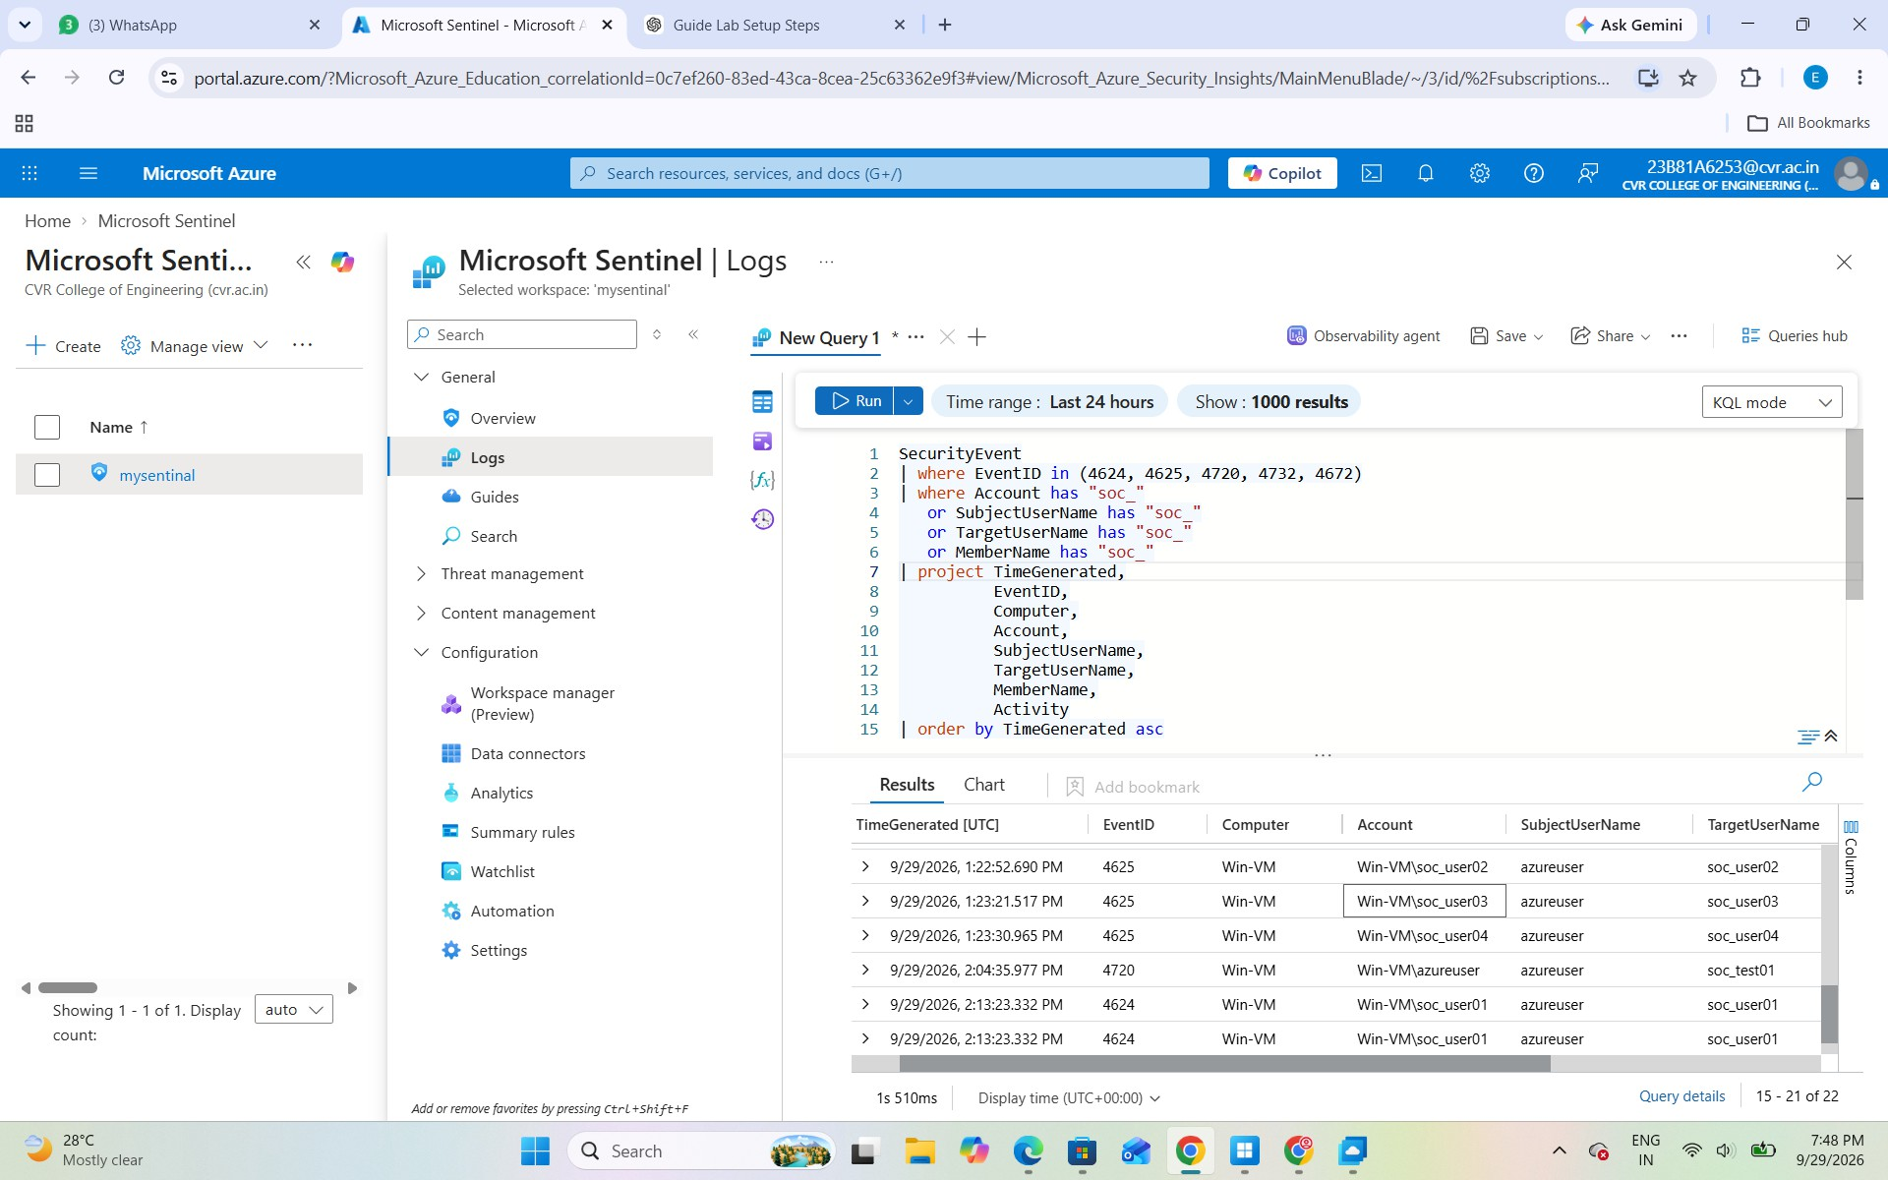

Attack 7 – Process Creation

Objective:
To monitor and investigate newly created processes using Sysmon.

Procedure:
First, we verified that Sysmon was running and checked the Sysmon Operational event log. We then generated some harmless process activity by running Notepad, whoami, ipconfig, and Get-Process.

Investigation:
We searched the Sysmon Operational log for Event ID 1, which records process creation. The event provides useful details such as the process, command line, parent process.

Observation:
Process creation events (Sysmon Event ID 1) were investigated locally on the Windows VM using the Sysmon Operational event log. These events were not verified as collected in Microsoft Sentinel.

Check whether Sysmon is running: Get-Service Sysmon

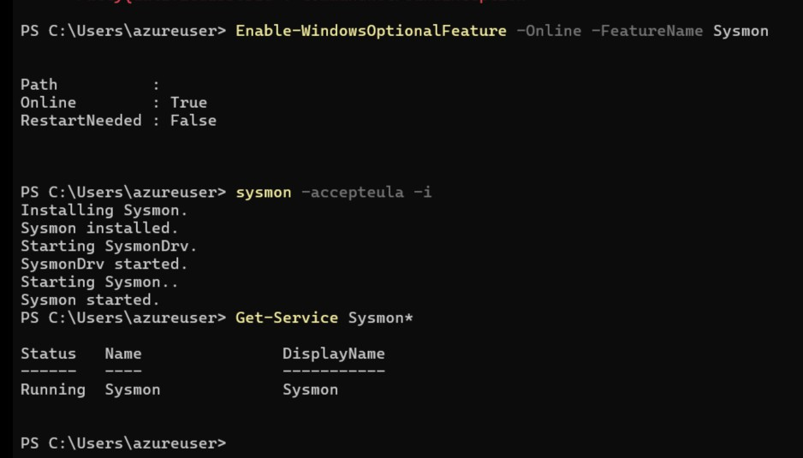

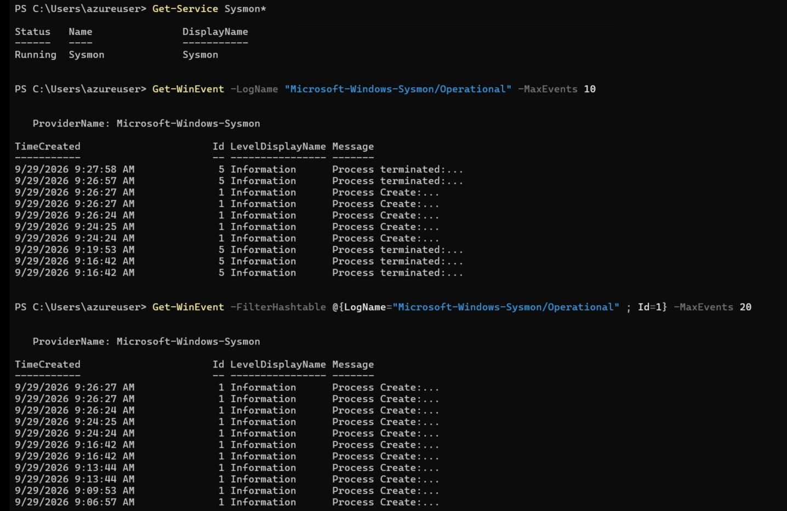

Attack 8 – PowerShell Investigation

Objective:
To investigate PowerShell activity and understand how process telemetry can be used during a SOC investigation.

Procedure:
We ran harmless PowerShell commands such as:

Get-Process Get-Service
We then investigated the corresponding process-creation events using Sysmon Event ID 1

Investigation:
The investigation focused on identifying:

- Who executed PowerShell
- Which parent process started it
- What command line was executed

- When the process was created
Note: PowerShell process activity was examined locally using Sysmon Event ID 1. The investigation focused on the executed command, parent process, user, and timestamp.
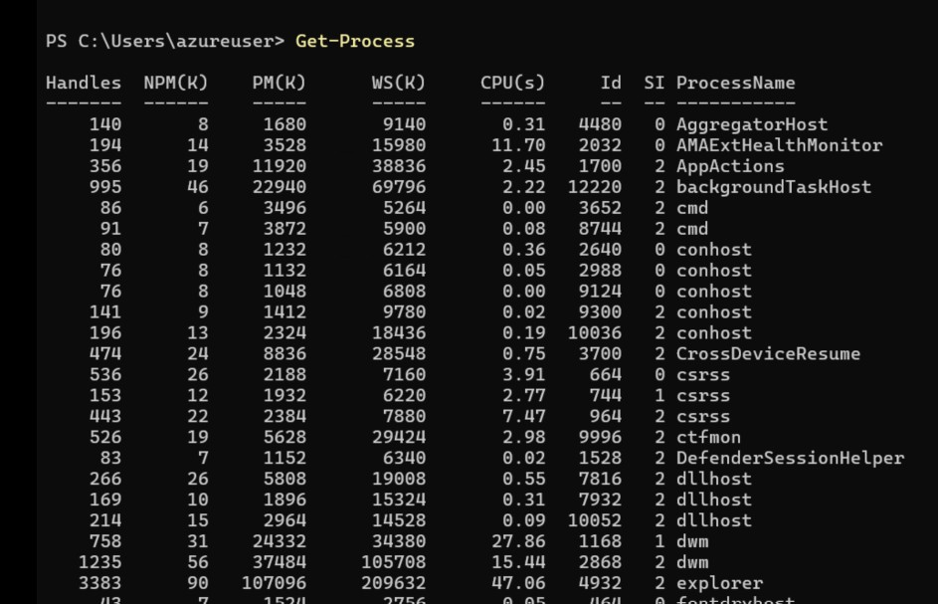
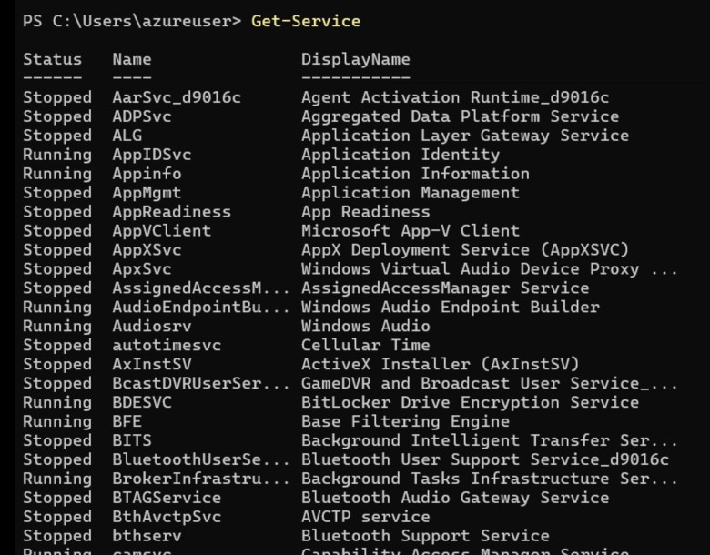

Attack 9- File Creation

Objective:
To simulate a harmless file-creation activity on the Windows Virtual Machine and verify that Sysmon records the activity.

Steps Performed
- Open PowerShell

PowerShell was opened on the Windows Virtual Machine.

- Create a Temporary Directory

The following command was executed:

New-Item C:\Temp -ItemType Directory -Force
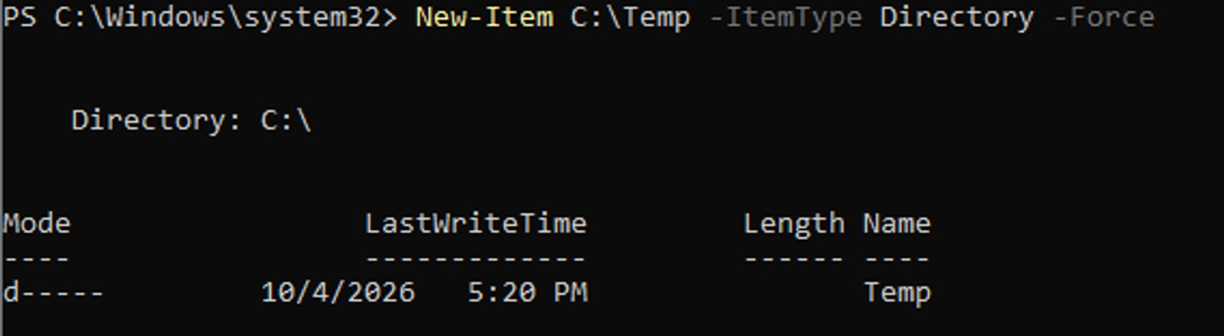

This creates the C:\Temp directory if it does not already exist.

- Create a Test File

A harmless test file was created using:

"Sentinel SOC Lab Test" | Out-File C:\Temp\soc-test.txt

This created the file soc-test.txt inside the C:\Temp directory.

- Sysmon Event Generation

The file-creation activity was recorded by Sysmon Event ID 11, which represents file creation activity.
- Verify the Event Locally

The following PowerShell command was used:

Get-WinEvent -FilterHashtable @{ LogName='Microsoft-Windows-Sysmon/Operational' Id=11

} -MaxEvents 20

The output displayed multiple Event ID 11 – Information entries with messages indicating that files were created.
Note: File creation activity was verified locally using Sysmon Event ID 11 in the Sysmon Operational event log. Sentinel ingestion of this Sysmon event was not verified.

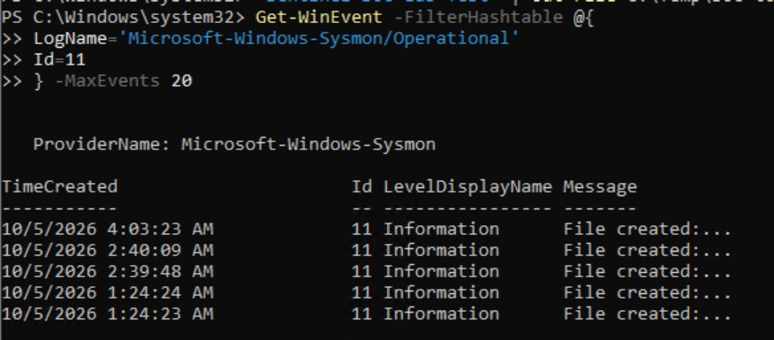

Attack 10 – DNS Investigation

Objective:
To investigate DNS queries and understand how a domain name is resolved to an IP address.

Open PowerShell.
● Run: nslookup example.com
This generates DNS query activity.
● Sysmon Event ID 22 records DNS query activity.
● Then look for the DNS event:
Get-WinEvent -FilterHashtable @{
LogName='Microsoft-Windows-Sysmon/Operational'
Id=22
} -MaxEvents 20

Note: DNS query activity was investigated locally using Sysmon Event ID 22. The event was checked through the Sysmon Operational event log on the Windows VM.
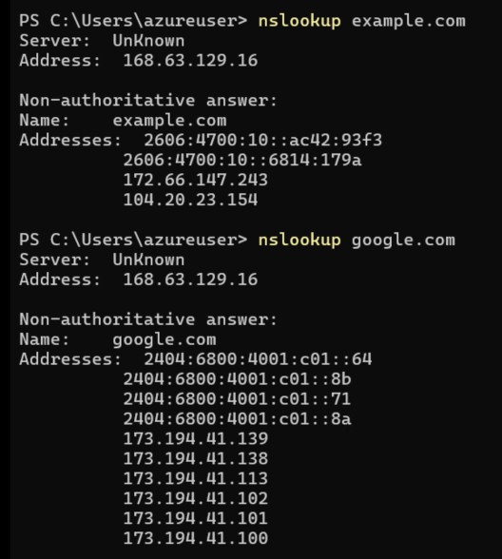

Attack 11 - Test Network Connectivity

In this task, we used the PowerShell command Test-NetConnection to check whether the Windows VM could establish a network connection with example.com on port 443 (HTTPS).

The output shows:

- Remote Address: 104.20.23.154
- Remote Port: 443
- Interface: Ethernet
- Source Address: 172.16.0.4
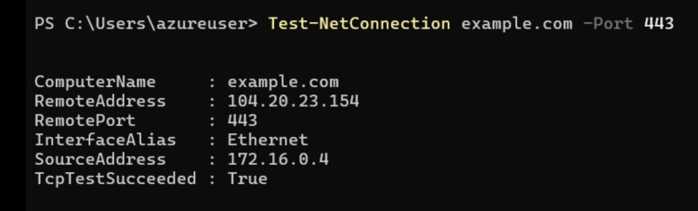

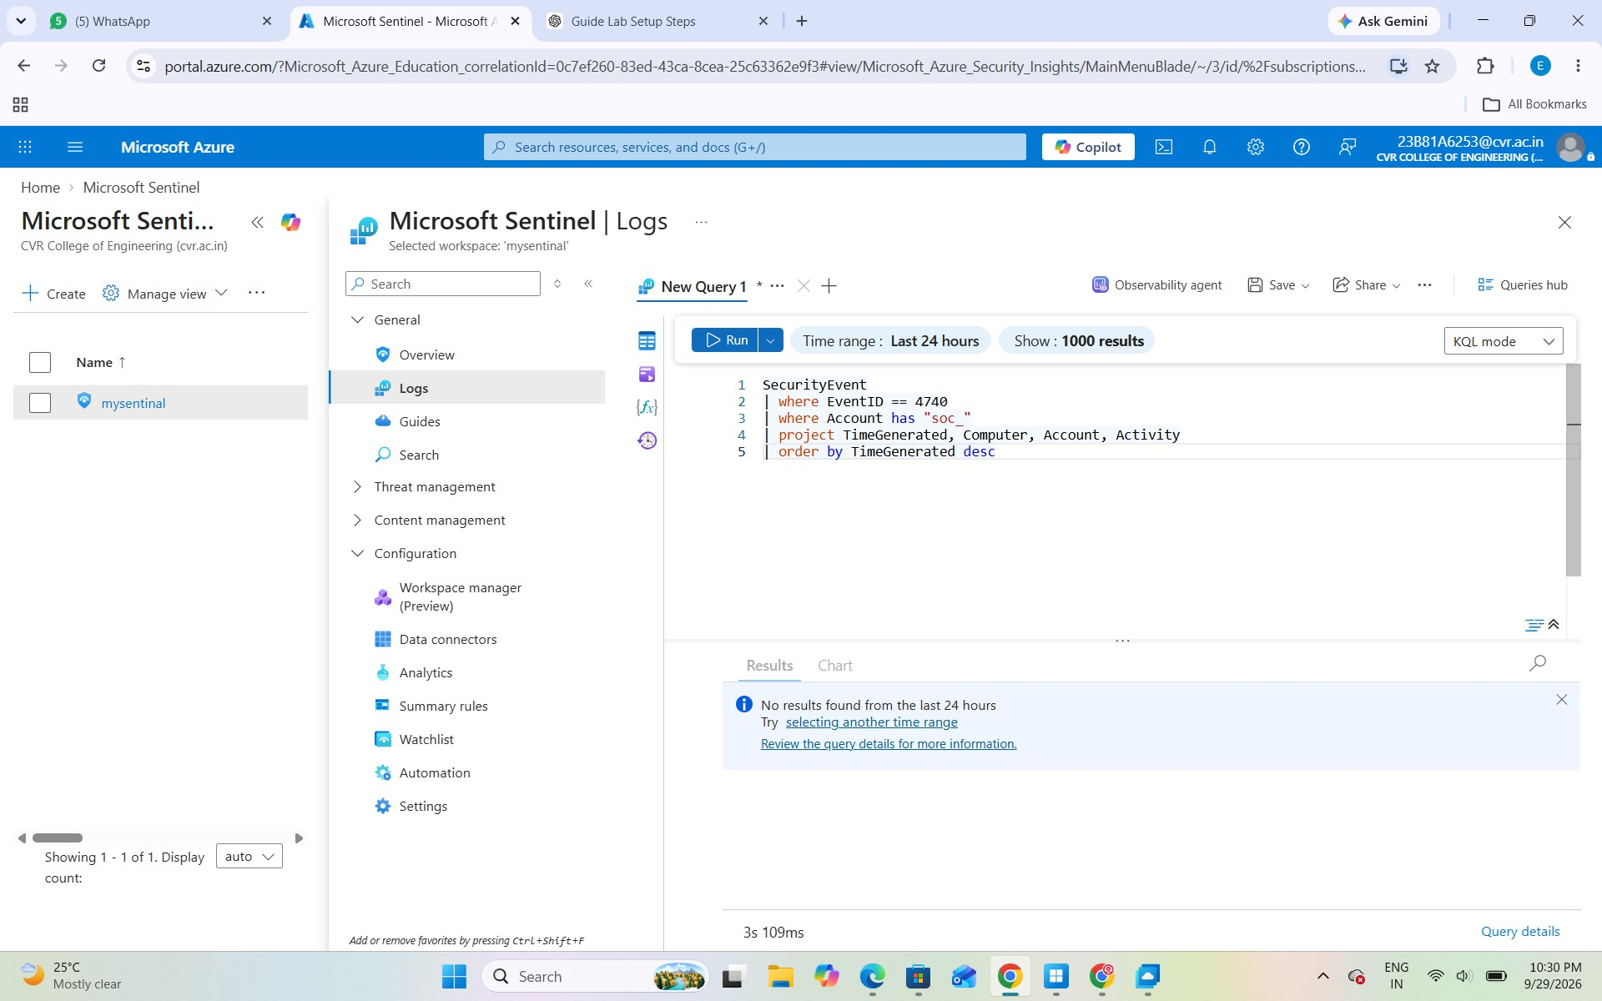

Attack 12 — Registry Modification

Objective
Create a harmless registry entry in the Windows VM and observe the registry modification through Sysmon.

Create the test registry key
Open PowerShell/CMD as Administrator and run:

reg add HKCU\Software\SOC-Lab /v TestValue /t REG_SZ /d "SentinelDemo" /f

In this activity, a harmless registry entry named SOC-Lab was created on the Windows VM. Sysmon Event IDs 12–14 were used to investigate registry activity locally through the Sysmon Operational event log. These events were not verified as collected in Microsoft Sentinel.
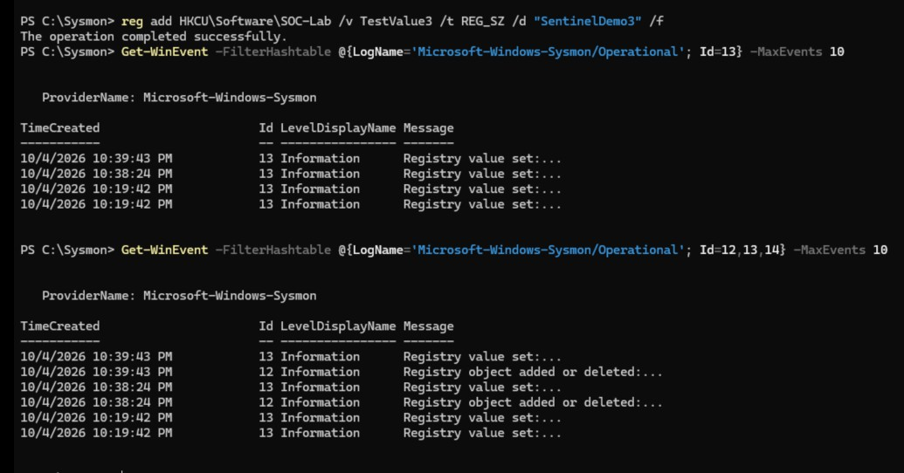

Attack 13 — Account Lockout

Objective
Generate incorrect login attempts on a lab account until the Windows account-lockout policy is triggered.

Use a lab account

Use the lab account soc_user02 for generating incorrect login attempts. Do not use your Azure administrator account.
Do not use your Azure/administrator account.

Generate incorrect login attempts
Enter an incorrect password several times for the test account. The exact number depends on your Windows Account Lockout Policy.
The goal is to generate an account lockout event.

Check in Microsoft Sentinel
Go to: Microsoft Sentinel → Logs

SecurityEvent
| where EventID == 4740
| where Account has "soc_"
| project TimeGenerated, Computer, Account, Activity
| order by TimeGenerated desc

Event ID 4740 = A user account was locked out.

Your flow diagram is also correct:

Wrong password attempts
↓
Account reaches lockout threshold
↓
Windows generates Event ID 4740
↓
Sentinel collects the event
↓
KQL identifies the locked account

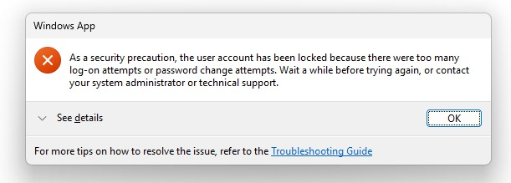

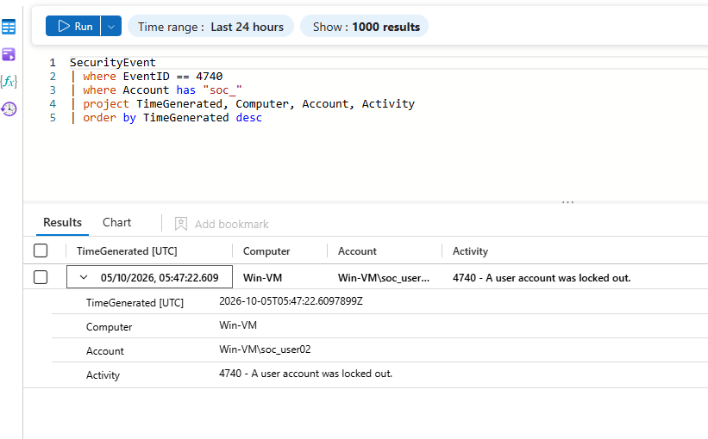

Attack 14 — Scheduled Task

Objective
Create a harmless scheduled task on the Windows VM and detect its creation through Microsoft Sentinel.

- Create the scheduled task

Open PowerShell as Administrator and run:

schtasks /create /sc once /tn "SOC-Lab-Test" /tr "notepad.exe" /st 23:59
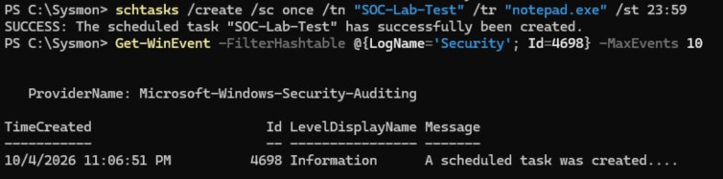

This creates a task named SOC-Lab-Test that is configured to run notepad.exe once at the specified time.

- Expected Windows Event The task creation generates:
Event ID 4698 — A scheduled task was created.
- Check it in Microsoft Sentinel Go to: Microsoft Sentinel → Logs SecurityEvent
| where EventID == 4698

| project TimeGenerated, Computer, SubjectUserName, Activity
| order by TimeGenerated desc

You should see the scheduled-task creation event.

- SOC Investigation

The important question is:

Who created the scheduled task and when was it created?

Look at:

  - TimeGenerated → When it happened
  - SubjectUserName → Account that created it
  - Computer → Which machine
  - Activity → Event description

- Delete the test task

After the demonstration, remove the task:

schtasks /delete /tn "SOC-Lab-Test" /f

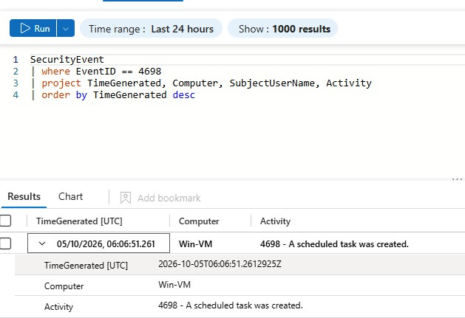

Attack 15 - Security Log Clearing

Objective:
Demonstrate how an attempt to clear the Windows Security log generates its own security event.

Steps:

Open PowerShell as Administrator.

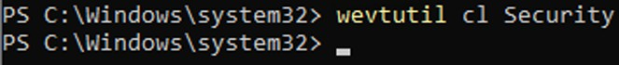
wevtutil cl Security

This clears the Windows Security Event Log on the isolated lab VM. Windows records the log-clearing activity as Event ID 1102.
Verify the event locally using:

Get-WinEvent -FilterHashtable @{ LogName='Security'
Id=1102
} -MaxEvents 5 | Format-List TimeCreated, Id, Message

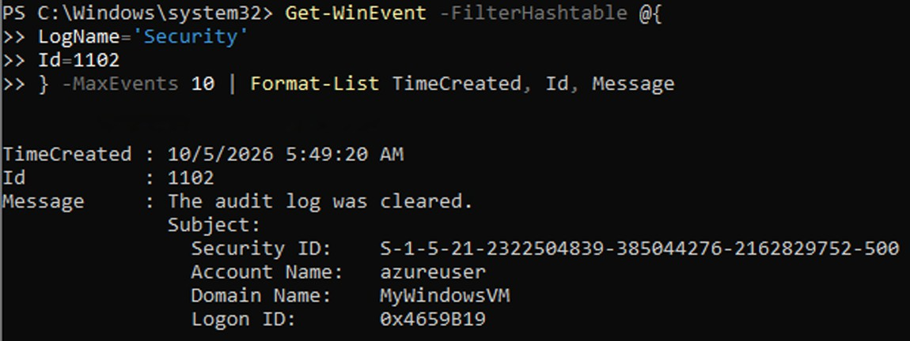
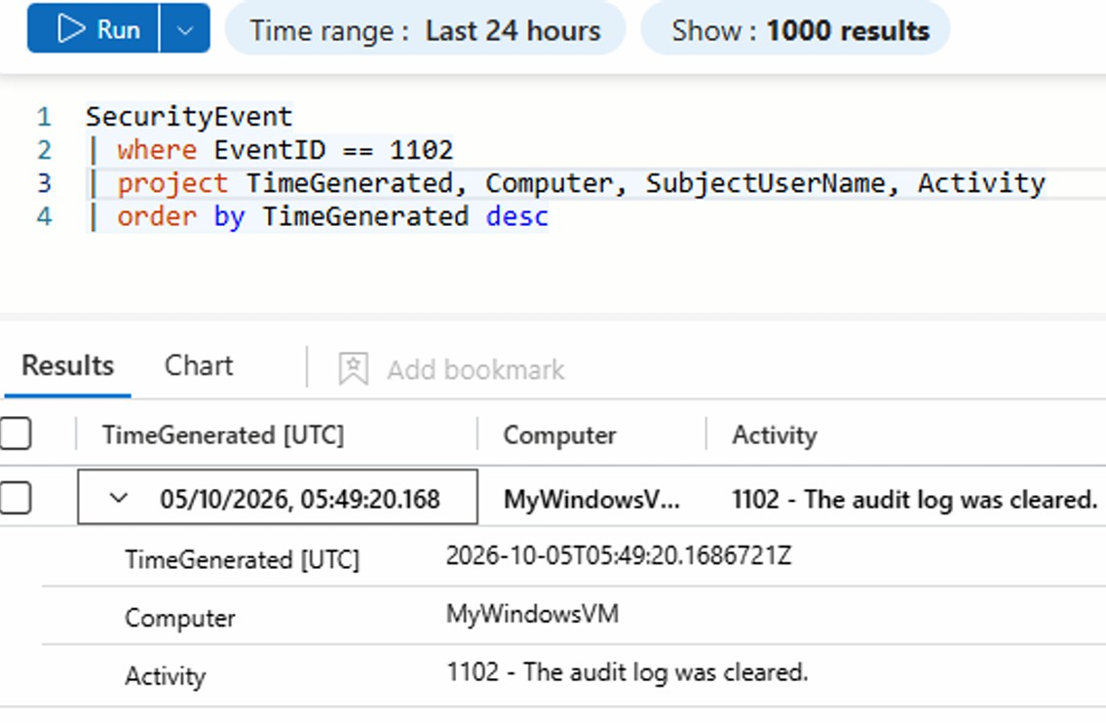

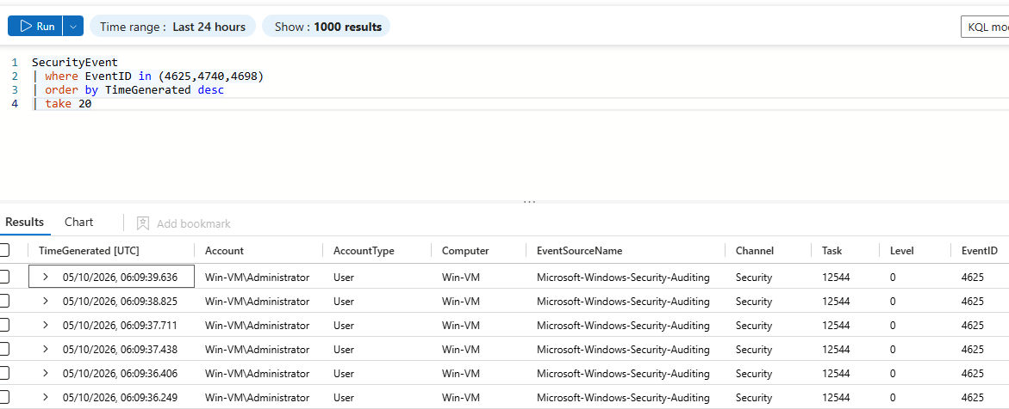

IX. Creating Microsoft Sentinel Analytics Rule

General Settings

  - Rule Name: SOC Lab - Multiple Failed Logins
  - Description: Detects multiple failed Windows login attempts within a short time period.
  - Severity: Medium
  - Status: Enabled

Set Rule Logic

The following KQL query is used:

SecurityEvent
| where EventID == 4625
| summarize FailedAttempts=count()
by Account, IpAddress, bin(TimeGenerated, 5m)
| where FailedAttempts >= 5
| order by TimeGenerated desc

Explanation:
The query searches for Windows Event ID 4625, which represents a failed login. It counts failed attempts for the same account and IP address within a 5-minute window. If the number of failures reaches 5 or more, the activity is detected as a potential brute-force login attempt.

Query Scheduling
  - Run query every: 5 minutes
  - Lookup data from the last: 5 minutes
  - Start running: Automatically

This allows Microsoft Sentinel to periodically execute the detection query against the collected
SecurityEvent data.
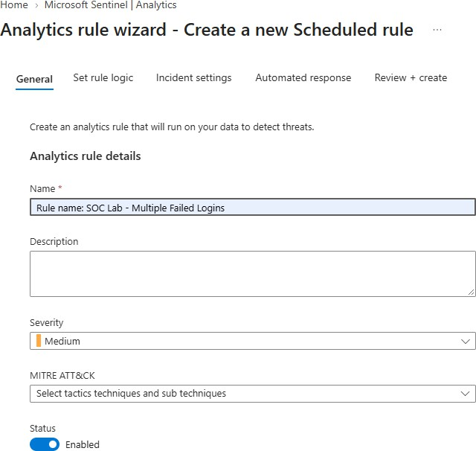

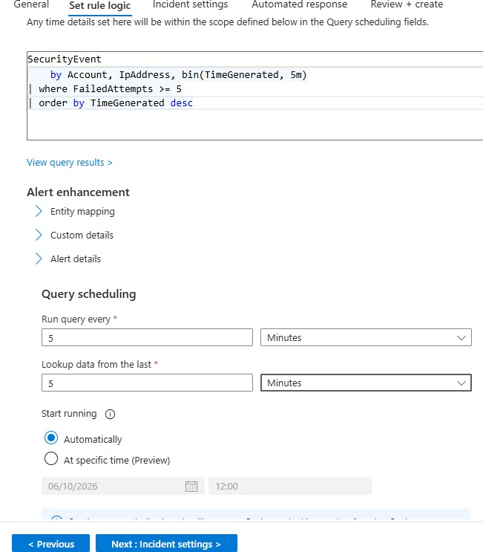

X. Review Questions

1a. Identify and explain the purpose and availability of the Microsoft Sentinel, Log Analytics Workspace, Azure Monitor Agent (AMA), Data Collection Rule, and KQL tools used in the SOC attack simulation. Explain how each tool supports security monitoring and ethical security investigation.
The Microsoft Sentinel–Based SOC Attack Simulation project uses five important tools for security monitoring and investigation.
- Microsoft Sentinel: Microsoft Sentinel is a cloud-based Security Information and Event Management (SIEM) and Security Orchestration, Automation, and Response (SOAR) solution. It detects suspicious activities, generates alerts, and helps security analysts investigate incidents.
- Log Analytics Workspace: It is a centralized storage location for collecting and analyzing logs from monitored resources. In this project, it stores Windows security events generated during the simulated attacks.
- Azure Monitor Agent (AMA): AMA collects configured security and monitoring data from the Windows virtual machine and forwards it to the designated Log Analytics Workspace.
- Data Collection Rule (DCR): A DCR specifies which event data should be collected, how it should be collected, and where it should be sent. It ensures that relevant Windows logs are available for investigation.
- Kusto Query Language (KQL): KQL is used to search, filter, summarize, and correlate log data. In this project, it helps identify failed login attempts (Event ID 4625), account creation (Event ID 4720), and administrator-group modifications (Event ID 4732).
How these tools work together: The Windows VM generates security events, AMA collects the configured events according to the DCR, and the Log Analytics Workspace stores them. Microsoft Sentinel analyzes this data using KQL-based analytics rules to detect suspicious behavior and generate alerts for investigation.
These tools support ethical security investigation by allowing students to simulate attacks in an isolated laboratory environment, analyze evidence, identify potential threats, and recommend appropriate response actions.

1b . Explain the business and security implications of the simulated activities, including authentication failures, password-spray activity, account creation, privilege modification, process and file activity, and DNS/network activity. How can Microsoft Sentinel help organizations address these security risks?
The simulated security activities demonstrate how different attacks can affect an organization's security and how Microsoft Sentinel helps detect them.
- Authentication Failures: Repeated failed login attempts may indicate incorrect passwords or brute-force attacks. Monitoring these events helps identify possible unauthorized access.
- Password-Spray Activity: Attackers may try a common password against multiple accounts. Detecting failures across several accounts helps identify potential password-spray attacks.
- Account Creation: Unauthorized account creation may allow attackers to gain or maintain access to a system. Monitoring account-creation events helps identify suspicious changes.
- Privilege Modification: Adding a standard user to the Administrators group grants elevated permissions. If unauthorized, this can expose sensitive data and allow critical system changes.
- Process and File Activity: Unexpected processes or file creation may indicate suspicious execution or unauthorized modifications. Investigating these events helps analysts understand system activity.
- DNS and Network Activity: Unusual DNS queries and network connections may indicate communication with suspicious destinations. Monitoring this activity helps identify potential threats.
Role of Microsoft Sentinel: Microsoft Sentinel analyzes security events, correlates related activities, and generates alerts through Analytics Rules. It helps security analysts investigate incidents and recommend appropriate responses. However, an individual event does not automatically prove an attack; its context must be examined before taking action.

1c. Using Kusto Query Language (KQL) in Microsoft Sentinel, correlate the security events generated during the attack simulations and construct an incident timeline. Identify the affected account, host, sequence of activities, and potential security risks.

Microsoft Sentinel uses KQL to investigate and correlate security events generated on the Windows virtual machine. By analyzing event IDs and timestamps, a SOC analyst can reconstruct the sequence of activities and identify suspicious behavior.

KQL query to construct the incident timeline

SecurityEvent

| where Account has "soc_"

| where EventID in (4624, 4625, 4648, 4672, 4688,

4697, 4720, 4728, 4732, 4740, 1102)

| project TimeGenerated, EventID, Computer, Account, SubjectUserName, TargetUserName, Activity
| order by TimeGenerated asc
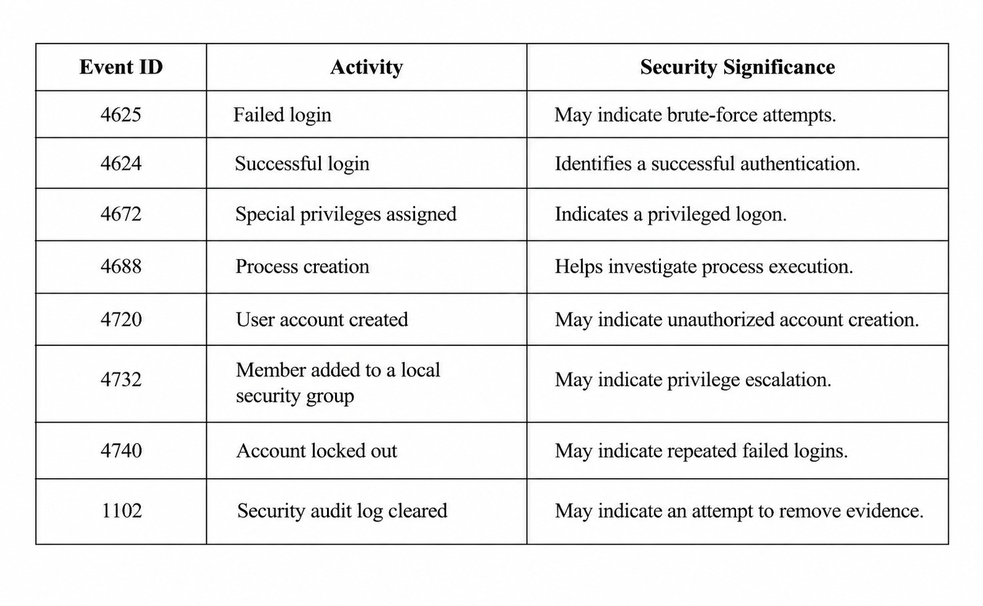

Incident timeline and investigation

The analyst sorts the events by TimeGenerated to determine the order in which activities occurred. For example, repeated failed logins followed by a successful login may require investigation. If the same sequence is followed by account creation or an unexpected administrator-group modification, the activities should be correlated to determine whether an account was compromised.
  - Affected account: Identify the account shown in the event records, such as
soc_user01.
  - Affected host: Identify the Windows VM from the Computer field, such as Win-VM.
  - Activity sequence: Review authentication failures, successful login, privilege changes, and other related events.
  - Potential risk: Unauthorized access, privilege escalation, persistence, or evidence removal.
Conclusion: Microsoft Sentinel helps SOC analysts correlate events, reconstruct an incident timeline, and identify potential threats. However, an individual event does not automatically prove an attack; the analyst must validate the evidence and surrounding context before recommending a response.

1d. Develop appropriate detection logic in Microsoft Sentinel using KQL Analytics Rules to identify suspicious activities generated during the attack simulations. Explain how these rules help detect potential security threats.
Microsoft Sentinel Analytics Rules automatically execute KQL queries at scheduled intervals to identify suspicious activities and generate alerts when the configured conditions are met.

Multiple Failed Logins

SecurityEvent
| where EventID == 4625
| summarize FailedAttempts=count()
by Account, IpAddress, bin(TimeGenerated, 5m)
| where FailedAttempts >= 5

Purpose: Detects five or more failed login attempts for the same account and IP address within a five-minute window.

New Account Creation

SecurityEvent
| where EventID == 4720

Purpose: Detects newly created user accounts that may require investigation.

User Added to Administrators Group

SecurityEvent
| where EventID == 4732
| where TargetUserName =~ "Administrators"

Purpose: Identifies changes to local security group membership that may indicate unauthorized privilege escalation.

Security Log Cleared

SecurityEvent
| where EventID == 1102

Purpose: Detects the clearing of the Windows Security audit log, which may indicate an attempt to remove evidence.

Conclusion

These Analytics Rules help automate security monitoring, identify suspicious events, and generate alerts for SOC analysts. Analysts should investigate the related accounts, source IP addresses, affected host, and event timeline before classifying an activity as malicious.

1e. Document the investigation findings and recommend appropriate response actions based on the security events detected during the Microsoft Sentinel attack simulation.
The investigation was performed using Microsoft Sentinel to analyze Windows Security Events generated on the Azure Windows virtual machine. KQL queries were used to identify suspicious authentication attempts, account creation, privilege modifications, and other activities.

Investigation Findings

- Failed Login Attempts: Event ID 4625 was analyzed to identify repeated authentication failures that could indicate brute-force activity.
- Successful Login: Event ID 4624 was examined to determine whether successful authentication occurred after failed attempts.
- Password-Spray Activity: Failed logins across multiple accounts were investigated to identify possible password spraying.
- Account Creation: Event ID 4720 was checked to identify newly created accounts and determine who created them.
- Privilege Modification: Event ID 4732 was analyzed to identify changes to local security group membership.

- Process and Network Activity: Process execution, file creation, DNS queries, and network connections were investigated where the relevant telemetry was available.
- Incident Timeline: Events were arranged chronologically to understand the sequence of activities and identify potentially related actions.

Recommended Response Actions

  - Validate the alerts and investigate the affected account, host, source IP address, and event timestamps.
  - If account compromise is suspected, disable or restrict the affected account and reset its credentials according to organizational procedures.
  - Remove unauthorized administrator privileges and accounts after confirming that the changes are not legitimate.
  - Isolate the affected host if evidence indicates an active compromise, following the organization's incident-response process.
  - Preserve relevant logs and evidence for further investigation.
  - Configure Microsoft Sentinel Analytics Rules to detect repeated failed logins, unauthorized account creation, privilege changes, and security log clearing.
  - Monitor the system after remediation to verify that suspicious activity has stopped.

Conclusion: Microsoft Sentinel supports security monitoring, threat detection, and incident investigation by correlating events and generating alerts. The recommended response is to validate the evidence, contain confirmed threats, restore secure configurations, and continue monitoring. The simulated events demonstrate potential security risks; they do not independently prove that a real attack occurred.

