ROS camera driver

What is ROS?
The Robot Operating System (ROS) is a set of software libraries and tools that help you build robot applications. From drivers to state-of-the-art algorithms and with powerful developer tools, ROS has what is needed for a robotics project. It is all open source (Source: ROS.org). For more details, also refer to ROS.org and ROS Wiki sensors.

Installation
System requirement: Linux operating system.
Download the “TOFCAM635_SW_Package” from the website www.espros.com, section Downloads, 02_Cameras_and_Modules.
There is enclosed the “TOFCAM635_ROS_driver” file. Unpack this ZIP file.
This driver works with two types of cameras: TOFcam635 and TOFcam635-S. The driver automatically detects which camera is connected. The camera TOFcam635-S has less parameters and unusable parameters will be ignored.

Running the ROS driver
Change to the home directory and open the bash-file:
> cd ~
> gedit .bashrc

Insert the following line at the end of the bash-file:
source ~/projects/cam635_driver/devel/setup.bash

Save the file, close editor and re-login linux.

Start the ROS with GUI in terminal mode with the following command:
roslaunch espros_cam635 camera.launch

The ROS tool opens with the different node windows and is ready to use.
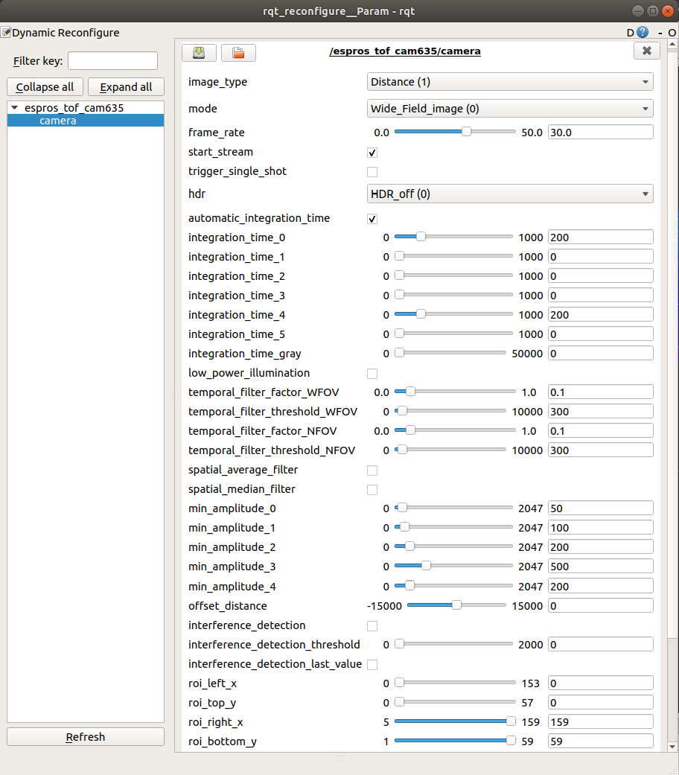
Text 1: Figure 16: Example of the “dynamic reconfigure” node window
Start the camera operation by changing in the menu the parameter “start_stream” from false to true.

ROS API
This is the official driver for the ESPROS TOFcam635. The annotation follows the rules of ROS.org.

Start of the node
If you use in terminal mode the APIs only, without GUI:
Start the ROS operating system in a terminal with the command: roscore&
Start the cam635_node with the command: rosrun espros_cam635 cam635_node

Published topics

Topic name | ROS msgs file | ROS message type | Function
camera/image_raw1 | sensor_msgs | Image | Sends the grayscale or amplitude image  according the selected image type parameter
camera/image_raw2 | sensor_msgs | Image | Sends the distance image  for image type parameters which include distance
camera/image_header | std_msg | Int32MultiArray | Sends the image header. Refer to Table 2.
camera/points | sensor_msgs | PointCloud2 | Sends the point cloud image  for image type parameters which include distance
Table 1: ESPROS ROS topics

Entry | Index |  | Entry | Index
Header version | 1 |  | reserved2 | 22
Frame counter | 2 |  | AmplitudeLimit0 WFOV | 23
Timestamp | 3 |  | AmplitudeLimit1 WFOV | 24
TOFCOS version | 4 |  | AmplitudeLimit2 WFOV | 25
Hardware version | 5 |  | AmplitudeLimit3 WFOV | 26
Chip ID | 6 |  | AmplitudeLimit4 NFOV | 27
Image width (x-axis) | 7 |  | Binning type | 29
Image height (y-axis) | 8 |  | DistanceTemporalFilter-Factor WFOV | 30
Image origin X | 9 |  | DistanceTemporalFilter-Threshold WFOV | 31
Image origin Y | 10 |  | SingleValueTemporalFilter-Factor NFOV | 32
CurrentIntegrationTime3D WFOV | 11 |  | SingleValueTemporalFilter-Threshold NFOV | 33
CurrentIntegrationTime3D NFOV | 12 |  | Modulation frequency | 34
CurrentIntegrationTimeGrayscale | 13 |  | Modulation channel | 35
IntegrationTimeGrayscale | 14 |  | Flags | 36
IntegrationTime0 WFOV | 15 |  | Temperature | 37
IntegrationTime1 WFOV | 16 |  | Illumination beam | 38
IntegrationTime2 WFOV | 17 |  | NFOV distance | 39
IntegrationTime3 WFOV | 18 |  | NFOV amplitude | 40
IntegrationTime4 NFOV | 19 |  | reserved3 | 41
Integration time5 NFOV | 20 |  | n/a | n/a
reserved1 | 21 |  | n/a | n/a
Table 2: Header parameters (see also notes below)

Notes:
- ROS header bytes: In total 164 bytes. Each parameter is transmitted in corresponding 32 bit data format (Int32MultiArray).

Dynamically reconfigurable parameters

Refer for details on the dynamically reconfigurable parameters to the enclosed “dynamic_reconfigure package” or to http://wiki.ros.org/dynamic_reconfigure.
Parameter | Function | Data format | Default | Reference
~image_type | Sets the image acquisition type  0: Grayscale  1: Distance  2: Distance and amplitude  3: Distance and grayscale | int | 1 | n/a
~mode | Sets the operation mode  0: WFOV  1: NFOV manual  2: NFOV result  3: NFOV result and image  4: WFOV and NFOV result  5: Either WFOV, if object is inside range, else NFOV spot.  6: WFOV and NFOV image | int | 0 | n/a
~frame_rate | Sets image acquisition frame rate. Range 0 ... 50 frame/sec | double | 30 | n/a
~start_stream | Enables image streaming | bool | False | n/a
~trigger_single_shot | Starts single measurement after change from false to true | bool | False | n/a
~hdr | Sets HDR mode:  0: HDR OFF  1: HDR spatial  2: HDR temporal | int | 0 | n/a
~automatic_integration_time | Automatic mode: Integration time is set automatically for WFOV and NFOV between 1 and 1'000 μs. | bool | True | n/a
~integration_time_0 | Sets the WFOV integration time for distance measurements  in microseconds. Range: 1 … 4'000 µs | int | 200 | n/a
~integration_time_1 |  | int | 0 | n/a
~integration_time_2 |  | int | 0 | n/a
~integration_time_3 |  | int | 0 | n/a
~integration_time_4 | Sets the NFOV integration time for distance measurements  in microseconds. Range: 1 … 4'000 µs | int | 200 | n/a
~integration_time_5 |  | int | 0 | n/a
~integration_time_gray | Sets the integration time for grayscale measurements  in microseconds. Range: 0 … 50'000 µs | int | 0 | n/a
~low_power_illumination | Enables low power illumination | bool | False | n/a
~temporal_filter_factor_wfov | Sets the factor 'k' of the WFOV temporal filter (Kalman) | int | 10 | n/a
~temporal_filter_threshold_wfov | Sets the threshold 'T' of the WFOV temporal filter (Kalman) | int | 300 | n/a
~temporal_filter_factor_nfov | Sets the factor 'k' of the NFOV temporal filter (Kalman) | int | 10 | n/a
~temporal_filter_threshold_nfov | Sets the threshold 'T' of the NFOV temporal filter (Kalman) | int | 300 | n/a
~spatial_average_filter | Enables the spatial average filter for distance filtering | bool | False | n/a
~spatial_median_filter | Enables the spatial median filter for distance filtering | bool | False | n/a
~interference_detection | Enables interference detection | bool | False | n/a
~interference_detection_threshold | Interference detection threshold. Range: 0 … 2000 mm | int | 0 | n/a
~interference_detection_last_value | Enables use last detection value | bool | False | n/a
~min_amplitude_0 | Sets the amplitude limits for WFOV. Range 0 … 2'047 LSB | int | 50 | n/a
~min_amplitude_1 | Sets the amplitude limits for WFOV. Range 0 … 2'047 LSB | int | 100 | n/a
~min_amplitude_2 | Sets the amplitude limits for WFOV. Range 0 … 2'047 LSB | int | 200 | n/a
~min_amplitude_3 | Sets the amplitude limits for WFOV. Range 0 … 2'047 LSB | int | 500 | n/a
~min_amplitude_4 | Sets the amplitude limits for NFOV. Range 0 … 2'047 LSB | int | 200 | n/a
~offset_distance | Set distance offset. Range -15'000 … 15'000 mm | int | 0 | n/a
~roi_left_x | Sets the left edge of the ROI | int | 0 | n/a
~roi_right_x | Sets the right edge of the ROI | int | 159 | n/a
~roi_top_y | Sets the top edge of the ROI | int | 0 | n/a
~roi_bottom_y | Sets the top edge of the ROI | int | 59 | n/a
Table 3: ROS parameter table

Parameter | Function | Data format | Default | Reference
~lens_center_offset_x | Lens optical axis offset relative to sensor center (x direction). Range -100 … 100 pixels. | int | 0 | n/a
~lens_center_offset_y | Lens optical axis offset relative to sensor center (y direction). Range -100 … 100 pixels. | int | 0 | n/a
~enable_cartesian | Enables point cloud cartesian transformation (false = spheric) | bool | True | n/a
~enable_images | Activates imagePublisher1 and imagePublisher2 nodes to send information (camera/image_raw1/2) | bool | True | Table 1
~enable_point_cloud | Activates pointCloud2Publisher node to send information (camera/points) | bool | True | Table 1
~enable_image_header | Activates imageHeader node to send information (camera/imageHeader) | bool | True | Table 1
Table 3 cont: ROS parameter table

Notes: The parameters: mode, low_power_illumination, integration_time_4, integration_time5, min_amplitude_4, temporal_filter_factor_nfov, temporal_filter_threshold_nfov exist, but with the camera cam635-S are unused and will be ignored.

