TOFcam660
Installation an Operation Manual

ROS camera driver

What is ROS?
The Robot Operating System (ROS) is a set of software libraries and tools that help you build robot applications. From drivers to state-of-the-art algorithms and with powerful developer tools, ROS has what is needed for a robotics project. It is all open source (Source: ROS.org). For more details, also refer to ROS.org and ROS Wiki sensors.

Building the ROS driver
Extract zip file for example in ~/projects/ directory
Change current directory:
> cd ~/projects/cam660_driver
Build a project from the command:
> catkin_make

Change to the home directory and open the bash-file:
> cd ~
> gedit .bashrc

Insert the following line at the end of the bash-file:
source ~/projects/cam660_driver/devel/setup.bash

Save the file and exit editor.
Log-out and again log-in linux or execute command:
> source ~/projects/cam660_driver/devel/setup.bash

Running the ROS driver with launch file

Start the ROS with GUI in terminal mode with the following command:
roslaunch espros_cam660 camera.launch

The ROS tool opens with the different node windows and is ready to use.

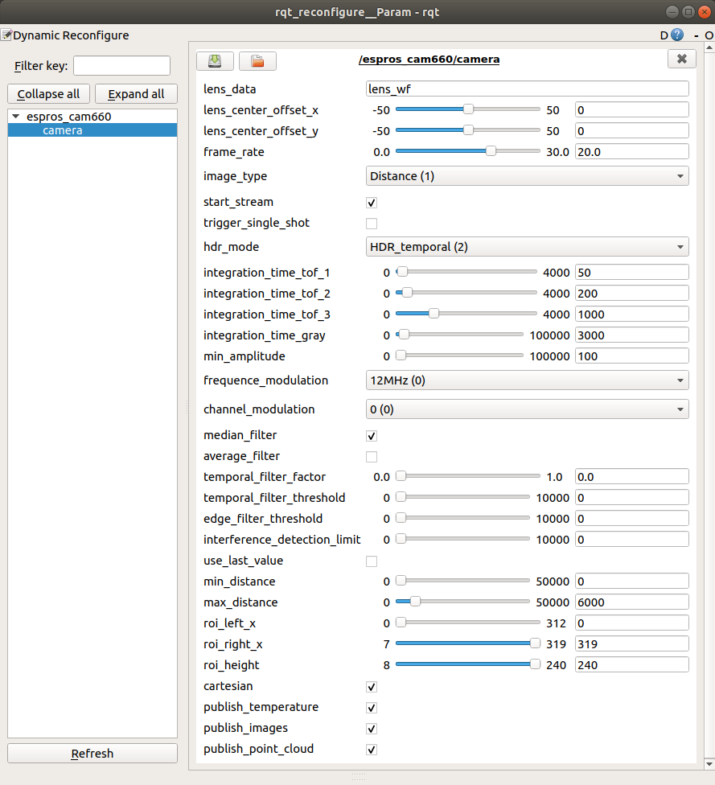
Figure 1: Example of the “dynamic reconfigure” node window
Start the camera operation by changing in the menu the parameter “start_stream” from false to true.

ROS API
This is the official driver for the camera ESPROS TOFcam660.

Start of the node
If you use in terminal mode the APIs only, without GUI:
Start the ROS operating system with the command: roscore&
Start the TOFcam660 with the command: rosrun espros_cam660 cam660_node

Published topics

Topic name | ROS msgs file | ROS message type | Function
camera/image_raw1 | sensor_msgs | Image | Sends the grayscale or amplitude image  according the selected image type parameter
camera/image_raw2 | sensor_msgs | Image | Sends the distance image  for image type parameters which include distance
camera/temperature | sensor_msgs | Temperature | Sends temperature of sensor
camera/points | sensor_msgs | PointCloud2 | Sends the point cloud image  for image type parameters which include distance
Table 1: ESPROS ROS topics

Lens distortion table

TOF cameras are measuring the distance between the camera (center of the lens' front-surface) and the object (surface reflected by Lambertian reflector) by estimating the time-of-flight (TOF) forth and back of the light emitted by the camera itself. Due to this principle, the obtained measurement data are given by polar coordinates, whereas distance D is the vector length, and the vector position in the sphere is given by the individual, effective view of each pixel through the lens, depending of the field of view (FOV).
In many cases, the user needs the distance information in a vector format which is locatable in a cartesian coordinate system.
Camera driver makes polar - cartesian transformation based on the lens data from the lens manufacturer. Lens data are written in lens distortion file which is in /lensData directory. The file name is optional and is written as string parameter ~lens_data.
Lens data file consist of two arrays and format is as follows:

size = 101
angle
0.00
0.74
1.48
2.22
2.95
…

radius
0.00
0.05
0.10
0.14
0.19
...

Where: size – the size of array
angle – in grad
radius – lens circle projection radius on the sensor mm.

Dynamically reconfigurable parameters

Refer for details on the dynamically reconfigurable parameters to the enclosed “dynamic_reconfigure package” or to http://wiki.ros.org/dynamic_reconfigure.
Parameter | Function | Data format | Default | Reference
~lens_data | Sets the lens data file name for point cloud cartesian transformation. This file must be in /lensData directory. | string | 0 | n/a
~lens_center_offset_x | Sets the offset of lens center relative to sensor center  Range: -50 … 50 pixels | int | 0 | n/a
~lens_center_offset_y |  | int | 0 | n/a
~image_type | Sets the image acquisition type  0: Grayscale  1: Distance  2: Distance and amplitude | int | 1 | n/a
~start_stream | Enables image streaming | bool | True | n/a
~integration_time_tof_1 | Sets the integration time for distance measurements  in microseconds. Range: 1 … 4'000 µs | int | 50 | n/a
~integration_time_tof_2 |  | int | 400 | n/a
~integration_time_gray | Sets the integration time for grayscale measurements  in microseconds. Range: 0 … 50'000 µs | int | 3000 | n/a
~offset | Sets distance offset. Range: -10000 … 10000 mm | int | 0 | n/a
~min_amplitude | Sets the amplitude limits. Range 0 … 2'047 LSB | int | 100
~frequency_modulation | Sets camera frequency modulation. Range: 24 … 0.75 MHz | int | 0 | n/a
~channel | Sets camera frequency modulation offset. | int | 0 | n/a
~median_filter | Enables the spatial median filter for distance filtering | bool | False | n/a
~average_filter | Enables the spatial average filter for distance filtering | bool | False | n/a
~temporal_filter_factor | Sets the factor 'k' of the temporal filter (Kalman).  Range: 0.0 ... 1.0 | double | 0 | n/a
~temporal_filter_threshold | Sets the threshold of the temporal filter (Kalman).  Range: 0 ... 10000 mm
~edge_filter_threshold | Spatial edge filter threshold. Range: 0 … 10000 mm | int | 0 | n/a
~temporal_edge_filter_threshold_low | Temporal edge filter low threshold. Range: 0 … 10000 mm | int | 0 | n/a
~temporal_edge_filter_threshold_high | Temporal edge filter high threshold. Range: 0 … 10000 mm | int | 0 | n/a
~interference_detection_limit | Interference detection threshold. Range 0... 10000 mm | int | 0 | n/a
~use_last_value | Enables interference detection last value | bool | False | n/a
~enable_cartesian | Enables point cloud cartesian transformation (false = spheric) | bool | True | n/a
~enable_point_cloud | Activates pointCloud2Publisher node to send information (camera/points) | bool | True | Table1
Table 2: ROS parameter table

