# Format

Homework was made using React JS to create a website for both practical homework assignments. You can switch between the Assignments using the *Navbar Menu*.

# Instructions

[Node.js](https://nodejs.org/en/) is required to launch the homework in a browser. When Node.js is installed and homework folder is extracted:

1. Go to the homework directory path in a terminal of your choice
2. Install all the required dependencies with “*npm install*”
3. Run “npm start”
4. The browser should open automatically with the home page loaded, if it doesn’t then it should be available at “localhost:3000” or with some other port that “npm start” offers.

# Assignment 1

## Task description

* **Input:** An arbitrary length string, a key (or keys), (for CFB/OFB decryption) a MAC value (if stored separately), a choice of chaining mode and a choice of whether to encrypt or decrypt.
* **Output:** An file with encryption/decryption of the string under the specified chaining mode with the specified key (for CFB/OFB encryption – a file with MAC code, if you chose to store the code separately), (for CFB/OFB decryption) the information (could be in any format – shown in GUI, printed on screen, stored in file etc.) whether the MAC value is correct.

Naturally, decrypting an encrypted string should give back the clear text. For this task, you may use block ciphers from an external library, but **you must implement the chaining (both for encryption and MAC computation) and the special processing of the last block(s) by yourself.** In other words, you may only use a function that takes one block as input, performs regular encryption, and returns the encrypted block. You don’t have to implement error handling of any kind – you can assume that the format of the input is correct, and it is perfectly all-right to crash on invalid input!

## File structure

Here is a list of important files for this assignment.

### src/components/

This folder contains components used for both assignments

* *FileTransfer.jsx* – contains *FileUpload* & *FileDownload* components, **conversion to downloaded file format**

### src/Assignment1/

* *Task.md* – Task description
* *Assignment1.jsx* – Contains just the Tab system to switch between Task description, CBC & CFB

### src/Assignment1/components

* *CBCMode.jsx –* **CBC encryption & decryption input (iv, key & message)**
* *CFBMode.jsx –* **CFB encryption & decryption input (iv, key, mac & message)**
* *Cryption.jsx* – **Encryption/Decryption & MAC calculation**

## Solution for CBC

### Encryption

Input is a JSON object containing {iv, key, message} and converts it to Uint8Array buffers.   
The algorithm takes a block of bits as input to encrypt until no there’s not enough for a full block (message too short).   
Padding for the last block is filled with bytes of missing block length, for example, if the last block of a message is only 9 characters, then the padding will be filled with the byte “7”.   
After padding the last block is encrypted and sent to output in hex format, which can then be copied back to message field to decrypt or downloaded to binary format.

### Decryption

Input is a JSON object containing {iv, key, message} and converts it to Uint8Array buffers.   
The algorithm decrypts all but the last block normally and the padding includes the length of the padding itself, so if the last bit is <16, the size for the padding, then there’s padding, otherwise the message was already a full block length and didn’t require any padding.

### Formats

* Initialization vector – 16-bit hex filled with all 0s
* Key – 16-bit hex with random generation & file upload
* Input message – UTF-8 or hex, if encrypting or decrypting. Upload can be from binary file and the program automatically translates it into readable hex code
* Decrypted output – UTF-8 (or hex if double encrypted)
* Encrypted output – Hex in output field, but downloaded to binary format.

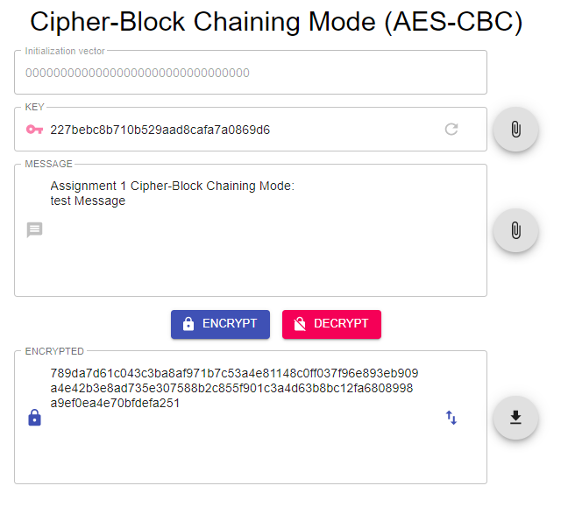

## Solution for CFB

Encryption and decryption uses the same functions as CBC mode, with the algorithm mode set to *AES-CFB.* MAC is calculated after encryption from *input.macKey* *& input.message*. When decrypting, the MAC is calculated again and checked with already calculated MAC and returns *true* or *false*.

### Formats

* IV – 16-bit hex with random generation & file upload
* Key – 16-bit hex with random generation & file upload
* macKey – 16-bit hex with random generation & file upload
* Input message – UTF-8 or hex, if encrypting or decrypting. Upload can be from binary file and the program automatically translates it into readable hex code
* Decrypted output – UTF-8 (or hex if double encrypted)
* Encrypted output – Hex in output field, but downloaded to binary format
* Mac – 16-bit hex, when encrypting, true or false when decrypting

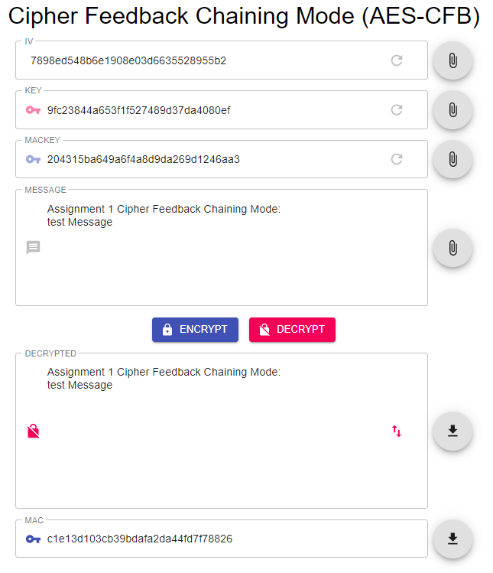

# Assignment 2

## Task description

Your task consists of the following 3 steps:

1. Write a program that creates a valid X.509 standard compliant root (i.e. self-signed) certificate on your name and issued by yourself (you can freely choose the values for other “meaningful fields”). The certificate should sign your public encryption key of **RSA** algorithm (desirably with ***at least 2048 bit*** key) and the certificate itself should be signed using **RSA** and **SHA-2** message digest algorithm.
2. Write a program that verifies your certificate (since it is a root certificate, it is sufficient to check whether certificate issuer and subject are the same and whether a digital signature of the issuer matches the subject’s public key).
3. Write a program that encrypts and decrypts a message of suitable length using the public RSA key from the certificate/private key file that you have created and one of RSA encryption/padding schemes specified in PKCS #1 standard.

## File structure

Here is a list of important files for this assignment.

### src/actions/

* *actions.jsx* – contains the redux actions for reducer storage

### src/reducers/

* *reducers.jsx* – contains the certificate reducers, **Certificate creation & upload from file**

### src/components/

This folder contains components used for both assignments

* *FileTransfer.jsx* – contains FileUpload & FileDownload components, **conversion to downloaded file format**

### src/Assignment2/

* *Task.md* – Task description
* *Assignment2.jsx* – Contains just the Tab system to switch between Task description, Certification & Encryption/Decryption

### src/Assignment2/components

* *Certification.jsx –* The outline of the certificate creation/verification processes
* *Create.jsx –* Contains dispatch functions to redux to create & upload certificates.
* *Cryption.jsx –* **Contains encryption & decryption functions**
* *Panel.jsx –* Contains the panels for PEM formatted output
* *Verify.jsx –* **Contains certificate verification**

## Creating a certificate

To create a certificate go to the CERTIFICATIONtab and click the 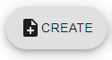 button or upload a certificate by clicking the button. After certificate creation, you can view all the PEM formatted outputs (certificate, private key, public key) and they’re available for copying or downloading, or uploading each file (certificate, private key, public key) separately. If you import a certificate from a file, then you need to upload the private key yourself.

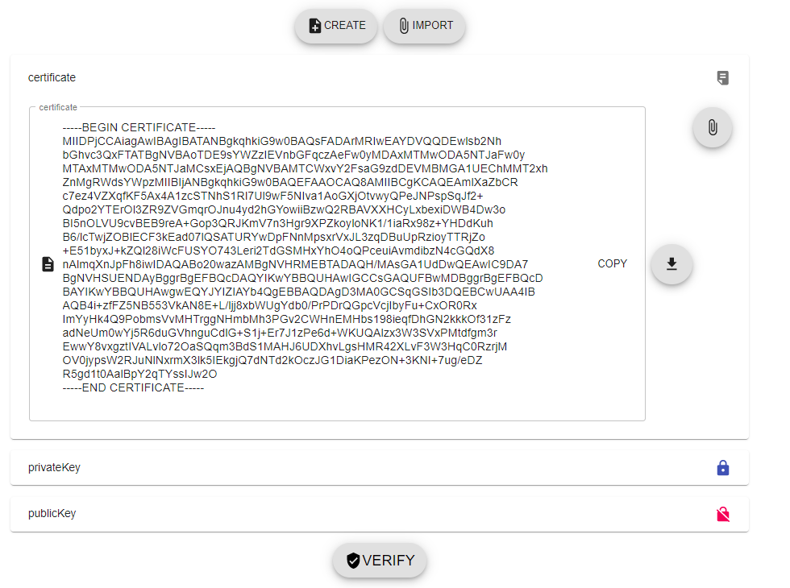

**The code for certificate creation & upload is in *src/reducers/reducers.jsx*.** The certificate uses RSA algorithm with 2048 bit keys. It’s signed using generated the private key and SHA256 message digest algorithm. The certificate and it’s private key are stored in a redux store and saves it even after a tab change, but not after a reload.

## Verifying a certificate

Verification happens in the same tab as certificate creation – CERTIFICATION.

To verify the certificate click on the button under all the panels and it should change to either or depending on wheter the certificate is verified or not. **The code for certificate verification is in *src/Assignment2/components/Verify.jsx*.**

## Encrypting & Decrypting a message

Encryption & Decryption follows the same structure as Assignment 1. There’s inputs that are available to edit and upload from files. You can also create and import a certificate from this tab. Output can be downloaded or copied to message field for Decryption. There’s also an option to upload keys from inside the panels.

### Formats

* Input message – UTF-8 or hex, if encrypting or decrypting. Upload can be from binary file and the program automatically translates it into readable hex code.
* Public key – must be PEM format
* Private key – must be PEM format
* Decrypted output – UTF-8 (or hex if double encrypted)
* Encrypted output – Hex in output field, but downloaded to binary format.

