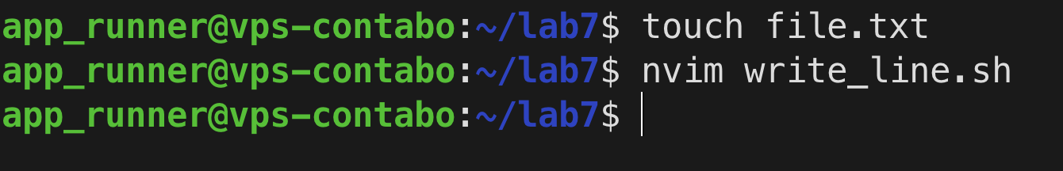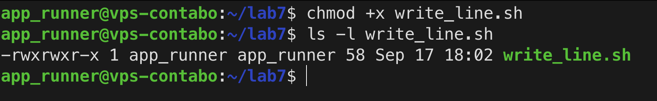
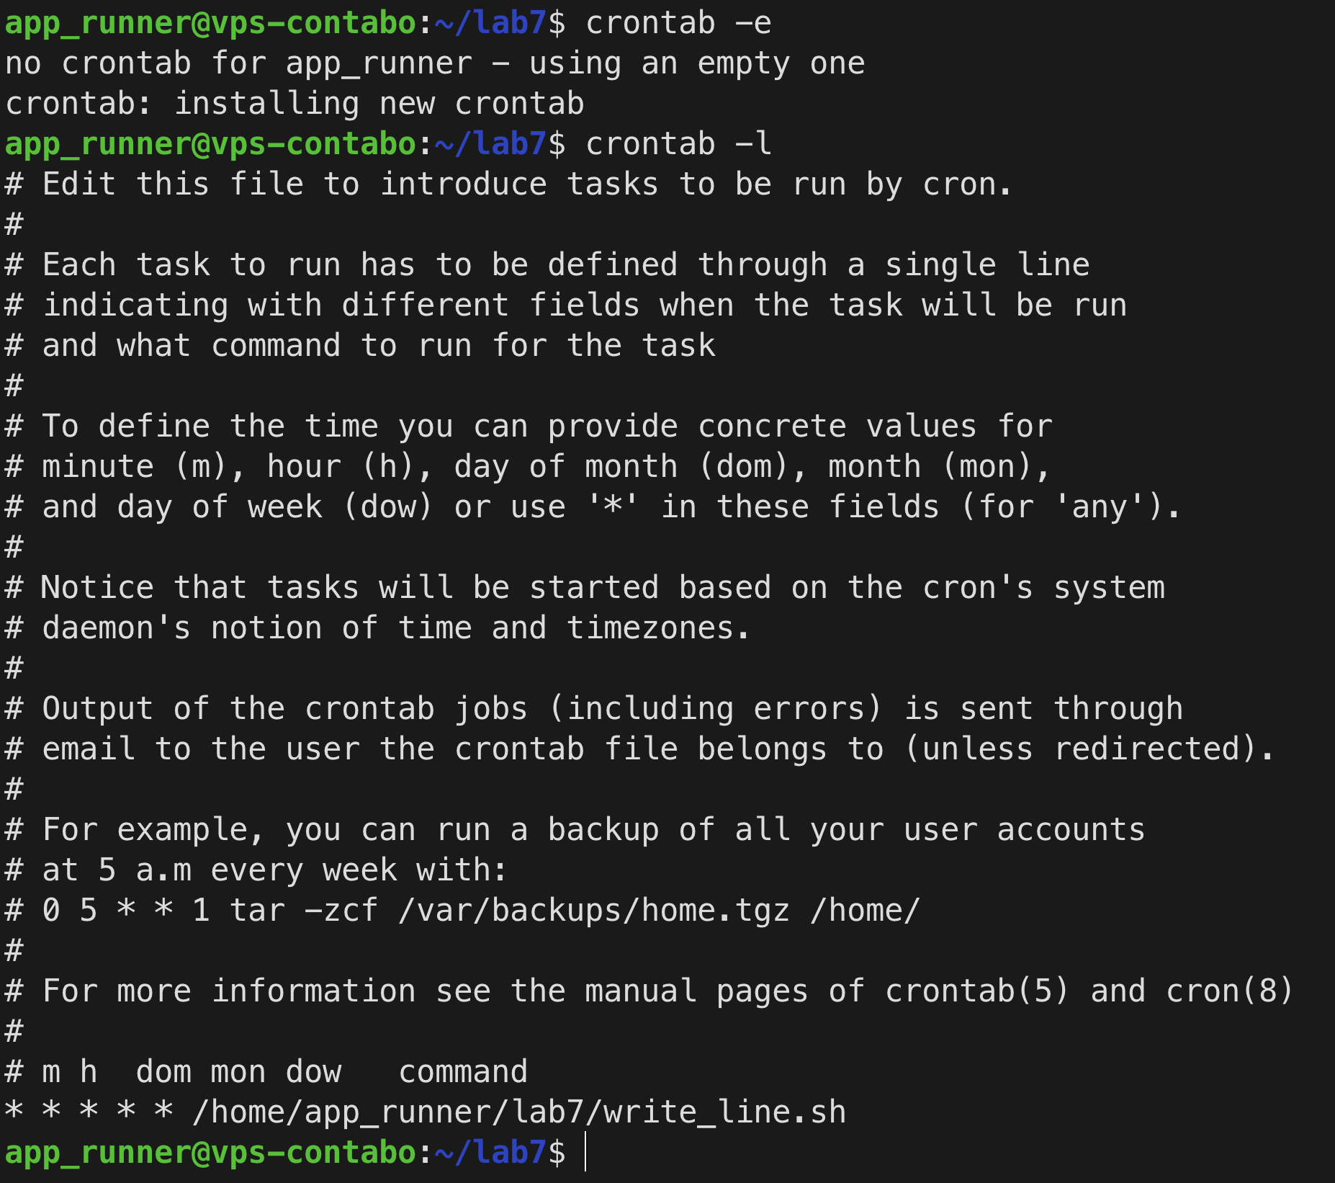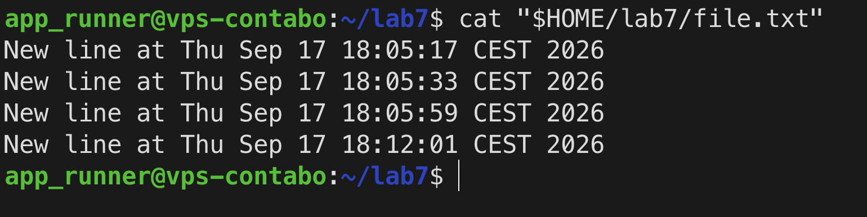

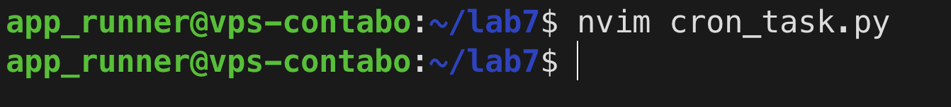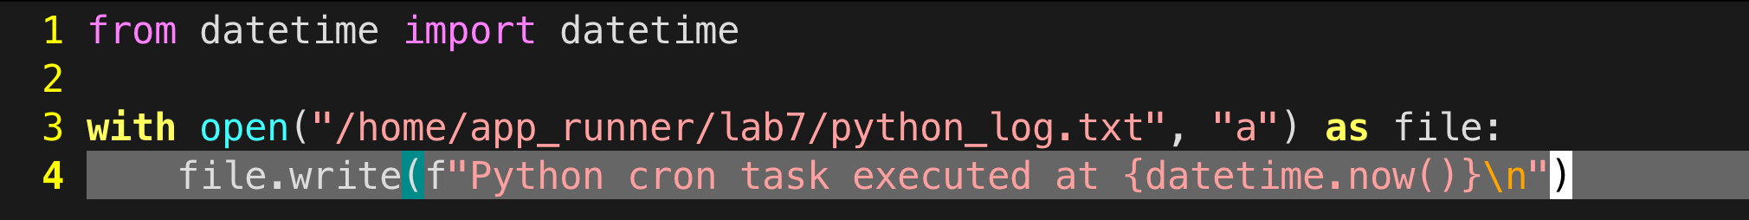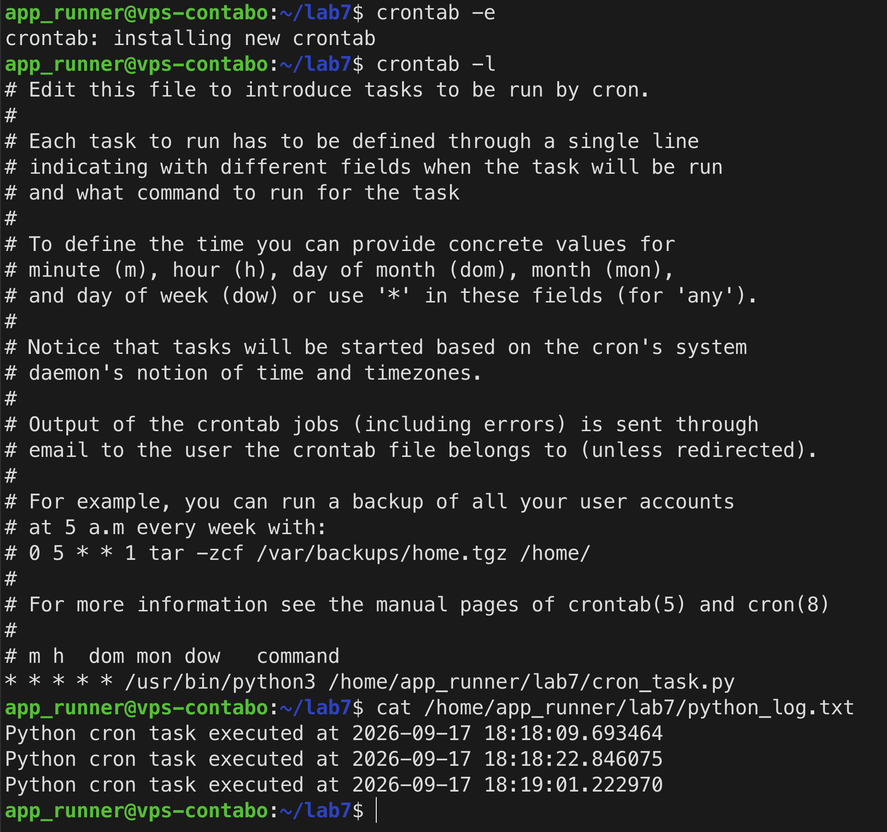
Task: try to create cron that runs python script with some functionality, e.g. sending email to server owner

