HW1
Essie
2026-09-09
#PI indicated that the 999 value was an error, needs to be corrected to 99.
df <- df %>%
mutate(IQ = if_else(IQ == 999, 99, IQ))
#ChatGPT help here to remember the mutate format.
In this study, individual IQs were measured. Each person’s home residence was also categorized as either “Far” or “Near” the local smelter. Below is a table summarizing the findings, grouped by smelter distance.
 | Far  (N=67) | Near  (N=57) | Overall  (N=124)
IQ
Mean (SD) | 92.7 (16.0) | 89.2 (12.2) | 91.1 (14.4)
Median [Min, Max] | 93.0 [46.0, 141] | 88.0 [56.0, 115] | 91.0 [46.0, 141]
Below is a plot displaying IQ by distance from the smelter.
#plot IQ according to distance
plot <- ggplot(df, aes(x = Smelter, y = IQ)) +
geom_boxplot() +
labs(title = "IQ by Smelter Distance",
caption = "Average IQ by distance from the local smelter")
plot
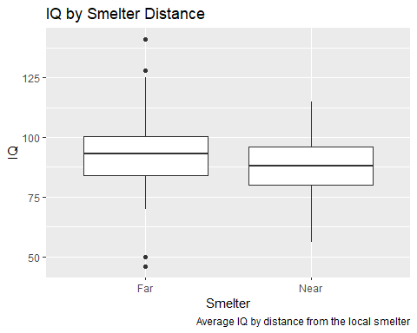
The mean IQ was
## [1] 91.08065
The IQ by group is shown below.
df %>%
group_by(Smelter) %>%
summarise(mean_IQ = mean(IQ, na.rm = TRUE))
## # A tibble: 2 × 2
## Smelter mean_IQ
## <chr> <dbl>
## 1 Far 92.7
## 2 Near 89.2
#A little ChatGPT help here to remember the group_by. I didn't use R all summer! I'm rusty!

