Introduction
There is a lot of research done on the topic of studying and learning behavior. This document tries to give an overview of the research that lies behind the design of this project. It is not meant as an meta-study, see it as an Reference document to know what’s going on behind the curtains.

General research
While there are many studies done in the domain that is for interest of this project, a couple of them are especially interesting. They do not exactly fit into one category but are more or less “overall” or “general” studies which mainly prove that there is a big difference between currently used study methods and optimized ones.
(Eich, 2009) link gives a summary and meta-study on the most commonly known effects in learning behavior. Many of the concepts used in this project are explained here, so if you’re interested this is a good point to start.
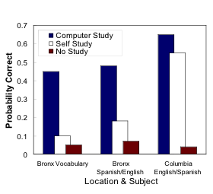
(Metcalfe, Kornell, & Son, 2007) did a study where a software program was written “stuffed” with effects that should improve learning behavior. Afterwards, they compared their study to self-study, where students could pick their preferred study methods. As can be seen in the image (from (Eich, 2009)) to the right here, the results were quite amazing. “Good” students improved from 55% to 67%, while “challenging” students went up from 10% to 45%! Note that the students used the same amount of time in both self- and computer study.
Both researches (with many more out there) show the potential for a project set up in the same way as (Metcalfe et al., 2007).

Components
The project consist of several components, which are tied together to create the whole of the program. Each component is listed here, accompanied by an explanation about the theoretical effect it should have, which is tried to copy in this project.

Mindmap
The choice for using a mindmap comes forth out analysis of ‘competitors’ like http://www.quizlet.com, http://www.memrise.com and anki (http://ankisrs.net/). They are, in the base, all comparable to the following concept: create a set of terms with answers in a flashcard kind of way, then learn those terms. This is fabulous for studying thing like languages or topography. What I find is that more often than not, learning material falls out of this range. For example marketing & management learning material is not just about the definition of certain terms, but also about the connection between those terms. Ideally even the application of those terms, but that is outside this projects scope for now, because of the extreme complexity involved.
Mindmapping is strategy that is perfect for this situation: it visually connects terms, giving a good overview and deeper understanding of the material, especially when the mindmap needs to be constructed. Research for this is limited and contradicting especially in the scope it’s used in this project. (D’Antoni V.A., Zipp, G.P., Olson, V.G., Cahill, 2010) suggests it’s effect is equal in the short term, compared to other note-taking strategies.

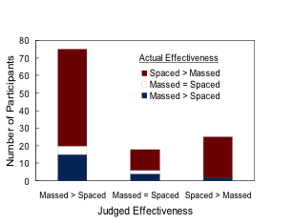
Spaced repetition
Spaced repetition (learning multiple times instead of all at once) is something most students, but find either hard to apply or believe that it doesn’t count for them. (Eich, 2009) shows this in the image to the right. The height of the bars represents the amount of people believing in effectiveness, while the blocks represent the actual effectiveness. As you can see, 75 out of 120 participants believed massed practice is better, but only 15 of them actually did better. In total 78% did better with spaced practice.
The intervals between those study times is something that is being researched for a long time, even in the time before computers (that is, all done by hand and some mad administration skills).

