# Introduction

For the third lab we had the task to use a combination of an Activity and a Service or an Activity and a Broadcast to implement a Simple Timer. The Timer was to be implemented so that it ran in the background and send the current time to the Activity to display. The Service would send an update every 5 seconds to the Activity.

# Main

The first part for this task was to implement the activity. Only 2 TextViews were needed for this implementation that was using RelativeLayout. The first TextView was just a label and the second TextView will hold the current time.

The second part was to setup the TimerService. I used the TimerTask class to setup the timer to run every 5 seconds where the abstract function run was set up to create a time message holding the current time as a string and using sendBroadcast to send the Intent.

The third part was to setup the MainActivity. Initially the setContentView needed to be set up. Secondly starting the service using the startService fuction and using a new instantiation of Intent with the TimerService as a parameter of Intent. This would start our TimerService we needed. In order to use our TimerService we need to setup a Receiver to get that data. In this case BroadcastReceiver was setup to get the time data and update the TextView. The BroadcastReceiver need to be registered using registerReceiver function and the BroadcastReceiver and an instance of IntentFilter looking for our time message. In the onPause method of the activity, unregistering the receiver was necessary when the activity is not in focus. In the onStop() method stopping the service is necessary using the stopService() method.

Lastly the AndroidManifest file needed to be modified to include the service.Below is a sequence of snapshots showing the time getting updated.

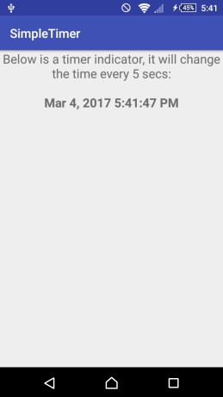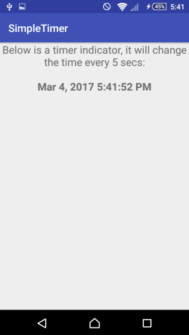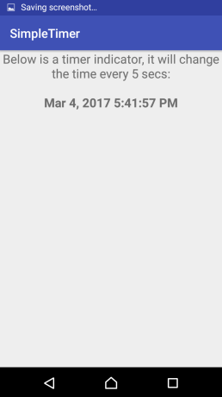

This youtube link shows will have a demo capture in video. https://youtu.be/QaEvLDysM_4

# Discussion and Conclusion

This was a initially a very frustrating task. Getting my head around how Service works took me a while. Once the Service was setup I using the logcat to see what message the service was send producing. The second task that took me longer to figure out was setting up the receiver. Looking back now this was a simple task and a very important one that I will take and use in any future projects.

# Appendix A: Code

**MainActivity.java**

**package** com.hw4.jasonesquivel.simpletimer;  
  
**import** android.content.*;  
  
**import** android.support.v7.app.AppCompatActivity;  
**import** android.os.Bundle;  
  
**import** android.util.*;  
**import** android.widget.TextView;  
  
**public class** MainActivity **extends** AppCompatActivity {  
 **private** String **msg** = **"Activity Main : "**;  
 **private** BroadcastReceiver **mReceiver**;  
  
 @Override  
 **protected void** onCreate(Bundle savedInstanceState) {  
 **super**.onCreate(savedInstanceState);  
 setContentView(R.layout.***activity_main***);  
 Intent intent = **new** Intent(**this**, TimerService.**class**);  
 startService(intent);  
 Log.*i*(**msg**, **"Started Service"**);  
  
 }  
 */** Called when the activity is about to become visible. */* @Override  
 **protected void** onStart() {  
 **super**.onStart();  
 Log.*i*(**msg**, **"The onStart() event"**);  
 }  
  
 */** Called when the activity has become visible. */* @Override  
 **protected void** onResume() {  
 **super**.onResume();  
 Log.*i*(**msg**, **"The onResume() event"**);  
  
 IntentFilter intentFilter = **new** IntentFilter(**"timerFilter"**);  
 **mReceiver** = **new** BroadcastReceiver(){  
 @Override  
 **public void** onReceive(Context context, Intent intent) {  
 *//extract our message from intent* String msg_for_me = intent.getStringExtra(**"time"**);  
 *//log our message value* Log.*i*(**msg**, msg_for_me);  
 TextView textView = (TextView)findViewById(R.id.***time***);  
 textView.setText(msg_for_me);  
  
 }  
 };  
 *//registering our receiver* **this**.registerReceiver(**mReceiver**, intentFilter);  
 }  
  
 */** Called when another activity is taking focus. */* @Override  
 **protected void** onPause() {  
 **super**.onPause();  
 Log.*i*(**msg**, **"The onPause() event"**);  
 **this**.unregisterReceiver(**mReceiver**);  
 }  
  
 */** Called when the activity is no longer visible. */* @Override  
 **protected void** onStop() {  
 Intent intent = **new** Intent(**this**, TimerService.**class**);  
 stopService(intent);  
 Log.*i*(**"Main"**, **"Started Service"**);  
 **super**.onStop();  
 Log.*i*(**msg**, **"The onStop() event"**);  
 }  
  
 */** Called just before the activity is destroyed. */* @Override  
 **public void** onDestroy() {  
 **super**.onDestroy();  
 Log.*i*(**msg**, **"The onDestroy() event"**);  
 }  
  
}

**TimerService.java**

**package** com.hw4.jasonesquivel.simpletimer;  
  
**import** android.app.Service;  
**import** android.os.IBinder;  
**import** android.content.Intent;  
**import** android.util.Log;  
  
**import** java.text.DateFormat;  
**import** java.util.*;  
  
*/**  
 * Created by Jason Esquivel on 3/3/2017.  
 */***public class** TimerService **extends** Service {  
 **private static** Timer *timer* = **new** Timer();  
 @Override  
 **public** IBinder onBind(Intent intent){  
 **return null**;  
 }  
 @Override  
 **public int** onStartCommand(Intent intent, **int** flags, **int** startId){  
 *timer*.scheduleAtFixedRate(**new** sendTimeTask(), 0, 5000);  
 **return *START_STICKY***;  
 }  
 **private class** sendTimeTask **extends** TimerTask  
 {  
 **public void** run()  
 {  
 Intent i = **new** Intent(**"timerFilter"**);  
 String time = DateFormat.*getDateTimeInstance*().format(**new** Date());  
 i.putExtra(**"time"**,time);  
 sendBroadcast(i);  
 Log.*i*(**"TimerService"**, time);  
 }  
 }  
}

**activity_main.xml**

*<?***xml version="1.0" encoding="utf-8"***?>*<**RelativeLayout xmlns:android="http://schemas.android.com/apk/res/android"  
 xmlns:tools="http://schemas.android.com/tools"  
 android:layout_width="match_parent"  
 android:layout_height="match_parent"  
 tools:context="com.hw4.jasonesquivel.simpletimer.MainActivity"**>  
  
 <**TextView  
 android:id="@+id/label"  
 android:layout_width="match_parent"  
 android:layout_height="wrap_content"  
 android:text="Below is a timer indicator, it will change the time every 5 secs:"  
 android:textSize="20dp"  
 android:textAlignment="center"**/>  
 <**TextView  
 android:id="@+id/time"  
 android:layout_width="match_parent"  
 android:layout_height="wrap_content"  
 android:layout_below="@+id/label"  
 android:paddingTop="20dp"  
 android:textSize="20dp"  
 android:textAlignment="center"  
 android:textStyle="bold"  
 android:text="temp"**/>  
  
</**RelativeLayout**>

**AndroidManifest.xml**

*<?***xml version="1.0" encoding="utf-8"***?>*<**manifest xmlns:android="http://schemas.android.com/apk/res/android"  
 package="com.hw4.jasonesquivel.simpletimer"**>  
  
 <**application  
 android:allowBackup="true"  
 android:icon="@mipmap/ic_launcher"  
 android:label="@string/app_name"  
 android:roundIcon="@mipmap/ic_launcher_round"  
 android:supportsRtl="true"  
 android:theme="@style/AppTheme"**>  
 <**activity android:name=".MainActivity"**>  
 <**intent-filter**>  
 <**action android:name="android.intent.action.MAIN"** />  
  
 <**category android:name="android.intent.category.LAUNCHER"** />  
 </**intent-filter**>  
 </**activity**>  
 <**service android:name=".TimerService"**/>  
  
 </**application**>  
  
</**manifest**>