Milestone 1: experiment results
Training a CNN encoder from scratch on CUB-200-2011
multimodal-bird-vision · CSE488 · status as of 26 Oct 2026 · validation results unless marked as test

1. Summary
We trained a CNN encoder from scratch for 200-class bird classification and ran four groups of experiments: an augmentation ablation, an architecture comparison, a hyperparameter search comparing grid and random search, and a longer training schedule with strong augmentation. All runs are logged in W&B (team deep_learning_birds, project multimodal-bird-vision); the run IDs are listed in the appendix.
Question | Answer | Evidence
Which augmentation level? | Light at 40 epochs; strong with a longer schedule | 46.4% val, best of none / light / strong at 40 epochs; at up to 80 epochs strong beats light by 2.3 points (section 7)
Which architecture? | Residual CNN, 11.3M parameters | 53.1% val vs. 40.4% for a plain network of the same depth
Grid or random search? | Equally good results; random was more efficient | 29.7% vs. 29.4% best (15-epoch trials); random needed 3 trials to get within 2 points, grid 7
Did tuning help? | Slightly, within noise | Tuned (random) 54.6% val vs. 53.1% with default settings
Does training longer help? | Yes, the largest gain | Up to 80 epochs: 59.3% val with light augmentation (+6.2 over 40 epochs)
Does strong augmentation add to that? | A little (borderline) | 61.6% vs. 59.3% val, 60.5% vs. 57.7% macro-F1, less overfitting
Final scratch model | Residual CNN, strong augmentation, up to 80 epochs | Test: 62.2% top-1, 84.6% top-5, 61.9% macro-F1

Note: All model choices were made on the validation split (599 images). The test set (5,794 images) was only used to report the final candidates, after they had been selected on validation (section 8).

2. Experimental setup
Every run below shares these settings unless a section says otherwise. Each experiment changes one thing, so differences can be attributed to it.
Setting | Value
Data | CUB-200-2011 with captions (Hugging Face). Train 5,390 / val 599 (stratified, about 3 per species, seed 42), from the official train split after removing 5 duplicates. Test: the full official 5,794 images, untouched
Input | 224 × 224 RGB; normalized with the train-split mean and std
Augmentation (default) | Light: random resized crop (50–100% of the image) + horizontal flip. Validation: resize + center crop only
Model (baseline) | Scratch CNN: stride-2 stem, 4 stages (64 → 128 → 256 → 512 channels), 2 conv-BN-ReLU blocks per stage, max-pooling between stages, global average pooling, dropout 0.3, linear head (200 classes)
Optimizer and schedule | AdamW, lr 1e-3, weight decay 0.05; 2 warm-up epochs then cosine decay to 0
Loss | Cross-entropy with label smoothing 0.1
Training | 40 epochs, batch 64, mixed precision (AMP); best epoch by val accuracy is kept
Hardware and tracking | Tesla T4 GPU (Colab / Kaggle); every run logged to W&B with its full config and git commit

Metrics. Top-1 accuracy (the most likely species is correct) is the main metric, which is fair here because CUB is balanced (about 30 images per class). Top-5 accuracy shows near misses between similar species. Chance level is 0.5% (1 in 200).
Note: With only 599 validation images, one image is worth 0.17% and accuracy moves by about ±2 points between runs by chance. We treat differences below about 2 points as not meaningful.

3. Baseline: scratch CNN
Run | Best val top-1 | Best epoch | Val top-5 (best epoch) | Final train top-1 | Parameters | Time
scratch_v1 | 46.4% | 33 | 73.0% | 73.8% | 4.83M | 22 min

- The first-epoch loss was 5.24, close to the expected ln(200) ≈ 5.30 for random guessing, which confirms the pipeline is correct.
- Validation accuracy rose steadily until about epoch 33 and then plateaued as the cosine schedule brought the learning rate towards 0.
- The gap between train (73.8%) and val (46.4%) accuracy shows overfitting, expected with about 27 training images per species.

4. Augmentation ablation
Same plain model and settings as the baseline; only data.augment changes.
Augmentation | Transforms | Best val top-1 | Final train top-1 | Train − val gap | Time / epoch
None | resize + center crop | 44.4% (ep. 35) | 97.2% | ≈ 53 points | 36 s
Light | random crop 50–100%, flip | 46.4% (ep. 33) | 73.8% | ≈ 29 points | 33 s
Strong | light + crop 35–100%, ±15° rotation, color jitter (no hue), random erasing | 41.4% (ep. 38) | 52.2% | ≈ 11 points | 43 s

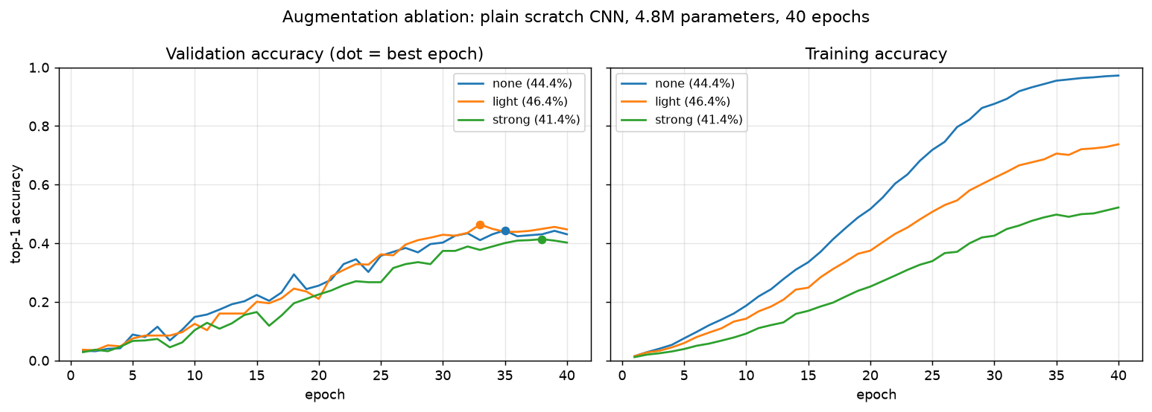
Figure 1. Augmentation ablation: validation and training accuracy per epoch.
Finding: Augmentation acts as a regularizer: the train/val gap shrinks from about 53 points (none) to 29 (light) to 11 (strong). Without augmentation the model memorizes the training set (97% train accuracy). Strong augmentation reduces overfitting the most but underfits within 40 epochs: its validation accuracy was still rising when training ended. Light augmentation gives the best validation accuracy at this budget and is used for all later experiments.
The difference between light and none (2 points) is close to the noise level, but light also has the lower validation loss (2.87 vs. 2.95) and a much smaller overfitting gap, so the choice is consistent across metrics. Strong augmentation might win with a longer schedule; this was not tested.

5. Architecture comparison
Same light augmentation and training settings; only the network changes. The deeper plain network and the residual network both have 4 convolutions per stage and nearly the same parameter count, so comparing them isolates the effect of the skip connections.
Model | Blocks per stage | Convs per stage | Parameters | Best val top-1 | Val top-5 | Final train top-1
Plain (baseline) | 2 × conv-BN-ReLU | 2 | 4.83M | 46.4% | 73.0% | 73.8%
Plain, deeper | 4 × conv-BN-ReLU | 4 | 11.10M | 40.4% | 69.1% | 61.5%
Residual | 2 × residual block | 4 | 11.27M | 53.1% | 77.0% | 88.1%

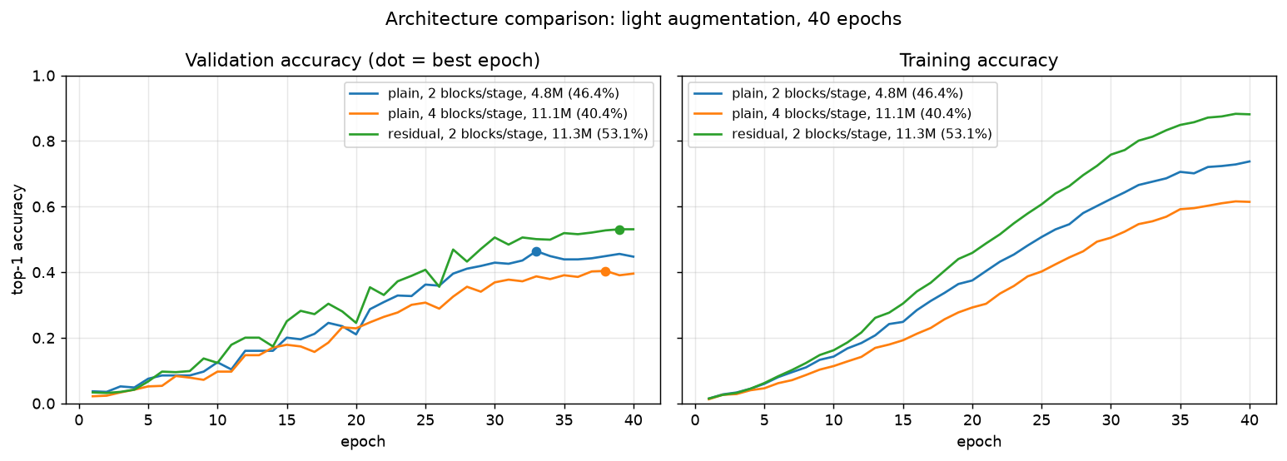
Figure 2. Architecture comparison: validation and training accuracy per epoch.
Finding: Making the plain network deeper made it worse, and not because of overfitting: even its training accuracy dropped (61.5% vs. 73.8%). The deeper plain network is harder to optimize. With the same depth and parameter count, adding skip connections (residual blocks) gave +12.7 points over the deeper plain network and +6.7 points over the baseline. This is the degradation problem that motivated ResNet (He et al., 2016): skip connections give gradients a direct path back through the network, so deeper models train well.
A residual block computes relu(F(x) + shortcut(x)), where F is conv-BN-ReLU-conv-BN and the shortcut is the identity, or a 1×1 conv + BN when the channel count changes. The residual model is selected as the scratch baseline and is the model used for tuning.

6. Hyperparameter tuning: grid vs. random search

6.1 Setup
Both searches tune the residual CNN with the same budget and the same fixed settings (light augmentation, seed 42, same data). Only the values they try differ.
 | Grid search | Random search
Learning rate | {3e-4, 1e-3, 3e-3} | log-uniform 2e-4 to 5e-3
Weight decay | {0.01, 0.1} | log-uniform 0.005 to 0.2
Dropout | {0.1, 0.3, 0.5} | uniform 0 to 0.6
Trials | 18 (every combination) | 18 (fixed by seed 42)
Per trial | 15 epochs, no early stopping, no checkpoint upload | same

The random ranges contain every grid value, so both methods search the same region. Trials were short (15 instead of 40 epochs) to keep 36 trials affordable; their scores are used to rank settings, not as final accuracies. All trials ran on Tesla T4 GPUs.

6.2 Results
 | Grid | Random
Trials completed / failed | 18 / 0 | 18 / 0
Best val top-1 (15 epochs) | 29.4% (trial 6) | 29.7% (trial 15)
Best settings | lr 1e-3, wd 0.01, dropout 0.1 | lr 2.67e-3, wd 0.021, dropout 0.17
Mean ± std over trials | 24.4% ± 3.2 | 24.3% ± 3.6
Trials to reach its own best | 7 | 16
Trials to get within 2 points of the overall best (27.7%) | 7 | 3
Total GPU time | 184 min (10.2 min / trial) | 167 min (9.3 min / trial)

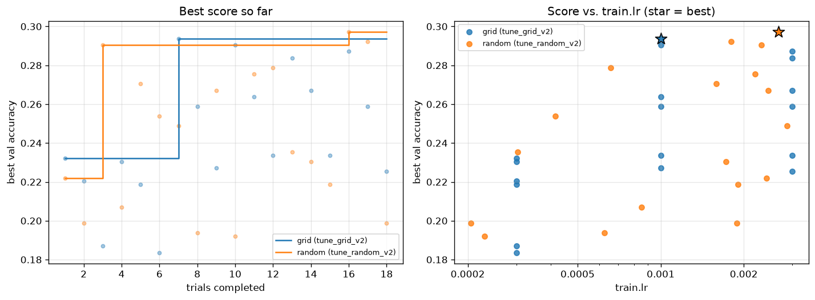
Figure 3. Left: best score found so far vs. number of trials. Right: each trial's score against the learning rate (star = best).
Finding: The two methods found equally good settings: the 0.3-point difference is far inside the ±2-point validation noise. Random search got close to the best much sooner (3 trials vs. 7) because it tried 18 different learning rates while grid search tried only 3, and the learning rate is the hyperparameter that matters most here. This matches the standard argument for random search (Bergstra & Bengio, 2012). Grid's best-so-far curve also depends on the order its combinations are listed in, which is a weakness of the method.

6.3 What the trials show about the hyperparameters
Rank | Method | Trial | Learning rate | Weight decay | Dropout | Val top-1
1 | random | 15 | 0.002667 | 0.0209 | 0.173 | 29.7%
2 | grid | 6 | 0.001 | 0.01 | 0.1 | 29.4%
3 | random | 16 | 0.001799 | 0.0084 | 0.120 | 29.2%
4 | grid | 9 | 0.001 | 0.1 | 0.1 | 29.1%
4 | random | 2 | 0.002318 | 0.0908 | 0.077 | 29.1%

- Learning rate matters most. Trials at 2e-4 to 3e-4 reached only 18–23%; the best trials lie between 1e-3 and 2.7e-3.
- Low dropout (0.08–0.17) won in 15-epoch trials. This may not hold for 40 epochs, where more regularization usually helps, so it must be confirmed by a full retrain.
- Weight decay barely matters in the tested range: both 0.01 and 0.1 appear among the top trials.

6.4 Full retrain of the best settings
The two best settings were retrained for the full 40 epochs with everything else unchanged, and compared with the residual model using the default settings.
Run | lr | Weight decay | Dropout | Best val top-1 | Val top-5 | Final train top-1 | Final val loss
Default settings | 1e-3 | 0.05 | 0.3 | 53.1% (ep. 39) | 77.0% | 88.1% | 2.70
Tuned (random, trial 15) | 2.67e-3 | 0.021 | 0.17 | 54.6% (ep. 40) | 77.8% | 96.0% | 2.67
Tuned (grid, trial 6) | 1e-3 | 0.01 | 0.10 | 51.6% (ep. 40) | 76.0% | 94.9% | 2.72

Finding: Tuning helped only slightly: the random-search setting is +1.5 points over the defaults and the grid setting -1.5, both inside the ±2-point noise. The default settings were already close to optimal. Both tuned runs overfit more (95-96% train accuracy vs. 88%): the 15-epoch trials favoured low regularization, because settings that learn fast win short trials, but over 40 epochs that widens the train/val gap. The random-search setting is still the best on all three validation metrics (top-1, top-5, loss) and was the best 40-epoch model.

7. Training length vs. augmentation strength
Two observations from the earlier experiments pointed in the same direction: the best 40-epoch runs overfit strongly (96% train vs. 54.6% val), and strong augmentation reduced overfitting the most but was still improving when its 40 epochs ended. We therefore trained the residual CNN for up to 80 epochs with early stopping (8 epochs without improvement), once with strong augmentation and once with light augmentation as a control. Both runs use the default settings (lr 1e-3, weight decay 0.05, dropout 0.3), so the only difference between them is the augmentation.
Run | Augmentation | Epochs | Best val top-1 | Val top-5 | Val macro-F1 | Final train top-1 | Final val loss
Residual, default settings | light | 40 | 53.1% (ep. 39) | 77.0% | - | 88.1% | 2.70
Residual, tuned (random) | light | 40 | 54.6% (ep. 40) | 77.8% | - | 96.0% | 2.67
Residual, long (control) | light | 74 (early stop) | 59.3% (ep. 66) | 81.6% | 57.7% | 99.7% | 2.42
Residual, long, strong | strong | 70 (early stop) | 61.6% (ep. 62) | 81.5% | 60.5% | 94.8% | 2.37

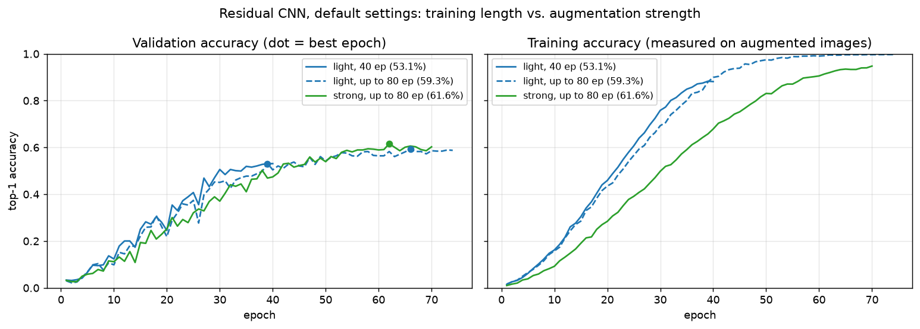
Figure 4. Residual CNN with default settings: 40 vs. up to 80 epochs, light vs. strong augmentation. Training accuracy is measured on augmented images, so it is lower under strong augmentation.
Finding: Training longer gave most of the improvement: with light augmentation, extending the schedule from 40 to up to 80 epochs raised validation accuracy from 53.1% to 59.3% (+6.2 points), the largest single gain after adding residual blocks. Strong augmentation then added +2.3 points on top (61.6%). That alone is at the edge of the ±2-point noise, but every other metric points the same way: macro-F1 +2.8 points, lower validation loss (2.37 vs. 2.42), and much less memorization (94.8% vs. 99.7% training accuracy). With light augmentation the long run memorizes the training set almost completely; strong augmentation keeps it learning for longer. Both runs stopped early (epochs 70 and 74), so the 80-epoch budget was enough.
Note: Our earlier guess, that most of the +7 points came from strong augmentation, was wrong: the control run shows that most of it came from the longer schedule. This is why the control was needed. It also corrects the reading of section 4, where strong augmentation lost at 40 epochs: it was not too strong in general, it needed more epochs to pay off. The strong-augmentation run is kept as the final scratch model because it is the best on validation accuracy, macro-F1 and loss.

8. Final model: test-set results
Each candidate was evaluated on the full official test set (5,794 images) only after it had been selected on validation. The strong-augmentation model is the final scratch model.
Metric | 40 epochs, light, tuned | Final: strong, up to 80 epochs | What it means
Top-1 accuracy | 56.1% | 62.2% | The most likely species is correct; chance is 0.5%
Top-5 accuracy | 80.6% | 84.6% | The true species is among the 5 most likely
Macro precision | 56.9% | 63.4% | Of the images predicted as a species, how many are that species, averaged over species
Macro recall | 56.1% | 62.3% | Of each species' images, how many were found, averaged over species
Macro F1 | 56.0% | 61.9% | Harmonic mean of precision and recall per species, every species weighted equally

- Test agrees with validation (62.2% vs. 61.6%; previously 56.1% vs. 54.6%). The test set is about 10x larger, so it is the more reliable number, and the improvement holds on it: +6.1 points top-1, +5.9 points macro-F1.
- Precision, recall, F1 and accuracy are all about equal: the model is not strongly biased towards or against particular species. Every species is recognised at least sometimes (no class has 0% recall); the median per-species F1 is 65.3%.
- Most errors are near misses: top-5 is 22.4 points above top-1. The model is much less confident when it is wrong (mean confidence 33% vs. 64% when correct), which is useful for picking Grad-CAM examples.
Most confused pairs of the final model (true species, predicted species, number of test images):
True species | Predicted as | Images
American Crow | Fish Crow | 11
Chuck-will's-widow | Whip-poor-will | 10
Western Wood-Pewee | Olive-sided Flycatcher | 10
Field Sparrow | Tree Sparrow | 10
Horned Grebe | Eared Grebe | 9
Parakeet Auklet | Crested Auklet | 8
California Gull | Herring Gull | 8
Anna's Hummingbird | Ruby-throated Hummingbird | 8

Every pair is two closely related species that differ in small details (bill shape, leg colour, wing pattern). The Chuck-will's-widow / Whip-poor-will pair is also where the EDA found an identical image under both labels, so part of this confusion is label noise in the dataset, not only a model error. The hardest species are almost entirely black, grey or plain brown: American Crow (F1 0.10), Western Wood-Pewee (0.12), Glaucous-winged Gull (0.14), California Gull (0.19), Brewer's Blackbird (0.24). The easiest have distinctive colours or markings: Red-bellied Woodpecker and Heermann's Gull (0.89), Painted Bunting and Horned Lark (0.88), Cerulean Warbler (0.87). This supports the decision not to change hue during augmentation: colour is one of the model's main cues.
Note: For context: ImageNet-pretrained CNNs fine-tuned on CUB-200-2011 are commonly reported around 80-86% top-1. The transfer-learning experiments (next steps) will measure that gap on our own split, and the benchmarking section will cite exact published numbers.

9. Problems and what we learned
- First tuning attempt on the wrong model (tune_grid_v1). A Colab session pulled the code before the switch to the residual model was pushed, so 3 trials trained the plain CNN (4.83M parameters instead of 11.27M). We spotted it from the parameter count in the log, renamed the searches to v2, and reran. The v1 runs remain in W&B in their own group and are excluded from the results.
- Random search initially ran only a quarter of its trials, because it was started with --shard 1/4. The report showed 5/18 trials; the remaining 13 were run before comparing.
- GPU limits. The free Colab quota ran out during tuning, so tuning moved to Kaggle (2 × T4). Data loading on the CPU, not the GPU, is the bottleneck (about 190 images/s); running one trial per GPU in parallel used both GPUs.
- Short tuning trials are biased. 15-epoch trials favoured settings that learn fast (low regularization); over 40 epochs those settings overfit more, and tuning gained only 1.5 points. Training longer and with stronger augmentation (section 7) gained far more.
- Small validation set. With 599 images, differences under about 2 points are noise. We compared on several metrics (accuracy, top-5, loss, train/val gap) before drawing conclusions.

10. Next steps
Step | Status
Retrain the two best tuned settings for 40 epochs | done (section 6.4)
Strong augmentation with a longer schedule | done (section 7)
Evaluate the final scratch model on the test set | done (section 8)
80-epoch control run with light augmentation | done (section 7)
Transfer learning (ResNet-50, EfficientNet-B0): linear probe vs. fine-tuning | not started
Grad-CAM on correct and wrong predictions, scratch vs. pretrained | not started
Benchmark against published CUB-200-2011 results | not started
Caption EDA (Task 1.1) | not started

Appendix: run index
All runs are in the W&B project deep_learning_birds/multimodal-bird-vision. Each run stores its full config, git commit and hardware; the training runs also store their best checkpoint.
Run name | W&B ID | What changed | Best val top-1
scratch_v1 | ygb0tvo6 | baseline (plain, light augmentation) | 46.4%
scratch_aug-none | e6pbxwmx | no augmentation | 44.4%
scratch_aug-strong | eyp4qy9n | strong augmentation | 41.4%
scratch_plain4 | k8qmboe8 | plain, 4 blocks per stage | 40.4%
cls_scratch_residual | 5vekzx06 | residual blocks | 53.1%
group tune_grid_v2 | 18 runs | grid search, 15-epoch trials | 29.4%
group tune_random_v2 | 18 runs | random search, 15-epoch trials | 29.7%
scratch_tuned_random | 40qg3kcq | residual, random-search settings | 54.6%
scratch_tuned_grid | 8bmrfexy | residual, grid-search settings | 51.6%
scratch_final_eval-test | h6ynwddv | test evaluation of the tuned 40-epoch model | test 56.1%
scratch_residual_strong80 | d4zbwocv | residual, strong augmentation, up to 80 epochs (final model) | 61.6%
scratch_residual_strong80_eval-val | kuiotsgh | validation evaluation of the final model | 61.6%
scratch_residual_strong80_final_eval-test | 99s3e1dq | test evaluation of the final model | test 62.2%
scratch_residual_light80 | 4irq7fkj | control: light augmentation, up to 80 epochs | 59.3%
scratch_residual_light80_eval-val | 9v0quiek | validation evaluation of the control run | 59.1%

Files: reports/tuning/ (trial table, comparison JSON, figure 3) and reports/figures/ (figures 1, 2 and 4). Reproduce figure 3 with python -m src.cli tune-report --config configs/tune_grid.yaml --config configs/tune_random.yaml.
References. K. He, X. Zhang, S. Ren, J. Sun, "Deep Residual Learning for Image Recognition", CVPR 2016. J. Bergstra, Y. Bengio, "Random Search for Hyper-Parameter Optimization", JMLR 13, 2012. C. Wah et al., "The Caltech-UCSD Birds-200-2011 Dataset", 2011.

