**Name: Esraa Ibrahim moslhy Abo rezk**

**B.N: 168**

**EDU .EMAIL:** [**esraa195318@feng.bu.edu.eg**](mailto:esraa195318@feng.bu.edu.eg)

**Topic:** **Artificial Intelligence**

**GETHUP LINK:**

**GETHUP PAGE:**

Application brief:

The beginnings of artificial intelligence are traced to philosophy, fiction, and imagination. Early inventions in electronics, engineering, and many other disciplines have influenced AI. Some early milestones include work in problems solving which included basic work in learning, knowledge representation, and inference as well as demonstration programs in language understanding, translation, theorem proving, associative memory, and knowledge-based systems. The article ends with a brief examination of influential organizations and current issues facing the field.

SCREEN SHOTS:

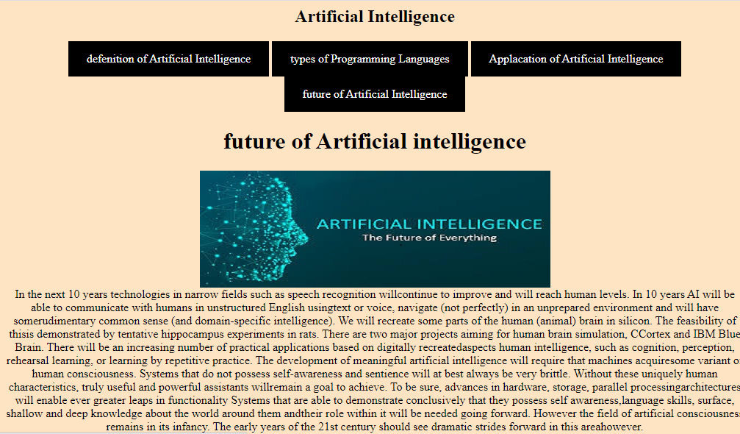

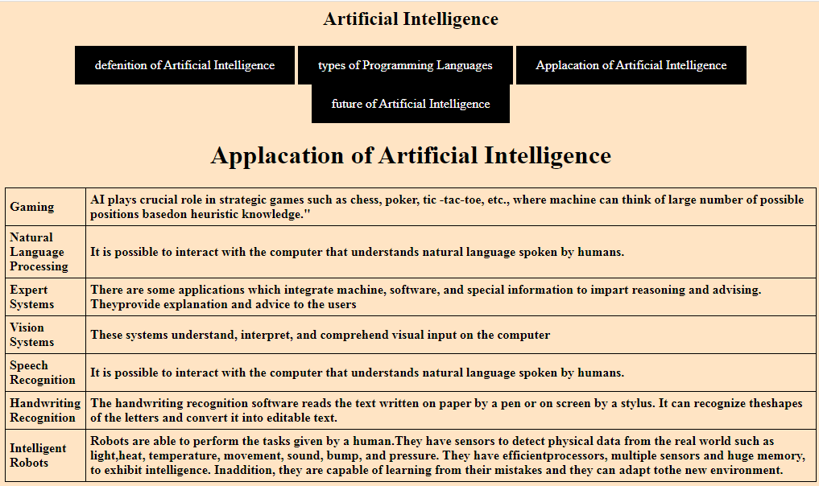

SCREEN RESOURCE

