

Network project

SWITCHING, ROUTING AND WIRELESS ESSENTIALS (CCNA2)

NETWORK DESIGN
Esra Esam

Scenario:
Fresh Blooms Trading is one of those e-business companies that deals in the sale and delivery of fresh flowers and customized gifts all across the nation. Initially established by two entrepreneurs, the company has grown into a mid-sized firm with 40 staff members, distributed among four work teams: Admin (6 staff members), IT/Network (4 staff members), Sales (15 staff members), and Creative (15 staff members). The firm is run from a two-story open-plan office building, and each floor has capacity for 20 staff members.

The existing infrastructure in the company includes a router that is connected to the local ISP, a distribution switch, and two access switches, each on one floor, linking end devices like PCs and laptops. The network was initially established with simple configurations with remote access enabled using Telnet and with all the devices placed in one default VLAN with the use of the IP address range of 192.168.1.0/24.

Network staff have been requested to inspect and enhance the existing network since the employees are suffering from sluggish and erratic network connections caused by heavy file transfers between the employees in the Creative Team and unstable trunks from the access switches to the distribution switch. The staff is also required to inspect the security of the network and recommend settings and configurations based on security best practice in order to harden the switches.

Tasks:

Task 1: Current Network Topology
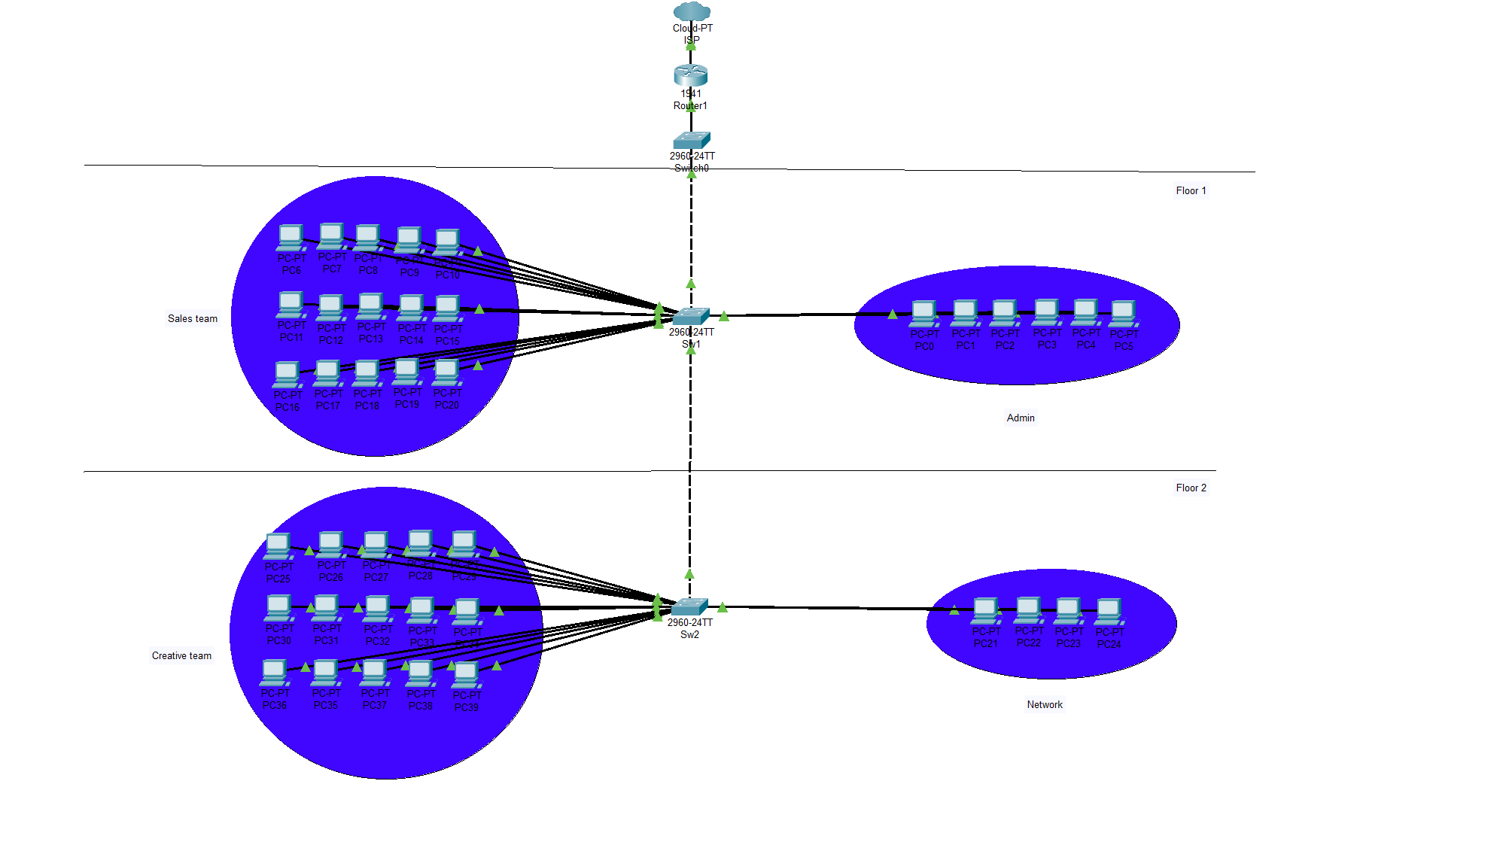

Task 2: Current IP Addressing Scheme

- Network: 192.168.1.0/24
- Subnet Mask: 255.255.255.0
- Default Gateway: 192.168.1.1 (Router)
- DHCP-enabled assumed static IPs.
- All users reside in one broadcast domain, increasing collision and congestion.

Task 3: Propose an improved network that is efficient, reliable, and secure.
Solution | Function | Benefits
Different VLAN | Function: Divides the network into smaller broadcast domains.  Problem:  - Slow internet connections  - Heavy file sharing | - Improves security by limiting communication to within the same VLAN.  - Better performance by reducing traffic and improving bandwidth.
STP | Function:  - Prevents bridge loops in LANs with redundant links.  - Prevents broadcast storms.  Problem: Heavy file sharing | - Increases aggregate bandwidth.  - Enhances network resilience by providing backup paths in case of link failure.
Router-on-a-Stick | Function: Connects a router to a switch using one physical interface and enables IP routing between VLANs.  Problem:  - Need secure configuration and best practices for switch hardening | - Ensures VLAN traffic is isolated to control data flow between segments.  - Improves network security.  - Simplifies management via centralized routing.

Task 4: New IP Addressing Scheme
VLAN | Department | Subnet | Gateway | Hosts Needed
10 | Admin | 192.168.10.0/24 | 192.168.10.1 | 6
20 | Network | 192.168.20.0/24 | 192.168.20.1 | 4
30 | Sales | 192.168.30.0/24 | 192.168.30.1 | 15
40 | Creative | 192.168.40.0/24 | 192.168.40.1 | 15
99 | Management | 192.168.99.252/24 | 192.168.99.254 | 3 Switches

Task 5: Reducing Administration Workload

- Use DHCP to automate IP address assignments instead of static
- Introduce a management VLAN (VLAN 99) for switch administration
- Enable SSH for secure remote access
- Use centralized configuration and port descriptions

Task 6: Security Enhancements
Security Issue | Solution / Configuration
Open the default VLAN | - Create and assign users to separate VLANs based on department
Unused ports active | - Disable unused ports: interface range fa0/10 - 24 shutdown
Unsecured switch management access | - Assign static IPs in VLAN 99 for switch management
Insecure remote access (Telnet) | - Enable SSH for encrypted access and disable insecure services like CDP
Weak authentication | - Use strong login credentials - Enable warning/login banners

Task 7: New Network Topology
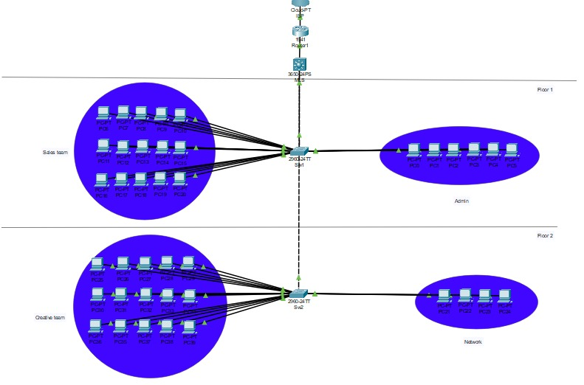

- Router with subinterfaces: G0/0.10, G0/0.20, G0/0.30, G0/0.40
- Trunk links from the router to the distribution switch and from the distribution switch to other switches.
- VLANs are labelled on appropriate switch ports
- DHCP zones per VLAN
- Management VLAN (VLAN 99) configured for switch control

