Taint && Tolerations

Lab –

How many nodes exist on the system?

$ kubectl get nodes

Do any taints exist on node01 node?

$ kubectl describe node node01 | grep Taint

Create a taint on node01 with key of spray, value of mortein and effect of NoSchedule

$ kubectl taint node node01 spary=mortein:NoSchedule

Create a new pod with the nginx image and pod name as mosquito.

cat pod1.yaml

apiVersion: v1

kind: Pod

metadata:

name: mosquito

spec:

containers:

- name: c1

image: nginx

$ kubectl create -f pod1.yaml

Create another pod named bee with the nginx image, which has a toleration set to the taint mortein.

Image name: nginx

Key: spray

Value: mortein

Effect: NoSchedule

Status: Running

cat pod2.yml

apiVersion: v1

kind: Pod

metadata:

name: bee

spec:

containers:

- name: bee

image: nginx

tolerations:

- key: "spray"

operator: "Equal"

value: "mortein"

effect: "NoSchedule"

$ kubectl create -f pod2.yml

Pod not scheduled on node01 because of -🡪 taint-effect : NoSchedule that scheduler will not schedule this pod on this node

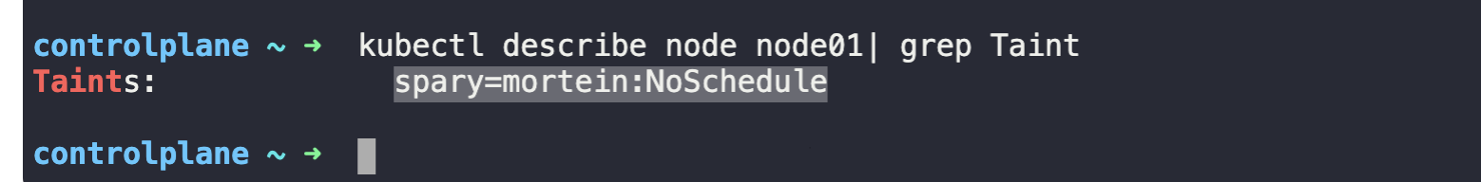

How to remove taint from controlplane?



$ kubectl taint nodes controlplane node-role.kubernetes.io/control-plane:NoSchedule-

