Namespaces----------🡪 we can think on namespace as box or logical container that hold our deployed k8s objects.

But its not good idea if we have same cluster for development and production we need some kind of isolation between prod and dev component so we need different namespaces.

When we create pods or other resources and we don’t provide namespace those resources are deployed on default namespace.

Kubernetes has namespace called kube-system that has component related to Kubernetes .

Resources in same namespace can refer each other by name.

How to Create namespace ?

$ kubectl create namespace namespace_name

How to delete namespace ?

$ kubectl delete namespace. Namespace_name

How to create namespace declarative way ?

$ kubectl create -f ns.yml

How to deploy. Pod on tailer namespace?

apiVersion: v1

kind: Pod

metadata:

name: pod1

namespace: tailer

labels:

app: LB

spec:

containers:

- name: c1

image: nginx

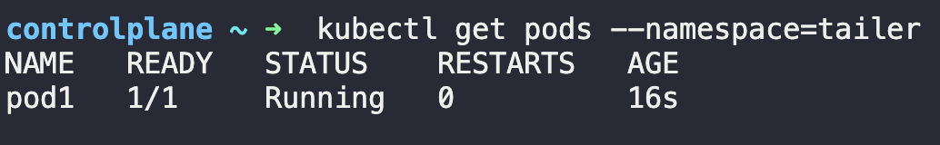

-------------------------LAB----------------------

How to get pods ?

$ kubectl get pods --------🡪 this gets pods on default namespace

$ kubectl get pods --namespace=namespace_name -----🡪 get pods on specific namespace

How many Namespaces exist on the system?

$ kubectl get namespaces

How many pods existing on research namespace ?

$ kubectl get pods --namespace=research

* Create a POD in the finance namespace 🡪   
  Name: redis
* Image name: red

$ kubectl run redis --image redis --namespace=finance

$ kubectl get pods --namespace=finance

Which namespace has the blue pod in it?

$ kubectl get pods --all-namespaces



What DNS name should the Blue application use to access the database db-service in the dev namespace?

Blue app on marketing namespace

db-service --🡪 dev namespace

$ kubectl get services --namespace=dev

Service_name.namespace_name.svc.cluster.local

