Why pods ?

We see on docker app has been containerized inside container that works on isolated file system on /var/lib/docker/containers/container_id but share with host kernel.

But what happens if container fails ? or if container failed and we didn’t notice that ?

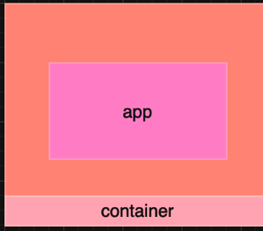

We need so kind of orchestration and self-healing so that if container fails we need some kind on monitoring and automation to provision new containers from themselves no need for human interface.-----🡪 solution is k8s.

What is pods? ----🡪 k8s object that has single instance of application.

Pod can be --🡪

1. Single container pod
2. Multi-container pod (but not for same app)

Each pod has ip that is dynamic.

Pod is smallest object we can create on k8s.

Pods are running on worker nodes on k8s cluster.

How to create pod ?

kubectl run pod_name --image image_name

image is pulled from docker hub registery.

Create pod from yml file?

How to create pod (declarative) ?

apiVersion: v1 ------🡪apiVersion for k8s api for creating object

kind: Pod. ------🡪 object kind we’re trying to create

metadata: --------🡪 info about object

name: pod_name

spec:

containers: # list of container pod can be multi-container pod

- name: c1

image: image_name

$ kubectl appy -f filename.yml

Each yaml file on k8s has main for component ?

1_ apiVersion

2_. kind

3_. metadata ------🡪 info about object we’re trying to create (name,namespace ,labels)

4_. spec -----🡪 specification for object

How to list pods ?

$ kubectl get pods

Create a new pod with the nginx image.?

$ kubectl run pod1 --image nginx

Get detailed info about pod?

$ kubectl describe pod pod_name

To get which node that pod deployed on?

$ kubectl get pods pod_name -o wide

How to delete pod?

$ kubectl delete pod pod_name