Indoe --🡪 index node is unique identifier for metadata on filesystem

Each file or directory has is own inode number that assigned to it when created.

$ touch /home/esraa/text1.txt ----🡪 there is file created on /home/esraa that has name ca;;ed text1.txt and indoe assigned to it.

User access file via its name but internally in system you access data on this file via indoe number.

Inode is uniqued per file system.

To get number of indoes available on file system ?

$ df -i /path/to/filesystem

You you will get total number of indoes , used, free.

To get inode of file

$ ls -i /path/to/file

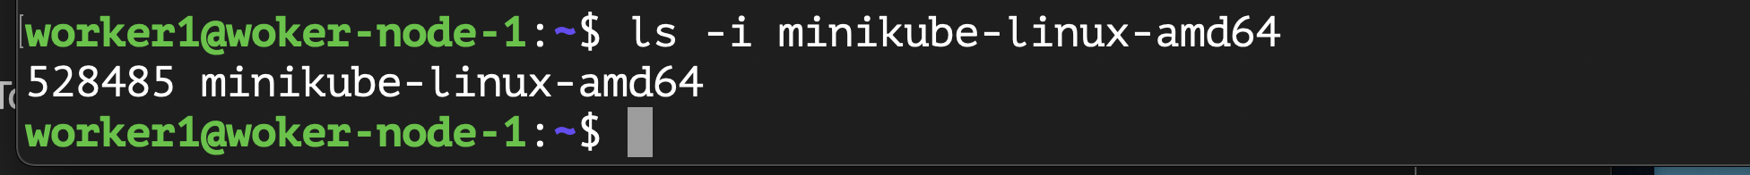

To get inode of directory

$ ls -idl /path/to/dir

i ----🡪 inode

d -----🡪 directory

l ----🡪 long format

Notes 🡪

When you copy a file, Linux assigns a different inode to the new file.

When you move a file ----🡪

1. destinition on same file system ----🡪 inode remains
2. destinition on different file system ----🡪 different inode is assigned

