1. INTRODUCTION:
This section gives a scope description and overview of everything included in this SRS document. Also, the purpose for this document is described and a list of abbreviations and definitions is provided.

1.1. Purpose:
The purpose of this document is to give a detailed description of the requirements for the

“gam3ana web site” software. It will illustrate the purpose and complete declaration for the
development of system. It will also explain system constraints, interface and interactions with
other external applications.

1.2. Scope:

“gma3na ” is a web application which serves many types of users that seek to connect with others for doing activities

Administration staff can provide their categories and user information using the web-portal. This information will act as the bases for the users and permissions. An administrator also uses the web-portal in order to administer the system and keep the information accurate. The administrator can, for instance, verify manage user information.

Furthermore, the software needs Internet connection to fetch and display data. All system information is maintained in a database, which is located on a web-server. By using “Gam3na ” users will be able to view the nearest activities according to his / her preferences , create new event , report past events , connect with friends , rate events. Etc.
The Web Application is for the automation people activity gathering all over the world. It maintains the event with its participants allow post photos and share videos.

- Sign Up
  - Using Face book
- Create Event
  - Event Attribute
    - Location
    - Category , Sup category
    - Name ( suggest Name ) [ City , Category ]
    - Description ( min length )
    - Date Time ( support recurring Events )
      - Members
      - Past members
    - Ticketed event will be charged
- Members
  - Find EVENT
    - Suggest by location and interests ( N Numbers of Mils away )
- Application
  - Track event attendance status
  - Connect with network ( follow ) ( Facebook friend suggest )
  - Show latest Events
  - Sent Messages
  - Notifications
  - Share Photos / Videos
  - Browse Members
  - View event Review
  - Submit Review
    - Ask for feedback
  - Rank Members / event .
  - Open Discussion ( of event )
  - Join Discussion ( of event )
  - Add sponsors ( of event )
  - Report Event

2. Overall description

This section will give an overview of the whole system. The system will be explained in its context to Show how the system interacts with other systems and introduce the basic functionality of it. It will also describe what type of stakeholders that will use the system and what functionality is available for each type.

2.1 Product perspective
This system will consist of : web portal .the web portal will be used for managing the information about the events and the system as a whole.

Since this is a data-centric product it will need somewhere to store the data. For that, a database will be used. The web portal will communicate with the database. The web portal will add and modify data. All of the database communication will go over the Internet.

2.2 Product functions
With the web site , the users will be able to search for events , attended or create new one . The user will notified by the event . The user will be also able to view past event rate , and submit feedback about the attended events through web portal .The web portal will provide functionality to both user and administrator to manage and update the both events and application information. It will also provide information about the system, for example show when there is a new update.

2.3 User characteristics
There are Two types of users that interact with the system: user and administrator , Administrator will access the application through the web portal however event feature will be available though web portal . Each of these two types of users has different use of the system so each of them has their own requirements.

users can use the application to find event , attend , create new one , rate , submit feedback , report or upload photos and videos . This means that the user have to be able to search for event, choose a specific event from that search and then navigate to it. In order for the users to get a relevant search result there are multiple criteria the users can specify and all results matches all of those. The administrator will manage the information about their users and data through the web portal , for example add new category , remove event , block user ..etc .
3. SPECIFIC REQUIREMENTS

This section contains all of the functional and quality requirements ( Nun Function ) of the system. It gives a detailed description of the system and all its features.

3.1 Functional requirements

- TITLE : User registration
DESC : The user must provide user-name, password and e-mail address. The user can choose to provide a regularly used phone number

- TITLE :Get Suggested Contact
DESC: The User Select to Sig-up with Face book account ,the application Find the user
friends who use Gm3na application and suggest to the user to connect with them .

- TITLE : User log-in

DESC :Given that a user has registered or select to login through the Facebook , then the user should be able to log in to Gm3na web site

- TITLE : Retrieve password
DESC : Given that a user has registered, then the user should be able to retrieve his/her password by e-mail.

- TITLE :Select Action
DESC:Given that a user is logged in to the gm3na web application, then the first page that is shown should be the
Action Selection Page. The user should be able to Choice the type of action he/she need to ake,according to the type the application will response and redirect to the action. The action Types
are find event , create new event rate the past event or upload photo or video .

- TITLE :add New Event
DESC: the User Must Provide Location ,Category , Sub category ,Name ( suggest Name ) [ City ,Category ] ,Description ( min length ) ,Date Time ( support recurring Events ) ,Members ,Past members.

- TITLE :Add Member To event
DESC: the user select one or more from his/her connected members to suggest adding to the event.

- TITLE :Track Event status
DESC: the event creator Receive Notification when new member joined the event or when new photo or video is uploaded.

- TITLE :Show latest Events
DESC: after login the user see on his profile both upcoming event i or latest events from his favorite categories

- TITLE :attend event
Desc: the user select an event action " going " ; the user will be added to attends list of the event .

- TITLE :Notifications
DESC: the user shall get notification and reminder about the upcoming event for his favorite categories,when someone follow him ,when event has updates.

- TITLE :Share Photos / Videos
DESC: the user provide a photo or video to upload related to an attended event .

- TITLE :Browse Members
DESC:the user shall be able to search other users account and follow them.

- TITLE :View event Review
DESC: the user shall be able to select an event to view its reviews .

- TITLE : Ask for feedback
DESC: After Event is occurred participant shall be asked to provide his feedback .

- TITLE : Rank Members / event
DESC: during the event feedback the user shall provide a rand out of 5 for the event , member get their rand as an average of their events .

- TITLE : Open Discussion
DESC:the user shall be able to open a discussion about any event and will provide a question or comment .

- TITLE : Join Discussion
DESC: the user select a discussion of an event to join , the user can either view post comment and be able to add new one .

- TITLE : Add sponsors
DESC: add event’s sponsor.

- TITLE : Report Event
DESC: the user select to report event , defined reporting list shall be filled .

- TITLE : add advertisement.
DESC: advertisement appear from time to time .

- TITLE : View event data
DESC: the data for the event(location , duration, people join that event, description,photos and videos).

3.3 Non-Functional requirements

The requirements in this section provide a detailed specification of the user interaction with the software and measurements placed on the system performance.

- Prominent application feature
TITLE : Prominent feature
DESC : The website system should be prominent and easy to find for the user. In order to for a user to find any feature easily.

3.3.2 Response time

SCALE: The response time of a get data

3.3.3 Security
TAG : UserCreateAccountSecurity

DESC : The security of creating account for users of the system. If a user wants to create an account and the desired user name is occupied, the user should be asked to choose a different user name.

3.3.4 Maintainability

TITLE : Application extendibility
DESC : The application should be easy to extend. The code should be written in a way that it favors
implementation of new functions. In order for future functions to be implemented easily to the application.

TITLE : Application testability
DESC : Test environments should be built for the application to allow testing of the applications different
functions.
RAT : In order to test the application.

Website Home Page
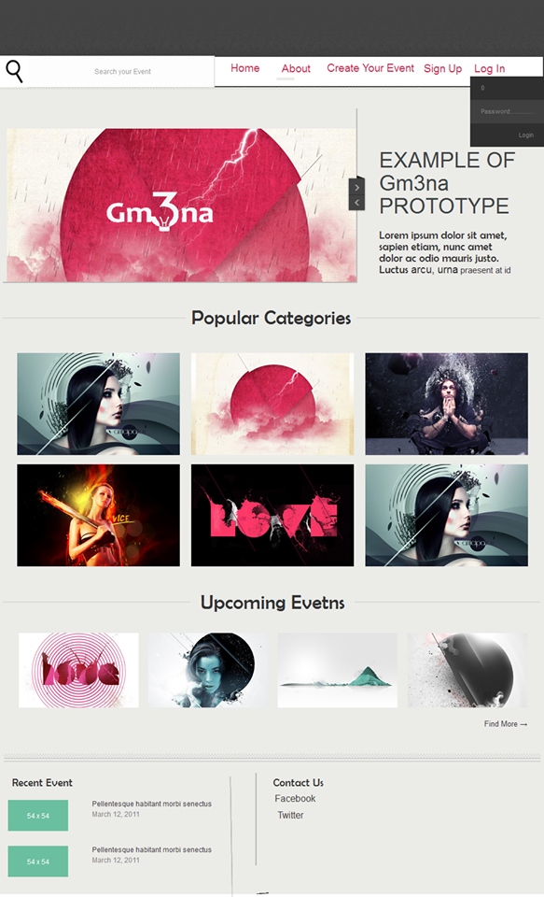

sign-up form

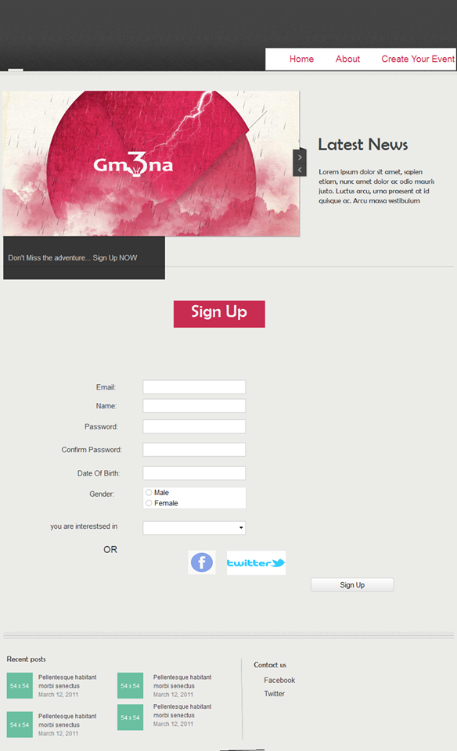

profile
