**TPA**

An Android Mobile Application that helps the user to record his planned trips and remind the user with his trips on the time specified by the user. The application should navigate the user to his destination. After that, the application should keep track with the upcoming and past trips.

The app has the following features:

1- Login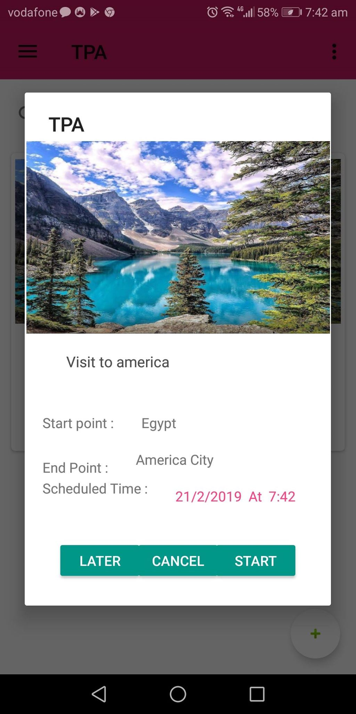

2-Signup

3- Create trip

4- Alarm to remind the user with the trip date

5- Track the user during trip using google map

6- Add notes

7- Postpone or remove trip

8- Log the user`s trip history

9- Change user profile information.