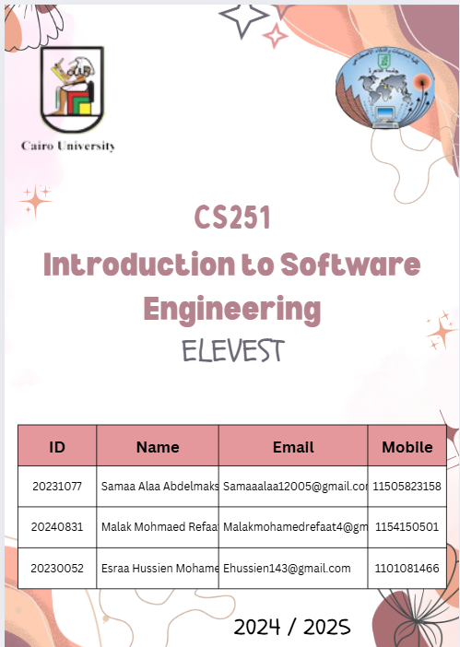

**TechRadar**

**Terraform (Adopt) – Samaa**

Terraform is the leading Infrastructure as Code (IaC) tool for automating cloud and on-prem infrastructure provisioning. Using declarative HCL/JSON files, it enables version-controlled, repeatable deployments across AWS, Azure, GCP, and more.

Key Features

Declarative Syntax – Define infrastructure as code for consistent environments.  
State Management – Tracks real-world resources to prevent drift.  
Multi-Cloud Support – 3,000+ providers for clouds, Kubernetes, and SaaS.  
Modules – Reusable templates standardize deployments.  
Plan/Apply Workflow – Preview changes before execution.

Limitations

Learning Curve – HCL syntax and state management require training.  
State File Risks – Local files may expose sensitive data if unsecured.  
Debugging Challenges – Errors can be vague for complex deployments.

Verdict: Adopt

Terraforms **maturity, ecosystem, and multi-cloud flexibility** make it the **IaC standard**. For enterprises, it outperforms alternatives like Pulumi (developer-centric) or AWS CDK (AWS-only).

Recommendations:

Use Terraform Cloud for secure state storage.

Implement Terragrunt for large-scale deployments.

Terraform is mature, widely supported, and essential for modern DevOps. While alternatives like Pulumi offer developer-friendly coding, Terraform’s ecosystem and stability make it ideal for enterprises.

Terraform remains the de facto standard for IaC, balancing flexibility with robustness. Teams should invest in training to maximize its potential while mitigating state management risks.

**Claude 3.5 Sonnet – Generative AI Model --Malak**

Claude 3.5 Sonnet, released by Anthropic in June 2024, represents a significant evolution in large language models. It is an advanced language model that excels in coding, writing, analysis and visual processing. It's available in the browser, terminal, most major IDEs and even integrates with GitHub Copilot. After rigorous testing across coding, reasoning, and creative tasks, this review evaluates its performance, ethics, and practical applications.

**Easy to Use:**

Works like a super-smart chatbot. Just type questions or upload files (images, docs).

Answers in plain English, not robotic jargon.

**Great at Everyday Tasks:**

Fixes coding errors step-by-step

Writes clear emails, summaries, or social media posts.

Explains complex topics simply.

**Fast & Affordable:**

Responds instantly (like a quick Google search), 120 words/sec output (2× faster than Claude 3 Sonnet).

Costs half as much as similar tools like GPT-4.

**Image Understanding:**  
Upload a messy notes photo → turns it into a neat to-do list.

**Math & Data Help:**  
Solves equations or explains charts from spreadsheets.

**Multi-Language Support:**  
Speaks Spanish, French, German, etc. (but best in English).

**Conclusion**

Claude 3.5 Sonnet establishes itself as the new performance leader in enterprise AI. Its combination of speed, accuracy, and safety makes it ideal for:

Developers needing "AI pair programming" support

Analysts processing mixed-format reports (PDFs + spreadsheets)

GitHub Screenshots

