**Esraa’s Pizza** is a restaurant from which you can order food onlineby using our app.

**First(Log in):** you need to ask Esraa’s customer service for an ID and password to use their app.

-By opening the app you will be asked to enter your ID 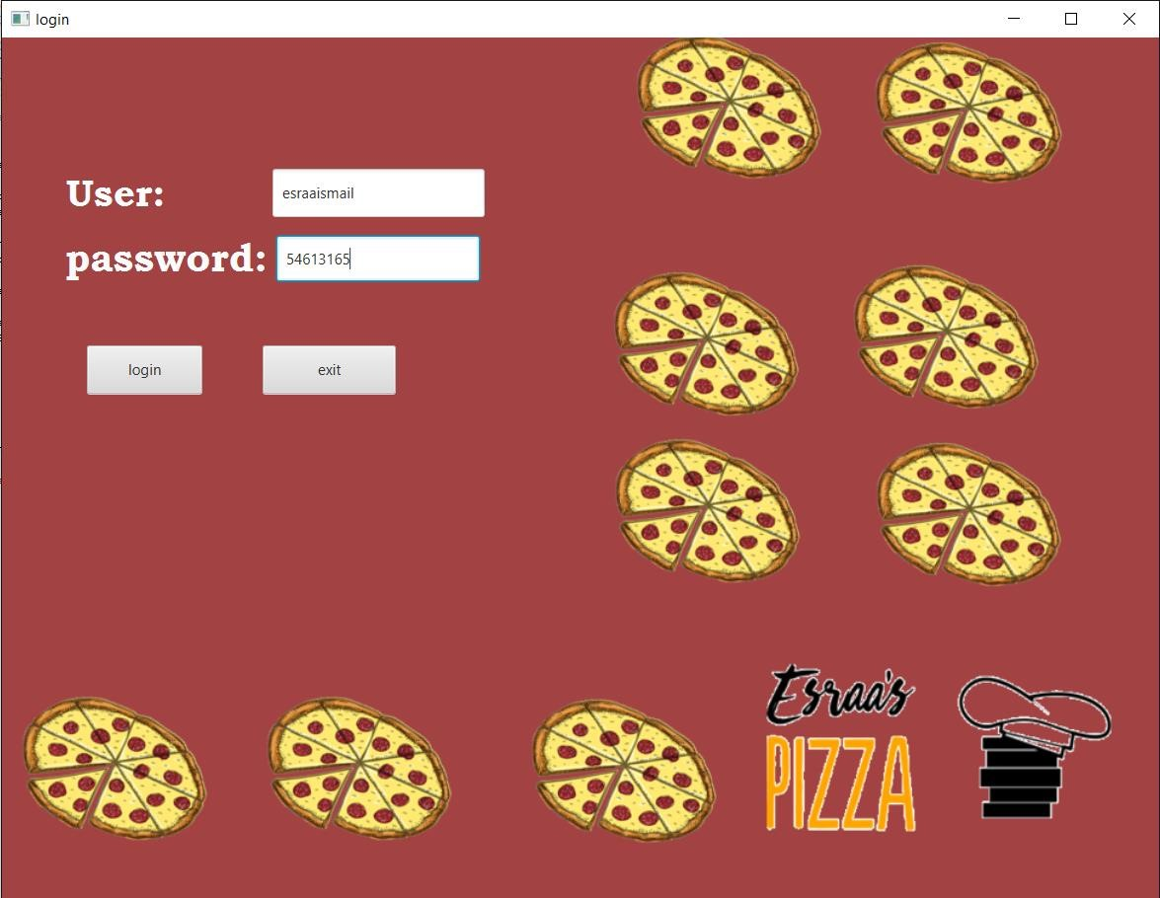

“username” and password

If you entered a wrong data then an error massage will appear.

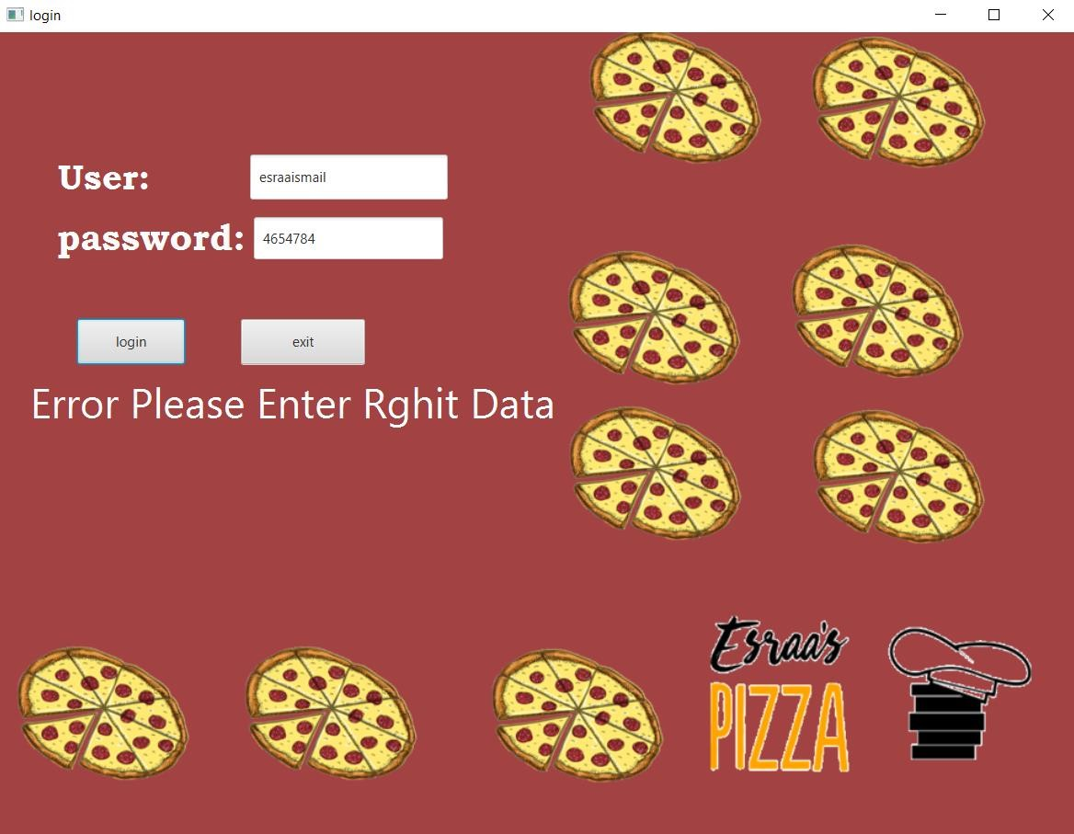

if you entered the right data then you will be able to make your order

**Ps: a song will be played once you start using our app to make you enjoy ordering our tasty food.**

**Second (Order):** we have 3 menus pizza menu, desserts menu and drinks menu.

You can place your order by selecting your item type, quantity and size and the click on the “Order” button to add your item on your order list. In addition, you can choose crust pizza by checking the button of Add Crust.

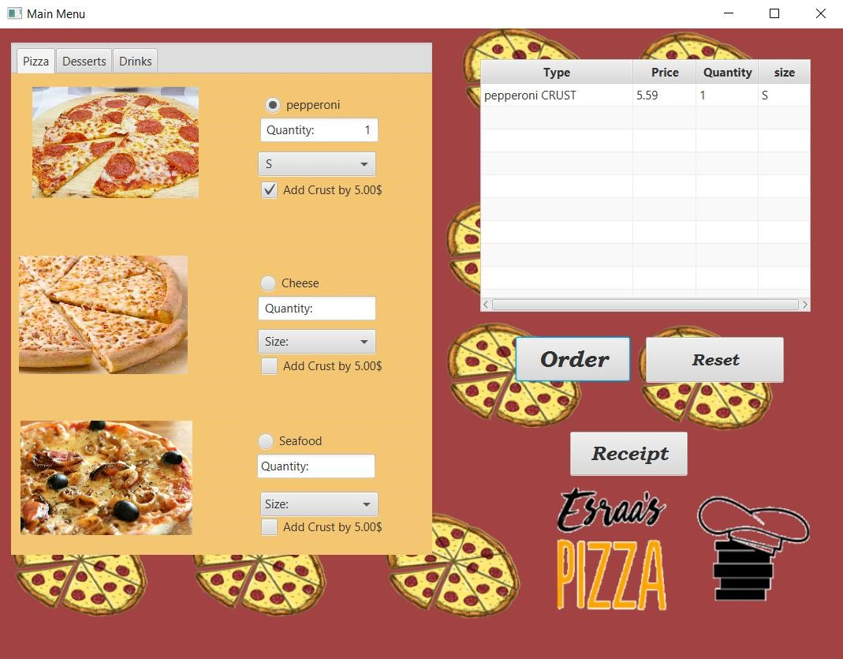

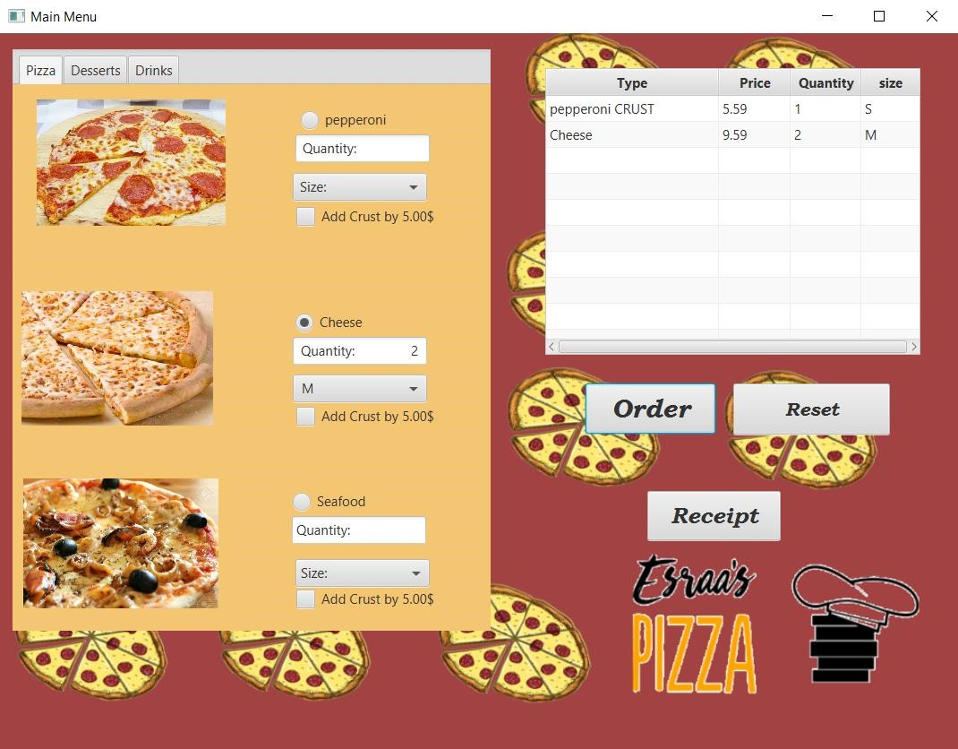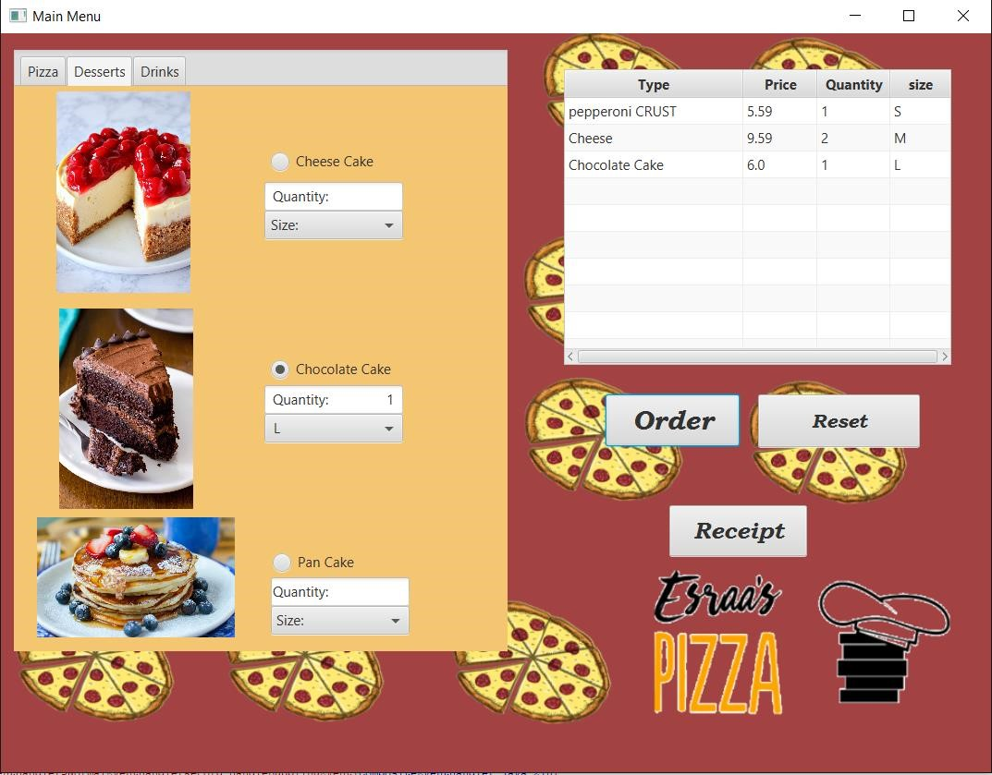

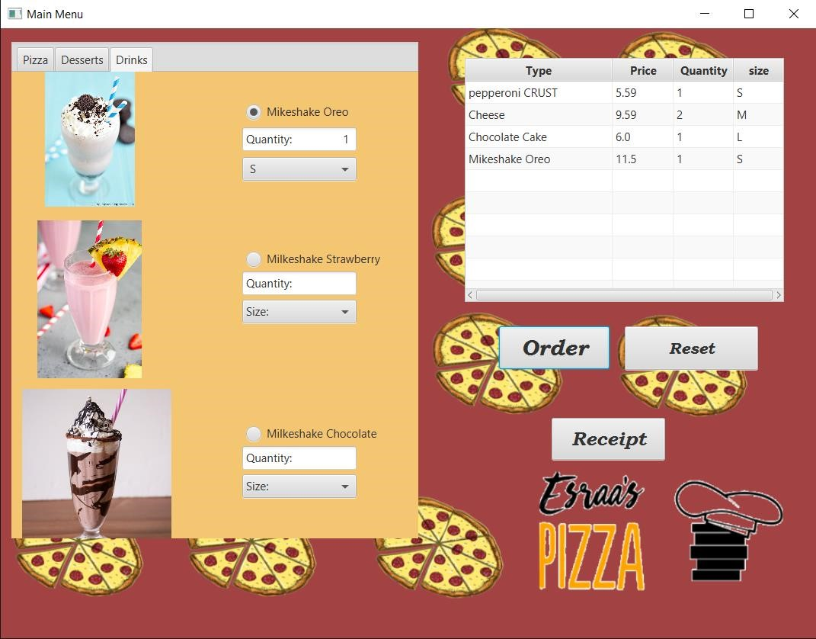

You can clear all your previous choices by clicking the “Reset” button. And if you’re done with your order you can click the “Receipt” button to print your receipt.

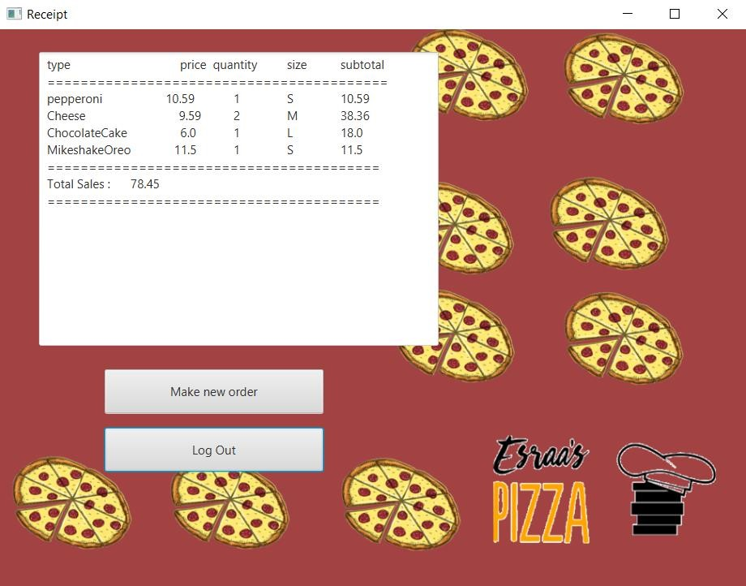

You can go back to make a new order by clicking “Make new order” button. Or log out from your account if you’re done.

**Third (Log out):**

Once you clicked the “Log out” button an ad will apear to make you follow our instagram page, you can skip it and log out by clicking the “Maybe later” button or you can go follow our page by clicking “OK!” button, and we’ll appreciate it a lot and your next order will be free *kisses*.

